SOLDER PASTE

1. Solder paste is basically solder balls suspended in flux
2. Has a consistency like peanut butter
3. Solder paste is available in 2 types
   1. **Bucket** – usually bigger solder balls. Ideal for application with a solder paste stencil
   2. **Syringe** – smaller solder balls as they need to pass through needle. Ideal for hand application
4. Should be kept at cold but not freezing temperature. Usual lifespan is 8 months
5. If solder paste dries up, mix little bit of IPA (Isopropyl Alcohol) to rehydrate it
6. They key to using it by hand is to apply just the right amount. This is where the needle + syringe is helpful as you can dispense controlled amounts
7. Before applying solder paste, apply flux to the pads so that the solder easily moves and attaches to the pads when the solder paste melts
8. On my hot air station, the temperature setting to melt solder paste is **250 C @ Fan** **speed 4 + Thin nozzle**
9. Application Procedure
   1. For components with few individual pads, place a small blob of solder paste on each pad  
      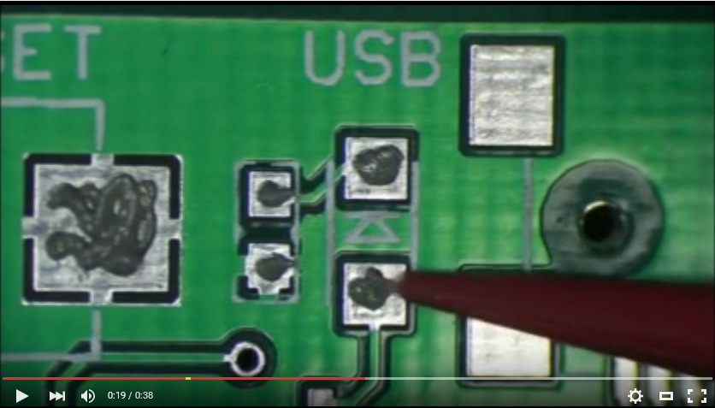
   2. For components with thin and a lot of pads (eg: TQFP), apply a line of solder paste perpendicular to the pads and joining all the pads. Don’t worry, the solder between the pads will flow to the pads due to capillary action and flux  
      