ANKIT KUMAR MISHRA

2125

Repo URL : <https://github.com/ankitmishra2232/2125_SE_ENDSEM>

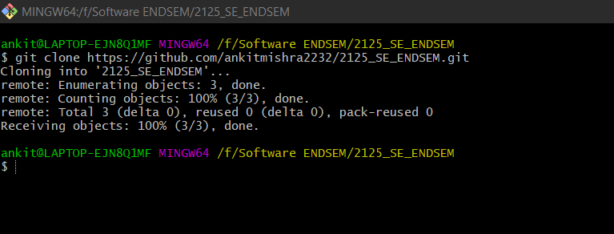

Ant script result

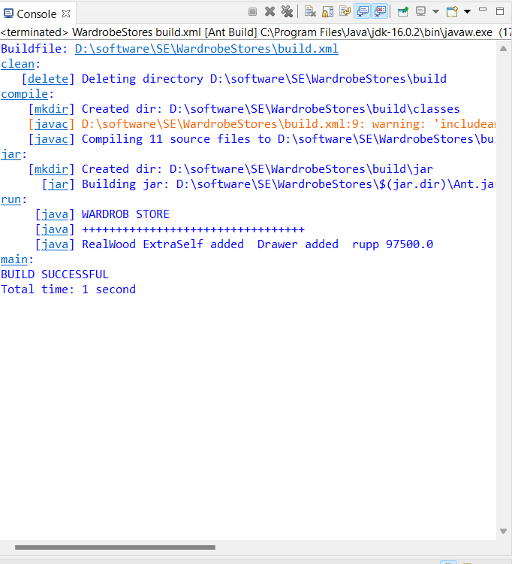

Wardrobe console results

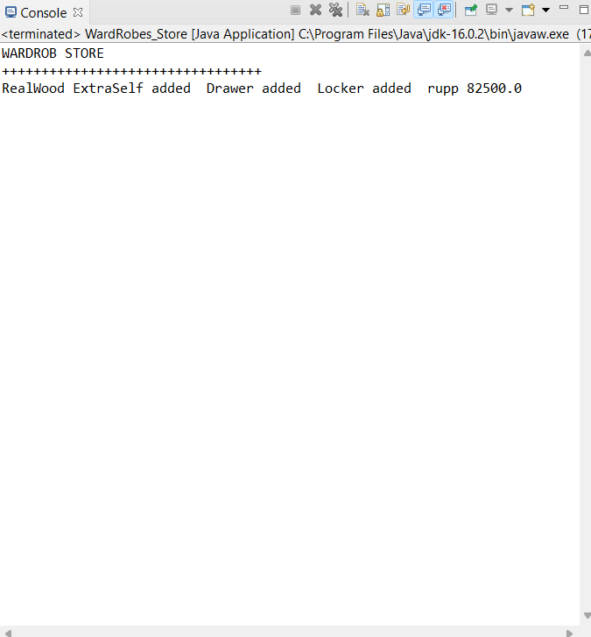

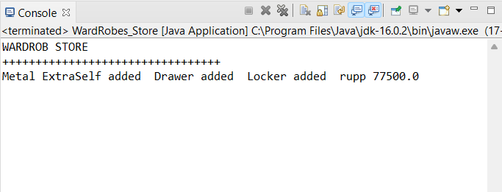

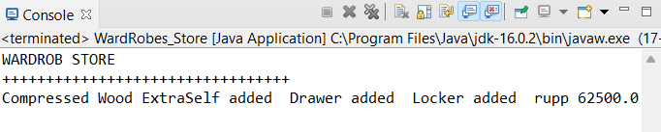

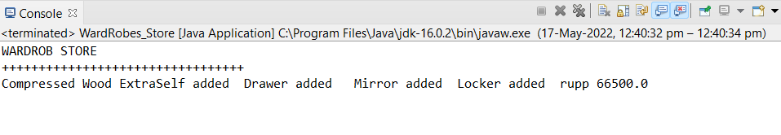

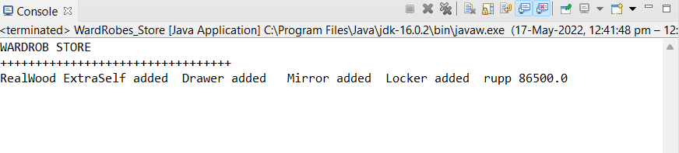

In the code you can select the doors it wont show into the console but there are different prices are addded

Git commands

