# Trash Scanner

Introduction

When we look in our surroundings, people throw away waste materials / garbage. When there is garbage in our surroundings, it stays there for a very long period of time because we lack information about their disposal and its harmful effects to our environment. There are some people who want to contribute to cleanliness but don’t have enough knowledge to effectively categorize and manage the waste.

If we truly want to bring a change in waste management and keep our surroundings clean, then we have to start at an individual level. Then only our country and this whole world becomes and stays clean. We are making an artificial intelligence application that is intended to identify various types of waste materials around our environment and guide people with the correct way of segregating the waste. Also, we will be informing about the harmful effects of not managing the waste.

Activities Carried Out

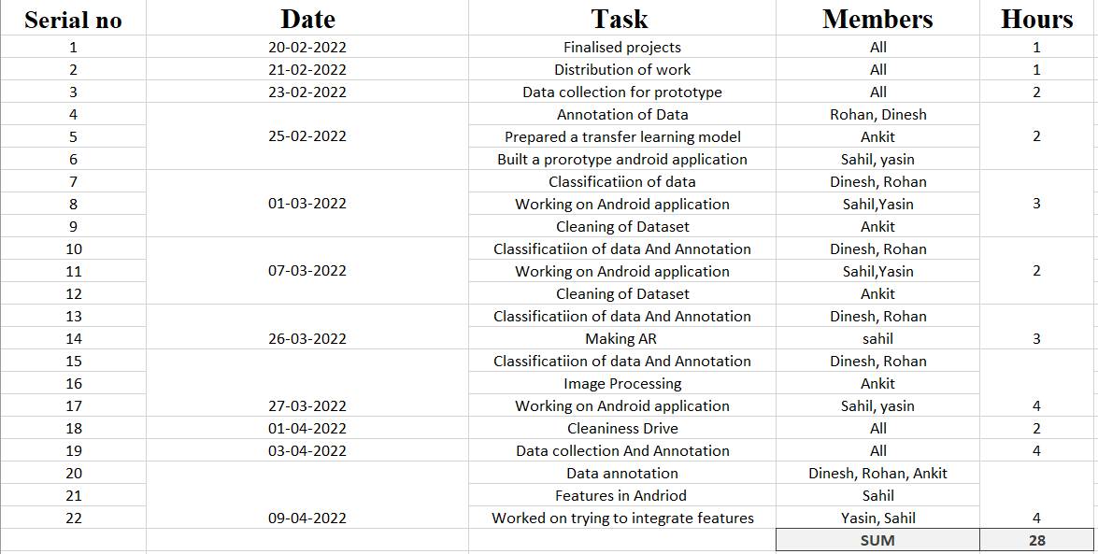

Reported by:

Rohan Vishwakarma,

Dinesh Gawas,

Sahil Asolkar,

Yasin Honnolli,

Ankit Kumar Mishra