**Exercise on Github and Git**

**What is GitHub?**

Github is a version control system which is used by multiple developers in a group/team/organization to maintain the codebase and push updates efficiently. Github also allows users to share the code to the community.

**When and why it was created?**It was founded on February 08, 2008 and was launched on April 10, 2008. It was created to provide basic and high-level management for the projects.

**By who?**   
Github was founded by Tom Preston-Werner.

**What similar platforms exist?**   
Platforms which have version control repositories and have similar functionality are:

1. Concurrent Version System
2. Apache Subversion (SVN)
3. Mercurial

**Why would you use such a platform?**

We use Github because it is a GIT repository hosting service and it provides a web-based graphical interface. It also provides access control and various features like wikis and other task management tools.

**Git Tutorial:**

After following the github tutorial posted in the assignment, following are the commands that I tried out:

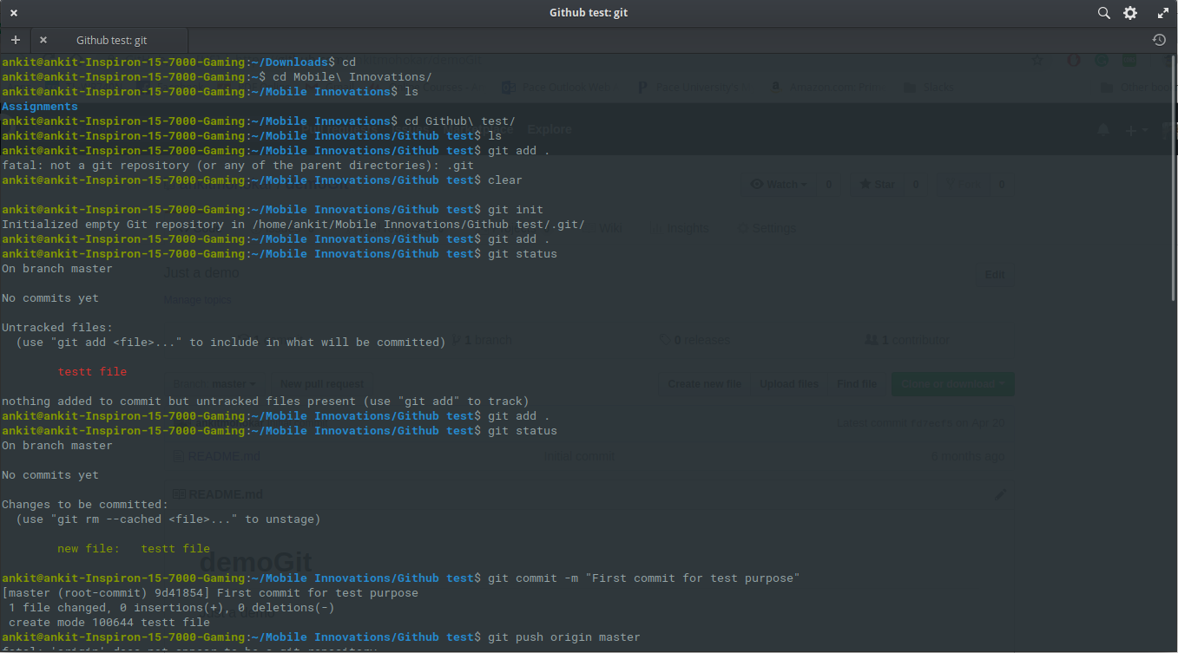

I first initialized a new local repo in my laptop. Then used git add . To add files to it.

Then I added a new file called test file. I checked the status and then I used the same command to add it again. Then I used add origin to add existing remote repo. Then I committed the changes and pushed it.

**Definitions:**

Repository: A place where multiple files can be stored in an organized way is known as a repository.

Commit: Commit is some change to the current version of the file (or files). It’s like a save or a snapshot which we can revert back.

Push: Push command is sending the changes which we have committed to the repository. It allows other members to see the changes.

Branch: Branch is a separate thread in the development cycle and the changes don’t affect the master code.

Fork: Fork is creating a copy of some other user’s project on Github.

Merge: Merge combines multiple commits and gives out a unified history.

Clone: Clone is creating a local repository of the code provided by the source.

Pull: Pull is used to take the latest code of repository to local repository.

Pull request: Pull request is the command which lets the user tell others to review the code changes user has posted.

**Commands and strategy used to do this exercise:**

To upload the docx file to my repository. I started with the following commands:

$ git init

$ git add .

$ git commit -m ‘Initial commit’

$ git remote add origin <https://github.com/ankitmohokar/CS6432018.git>

$ git push origin master

These commands allowed me to push the code to my repository.

**Steps for the pull request:**

1. To update my name in shared repository, I first forked the existing repo into my account.

2. Then I cloned that repository into my local machine.

3. I updated the Readme.md file and added my name and timestamp.

4. Pushed the changes onto forked repository.

5. Then created a pull request on given repository.