**E-commerce Customers**

By Ankit Mordhwaj (16csu042)

AIM

To predict the Yearly Amount spent by customers with the help of other factors present in Dataset.

OBSERVATION

In Dataset there are total seven features that can be used to predict the target which is Yearly Amount spend. Results or prediction of our model does not depend on Email, Address, Avatar.

Avg. Session Length, Time on App, Time on Website, Length of Membership are those feature which will be used to predict the result with the following formula:

Prediction=25.9* Avg. Session Length + 38.77* Time on App + 0.45* Time on Website+ 61.77* Length of Membership + (-1060.26)

In the formula 25.9, 38.77, 0.45, 61.77 are coefficients of the feature and -1060.261 is intercept.

We can also see from the formula that Time on website contribution to the prediction is much less as compared to other so to reduce computation we can also remove that feature.

Conclusion

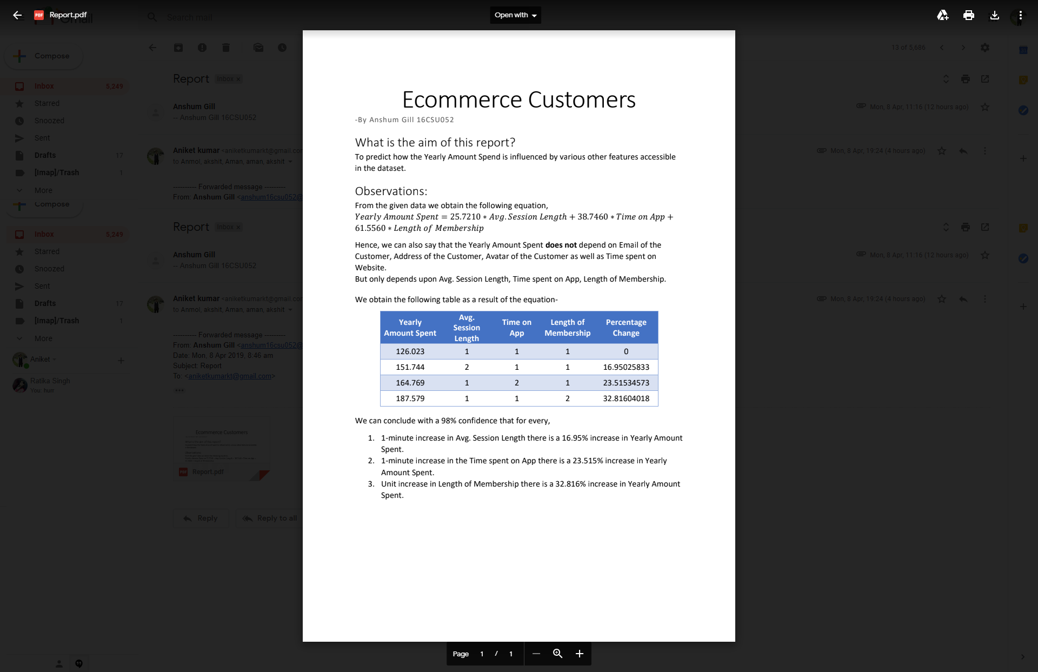

We can predict with 98% confidence that

* There is 16.9% change in Yearly Amount spent if we increase one unit of Avg. Session Length.
* There is 23.5% change in Yearly Amount spent if we increase one unit of Time on App.
* There is 32.8% change in Yearly Amount spent if we increase one unit of Length of Members.