**Uber Context Level DFD (Level 0)**

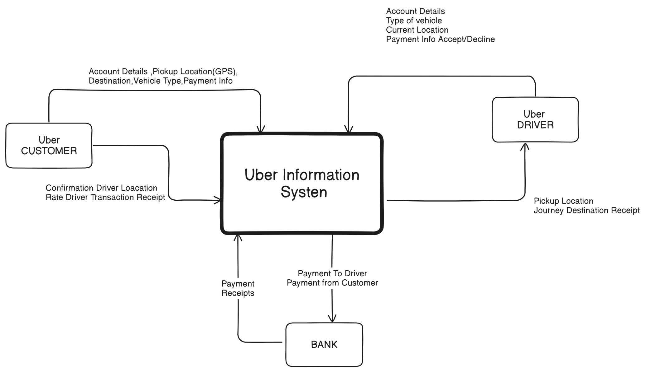

**Uber 1st Level DFD for User & Driver**

