Assignment 2 : Study of Linux Networking Commands Assignment

Name : Aakanksha Sanjay Sonawane
Class : B.Tech
MIS : 111903001
Batch : CS1
Q. Type the following commands on the terminal and take a snapshot of the output, paste it into a word file and write a short description of the command.
1. ifconfig :

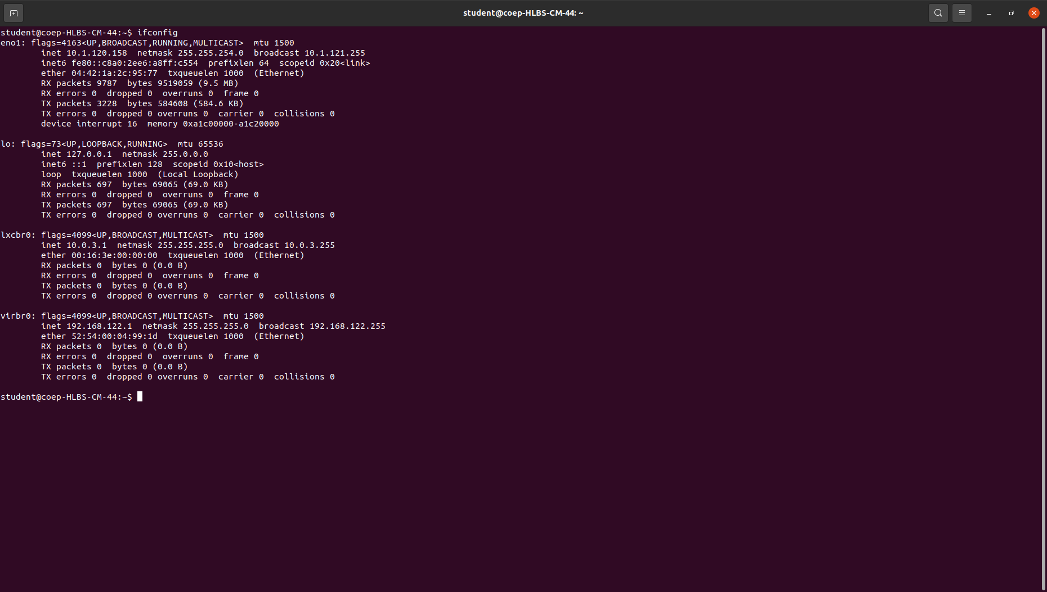
command to assign an address to a network interface and to configure or display the current network interface configuration information. The ifconfig command must be used at system startup to define the network address of each interface present on a system.

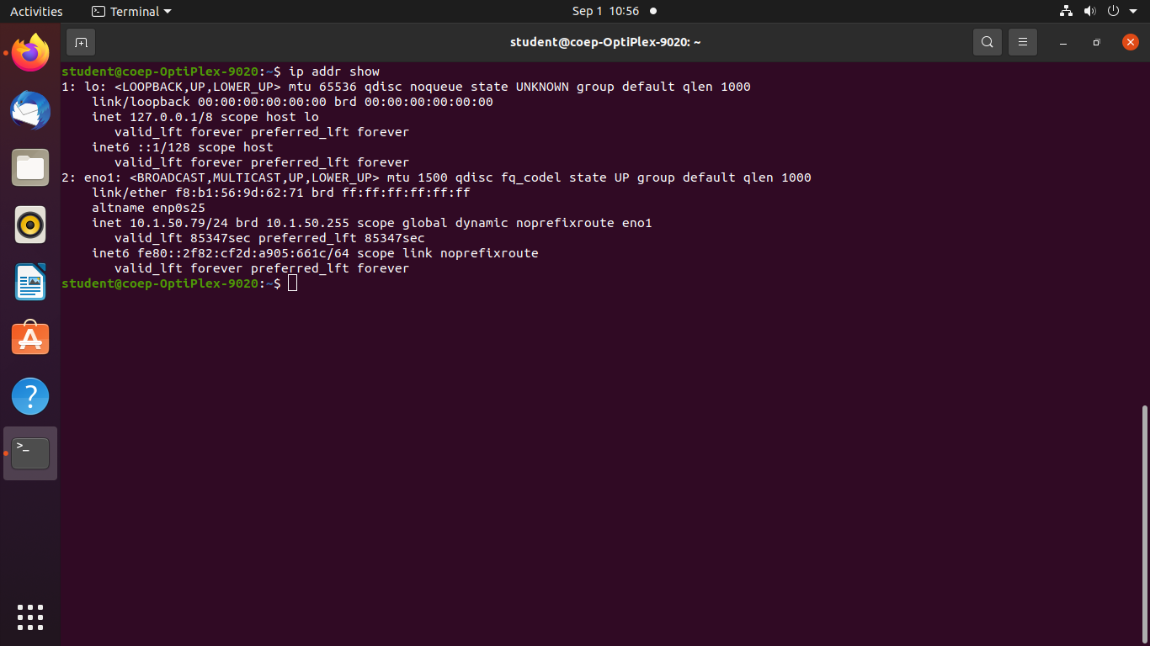
2. ip :

ip command in Linux is present in the net-tools which is used for performing several network administration tasks. IP stands for Internet Protocol. This command is used to show or manipulate routing, devices, and tunnels. It is similar to ifconfig command but it is much more powerful with more functions and facilities attached to it.

3. traceroute :

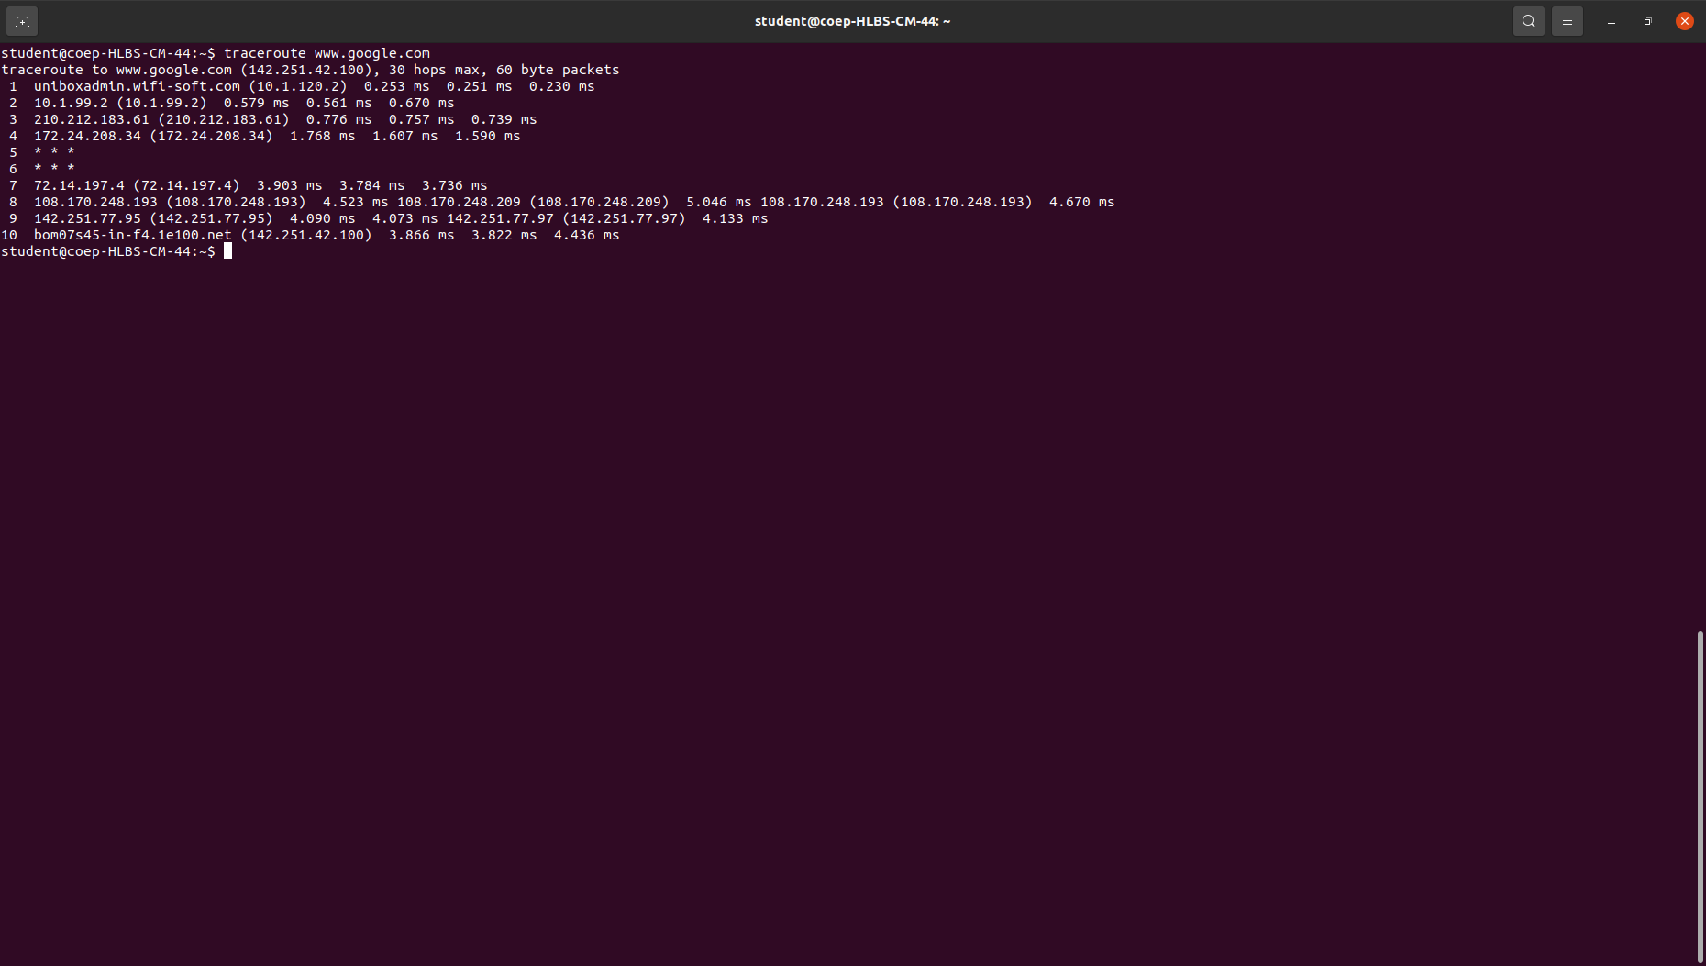
traceroute command in Linux prints the route that a packet takes to reach the host. This command is useful when you want to know about the route and about all the hops that a packet takes.

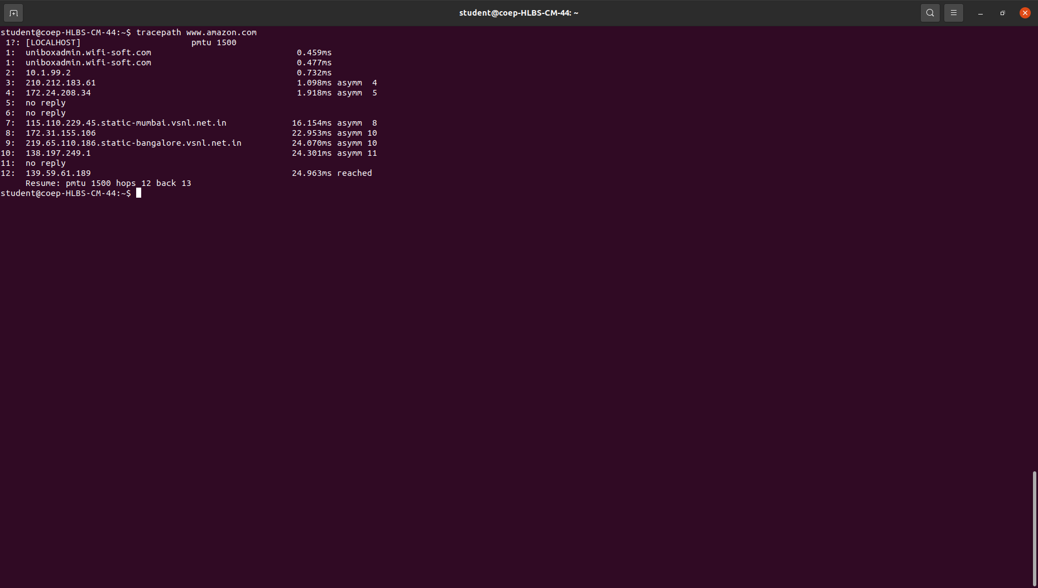
4. tracepath :

tracepath command in Linux is used to traces path to destination discovering MTU along this path. It uses UDP port or some random port. It is similar to traceroute, but it does not require superuser privileges and has no fancy options.

5. ping :

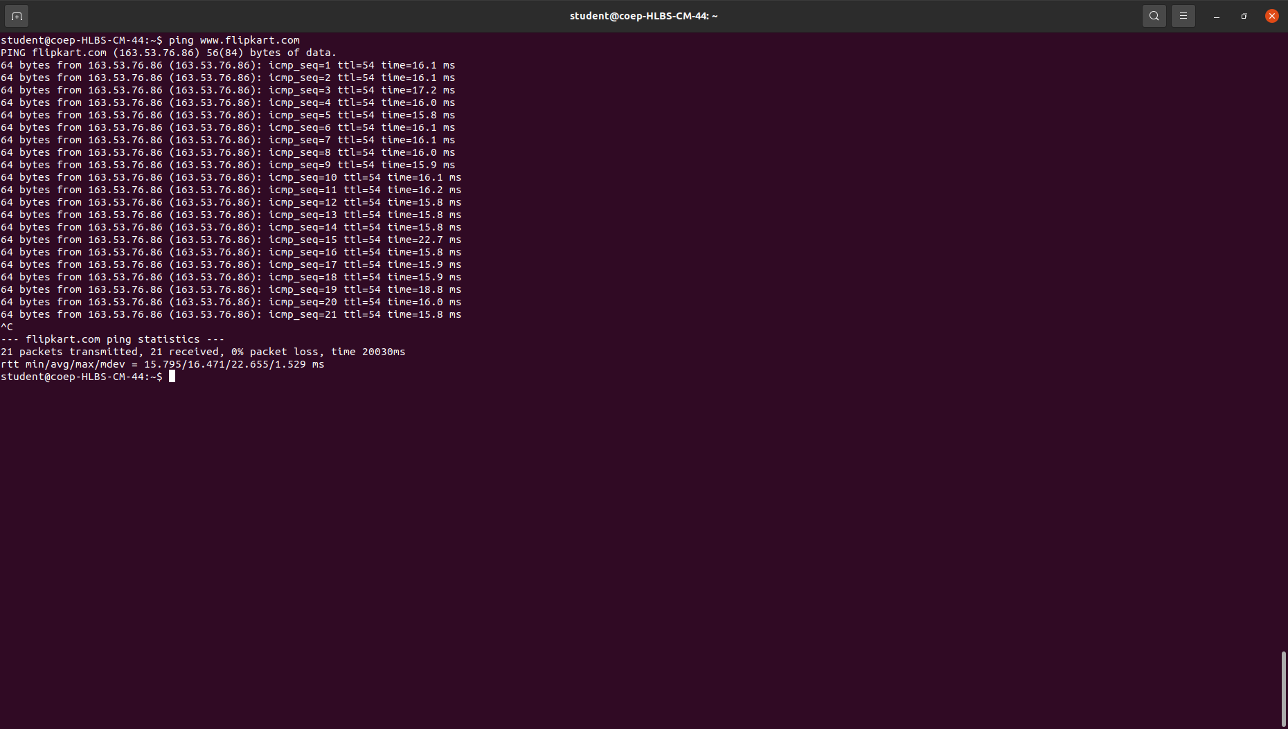
PING (Packet Internet Groper) command is used to check the network connectivity between host and server/host. This command takes as input the IP address or the URL and sends a data packet to the specified address with the message “PING” and get a response from the server/host this time is recorded which is called latency. Fast ping low latency means faster connection.

6. netstat :
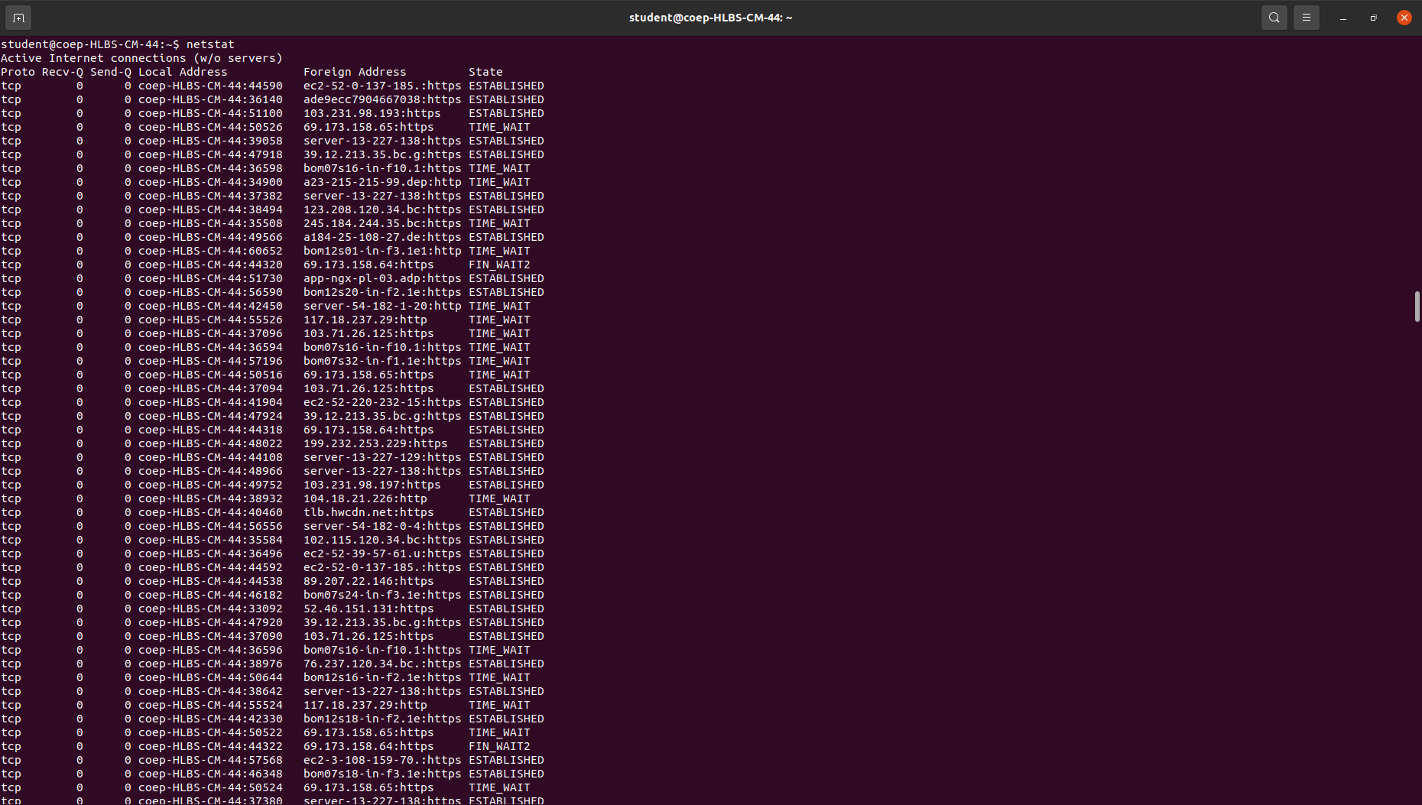
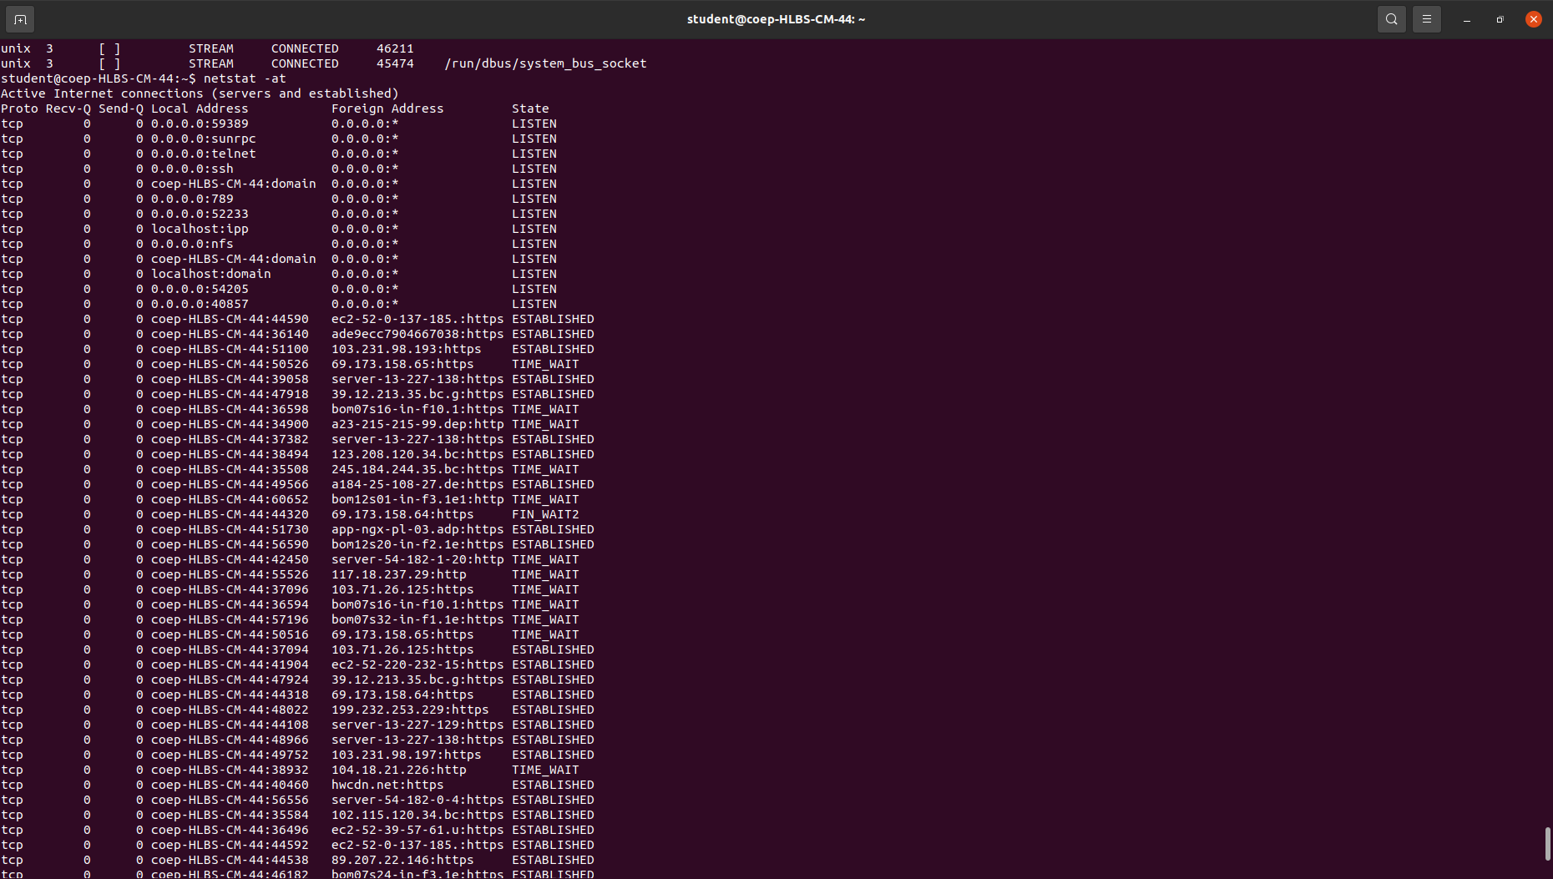

Netstat command displays various network related information such as network connections, routing tables, interface statistics, masquerade connections, multicast memberships etc.

7. nslookup :
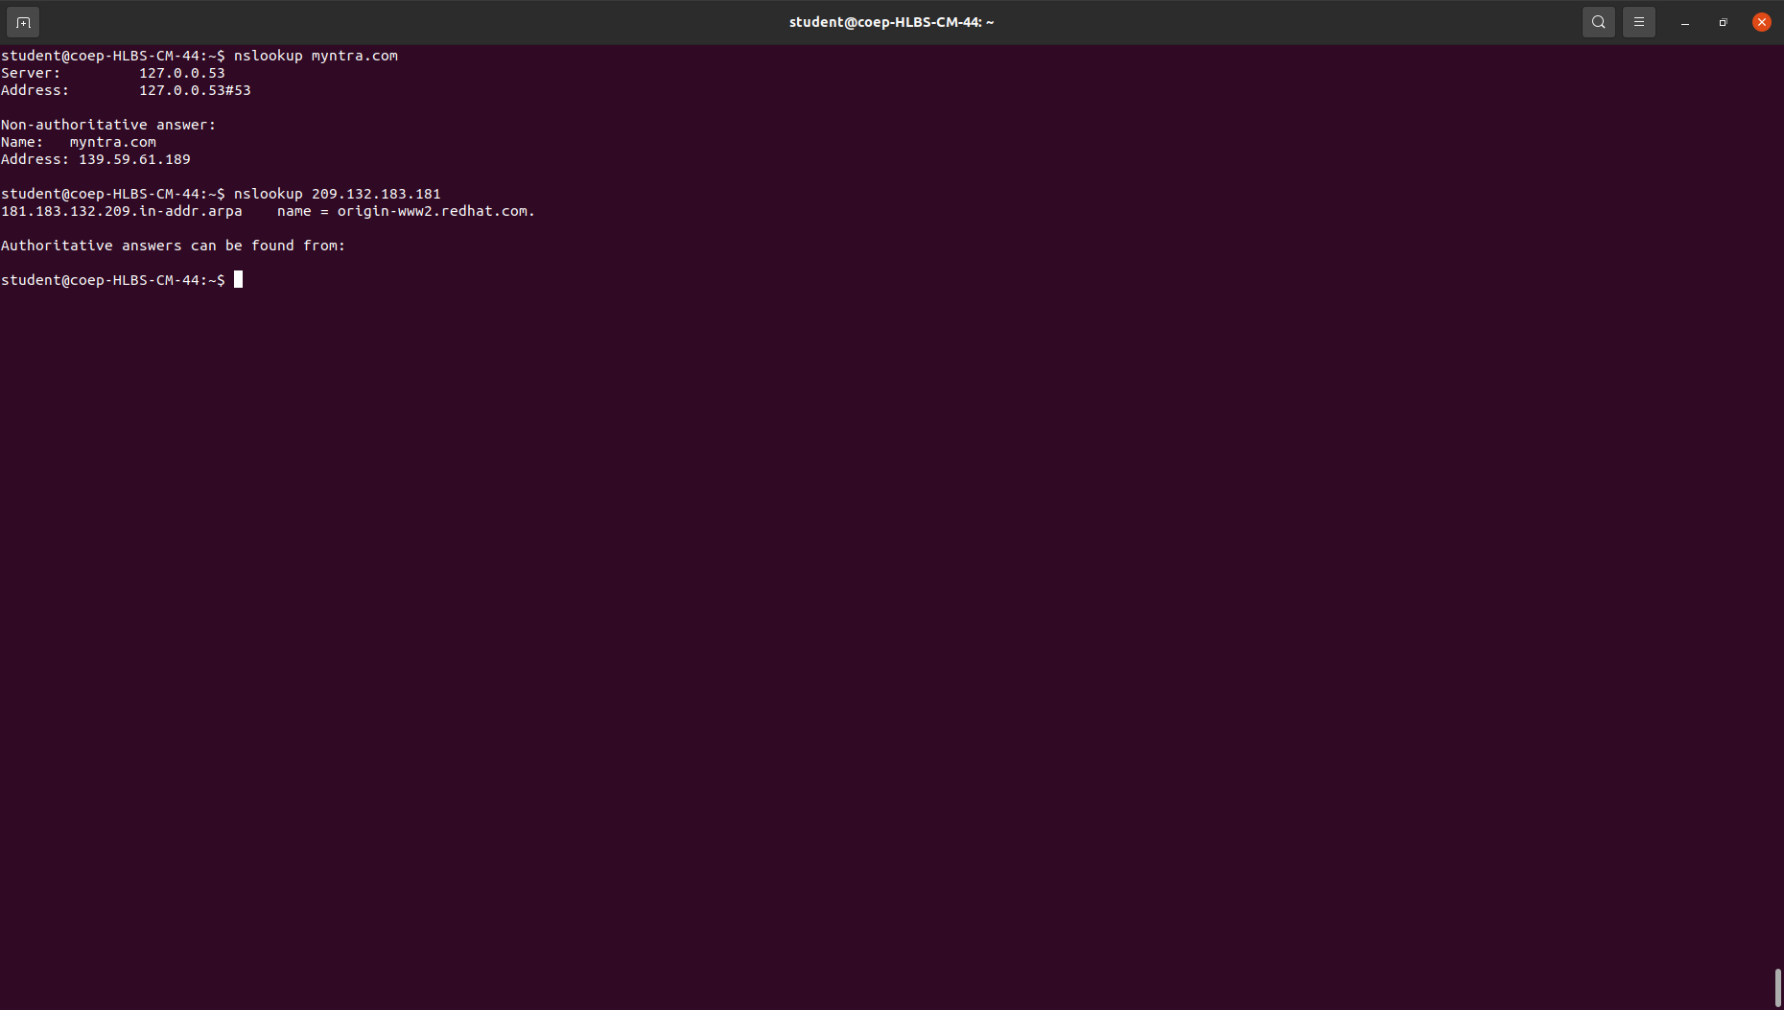

Nslookup (stands for “Name Server Lookup”) is a useful command for getting information from the DNS server. It is a network administration tool for querying the Domain Name System (DNS) to obtain domain name or IP address mapping or any other specific DNS record

8. dig :

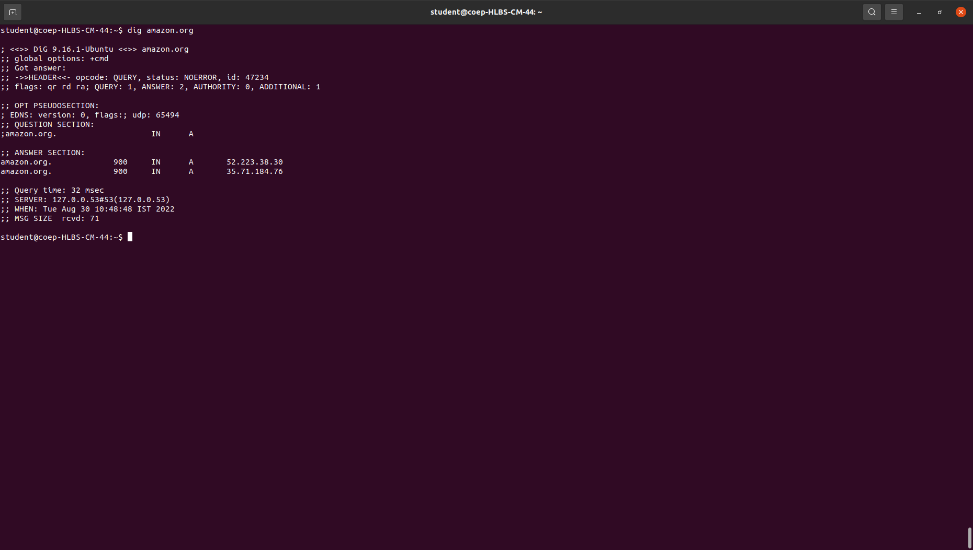
dig command stands for Domain Information Groper. It is used for retrieving information about DNS name servers. It is basically used by network administrators. It is used for verifying and troubleshooting DNS problems and to perform DNS lookups.

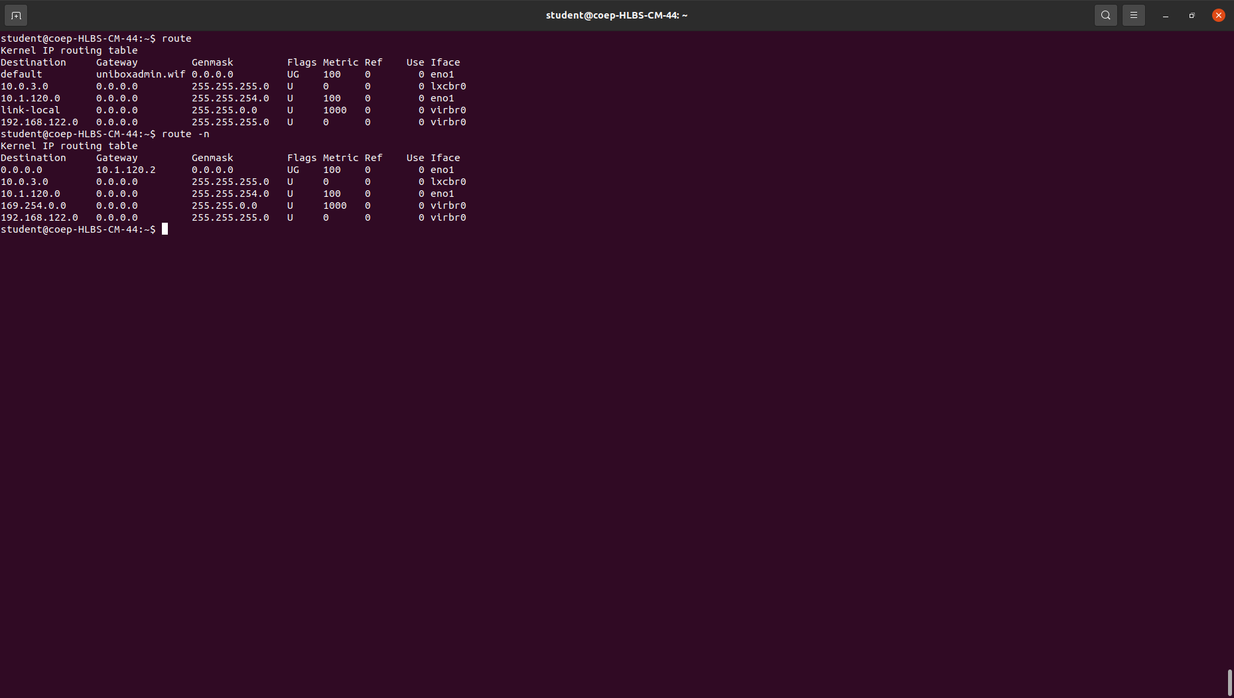
9. route :

route command in Linux is used when you want to work with the IP/kernel routing table. It is mainly used to set up static routes to specific hosts or networks via an interface. It is used for showing or update the IP/kernel routing table.

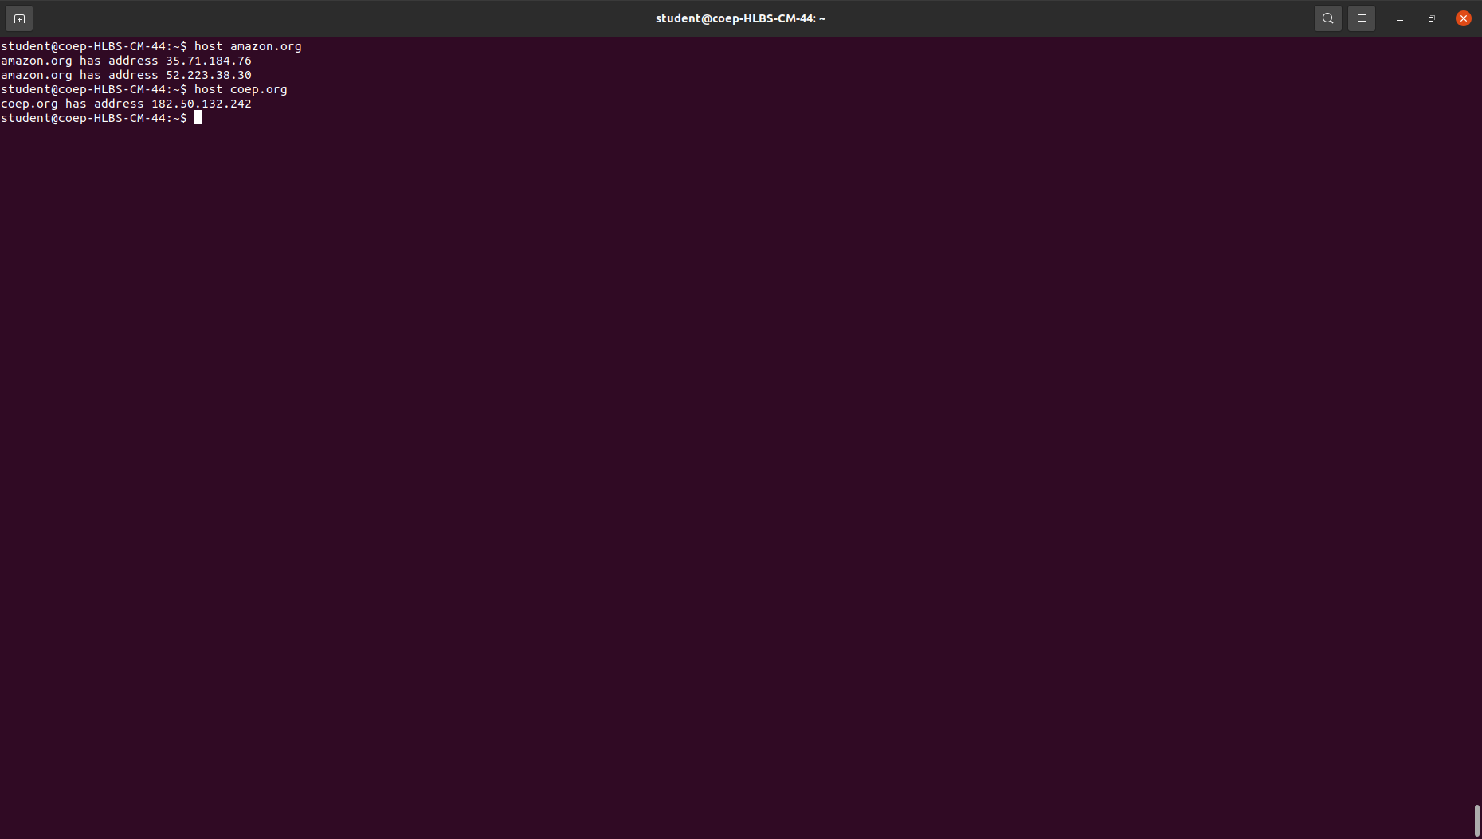
10. Host :

host command in Linux system is used for DNS (Domain Name System) lookup operations. In simple words, this command is used to find the IP address of a particular domain name or if you want to find out the domain name of a particular IP address the host command becomes handy.

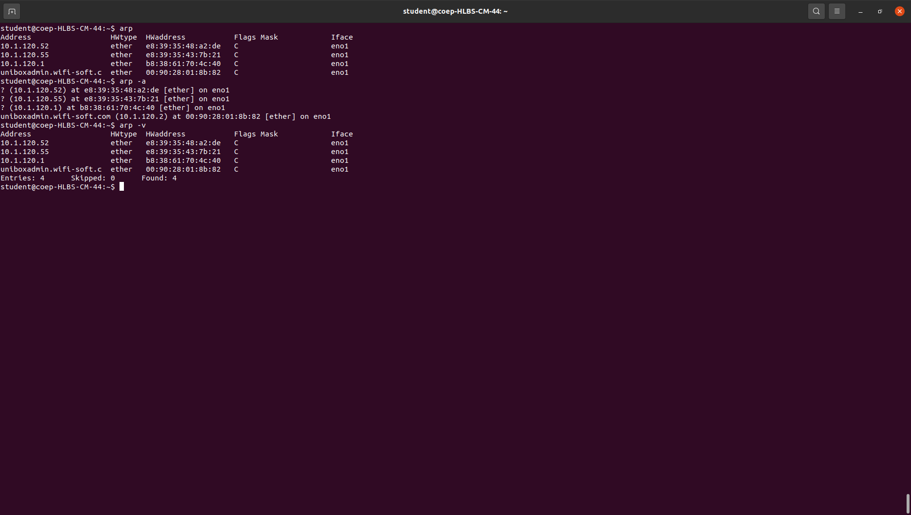
11. arp :

arp command manipulates the System’s ARP cache. It also allows a complete dump of the ARP cache. ARP stands for Address Resolution Protocol. The primary function of this protocol is to resolve the IP address of a system to its mac address, and hence it works between level 2(Data link layer) and level 3(Network layer).

12. iwconfig :

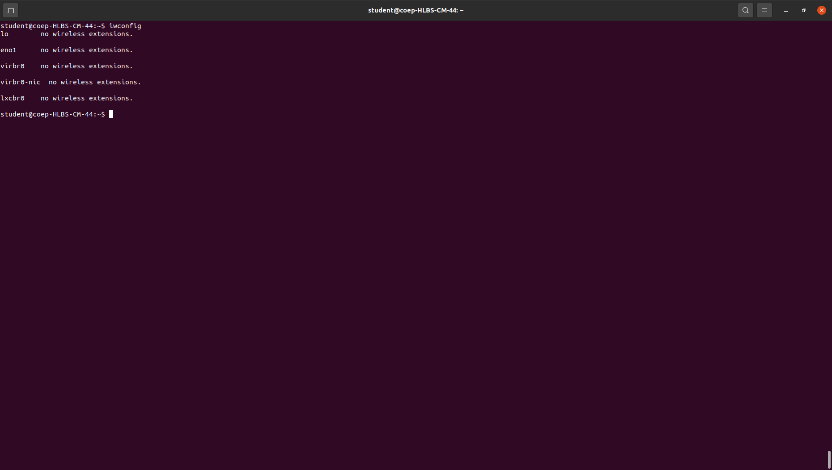
iwconfig command in Linux is like ifconfig command, in the sense it works with kernel-resident network interface but it is dedicated to wireless networking interfaces only. It is used to set the parameters of the network interface that are particular to the wireless operation like SSID, frequency, etc.

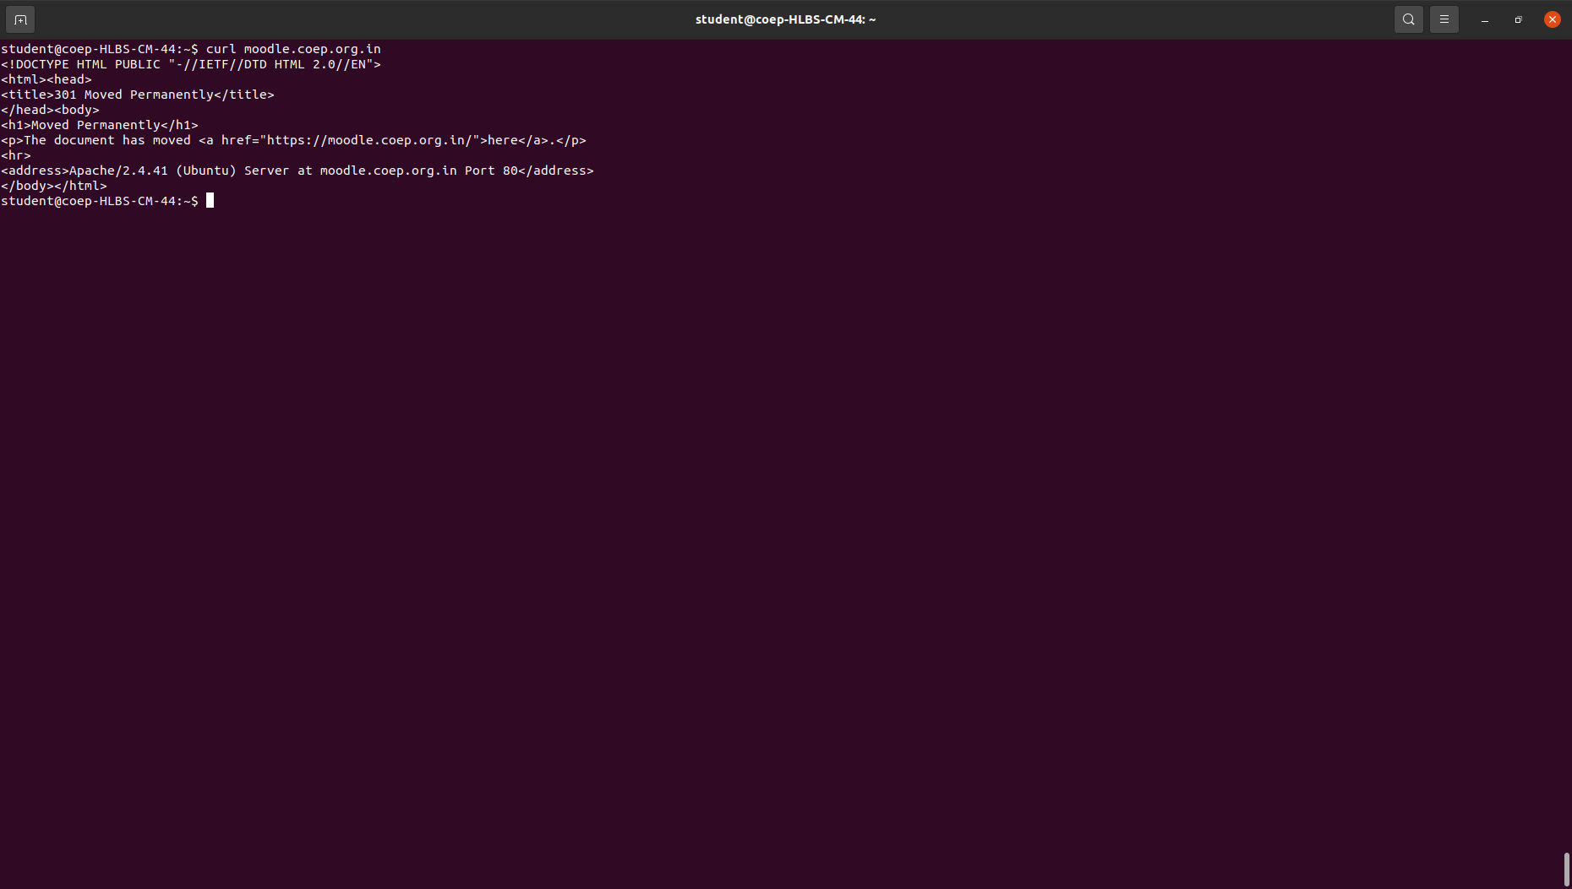
13. curl :

curl is a command-line tool to transfer data to or from a server, using any of the supported protocols (HTTP, FTP, IMAP, POP3, SCP, SFTP, SMTP, TFTP, TELNET, LDAP, or FILE).

14. wget :
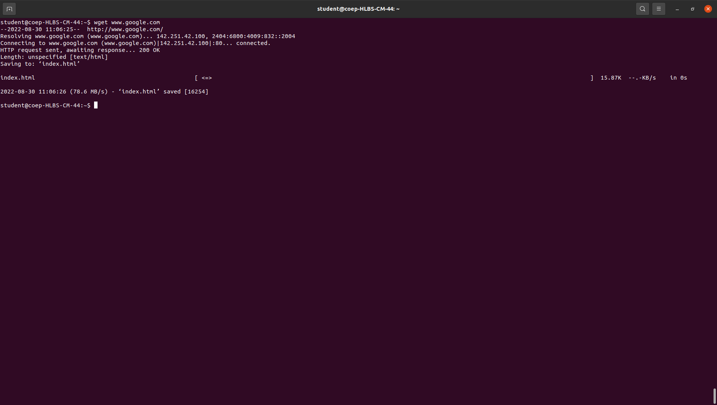

Wget is the non-interactive network downloader which is used to download files from the server even when the user has not logged on to the system and it can work in the background without hindering the current process.

15. telnet :
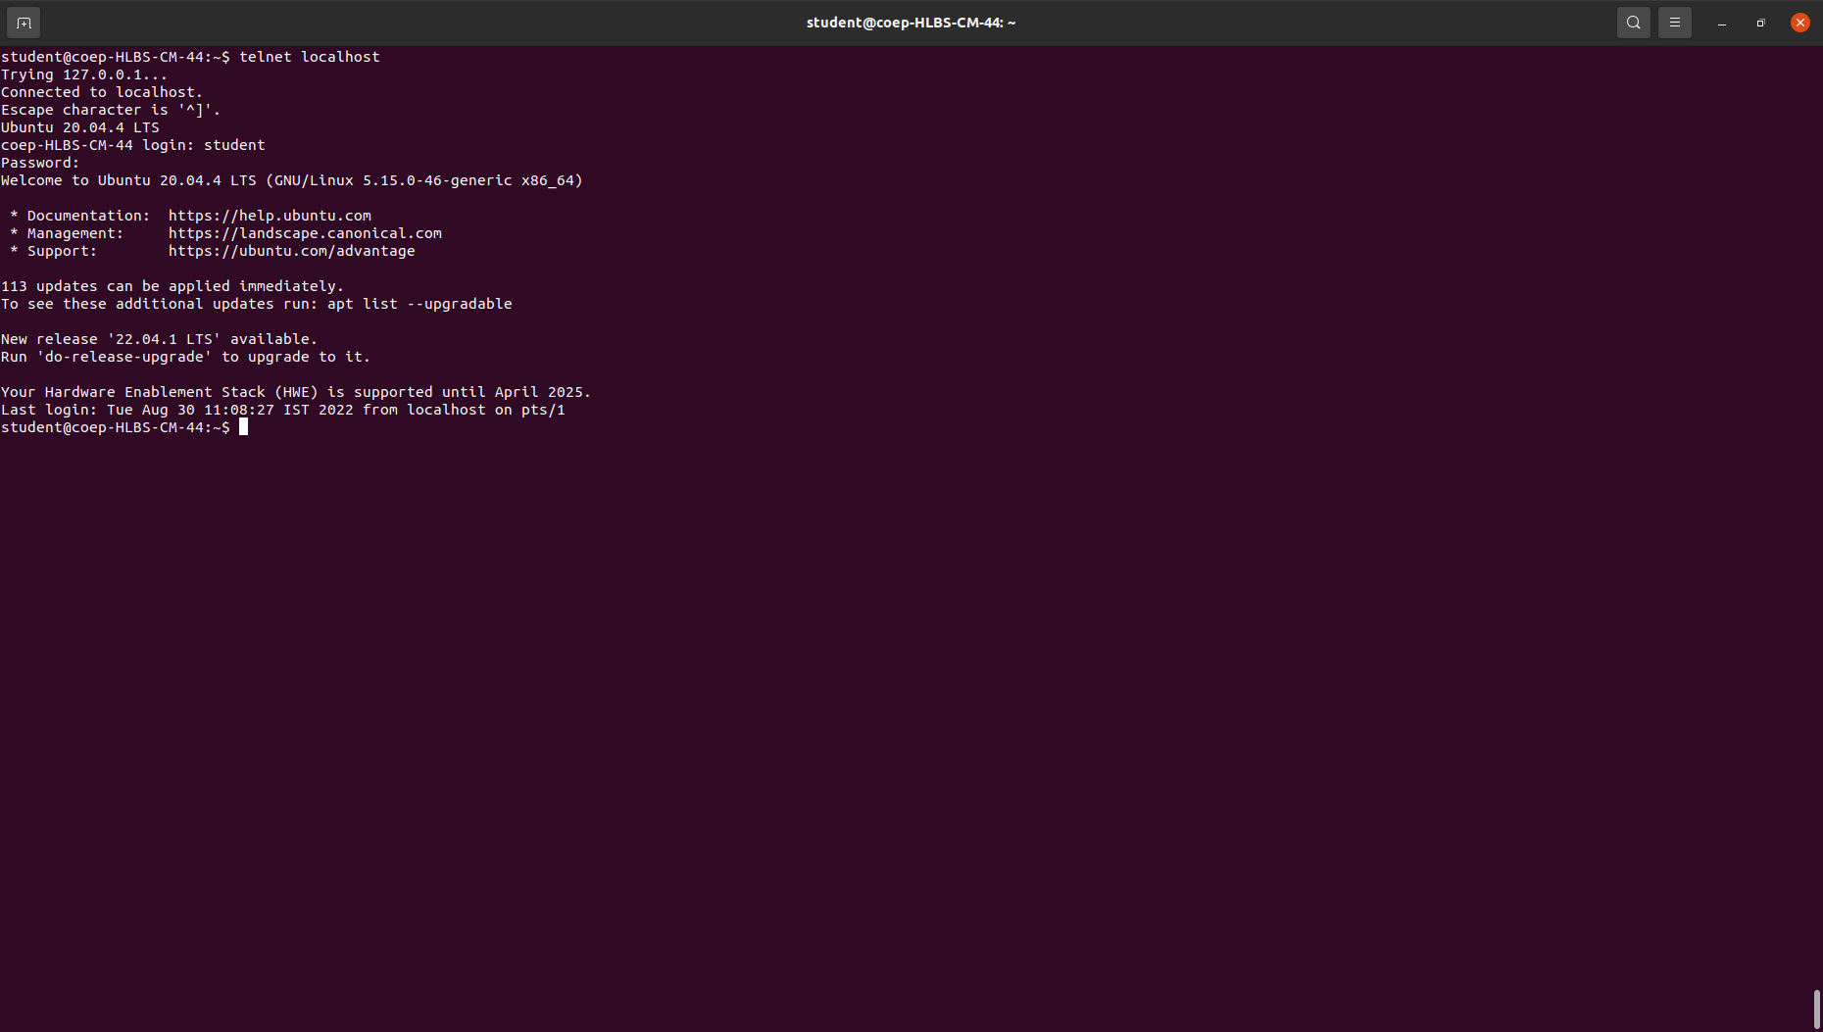

the telnet command is used to create a remote connection with a system over a TCP/IP network. It allows us to administrate other systems by the terminal. We can run a program to conduct administration.

16. whois :
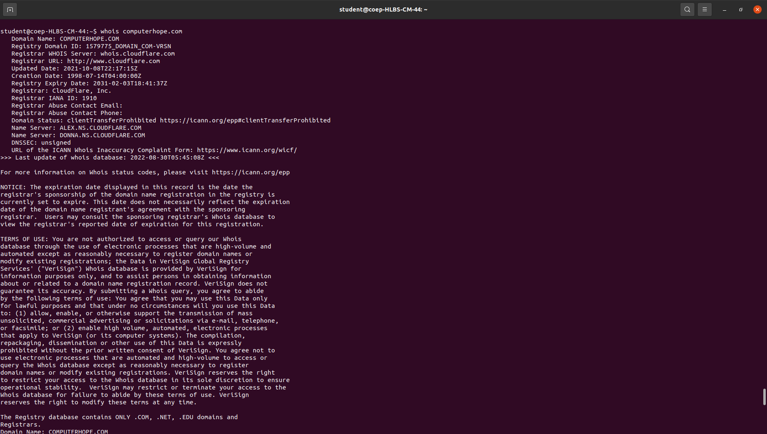
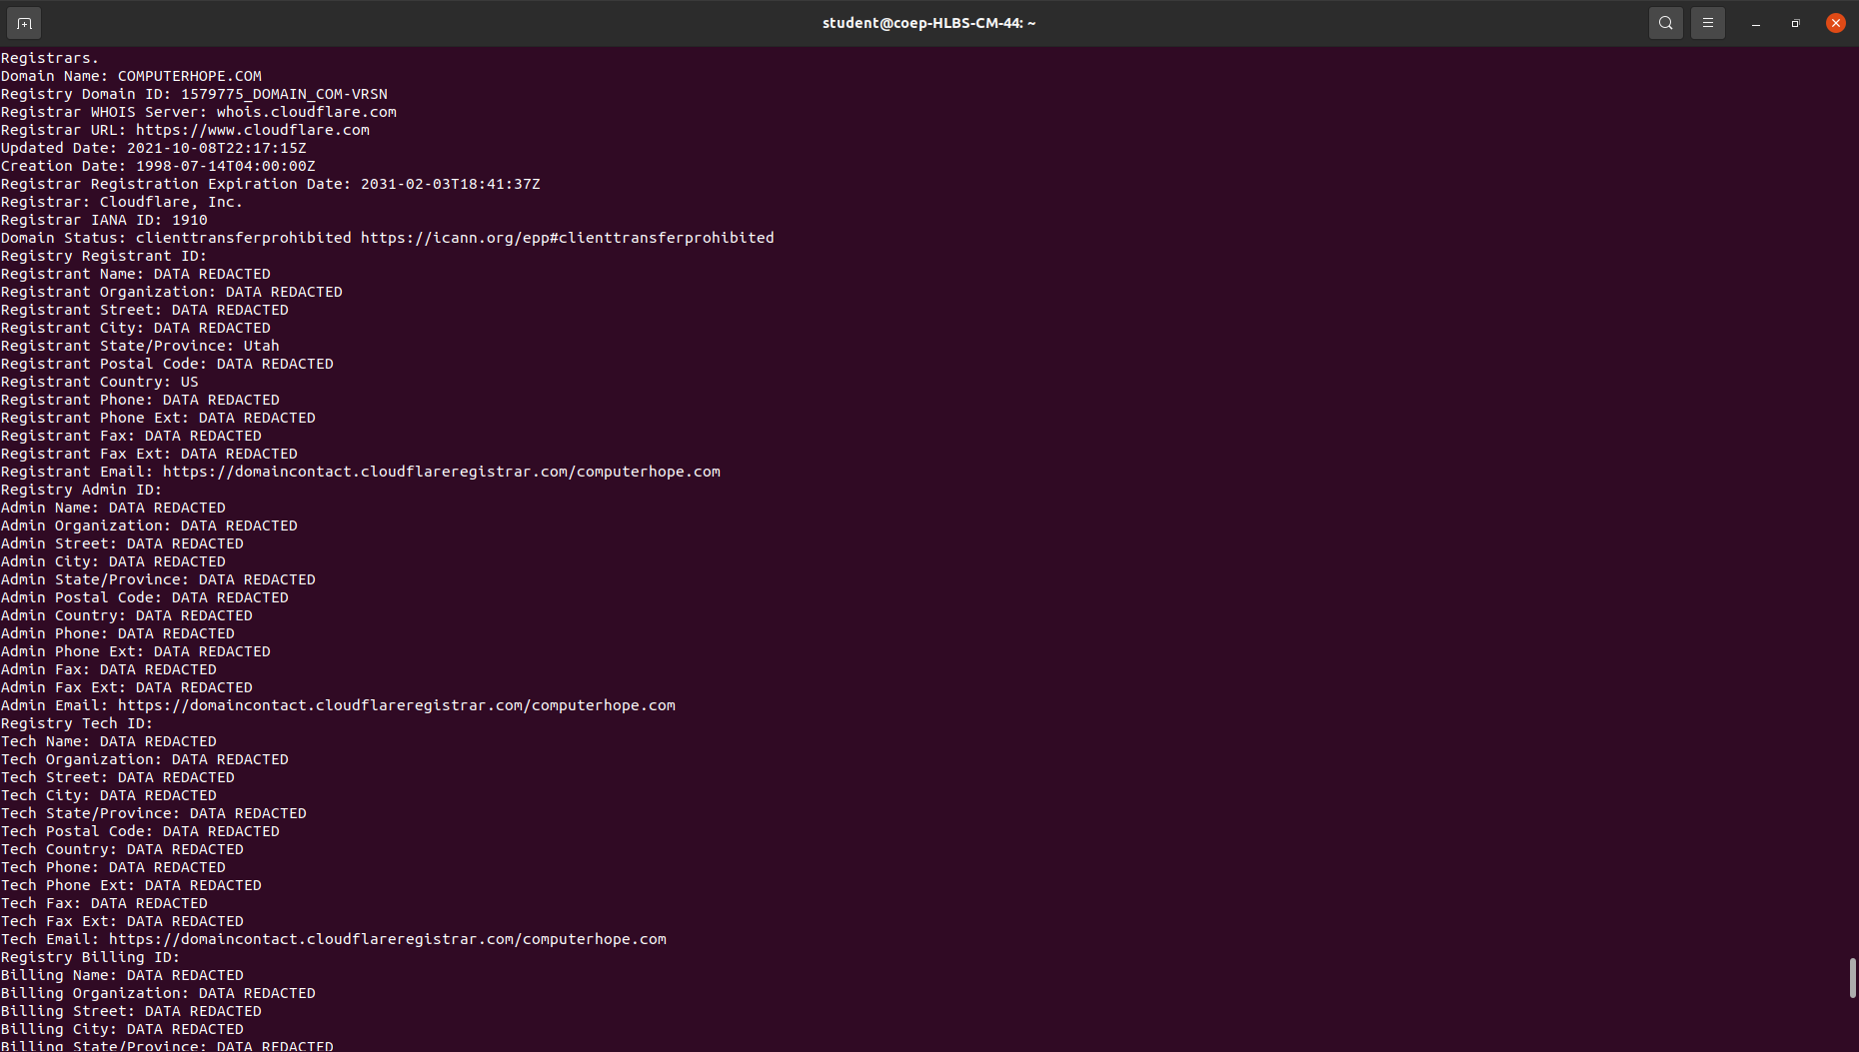

whois searches for an object in a WHOIS database. WHOIS is a query and response protocol that is widely used for querying databases that store the registered users of an Internet resource, such as a domain name or an IP address block, but is also used for a wider range of other information.

17. ifplugstatus :
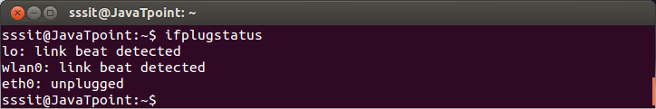

This command tells us whether a cable is plugged into our network interface or not. By default, it is not installed in Ubuntu, to install it use command sudo apt-get install ifplugd.

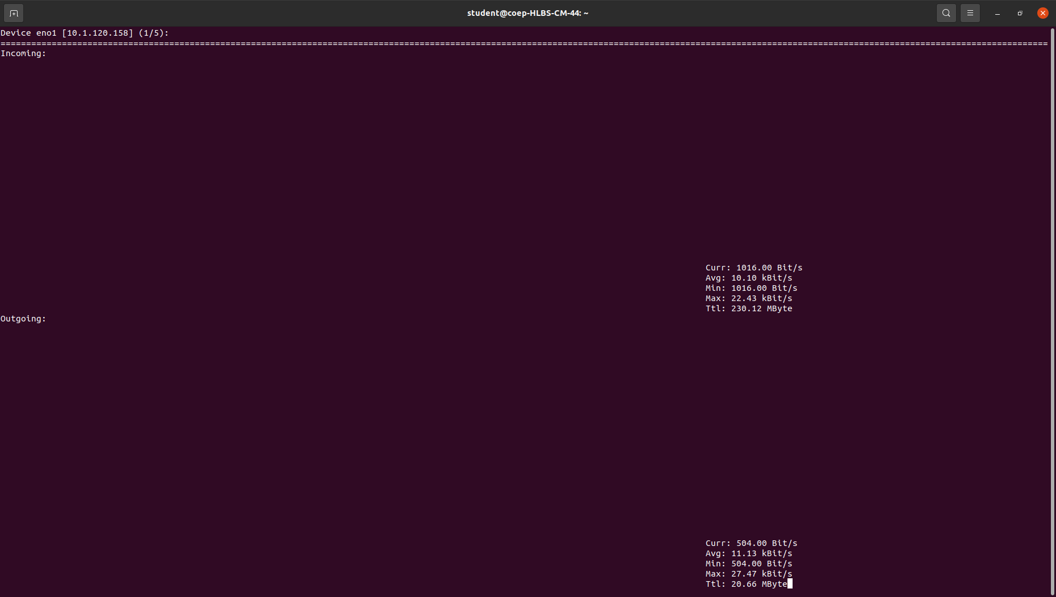
18. nload :

nload is a command-line tool to keep an eye on network traffic and bandwidth usage in real time. It helps you to monitor incoming and outgoing traffic using graphs and provides additional information such as the total amount of transferred data and min/max network usage.

20. mail :
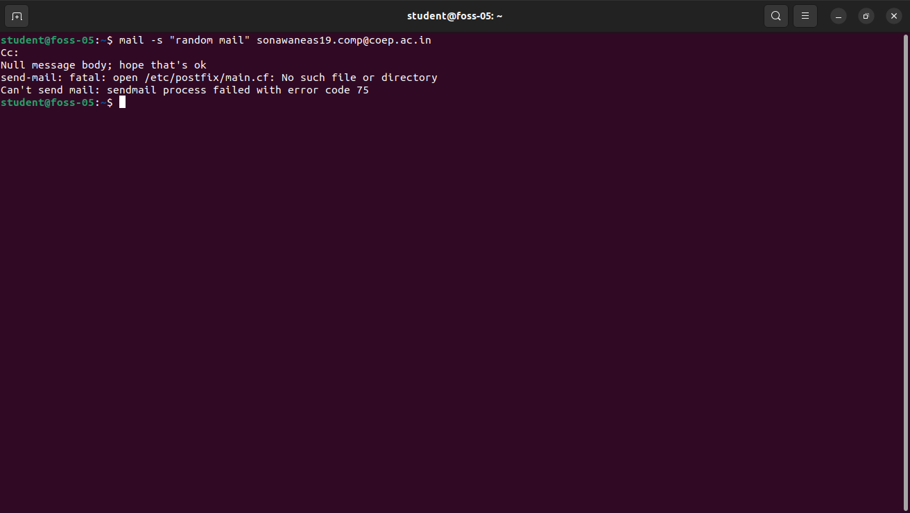

mail command is a command-line utility that allows us to send emails from the command line. It will be quite useful to send emails from the command line if we want to generate emails programmatically from shell scripts or web applications.

