# MQTT Data Report for California Reservoirs

This report summarizes the daily average Water Mark Levels (TAF) for the Sonoma reservoir, collected and aggregated through an MQTT-based system. The data reflects readings for a week in early October 2024, demonstrating the system's capabilities in handling and processing real-time environmental data.

|  |  |  |
| --- | --- | --- |
| Date | Reservoir | Average TAF |
| 9/29/2024 | Sonoma | 192.0 |
| 9/30/2024 | Sonoma | 193.0 |
| 10/1/2024 | Sonoma | 192.0 |
| 10/2/2024 | Sonoma | 194.0 |
| 10/4/2024 | Sonoma | 191.0 |
| 10/5/2024 | Sonoma | 193.0 |
| 10/5/2024 | Sonoma | 193.0 |
| 10/6/2024 | Sonoma | 192.0 |
| 10/7/2024 | Sonoma | 192.0 |

Below is a screenshot of the system output showing the connection status and received data:

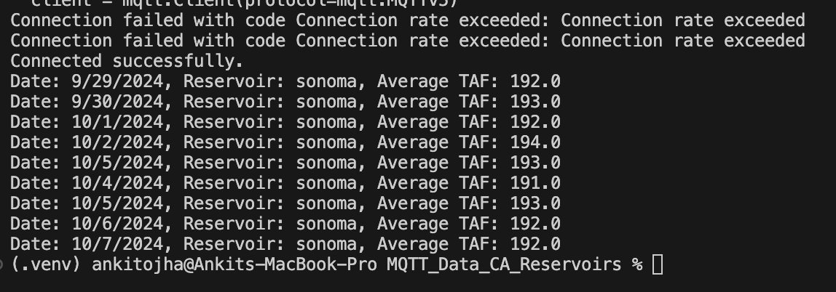

The data shows consistent TAF readings with minor fluctuations over the observed period. Such information is crucial for effective water resource management, especially in regions susceptible to drought and environmental variability.