Errors on Client Side Dashboard ( Checked on Blacksilver account of yours )

1. unpaid Orders are showing error page (<http://senew.seoeaze.co.uk/dashboard/incomplate_orders> )

ErrorException in a248e8ce62662a486c6f649833cc01ac01b39108.php line 497:Undefined variable: invoice (View: /home/seoeazec/public_senew/resources/views/admin/incomplate_orders.blade.php)

1. Error on Order Details Submission Form , cant upload details

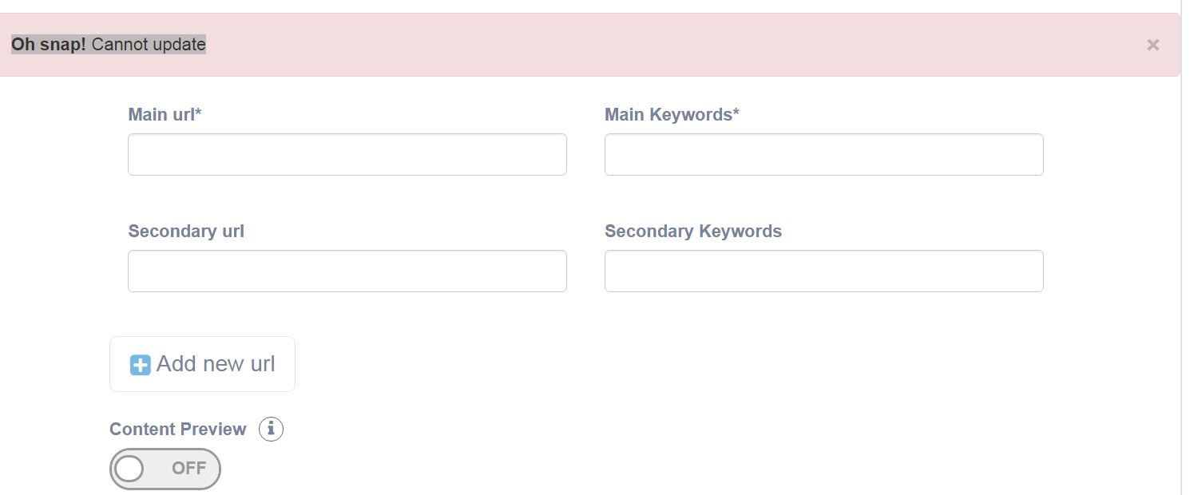

1. In Invoices Section <http://senew.seoeaze.co.uk/dashboard/invoices>

Service Name | Plan Name | Amount | Quantity | Invoice Status ( This should be the order )

Also reduce width of Amount & Quantity tabs & Increase with of service & Plan tabs so It can look normal. Invoice Status Should show as Paid If Customer Pay it )

1. When We Send invoice to any Customer , In Email Title Should be

**New Service Invoice Generated – SeoEaze** currently its just showing as I**NVOICE**

**In that email**



It is showing Service Name as **Silver** Which is not Service name its **PLAN NAME**

In email it should show 4 things

Service Name, Plan Name, Amount, Quantity

1. When We Update Order Status to Completed , Client will Receive an email with following Title

**One of Your Order is Complete – Report(s) Available for Download –SeoEaze**

In this email , there will be **Service Name, Plan Name** & button to send customer to Dashboard by Login Button Text would be

**Download Order Report**

When Client will click the button he will go to dashboard if logged in or login page to login

1. No email Received for both Client & Admin After Submitting Contact Form, Social Media form , PPC, Panda Penguin Recovery
2. After filling Reputation management form ,its taking to 404 page - <http://senew.seoeaze.co.uk/reputation_managment_post>
3. Submit Button not working in Blog Management Service , Nothing happening on clicking Submit

<http://senew.seoeaze.co.uk/blog_management_service>

**Admin Side Pending Issues**

1. In current order, Order Status Option with Option to Update Pending Orders to On Progress & Complete ( When complete automatic email sent to client )
2. In invoices section Just add a button on bottom or top to Issue New Service Invoice ( Link it to Users ) so when someone will click it, he will go to users page & from there he can raise invoice
3. On Current Orders ( If Details are not submitted by Client , a Button to Send email Reminder to Submit Order Details just like we have for Unpaid orders )

That’s all I found as of now as there is nothing in completed orders, cant look for any issues

Plans and all are working fine , coupons & discount are also working fine.

Big troubles on clients side I guess

Please fix it ASAP