TRANSCASH CARD FEATURES AND LIMITS

The TransCash pack is composed of 2 Visa Prepaid Debit Cards: The Black card which is the Primary card and the Red card which is the Secondary card.

“The Black Card”:
The black card is the primary card.
It is a general purpose reloadable debit card. It can be used just like any other type of debit card anywhere Visa is accepted worldwide. The card has limitation in spending, loading and card balance to comply with the banking regulations. The card can be reloaded via cash using the Visa ReadyLink loading network, via direct deposit (payroll, tax refund, insurance benefits, PayPal…etc), via using a personal credit/debit card or even via card to card transfer.

“The Red Card”:
The red card is the secondary card.
It is a general purpose reloadable debit card for which we have removed the loading capabilities.
The only way the red card can be reloaded is via a card to card transfer from the black card. The reason why this feature has been removed is because the KYC is only done on the primary card and the second card could end up in the hands of a family member with no KYC for them. In order to comply with the regulation and fight against fraud, we had to set some rules and limitations on both the black and the red cards.
It is important to note that both cards are linked to a different account and therefore the red card does not have access to the fund on the black card.
The red card can also be used just like any other type of debit card anywhere Visa is accepted worldwide (except for the reload function).
In terms of spending limits and card balance, the 2 cards have exactly the same limits. Therefore, the only difference is that the red card is not reloadable.

“Fees”:
Both cards are assessed fees as per the Terms and Conditions: some fees are charged per transaction basis; the black card also has a maintenance monthly fee and reload fees.
See below for a detailed Fee Schedule and card limitations.

Purchase Fee (one time fee) $9.99 Monthly Membership Fee$9.99 Card Activation FREE Direct Deposit/ACH (Payroll, Tax Refund, PayPal Deposit) FREE Card-to-Card Transfer - Transfer funds from your card to another prepaid card FREE Card-to-Bank Transfer - Transfer funds from your card to your bank account FREE PIN POS Purchase -Domestic -Debit type purchase requiring you to enter PIN FREE PIN POS Purchase - International FREE PIN POS Purchase + CASH BACK -ACCESS CASH WITHOUT ATM FEE FREE POS Signature -Domestic -Credit type purchase requiring you to sign the sales slip FREE POS Signature - International FREE Check Balance via web or IVR FREE IVR Customer Service Automated Customer Service FREE PIN Decline - Transaction is declined because of invalid PIN entry FREE Internet Statement - Internet statements views are free FREE Live Agent Customer Service During Business Hours -Monday through Friday, 10AM to 7PM PST, excluding holidays. After hours see Fee based transactions below FREE ATM Domestic -Withdraw funds from an ATM $1.00 ATM International -Withdraw funds from an International ATM $2.50 ATM Declines -ATM decline due to insufficient funds $0.75 TransLoad -Price to load your card at a TransCash location $3.00 Visa ReadyLink Reload -Fee charged by TransCash when using Visa ReadyLink reload service (ReadyLink Fees are charged separately and can vary from $3.95 to $4.99) $1.00 Bank-to-Card Transfer -Transfer funds from your bank account to your card account $0.50 Live Agent Customer Service after hours 3.99 per call Bill Payment -TransCash Online Bill Payment Service $0.95/bill ATM Balance Inquiry $0.75 Bill Payment Decline $0.75 Paper Statement -Paper statements are sent only upon request $3.00 PIN Change -PIN change via IVR (*First change free) *$2.00 Replacement Card Lost card requires purchase of new card $9.99 Refund Processing Fee - Upon closing your account you can request a check for the remaining balance $4.50 Overdraft Fee -If card balance falls negative FREE Foreign Transactions -Foreign exchange fee per transaction when traveling outside the USA 3% Maximum Daily Withdrawal $500 Maximum Daily Load Amount $950 Maximum Monthly Load/Balance Amount - General Purpose Card $5,000 Maximum Monthly Load/Balance Amount - Payroll Card $10,000 Maximum Loads per Month 10 loads

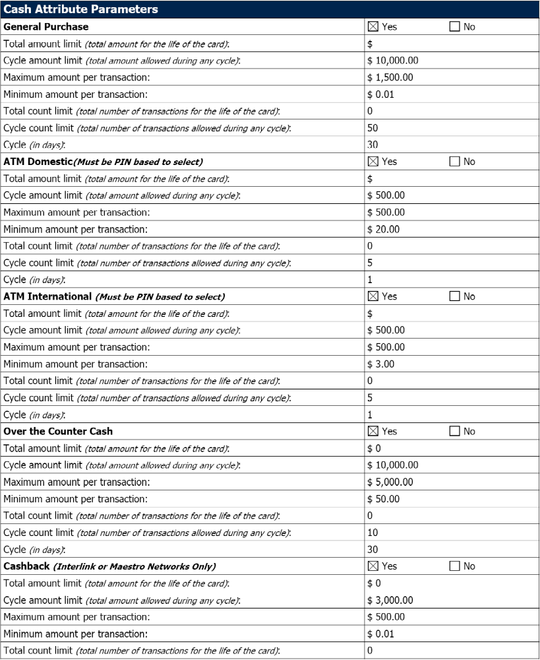

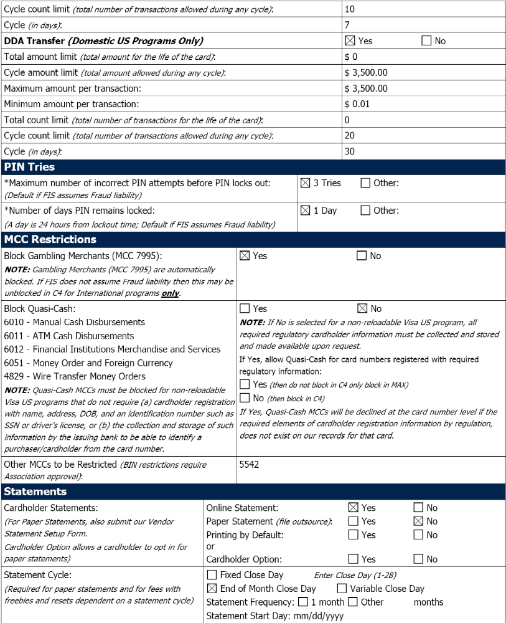

TRANSCASH LOADING ISSUES AND RESOLUTION

Transcash can offer additional options to its customers. However, some of them have been suspended as they present potential issues such as high risk of fraud, etc.
- DDA transfer or Bank to Card transfer
Until recently, TransCash was offering an extra loading option called DDA transfer or Bank to Card transfer.
This loading option gave cardholder the rights to use their personal bank account to load their TransCash card. The request was made via the MyAccount site by adding a new funding source and specifying the customer’s personal bank account information (Bank name, account and routing number…etc)
The loading option was very convenient and inexpensive for cardholders as they could initiate the transfer from home for as low as $0.50 per transfer for transfers up to $950.00. Once the request was submitted, it would only take up to 2 business days for the funds to post.
Technically, this type of transfer was an ACH transfer but initiated by our processor (FIS). In a few words, when the cardholder was requesting a fund transfer, the funds were transferred from the cardholder external account and deposited onto its TransCash account via a TransCash general account (and not directly into the cardholder TransCash account).
In early 2011, TransCash was the victim of a fraudulent series of transactions with the Bank to card transfer. The early 2011 fraud was done by a cardholder who stole someone’s bank account information and somehow managed to use it as a funding source. The money was debited from SunTrust Bank based in Florida until the actual account holder filed an affidavit and rejected the debits.
Per the NACHA rules, any reject can happen within 60 days (and sometimes more). If the originator did not authorize the transaction, a chargeback occurs. The TransCash cardholder was a fraudulent cardholder and was not reach-able once he realized that the fraud had been detected. Therefore, TransCash became liable for the loss.
This fraud prompted a review of the process by TransCash, the bank FCB and the Processor FIS. It was determined that there was a loophole in the process as in case of a return, the funds were being withdrawn from the general account (which always had a positive balance) and not the TransCash cardholder account (which in certain instance, has a negative balance and which would, in this case, not allowed the funds returns).
As no satisfactory solution could be done to avoid this type of fraud, the DDA load feature was turned off to avoid such fraud to happen again. FIS has since then created a software called Trial Deposits to better screen cardholders’ external bank information to make sure that they indeed belong to the TransCash Cardholder. However, it is still a Beta trial. Furthermore, the issue of the transfer via the general account has not been solved to satisfy FCB’s requirements and therefore the option cannot be used.
- The Credit/Debit card
In order to provide loading convenience to our customers, the bank FCB and processor FIS agreed to authorize TransCash to use the Credit/Debit card loading option until FIS provides a fix for the DDA loading service. FIS believes that Credit/Debit card fraud can be more controlled and fraud can be minimized.
The Credit/Debit card loading option is also convenient as it allows a cardholder to load its TransCash card using a credit or a debit card. According to FIS, in case of fraud, the risk (and therefore the loss) is transferred to the credit or debit card company (via zero liability advantages) – We are checking on this. Unfortunately, this service is more expensive than the DDA loading service for our customer as we will charge a loading fee and a percentage of the load amount as we are being billed as a Merchant for accepting Credit and Debit cards by the Network (Interchange), the Merchant Processor (IRN) and the Gateway (Authorize.net). The exact percentage varies from companies and amount of transaction, but we estimate that it will be approx. 3.5% (which can be substantial for our target market on a $950 load.)
Technically, TransCash will use its existing Merchant account (IRN) to provide this service.

TRANSCASH CARD FRAUD AND PREVENTION

Fraud is a constant issue of Prepaid Debit cards. Therefore, it is important to be well prepared and equipped to prevent fraud.
The major fraud with Prepaid debit card is during the loading process. Therefore, securing the loading process is key to minimizing fraud. This prevention is done by establishing a strong verification of IDs during the KYC and verifying the loading source.
Another important type of frauds is transactional frauds. To minimize and prevent this type of fraud, the company can rely on an internal team of compliance staff which checks the cardholder’s usage of their cards by relying on reports sent by the processor.

TYPES OF FRAUD FOR PREPAID DEBIT CARDS

- VALUE LOAD FRAUD
Value Load Fraud can be as simple as someone using a stolen credit/debit card to purchase the prepaid debit card and load it with money.
Precautions executed by TransCash:
When purchases of cards are made at Kiosk locations the agent can verify identification and banks statement to make sure the account belongs to the new potential client. However, when purchases are done online there are no in person screening, therefore here at TransCash the immediate precautionary steps are requesting a scanned image of the clients photo ID and a scanned document of their bank statement showing clearly the Bank logo/name and customer’s name and address. There are also manual verifications; such as double checking Billing Address and Delivery Address (if different), personally contacting cardholder through e-mail and phone to verify that they are in fact making the prepaid debit card purchase, checking IP addresses for any discrepancies,
FIS Tools
FIS offers a strategy for prevention of value load frauds. The standard featured offered by FIS is an authorization system through which all value load transactions must pass.
- Negative Files- FIS keeps a negative database of cards, addresses and phone numbers associated with past fraud and they provide a filter against which new card applicants and value loads may be screened.

- AVS- Funding AVS Validation- accepting XY (street & zip 9 digit/ 5 digit match)
This service provides significant verification confirmation; it validates that the purchaser entered the address that funding card issuer has on file for the cardholder. FIS uses a full match of the address and zip code.

- eFalcon- FIS also uses the eFalcon system to detect fraudulent funding into a client’s prepaid debit card. eFalcon is neural network tool that examines the clients card activity in order to detect any suspicious activity for example commercial billing address. The system can also created behavioral models from which value loads are scored 100 lower risks to 999 higher risks.

- RiskWise- FIS also utilizes RiskWise in order to identify new accounts that seem fraudulent. They captured enrollment data such as; name, address, phone, SSN, DOB and using a list of reasons codes RiskWise provides a verification score. This score can be used to determine the approval decision about opening the new account and shipping a card. Issuers provide their own criteria for scoring and decision.

- Octopus- This tool is used to identify any types of fraudulent activity when funding the prepaid debit card. Octopus identifies all other prepaid debit cards in our portfolio that have been loaded with the same funding card; if any of these debit cards have been identified as fraud then the value load from the funding card will not be permitted to proceed. In addition to funding source, Octopus can perform matches on address and phone number to search for fraudulent cards that match any of these criteria.

- DEFRAUDING THE SYSTEM
Fraudulent customers will attempt to buy the card in order to defraud the system.
FIS Tools
- KYC- FIS can provide a secondary validation on high risk address. What this tool does is that it provides a secondary scoring engine for all high risk or failed RiskWise cases.

- TRANSACTIONAL FRAUD
Transactional Fraud happens when there are unauthorized uses of the prepaid debit card due to a card being lost or stolen.
Precautions taken by TransCash
As soon as a client informs TransCash that a card was stolen or lost that account is automatically closed and they are issued a new card. However, there can be instances where the client is not even aware the card was stolen or is being used unauthorized.

FIS Tools
- Authorization Tolerance Factors- as a preventive tool FIS offers clients the option to specify a tolerance factor for authorizations from selected merchant category codes MCCs where estimated authorizations are utilized such as restaurants, car rentals, hotels etc.

- AVS Verification on Purchases Transactions- FIS supports the AVS for merchants requesting verification for purchase transactions involving prepaid debit cards.

- Cardholder Profile Matching- FIS has the ability to detect multiple or excessive enrollments by a card buyer or card user. The model created based on funding source, scores individuals meeting client-defined criteria for excessive funding sources and for multiple card purchases by the buyer and by the cardholder. The scores are then generated and appropriate action is taken based on the scoring pattern.

- Auto-Status Accounts & Auto E-mail Notification- this is another control method that FIS provides which is the ability to automatically change the status of an account and send an e-mail notification to the buyer or cardholder. Status of card is changed based on the defined criteria in Falcon, e-Falcon, RiskWise, Cardholder Profile Matching or Octopus. The e-mail will self generate from FIS at the time an account is auto-statused.

- Excessive Credit Monitoring- Falcon- this analysis consists of the identification and assessment of risk on accounts receiving credits (purchase returns) in excess of a specified amount or more than a specified number of credits in a thirty day period. The Falcon system is used by FIS in order to detect fraudulent transactions in clients prepaid debit cards. The network examines transactional, cardholder and merchant data to detect a wide range of payment card fraud and then provides a score 0 to 999.

FIS Tools-
- eRacer- Electronic Rapid Assessment Capture Environment

This is a proprietary web-based interface used for decision making and analysis of output from the fraud tools. eRacer consolidates all results from all the different detections tools discussed above, in order to review the details of transactions from the prepaid debit card in question. FIS provides direct access to this application providing a unique use ID and password.

