BUSINESS EXECUTIVE SUMMARY

I. EXECUTIVE SUMMARY

TransCash, Inc. is headquartered in Los Angeles, CA. The company’s core business is making international and domestic money transfers simpler and more affordable along with providing accessible and essential financial products and services to underserved markets that have traditionally been undervalued by mainstream banks. Specifically, it can facilitate international money transfers with at least 75% savings over existing services such as Western Union, etc. These markets include working individuals that are: unbanked, defined as those with no banking relationships; under-banked, those with an average daily bank balance of less than $600; foreign-born and multi-national; or of low-to moderate-income; and the why bank? – a new category of consumers who sees little value in banking relationships designed to extract huge fees from low usage banking services. Well over 50% are minorities and reside in urban neighborhoods. To meet the unique needs of these individuals, TransCash has designed an integrated financial services program to address the banking and finance concerns of this marketplace. The company’s approach is to introduce innovative, strategic and focused products, marketing solutions, customer retention strategies, partnerships and non-traditional pricing and revenue models. The goal is to attract target customers away from check-cashing agents, money orders, money transmission services, and bill pay centers by providing them with an easier, more convenient and lower-cost alternative to mainstream banking and non-traditional financial service providers.

The cornerstone of the program is the TransCash Card. The TransCash Card program is a set of two (2) stored value cards (one re-loadable) that will be provided through employer payroll deposit plans or be purchased for a nominal fee at different locations – primarily convenience stores such as Rite Aid, Walmart, gas stations, etc. Funds can be loaded on the TransCash account with one card and the other card can be sent to someone outside the US or within the US where the other cardholder can withdraw funds at ATM’s and POS locations. The TransCash program facilitates the movement of funds in a much more cost effective manner than traditional money transfer services. As recently as September 28, 2011 Western Union rate for sending $100.00 to Mexico was $10.00-$12.00 and can go much higher to other countries, compared to TransCash flat monthly fee of $9.99 regardless of destination and amount of transfers or transactions at the POS.

According to the World Bank figures, in 2010 migrant workers from around the world sent $325 billion abroad. Flows are expected to rise to $346 billion in 2011 and $374 for 2012. Wire companies, Western Union chief among them earned $30 billion from the exchange, or average fee of almost 15%. According to Robertson Stephen’s research on industry trends, electronic payment volume is expected to grow in excess of 20% (domestic and international) per year through 2010, exceeding $1 trillion in funds transferred and 10 billion transactions per year.

Remittances- Developing Countries

US $ billions | 1995 | 2000 | 2004 | 2005 | 2006 | 2007 | 2008 | 2009 | 2010
Inward World-Remittance flows | 101.3 | 131.5 | 237.0 | 274.9 | 317.9 | 385.0 | 443.1 | 416.0 | 440.1
All developing countries | 55.2 | 81.3 | 159.3 | 192.1 | 226.7 | 278.5 | 324.8 | 307.1 | 325.5
Outward World Remittance flows | 97.5 | 108.5 | 168.0 | 185.3 | 213.7 | 255.2 | 295.7 | 282.5 | -
All developing countries | 10.4 | 9.5 | 28.5 | 33.0 | 41.0 | 52.7 | 67.3 | 58.7 | -
Source: World Bank http://siteresources.worldbank.org/INTLAC/Resources/Factbook2011-Ebook.pdf

Domestic to international transactions, which includes U.S. to Mexico, offers significant potential due to guest workers and immigrants sending money to their home countries. According to World Bank in 2010 Latin America alone received around $58.1 billion in remittances. To put it in perspective, the World Bank states the value of remittances flowing to Mexico is greater than the value of the country’s tourism and only slightly less than the value of the country’s oil supply.

Latin America-Remittance
US $ billions | 1995 | 2000 | 2004 | 2005 | 2006 | 2007 | 2008 | 2009 | 2010
Inward Remittance flows | 13.3 | 20.2 | 43.4 | 50.1 | 59.2 | 63.3 | 64.6 | 56.9 | 58.1
All developing countries | 55.2 | 81.3 | 159.3 | 192.1 | 226.7 | 278.5 | 324.8 | 307.1 | 325.5
Outward Remittance flows | 1.1 | 2.0 | 2.1 | 2.3 | 2.7 | 3.6 | 4.3 | 3.8 | -
All developing countries | 10.4 | 9.5 | 28.5 | 33.0 | 41.0 | 52.7 | 67.3 | 58.7 | -
Source: World Bank http://siteresources.worldbank.org/INTLAC/Resources/Factbook2011-Ebook.pdf

■ Top 10 remittance recipients in 2010 (billions):

Mexico ($22.6 bn)
Brazil ($4.3 bn)
Guatemala ($4.3 bn)
Colombia ($3.9 bn)
El Salvador ($3.6 bn)
the Dominican Republic ($3.4 bn) Honduras ($2.7 bn)
Ecuador ($2.5 bn)
Peru ($2.5 bn)
Jamaica ($2.0 bn)

■ Top 10 remittance recipients in 2009 (percentage of GDP):

Honduras (19.3 percent)
Guyana (17.3 percent)
El Salvador (15.7 percent)
Haiti (15.4 percent)
Jamaica (13.8 percent)
Nicaragua (10.3 percent)
Guatemala (9.8 percent)
Grenada (8.7 percent)
the Dominican Republic (7.3 percent)
St. Kitts and Nevis (7.3 percent)

But TransCash is more than just a money transfer business. The TransCash program
provides the cardholder with access to a full-service ATM and POS transactions in a single card relationship for unbanked individuals, enabling the cardholder to do the following at a low flat fee of $9.99 per month:

 | TransCash | Traditional Money Transfer Services
Provide a continuous usage money transfer vehicle | YES | NO
Load cash on a money transfer vehicle | YES | NO
Reload cash on the same money transfer vehicle | YES | NO
Automatically load funds from payroll or other sources | YES | NO
Withdraw funds at ATM locations world wide | YES | NO
Pay for goods and services at POS world wide | YES | NO
Provide additional money transfer vehicles tied to original | YES | NO
Receive a monthly statement via mail or electronically | YES | NO

The TransCash program is the right solution for those who are unfamiliar or uncomfortable with banks, cannot afford minimum balances or account-related fees, have no access to traditional banking services, live paycheck to paycheck, frequently send money to friends and family domestically or aboard and speak little or no English.

Furthermore, in recent years, the lingering effect of the recession continues to reverberate. Experts are seeing a shift in consumer behavior in the sense that they are reluctant to take on more debt. Financial institutions remain cautious about lending money. It is believed that this shift will continue to see rapid growth in both debit and prepaid. Prepaid is going to grow more rapidly than debit cards

II. BUSINESS OVERVIEW

The TransCash Card enables the cardholder to make affordable international and domestic money transfers and utilize various financial services.

The TransCash Card program provides five core financial services that are heavily utilized by the unbanked. The goal is to offer services that are not attractively offered by banks and are overpriced by retail competitors. These services are offered via the single multi-functional TransCash Card account:

- Load value via cash at POS Locations
- Load check value at multiple retail locations
- Share money internationally and nationally
- Load value via direct deposit of payroll or other recurring source
- Withdraw cash at over 1,000,000 ATM’s worldwide,
- Pay for goods and services worldwide via ATM pin or Visa at over 1,000,000 locations.

The Need

More than 215 million people live outside their countries of birth. Remittances, the money sent home by migrants, are three times the size of official development assistance and they provide an important lifeline for millions of poor households. Remittances to developing countries are estimated to reach $372 billion in 2011. The overall economic gains from international migration for sending countries, receiving countries, and the migrants themselves are substantial.

- Remittance flows to developing countries are estimated to total $351 billion in 2011, an increase of 8% over the previous year, according to figures contained in the latest issue of the World Bank’s Migration and Development Brief.

- Global remittance flows, including those to high-income countries, were an estimated $483 billion in 2011.

- The top recipients of officially recorded remittances in 2011 were India ($58 billion), China ($57 billion), Mexico ($24 billion), and the Philippines ($23 billion). Other large recipients included Pakistan, Bangladesh, Nigeria, Vietnam, Egypt and Lebanon. However, as a share of GDP, remittances were larger in smaller and lower income countries; top recipients relative to GDP were Tajikistan, Lesotho, Nepal, Samoa and Tonga.

- The top migrant destination country is the United States, followed by
the Russian Federation, Germany, Saudi Arabia, and Canada. The top
immigration countries, relative to population, are Qatar (87 percent),
Monaco (72 percent), the United Arab Emirates (70 percent), Kuwait (69 percent), and Andorra (64 percent).

- Remittances sent home by migrants to developing countries are three times the size of official development assistance and represent a lifeline for the poor.

- Despite the current global economic weakness, remittance flows are expected to continue growing, with global remittances expected to exceed $593 billion by 2014, of which $441 billion will flow to developing countries.

- Reducing the cost of remittance transfers produces significant benefits not only to the migrants and their families, but also to receiving countries, as the steady stream of foreign currency improves a country's creditworthiness for external borrowing.

Remittances Wordwide

US$ billions | 1995 | 2000 | 2004 | 2005 | 2006 | 2007 | 2008 | 2009 | 2010 | 2011e | 2012f | 2013f | 2014f
Inward Flows | 101.3 | 131.5 | 237.0 | 274.9 | 317.9 | 385.0 | 443.2 | 416.0 | 440.1
All Developing Countries | 55.2 | 81.3 | 159.3 | 192.1 | 226.7 | 278.5 | 324.8 | 307.1 | 325.5 | 372 | 399 | 430 | 467
Outward Flows | 97.5 | 108.5 | 168.0 | 185.3 | 213.7 | 255.2 | 295.7 | 282.5 | -
All Developing Countires | 10.4 | 9.5 | 28.5 | 33.0 | 41.0 | 52.7 | 67.3 | 58.7 | -
e= estimate; f=forecast
Source:http://siteresources.worldbank.org/INTPROSPECTS/Resources/3349341110315015165/MigrationandDevelopmentBrief18.pdf

Top 10 remittance recipients in 2010 (billions):
- India ($55.0 bn),
- China ($51.0 bn),
- Mexico ($22.6 bn),
- Philippines ($21.3 bn),
- France ($15.9 bn),
- Germany ($11.6 bn),
- Bangladesh ($11.1 bn),
- Belgium ($10.4 bn),
- Spain ($10.2 bn),
- Nigeria ($10.0 bn)

Top 10 remittance senders in 2009 (billions):
- the United States ($48.3bn),
- Saudi Arabia ($26.0 bn),
- Switzerland ($19.6 bn),
- Russian Federation($18.6 bn),
- Germany ($15.9 bn),
- Italy ($13.0 bn),
- Spain ($12.6 bn),
- Luxembourg ($10.6 bn),
- Kuwait ($9.9 bn),
- Netherlands ($8.1 bn)

Customer Experience

- Marco walks into retailer and purchases the TransCash Card
- Marco pays cashier $9.99 for initial card purchase
- Marco loads card with $200 + a ReadyLink load fee (up to $4.95)
- Cashier scans package and credits Marco’s card $200
- Marco calls customer service to register himself and activate card (first time only)
- Cards and funds are active and available
- Marco mails the red card to his mother Julia in Mexico
- Julia securely withdraws funds from ATM or purchases at any POS where Visa Debit cards are accepted near her home

The Strategy

There are a few essential strategies that must be implemented to unleash the full financial potential of a stored value card program for the unbanked. Accordingly, there are several critical success factors that serve as differentiators between TransCash and competitors:

- Commit to fully developing the product offering, pricing model, sales and marketing program, account retention and account servicing aspects of the program. All of these components are interdependent and integral parts of the business model. Competitive advantage is not derived from any single component; it is the sum of all parts, a well-planned and executed turn-key solution, which delivers program success.

- Employ culture specific marketing plan as part of a major marketing campaing. The most successful advertising comes through word of mouth rather than elaborate marketing schemes. However to be heard, a major marketing campaign needs to be launched.

- Provide unparalleled customer retention and unprecedented levels of customer service including a multilingual call center and multilingual correspondence. Emphasize building relationships with customers rather than merely focusing on customer acquisition. The customer experience and customer contact play a vital role in customer retention.

- Create hooks to make TransCash a lifestyle and increase customer retention. In order to increase customer retention, TransCash can establish partnership with several companies to offer services payable by TransCash Card. For instance, TransCash and AFLAC are in talks to offer the cardholder the opportunity to sign up for the AFLAC insurance. This type of hooks will not only increase customer retention but also add a source of revenue for TransCash. Other potential hooks are micro credit, credit building, prepaid telecom recharge, etc.

- Establish trust with the consumer. They currently are secure with the higher cost solutions of wiring money but remain open to a low cost solution that they can trust.

- The receipt of funds must be safe and secure. Crime and safety is a dominant feature to the recipient of large funds. Value deposited in the card is not visible to intruders and there is no need to carry large sums of cash with the card.

The strategy behind the TransCash marketing campaign is a combination of print, radio and promotional investments. The cities in which to launch will need to be determined at a later date.

The advertising campaign needs to focus on the following elements: brand identity, celebrity endorsement and special events for the targeted community.

The TransCash launch strategy will have three main aspects and will take place during several months.

- A special event: the launch event
- Traditional advertising
- Grass root marketing

- The Transaction Processor Relationship

Transaction processors typically provide all back-office operational support for bank-issued credit and debit card programs and provide an integral component of the program. Because the transactions are unique, and in many cases industry firsts, the processor must be able to deliver and support these transactions within their systems framework in order to provide cardholder services. The scope of core processing services may include card embossing, card carrier development and delivery, PIN selection and activation, statements, switching and routing of funds/transactions, data storage, clearing and settlement, fraud and risk mitigation, call center (live operator and interactive voice response or IVR), on-line support and reporting. TransCash works with the processor to design the specifications for each operational component. The model involves working with the processor to jointly deliver a turn-key solution to the cardholder.
Please refer to document “Business Overview – BIN Sponsor for further detailed on major players role.
The Company has partnered with FIS, a leader in the processor industry, for this new business endeavor. FIS

All compliance verification is handled independently of TransCash using companies such as Veratad for online sales.

For retail sales, TransCash will use one of the following two options:
- FIS CardWiz with Built-in KYC verification
- TransCash personalized registration software with Built-in Veratad verification
Customers register by phone with a TransCash agent by providing all applicable personal information in order to comply with Patriot Act requirements. New customers will need to supply some form of governmental issued ID; Mexican, Dominican, Brazilian, US, etc. (see bank contract agreement for a list of approved ID) and meet all standards before a card is activated. Identification Standards are those set by the “Know Your Customer” (KYC) provision set for in the Patriot ACT. TransCash is not liable or responsible for the validity of the identification of the customer.
- AML Compliance Program
TransCash and all its employees strictly follow the compliance program to prevent criminals from laundering money that comes from illegal activity.
Keeping track of transactions and customers that are transferring money from Cards to Cards and in other countries is important because we want to make sure that no customer goes undetected through our system, these policies are according and compliant with FinCEN and Patriot Act.

In brief TransCash employees are expected to comply with the following policies:
NOTE: This page is a brief summary of the policies and does not replace the information included in this program.
- Know Your Customer (KYC) Due Diligence
It is important for TransCash to know who we sell our cards to. Customers will be buying our cards online and at retailers therefore this step of the activation process is very important. What this means is we do not have face to face customer relationship and gathering the proper information over the phone and proper copies of valid IDs is crucial to our KYC policies and due diligence. Establishing this initial relationship can help us determine the quality of customers we have and reassures the customers the quality of service we provide. Lastly, KYC helps us report any suspicious customer that may be involved in illegal transactions and is trying to use our cards as a cover up, with this we work close with FinCEN.

- Structuring
As a TransCash employee you will have access to customers’ accounts and their card activity. It is important to learn what the “usual” transactions customers do are and what are suspicious transactions. The law says any transaction of over $10,000 has to be reported to the government. For MSBs any transaction over $2,000 must be reported to the government. Therefore, here at TransCash we use our card limitations of $950 per load and try to detect if customers are trying to purposely stay away from the limits by breaking up transfers or loads to cards. The section on structuring will go more into details about examples.
- Red Flags
TransCash has two levels of reporting; the first is Red Flag Reports the second are SARs which will be explained in the next bullet point. As an employee who has everyday contact with customers it is important to know your Red Flags and know when to report Red Flags to Customer Service Manager (CSM) and Compliance Officer.
- Suspicious Activity Report (SAR)
A SAR is the second and more serious level of reporting here at TransCash. This report is filed by the Compliance Officer after a Customer Service Representative (CSR) submits a Red Flag Report. This means the Red Flag report was reviewed by the Customer Service Manger and needs further investigation and reporting to FinCEN. Compliance Officer will take care of procedures from here.
- The TransCash Website
As an additional feature, TransCash Cardholders can access all account information in real time through back end software provided by processor. Cardholders can view transaction history, check balances and even make payments over our website, which can be viewed at:
http:www.transcash.com

III. INDUSTRY OVERVIEW

Money Transmission Services

According to InfoUSA, close to 10,000 businesses classify their primary line of business as money transfer services. Nearly all of these outlets are affiliated with either Western Union or MoneyGram. The market for traditional wire transfers is vast and growing. Western Union holds a dominant position in this segment with over 36 million customers. In 1999, Western Union experienced a 56% increase in international money transfers and a 13% increase in domestic-to-domestic transfers. This is a high margin business, and Western Union company data indicates that the marginal operating income net of agent fees vary between $22 and $31 per transaction.

International activity is an important growth driver as person-to-person payment services are expanded worldwide. It is anticipated that 70% of funds transfer transaction volume will be derived from foreign born immigrants, while the remaining 30% of transactions will come from the domestic marketplace. Population migration has been a key factor underpinning growth in the funds transfer industry, with immigration destinations in the U.S., i.e., the West Coast and South Florida. Person-to-person payments in particular have capitalized on and benefited from the influx of immigrants and expatriates into the U.S. and the resulting rise in income transferred back to home countries. The U.S. to Mexico corridor represents the largest market segment for fund transfers. International money transfers continue to grow rapidly with no signs of slowing.

The foreign-born population has been generally overlooked as a profitable target market. There is a very savvy, money conscience educated group of consumers within the target market for wire transfer that, if catered to, will become high frequency, high dollar transactors of fund transfer services and debit card transactions. Accordingly, TransCash expects a large book of business to be derived from overseas activities. The domestic transfer business (in which the U.S. is at both ends of the transaction) is the most mature segment of the money transfer industry.

TransCash is on the frontier of a new funds transfer model, one that does not require an elaborate bricks and mortar or distribution channels, but leverages strategic partnerships of in place services. Card-to-card payments represent a substantial revenue stream for the TransCash bank partner.

IV. PRODUCTS AND SERVICES

a) Account Establishment and Registration
International government regulations require that information be collected and verified to “know your customer” for financial institutions (members of the VISA and MasterCard network). TransCash worked with sponsoring financial institutions to develop procedures, controls and processes to meet both U.S. government and sponsoring financial institution requirements. Card enrollment will occur at retail locations in target markets. Following is a summary of the procedures, controls and processes for enrollment:

- Consumers will purchase the TransCash Visa dual card pack (defined Products section) at retail location and load value on the card.
- Consumers will then call the support center to provide KYC information.
- Agent will provide the consumer with an instant approval response based on the KYC software approval process.
- Consumer if approved can call the IVR or register online to activate the cards
- The cardholder can start using the TransCash Cards immediately at ATM and POS locations wherever Visa Debit Cards are accepted worldwide.

b) Patent Received

In 2009, TransCash received US Patent 7,581,674 B2 entitled “Financial Transaction System and Method” from the United States Patent and Trademark Office.

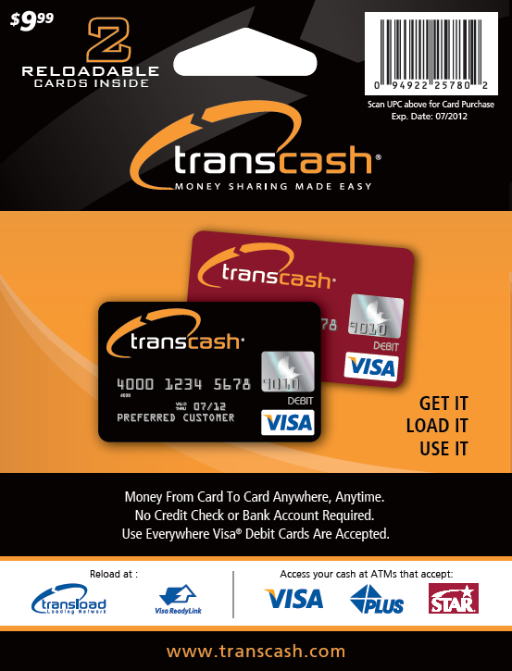

c) The TransCash Dual Card Package

The TransCash Product is a sealed package containing two Visa® prepaid debit cards, conveying all rights and privileges to load money and enjoy purchasing goods and services everywhere VISA® is accepted worldwide and providing the easiest and least expensive transfer of funds to families and friends around the world. The card carries global ATM and POS marks (Plus, Interlink, Cirrus, Maestro), which allows the cardholder to use this card globally at POS and ATM locations. The Black card is held by the purchaser as the control card while the red card is sent to the sharing companion. The red card remains restrictive in its use and control, but provides the sharing companion all the privileges of cash withdrawals and POS activities as the control cardholder deems appropriate.

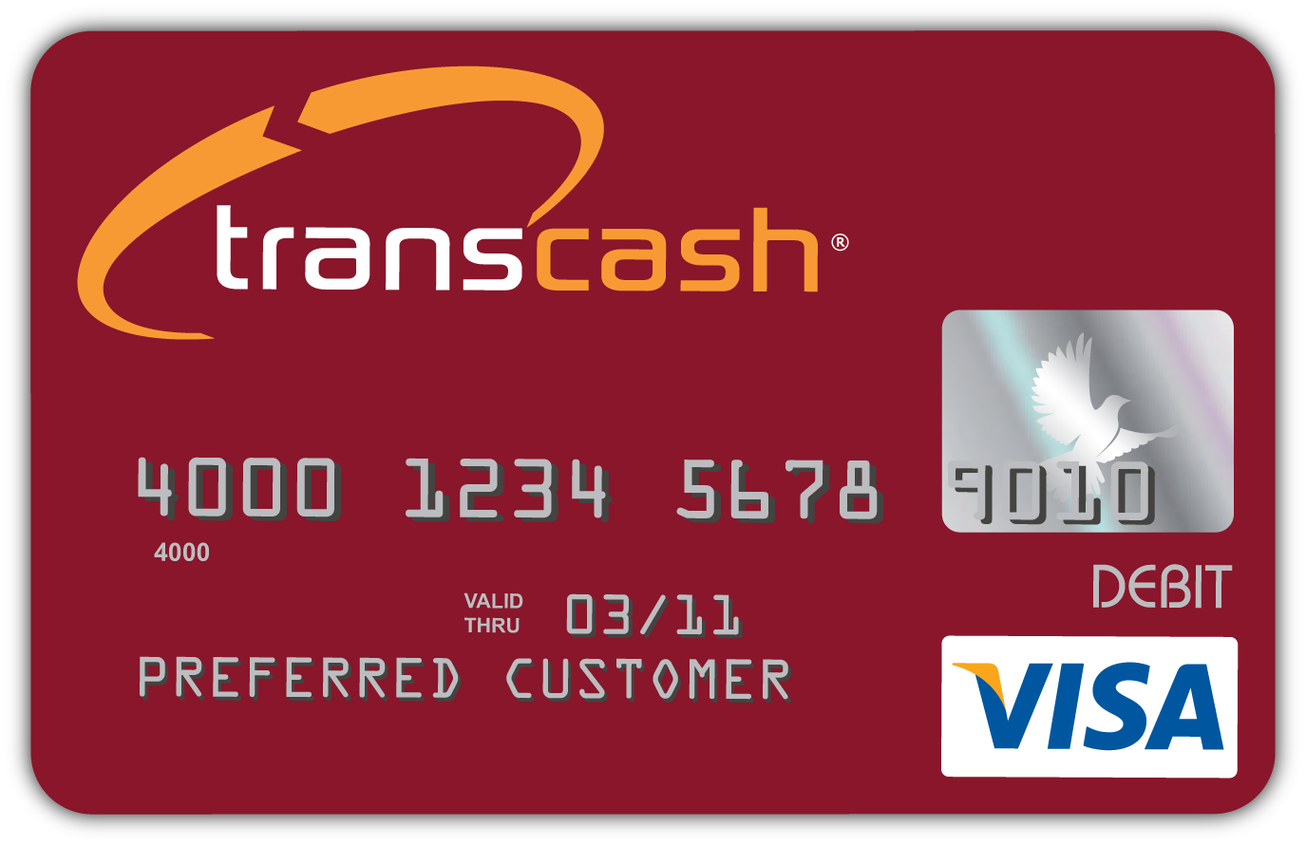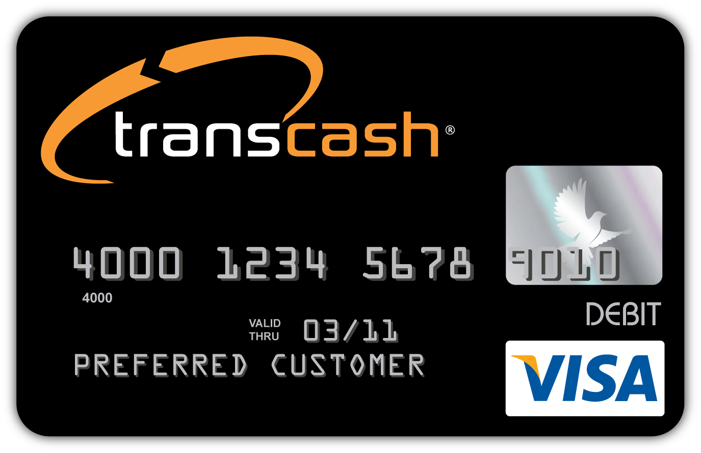

The TransCash Card can be used just like any other debit or prepaid card:

Method | Description
ATMs | Get cash from any ATM displaying the following symbols  
Purchase | Buy with confidence from any merchant worldwide accepting Visa®.
Pay Bills | Pay bills using your TransCash™ card! If a merchant does not accept Visa®, call our customer service department 1.800.770.8861
Budget | Great way for parents to manage teen’s allowance
More Features | Shop online, Pay for gas, Rent a car, Purchase travel tickets, and Paycheck direct deposit.

And, Reload the TransCash Card several different ways:
Method | Description
Credit Card | Use your credit card to deposit funds to your TransCash™ card. You will be required to establish an online account. – pending bank approval
Bank | Transfer funds from your bank account to your TransCash™ card. You will be required to establish an online account. – pending bank approval
Direct Deposit | Sign up for Direct Deposit, and enjoy free reloading.
Visa ReadyLink™ | Find your closest Visa ReadyLink location. Follow the loading instructions and your funds will be available instantly. Reload your card with Visa ReadyLink is easy and convenient. Give the money to the cashier, swipe the card et get your receipt. It's that easy!
MoneyGram™ | Find your closest MoneyGram location on the Visa ReadyLink website. Follow the loading instruction and your funds will be available in minutes. Reload your Prepaid Visa Cards with MoneyGram using Visa ReadyLink is easy. Complete the MoneyGram Blue Form or proceed to the MoneyGram phone to start your load.

V. MARKETING CAMPAIGN

The strategy behind the TransCash marketing campaign is a combination of print, radio and promotional investments

Customer Acquisition

The TransCash marketing strategy involves a combination of price, product features, product convenience and ease of use. Pricing the TransCash Card is critical element to each market.

Card Sales

The sales team focuses on the acquisition of retailers and building strategic relationships with cultural partners. These partners are selected based upon their ability to attract cardholders, incentivize them to transact and encourage customer loyalty. The sales team focuses on leveraging various distribution channels to deploy the TransCash Card program. These include:

- Mass market retailers
- Grocery retailers
- Convenience stores
- Check cashing locations

- The Product

General Purpose Card and Payroll Card:

The TransCash Visa Prepaid Debit Cards are especially designed for everyday consumers and they work similar to a portable bank account. A TransCash Visa Prepaid Debit Card works exactly like a debit card. In order to make purchases, sufficient funds need to be available in the linked account. If the account contains insufficient funds, the intended prepaid debit card purchase or withdrawal will not be approved. The TransCash Visa Prepaid Debit Cards can be used worldwide, wherever Visa is accepted. If the cards are lost or stolen, the account and the cardholder’s money remain safe. The cards can be easily replaced.

- Customer Care

TransCash has an in-house call center. The scripts used to interact with each customer are carefully crafted and customer service representatives are trained to demonstrate an understanding of the cultural nuances of each cardholder. Call center representatives require skilled and knowledgeable individuals that are focused on providing quick and accurate resolutions. By employing this approach, time and money is saved on customer retention efforts, satisfaction rates of customers improve.

VI. COMPANY STRUCTUREThe company is structured as follows:

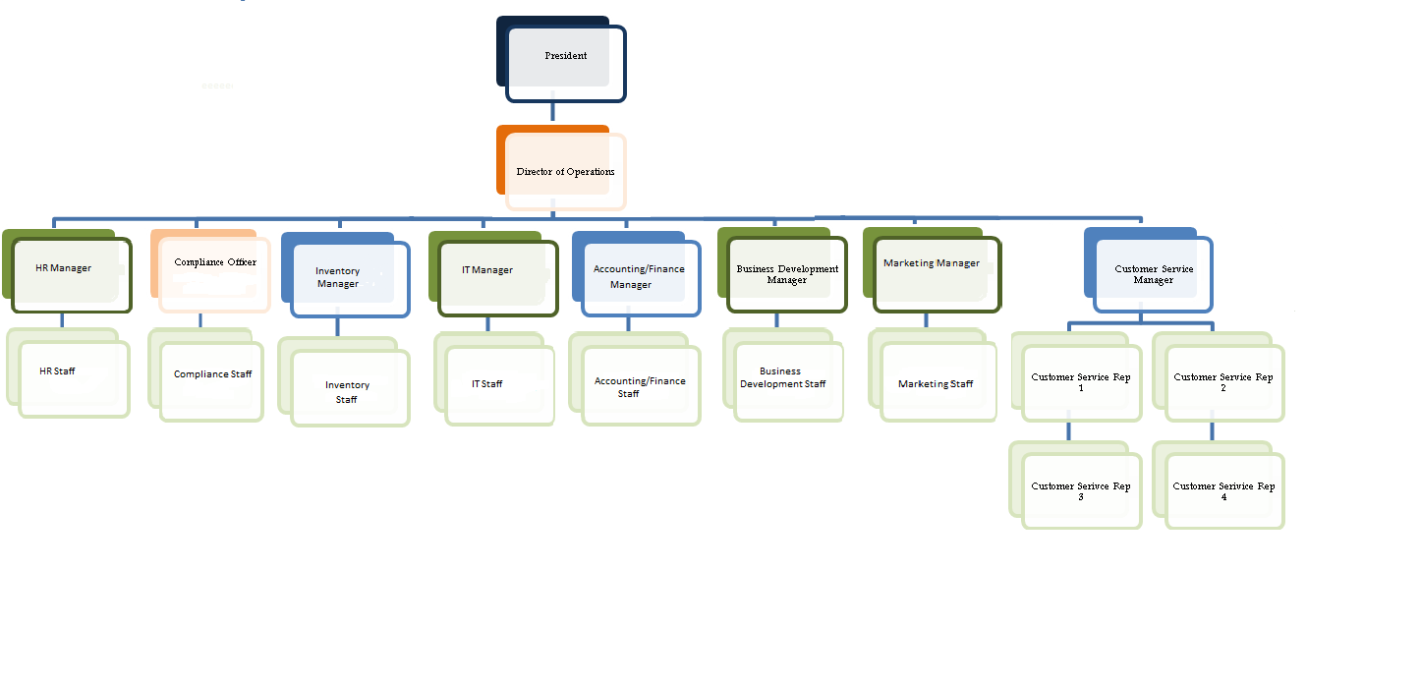

Manager descriptions are listed in Employees Job Description- HR section.

Throughout this document, the term unbanked is used to collectively refer to the unbanked, under-banked, foreign-born, and low to moderate-income individuals.
Urban neighborhoods are defined as census tracts with an excess of 100,000 people. Urban neighborhoods are typically more ethnically diverse than non-urban neighborhoods.

