**INTERNSHIP PROJECT REPORT**

(Project Term January-April, 2018)

## People Tracking

Submitted by

**Shivani Singh**

**Registration Number: 11402047**

**Course Code: CSE441J**

Under the Guidance of

**Mr. Rajesh Karthik Ramalingam**

**(Manager IT, Robert Bosch Engineering and Business Solutions Private Limited (RBEI))**

# School of Computer Science and Engineering



**CERTIFICATE FROM THE COMPANY**

**CERTIFICATE OF ORIGINALITY**

This is to certify that the project report entitled **“People Tracking”**, submitted to Lovely Professional University, Phagwara in partial fulfillment of the conditions for the award of B.Tech degree in Computer Science and Engineering from Lovely Professional University, Phagwara is an original work carried out by **Ms. Shivani Singh**, under guidance of **Mr. Rajesh Karthik Ramalingam**. The matter embodied in this project is a genuine work done by Sachin Shivprakash Vishwakarma to best of my knowledge and belief and has not been submitted before, neither to this University not to any other University for the fulfillment of the requirement of any course of study.

**Signature of the Student Signature of the Guide**

**Designation**

**ACKNOWLEDGEMENT**

The satiation and euphoria that accompany the successful completion of project would be incomplete without the mention of the people who made it possible.

I would like to take the opportunity to thank and express my deep sense of gratitude to my corporate mentor Mr. Rajesh Karthik Ramalingam. I am greatly indebted to him for providing their valuable guidance at all stages of study, advice, constructive suggestions, positive and supportive attitude and continuous encouragement, without which it would not have been possible to complete the project.

I owe my whole hearted thanks and appreciation to my entire team for their corporation and assistance during the course of my project.

I hope that I can build upon the experience and knowledge that I have gained and make a valuable contribution towards this industry in coming future and make the world a better place.

**Shivani Singh**

LPU, Phagwara

Punjab **Signature**

**TABLE OF CONTENTS**

Inner first page ………………………………………………………………….. (i)

Certificate form the Company ………………………………………………….. (ii)

Certificate of Originality……..…….……………………………………………. (iii)

Acknowledgement…………………...………………………………………….. (iv)

Table of Contents……………………...………………………………………… (v)

1. **INTRODUCTION 1**
   1. FACE DETECTION  **2**
   2. NFC **2**
   3. GPS **3**
2. **PROFILE OF PROBLEM 4**
3. **EXISTING SYSTEM 5**
   1. INTRODUCTION **5**
   2. EXISTING SOFTWARE **5**
      1. AZRUE FACE API **5**

3.2.1.1 FACE GROUPING **6**

3.2.1.2 FACE DETECTION **6**

* + 1. SHARE GPS **7**
  1. DFD  **8**
  2. WHAT’S NEW IN THE SYSTEM TO BE DEVELOPED **10**

1. **PROBLEM ANALYSIS 11**
   1. PRODUCT DEFINITION **11**
   2. FEASIBILITY ANALYSI**S 11**
      1. TECHNICAL FEASIBILITY  **11**
      2. LEGAL FEASIBILITY **11**
   3. PROJECT PLAN **12**
2. **SOFTWARE REQUIREMENT ANALYSIS 13**
   1. INTRODUCTION **13**
   2. GENERAL DISCRIPTION  **13**
      1. HARDWARE REQUIREMENTS **13**
      2. SOFTWARE REQUIREMENTS **13**
   3. FUNCTIONAL REQUIREMENTS **14**
      1. FUNCTIONAL REQUIREMENT 1 **14**
      2. FUNCTIONAL REQUIREMENT 2 **14**
      3. FUNCTIONAL REQUIREMENT 3 **14**
      4. FUNCTIONAL REQUIREMENT 4 **14**
      5. FUNCTIONAL REQUIREMENT 5 **15**
      6. FUNCTIONAL REQUIREMENT 6 **15**
      7. FUNCTIONAL REQUIREMENT 7 **15**
      8. FUNCTIONAL REQUIREMENT 8 **15**
      9. FUNCTIONAL REQUIREMENT 9 **15**
      10. FUNCTIONAL REQUIREMENT 10 **16**
      11. FUNCTIONAL REQUIREMENT 11 **16**
3. **DESIGN 17**
   1. SYSTEMDESIGN **17**
   2. FLOW CHARTS **18**
   3. PSEUDO CODE **19**
4. **TESTING 20**
   1. FUNCTIONAL TESTING **20**
   2. STRUCTURALTESTING **20**
   3. LEVELSOFTESTING **21**
      1. UNIT TESTING **21**
      2. INTEGRATION TESTING **21**
      3. SYSTEM TESTING  **21**
5. **PROJECT LEGACY**
   1. CURRENT STATUS OF PROJECT AND REMAINING AREAS OF CONCERN **22**
   2. TECHNICAL AND MANAGERIAL LESSIONS LEARNT **22**
   3. POST-IMPLEMENTATION AND SOFTWARE MAINTENANCE **23**
6. **SYSTEM SNAPS 24**
7. **BIBLIOGRAPHY 27**
8. **INTRODUCTION**

People tracking system track people using face recognition, NFC tag and GPS. People tracking system enable the ability to track person inside an infrastructure like cooperate building, airport, railway station, etc. People tracking system also provide security to home and complete children tracking solution. People tracking system works in two principle, detection and tracking. Both detection and tracking people are challenging problems, especially in complex real world scenes that commonly involve multiple people, complicated occlusions, and cluttered or even moving backgrounds. People detectors have been shown to be able to locate pedestrians even in complex street scenes, but false positives have remained frequent. The identification of particular individuals has remained challenging as well. Tracking methods are able to find a particular individual in image sequences, but are severely challenged by real-world scenarios such as crowded street scenes. People detection system is easily installable at door and can be integrated into existing system. It provide home security by identifying you and your family members and sends the notification on unknown detection of face also provides monitoring and alert setting for particular faces. The NFC tags in people tracking helps in tracking of children in school transit and attendance system. People tracking system provide full tracking solution for children tracking to school, bus tracking and attendance monitoring and also provides alert on child’s delay on reaching home. Whenever child board the bus the camera on bus detects the child face trigger the GPS on the bus and provides the feedback to parents about the child’s movement along with bus location. After reaching to school the NFC reader detect the NFC tag in child’s I-Card and marks the attendance in school database as well as in parents logging system so the parents can monitor the attendance in real time. Parents can set alert for child’s returning time (for example alert between 1pm to 2pm) and if face camera do not detect child’s returning in the specified time it will trigger the alert to parent and ask them to take necessary actions. This the one use case for people tracking system this system is been extended to provide tracking solution for airport and cooperate sectors.

* 1. **Face Detection**

Face detection is a PC innovation being utilized as a part of an assortment of utilizations that distinguishes human faces in computerized images. Face detection additionally alludes to the mental procedure by which people find and take care of countenances in a visual scene. Face detection system detect the faces of person by facial mapping using azure face API. Face detection system provides Machine learning to train the system about the faces of known person and also enable user to tag person face with specific groups like friends, family, etc. People tracking system uses Raspberry Pi, USB web camera and motion library to detect motion in the vicinity and capture images and uploads it to Azure cloud blob storage. It provide live streaming of camera in the network for real time monitoring also sends the best snaps on motion detection for facial recognition. Face detection system is self-adaptive and provides major contribution in people tracking system

* 1. **NFC**

NFC stands for “Near Field Communication” and, as the name implies, it enables short range communication between compatible devices. This requires at least one transmitting device, and another to receive the signal. A range of devices can use the NFC standard and will be considered either passive or active. Passive NFC devices include tags, and other small transmitters, that can send information to other NFC devices without the need for a power source of their own. However, they don’t really process any information sent from other sources, and can’t connect to other passive components. These often take the form of interactive signs on walls or advertisements. Active devices are able to both send and receive data, and can communicate with each other as well as with passive devices. Smartphones are by far the most common form of active NFC device. Public transport card readers and touch payment terminals are also good examples of the technology. Just like Bluetooth and WiFi, and all manner of other wireless signals, NFC works on the principle of sending information over radio waves. Near Field Communication is another standard for wireless data transitions. This means that devices must adhere to certain specifications in order to communicate with each other properly. The technology used in NFC is based on older RFID (Radio-frequency identification) ideas, which used electromagnetic induction in order to transmit information. This marks the one major difference between NFC and Bluetooth/WiFi. The former can be used to induce electric currents within passive components as well as just send data. This means that passive devices don’t require their own power supply. They can instead be powered by the electromagnetic field produced by an active NFC component when it comes into range. In people tracking system NFC is used to track people where there is not possible to install camera due to lack of resources and security issues. Here NFC TAG’s are used to detect person’s movements.

* 1. **GPS**

The Global Positioning System (GPS), initially Navistar GPS, is a satellite-based radio navigation framework. It is a worldwide route satellite framework that gives geolocation and time data to a GPS beneficiary anyplace on or close to the Earth where there is an unhampered observable pathway to at least four GPS satellites. Obstacles, for example, mountains and structures obstruct the generally feeble GPS signals. The GPS does not require the client to transmit any information, and it works autonomously of any telephonic or web gathering, however these advancements can improve the value of the GPS situating data. The GPS gives basic situating capacities to military, common, and business clients around the globe. In People Tracking System two GPS are used one is standalone GPS sensor and other is smart phone GPS. The standalone GSP sensor is used for installing in vehicle like bus for tracking and geo fencing and mobile GPS is used to monitor person movement along with mobile phone. The person with GPS phone will constantly update its location coordinate on the central database and authorized users like family members and parents can view it as a part of teenagers tracking

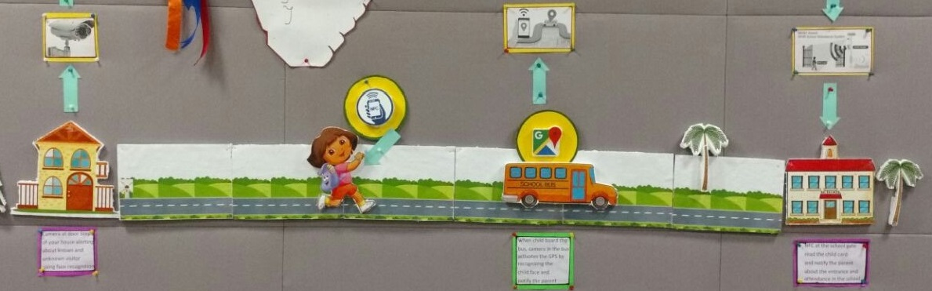

Figure 1: Work Flow of People ttracking system for childern traking

1. **PROFILE OF PROBLEM**
2. **EXISTING SYSTEM**
   1. **INTRODUCTION**

People tracking system track people using face recognition, NFC tag and GPS. People tracking system enable the ability to track person inside an infrastructure like cooperate building, airport, railway station, etc. It provide home security by identifying you and your family members and sends the notification on unknown detection of face also provides monitoring and alert setting for particular faces. GPS is also used to track people. The person with GPS phone will constantly update its location coordinate on the central database and authorized users like family members and parents can view it as a part of teenagers tracking. NFC is used to track people where there is not possible to install camera due to lack of resources and security issues. Here NFC TAG’s are used to detect person’s movements.

* 1. **EXISTING SOFTWARE**

People tracking system uses the Azure Face API for face detection and share GPS module following are the detailed description of these existing systems

* + 1. **AZURE FACE API**

Microsoft Face API, a cloud-based administration that gives the most developed face calculations. Face API has two fundamental capacities: face detection with attributes and face recognition. Face API detects up to 64 human faces with high precision face location in an image. And the image can be specified by file in bytes or valid URL. Face rectangle (left, top, width, and height) indicating the face location in the image is returned along with each detected face. Optionally, face detection extracts a series of face-related attributes such as pose, gender, age, head pose, facial hair, and glasses. Four face recognition functions are provided: face verification, finding similar faces, face grouping, and person identification. Face API verification performs an authentication against two detected faces or authentication from one detected face to one person object.

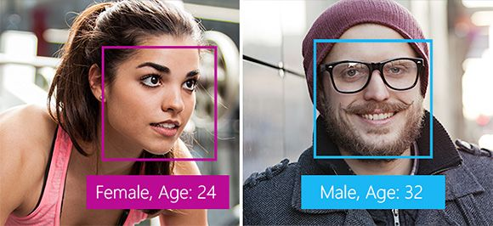

Figure 2: Face Attribute and face rectangle

* + - 1. **FACE GROUPING**

Given one set of unknown faces, face grouping API automatically divides them into several groups based on similarity. Each group is a disjointed proper subset of the original unknown face set, and contains similar faces. And all the faces in the same group can be considered to belong to the same person object.

* + - 1. **FACE IDENTIFICATION**

Face API can be used to identify people based on a detected face and a people database (defined as a LargePersonGroup/PersonGroup). Create this database in advance, which can be edited over time. The following figure is an example of a LargePersonGroup/PersonGroup named "myfriends". Each group may contain up to 1,000,000/10,000 person objects. Meanwhile, each person object can have up to 248 faces registered. After a LargePersonGroup/PersonGroup has been created and trained, identification can be performed against the group and a new detected face. If the face is identified as a person object in the group, the person object is returned. Face Storage allows a Standard subscription to store additional persisted faces when using LargePersonGroup/PersonGroup Person objects (PersonGroup Person - Add Face/LargePersonGroup Person - Add Face) or LargeFaceLists/FaceLists (FaceList - Add Face/LargeFaceList - Add Face) for identification or similarity matching with the Face API. The stored images are charged at $0.5 per 1000 faces and this rate is prorated on a daily basis.

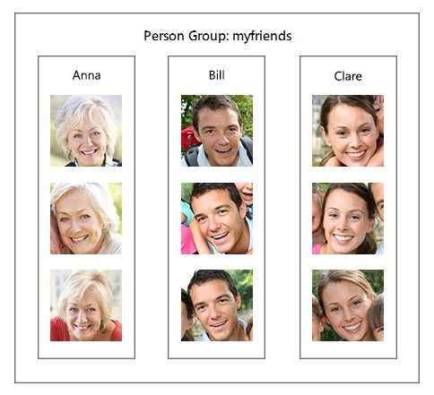 Figure 3: Face Attribute and face rectangle

* + 1. **SHARE GPS**

Share GPS uses the broadcasting services to send location updates to its authorized subscriber its an existing system for logistic managements which uses mobile GPS for tracking. It has two past one is master and other is slave. Slave is simple a android app which contains only service without any user interface, this service is only responsible for getting data from GPS sensor and broadcasting it to all authorized people only. People tracking uses this service to track people continuously and extends it to face child school tracking use case. Figure 3 shows the live location tracking of four people along with the estimated time for arrival and distance updates

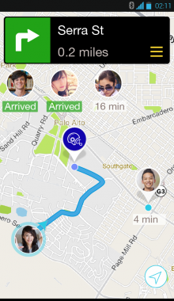Figure 4: Live Tracking and GPS sharing

* 1. **DFD OF PEOPLE TRACKING SYSTEM**

In people tracking system most important part is face recognition and face identification along with user alerts. Whenever the intrusion is detected the Raspberry-pi with USB camera capture the number of image for next 30 seconds and sends the best image out of it using motion library and azure SDK to azure blob storage where it trigger the azure function which compare the image with known faces and send back the notification to user on its mobile phone also function generates the logs and saves it to azure tables for future use. Figure 4 shows the diagrammatical presentation of data flow motion detection, face detection, and face identification and user notification

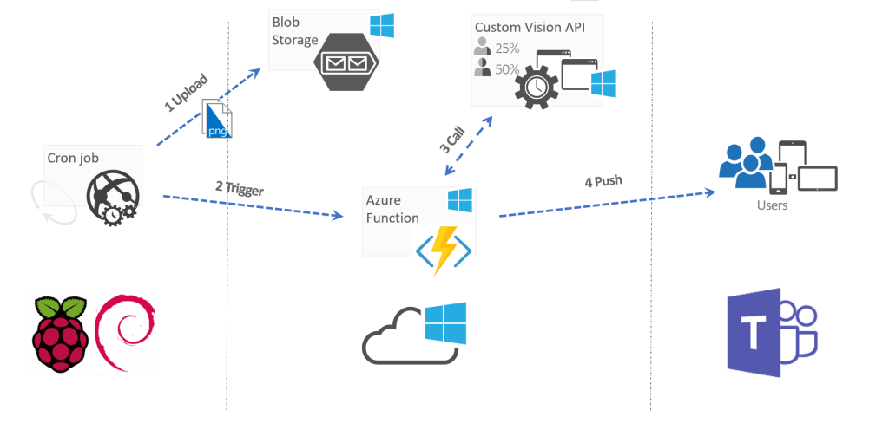

Figure 5: Dataflow diagram for face detection system

* 1. **WHAT’S NEW IN THE SYSTEM TO BE DEVELOPED**

People tracking system is an independent project which uses few pre-existing technology (azure and Share GPS). Following are the new system to be developed in people tracking system.

* In people tracking system motion detection and face identification connecting system needed to be developed with constrain in computation power of raspberry pi microprocessor.
* Storage and security of image captured needed to be implemented.
* Azure function that can process the image and send notification and also maintaining logs is required to be developed.
* Synchronization between NFC system and Face recognition module needed to be implemented.
* Android app that can provide visitor image view long with alert on intrusion.
* Also app should provide full user control to manage face registration and deletion.
* Application should provide the ability to set alert for people alert tagging for time constrains.
* Application also show the live tracking data of GPS
* Self-learning and adaptive face recognition system needed to be developed which can recognize the changes in faces like bread and facial hair changes

1. **PROBLEM ANALYSIS**
   1. **PRODUCT DEFINITION**

People Tracking System is finished tracking arrangement inside framework, airplane terminal and child's and adolescents tracking. People tracking utilizes Camera (Face distinguishing proof), GPS and NFC to track people. These three innovation makes a strong situation for tracking and security in People Tracking system.

* 1. **FEASIBILITY ANALYSIS**
     1. **TECHNICAL FEASIBILITY**

Following are the technical requirement for people tracking system:

* Android Studio and Visual Studio 2017 environment set up with a fast SSD and processor and RAM of more than 16GB.
* Latest android version package available on google git to be pulled and kept on the same machine
* Microsoft Azure Storage account (blob and tables ) and Azure functions 3.0
* Microsoft Azure Notification namespace and Notification hub
* Google firebase free account (for notification legacy server)
* Raspberry Pi 3 model B , USB camera, power supply, Display unit(monitor for RPI)
* NFC reader with USB and NFC TAGS (minimum 2)
* GPS sensor and android enabled device with GPS

All the technical requirements can be easily fulfilled and all packages that are required are open sourced and can easily be pulled from repositories. Technically project is feasible to implement with proper architecture.

* + 1. **LEGAL FEASIBILITY**

Most of the project is built on the open source technology for services like Azure face API purchasing of subscription is required following are the license which are require:

* Microsoft Azure Subscription (Recommended: Pay-As-You-Go subscription)
* Windows 10 license
* Microsoft Visual Studio 2017 developer edition license
* Google firebase Subscription

Other than above mentioned license picture and location data privacy law of targeted countries should be considered.

1. **SOFTWARE REQUIREMENT ANALYSIS**
   1. **INTRODUCTION**

People tracking system aims to provide solution for all kind of tracking without human intervention. Following are the detailed hardware and software requirement of the People Tracking System along with functional requirement. It will give a detailed description of the system and all its features.

* 1. **GENERAL DESCRIPTION**
     1. **HARDWARE REQUIREMENTS**

People tracking system is IOT based solution. Hardware should be able to detect motion and capture image also should able to send HTTP request. System should reads the NFC tags and can register new tags in database. System should be able to send Location coordinates to server or central database. Following hardware should be used

* Raspberry PI and USB camera – to detect motion and capture image also raspberry pi upload image to azure blob storage
* GPS sensor – to get location co-ordinates
* NFC reader – To read NFC Tags
* NFC TAGS – To generate and register hexadecimal values
  + 1. **SOFTWARE REQUIREMENTS**

Following are software requirement for People tracking system:

* Full control over management of Faces
* Data encryption and secure communication.
* Event logging
* Alert notification to authorized users only.
* Identification accuracy should be greater than 60% and should be self-adaptive and self-learning
* Synchronization between NFC , GPS and Face Detection
  1. **FUCTIONAL REQUIREMENTS**
     1. **FUNCTIONAL REQUIREMENT 1**

**ID: FR1**

TITLE: Motion Detection

DESC: System should detect the motion over constant monitory through camera only. Detection area should be area of camera coverage

* + 1. **FUNCTIONAL REQUIREMENT 2**

**ID: FR2**

TITLE: Automatic image capturing on motion detection

DESC: Automatic image capturing should happen when whenever there is motion in the camera range

* + 1. **FUNCTIONAL REQUIREMENT 3**

**ID: FR3**

TITLE: Storing Captured image on Azure cloud

DESC: Captured Images should be saved on Azure cloud and should be encrypted and secured transferred should be done. Image should be saved locally also for temporary time period also and should get auto deleted after 15 days

* + 1. **FUNCTIONAL REQUIREMENT 4**

**ID: FR4**

TITLE: Face Identification

DESC: Face should be identified and should get the name of person from saved known faces along with the groups attached to it

* + 1. **FUNCTIONAL REQUIREMENT 5**

**ID: FR5**

TITLE: Android app for face manage

DESC: Android app should provide functionality view last visited face and register new faces, manage old faces and should be able to set alert for specific face and time. Application should also be able to receive notification

* + 1. **FUNCTIONAL REQUIREMENT 6**

**ID: FR6**

TITLE: Notification push on unknown face along with image

DESC: Notification push on new motion detection and user should get the image of unknown person and on alert setting.

* + 1. **FUNCTIONAL REQUIREMENT 7**

**ID: FR7**

TITLE: Log display

DESC: Android app should display all the log of face events and NFC.

1. **DESIGN**
   1. **SYSTEM DESIGN**
   2. **FLOW CHARTS**



Figure 6: Dataflow diagram for face detection system

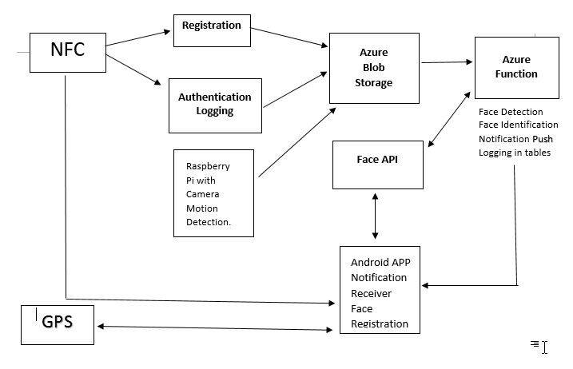

Figure 7: Dataflow diagram for People tracking system

* 1. **PSEUDO CODE**.

1. Capture image on motion detection
2. Save image locally
3. Send best picture to azure blob storage
4. Data encryption while saving data to blob
5. Blob Azure Function trigger on after triggering
6. Identifying faces in the image
7. Sending result in the form of notification to users android app
8. Saving logs
9. Downloading last visited image in android app to show to user when notification received
10. Alert setter page for face alert and time fencing
11. Checking on log after time fencing to check persons visit
12. Displaying logs along with the name of the person detected
13. Taking picture from image gallery or camera to train new faces along with there name and tags
14. NFC registration on NFC tapping of new cards
15. NFC data logging
16. NFC tag data retrieval from database
17. GPS data request from app
18. GPS location synchronization on request approval
19. Person movement 3d display on maps
20. Mapping person movement inside building
21. App optimization for fast face processes
22. Increasing face computation power
23. Group management of faces
24. Prediction on person visit through face , NFC and GPS logs
25. **TESTING**
    1. **FUNCTIONAL TESTING**

Each and every functionality of the system is tested by providing appropriate input, verifying the output and comparing the actual results with the expected results. This testing involves checking of User Interface, APIs, Database, security, client/ server applications and functionality of the Application under Test. The testing is done manually. Each functions that do not have any dependency is checked.

1. Tested automatic motion detection on various motion on different speed
2. Tested automatic image capturing and image quality on fast and slow movements
3. Tested selection of best image by giving mostly distorted and blurry images
4. Tested face detection and face identification accuracy by providing different images of same person face from different angle and different facial expressions
5. Tested face registration and face management from app by providing group photos with many faces ad files of different sizes
6. Tested NFC to get hexadecimal value from number of NFC tags
7. Tested NFC tag registration and TAG data retrieval from database with parallel tapping
8. Tested data encryption and package security through WI shark
9. Tested user registration for valid and invalid camera and RPI id’s
   1. **STRUCTURAL TESTING**

In structural testing is done by developer who had knowledge of the code. It is more concerned with how system does it rather than the functionality of the system. It provided more coverage to the testing. For ex, to test notification error message in android app for intrusion detection, we need to test the trigger condition for it, but there are many trigger for it. It is possible to miss out one while testing the requirements drafted in SRS. But using this testing, the trigger is most likely to be covered since structural testing aims to cover all the nodes and paths in the structure of code. It is complementary to Functional Testing. Using this technique the test cases drafted according to system requirements is first analyzed and then more test cases were added to increase the coverage. It is also used on different levels such as unit testing, component testing, integration testing, functional testing etc. Its helped us in performing a thorough testing on software. The structural testing is mostly automated but for people tracking the testing is done using people movement in garden near office. This testing mainly focus on to finding error in face detection and identification flow from pi camera to azure blob and function trigger to android app notification.

* 1. **LEVELS OF TESTING**
     1. **UNIT TESTING**

In unit testing individual units of a people tracking system are tested. The purpose is to validate that each unit of the software performs as designed. In unit testing face capturing, face detection, trigger, face management and NFC registration are tested by giving appropriate input manually.

* + 1. **INTEGRATION TESTING**

In integration testing individual units were combined and tested as a group. The purpose of this level of testing is to expose faults in the interaction between integrated units. Face capturing and blob triggering were combined to test the data flow between them, similarly the NFC logging system and face Logging system were integrated and tested. Share GPS were integrated with GPS sensor and were tested by moving GPS sensor remotely.

* + 1. **SYSTEM TESTING**

In this testing complete, integrated system is tested. The purpose of this test is to evaluate the system’s compliance with the specified requirements of people tracking. All the three module face detection, NFC and GPS were tested for data flow and triggers also android app were tested for notification and log views along with face management.

1. **PROJECT LEGACY**
   1. **CURRENT STATUS OF PROJECT AND REMAINING AREAS OF CONCERN**

Currently all the functional requirements are fulfilled except the data security and encryption. System is able to detect motion and send data to blob storage for saving and face identification. The identification is also working great with promising accuracy of 85%. Notification hub is managing notification pushes efficiently along with logging synchronization with NFC and GPS modules. System is able to track specific person using face where there is camera and using GPS when there is no camera apart from this system is also able to track person where there is no GPS available using NFC tags. Following are remaining areas of concerns

* Security of images stored and data transferred
* Country GPS policy
* User specific data notification
* Face identification accuracy
  1. **TECHNICAL AND MANAGERIAL LESSONS LEARNT**

Working in this project was a challenge as the android automotive system and its working was new to me and also a new field in the market as well. Microsoft Azure cloud was new for me but after working for few days with experienced people I have learnt a lot special how to make a production ready product also learnt the coding standard. Open source package which can be found on the repositories needs to be understood because some of the documentation cannot be found on the web. It was because of my Mentor and my team who helped me at every step that I was able to grab the knowledge as quick as possible. Now I know the architecture of IOT project and how the data flows between different layers of the system. I can now develop system apps for smart home systems which can provide security, alerts notification, and NFC controlled door also can get sensor data and make apps to show it. While working along with project I have learnt many thing about team management and to keep motivating and innovating under high work pressure. Overall it was great learning and great fun working with people tracking team.

1. **SYSTEM SNAPS**
2. **BIBLIOGRAPHY**