* SDLC means softwear development life cycle.
* softwear testing is process to used to identify completness,correctness and quality used to development softwear testing.
* ->agile methodology is way on project and work on planning and executing and term and condition.
* SRS means softwear requirment specification.
* OOPS means object orianted programming system.
* the basic consept of oops is object,class,abstraction,encapsulation,inharitance,polymorphism.
* ->object is a one type of item collet that is called object.
* ->class is perform object and behaviour object that is called class.
* ->encapsulation is collect a group of data that's called encapsulation.
* inharitance is work on data inharit and onther class make relationship in inharitance.
* ->polymorphysm is a greek world and polymorphism is function operate in many ways that's called polymorphism.

->usecase diagram of online book shoping.

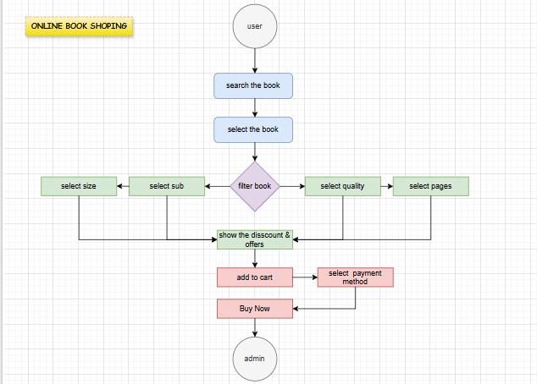

->usecase diagram of online bill payment system

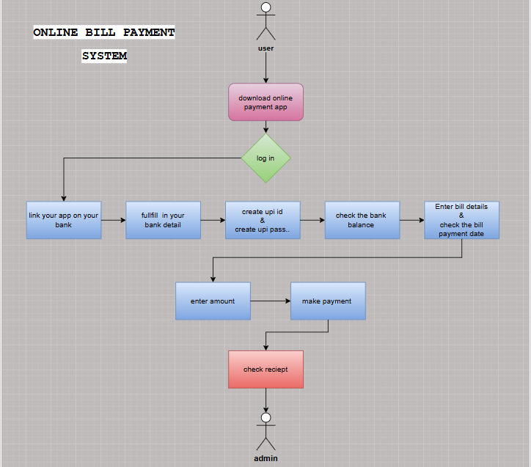

->write SDLC phases with introduction:

* Requirment gathering:customer related
* Analysis: model data analysis
* Design: model specification and designed
* Implementation:data implement and model solution
* Testing: software testing and solution
* Maintenance: defect repair and requirement solution

-> Phases of waterfall model : waterfall model phases is classical software model on various software development.

->phases of spiral model : spiral model phases is planning,risk,and analysis,engineering and etc.

->Agile manifesto principle :

* Customer satisfaction and delivery
* Avoid of requirement features
* Working software deliver
* Collobration the business developers
* Successful communication
* Explain agile methadolody pros and cons.
* High ability project frequently
* Development process is high
* Project result is batter
* Project quality and detail is batter provide

->Use case diagram on online shoping product using COD

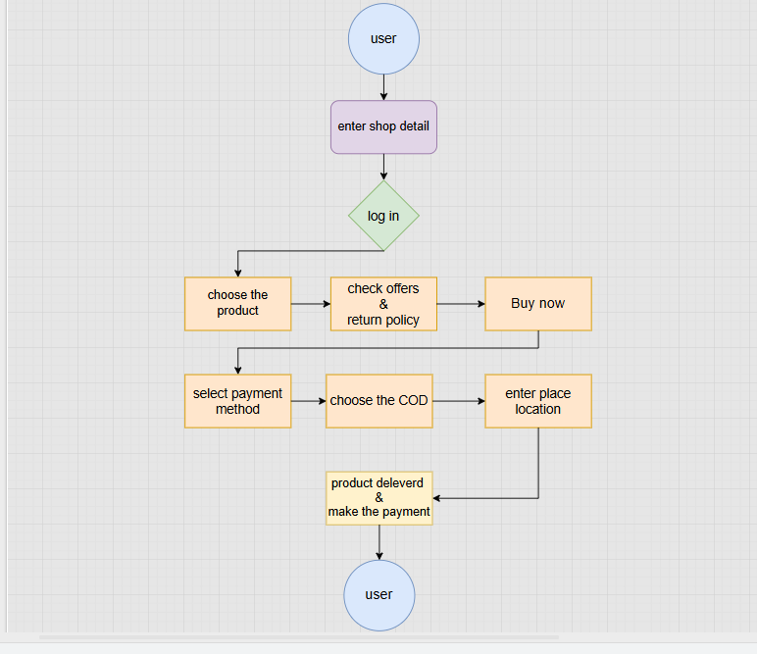use case diagram on online shoping product using payment gateway

