INTERNSHIP TRAINING REPORT
ON
"WEB APPLICATION DEVELOPMENT WITH SPRING MVC FOR SIMULATED SENSOR DISPLAY IN AUV OPERATIONS"

AT

INSTITUTE FOR SYSTEMS STUDIES & ANALYSES (ISSA)
DEFENCE RESEARCH & DEVELOPMENT ORGANISATION (DRDO)
METCALFE HOUSE, DELHI - 110054

UNDER THE GUIDANCE OF
SRISHTI (Scientist 'F', ISSA)
SUBMITTED BY
ANKIT RAJ
Roll No: 02718011922
Bachelor of Technology in Artificial Intelligence and Data Science
Delhi Technical Campus
(Affiliated to Guru Gobind Singh Indraprastha University — GGSIPU)

DECLARATION

I, Ankit Raj, Roll No. 02718011922, student of Bachelor of Technology in Artificial Intelligence and Data Science at Delhi Technical Campus, affiliated to Guru Gobind Singh Indraprastha University (GGSIPU), Delhi, hereby declare that this Internship Report titled "Web Application Development with Spring MVC for Simulated Sensor Display in AUV Operations" is being submitted in partial fulfilment of the requirements of the training programme undertaken at the Institute for Systems Studies & Analyses (ISSA), Defence Research and Development Organisation (DRDO), Metcalfe House, Delhi - 110054.

This report is an authentic and original record of the work performed by me during the internship period under the supervision and guidance of my assigned mentor at ISSA. All technical work, analysis, and findings documented herein are a result of my own efforts and learning during the training. I further declare that the content of this report has not been submitted previously to any institution for the award of any degree, diploma, or certificate. I have maintained all confidentiality and security obligations as required by the organization.

Ankit Raj
B.Tech — Artificial Intelligence and Data Science
Roll No: 02718011922
Delhi Technical Campus, GGSIPU
Date: _______________

CERTIFICATE

This is to certify that Mr. Ankit Raj, student of Bachelor of Technology in Artificial Intelligence and Data Science from Delhi Technical Campus, affiliated to Guru Gobind Singh Indraprastha University (GGSIPU), Delhi, has successfully completed the internship training programme at the Institute for Systems Studies & Analyses (ISSA), Defence Research and Development Organisation (DRDO), Metcalfe House, Delhi - 110054.

During the internship, the student worked on the design and development of a web-based visualization tool for simulated sonar sensor display in Autonomous Underwater Vehicle (AUV) operations, using Java Full Stack technologies including Spring MVC, Java Servlets, JSP, HTML5, CSS3, and JavaScript. The student demonstrated sincere dedication, technical aptitude, and professional conduct throughout the training period.

The work documented in this report is a genuine account of the contributions made by the student during the training programme. This certificate is issued in recognition of successful completion of the internship.

Srishti
Scientist 'F', ISSA
Defence Research and Development Organisation (DRDO)
Metcalfe House, Delhi - 110054
Date: _______________

ACKNOWLEDGEMENT

It gives me immense pleasure and a deep sense of fulfillment to have successfully completed my summer internship at the Institute for Systems Studies and Analyses (ISSA), Defence Research and Development Organisation (DRDO), Delhi, and to present this report as a comprehensive record of the work and learning undertaken during this period.

I am wholeheartedly thankful to my guide and mentor, Srishti (Scientist 'F', ISSA), for their invaluable guidance, consistent encouragement, and patient mentorship throughout the internship. Their deep technical knowledge, willingness to explain complex concepts, and constructive feedback on my work were instrumental in the successful completion of my assigned tasks.

I extend my sincere gratitude to all the staff and scientists at ISSA who provided their time, expertise, and support throughout this training. The professional environment at DRDO greatly enriched my technical understanding of defense-grade software systems.

I also owe a debt of gratitude to the faculty at Delhi Technical Campus, GGSIPU, whose academic guidance laid the foundation for this work. Finally, I express my deepest thanks to my parents and family, whose unwavering support and belief in my abilities have been my greatest source of motivation.

Ankit Raj
B.Tech Final Year — Artificial Intelligence and Data Science
Delhi Technical Campus, GGSIPU

ABSTRACT

This report presents a detailed account of the internship training carried out at the Institute for Systems Studies and Analyses (ISSA), Defence Research and Development Organisation (DRDO), Delhi, during the summer training programme. The internship focused on the design and development of a web-based visualization tool for simulated sonar sensor display in Autonomous Underwater Vehicle (AUV) operations using Spring MVC and Java Full Stack technologies.

The primary objective of the internship was to gain hands-on exposure to modern web application development using the Spring MVC framework integrated with a Java backend, HTML5, CSS3, and JavaScript on the frontend, and PostgreSQL as the relational database backend. The project involved building an interactive, browser-based sonar visualization interface capable of dynamically rendering simulated sensor data received from backend services representing underwater environments.

The tool renders a simulated sonar display with real-time range ring visualization, angular grid overlays, and dynamic data point markers representing tracked underwater objects. The backend processes simulated AUV sensor data and serves it to the frontend through RESTful API endpoints built with Spring MVC. JavaScript handles dynamic canvas rendering, state management, and user interaction on the visualization panel.

This internship provided substantial exposure to professional software development practices within a defense research context, offering invaluable experience in full-stack Java development, system architecture design, simulation data handling, and visualization engineering.

Keywords: Spring MVC, AUV, Sonar Simulation, Java Full Stack, Web Visualization, Sensor Display

TABLE OF CONTENTS

1. Introduction
1.1 Background
1.2 About the Organization
1.3 Scope of the Internship
2. Objectives
2.1 Primary Objective
2.2 Secondary Objectives
2.3 Expected Outcomes
3. Technology Stack
3.1 Overview
3.2 Spring MVC Framework
3.3 Java & Servlets
3.4 HTML5, CSS3, JavaScript
3.5 PostgreSQL
4. System Architecture and Design
5. AUV Sonar Visualization Tool
5.1 Sonar Display Panel
5.2 Range Ring and Grid Rendering
5.3 Track & Data Point Markers
6. Supporting Modules
7. Challenges and Solutions
8. Learnings
9. Conclusion
10. References
CHAPTER 1

INTRODUCTION

CHAPTER 1: INTRODUCTION

1.1 Background
In the contemporary landscape of defense technology and underwater warfare systems, the ability to visualize simulated sensor data in real time has become a critical capability for research and operational planning. Autonomous Underwater Vehicles (AUVs) represent a rapidly evolving domain within naval defense, offering uncrewed platforms capable of surveillance, mine detection, and intelligence gathering in complex underwater environments.

For research and development organizations such as DRDO, visualization tools that simulate the operational behavior of AUV sensor systems play a fundamental role in algorithm development, operational testing, and decision-support system design. Sonar — the primary sensing modality for underwater navigation — generates complex spatial and angular data that must be rendered clearly and accurately for analysis by operators and system designers.

This internship was undertaken in the context of this operational need. The project involved the full-stack development of a web-based sonar visualization tool using Spring MVC, capable of rendering simulated sensor tracks and range data in an interactive browser-based display.
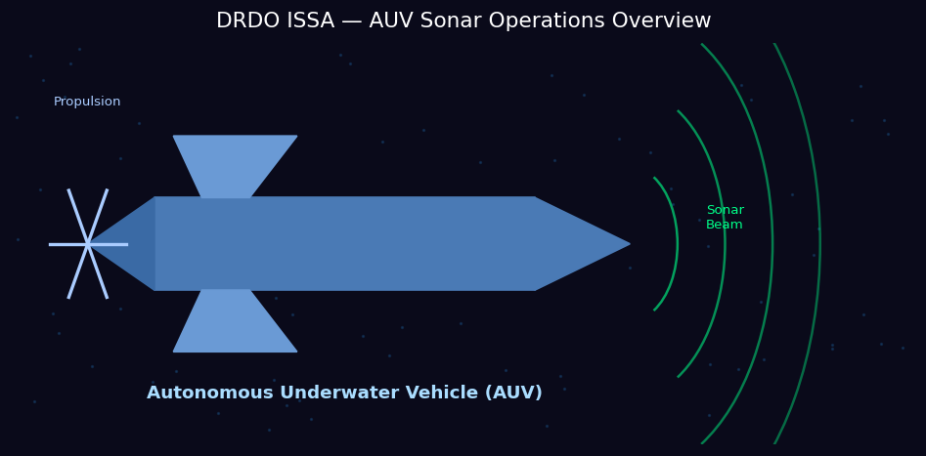
Figure: AUV Sonar Operations — Autonomous Underwater Vehicle Concept

1.2 About the Organization
The Defence Research and Development Organisation (DRDO) is India's premier government agency responsible for the research, design, development, and production of advanced technology for military use. Established in 1958 under the Ministry of Defence, Government of India, DRDO comprises more than 50 specialized laboratories, each focusing on a specific domain of defense technology.

The Institute for Systems Studies and Analyses (ISSA), located at Metcalfe House, Delhi, is one of DRDO's key research establishments. ISSA's primary mandate encompasses systems analysis, operational research, mathematical modeling, simulation, and the development of decision-support software systems for the Indian Armed Forces. Working within this environment provided an excellent foundation for understanding professional defense-grade software development practices.

1.3 Scope of the Internship
The scope of this internship covered the complete development lifecycle of a web-based sonar visualization tool for AUV simulation, including requirement analysis, system design, frontend and backend development, database integration, and functional testing. The specific scope included:
- Design and implementation of a Spring MVC web application for AUV sonar visualization
- Development of a dynamic sonar display with range rings, angular grids, and data point markers
- Integration of simulated AUV sensor data from a PostgreSQL database
- RESTful API design for structured frontend-backend data communication
- Testing and validation of the visualization tool against simulated operational scenarios
CHAPTER 2

OBJECTIVES

CHAPTER 2: OBJECTIVES

2.1 Primary Objective
The primary objective of this internship was to design and develop a fully functional, web-based sonar sensor visualization tool for simulated AUV operations using Spring MVC and Java Full Stack technologies. The tool was required to provide a clear, real-time-like graphical representation of sonar tracking data in a browser environment, suitable for use in a defense research context.

2.2 Secondary Objectives
- To gain practical experience with the Spring MVC framework and its integration with frontend web technologies
- To understand and implement RESTful API architecture for structured sensor data communication
- To design and build an interactive sonar display panel with range rings, angular overlays, and labeled data point markers
- To develop supporting modules for data configuration, search and filtering, and administrative control
- To apply professional software development practices including version control, modular design, and documentation
- To understand the operational requirements of AUV sensor systems and sonar visualization in a defense context

2.3 Expected Outcomes
- A fully functional Spring MVC web application deployed and tested in the ISSA development environment
- A dynamic sonar display interface rendering simulated AUV sensor tracks and range data
- Practical proficiency in Java Full Stack development with Spring MVC, JSP, HTML5, CSS3, and JavaScript
- A comprehensive internship report documenting all technical work, architecture, and learnings
CHAPTER 3

TECHNOLOGY STACK

CHAPTER 3: TECHNOLOGY STACK

3.1 Overview
The project was developed using a Java Full Stack approach, with Spring MVC serving as the central web application framework. The technology stack was selected to align with ISSA's existing infrastructure and software standards. The following table summarizes the key technologies employed:

Technology | Purpose
Spring MVC | Core web application framework — MVC architecture, request routing, controller logic
Java (JDK 11) | Primary server-side programming language
JSP (JavaServer Pages) | Server-side templating for dynamic HTML generation
HTML5 / CSS3 | Frontend structure and styling of the visualization interface
JavaScript (Vanilla) | Client-side rendering, Canvas API for sonar display, dynamic updates
PostgreSQL | Relational database for simulated sensor data storage and retrieval
Apache Tomcat | Web application server for deployment
Git | Version control and code management
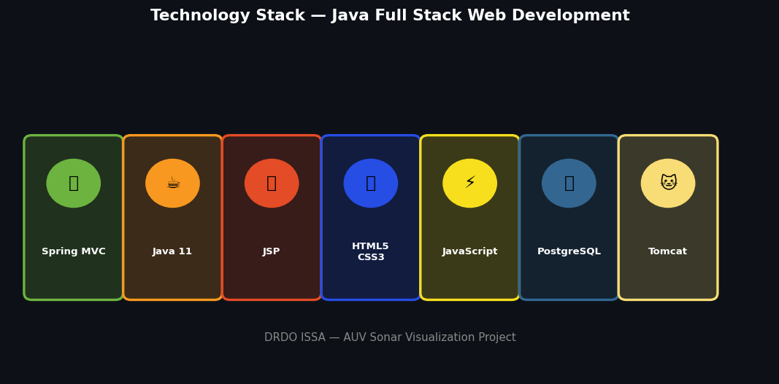
Figure: Technology Stack — Java Full Stack Tools Used in the Project

3.2 Spring MVC Framework
Spring MVC is a component of the Spring Framework that implements the Model-View-Controller (MVC) design pattern for web application development. In this project, Spring MVC served as the backbone of the server-side architecture. The DispatcherServlet handled all incoming HTTP requests, routing them to the appropriate @Controller classes. The controller layer processed business logic and data retrieval, passing model objects to JSP views for rendering. Spring MVC's clean separation of concerns significantly improved code maintainability and testability throughout the project.
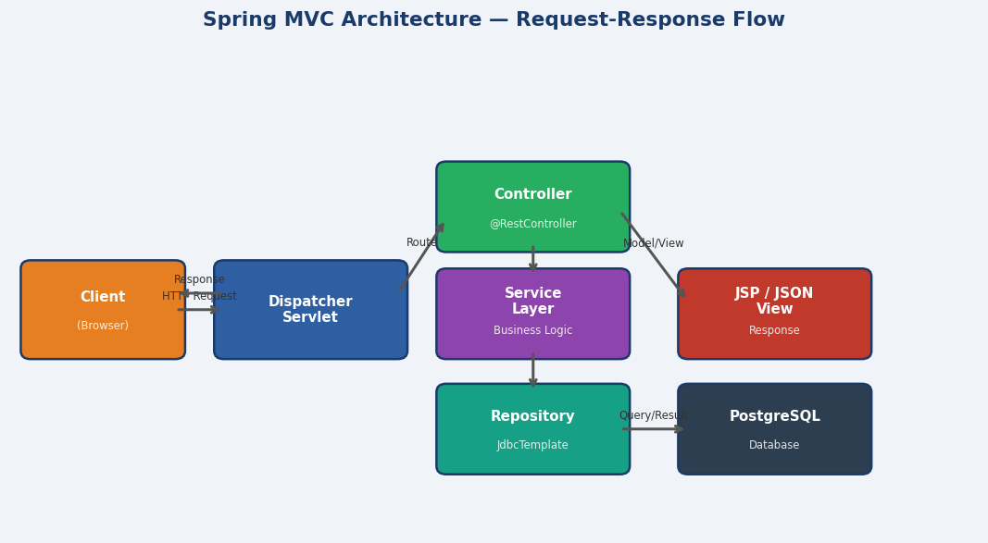
Figure: Spring MVC Architecture — Request-Response Flow

3.3 Java & Servlets
Java 11 was used as the primary server-side programming language. The strong typing, object-oriented architecture, and extensive library support of Java made it well-suited for implementing the data processing and business logic layers. Java Servlets underpinned the Spring MVC request handling pipeline, with the DispatcherServlet acting as the central front controller for all web requests.

3.4 HTML5, CSS3, JavaScript
The frontend of the visualization tool was built using HTML5 for structural markup, CSS3 for styling and layout, and vanilla JavaScript for all dynamic functionality. The HTML5 Canvas API was the central technology for rendering the sonar display, enabling pixel-level control over the visualization of range rings, angular grid lines, and labeled data point markers. CSS3 provided the dark-themed, high-contrast interface appropriate for a defense operations display context.

3.5 PostgreSQL
PostgreSQL served as the relational database backend, storing simulated AUV sensor data including track identifiers, bearing angles, range values, and timestamps. JDBC was used to connect the Java backend to the PostgreSQL database, with Spring's JdbcTemplate simplifying query execution and result set mapping. The database schema was designed to efficiently support the query patterns required by the visualization tool.
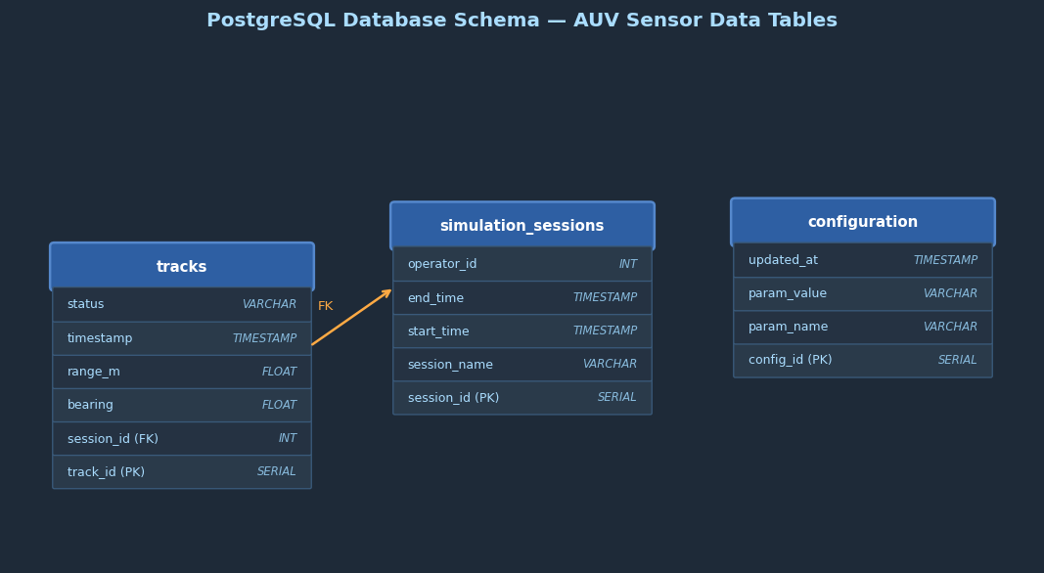
Figure: PostgreSQL Database Schema — Primary Tables
CHAPTER 4

SYSTEM ARCHITECTURE AND DESIGN

CHAPTER 4: SYSTEM ARCHITECTURE AND DESIGN

4.1 Architectural Overview
The system follows a classic three-tier MVC web architecture. The presentation layer (View) consists of JSP pages and JavaScript-driven Canvas rendering on the client side. The business logic layer (Controller/Model) is implemented using Spring MVC controllers and Java service classes. The data layer consists of PostgreSQL database accessed via JDBC and Spring's JdbcTemplate.
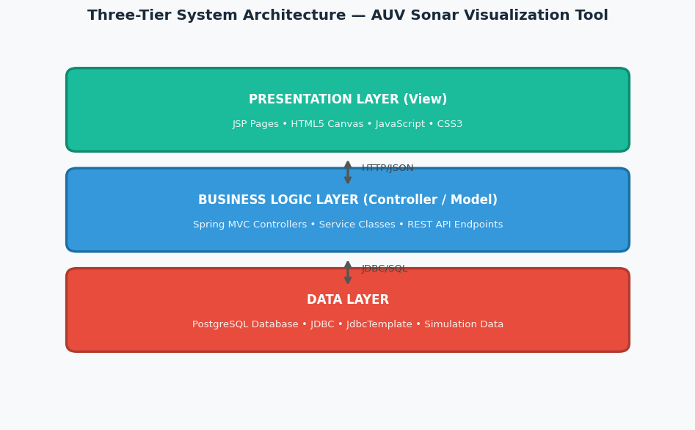
Figure: Three-Tier System Architecture

4.2 Frontend Architecture
The frontend is centered on an HTML5 Canvas element that serves as the primary sonar display surface. JavaScript handles all rendering operations including:
- Drawing concentric range rings at configurable distance intervals (200 m, 400 m, 600 m, 800 m)
- Rendering angular grid lines representing bearing directions from the AUV's reference heading
- Plotting data point markers at correct positions derived from bearing and range values
- Displaying labeled TRACK INFO panels with bearing and range readouts for each tracked contact
- Handling user interactions such as zoom, pan, and data selection

4.3 Backend Architecture
The backend uses Spring MVC's @RestController to expose RESTful JSON endpoints that supply sensor data to the frontend. The service layer retrieves simulated track records from PostgreSQL and formats them as JSON responses. The DispatcherServlet routes requests, and Spring's dependency injection manages service and repository component lifecycles. Apache Tomcat serves as the web application server.

4.4 Database Design
The PostgreSQL schema was designed with the following primary tables: a Tracks table storing individual sensor contact records with fields for track ID, bearing (degrees), range (meters), timestamp, and status; a Simulation Sessions table linking track records to specific simulation runs; and a Configuration table storing display parameters and system settings.

4.5 Communication Flow
The data flow in the system proceeds as follows: the browser loads the main JSP page served by Tomcat through Spring MVC. JavaScript on the client issues periodic AJAX GET requests to the Spring REST endpoints. The controller retrieves the latest simulated sensor data from PostgreSQL and returns it as a JSON array. The JavaScript parsing function converts the JSON into display coordinates and renders updated track positions and annotations on the Canvas element.
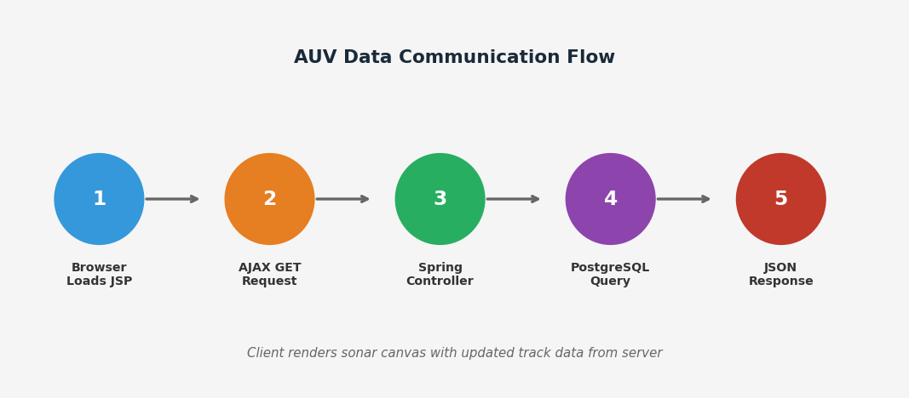
Figure: AUV Data Communication Flow — Browser to Database
CHAPTER 5

AUV SONAR VISUALIZATION TOOL — DESIGN AND DEVELOPMENT

CHAPTER 5: AUV SONAR VISUALIZATION TOOL — DESIGN AND DEVELOPMENT

5.1 Tool Overview
The core deliverable of this internship is a web-based sonar visualization tool designed to simulate the kind of sensor display used by operators monitoring Autonomous Underwater Vehicle (AUV) missions. The tool provides a clear, interactive graphical representation of sonar tracking data, replicating the look and functionality of a real-time sonar operator console in a browser environment.

The tool renders a fan-shaped sonar scanning area from the AUV's position, displaying all simulated contacts (tracked underwater objects) within the sensor's range, along with their bearing, range, and track identifier. The display shown below illustrates the implemented visualization panel:

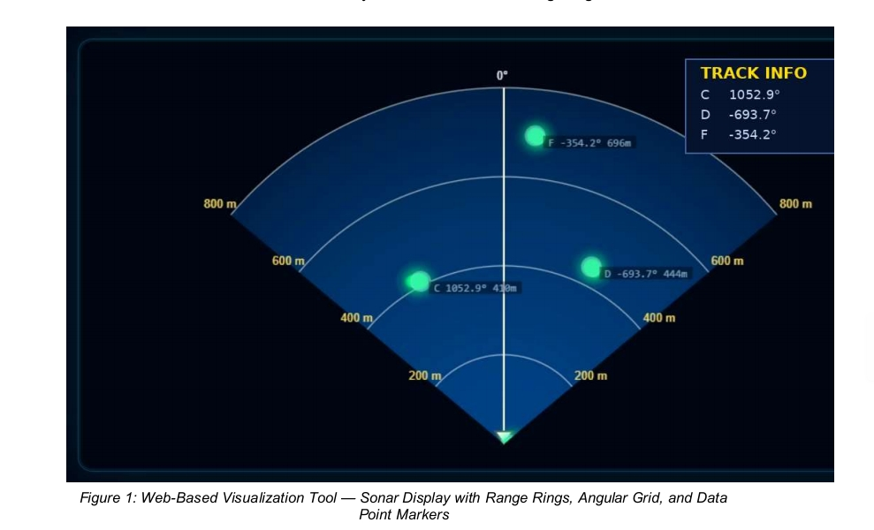
Figure 1: Web-Based Visualization Tool — Sonar Display with Range Rings, Angular Grid, and Data Point Markers

5.2 Range Ring and Angular Grid Rendering
The sonar display is rendered on an HTML5 Canvas using JavaScript. Concentric semi-circular range rings are drawn at uniform distance intervals — 200 m, 400 m, 600 m, and 800 m — from the AUV position at the base of the display. These rings provide operators with immediate spatial reference for estimating contact distances.

Angular grid lines radiate from the AUV position at regular bearing intervals, dividing the sonar fan into sectors that correspond to directional headings. A central vertical line represents the 0° forward heading of the vehicle. The grid is rendered with a subdued blue color scheme to maintain visual clarity while avoiding interference with the bright contact markers.

5.3 Track and Data Point Markers
Each simulated sonar contact is represented by a glowing circular marker rendered at the correct position on the Canvas, calculated from the contact's bearing (in degrees) and range (in meters) using standard polar-to-Cartesian coordinate conversion. Each marker is labeled with its track identifier (e.g., C, D, F) and numerical bearing and range values.

A TRACK INFO panel in the upper-right of the display provides a summarized readout of all active contacts and their latest bearing measurements, allowing operators to monitor all tracks simultaneously without needing to inspect each marker individually.

5.4 Dynamic Data Rendering
The visualization tool was designed to support dynamic, near-real-time data updates. At configurable polling intervals, the frontend JavaScript issues AJAX requests to the Spring MVC backend REST endpoint, retrieves the latest simulated sensor data in JSON format, and re-renders all contact positions on the Canvas. This creates a smooth, updating display that replicates the behavior of a live AUV sensor feed.

5.5 Layer and Color Management
The display uses a layered rendering approach, with the background, range rings, grid lines, and contact markers rendered in separate drawing passes. This approach allows individual layers to be selectively updated or hidden based on user preferences or operational context. The color scheme employs dark navy backgrounds with bright cyan/green markers and yellow range labels — consistent with standard sonar display conventions used in operational systems.
CHAPTER 6

SUPPORTING MODULES DEVELOPED

CHAPTER 6: SUPPORTING MODULES DEVELOPED

6.1 Data Configuration Module
A data configuration module was developed to allow administrators to adjust simulation parameters such as the number of simulated AUV tracks, their initial bearing and range values, update frequencies, and display thresholds. This module was implemented as a Spring MVC controller with a corresponding JSP configuration page, backed by the PostgreSQL Configuration table.

6.2 Entity Validation Module
An entity validation module was built to ensure the integrity of all sensor records entering the system. The module validates bearing values (0°-360°), range values (within maximum sensor range), track identifiers, and timestamp formats. Invalid records are flagged and logged without interrupting the main visualization stream.

6.3 Search and Filter Module
A search and filter module enables users to query historical simulation data, filter contacts by track ID, bearing range, or time window, and export filtered datasets for further analysis. This module was implemented as a set of Spring MVC REST endpoints with query parameter support and corresponding frontend UI controls.

6.4 Instructor / Admin Control Module
An instructor and administrative control module was developed to support training and demonstration scenarios. This module allows authorized users to inject specific simulated contacts into the live display, pause and resume simulation feeds, reset the display state, and configure alert thresholds for specific bearing and range zones. Access control was implemented using Spring Security basic authentication.
CHAPTER 7

CHALLENGES AND SOLUTIONS

CHAPTER 7: CHALLENGES AND SOLUTIONS

The development of the AUV sonar visualization tool presented several significant technical challenges. The following table summarizes the key challenges encountered and the solutions implemented:

Challenge | Solution
Accurate polar-to-Cartesian coordinate conversion for Canvas rendering | Implemented a dedicated coordinate transformation utility class accounting for canvas origin offset, scale factor, and north-up orientation conventions
Real-time display performance with frequent AJAX polling | Optimized Canvas rendering using requestAnimationFrame, incremental redraw, and client-side data caching to minimize full repaints
Spring MVC configuration and dependency management | Adopted Maven for dependency management; studied Spring MVC documentation extensively; resolved XML configuration conflicts through iterative debugging
Handling variable numbers of simulated tracks in JSON response parsing | Implemented a flexible JSON parsing function that dynamically creates marker objects based on array length rather than hardcoded track counts
Cross-browser Canvas rendering consistency | Tested and normalized rendering across Chrome, Firefox, and Edge; applied vendor-prefixed Canvas context settings where necessary
CHAPTER 8

LEARNINGS

CHAPTER 8: LEARNINGS

8.1 Technical Skills Gained
- Proficient use of the Spring MVC framework, including DispatcherServlet configuration, @Controller and @RestController annotations, ModelAndView, and Spring Security integration
- Design and implementation of RESTful APIs for structured JSON data communication between frontend and backend
- Advanced HTML5 Canvas API programming for complex, real-time graphical rendering
- Full-stack Java web application development using JSP, JSTL, JDBC, and Apache Tomcat
- PostgreSQL database design, query optimization, and integration with Java via Spring JdbcTemplate
- Professional use of Git for version control, branching, and collaborative development
- Understanding of defense-grade software development standards and quality assurance practices

8.2 Professional Skills Gained
- Experience working within the structured, security-conscious environment of a premier defense research organization
- Effective communication of technical progress and challenges to senior scientists and mentors
- Ability to analyze operational requirements and translate them into practical software solutions
- Time management and task prioritization within a structured internship programme with defined deliverables
- Understanding of documentation standards and report writing appropriate for professional and academic submission
CHAPTER 9

CONCLUSION

CHAPTER 9: CONCLUSION

9.1 Summary
This internship at ISSA, DRDO provided a comprehensive and invaluable experience in the design and development of a full-stack Java web application for simulated AUV sonar sensor visualization. The primary deliverable — a Spring MVC-based web tool rendering dynamic sonar displays with range rings, angular grids, and labeled contact markers — was successfully designed, developed, and tested within the internship period.

The project successfully demonstrated the application of modern Java web development techniques to a defense-relevant visualization problem, bridging academic knowledge of software engineering principles with the practical requirements of a professional research environment. The Spring MVC framework proved to be a robust and well-structured choice for this type of application, providing clean separation of concerns and scalable architecture.

9.2 Future Scope
Several directions for future enhancement of the system were identified during the internship:
- Integration with live AUV telemetry data feeds replacing the current simulated PostgreSQL data source
- Implementation of WebSocket-based real-time communication to replace AJAX polling and achieve true low-latency display updates
- Addition of 3D sonar visualization capabilities using WebGL for volumetric underwater environment rendering
- Multi-AUV display support allowing simultaneous tracking of multiple vehicle platforms and their sensor fields
- Integration of machine learning-based target classification modules to automatically label and prioritize detected contacts
- Migration to a Spring Boot deployment model for simplified configuration and containerized cloud deployment
CHAPTER 10

BIBLIOGRAPHY AND REFERENCES

CHAPTER 10: BIBLIOGRAPHY AND REFERENCES

1. Spring Framework Documentation — Spring MVC Reference Guide, Version 5.3. Pivotal Software, 2023. https://docs.spring.io/spring-framework/docs/current/reference/html/web.html

2. Hunter, J., & Crawford, W. (2001). Java Servlet Programming, 2nd Edition. O'Reilly Media.

3. Walls, C. (2022). Spring in Action, 6th Edition. Manning Publications.

4. Mozilla Developer Network (MDN). HTML Canvas API Documentation. https://developer.mozilla.org/en-US/docs/Web/API/Canvas_API

5. PostgreSQL Global Development Group. PostgreSQL 14 Documentation. https://www.postgresql.org/docs/14/

6. DRDO Annual Report 2022-23. Ministry of Defence, Government of India, New Delhi.

7. Burdic, W. S. (1991). Underwater Acoustic System Analysis, 2nd Edition. Prentice Hall.

8. Cheng, C., & Bhatt, D. (2019). AUV Sensor Fusion and Visualization Techniques for Underwater Target Tracking. International Journal of Naval Architecture and Ocean Engineering, 11(2), 745-758.

9. Gamma, E., Helm, R., Johnson, R., & Vlissides, J. (1994). Design Patterns: Elements of Reusable Object-Oriented Software. Addison-Wesley.

10. Git — Version Control System. Official Documentation. https://git-scm.com/doc
CHAPTER 11

VIKRAMADITYA NAVAL SYSTEM ANALYSIS — FIELD NOTES

CHAPTER 11: VIKRAMADITYA NAVAL SYSTEM ANALYSIS — FIELD NOTES
Dated: 9 January 2025 | Front-Looking Sonar Module

11.1 Plan Mission
The Plan Mission module includes a Mission sub-section with the following flow:
• Mission → Mark AOP → Save Mission
• After Save → Disable/Mark AOP; everything on Mission Window
• Disable Mission Submenu → Display additional options on Top Panel
• Show DB / Use Database integration for mission data

11.2 Entities
• Remove unnecessary ships from the database
• Validation check for speed: OK if speed is within range; flag if Max Speed is not available in DB

11.3 Mines (Max: 150)
• Maximum number of mines to be fixed (cap: 150)
• 0 (zero) number of mines should not be allowed for minefield creation
• Modify Mines: On changing only the number of mines, the scenario is not updated — Bug to be fixed

11.4 Dynamic Obstacles
• Modify → Same problem as Mines (scenario not updated on change)

11.5 Save Data
• Save Data functionality to be implemented and verified

11.6 Instructor Module
Edit Mission → Disable the following options:
• Launch Point
• Retrieve Point
• Save as Draft
• Fill transparent color in MGZ and FLS zones

11.7 Trance — Search Area
• Modify: If new location is not allowed (overlap), a message is displayed but the marker disappears — Bug
• Overlapped Search Area (SA) is being saved in DB — should not be saved
• Fix: If error occurs, do not change the SA location in DB (rollback on validation failure)

11.8 Additional Notes
• Panel: Merged MPS (latest workspace)
• Console debugging from Sonar Radar module
• Sector 56 module integration noted for further analysis

