SOFTWARE ENGINEERING LAB

BCSE301P

L15 + L16

PROJECT REPORT

SUBMITTED BY:
ANKIT RAJ
23BCE1298

Table of Contents
- Problem Statement
- Objectives
- Methodology / Approach
- Work Completed So Far (50% Implementation)
- Screenshots / Proof of Implementation
- GitHub Repository Link

1. Problem Statement
Tourists visiting the North-Eastern region of India often face significant difficulty accessing reliable safety information, emergency support, and real-time guidance in unfamiliar and remote terrains. The region's unique geography—comprising mountains, dense forests, valleys, and border zones—presents additional challenges for tourist safety and emergency response.
Existing systems for tourist monitoring, incident reporting, and identity verification are fragmented and lack technological integration. Currently, there is no unified platform that:
- Authenticates tourists using secure digital identities
- Monitors their safety through geo-fencing and AI-based tracking
- Detects potential threats or anomalous behaviour patterns
- Facilitates rapid communication with police and tourism authorities
Impact of the Problem:
Due to the absence of such an ecosystem:
- Tourists struggle to receive timely alerts in high-risk zones
- Authorities lack real-time visibility of tourist movements, distress incidents, or missing cases
- Manual monitoring is inefficient, especially in remote areas
- Emergency response is delayed due to lack of coordinated information
- Trust in tourism infrastructure is compromised
This highlights the critical need for an integrated, intelligent, and secure system to ensure tourist safety, enhance emergency responsiveness, and strengthen confidence in the region's tourism infrastructure.

2. Objectives
Based on the problem statement analysis, the following objectives have been established for T.R.A.I.L.:
Primary Objectives:
S.No | Objective | Description
1 | Digital Tourist Identity System | Create a secure digital identity for each tourist that can be verified across the platform, enabling authentication and tracking.
2 | Real-Time Safety Monitoring | Implement geo-fencing technology to monitor tourist movements and detect entry/exit from safe zones, restricted areas, or high-risk locations.
3 | AI-Based Anomaly Detection | Develop machine learning algorithms to identify unusual behavior patterns that may indicate distress, danger, or emergency situations.
4 | Unified Alert System | Create a centralized alert mechanism that notifies relevant authorities (police, medical, forest department) based on incident type and location.

Secondary Objectives:
S.No | Objective | Description
5 | Multi-Agency Coordination Hub | Enable seamless communication and data sharing between different response agencies (police, hospitals, forest department, disaster response).
6 | Incident Timeline Generation | Automatically create chronological records of incidents for investigation and analysis purposes.
7 | Resource Optimization | Use AI to recommend optimal deployment of response teams based on incident priority and resource availability.
8 | Analytics Dashboard | Provide authorities with data-driven insights about tourist patterns, risk zones, and response effectiveness.

3. Methodology / Approach
The development of T.R.A.I.L. follows a structured, phased approach combining agile methodology with iterative testing and feedback integration.
Development Phases:
Phase 1: Requirements Analysis & Planning (Completed)
- Studied SIH problem statement 25002 in detail
- Analyzed existing gaps in tourist safety systems
- Identified key stakeholders (tourists, police, hospitals, forest department)
- Defined technical architecture and technology stack
- Created wireframes and UI/UX designs
Phase 2: Core Architecture & Frontend Development (50% Completed - Current Phase)
- Established project structure and component hierarchy
- Developed responsive web dashboard interface
- Implemented 10 core modules with navigation
- Created visualization components for maps and charts
- Integrated font icons and styling framework
Phase 3: Backend & Database Integration (Upcoming)
- Set up user authentication and role-based access
- Implement real-time database for incident tracking
- Create APIs for mobile app communication
- Develop data persistence for geofencing

Phase 4: Mobile App Development (Upcoming)
- Build tourist-facing mobile application
- Implement GPS tracking and geo-fencing
- Create emergency alert functionality
Technology Stack:
Component | Technology Used
Frontend (Web) | HTML5, CSS3, JavaScript, Font Awesome Icons, Google Fonts (Inter)
Maps & Visualization | Google Maps API, Heatmap Layer, Drawing Library, Geometry Library
Charts & Analytics | Chart.js Library
Version Control | Git, GitHub

4. Work Completed So Far (50% Implementation)
A. User Interface & Navigation
- Responsive sidebar navigation with active page highlighting
- Hamburger menu toggle for mobile responsiveness
- Search bar functionality for incident lookup
- User profile section with role-based display
- Notification badge system
B. Mapping & Geofencing
- Google Maps integration with Northeast India focus
- Heatmap visualization showing tourist density
- Drawing tools for creating custom geofences
- Geofence persistence using local storage
- Export/import of geofences as GeoJSON
- Color-coded risk zones (High/Medium/Safe)
C. Data Visualization
- Interactive incident trends line chart (Chart.js)
- Response time distribution bar chart
- Real-time hotspot list with weight indicators
- Agency summary cards with status indicators
D. Alert Management
- AI-powered alert prioritization
- Critical/high/filtered alert categorization
- Alert cards with metadata (location, time, source)
- One-click dispatch buttons

E. Case & Evidence Management
- Case summary with critical/active/resolved counts
- Recent cases table with search and filter
- Auto-generated e-FIR form with tourist information
- Digital and physical evidence tracking
- Blockchain-verified chain of custody display
F. Resource Management
- Real-time resource inventory (police, medical, rescue, forest)
- AI deployment recommendations with confidence scores
- ETA calculations and priority-based recommendations
- Response time metrics and success rate tracking
G. Drill Management
- Upcoming drill schedule with leads and dates
- Past drill logs with after-action reports
- Drill readiness metrics (personnel, equipment)
- Quick action buttons for drill coordination
H. Cross-Agency Integration
- Hospital connectivity with bed availability
- Disaster response unit tracking
- Forest department ranger monitoring
- Security agency status updates
- Communication channel monitoring

I. Analytics & Reporting
- KPI cards with trend indicators
- Incident trends analysis
- Top incident types breakdown
- Export functionality (CSV, reports)
J. Configuration & Settings
- User account management
- Notification preferences
- AI threshold configuration
- Auto-dispatch controls
- Integration management

5. Screenshots / Proof of Implementation
Screenshot 1: Dashboard Overview
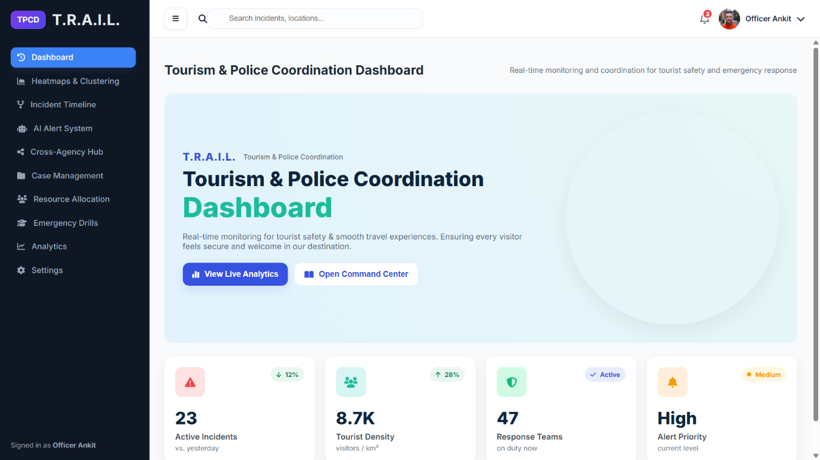
Screenshot 2: Heatmaps & Geofencing
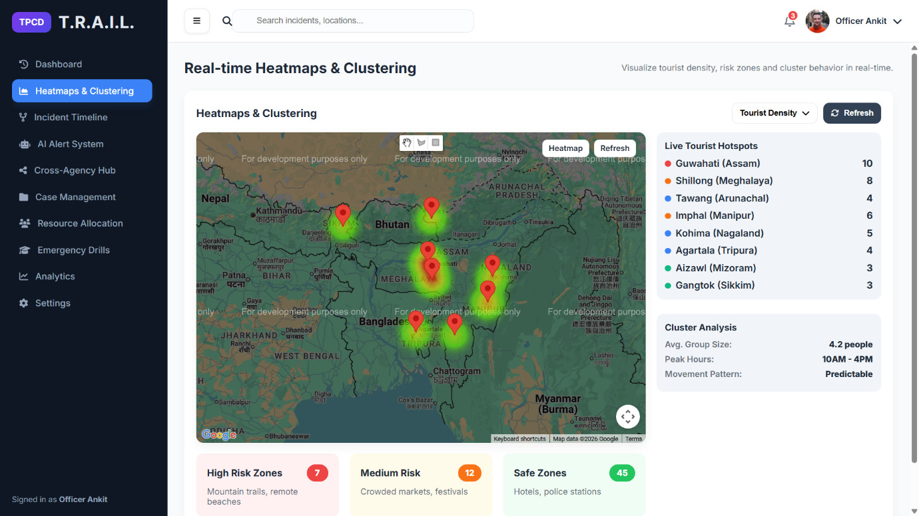

Screenshot 3: Incident Timeline
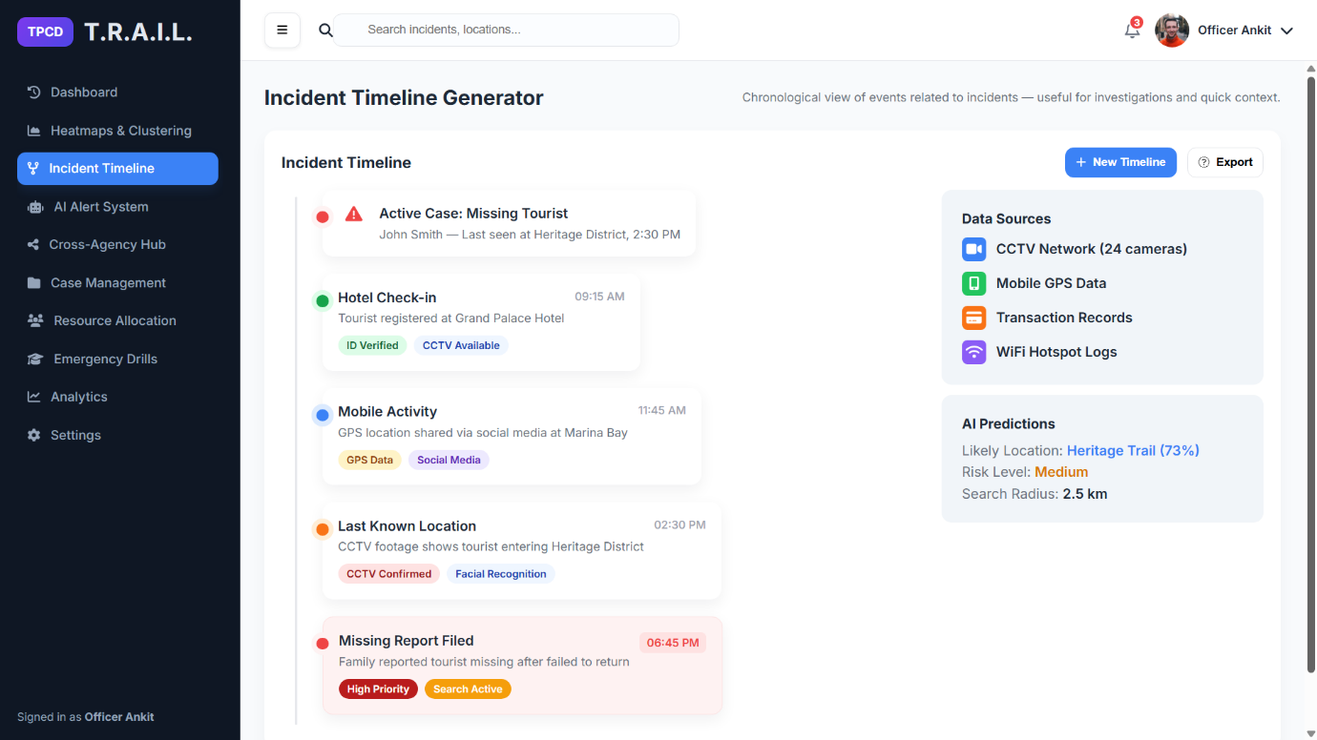
Screenshot 4: AI Alert System
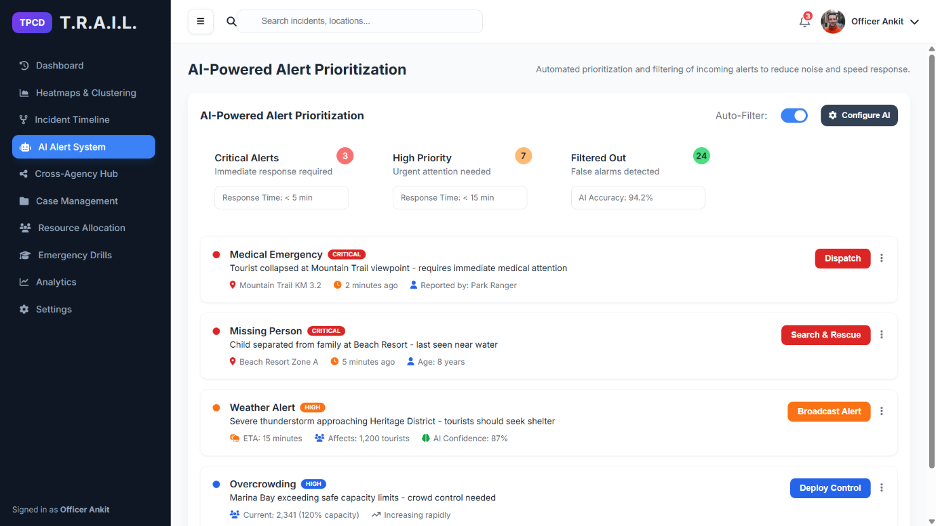

Screenshot 5: Cross-Agency Hub
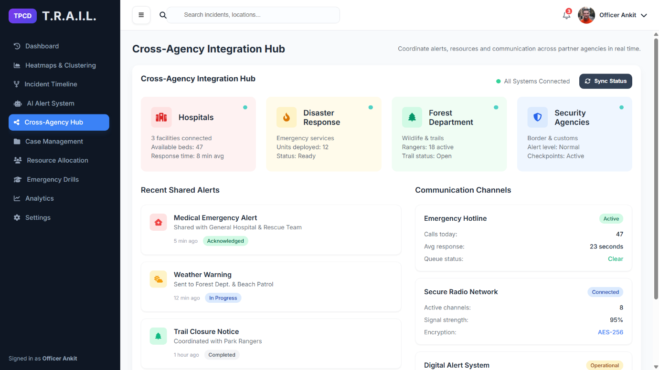
Screenshot 6: Case Management
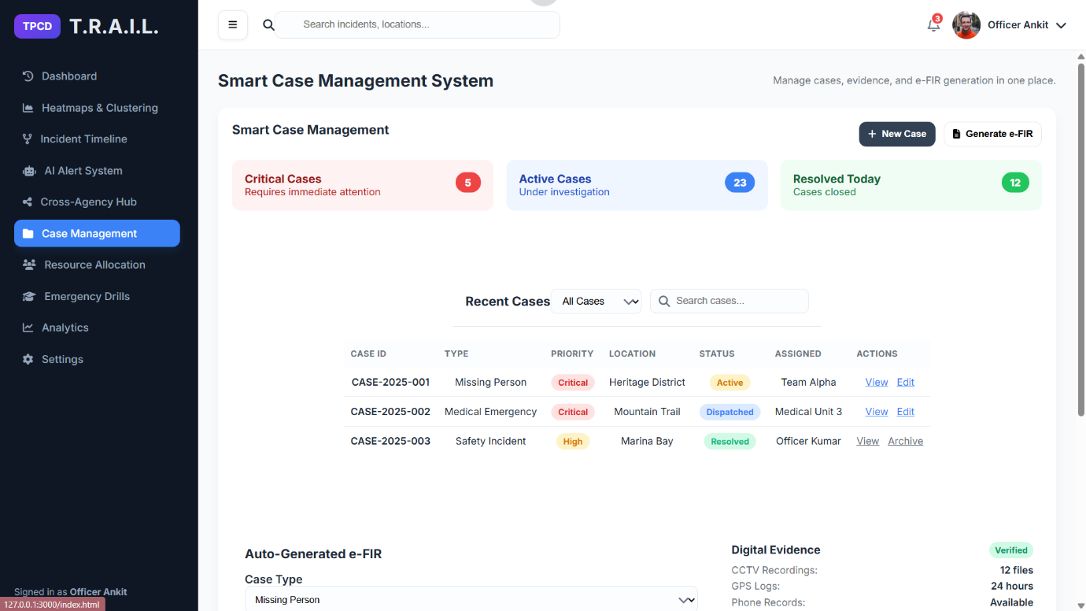

Screenshot 7: Resource Allocation
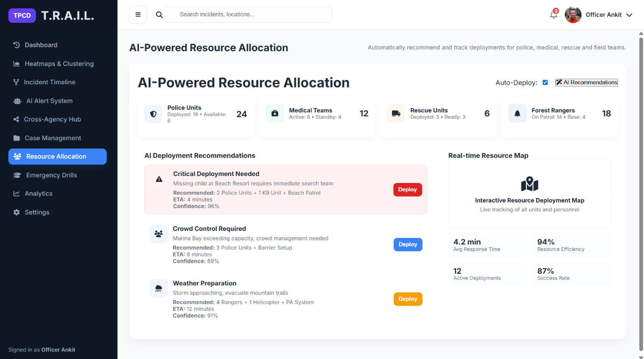
Screenshot 8: Emergency Drills
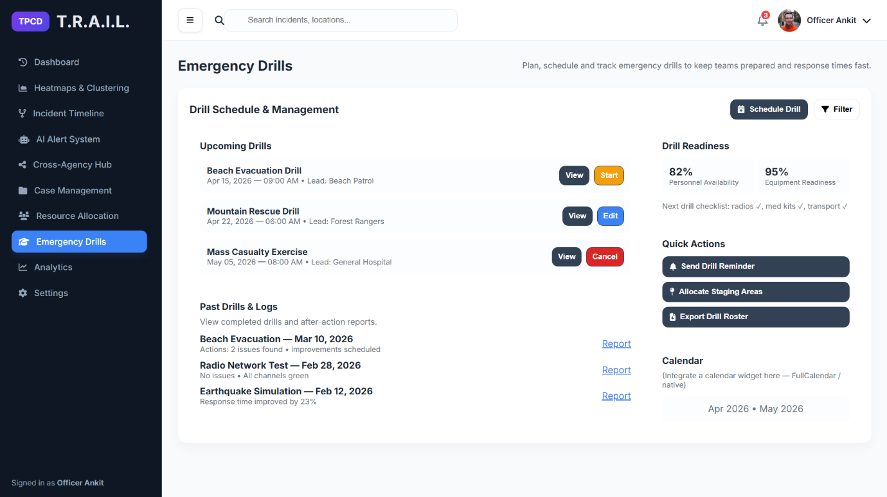

Screenshot 9: Analytics
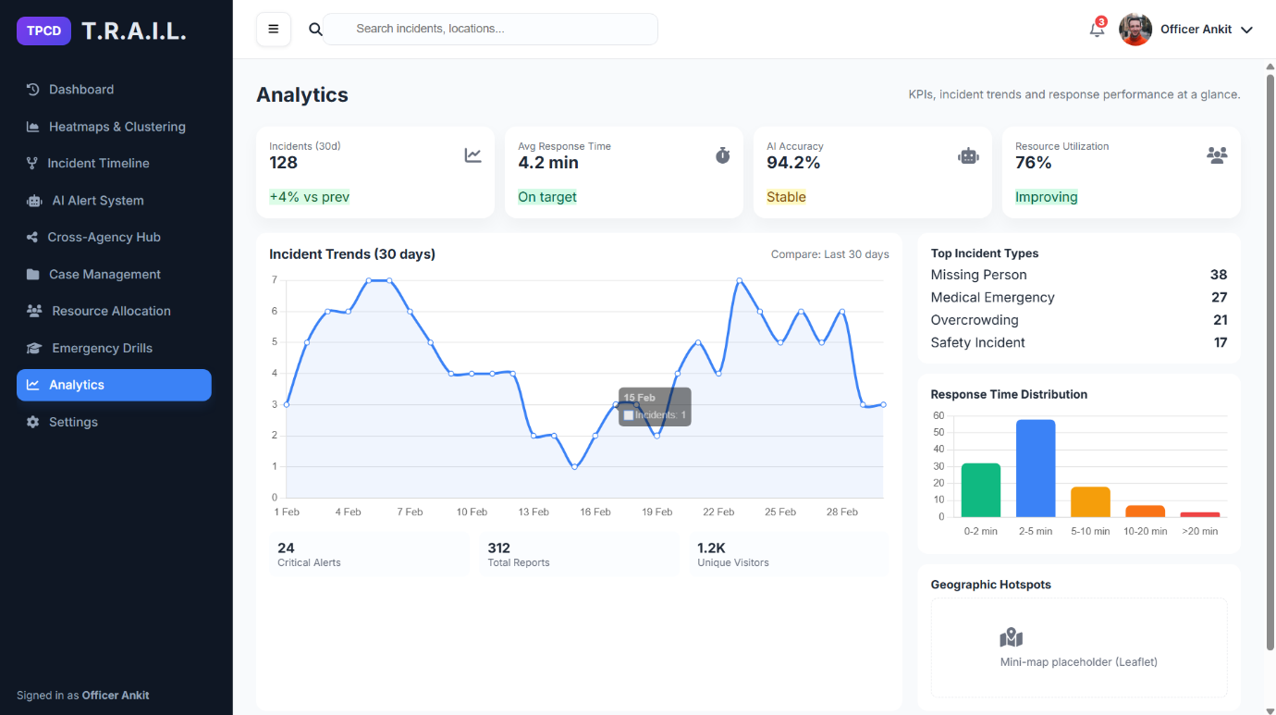
Screenshot 10: Settings
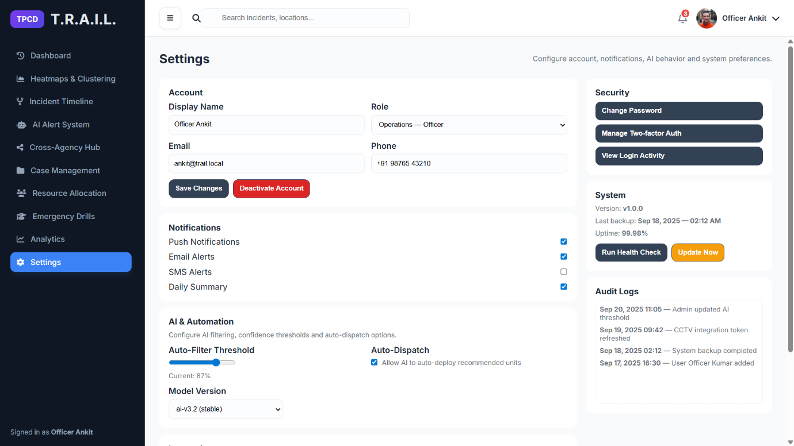

6. GitHub Repository Link
The complete source code for T.R.A.I.L. is available on GitHub:
https://github.com/ankitraj23bce1298/D2_23BCE1298_AnkitRaj

