SOFTWARE ENGINEERING LAB

BCSE301P

L15 + L16

PROJECT REPORT

SUBMITTED BY:
ANKIT RAJ
23BCE1298

Table of Contents
- Project Title
- Abstract
- Background
- Proposed System
- System Architecture
- Protocol Stack
- Testbed/Experimental Setup
- 100% Implementation

1. Project Title
T.R.A.I.L. (Tourist Risk Analytics & Incident Live-Response):
An Integrated AI-Based System for Tourist Safety and Real-Time Emergency Response
2. Abstract
Safety of the tourists at places which are remote and unsafe is still a major concern as these places do not get real-time monitoring. Moreover, emergencies are not responded to on time, and there is no integrated communication between the tourists and authorities. Intelligent Safety Solutions: Existing systems lack the reliability, intelligence and proactivity to protect people.
The project T.R.A.I.L. (Tourist Risk Analytics & Incident Live-Response) consists of an integrated system for tourists and the authorities comprising a mobile app and a dashboard respectively. Through leveraging artificial intelligence and geolocation tracking, the system has made use of qr-based identification to enhance the situational awareness and thereby a faster response to emergencies.
A mobile app to enable tourists for secure KYC verification, registration and tracking of luggage with QR codes, real-time tracking and SOS application for emergency services. Moreover, individuals can handle family groups and gain safety insights based on their location.
In contrast, the authority dashboard gives you the ability to monitor in real time, AI-based alert prioritisation, incident tracking, resource allocation and inter-agency. This guarantees quick decision-making by the authorities based on reliable data.
The system proposed improves the tourist’s safety and lowers the response time. It will create trust in tourism infrastructure which is not geographically feasible.
3. Background
Tourism is the most important activity which generates income in an area in the modern context. Safeguarding tourists in inaccessible areas like forests, mountains, and border regions becomes a challenging task. The tourists face issues the unavailability of a reliable guide at the location, a delayed emergency response and a lack of safety-related information.
The existing systems for tourist monitoring and incident management are highly fragmented and manual, making it difficult for the authorities to effectively track real-time situations. A centralised system that combines tourist identity verification system and geo-tracking, anomaly detection, emergency communication is missing. As a result, response times usually get delayed and crucial situations go unnoticed.
The problem ID 25002 of SIH talks about a single intelligent system that can work for a tourist’s safety using different technologies. This will require secure digital identity solutions, real-time monitoring, AI-based risk detection, and coordination among multiple agencies.
The T.R.A.I.L. system is designed to link tourists and authorities and thus, fill the gaps that have emerged. Utilization of AI, geofencing, mobile apps, etc to develop a safer tourism framework for quick response through modern technology in tourists.
4. Proposed System
The system T.R.A.I.L. (Tourist Risk Analytics & Incident Live-Response), is designed to solve the problem of enhancing the tourist safety. It uses real-time monitoring, AI-based system which will analyse the problems and will improve the communication between the tourist and the authorities.
Unlike older systems that used to rely on manual reporting and tools were fragmented, this system gives a unified platform where it will combine the mobile application and a dashboard as the central authority.
Key Contributions
- Digital Identity of Tourist (KYC-Based Verification: Each user has to finish a verification process before they can access the system. This ensures that there is authenticity and helps the authorities in the identification of individuals during emergencies.
- Real-time Location: The system will monitor continuously to track the tourist’s live location using GPS, which enables the authorities to monitor their movement and helps to identify the various unsafe zones.
- AI-Based Detection of Risks: The system will analyse the location and behavioural patterns to detect the anomalies and can generate alerts based on it. The alerts are then classified into various groups to reduce unnecessary noise and to improve the efficiency of the response.
- QR-Based tracking of Luggage: Tourists have the option to register the luggage items and generate the QR for it. This helps in the identification of the luggage. It helps in tracking of the item, recovery and to verify the ownership of the luggage.
- Emergency SOS System: There is an option of SOS-system which Is basically a one-click feature that can allow the tourists to instantly contact nearby police stations, hospitals or any emergency contacts that they have listed.
- Family/Group Managing: Users have the option to create and manage different family groups, which can allow for a better coordination and can help in the tracking of group members.
- Authority Dashboard: Central authority can monitor the tourists, can view the heatmaps, track various incidents, allocate the resources that are present and can coordinate across various agencies using a centralized dashboard.
Complete Workflow of the System
- User will first login into the mobile app and then they will complete their KYC verification
- User’s location is then tracked in real-time
- Data is then processed and analysed for various risk detection
- Alerts are then generated based on it and then sent to various authorities
- Authorities can then monitor the data that is sent through dashboard and then take the required action
- In case of emergencies, users can trigger the SOS button for immediate call for help.
Novelty and Originality
- The system consists of integration of AI, Geo-based location tracking, Dashboard and Mobile-App in a single system.
- Real-time prediction of risks and prioritising the alerts that are generated
- Combination of tourist-side features (App) and authority-side control (dashboard) in a single system
- QR-based method for tracking the luggage which is integrated with the safety system.
This approach will ensure that there is a real-time safety mechanism unlike older ones
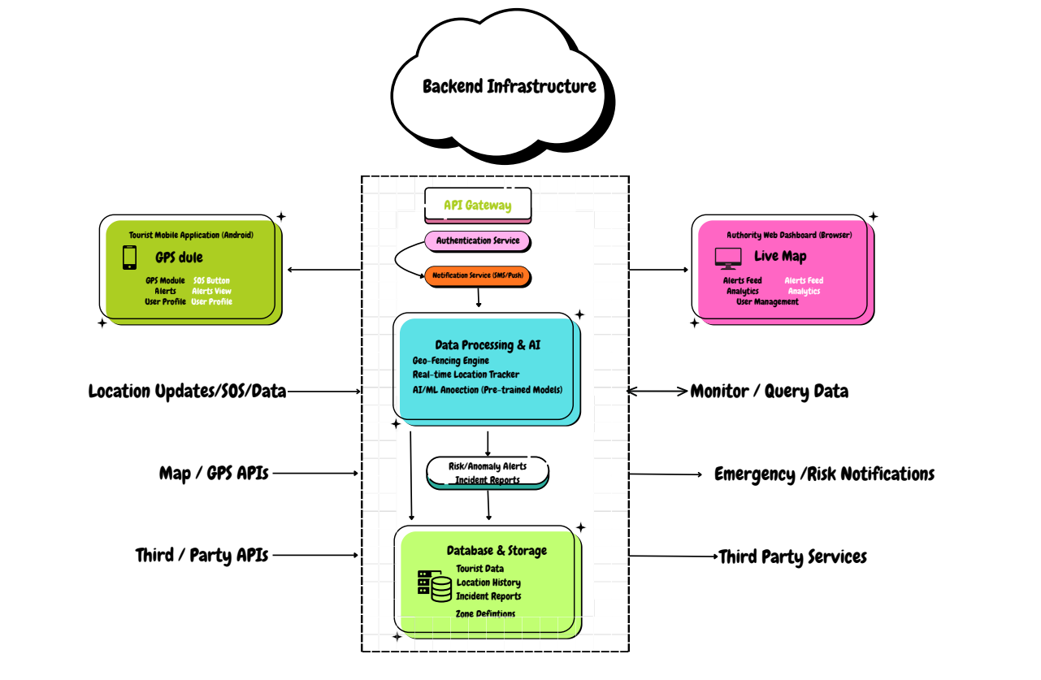
- System Architecture
- Protocol Stack
The T.R.A.I.L. follows a layered architecture model which is inspired from standard networking model. It ensures that there is standard and structured communication between various components.
The various layers that are present are:
- Application Layer
  - Mobile Application (What Tourist uses)
  - Web Dashboard (What authorities will use to manage the activities)
  - It handles the user interaction, visualization and the control part of it.
- Service Layer
  - Authentication (KYC, login, register)
  - QR-Code Processing for baggage
  - Handling of emergency SOS signals
  - Various logics and API Integrations
- AI & Analytics Layer
  - Algorithms to detect the risks
  - AI-based system for prioritising the alerts
  - Analyses the data is given and identifies certain patterns present there
- Data Layer
  - This stores the user profiles
  - Stores the location of the data
  - Contains the luggage details along with the QR
  - Contains the incident logs
- Network Layer
  - Manages the communication that is present between the app and the server.
  - Uses standard internet protocols for the transfer of the data
- Physical Layer
  - User phones (smartphones)
  - GPS sensors and various other sensorsServers and their infrastructures

- Testbed / Experimental Setup
The system that is developed here has been tested using a number of frontend technologies that is present as well as simulation data and mobile development tools.
Software Tools that were used are:
- React Native – this was used for developing the mobile application
- React.js (HTML, CSS, JavaScript) – It was used in the development of the dashboard (website)
- Supabase (initially) – This was used for the authentication service and for the backend services and storage of the data of the user and the baggage details.
- Google Maps API / Map Integration – This was used for assisting in the tracking of the location as well in the visualization of it.
Hardware Requirements
- Smartphone (Android/IOS) is required for the mobile app
- Laptop or Desktop is required for the dashboard and monitoring of it
- Internet Connectivity is required for some real-time features that are present.
Experimental Setup
- The mobile app that was developed was tested in the initial phase using a demo user environment first. The backend service was created after the testing.
- Static data was first used to simulate various features such as:
  - Tracking of the luggage
  - Safety scores
  - Various alert systems and their responses
- The dashboard present was tested locally to help to visualize:
  - Heatmaps that are present
  - Identification and tracking of various incidents
  - Allocation the various resources that are present

Observations
- Upon completion the system has finally shown:
  - Real-time updates of the UI
  - Smooth navigation between various pages and user interaction
  - Functional simulation of the safety features that are present
- The frontend-only setup that was present ensures that there is:
  - Relialble flow during the demonstration part
  - Independence of the frontend from various backend failures.
- 100% Implementation
The T.R.A.I.L. system has been implemented with all the modules functioning at the frontend level. The model demonstrates real-time interaction, with safety monitoring and emergency response through mobile application and web-based dashboard interface.
The following screenshots that have been provided are the representation of the current implementation and the working of the different modules
Screenshot 1: Dashboard Overview
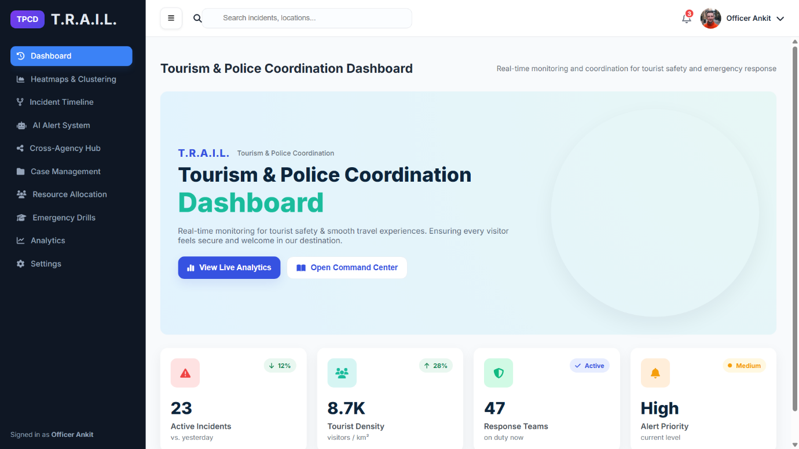

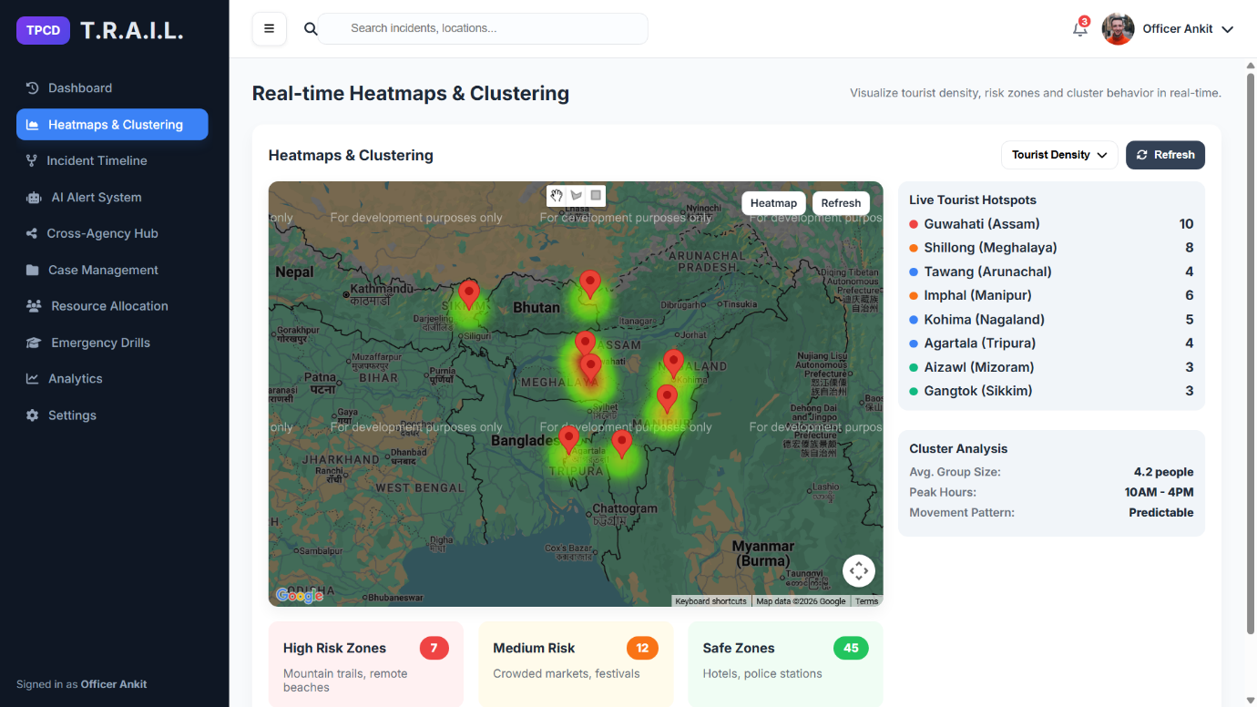
Screenshot 2: Heatmaps & Geofencing
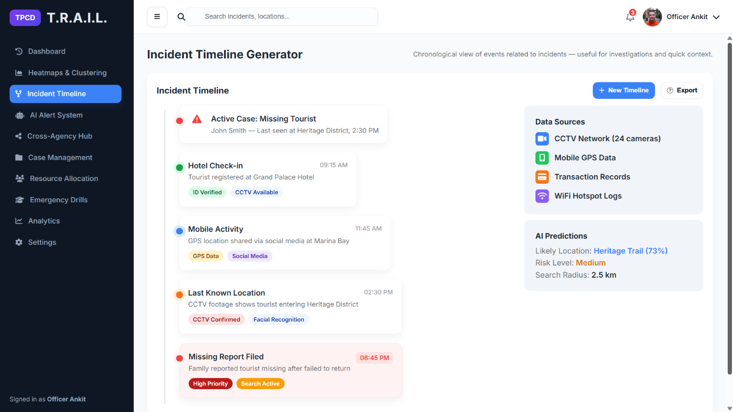
Screenshot 3: Incident Timeline
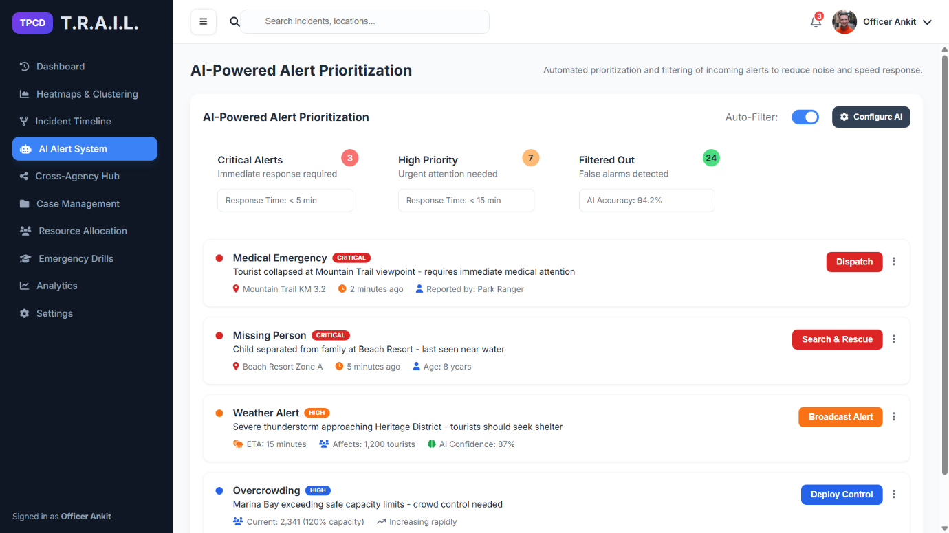
Screenshot 4: AI Alert System
Screenshot 5: Cross-Agency Hub
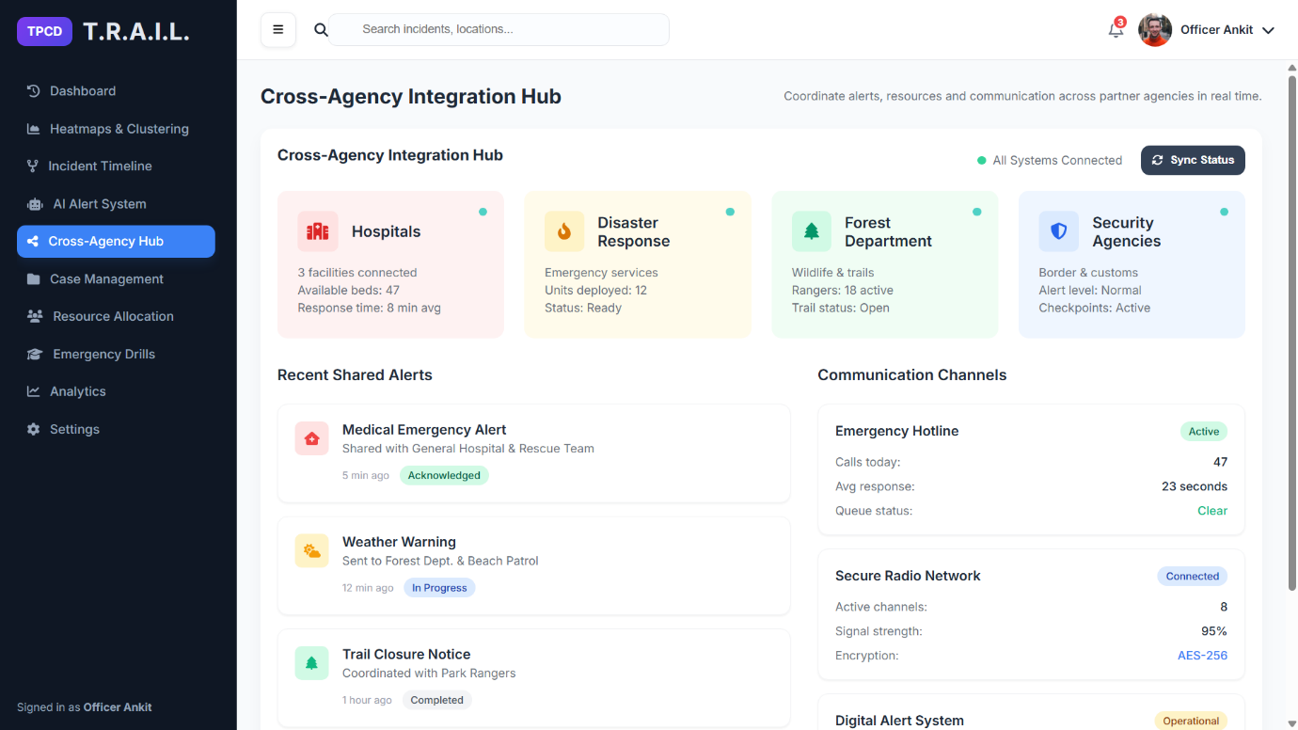
Screenshot 6: Case Management
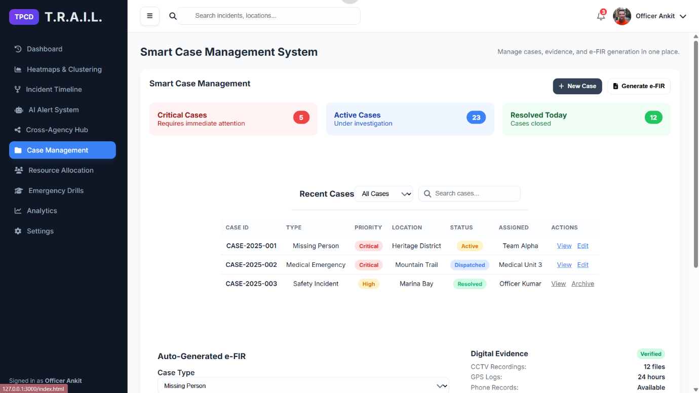

Screenshot 7: Resource Allocation
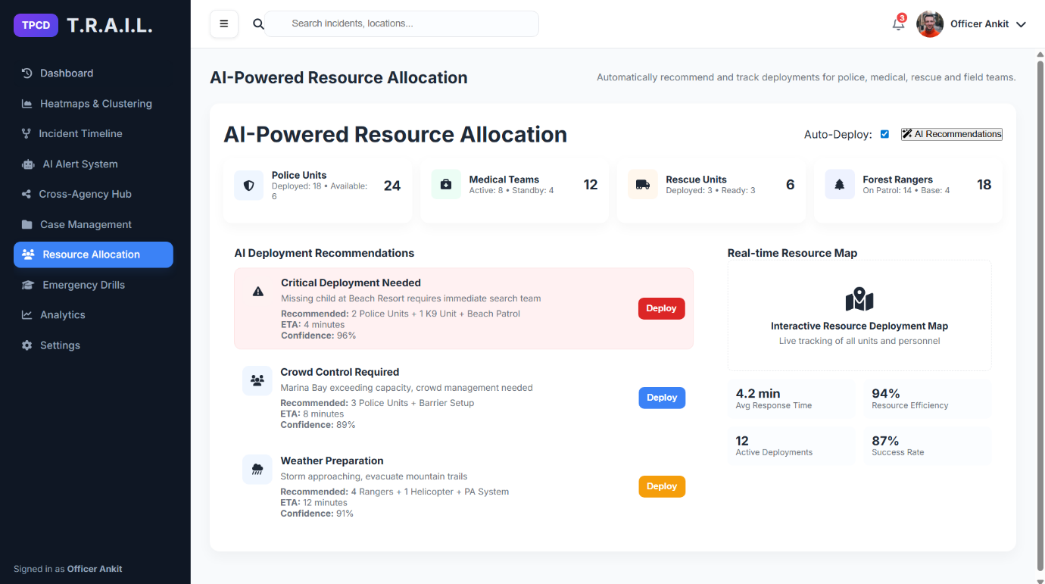
Screenshot 8: Emergency Drills
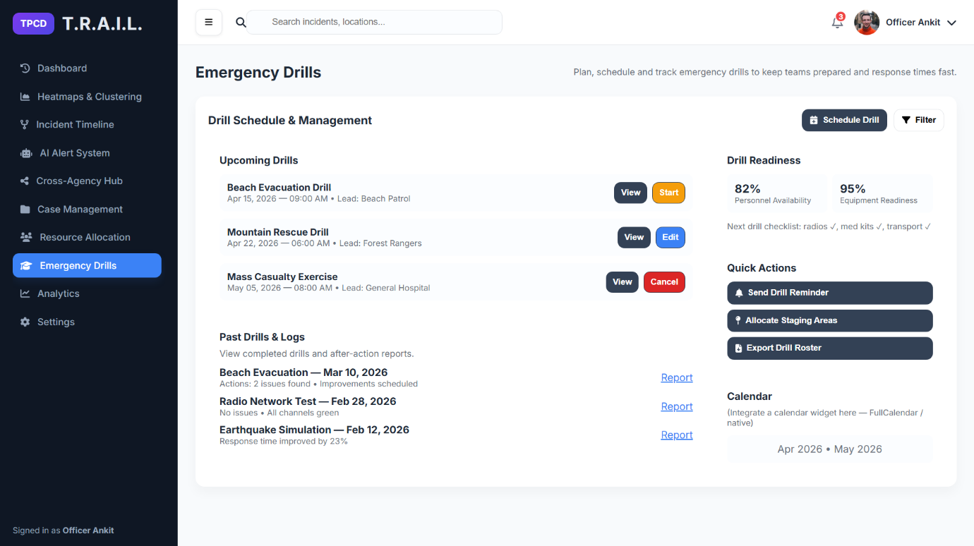

Screenshot 9: Analytics
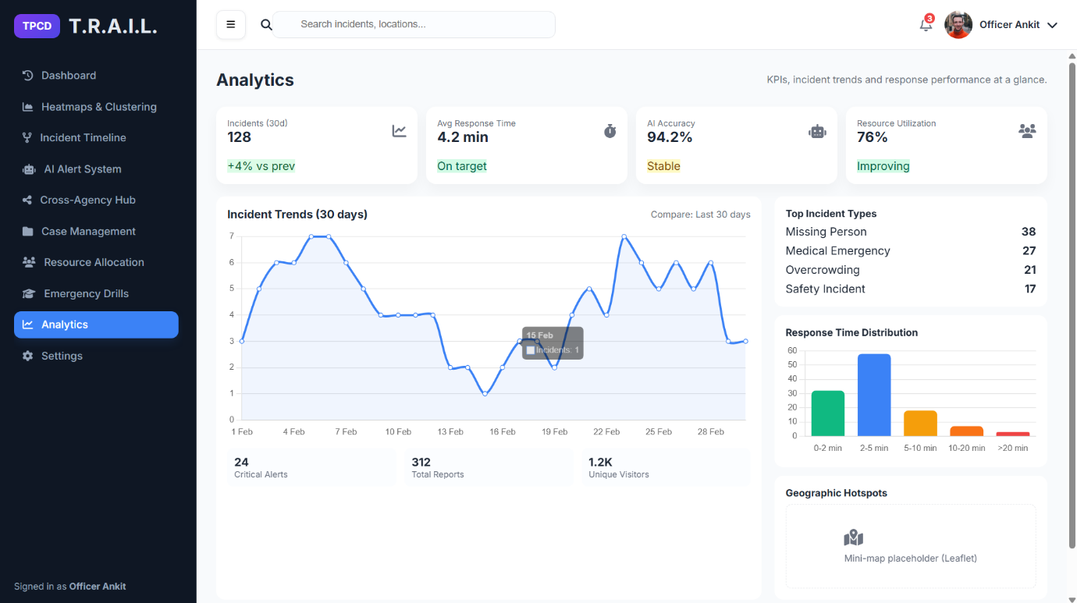
Screenshot 10: Settings
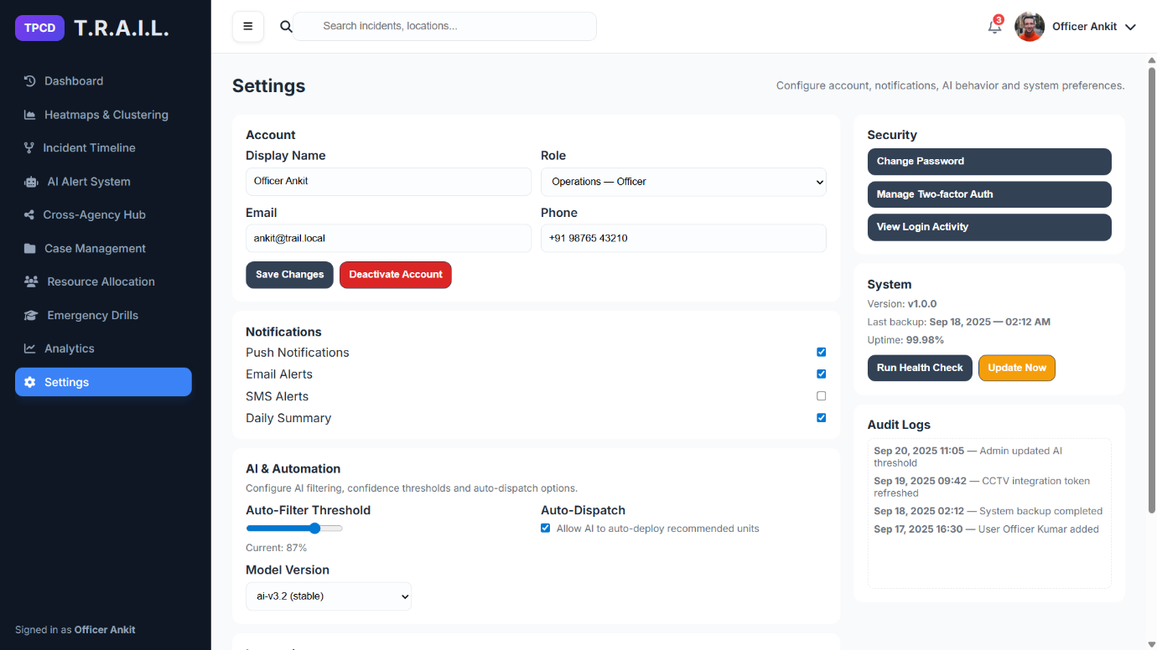

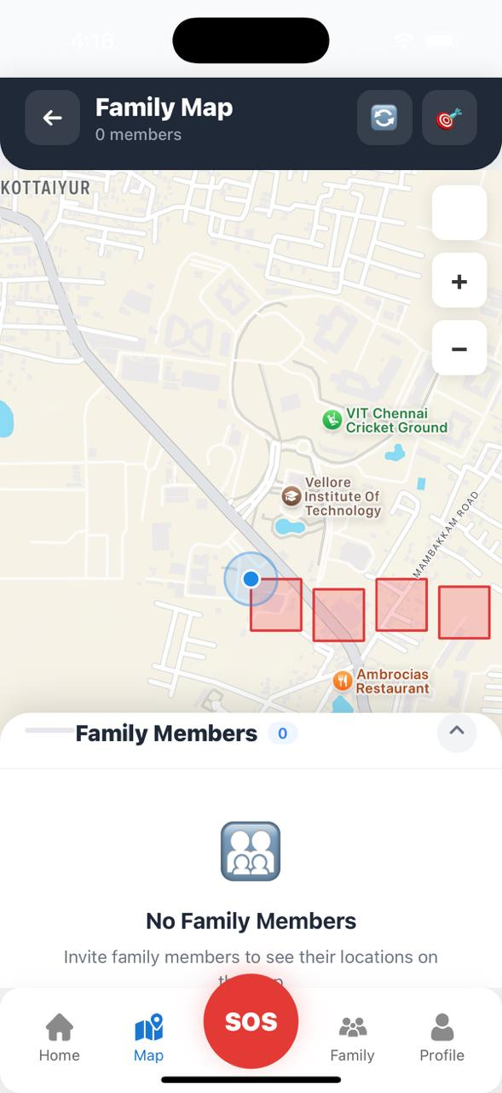
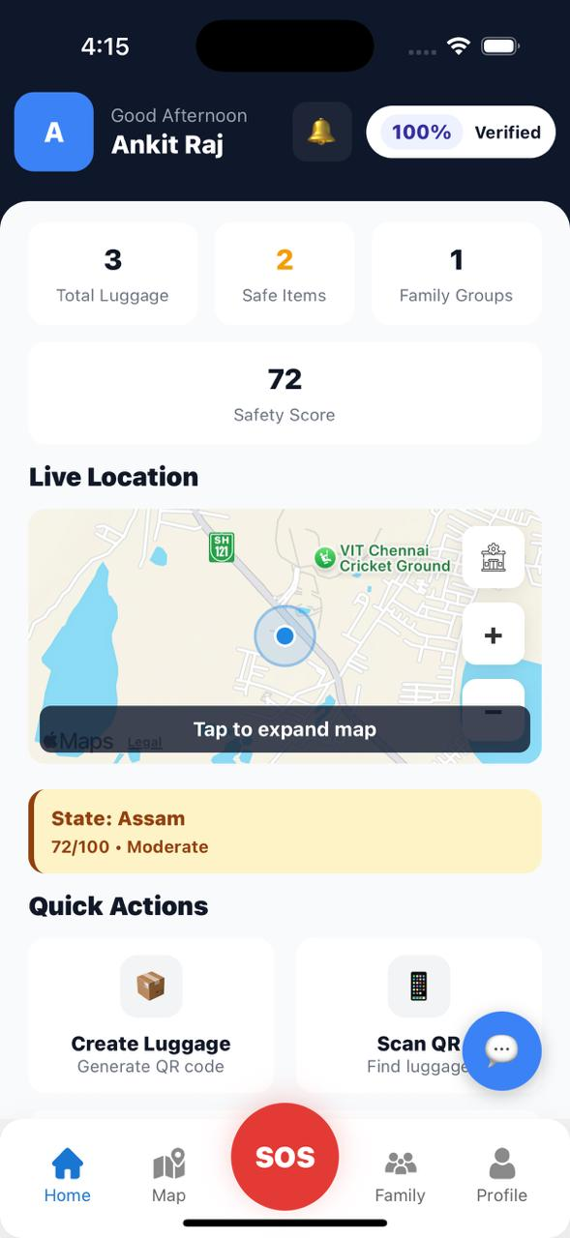
Screenshot 11 & 12: Home Screen of Mobile App & Live Location Monitoring Page of Mobile App

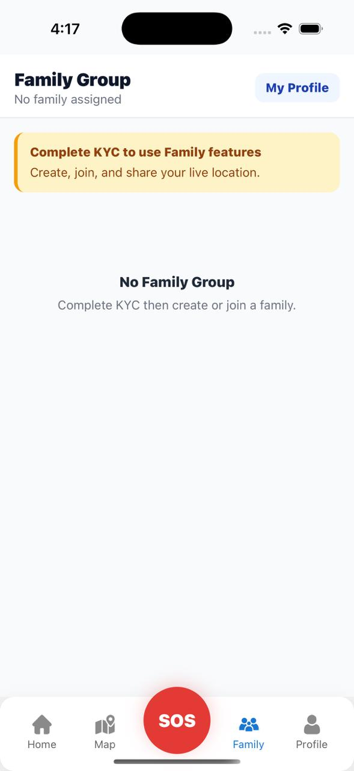
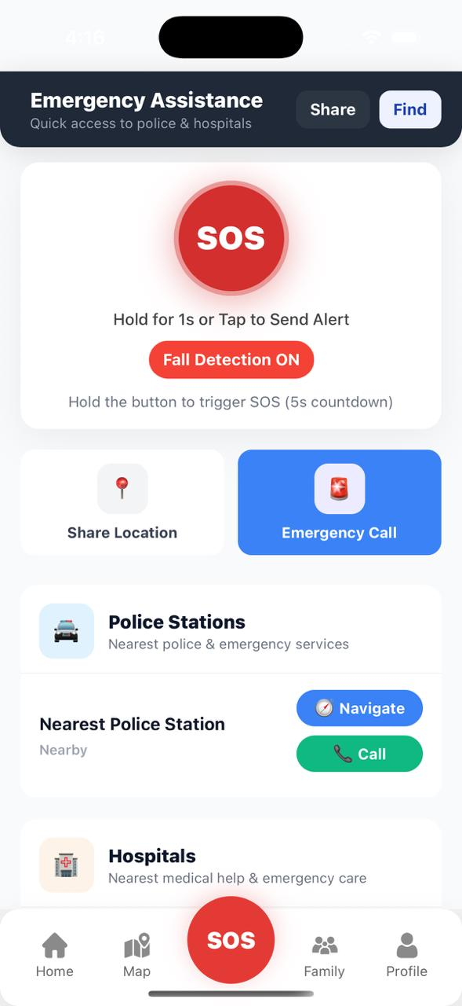
Screen shot 13 & 14: SOS Button Feature & Family Group Management

