HTTP Services

* HTTP is primary protocol to communicate to server.
* HttpModule is not a core Angular module . its an optional approach to web access. Its separate add-on module called @angular/http shipped in a separate file @angular/http.

Register for HTTP Services

* Need to access these services from anywhere in the application . So we need to register them all by adding HTTPModule to AppModule , import section.
* Go to AppModule and in the BrowserModule insert HttpModule .

Observables

* Each Http Service method returns an observable of Http Response object
* Observable is a stream of events that we can process with array like operators

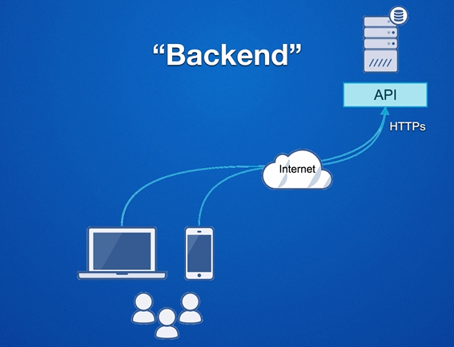

Steps to work with HTTP Service

We are going to use REST API : Data as Resources Http Verbs

1. Get /bookmarks -> List all
2. Get /bookmarks/123 => Get one
3. Post /bookmarks => Create
4. Put or patch /bookmarks/123 ->Update
5. Delete bookmarks/123 ->Delete

Step 1: Go to https://firebase.google.com/to create REST API

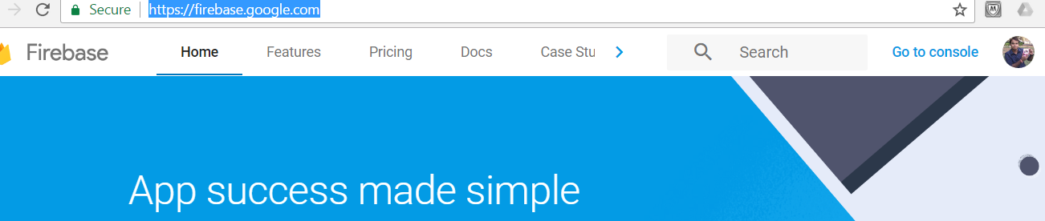

2. Click on Go to Console and Create New Project

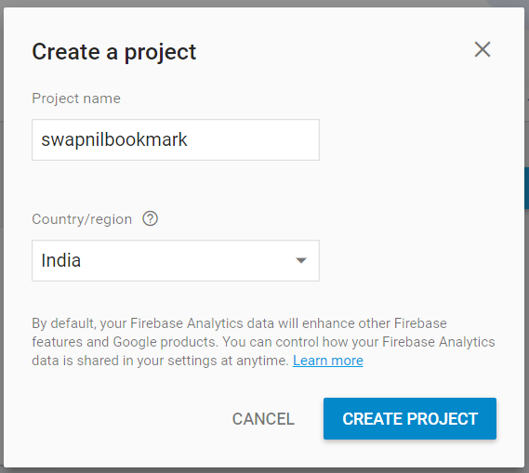

3. Select a database from a Menu

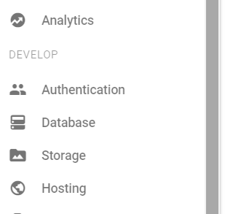

4. Go and Change the Rules and make it true.

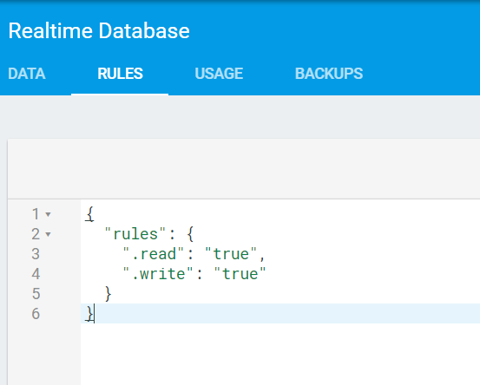

1. Install Insomnia add in into chrome and pass the Url along with json file name where you wan to store data .

Make sure the POSt method is selected

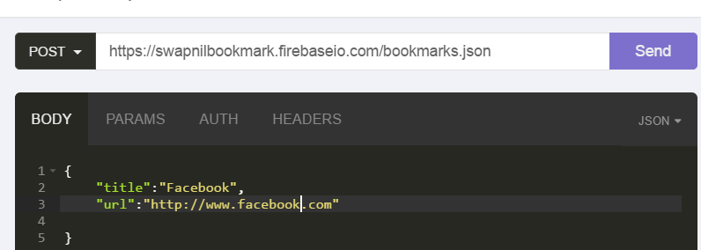

1. Check whether the data is entered or not

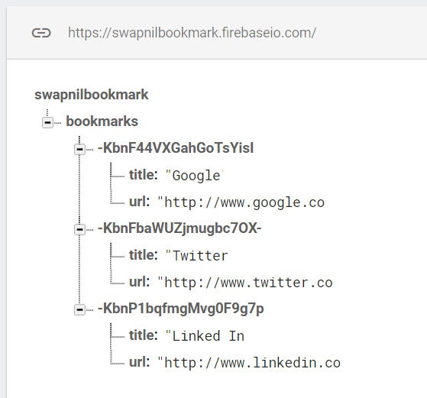

Viewdata data from firebase using REST API

1. Add import rxjs/RX to main.ts

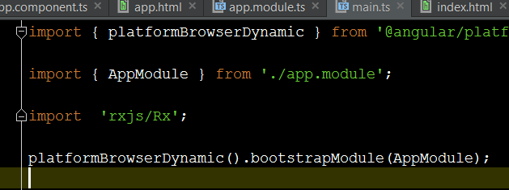

1. Import Http_Providers to Component to use HTTP and Register it @component using provider attribute.

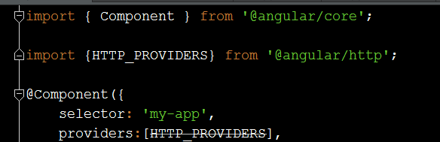

1. It’s a good practice to write retrieval code inside some service and then doing DI

Add bookmark.service.ts , Import Http from http module and injectable from core so that we can use http service and inject it.

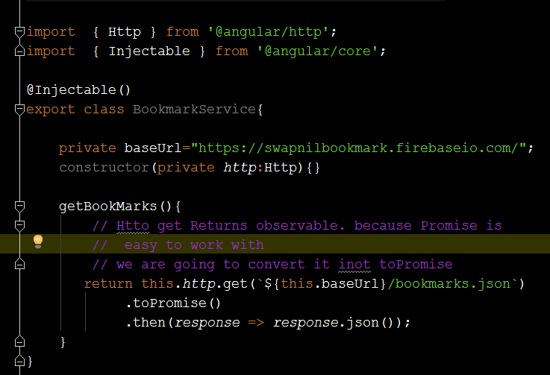

1. Use this in our main component. By importing and Registering with Providers

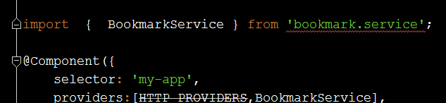

1. Now Use this Service in our component

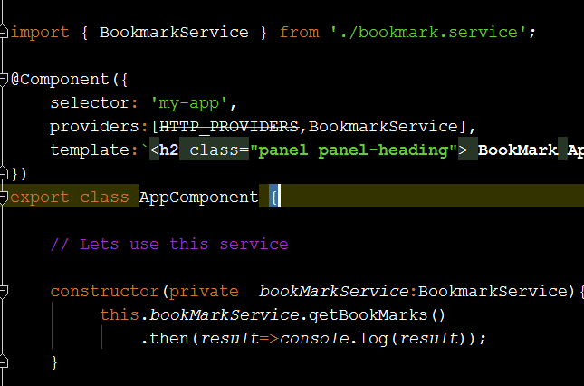

1. You will get the data in console .
2. Suppose you want to display the data you need to add some array variable into it. I have declared bookmarks[]



1. But the data received from the service is Json objects in the form of keys so we need to convert it into Array of object . hence we need to use map method to convert it into Array

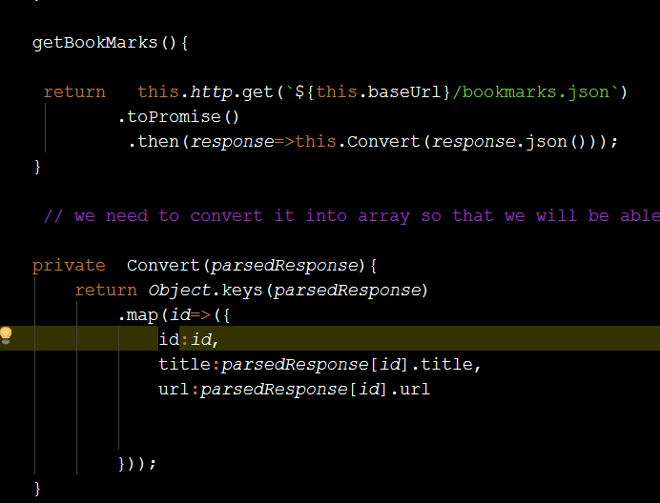

1. If you check the output is console , you will get same in the form of array.

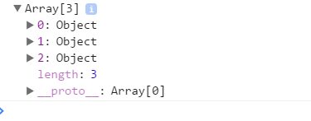

1. If you check the final code.

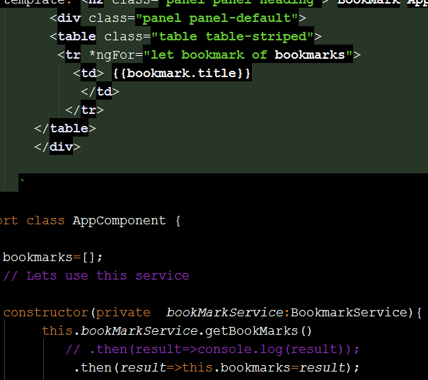

1. Output

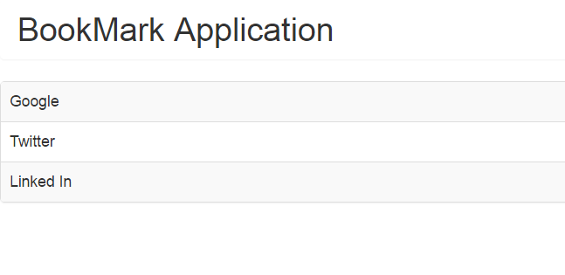

1. We can also make it as a URL

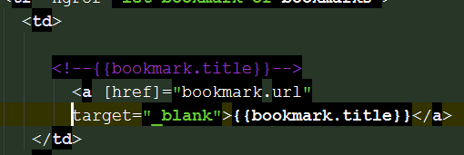

1. Sort the link alphabetically

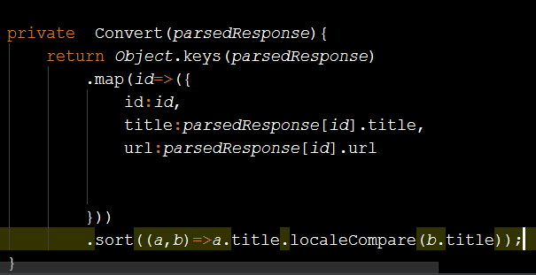

Demo 2 : Creating the data.

Rearrange the Demo 1 in following Ways

1. Lets Create a Separate Component for Viewing the data and name it as bookmarks-list. To do this just copy and paste the app.component and rename the component to bookmarks list.

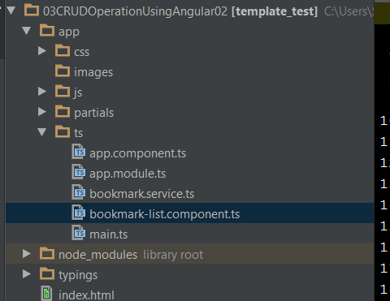

1. Remove the imports , constructor , rename the selector and use @Input to pass the data to the Root Component

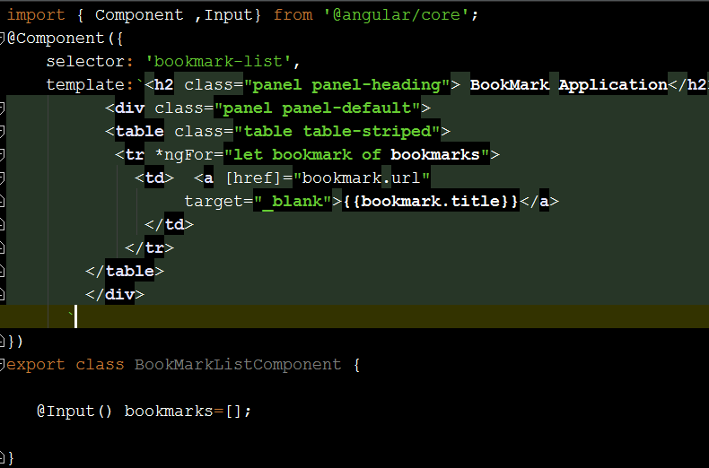

1. Go to the Root Component , Take a Reference of that here and inject it in the Root Component. Use the Selector Tag here as its shown

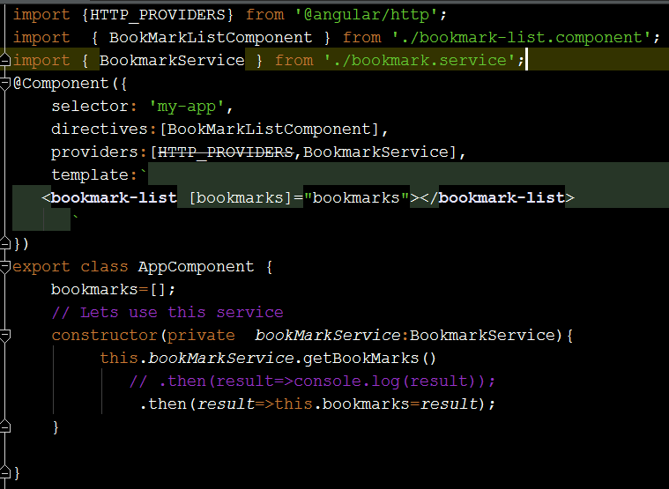

1. Now Add a new Component for add new Component and name it as bookmark-edit component. For that just copy and paste the same list component.

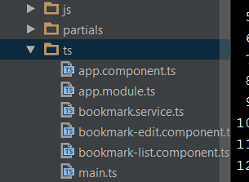

1. Desing Edit Component

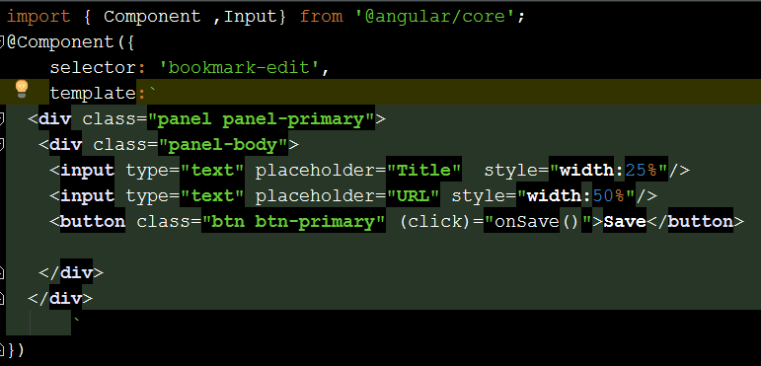

1. Add someng-Model attribute to it.

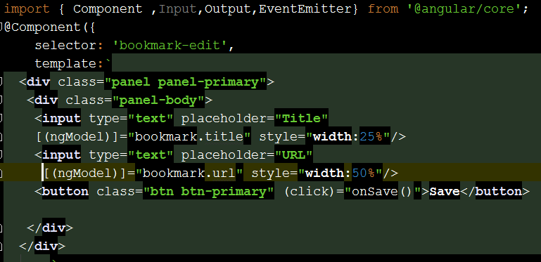

1. Add the code into Edit Component

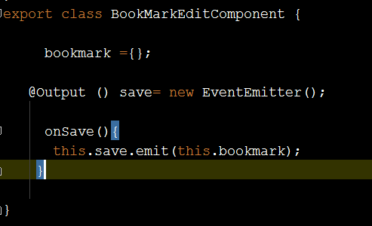

1. Go to Service and Add a method to add new bookmarks

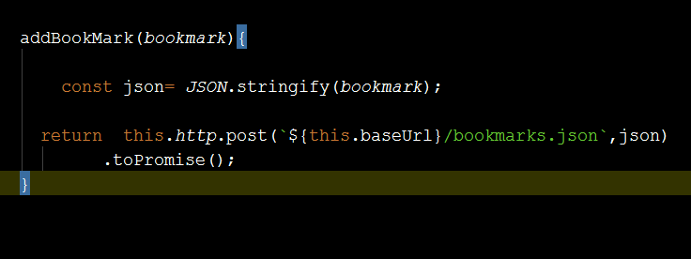

1. Call this method in Root Component

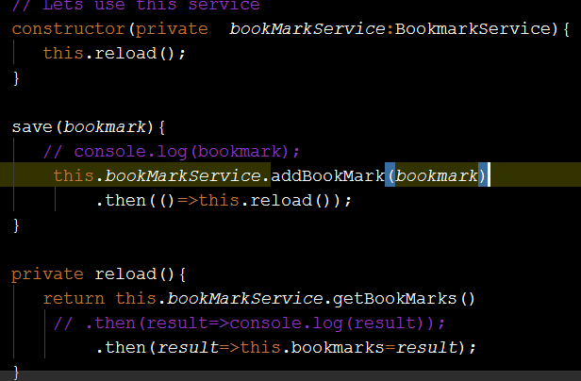

Demo 3: How to Delete a Request

1. Add a Remove button in BookListComponent

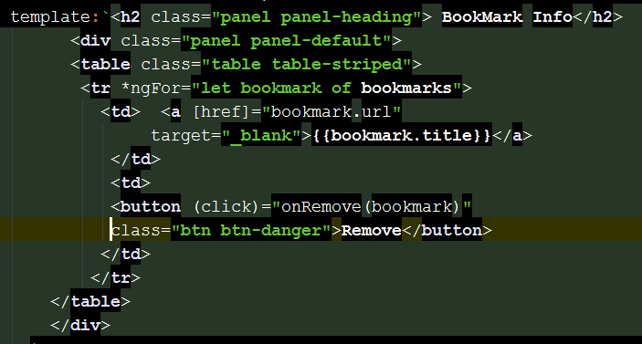

1. Use Event Emitter to send the event to the RootComponent

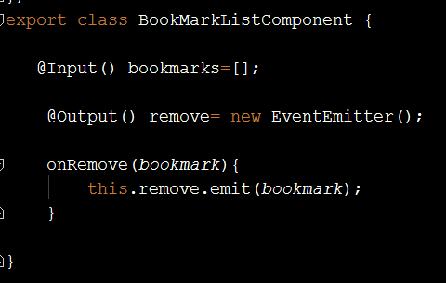

1. Add a Method to service to delete the data

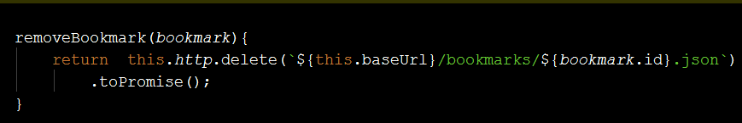

1. Call this method in Root Component

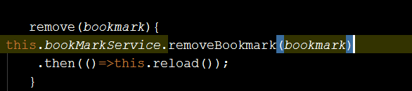

1. Add a call in Root Component

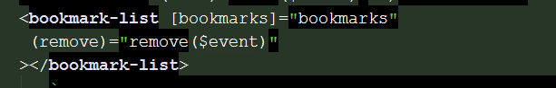

Demo 4: Edit Existing Bookmark.

1. Add the edit button in BookmarkList

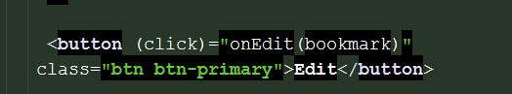

1. Add EventEmitter for that

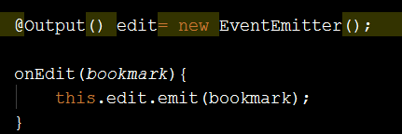

1. Go to Root Component: We have to pass the data user selected to the Edit Component hence we need to declare on object

And on edit we should pass the data to the edit component.

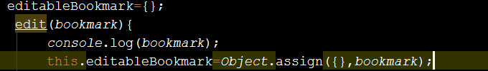

1. Pass this data to the edit component.

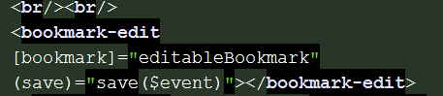

1. Add the Code into service to update the data

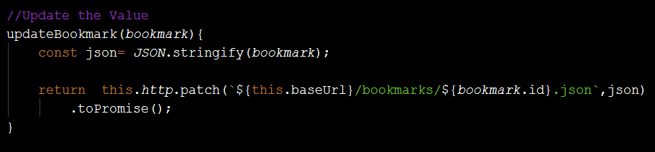

1. Call the code from the Root Component

