4. PROPOSED SYSTEM DESIGN
This chapter presents a comprehensive description of the Memory Blocks system architecture from a user-centric perspective. The system is designed to provide users with granular control over how contextual information is organized, accessed, and utilized by the conversational AI agent. Unlike traditional monolithic memory systems where all information resides in a single repository, Memory Blocks implements a modular, container-based architecture that allows users to create, manage, and selectively attach independent memory contexts. This design addresses the fundamental challenges of context isolation, retrieval precision, and user agency in long-term AI interactions.

4.1 System Architecture Overview
The Memory Blocks architecture is structured around the concept of memory containers – independent, self-contained knowledge repositories that users can create, configure, and attach to conversational sessions based on their specific needs. Each container represents a distinct semantic domain or functional context, such as a personal workspace, an academic project, a professional task, or a collaborative team environment. This modular approach enables users to maintain clear boundaries between different aspects of their interactions with the AI system, preventing unintended context leakage and improving retrieval relevance.

Figure 4.1 illustrates the high-level architecture of the Memory Blocks system. The design consists of three primary layers: the Memory Space Layer, which contains multiple user-defined containers; the Processing Layer, which orchestrates retrieval and update operations; and the User Interaction Layer, which manages the conversational interface and integrates context from attached memory blocks.

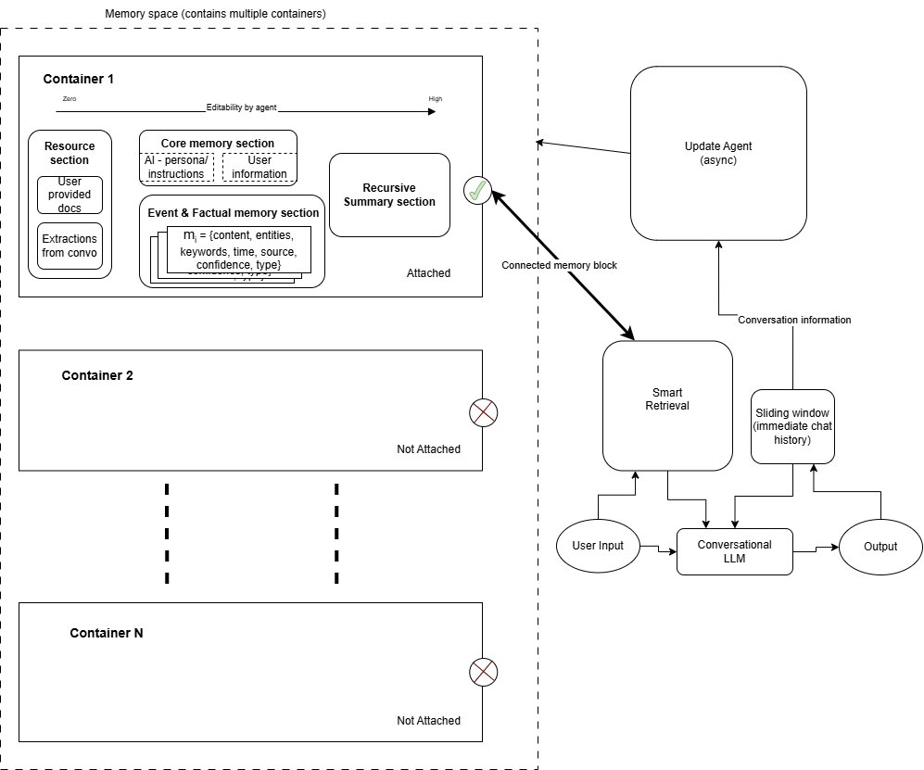
Figure 4.1: Memory Blocks System Architecture Overview

4.1.1 Container Attachment Mechanism
At the core of the system's flexibility is the dynamic attachment mechanism. Users explicitly control which memory containers are active during a conversation by attaching or detaching them through the user interface. When a container is attached (indicated by the connection symbol in Figure 4.1), its contents become accessible to both the Smart Retrieval component and the Update Agent. Conversely, containers that are not attached (marked with an X symbol) remain isolated from the current session, ensuring that their information does not influence responses or get retrieved inadvertently.
This explicit attachment model provides several key advantages:
- Context Isolation: Users can maintain separate memory spaces for different roles (personal, professional, academic) without cross-contamination. For example, a user working on a startup idea can attach only their entrepreneurship container, preventing personal preferences or unrelated project details from being retrieved.
- Reduced Retrieval Noise: By limiting the search space to only attached containers, the system dramatically reduces the likelihood of retrieving irrelevant information, improving both response quality and computational efficiency.
- User Privacy and Control: Users have transparent visibility into which knowledge domains are active, allowing them to make informed decisions about information exposure and preventing sensitive data from being accessed in unintended contexts.
- Collaborative Memory Management: Containers can be designated as shared or private, enabling team collaboration while maintaining individual privacy. A shared project container can be attached by multiple team members, while each member's personal container remains private.

4.2 Memory Container Internal Structure
Each memory container implements a structured, multi-section architecture designed to optimize both storage efficiency and retrieval accuracy. Rather than treating all information uniformly, Memory Blocks differentiates between different types of contextual data and applies specialized storage and retrieval strategies to each. As shown in Figure 4.1, every container is composed of four distinct sections, each serving a specific functional purpose.

4.2.1 Resource Section
The Resource Section serves as an immutable document repository, storing user-uploaded files, complete conversation transcripts, and agent-extracted reference materials. Unlike other sections that undergo continuous updates, resources are – once added, they are never modified by the agent. This design preserves the integrity of primary source materials and provides a reliable foundation for information retrieval.append-only – once added, they are never modified by the agent. This design preserves the integrity of primary source materials and provides a reliable foundation for information retrieval.
Resources are indexed using hybrid semantic search, combining vector embeddings generated by the Nomic Embed Text model with BM25 lexical matching. When a user uploads a technical specification document, API reference, or research paper, it is chunked, embedded, and stored in this section. During retrieval, the system can locate relevant passages based on semantic similarity to the current query, enabling the agent to reference authoritative information without hallucination.

4.2.2 Core Memory Section
The Core Memory Section maintains high-priority, persistent facts that should influence every interaction within the container's scope. This section is structured into two distinct blocks:
- Persona Block: Defines the agent's behavioral characteristics, tone, and domain expertise when operating within this container. For example, a technical support container might specify a formal, solution-oriented persona, while a creative writing container might adopt a more collaborative, exploratory tone.
- User Information Block: Stores enduring facts about the user that are relevant to the container's domain. This includes preferences (e.g., 'prefers Python over JavaScript for scripting tasks'), constraints (e.g., 'company policy prohibits use of GPL-licensed libraries'), and self-identifying attributes (e.g., 'team lead for the backend infrastructure project').
Core Memory is injected into every LLM invocation via system prompts, ensuring these foundational facts persistently shape the agent's reasoning and responses. The system implements a conservative update protocol for Core Memory – information is only added when explicitly stated by the user and confirmed to be long-term and high-priority. When Core Memory approaches its token capacity (typically 1,500 tokens), the system triggers a compression process that consolidates redundant information while preserving all critical facts.

4.2.3 Event and Factual Memory Section
The Event and Factual Memory Section implements a dynamic, graph-structured knowledge base that stores extracted events, facts, and opinions discovered through conversations. Unlike Core Memory, which contains only the most essential information, this section captures a broader range of contextual details that may be relevant for future interactions.
Each memory entry is represented as a structured node containing:
- Content: A concise, one-sentence description designed to be semantically searchable and evolutionarily updatable as new information arrives.
- Temporal Metadata: Timestamp indicating when the memory was created or last updated, enabling recency-based retrieval and temporal reasoning.
- Semantic Attributes: Keywords, tags, and entity annotations that facilitate multi-dimensional retrieval (e.g., domain tags like 'machine learning', functional tags like 'debugging', memory type tags like 'fact' or 'event').
- Confidence and Source: Reliability score and provenance tracking (user-stated, inferred, or externally sourced) to support trust-aware retrieval.
- Relationship Links: Pointers to semantically related memories, forming a knowledge graph that enables associative retrieval and context expansion.
A critical innovation in this section is recursive memory evolution. When new information arrives that relates to existing memories, the system does not simply add a redundant entry. Instead, an agentic process evaluates whether the new information should update, archive, invalidate, or establish relationships with existing entries. For instance, if a user initially states 'I prefer using MongoDB for document storage' and later says 'Actually, I've switched to PostgreSQL with JSONB columns for better consistency,' the system will update the original preference memory rather than creating a conflicting entry. This evolution mechanism ensures the knowledge graph remains coherent and reflects the user's current understanding.

4.2.4 Recursive Summary Section
The Recursive Summary Section addresses the challenge of intermediate-term context management. While the Sliding Window maintains immediate conversational continuity (typically the last 10 message pairs), and Core Memory stores long-term persistent facts, many important details fall into a temporal gap – too transient for permanent storage but too important to lose when the sliding window evicts older messages.
The Recursive Summary captures this intermediate context through progressive compression. When the conversation approaches the token limit of the LLM's context window (typically at 75% capacity), the system invokes a specialized summarization process that distills recent exchanges into a compact narrative. This summary preserves:
- High-level goals and objectives currently being pursued
- Decisions made and reasoning paths explored
- Unresolved questions or pending action items
- Constraints or requirements identified during the discussion
Critically, the Recursive Summary is designed to avoid redundancy with other memory sections. It does not repeat facts already captured in Core Memory or Event Memory, focusing instead on the flow of the conversation and contextual threads that span multiple turns. The summary is updated recursively – each new summarization incorporates the previous summary along with recent messages, creating a progressively refined compression of the session's context.

4.3 User Interaction Pipeline
From the user's perspective, interacting with the Memory Blocks system follows a seamless, conversational flow while sophisticated memory management operations occur asynchronously in the background. This section describes the end-to-end pipeline from user input to agent response, highlighting both the visible interaction layer and the invisible intelligence orchestration.

4.3.1 User Input and Context Assembly
When a user submits a query, the system initiates the Smart Retrieval process to assemble relevant context from attached memory containers. Figure 4.2 illustrates the retrieval pipeline, which consists of multiple parallel and sequential stages designed to maximize relevance while minimizing computational overhead.

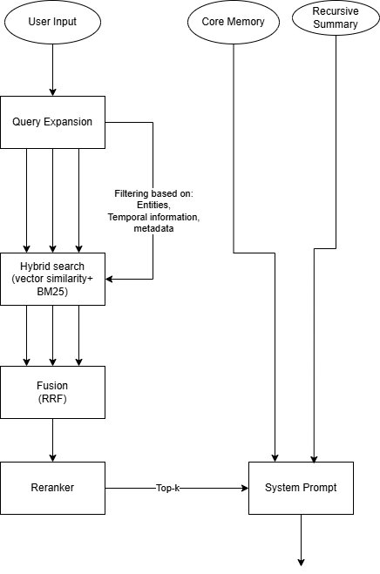
Figure 4.2: Smart Retrieval Pipeline

Step 1: Query Expansion and Analysis. The user's input is first analyzed to extract intent, entities, and temporal references. The system may expand the query by identifying synonyms, related concepts, or implicit requirements. For example, a query like 'How should I handle database migrations?' might be expanded to include terms related to 'schema evolution,' 'version control,' and 'data consistency.'

Step 2: Hybrid Search Execution. The expanded query is processed through a hybrid search mechanism that combines vector similarity search (using embeddings from the Nomic Embed Text model) with BM25 lexical matching. This dual approach captures both semantic relatedness and exact keyword matches, improving recall for both conceptual and technical queries.
The search is executed in parallel across multiple memory sections within attached containers:
- Core Memory is always included in its entirety (no search required)
- Event and Factual Memory is searched using vector similarity, with results filtered by metadata (temporal relevance, confidence score, entity matches)
- Resources are searched when the query suggests document references or technical specifications
- Recursive Summary is always included to provide recent conversational context

Step 3: Fusion and Reranking. Retrieved candidates from different search strategies are merged using Reciprocal Rank Fusion (RRF), which combines rankings from vector search and BM25 to produce a unified result set. The fused results are then passed through a reranking stage that considers:
- Semantic similarity to the query
- Recency (newer memories receive higher scores)
- Confidence level (user-stated facts ranked higher than inferences)
- Diversity (avoiding redundant results)

Step 4: System Prompt Construction. The top-k reranked memories are formatted into a structured system prompt that clearly delineates different information sources. The prompt includes:
- Core Memory (persona and user facts)
- Recursive Summary (recent conversation context)
- Retrieved Event and Factual memories (with metadata indicating type, confidence, and timestamp)
- Sliding Window (last N message pairs for immediate context)
- Current user input
This structured assembly allows the conversational LLM to distinguish between persistent facts, recent context, historical events, and the current query, enabling more accurate and contextually appropriate responses.

4.3.2 LLM Response Generation
With the assembled context, the conversational LLM (hosted via Groq API for high-throughput inference) generates a response. The LLM operates with full visibility into all attached memory containers' relevant information, enabling it to:
- Reference specific facts from Core Memory without hallucination
- Draw upon historical events from Event Memory to provide continuity
- Cite uploaded documents from the Resource section when applicable
- Maintain awareness of recent conversational threads via the Recursive Summary
The response is streamed back to the user in real-time, providing an interactive conversational experience. Importantly, the user sees no indication of the complex retrieval and ranking operations that occurred behind the scenes – the interaction feels natural and immediate.

4.3.3 Asynchronous Memory Updates
After the user receives a response, the system initiates an asynchronous Update Agent process to extract and integrate new information into the memory containers. This operation executes in the background without blocking user interaction, ensuring zero latency impact on conversational flow. Figure 4.3 illustrates the update pipeline.

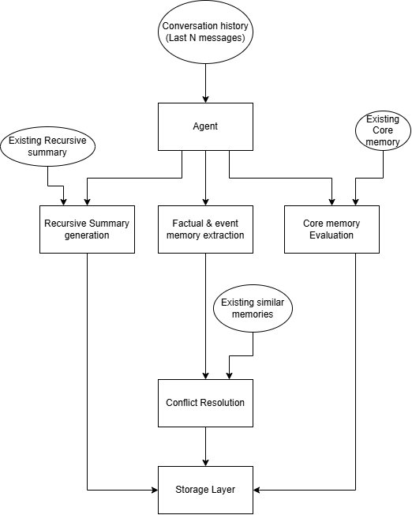
Figure 4.3: Update Agent Pipeline

The Update Agent processes the conversation history (last N messages) to determine what information should be extracted and how it should be integrated into existing memory structures. The pipeline operates in parallel across three specialized update paths:

Core Memory Evaluation
The agent evaluates whether the conversation contains information that qualifies for Core Memory storage. Using a conservative decision protocol, the system looks for explicit, long-term user statements such as:
- 'My name is Alex, and I work as a senior backend engineer at TechCorp.'
- 'I prefer to receive code examples in TypeScript rather than JavaScript.'
- 'Our team follows a policy of zero third-party dependencies in the core library.'
Critically, the system does not infer or assume Core Memory facts. Only information that is directly stated by the user and confirmed to be persistent is added. If Core Memory reaches capacity, a compression process consolidates redundant information while preserving all critical details.

Event and Factual Memory Extraction
The agent extracts events, facts, and opinions from the conversation using a structured note construction process. For each identified memory candidate, the system:
- Generates a concise content description (one sentence)
- Extracts keywords and tags (domain, functional, and type classifications)
- Identifies relevant entities and temporal markers
- Assigns a confidence score and source attribution

The structured memory is then embedded using the Nomic Embed Text model and compared against existing memories in the Event and Factual section via semantic similarity search. The top-k most similar memories are retrieved as candidates for potential relationship linking or conflict resolution.

Conflict Resolution and Memory Evolution
The Update Agent employs sophisticated conflict resolution logic to maintain knowledge graph coherence. When a new memory is similar to existing entries, the system decides between:
- ADD: Store the memory as a new, independent entry if it provides novel information.
- UPDATE: Merge the new information into an existing memory, enriching its context or updating outdated details.
- ARCHIVE: Mark an existing memory as outdated but preserve it for historical reference.
- INVALIDATE: Mark an existing memory as incorrect based on contradicting evidence.
- NO-OP: Take no action if the information is redundant.

For example, if the user previously stated 'I use React for frontend development' and later says 'I've migrated all projects to Vue.js,' the system will UPDATE the original memory to reflect the technology shift rather than creating a contradictory entry. The evolution process also establishes semantic links between related memories, creating a navigable knowledge graph.

Recursive Summary Generation
When the sliding window approaches capacity, the Recursive Summary is updated to compress recent conversation turns. The summarization process receives:
- The existing recursive summary
- New messages since the last update
- Context from Core Memory and Event Memory (to avoid duplication)

The LLM generates an updated summary that preserves high-level goals, unresolved questions, and recent decisions while removing resolved details and repetitive exchanges. The new summary replaces the old one, maintaining a consistent representation of intermediate-term context.

Storage Layer Integration
All memory updates are persisted to the Storage Layer, which interfaces with:
- Qdrant Vector Database: Stores memory embeddings for Event and Factual Memory, enabling efficient semantic search.
- Structured Storage: Maintains Core Memory blocks, Recursive Summaries, and container metadata.
- Document Store: Manages immutable resources (uploaded files, conversation transcripts).
The Storage Layer ensures all memory operations are atomic and consistent, preventing data loss or corruption even in the event of system interruptions.

4.4 User Control and Transparency Features
A fundamental design principle of Memory Blocks is user agency – users should have explicit control over what information is stored, how it is organized, and when it is accessed. This stands in contrast to many existing AI memory systems where memory extraction and retrieval are opaque, automated processes that users cannot easily inspect or override.

4.4.1 Container Management Interface
Users interact with memory containers through an intuitive management interface that allows them to:
- Create New Containers: Users can define a new memory container by providing a name, description, and scope (personal, shared, read-only, or collaborative). For example, a user might create a container titled 'PhD Research – NLP Models' with a description specifying that it contains literature notes, experiment logs, and paper drafts.
- Attach/Detach Containers: Before starting a conversation, users select which containers should be active. A simple toggle interface allows instant attachment or detachment, with visual indicators showing the current state (as illustrated by the connection/disconnection symbols in Figure 4.1).
- Inspect Container Contents: Users can browse the contents of each memory section within a container, viewing Core Memory facts, reviewing Event and Factual entries, or accessing stored resources. This transparency allows users to verify what the system has learned and correct inaccuracies.
- Edit or Delete Memories: Users retain the ability to manually edit memory entries, archive outdated information, or delete sensitive data. This addresses privacy concerns and gives users ultimate authority over their information.
- Export Containers: Containers can be exported as structured files (JSON or similar formats) for backup, migration, or sharing with collaborators.

4.4.2 Memory Visibility and Governance
Each memory entry includes visibility and governance metadata that controls how it can be accessed and shared:
- Scope: Personal (visible only to the creator), Shared (visible to all users with access to the container), or Team (visible to designated collaborators).
- Editability: Read-only (agent cannot modify), Read-write (agent can update or evolve), or Append-only (agent can add but not modify).
- Retention Policy: Permanent (never auto-archived), Time-limited (automatically archived after a specified period), or Session-only (deleted at the end of the conversation).
These governance controls enable fine-grained management of information lifecycle and privacy, ensuring compliance with organizational policies or personal preferences.

4.5 Collaborative and Multi-User Scenarios
While the primary user experience focuses on individual memory management, the Memory Blocks architecture inherently supports collaborative scenarios through shared containers. When multiple users attach the same shared container, they contribute to and benefit from a common knowledge base while maintaining their own private containers for personal information.

4.5.1 Shared Container Dynamics
In a team setting, a shared project container might store:
- Project requirements and constraints agreed upon by the team
- Technical decisions and architectural patterns documented during discussions
- Code repositories, API documentation, and design specifications uploaded as resources
- Historical events such as milestone completions, bug discoveries, or integration challenges

Each team member can interact with the shared container while simultaneously maintaining their own private containers for personal notes, experimental ideas, or sensitive information. This separation prevents accidental disclosure of private thoughts while enabling effective knowledge sharing.

4.5.2 Conflict Resolution in Shared Contexts
When multiple users contribute to a shared container, the Update Agent applies collaborative conflict resolution strategies:
- User Attribution: Each memory entry tracks which user contributed it, enabling accountability and credit assignment.
- Last-Write-Wins with Versioning: When conflicting updates occur, the most recent contribution takes precedence, but previous versions are archived for potential rollback.
- Consensus-Based Core Memory: Updates to shared Core Memory require explicit confirmation, preventing unilateral changes to foundational team knowledge.
- Opinion Coexistence: When users express different opinions on the same topic, the system stores both as separate entries rather than attempting forced reconciliation, preserving diverse perspectives.

4.6 System Design Summary
The Memory Blocks system represents a paradigm shift from monolithic, opaque memory architectures to a modular, transparent, user-controlled approach. By organizing contextual information into independent containers with specialized internal sections, the system addresses critical challenges in long-term AI interaction:
- Context Isolation: Users can maintain separate knowledge domains without cross-contamination, enabling multi-role usage patterns.
- Retrieval Precision: Multi-section architecture with hybrid search reduces noise and improves relevance compared to flat document retrieval.
- Memory Coherence: Recursive evolution and conflict resolution prevent knowledge graph degradation over time.
- User Agency: Explicit attachment controls, transparency features, and governance settings give users ultimate authority over their information.
- Scalability: Modular design enables independent container scaling and distributed storage strategies.

The architecture presented in this chapter provides the foundation for the implementation and evaluation described in subsequent chapters. By centering the design around user needs and real-world interaction patterns, Memory Blocks offers a practical, deployable solution to the memory management challenges facing modern conversational AI systems.

