4.1 Personnel Division and Time Arrangement (Who, What, When)
This project is structured into three distinct stages to balance collective foundational work with specialized technical development.

Phase 1: Foundation (Pre-Feb 23)
Before February 23, the team operated under a unified management model. Weekly tasks were decided collectively to ensure all members gained a comprehensive understanding of the project objectives. This collaborative effort was reflected in the CA1 submission, where every member contributed to the initial research and project scoping.

Phase 2: Specialized Development (Feb 23 - April 1)
During the core development period, the team transitions into specialized roles to maximize efficiency:

UI Design and Requirement Analysis (Tang Zixuan): Leads the preliminary research and layout planning.
Data Cleaning (Ranjan Ankit, Zeng Wenbin): Responsible for defining temporal network standards and preprocessing raw data.
BFS Algorithm (Ce Wang, Li Bowen): Focuses on the core time-aware algorithm logic and path generation.
Web Implementation (Liu Yiqing, Xu Xiaohan): Builds the interactive frontend framework based on Streamlit.

Phase 3: Integration and Finalization (April 1 - Post)
After the delivery on April 1st, the team will reconvene to handle bug fixes and system optimization through shared task assignments. The submission of CA2 will be the result of a joint effort. For the final report (CA4), each member will write their own chapters, documenting their specific technical findings and implementation effects to ensure a comprehensive project narrative. In addition, a separate Individual Contribution report will be provided.
4.2 Task Dependencies
All links of the project are closely interconnected. Firstly, the UI group needs to determine the interaction requirements, which directly determine which fields the data group needs to clean and the container layout of the web group. Secondly, the standard adjacency list output by the data group is a prerequisite for the algorithm group to operate; if the data format is determined late, the algorithm logic cannot be implemented. Finally, the web group relies on the function interfaces provided by the algorithm group for dynamic rendering. The overall process presents a linear dependency: requirement definition -> data processing -> algorithm implementation -> front-end integration. Any delay in the preceding links will cause subsequent development to enter an "idle running" state.

5. Implementation Plan
Implementation Flowchart：
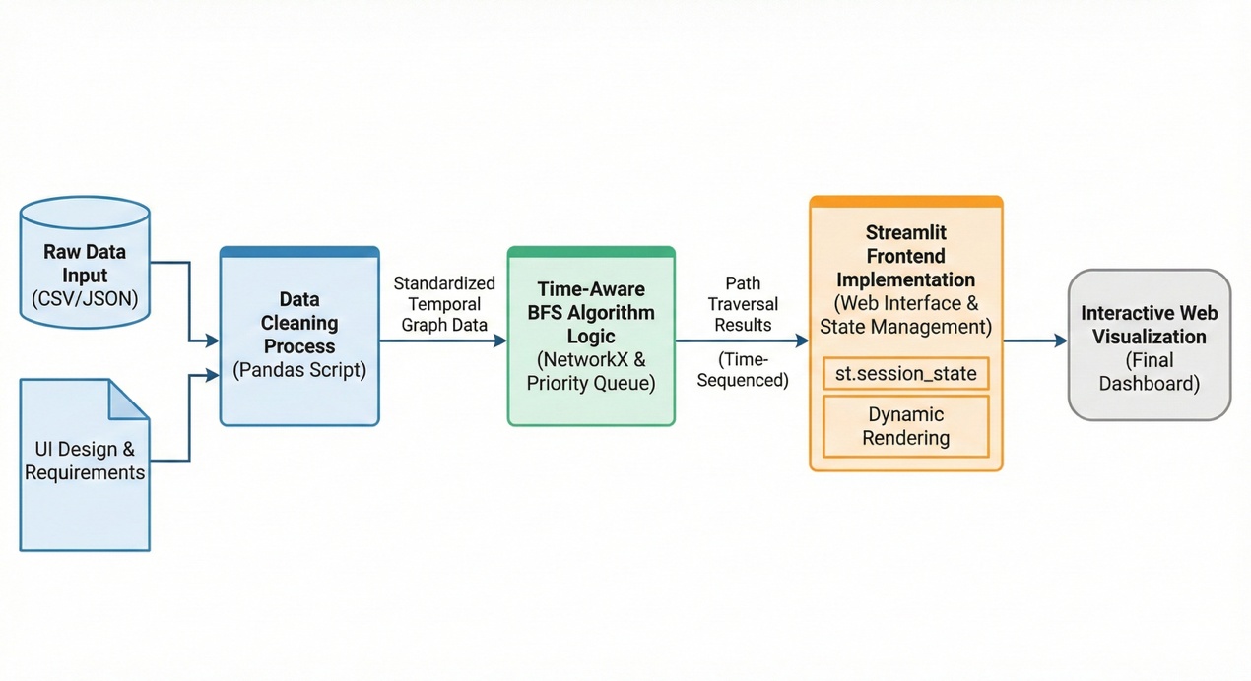

6. Gantt Chart and Risk Assessment and Mitigation Measures
6.1 Gantt Chart：
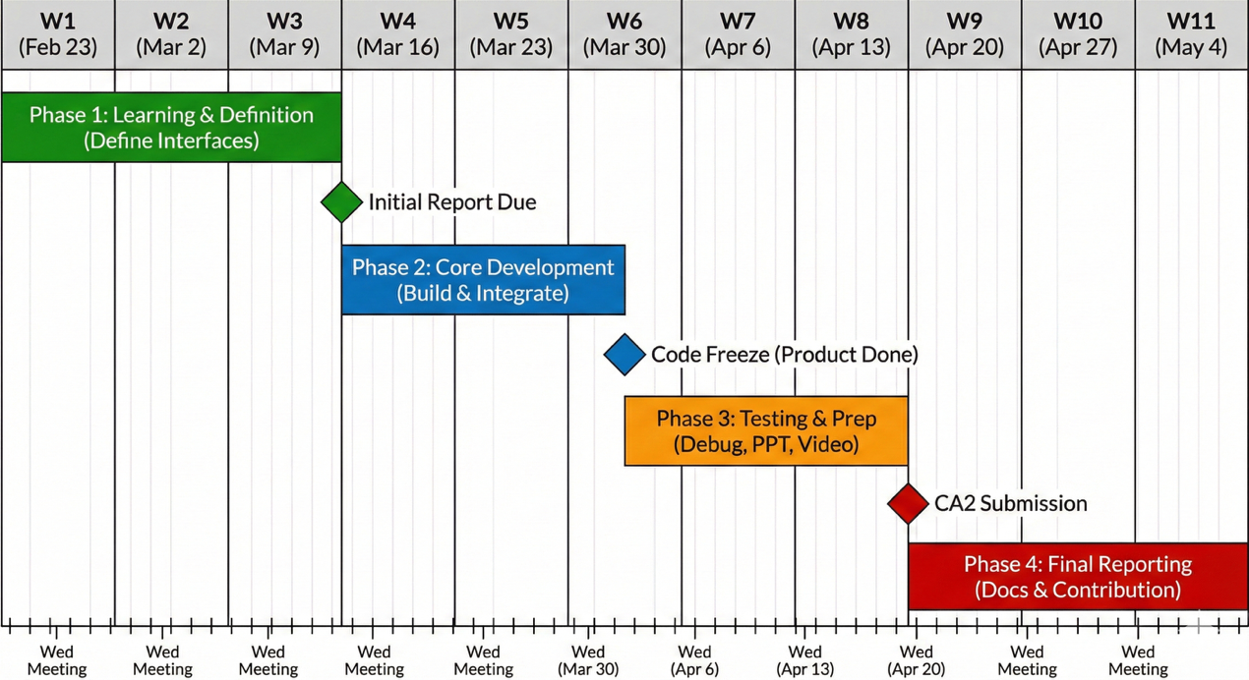

6.2 Technical Implementation Risk
Since the "time-aware BFS" is different from traditional algorithms and involves logical judgment of time steps, there may be a risk that the high algorithm complexity leads to slow web page response.
Mitigation Measures: The algorithm group must complete the feasibility prototype verification by March 11. If the efficiency is low, consider preprocessing the data or simplifying the time window.
6.3 Interface Docking Risk:
Inconsistent data formats or changes in function entry parameters may cause the web terminal to fail to call the algorithm normally.
Mitigation Measures: Strictly implement the Wednesday meeting system, requiring each group to submit a written "Interface Protocol Document" by March 11, and all subsequent changes must be known to all members.
6.4 Time Progress Risk:
The development cycle is only three weeks, and the later tasks of PPT and report are heavy, which may lead to low-quality output due to rushing work.
Mitigation Measures: Strictly take turns to record meeting minutes in alphabetical order, clarify the weekly Wednesday deadline goals, break down major tasks into weekly tasks, and ensure that bug fixes are scheduled in the buffer period at the beginning of April.

