- Introduction
This project mainly consists of five functions: nodes_set, BFS_Single, Arrive_time_and_Latency, sensitive, and modify.
Since the dataset contains a large number of nodes and edges, it is difficult to directly analyze the correctness of the code. Therefore, a relatively simple dataset is used for testing. The graph is shown below:
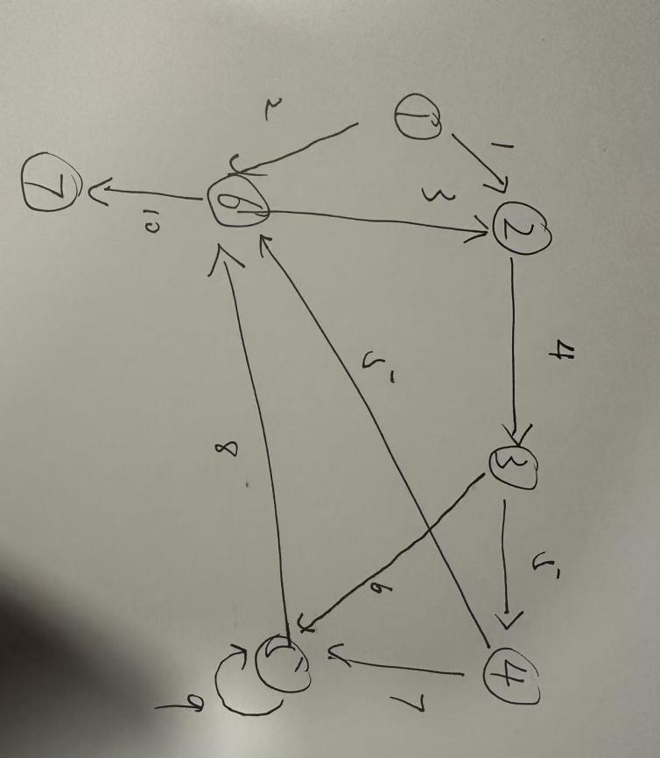

Modify_and_Sensitive_clean_draft.py: Contains the clean version of the functions without debug outputs.
Modify_and_Sensitive_draft.py: Includes debug outputs and several test cases.

- Functions

nodes_set:
Used to calculate how many nodes are in the graph.

- Parameter: Adjacency list

- Output: The set of vertices in the graph

- Format example:
Eg. {'1', '3', '5', '6', '7', '2', '4', ...}

- Time complexity: O(V + E)

(To Ranjan Ankit: I have a question—does the key set in your adjacency list adj_time include nodes that only have in-degree but no out-degree? Could you answer this on Teams?)

·’BFS_Single’
Used to calculate the arrival time and path from a simple SRC to TGT.

- Parameters: Adjacency list, SRC (start node), TGT (target node)

- Output: Arrival time, path

- Format: BFS: (time, path)
Path: [('TGT', time), ...]
Eg. (5, [('2', 3), ('3', 4), ('4', 5), ('6', 5)])

-Time complexity: O(V + E)

(To xiaohan xu: This does not represent the BFS used in the final project. I just need a BFS function to complete my part. The final version will use your function. I will modify my code according to your function. Your function only needs to output the time and path; the format does not have to be exactly the same.)

·’Arrive_time_and_Latency’
Calculates arrival time and latency, used for subsequent sensitivity analysis. Traverses the graph to compute the time and latency from each node to all other vertices (including itself).

- Parameters: Adjacency list, starting node SRC

- Output: Arrival time, latency

- Format: BFS: {tgt: [arrive_time, latency]}
Eg. {'6': [5, 2], '2': [3, 0], '7': [10, 7], '3': [4, 1], '4': [5, 2], '5': [6, 3]}

- Time complexity: O(V + E)

·’sensitive’
Analyzes the sensitivity of a graph using two evaluation metrics: global reachability and average arrival latency.

- Parameters: Original adjacency list, modified adjacency list, number of deleted nodes (deleting edges does not affect the calculation of these two metrics)

- Output: Global reachability, average latency

- Format: [global reachable, avg latency]
Eg. [0.5510204081632653, 2.3333333333333335]

- Time complexity: O(V * (V + E)))

·‘modify’
Modifies the graph by deleting edges and/or nodes, then outputs a comparison of paths from SRC to TGT before and after modification, along with global reachability and average latency.

- Parameters:
Adjacency list
Source node SRC
Target node TGT
Set of vertices to delete Vertexes (multiple vertices can be input as a space-separated list)
Set of edges to delete Edges (multiple edges can be input as a space-separated list)

- Output:

[
(arrival time before modification, path before modification),
(arrival time after modification, path after modification),
(global reachability before modification, average latency before modification),
(global reachability after modification, average latency after modification)
]

Time complexity: O(V * (V + E))

If you have any questions or suggestions for improvements, please feel free to reply on Teams. Thank you.

