Modue 3 Assignment  
  
Q1. Clone an existing repository on Github created during course and configure your local repo to point to the remote repository.

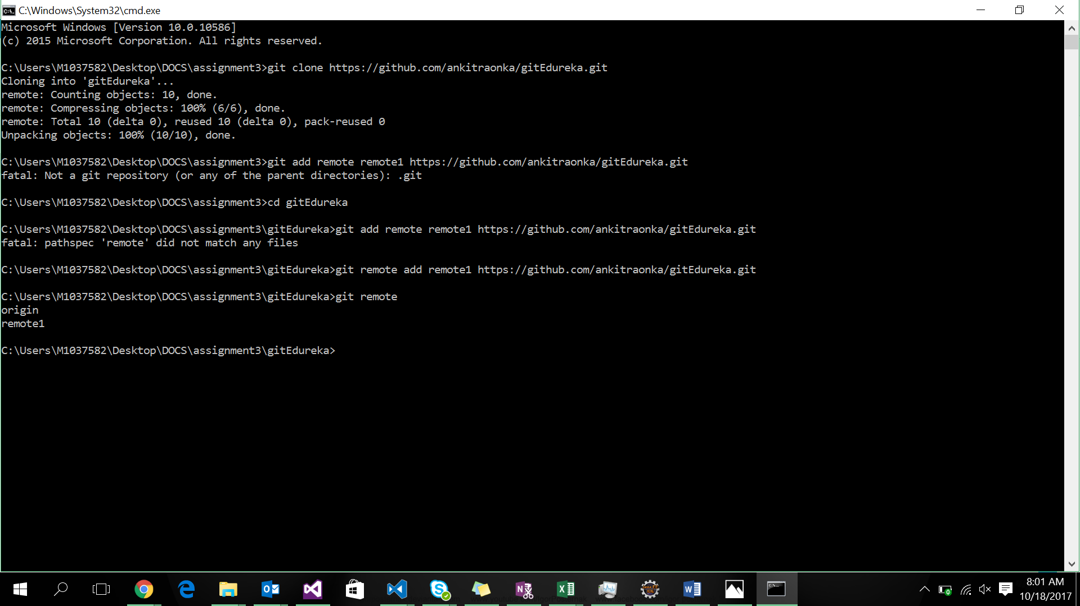

Q2. Perform some operation like add, remove, modify and finally push your changes to the remote repository

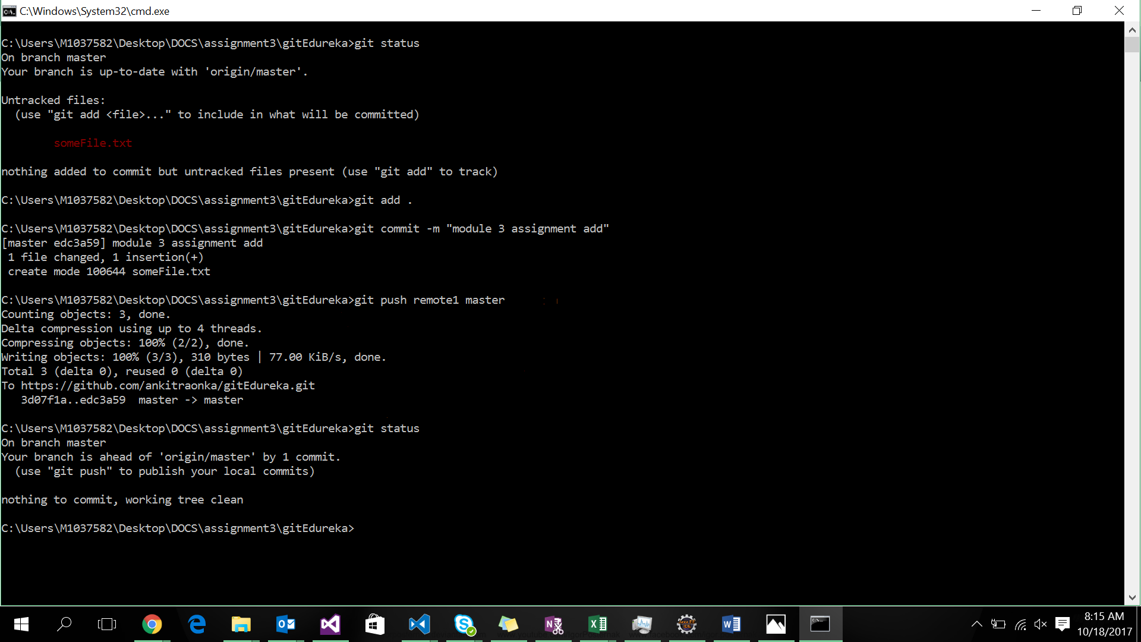

Q3. Try fetching the changes and perform the merge to get the difference between the pull and the merge command

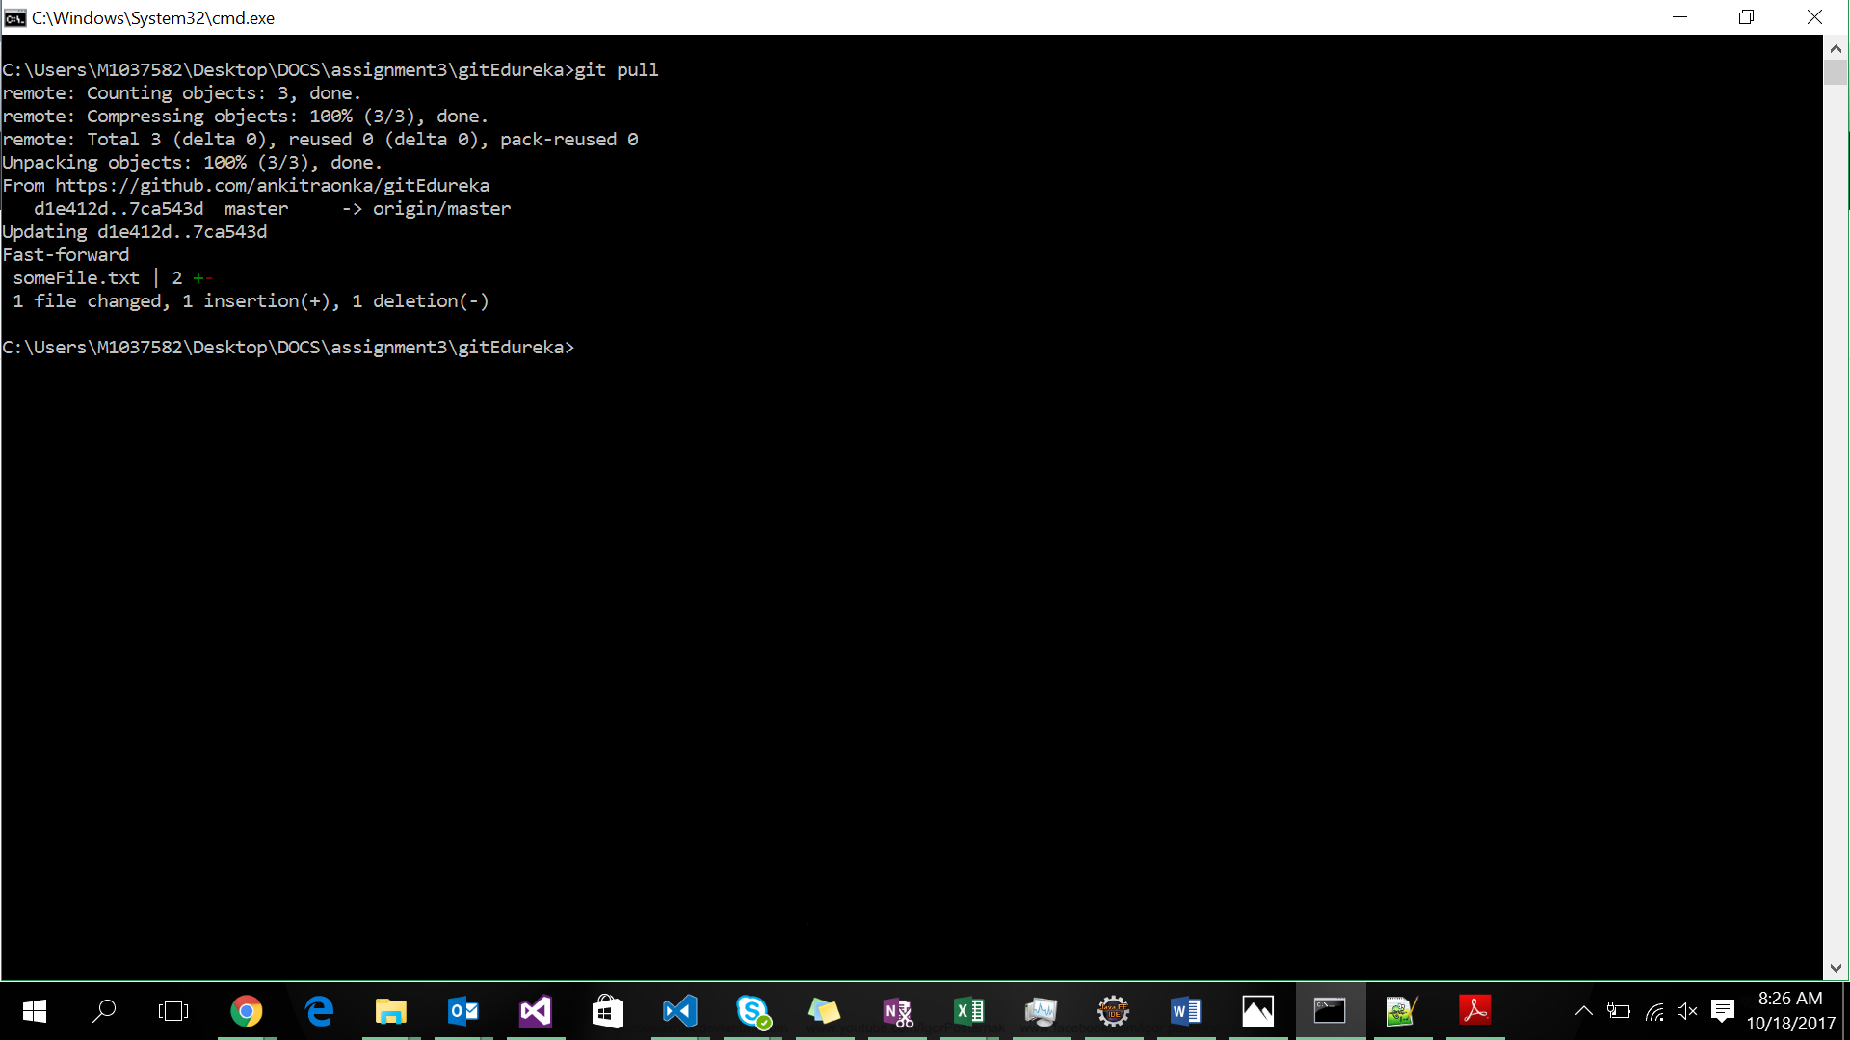

Q4. Try fetching the changes and perform the merge to get the difference between the pull and the merge command

A4.

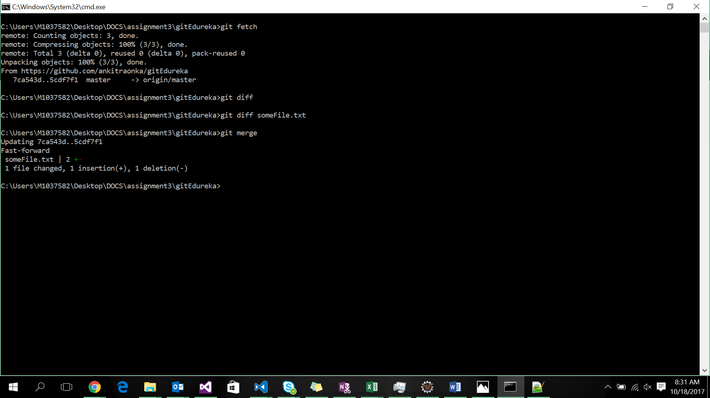

Q5. Perform some changes and before committing the changes, stash your changes and then pull the changes and finally apply the changes to understand how stashing works  
A5.

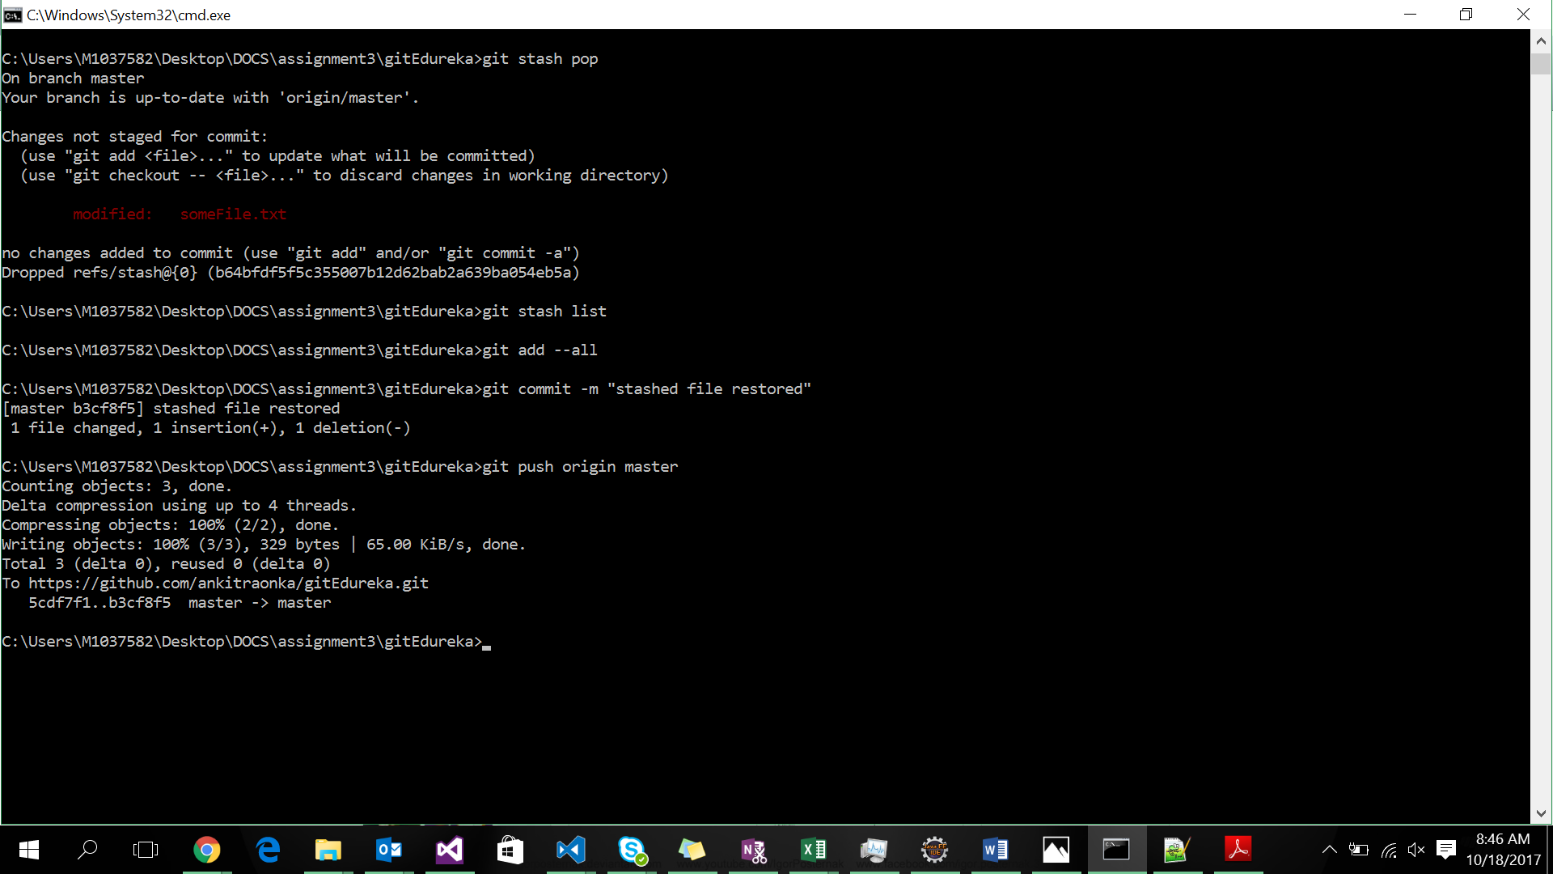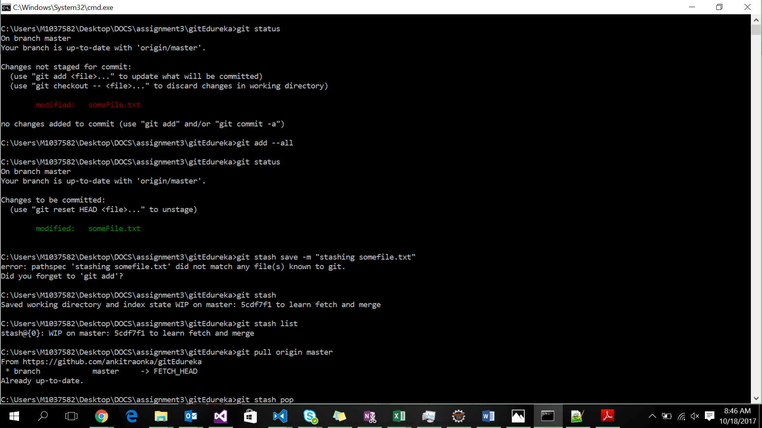

Q6. Create a feature branch and do some file operations in the branch and commit the changes to the branch

A6.

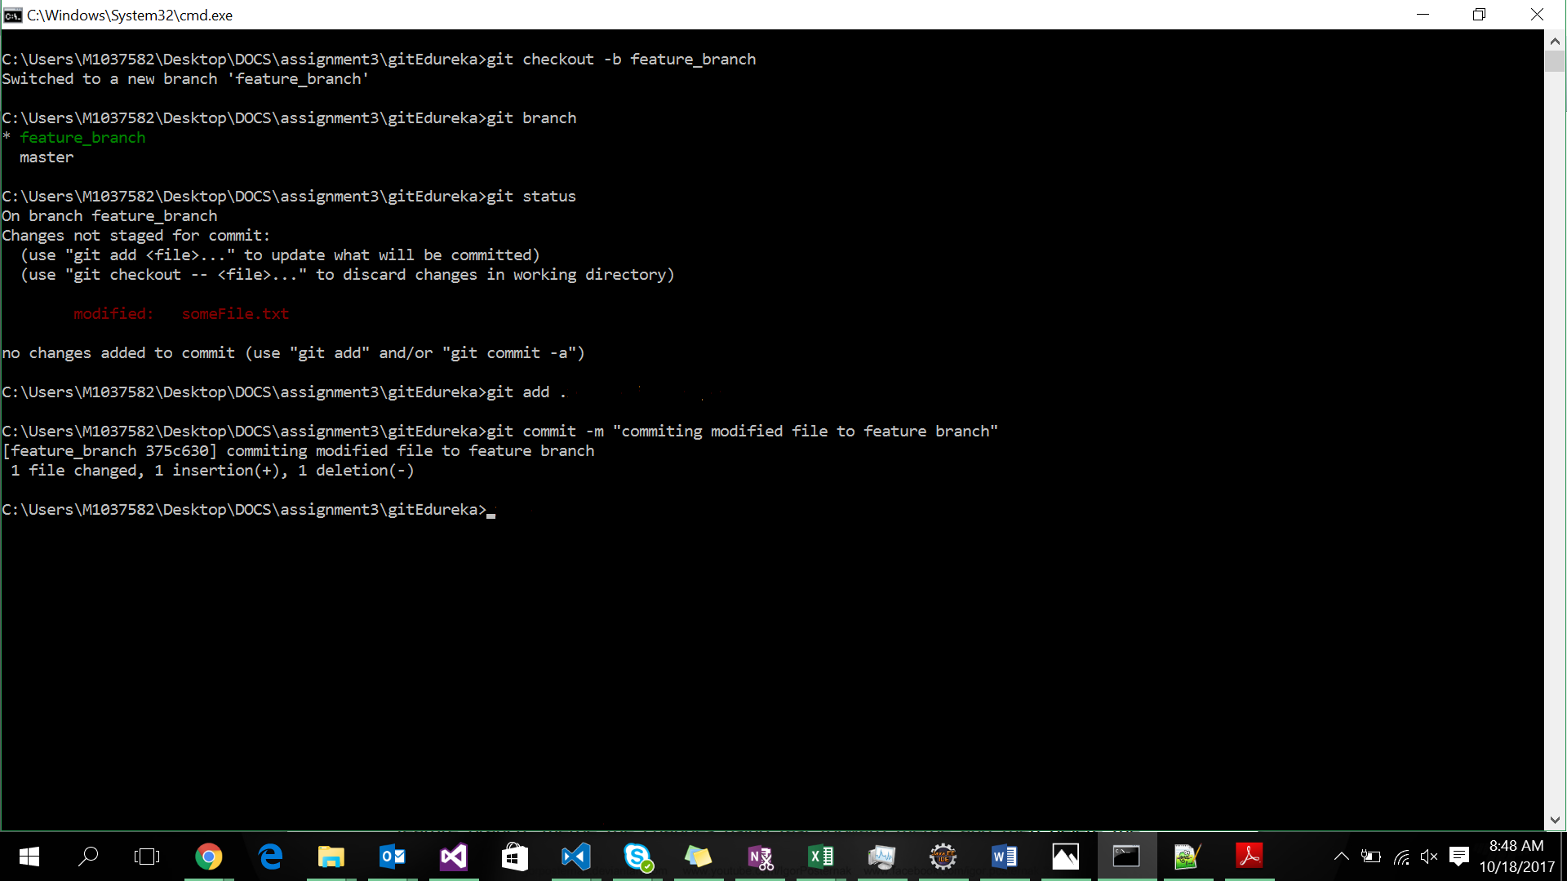

Q7. Merge the changes using the rebase command and finally perform a safe deletion of the feature branch  
  
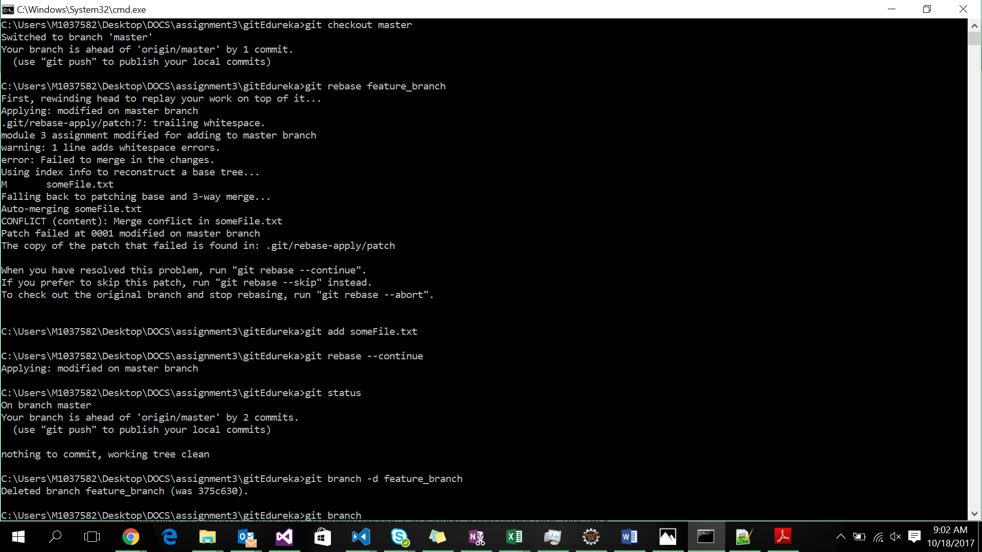

Q8 Create another feature branch and this time after committing the changes to the feature branch, merge the changes using fast forward merge and then delete the feature branch  
  
A8.  
  
