**Salesman ,orders,customer**

**Salesman - salesman_id primary key**

**orders -orderno primary key**

**customer_id foreign key**

**customer -customer id primary key**

**salesmanid foreign key**

use cdac1;

show tables;

select * from salesman;

select * from orders;

select * from customer;

desc customer;

alter table salesman add constraint primary key (salesman_id);

desc salesman;

alter table orders add constraint primary key (ord_no);

alter table customer add constraint primary key (customer_id);

desc orders;

alter table orders add constraint c2 foreign key(customer_id) references customer(customer_id);

alter table customer add constraint c3 foreign key(salesman_id) references salesman(salesman_id);

OUTPUT:  
FOR CUSTOMER TABLE:

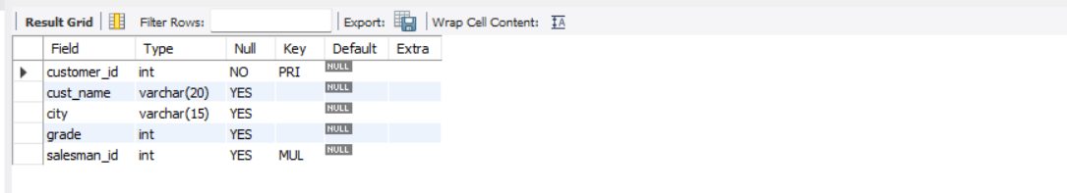

FOR ORDERS:

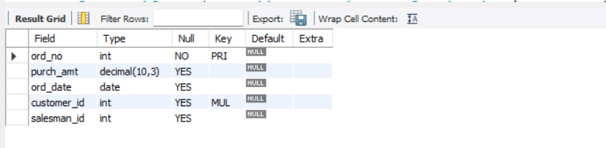

FOR SALESMAN:

