**Q1. From table salesman,create a view for those sales people who belong to the city of New York.**

create or replace view v1 as select salesman_id, city from salesman where city = "NewYork";

select * from v1;

**OUTPUT:**

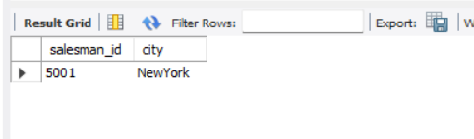

**Q2. From Salesman table,create a view to display the salespeople whose commission is more than 0.13.**

create or replace view v1 as select name , salesman_id from salesman where commission> 0.13;

select * from v1;

**OUTPUT:**

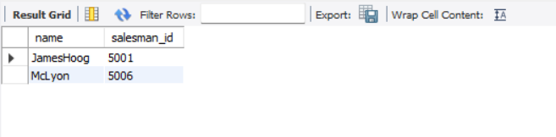

**Q3. From table Customer,create a view that counts the number of customers in each grade.**

create or replace view v2 as select count(customer_id) ,grade from customer group by grade ;

select * from v2;

OUTPUT:  
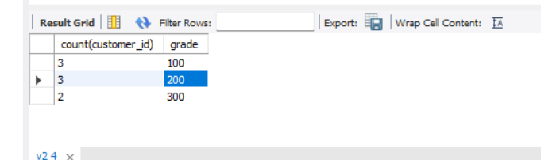

**Q4. From table Orders,create a view to count the number of unique customers, compute the average and the total purchase amount of customer orders by each date.**

**Q5. Create an index on 'custcity' column of the table 'customer'**