1. Write a query to display the name ( first name and last name ) for those employees who gets more salary than the employee whose ID is 206.

use cdac1;

select concat(first_name,” “, last_name) Name ,salary, employee_id from employees where salary >any(select salary from employees where employee_id ='206') order by salary asc;

select salary from employees where employee_id ='206';

OUTPUT:

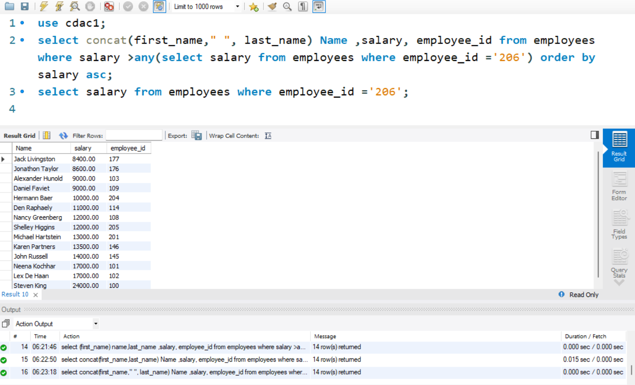

2. Write a query to display the name ( first name and last name ), salary, department id, job id for those employees who works in the same designation as the employee works whose id is 203.

select job_id,employee_id, concat(first_name," ", last_name) Name, department_id, salary from employees where employee_id in(select employee_id from employees where employee_id= '203');

OUTPUT:

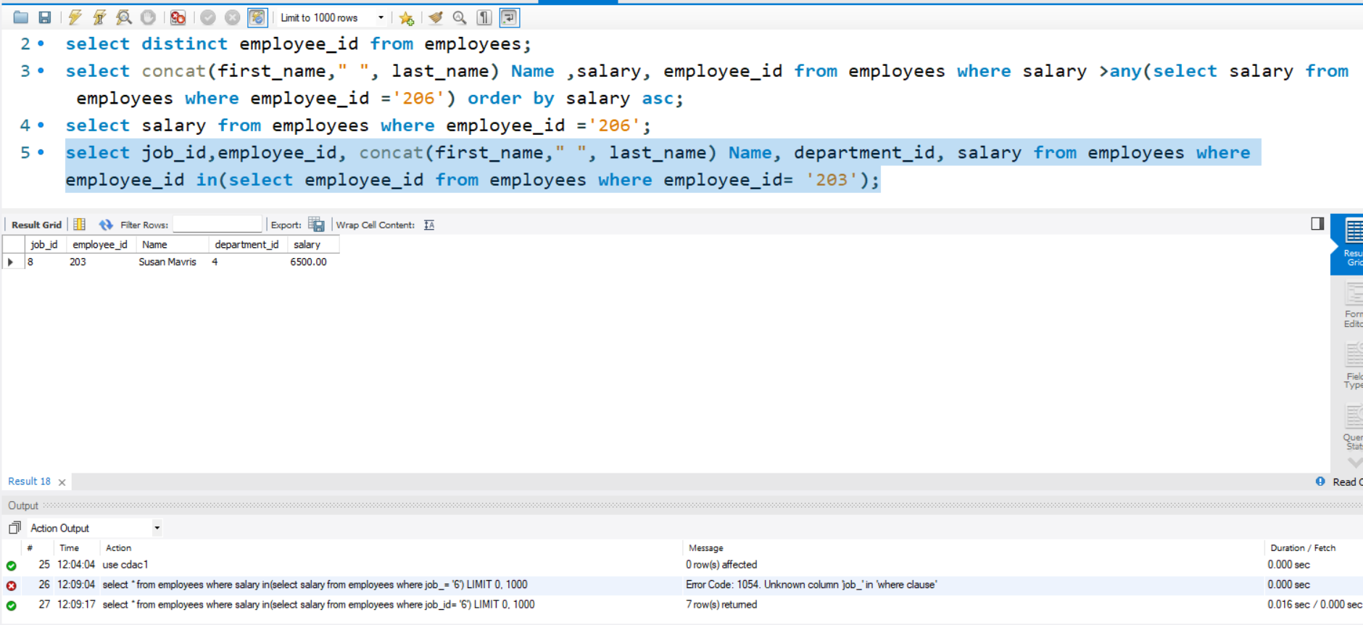

3.Write a query to display the name ( first name and last name ), salary, department id for those employees who earn such amount of salary which is the smallest salary of any of the departments

select concat(first_name," ",last_name)Name, department_id,salary from employees where salary in(select min(salary) from employees group by department_id);

output:  
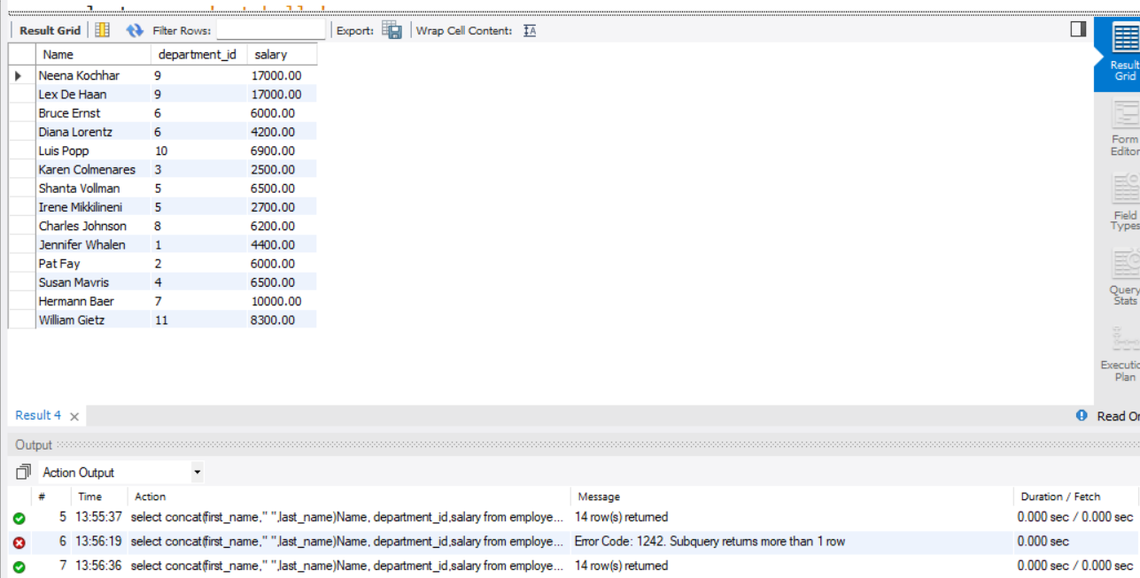

4. Write a query to display the employee id, employee name (first name and last name ) for all employees who earn more than the average salary.

select employee_id, concat(first_name," ",last_name)Name,phone_number, salary from employees where salary >(select avg(salary) from employees);

**Output:**

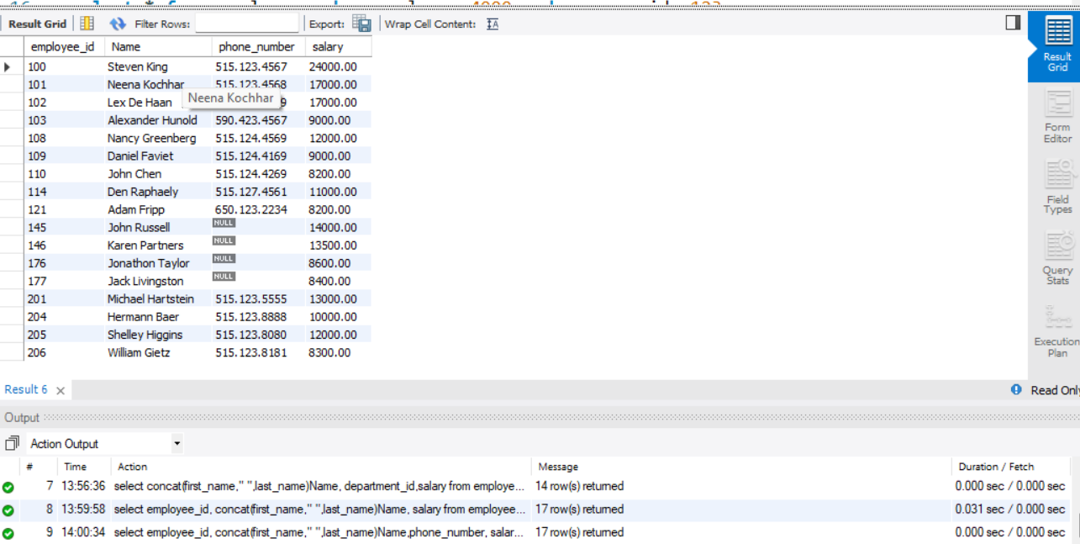

select concat(first_name, " ", last_name) Name, employee_id from employees where salary >any(select avg(salary) from employees);

Output **:**

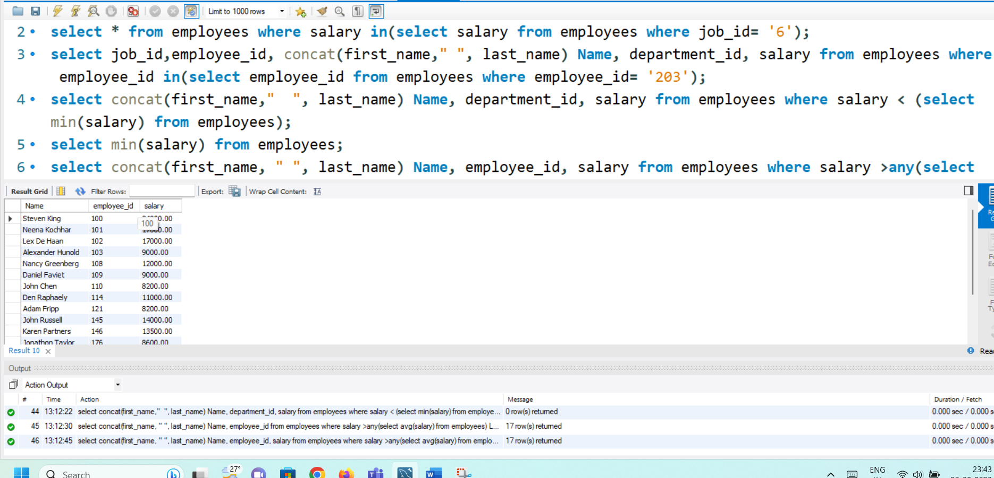

5. Write a query to display the employee name ( first name and last name ), employee id and salary of all employees who report to 'Pataballa'.

select concat(first_name, " ", last_name) Name, employee_id, salary from employees where last_name ='pataballa';

OUTPUT:

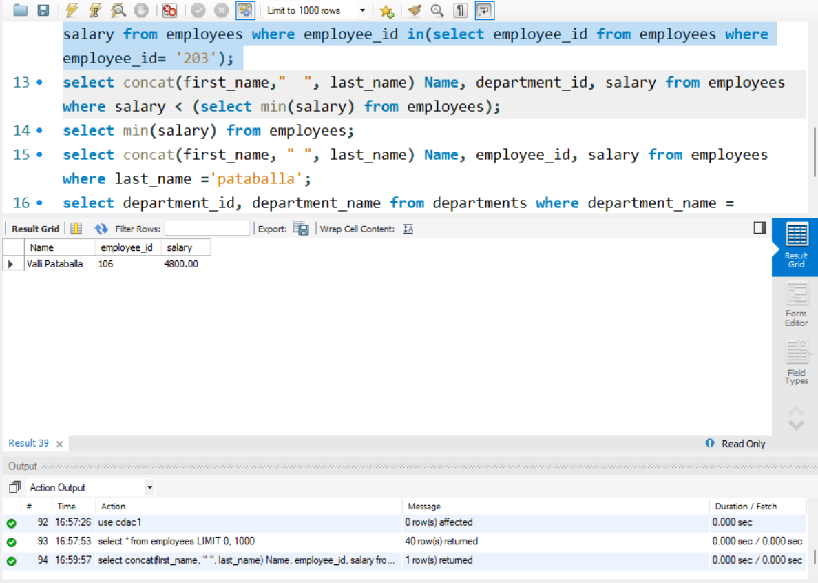

6. Write a query to display the department number, name ( first name and last name ), job and department name for all employees in the Finance department.

select department_id, department_name from departments where department_name ='finance';

OUTPUT:

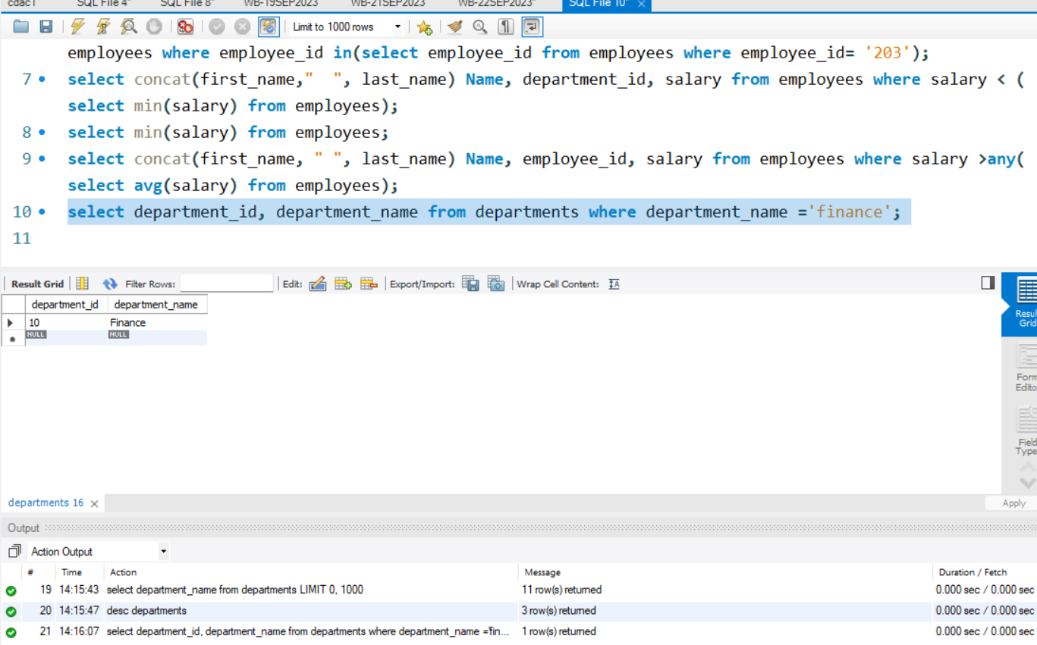

7. Write a query to display all the information of an employee whose salary and reporting person id is 4000 and 123 respectively.

select * from employees where salary= 4000 and manager_id =123;

OUTPUT:

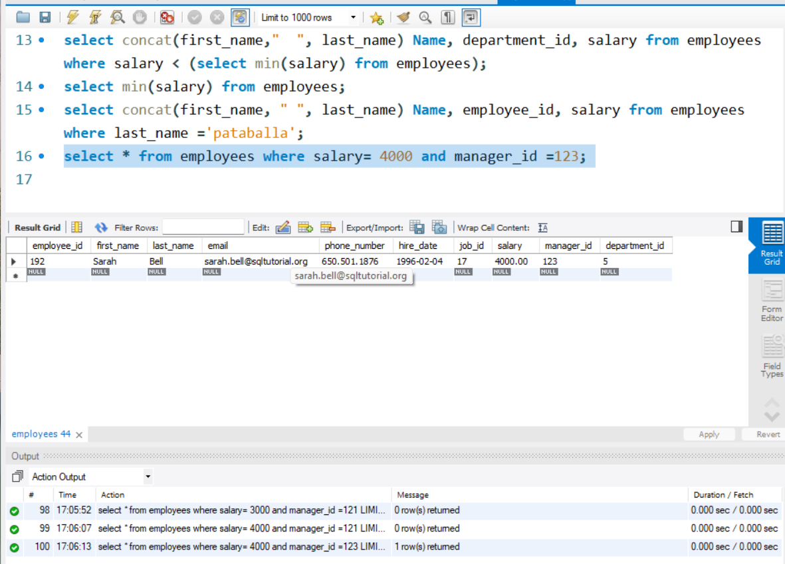

8. Display all the information of an employee whose id is any of the number 178, 192 and 203.

select * from employees where employee_id in(178,192,203);

OUTPUT:

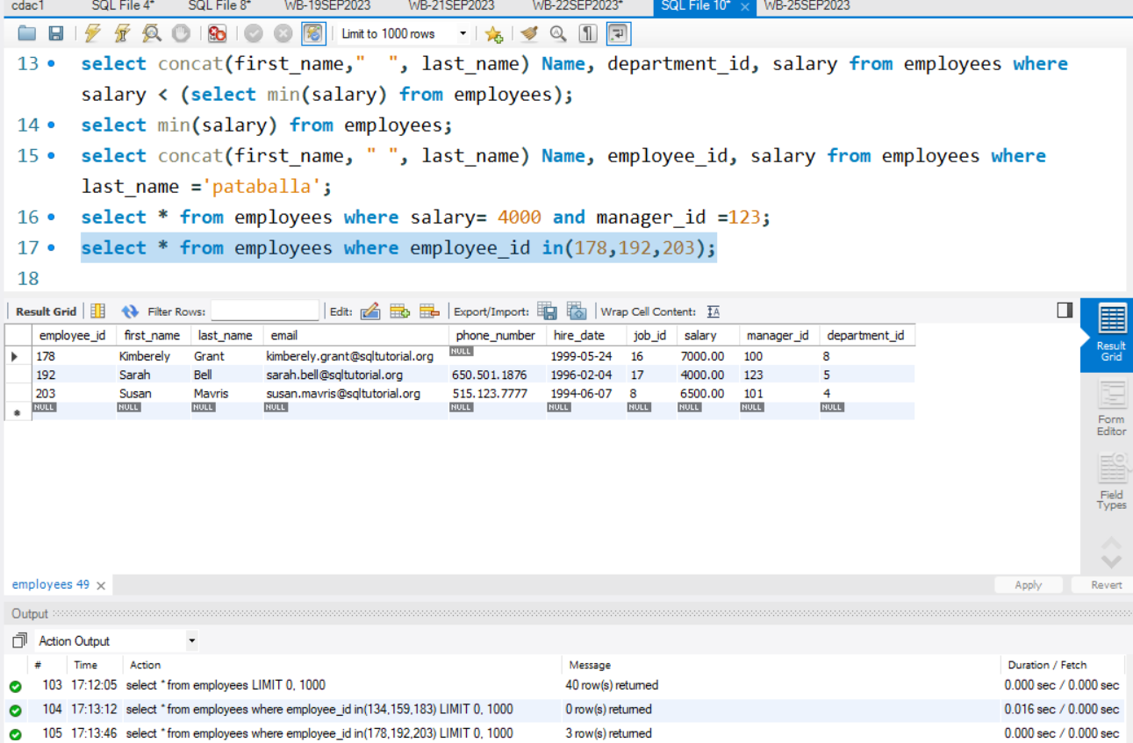

9. Write a query to display all the information of the employees whose salary is within the range 1000 and 3000.

select * from employees where salary between 1000 and 3000;

OUTPUT: 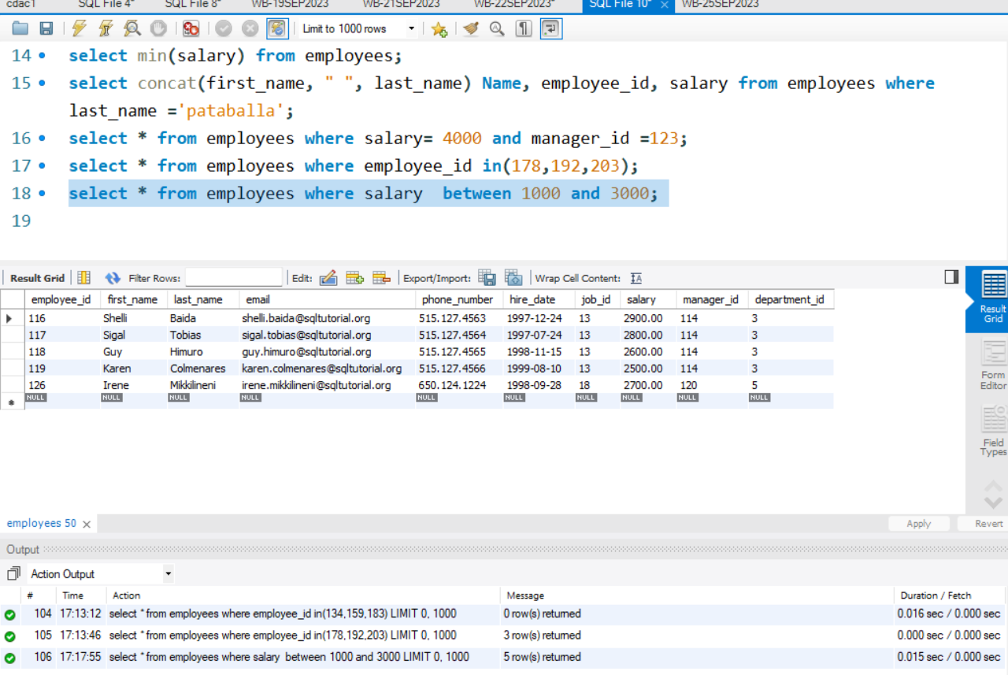

10. Write a query to display all the information of the employees whose salary is within the range of smallest salary and 5000.

11. Write a query to display all the information of the employees who does not work in those departments where some employees works whose manager id within the range 100 and 200.