Table of Contents

# TokenMetrics Mobile App - Architectural & Data Flow Diagrams

## Core Components

### Frontend Components

* Mobile App (React Native)
  + UI Components
  + Navigation System
  + State Management
  + API Integration
  + Error Handling
  + Analytics

### Backend Services

* Authentication Service
* Chat Service
* User Management Service
* Subscription Service

### External Services

* Supabase
* PostHog Analytics
* Sentry Error Tracking
* OAuth Providers
  + Google
  + Twitter
  + Discord
  + Apple

## Data Flow Patterns

### Authentication Flow

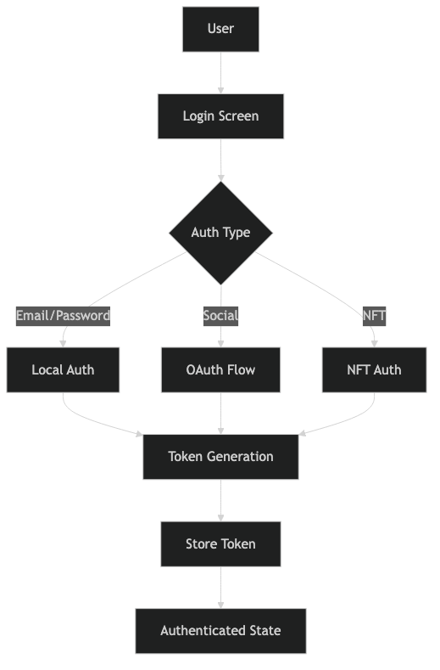

Authentication Flow Diagram

The authentication flow diagram shows the process of user authentication, including:

* Multiple authentication methods (Email/Password, Social, NFT)
* Token generation and storage
* State management for authenticated users

### Chat System Flow

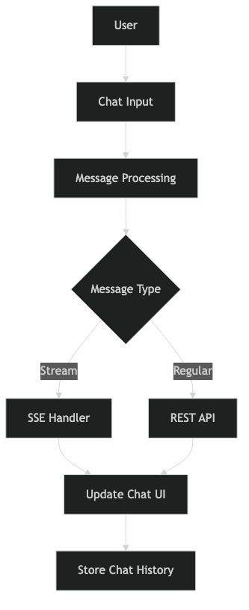

Chat System Flow Diagram

The chat system flow illustrates:

* User input processing
* Message type handling (Stream vs Regular)
* UI updates and history storage
* Integration with SSE and REST APIs

### State Management Flow

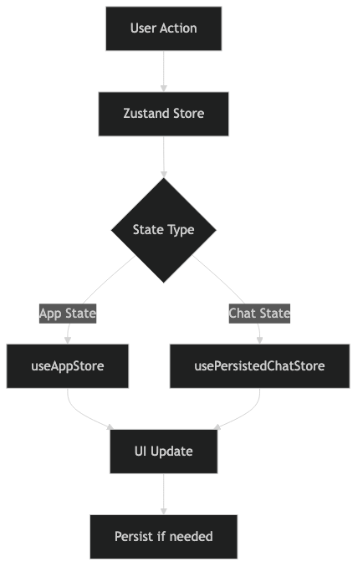

State Management Flow Diagram

The state management diagram demonstrates:

* Zustand store implementation
* Different state types (App State vs Chat State)
* UI updates and persistence logic
* State synchronization flow

## Error Handling Architecture

### Error Flow

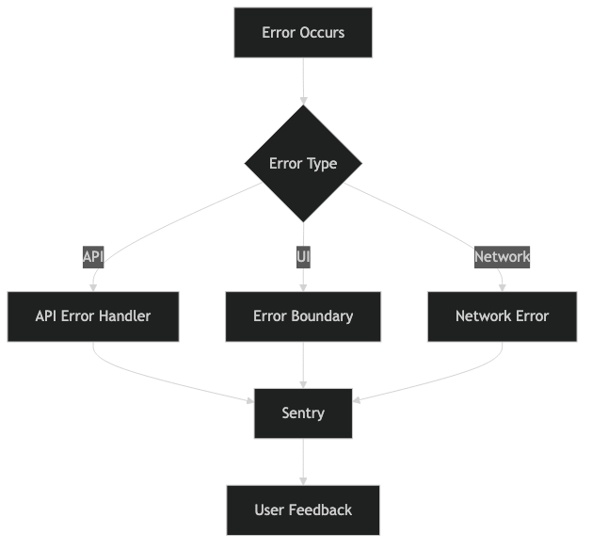

Error Handling Flow Diagram

The error handling architecture shows:

* Different types of errors (API, UI, Network)
* Error handling mechanisms
* Integration with Sentry
* User feedback flow

## Event Flow Architecture

### Event System

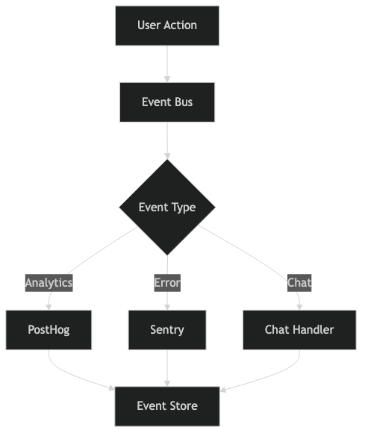

Event System Flow Diagram

The event system diagram illustrates:

* Event bus implementation
* Different event types (Analytics, Error, Chat)
* Integration with external services
* Event storage and handling

## Component Architecture

### UI Layer

└── App  
 ├── Navigation  
 │ ├── RootStack  
 │ ├── MainDrawer  
 │ └── BottomTabs  
 ├── Screens  
 │ ├── Auth Screens  
 │ ├── Main Screens  
 │ └── Modal Screens  
 └── Components  
 ├── Shared  
 ├── Features  
 └── Layout

### State Layer

└── State Management  
 ├── Global State (Zustand)  
 │ ├── App Store  
 │ └── Chat Store  
 ├── Local State  
 │ ├── Component State  
 │ └── Screen State  
 └── Persistence  
 ├── AsyncStorage  
 └── SecureStore

## API Integration Architecture

### Service Layer

└── Services  
 ├── API  
 │ ├── Auth  
 │ ├── Chat  
 │ ├── User  
 │ └── Prompts  
 ├── WebSocket  
 │ └── Chat Stream  
 └── External  
 ├── Supabase  
 ├── PostHog  
 └── Sentry

## Data Persistence Architecture

### Storage Hierarchy

└── Storage  
 ├── Secure Storage  
 │ ├── Auth Tokens  
 │ └── User Credentials  
 ├── AsyncStorage  
 │ ├── User Preferences  
 │ └── Cache  
 └── Memory Storage  
 ├── App State  
 └── UI State

## Security Architecture

### Security Layers

└── Security  
 ├── Authentication  
 │ ├── JWT  
 │ ├── OAuth  
 │ └── Biometric  
 ├── Data Protection  
 │ ├── Encryption  
 │ └── Secure Storage  
 └── API Security  
 ├── Token Management  
 └── Request Signing

## Notes for Diagram Styling

1. Color Scheme:
   * User Interface components: Blue (#4A7DFF)
   * Business Logic: Green (#4CAF50)
   * Data Storage: Yellow (#FFC107)
   * External Services: Purple (#7C5CFF)
   * Security Components: Red (#FF5C5C)
2. Connection Types:
   * Solid lines: Synchronous operations
   * Dashed lines: Asynchronous operations
   * Dotted lines: Event-based communication
3. Component Shapes:
   * Rectangles: Components
   * Diamonds: Decision points
   * Circles: External services
   * Hexagons: Security checkpoints
4. Layer Separation:
   * Clear boundaries between layers
   * Distinct zones for different responsibilities
   * Highlighted interaction points

This document serves as a comprehensive reference for the architectural and data flow diagrams of the TokenMetrics Mobile App, with visual representations of key system components and their interactions.