Software Requirements Specification

Library Management System
Version 1.00

Table of Contents
Table of Contents ii
Revision History ii
1. Introduction 1
1.1 Purpose 1
1.2 Document Conventions 1
1.3 Intended Audience and Reading Suggestions 1
1.4 Project Scope 1
1.5 References 1
2. Overall Description 2
2.1 Product Perspective 2
2.2 Product Features 2
2.3 User Classes and Characteristics 2
2.4 Operating Environment 2
2.5 Design and Implementation Constraints 2
2.6 User Documentation 2
2.7 Assumptions and Dependencies 2
3. System Features 3
3.1 Main Page 3
3.2 Member Maintenance 5
3.3 Maintain Books 8
3.4 Books Enquiry 11
3.5 Books Issue 14
3.6 Books Return 16
3.7 Books Lost 18
4. External Interface Requirements 19
4.1 User Interfaces 19
4.2 Hardware Interfaces 19
4.3 Software Interfaces 19
4.4 Communications Interfaces 19
5. Other Nonfunctional Requirements 19
5.1 Performance Requirements 19
5.2 Safety Requirements 20
5.3 Security Requirements 20
5.4 Software Quality Attributes 20
6. Other Requirements 20
Appendix A: Glossary 20
Appendix B: Business Workflow 20
Appendix C: Issues List 20

Revision History
Name | Date | Reason For Changes | Version

Introduction

Purpose
The purpose of this document is to describe the Library Management System. This document contains the functional, behavioral and non-functional requirements of the project and it also contains the guidelines for system engineers and designers to start working the project.

Document Conventions
Not Applicable

Intended Audience and Reading Suggestions
All the stakeholders of this project are intended audience.

Project Scope
Library Management System is basically automating the manual library system into a desktop-based application so that the Members can know the details of issued books, availability of books and fine when he/she doesn’t return the book.

The project is specifically designed for the use of librarians / library users. The product will work as a complete user interface for library management process and library usage from ordinary users. Library Management System can be used by any existing or new library to manage its books records and insertion and monitoring.
The member cancellation process is out of scope.

The features mentioned in the document are the only scope of the development.

References
- LMS_Busines_Requirements.doc
- Current manual library registers

Overall Description

Product Perspective
Library Management System is a replacement for the manual library management systems which depend on paper work for recording book and member’s information.

Product Features
This system has following features –
- Member Registration
- Maintain Books
- Issue of Books
- Returning Books
- Books Availability Enquiry.

User Classes and Characteristics
User of this system will be the person managing the library operations, primarily Librarian only.

Operating Environment
Not defined at this stage.

Design and Implementation Constraints
Not Applicable

User Documentation
Not Applicable

Assumptions and Dependencies
Following are the assumptions and dependencies for the development:
- The current scope of the software is member Maintenance, It allows adding new members, updating existing members which includes making the members active and inactive
- For books registration every book is input as different Book ID (Should be a running number generated by the system whilst entering the book info), so it does not maintain copies of the same book.
- Seeded data will be created for all lookup fields.

System Features
The Library Management System will provide following features:
- Member Registration – With this feature user will be able to input details of the library members in the system, which can be used while issuing and returning books.
- Maintain Books – With this feature user can maintain the inventory of books.
- User should be capable of recording lost or damaged books.
- Issue of Books – This feature will be used while issuing the books, it will save the details of issued books and the borrower.
- Returning Books – This feature will be used when member returns the book, it will see if book is returned within time range or not.
- Books Enquiry – This feature is used by the librarian if members inquire about books.

Main Page

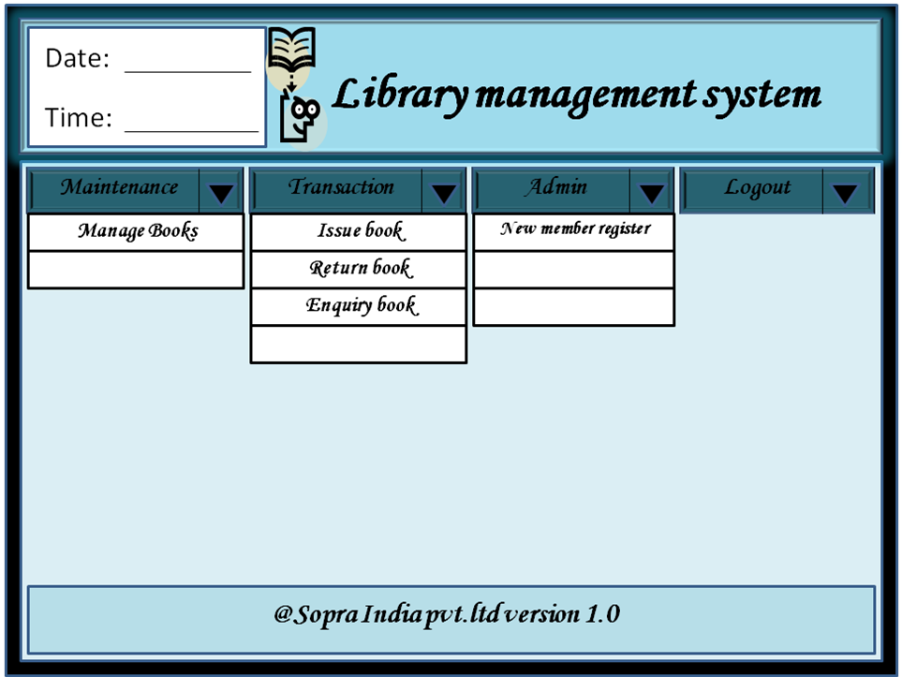

Please note:
- For Enquiry, a separate menu item “Enquiry” will be created and Enquiry book will be part of that menu.
- Logout will not be having expand mode enabled.
- Manage books will be changed to Maintain Books
- Date and time will not be displayed on this (or any) GUI.
- The logout option will be changed to Close

Functional Description: This is Main Page of this software. When the software is started, this page will be displayed first. This Page provides options to navigate further within software as per the activities.

Date and Time  Menu | These fields are labels.  In front of Date current Date and in front of Time Current Time will be displayed.  Date will be displayed in DD/MM/YYYY format. And Time will be displayed in HH:MM format.  Menu will be displayed as per the screen shot.  There will be drop down for Maintenance and Transaction  There should be Close, Minimize and Maximize options available as standard windows.
Control Flow: User can click on the options in the menu to navigate further.

Business Rules: Not Applicable

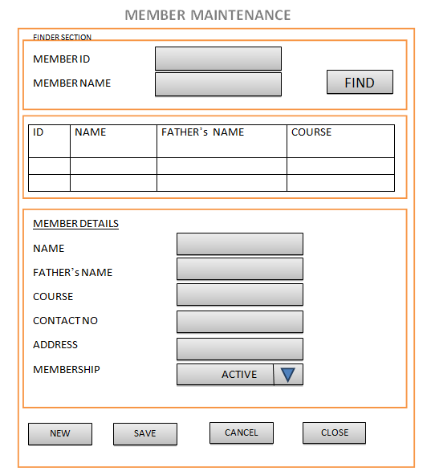
Member Maintenance

Finder Section:
Field | Description
Member Id | To find, one of the input fields must be entered
Member Name | To find, one of the input fields must be entered  Wild character search is allowed on this.

Member details

Field | Description
Name | Char (30)  Mandatory
Father’s Name | Char (30)  Mandatory
Course | Char (40)  Mandatory  It will be a lookup.
Contact number | Char (10)  Mandatory
Address | Char (60)  Mandatory
Membership | Active / Inactive

Functional Description: This is member maintenance window of this software.

Control Flow:
Initially screen opens with all initialized or blank values.
User can find an existing member to update, or he can press new to enter a new member.
After inputting information user presses Save button.
System checks for error, if there is an error in inputs, it throws errors.
If no error data is saved and member ID is generated and displayed in the respective field.

User can press Cancel button anytime to cancel the current operation.

Business Rules:
Save Button will be enabled only after all the mandatory information is entered.
Contact number should be 10 digits, else error should be shown.
Name and fathers name field should not have numeric values or special characters.

Maintain Books
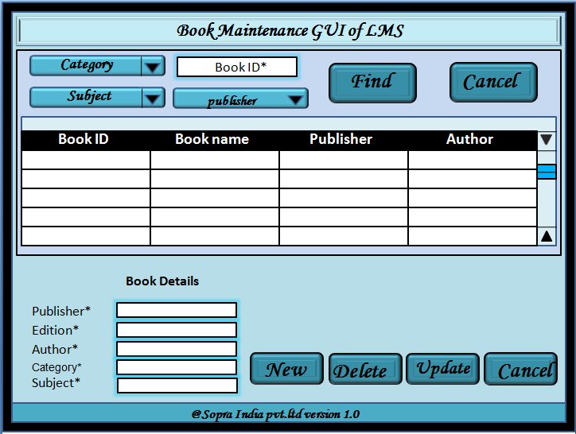

Book finder section

Category | It should be a dropdown  It is not mandatory
Book ID | It is not mandatory
Publisher | It is not mandatory  It is a drop down
Subject | It is not mandatory  It is a drop down
Please note: one of the input fields must be entered to search the books.

Book Details

Book Name | Char (40)  Mandatory
Publisher | Char (40)  Mandatory  Look up
Author | Mandatory
Category | Lookup  Mandatory
Subject | Lookup  Mandatory

Functional Description: This is books maintenance page of the software.

Book Name, Publisher, Author, Category, Subject  Button  - New  - Update  - Cancel | To Add a new record  To save the input Data  To cancel the current operation
Control Flow:
User can select Category, Subject and/or course to find the list of books.
User can select the checkbox to select the record from the list.
As soon as user selects the record, it will be displayed in the input fields below.
Then user can edit the record and press update button to save.
If user wants to add a record, click New to initialize the fields.
Category, subject and publisher fields will be as per the dropdown fields.
Then input values and press update to save.
Delete button will delete the selected record. When deleting, ask the user to enter the reason (i.e. lost or damaged etc.), The book record will not be deleted from db, rather it will be set as deleted.

Cancel to go back to the main page

Business Rules:
One book id will be generated for each book; number of copies is not maintained.
Books MRP should also be maintained.

Books Enquiry

Availability of Books
Check Book Availability
BOOK NAME
TEXT BOX 1
TEXT BOX 2
BOOK AUTHOR
TEXT BOX 3
BOOK PUBLISHER
Search
Cancel

BOOK NAME’S | PUBLISHER | AVAILABILITY Y/N | AVAILABILITY DATE
OK
REFRESH

Functional Description: This is books enquiry screen, it will be used by librarian to know, if book is available or not. If not available then when would be available.

Book Name, Author, Publisher  Book Name, Author, Publisher  Book Name, Publisher, availability (Y/N) and Availability Date  List  Book Name, Publisher, availability (Y/N) and Availability Date  Button  - Search  - Cancel  - OK  - Refresh | These fields are labels.  These fields are input fields, should be alpha-numeric.  Book Name – Char(30)  Author – Char(30)  Publisher – Char(40)  These fields are labels.  List filtered as the selections.  Scroll Bar to scroll the list.  To display the list  To go back to main menu  To go back to main menu  To initialize the input fields and initialize the search.
Control Flow:
User can input Book Name, Author and/or Publisher to find the list of books.
User can press search button to display the list.
If no results found, error message should be displayed.
If user tries to input mismatched values in Book Name, Author and/or Publisher fields then error message will be displayed.
User can press OK or Cancel to go back to main page.
Refresh button will be pressed to refresh the screen.

Business Rules:
If Book is issued the availability flag will be displayed as N.
If the book is issued then it will also display the return date as availability date, else it will be blank.
While searching, one of the 3 fields must be entered.
Search fields allow wild character search (* character).

Books Issue

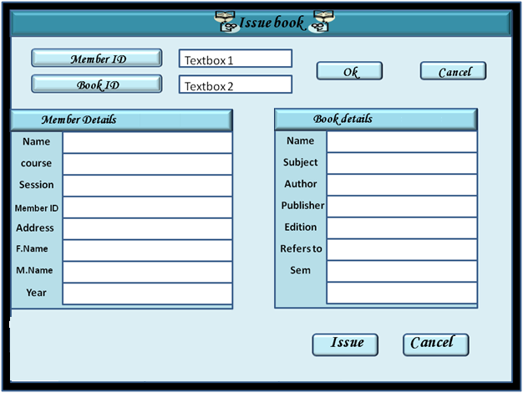

Please note: The OK button will be changed to Find.

Functional Description: This is books issue screen, it will be used by librarian to record the details of books issued.

Member ID, Book ID  Member ID, Book ID  Member details and book details  Button  - OK  - Cancel  - Issue  - Cancel | These fields are labels.  These fields are input fields, should be alpha-numeric. Both fields are mandatory.  The value of these fields will be fetched from database as per input above.  To display the Member and book details  To go back to main menu  To issue the book  To go back to main menu.  .
Control Flow:
User can input Member ID and Book ID to find the details.
User can press OK button to display the details.
If no results found, error message should be displayed.
If user tries to inputs invalid value then error message will be displayed.
User can press Cancel to go back to main page.
Issue button will be update the database to issue the book.

Business Rules:
A member can issue maximum 2 books at a time, error should be displayed if member wants to issue more than 2 books.
If book is already issued then also error should be thrown.
While storing the Data, the Issue date will be saved as current Date and return date will be after 14 days.
When the book is issued, the returned date is displayed to the user.

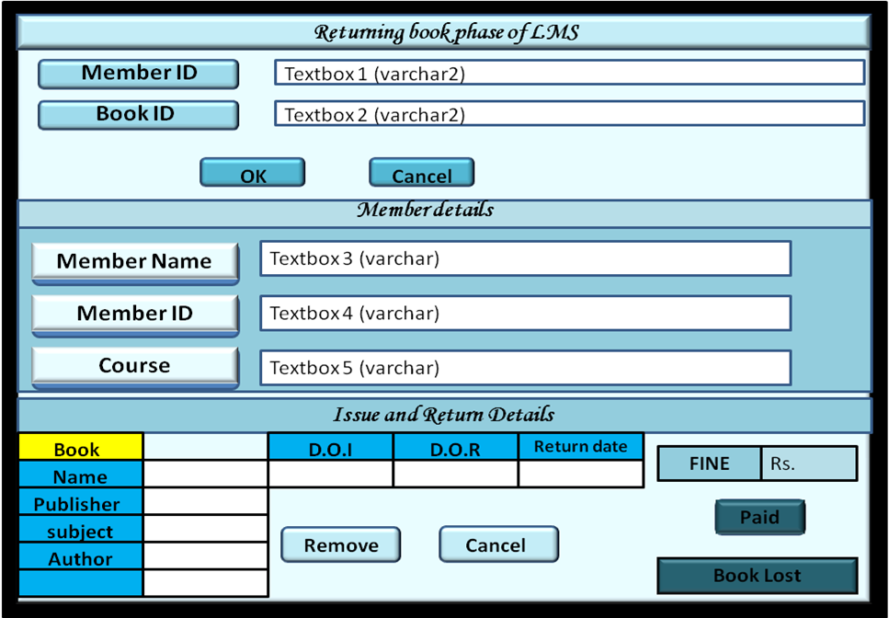
Books Return

Please note: The OK button will be changed to Find button.
The Remove button will be changed to Return.
Fine will not be saved in database so Paid button is not required.
The Return date label will be changed to Actual Return Date.

Functional Description: This is books return screen, it will be used by librarian to record the details of books returned.

Member ID, Book ID  Member ID, Book ID  Member details and book details  Date of Issue  Date of Return  Return Date  Fine  Button  - OK  - Cancel  - Remove (return)  - Cancel  - Paid  - Book Lost | These fields are labels.  These fields are input fields, should be alpha-numeric. Both are mandatory.  The value of these fields will be fetched from database as per input above.  This is output field, displays the issue date.  This is output field, displays the return date.  This is output field, displays the current date.  This is output field, displays the fine amount, if return date is more than the date of return.  To display the details  To go back to main menu  To go save the return details.  To go back to main menu  To mark in the database that the fine is paid  To maintain Book lost details
Control Flow:
User can input Member ID and Book ID to find the details.
User can press OK button to display the details.
If no results found, error message should be displayed.
If user tries to inputs invalid value then error message will be displayed.
User can press Cancel to go back to main page.
If any fine amount is displayed then Paid button will be enabled.
Return button will update the database to return the book.
Book lost button will display the next window.

Business Rules:
Fine will be calculated as 10 Rs for every day, which is more than the date of return.
If paid button is pressed then database will be updated as fine amount is paid.
If paid is not pressed and book is returned then database will be updated as fine amount is not paid.
If book is already issued then also error should be thrown.

Books Lost
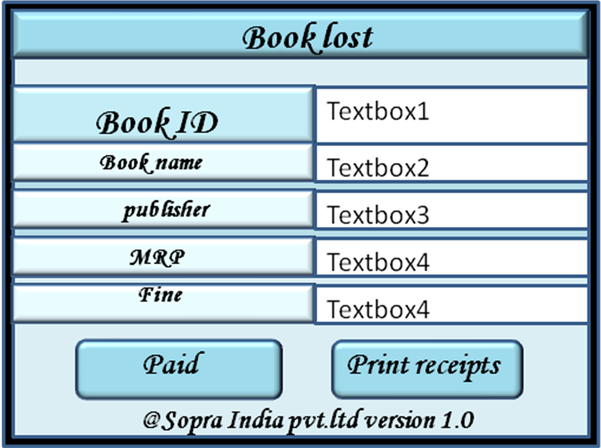

Please note: The buttons will be changed to as follows:

Functional Description: This is books lost window, it will be used by librarian to record the details of books lost.

Book ID  Book ID  Book details  Fine  Button  - Paid  - Print Receipts  - Close | These fields are labels.  All the fields are display only.  This is output field, displays the fine amount,  To update the DB.  To print the receipt  To go back to previous screen
Control Flow:
If no results found, error message should be displayed.
If user tries to inputs invalid value then error message will be displayed.
User can press Cancel to go back to previous page.
Paid button will update the database to mark that the book is lost.

Business Rules:
Fine will be calculated as 100 Rs + MRP

External Interface Requirements

User Interfaces
As mentioned in the above section

Hardware Interfaces
Not Applicable

Software Interfaces
Not Applicable

Communications Interfaces
Not Applicable

Other Nonfunctional Requirements

Performance Requirements
Not Applicable

Safety Requirements
Not Applicable

Security Requirements
Not Applicable

Software Quality Attributes
Not Applicable

Other Requirements
Not Applicable
Appendix A: Glossary
The following are the list of conventions and acronyms used in this document and the project as well:

USER/Librarian | A login id representing a user with user administration privileges to the software.  Client: Intended users for the software
SQL | Structured Query Language; used to retrieve information from a database.
SQL Server | A server used to store data in an organized format.
User Interface | The section of the assignment referring to what the user interacts with directly.
Data Base | The section of the assignment referring to where all data is recorded.
Use Case | A broad level diagram of the project showing a basic overview.
Interface | Something used to communicate across different mediums.
LMS | Library management system.
OS | Operating System
Licensing | give permission to access the software

Appendix B: Business Workflow

Appendix C: Issues List
Not Applicable

