Knowledge Based Community Sharing System

Software Design Description

Ankit Anshul Goel Rohit Ramesh

|  |  |  |  |
| --- | --- | --- | --- |
| **Approver Name** | **Title** | **Signature** | **Date** |
|  |  |  |  |
|  |  |  |  |
|  |  |  |  |

Contents

Section 1. Overview 3

1.1 Purpose 3

1.2 Scope 4

Section 2. System Architecture 5

Section 3. Class Diagram 6

Section 4. Sequence Diagram 7

Section 5. Activity Diagram 8

Section 6. State Chart Diagram 9

Section 7. Data Design 10

Section 8. Data Flow Diagrams 11

Section 9. User Interface Design 12

# Section 1. Overview

## Purpose

1. Presently if a student requires a book or need some reference material then he/she has to contact the professor concerned. Through this website he/she can download /view the corresponding books.

2. E-books can’t be easily accessed by the students, as they are not able to get proper links for the e-books. This website provides direct links to e-books.

3. A change in syllabus has to be intimated to the students in person, as there is no other way to inform them. Through this website a faculty can view it.

4. Approaching a busy professor is always a tough task for a student. So this website is built to make communication between them easier.

5. To associate with publication house to get soft copy.

## 1.2 Scope

The scope of this proposed Open Source software is to enable the creation of knowledge based community that combines audio lectures with quizzes and a table of contents of files that are uploaded.

The deliverables of the software should be a presentation file with a hosting HTML page as a single compressed folder. This presentation can then be published in the Internet.

This project has a lot of scope for future development. Features like ability to capture videos lectures, slide presentation and many more such functionalities can be implemented in the later versions of the software.

# Section 2. System Architecture

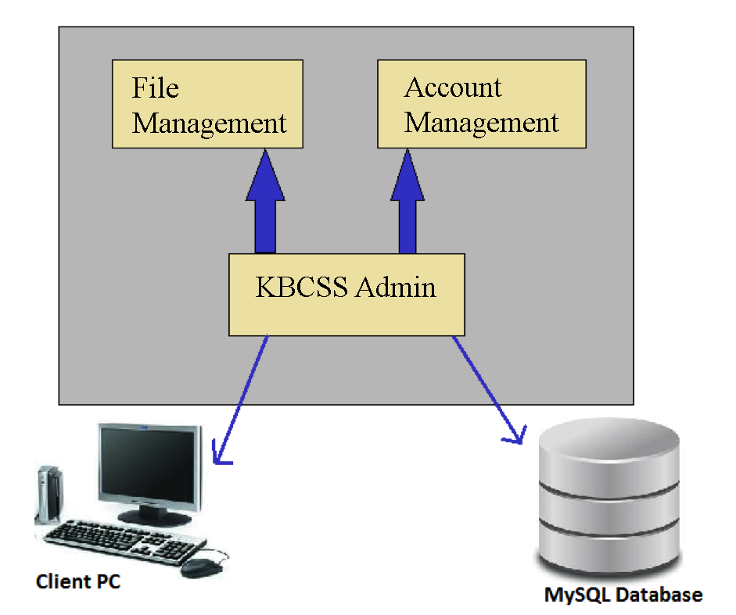

# Section 3. Class Diagram

Client PC

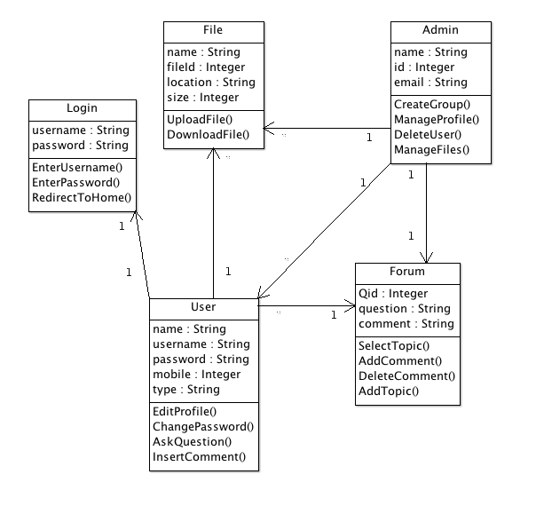

# Section 4. Sequence Diagram

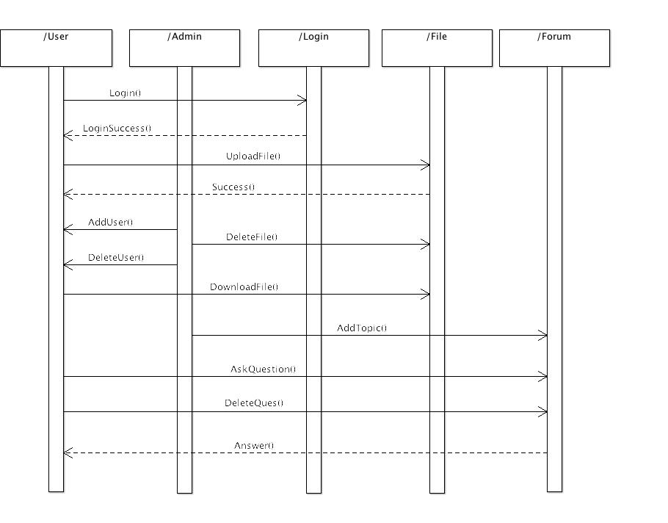

# Section 5. Activity Diagram

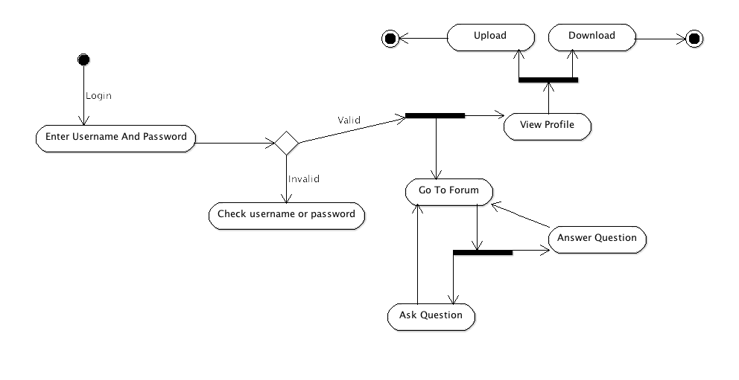

# Section 6. State Chart Diagram

6.1 Upload & Download Functionality

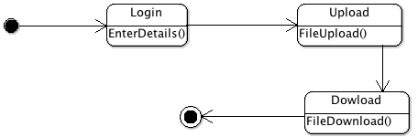

6.2 Forum Functionality

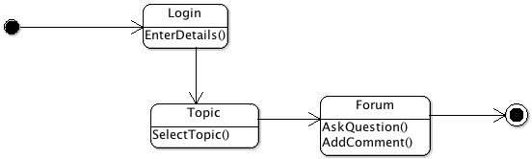

# Section 7. Data Design

7.1 ER diagram

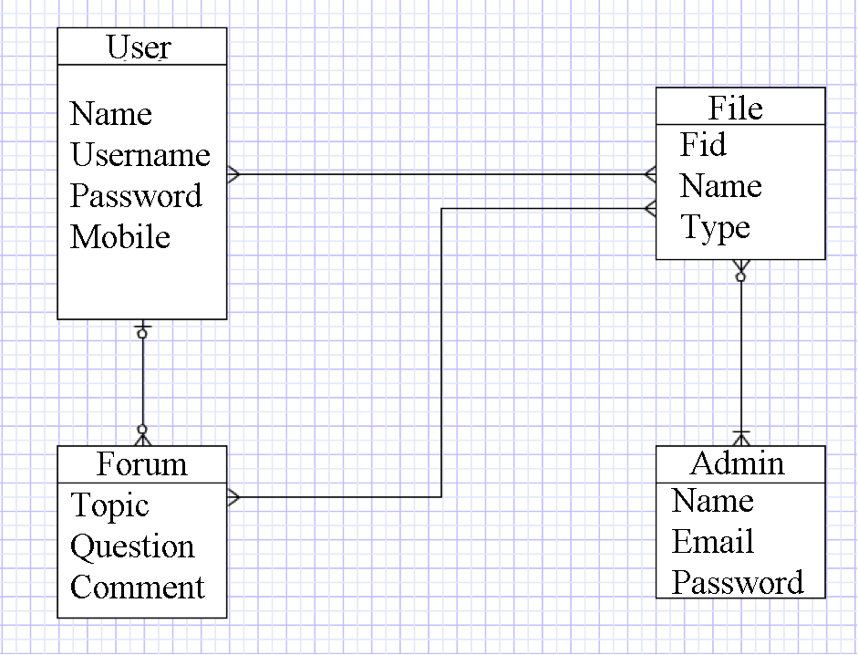

# Section 8. Data Flow Diagrams

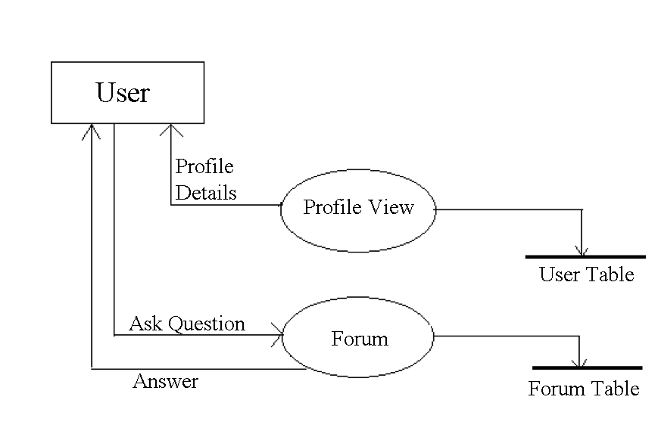

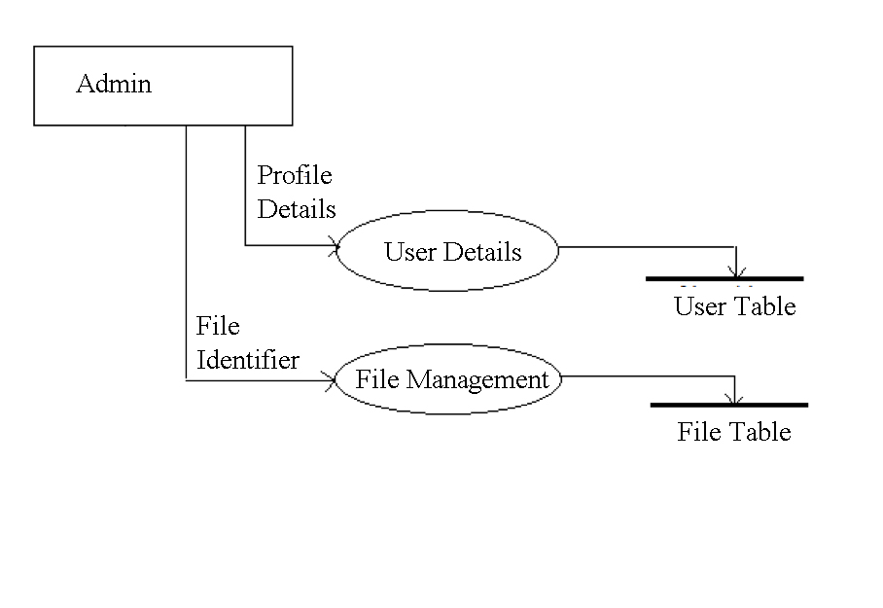

# Section 9. User Interface Design









