Software Requirement

Specification

Online Gym Management System

Submitted By:

Ankit Sardana(04)

Prabal Pratap(18)

Shikha Chauhan(34)

Table of Contents

- Introduction 3
1.1 Purpose 3

1.2 Scope 3

1.3 Definition, acronyms and abbreviations 4

1.4 References 4

- Overall description 4 2.1 Functional requirements 5
2.1.1 User Class 1 – Student 5

2.1.2 User Class 2 – Trainer 6

2.1.3User Class 3 – Administrator 6

2.1.4 User Class 4 – New User 7
2.2 User characteristics 8
2.3 Non Functional requirements 8

- Specific requirements 10

3.1 External Interface Requirements 10

3.1.1 User Interfaces 10

3.1.2 Hardware Interfaces 16

3.1.3 Software Interfaces 16

3.1.4 Communication Interfaces 16

3.2 Software System attributes 16

1. Introduction

We all know health is wealth.Being healthy and fit gives us energy to do
anything.Physical fitness is very necessary for a healthy and tension free life.Physical fitness includes diet,exercise and sleep.

Online Gym Management System has been developed to enable its customers to get all information about the gymnasium and He/She can access or enroll at the gym via online and also enables the trainers and administrator to update their details and information. So, as to handle all the necessary and minute details easily and proper database security according to the user.

This section gives a scope description and overview of everything included in this SRS document. Also, the purpose for this document is described and a list of abbreviations and definitions is provided.

1.1 Purpose

Online Gym Management System automates activities of gymnasium, provides opportunities to the customers to improve their body fitness and effectively communicate with their trainers.

It is easy to use gym and health club membership management system. It helps to beep records of members and trainers and allow easy communication between them and administrator.It is also feature packed,helping you in the management and growth of the gym.It also provides on time and before time alerts for renewals of memberships,gym plans.

The purpose of this document is to give a detailed description of the requirements for Online Gym Management System. It also explains system constraints, interface and interactions with other external entities. This document is primarily intended to be proposed to a customer for its approval and a reference for developing the first version of the system for the development team.

1.2 Scope

This project facilitates the members of the gymnasium to login their personal account and update their credentials time to time. They can view what different packages,trainers,time schedule are available for them. They can also see their personal progress. They can communicate with the trainers .

The trainers can give their personal details and update them time to time. He/she can choose their time schedules for their customers.They are responsible for mentoring their customers in their diet plans and exercises.They can also see their salary transactions.They can also answer to their customer queries,give suggestions to the administration.

The administrator is responsible for taking care of gym requirements.It keeps track of fee payments and salaries. He/she can also update and set packages and time schedules. He/she also keep track of members and trainers reports.

New users can register for a member or trainer account.He/she can visit about the gymnasium and can view what all facilities and different packages are provided by the gym.He/she can also make queries.

1.3 Definitions, acronyms and abbreviations

Term | Definition
Member | Someone who is the customer of gym
Trainer | Mentors of the customers
Administrator | Owner of the system
New user | Someone who access the system

1.4 References

- IEEE Software Engineering Standards Committee, "IEEE Std 830-1998, IEEE. Recommended Practice for Software Requirements Specifications", October 20, 1998.
- https://zenplanner.com/solutions/gym-owner
- http://gymmanagementsoftware.in/index.php
- Fundamentals of Software Engineering , Fourth Edition,Rajib Mall

2. Overall Description

The following section presents the complete set of functional and non-functional requirements. Functional requirements are listed first, according to their relationship to the overall system, members, trainers, new users and the administrator. The non-functional requirements that pertain to safety, security, usability, reliability and performance are subsequently presented. The functional requirements have been specified using a natural language description and as such, the reader is directed to refer Use case diagram for further detail.

2.1 Functional Requirements

This section includes the requirements that specify all the fundamental actions of the software system.

2.1.1 The Member

The following table presents the identified functional requirements that directly relate to the members who access the system.

Requirements | Description
M01 | The registered member must be able to login into the system.When the registered member login,screen must appear asking for user id and password.If member id and password are correct,member is logged in otherwise an error meessage is shown.
M02 | Member must be able to view his personal details and update them time to time.
M03 | Member must be able to see the time schedules and trainers.They must also be able to choose any of them.
M04 | They must be able to communicate with trainers and administration.
M05 | They must be able to pay gym charges.
M06 | They must be able to see their personal progress.
M07 | They must be able to change and select their packages.

2.1.2 Trainer

The following table presents the identified functional requirements that directly relate to the trainers who are registered with the system.

Requirements | Description
T01 | The registered trainer must be able to login into the system.When the registered trainer login,screen must appear asking for user id and password.If trainer id and password are correct,member is logged in otherwise an error meessage is shown.
T02 | The trainer must be able to see his personal details and update them from time to time.
T03 | The trainer must be able to set his time schedules.
T04 | The trainer must be able to see his salary transactions.
T05 | The trainer must be able to communicate with his customers and give suggestion to administration.

2.1.3 Administrator

The following table presents the identified functional requirements that directly relate to the administrator.

Requirements | Descriptiion
A01 | The administrator must be able to login into the system.When the administrator login,screen must appear asking for user id and password.If his/her id and password are correct,He/she is logged in otherwise an error meessage is shown.
A02 | Administrator must be able to keep track of members and trainers.
A03 | Administrator must be able to see and update time schedules and packages.
A04 | Administrator must be to see fee paid and salaries given.
A05 | Administrator must be able to check gym equipments(i.e.gym machines,food suppliments,gym merchandise etc.) and order them if needed.

2.1.4 New User

The following table presents the identified functional requirements that directly relate to any new user of the system.

Requirements | Description
NU01 | New User should be able to see about the gym
NU02 | New User should be able to contact the administrator.
NU03 | New User must be able to register. When the new user clicks on register button a drop down menu appears from where he/she must be able to select his category.
NU04 | In the register output screen,new user fills his details and clicks the register button.If all details are complete , registration succesfull will be shown and user can login according to category choosen by him from now on.If any of the mandatory fields are not filled or its not according to the prescribed  format,error message will be shown.

2.2 User Characteristics

There are three types of users who interact with the system : Members, Trainers and Administrator . Each of them uses the system in a different way, so each of them has their own requirements.

The system would enable the members to share their personal details and update them,see their personal progress,check and select time schedule and trainers,made fee payments and interact with trainers .

It allows trainers to share their personal details and update them from time to time,set time schedules,make gym routines,check salary transactions and interact with customers.

The administrator interacts with the portal,keep track of all the details of members and trainers,create and update new packages,launch new gym products, set time schedules and interacts with trainers.

2.3 Non-Functional Requirements

This subsection presents the identified non-functional requirements for the website. The subcategories of non-functional requirements given are safety, security, performance, reliability, usability.

2.3.1 Usability

Requirement | Description
U01 | The system must be easy to use by new users.
U02 | The menus of the system must be easily navigable  by the users with buttons that are easy to understand
U03 | The system must be intuitive and simple in the  way it displays all relevant data and relationships.
2.2.2. Reliability

Requirement | Description
R01 | The system should provide the user updates on completion of requested process and if the requested processes fail, it should provide the user reason of the failure.
R02 | The system should not update the data in any database for any failed processes

2.3.3. Performance

Requirement | Description
P01 | All the pages of the website should take less than 1 sec.
P02 | System shall be portable.
P03 | All the function of the system must be available to the user everytime the system is turned on.
P04 | The system shall be capable of restoring itself to its previous state in the event of failure(A system crash or power loss).

2.3.4 Security

Requirements | Description
S01 | An administrator password used for login must have a bit strength of 8 characters.
S02 | An administrator password used for tablet login must be changed every three months
S03 | An administrator shall only be able to log into one tablet at any given instance of time

3. Specific Requirements

3.1 External interface Requirements

This section provides a detailed description of all inputs into and outputs from the system. It also gives a description of the hardware, software and communication interfaces and provides basic prototypes of the user interface.

3.1.1 User Interfaces
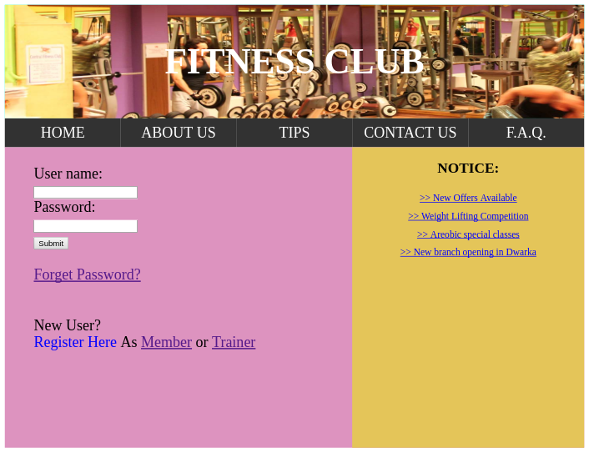
The Online Gym Management System offers a standardized UI framework that maintains a consistent set of user interface tools. Every page includes a standard header, including the important links. The home Page layout is as shown above :
From the home page the registered member can login using their user name and password.

Registration process:

Whenever a person clicks on the register link, a new register output screen appears which has the following layout.

Member:

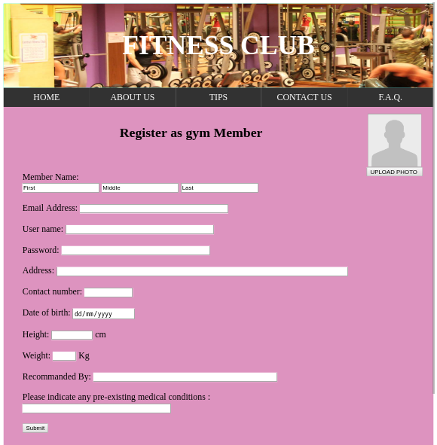
Trainer:

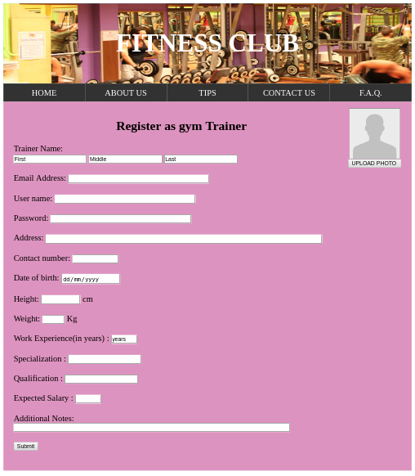

Login Process:

In the home screen, the registered member can login using their user name and password. When the use log-in according to his category his/her account is open with different layouts.

Admin:

When admin log-in the page layout of his account is as shown below:

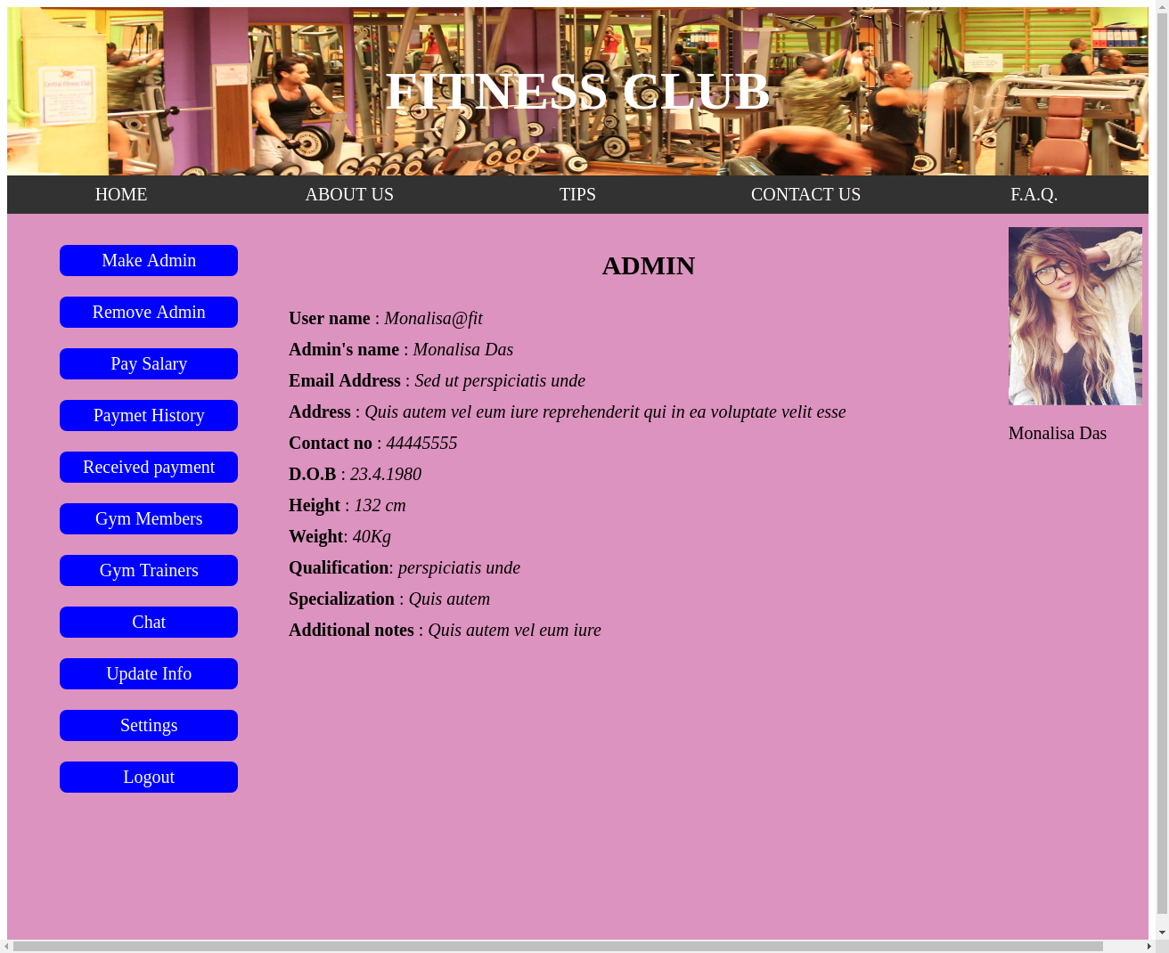

Member:

When Member log-in the page layout of his account is as shown below:

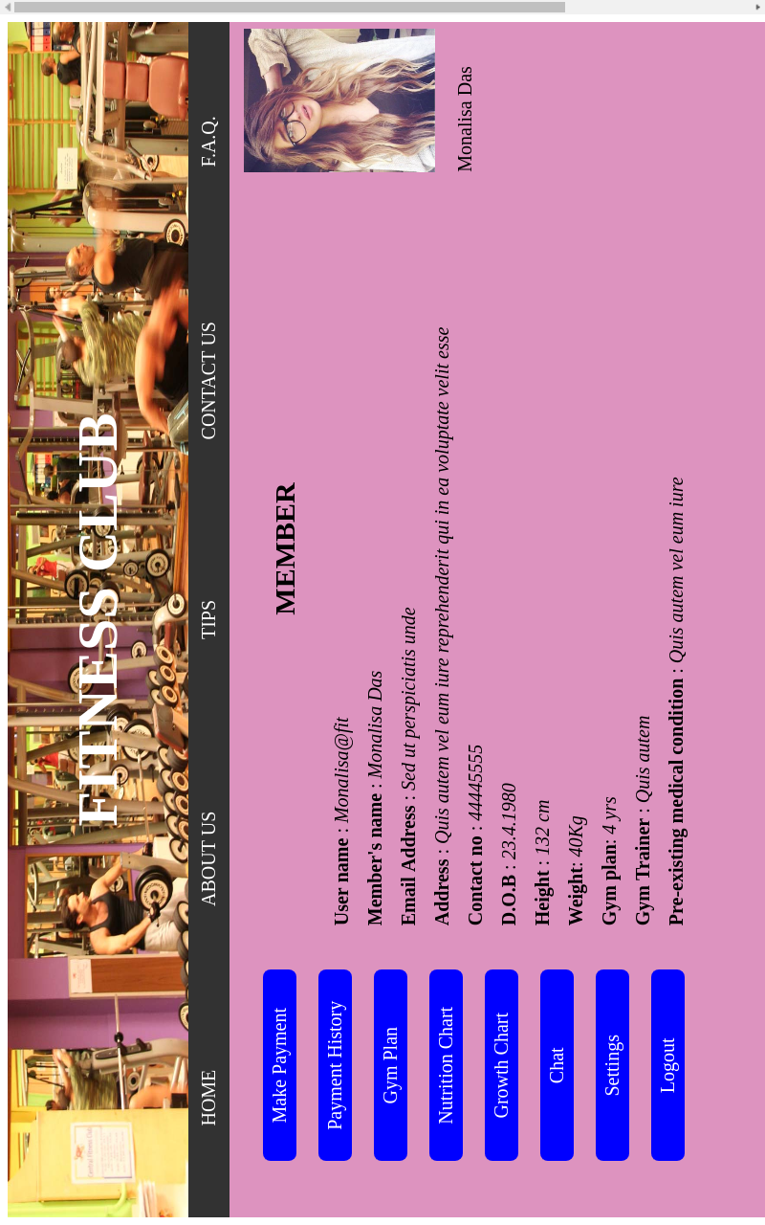
Trainer:

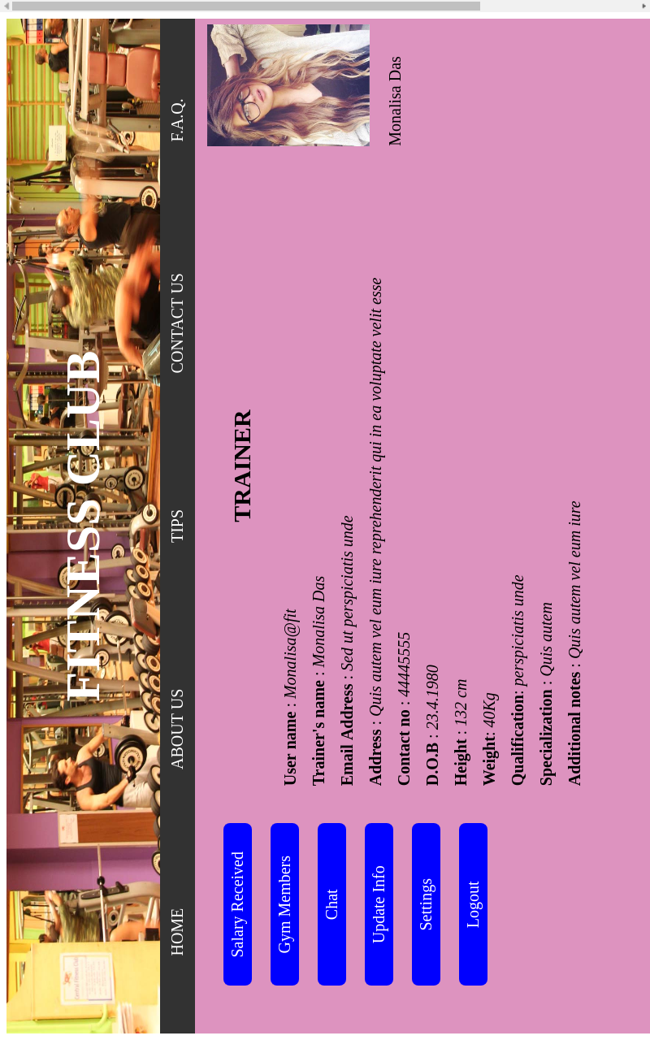
When Trainer log-in the page layout of his account is as shown below:

3.1.2Hardware Interfaces

The website does not use any hardware interfaces.

3.1.3 Software Interfaces

The system interfaces with a Database Management System (DBMS) that stores the information necessary for the system to operate. The DBMS must be able to provide, on request and with low latency,correct data that has been requested by a user. Any changes done by the administrator will be automatically reflected in the database.

3.1.4 Communication Interfaces

Our system will be secured via an HTTPS connection to prevent session hi-jacking.Furthermore, sensitive data will be stored in the database using industry standard encryption. Emails sent to restore a password change will contain a randomized temporary password (not in plaintext) so as to prevent identity theft.

3.2 Software System Attributes

3.2.1 Correctness

Our system will implement a method to verify correctness of the data provided. We will prevent automated spam bots from posting on our site. Beyond that, we must also verify and and validate the contents . Furthermore, we can impose a check to prevent duplicate data.

3.2.2 Adaptability

Our product must be adaptable in the sense that it displays properly and functionally to a user no matter what screen size they are using. This is important because today more than 30% of website traffic originates from a mobile device or tablet. We will accomplish this using a responsive CSS design that will downscale our layout according to the screen size of the viewer. This could be a strict downscale in which the content does not change, it simply shrinks, or it could be a full content switch in which larger items are replaced by smaller ones.

3.2.3 Availability

The website requires an active internet connection in order to load and communicate with the database.

3.2.4 Security

The website will provide security of the communication between the system and server. The messages should be encrypted for log-in communications so others cannot get user-name and password from those messages. Website will also provide Login Account Security. If a user tries to log in to the web portal with a non-existing account then the user should not be logged in. He should be notified about log-in failure. To ensure security of user accounts , the user should not be able to log-in to the web portal for a certain time period after three times of failed log-in attempts.

