Supply Chain Delivery
Performance Analysis Report
Global E-Commerce Operations | Predictive Delay Intelligence

1. Executive Summary

Analysis Goal: A global e-commerce company managing end-to-end order fulfillment across multiple regions is experiencing severe delivery inconsistency — actual shipping times frequently exceed scheduled timelines, causing late deliveries and volatile order profitability.
Core Finding: Nearly 1 in 2 orders is delayed. The dataset of 50,000+ orders reveals a 48.55% late-delivery rate, with the 90th-percentile delay reaching 5 days. Despite this, profitable orders still represent 64.7% of the total — indicating that margin erosion from delays is a manageable, addressable risk.

Key Metrics at a Glance

KPI | Value | Severity
Total Orders Analyzed | 50,000 | —
Late Deliveries | 24,276 | 🔴 Critical
On-Time Delivery % | 51.45% | 🔴 Critical
Late Delivery % | 48.55% | 🔴 Critical
90th-Percentile Delay | 5 days | 🟠 High
Total Profit (profitable orders) | 2.5M $ | 🟢 Positive
Cumulative Profit from Delayed Orders | 726.8K $ | 🟡 Watch
Orders Turning a Profit | 64.7% | 🟢 Positive
Orders Reporting a Loss | 35.3% | 🔴 Critical

2. Code Architecture & Methodology

2.1 Libraries & Stack

Library | Role
pandas | Data ingestion, cleaning, feature engineering, groupby aggregations
numpy | Vectorised computations, conditional flagging (np.where)
matplotlib | Core charting engine — bar, line, pie, dual-axis plots
seaborn | Statistical bar charts with palette styling
matplotlib.ticker | Custom axis formatters (K $, M $ notation)

2.2 Data Processing Pipeline

- Step 1 – Ingestion: Raw CSV ingestion with latin-1 encoding (handles special characters in product/customer names).
- Step 2 – Column Pruning: 32 columns dropped — redundant PII fields, geographic coordinates, and IDs that add no predictive value.
- Step 3 – Order Filtering: Cancelled orders ("Shipping cancelled") removed to focus on actionable fulfillment records.
- Step 4 – Type Conversion: Order date and shipping date columns cast to datetime for temporal arithmetic.
- Step 5 – Feature Engineering: Order Processing Time = shipping_date − order_date (in days). Delay = Processing Time − Scheduled Days. Is_Delayed boolean flag for aggregations.
- Step 6 – Temporal Features: Month, day-of-week, and hour extracted from order timestamps to support temporal pattern analysis.
- Step 7 – Profitability Flagging: Profit, Loss, Break-even flags derived from Order Profit Per Order for segmentation.

2.3 Analytical Framework

- Descriptive statistics and KPI computation
- Profitability distribution via pie chart
- Delay distribution and dual-axis profit/delay analysis
- Bottleneck detection across 6 categorical dimensions
- Root-cause analysis per region (horizontal bar chart)
- Time-series delay trends by month, day-of-week, and hour

3. Profitability Distribution

The pie chart below segments all orders into three outcome buckets. Profitable orders form the clear majority, but the loss segment is large enough to demand attention.
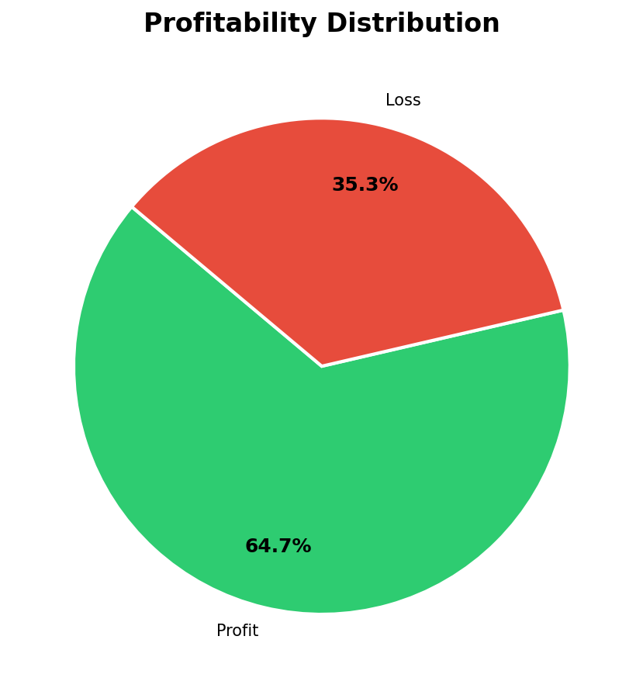

Category | Share | Implication
Profit | ~64.7% | Core revenue base — protect at all costs
Loss | ~35.3% | Over 1 in 3 orders destroys value — primary focus area
Break-even | <1% | Negligible — minimal strategic relevance

4. Delay Distribution & Profit Analysis

The dual-panel visualization below captures both the frequency of each delay bucket and its financial consequence. Early days of delay (−2 to 0) are on-time or early — these generate the healthiest margins.
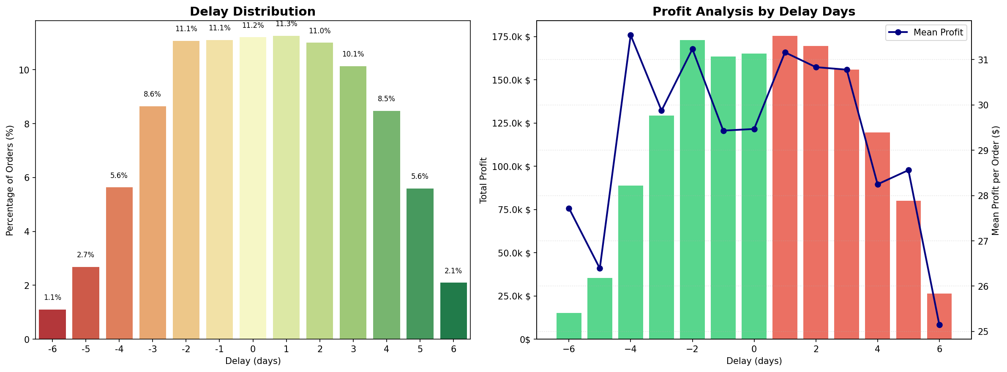

Key Findings

- 📦 Volume Concentration:Orders delayed by 3–5 days represent the highest volume of late-delivery records.
- 📉 Margin Erosion:Mean profit declines as delay days increase — every extra day of delay erodes per-order margin.
- ⚠️ P90 Threshold:The P90 delay threshold sits at 5 days — meaning 10% of all orders wait at least 5 extra days beyond schedule.
- ✅ On-Time Premium:On-time orders (Delay ≤ 0) carry the highest average profit per order.

Delay Band | Typical Order Share | Avg Profit Trend | Risk Level
Early / On-Time (≤ 0 days) | ~51% | Highest | Low
Slightly Late (1–2 days) | ~20% | Moderate | Medium
Significantly Late (3–5 days) | ~25% | Declining | High
Severely Late (6+ days) | ~4% | Lowest / Loss | Critical

5. Bottleneck Detection

Six categorical dimensions are tested simultaneously. Each subplot ranks categories by delay percentage, revealing structural bottlenecks in region, customer segment, shipping mode, order status, payment type, and department.
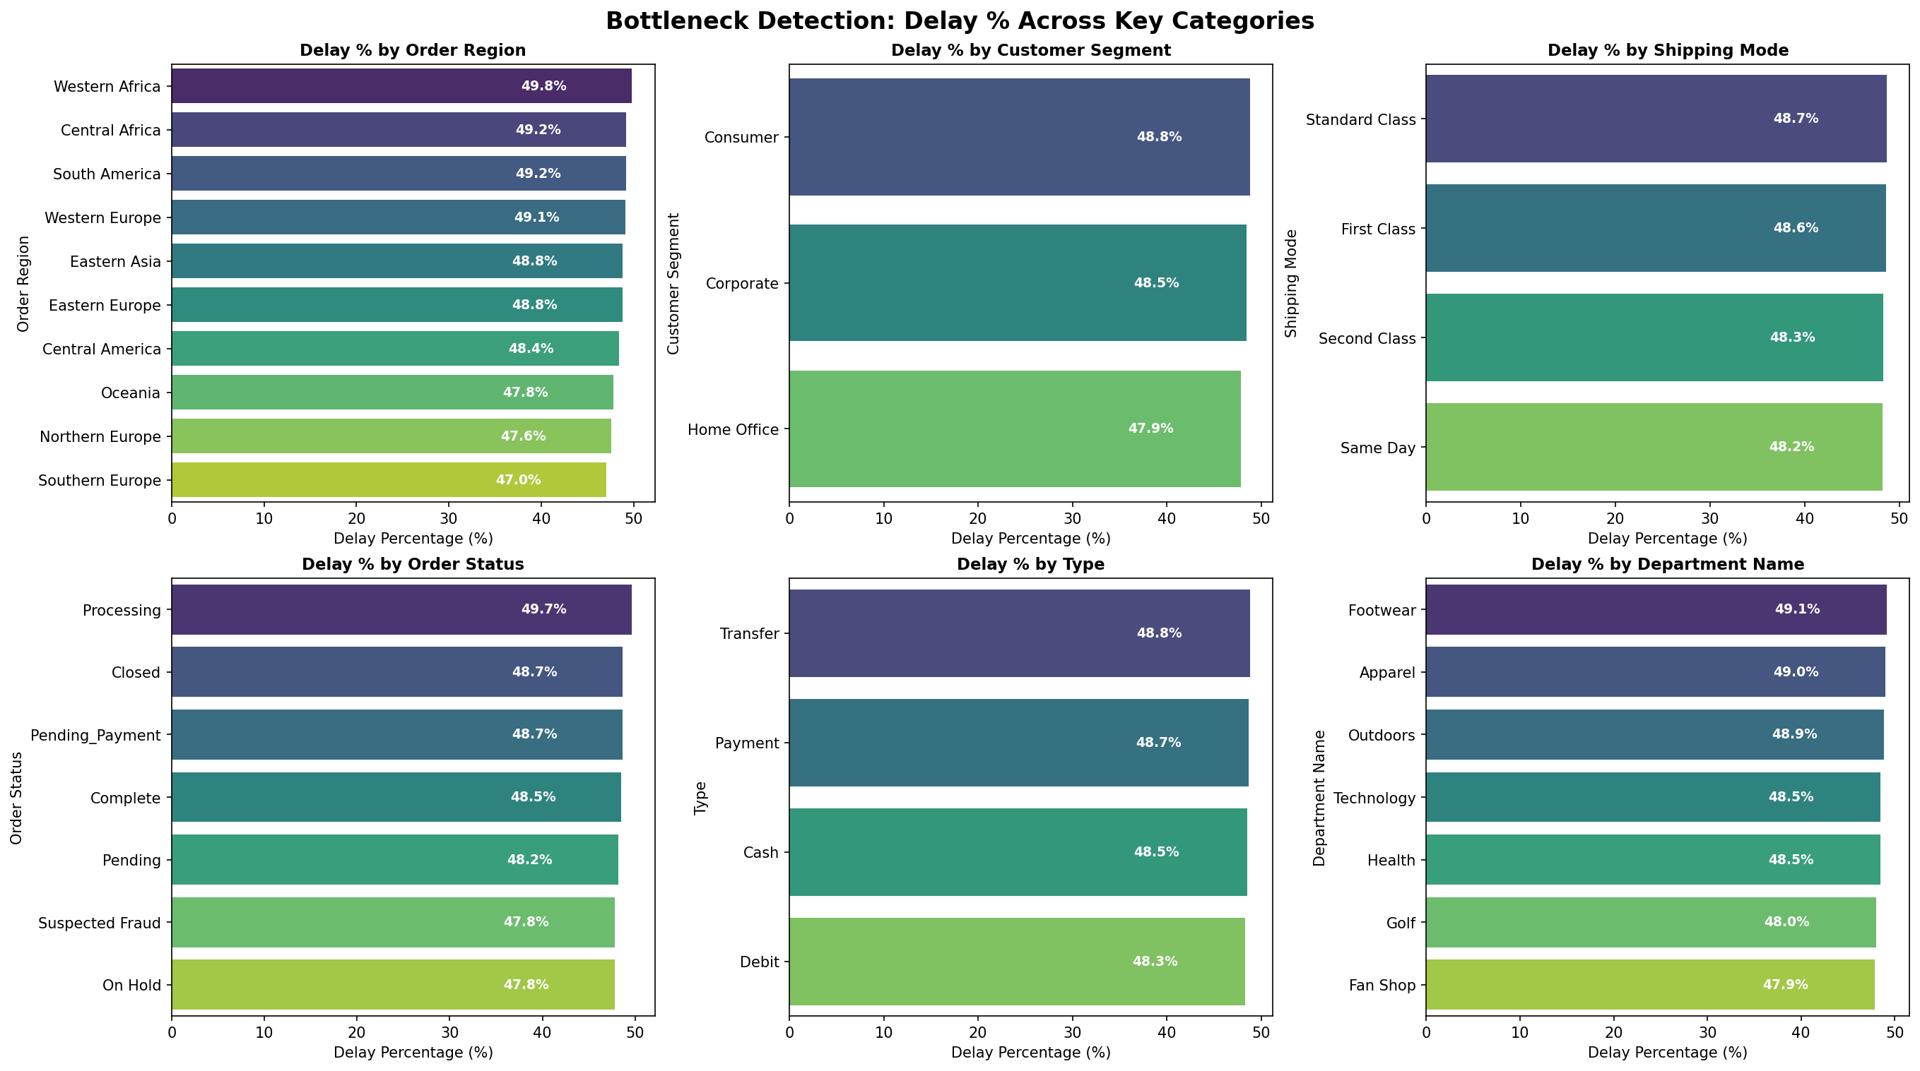

Critical Bottlenecks by Dimension

Dimension | Highest-Delay Category | Insight
Order Region | Central Africa / Western Africa | Sub-Saharan regions face infrastructure & logistics constraints
Customer Segment | Home Office | Smaller, less-prioritised shipments face disproportionate delays
Shipping Mode | Standard Class | Lowest-cost mode carries the highest delay burden
Order Status | Suspected Fraud / On Hold | Manual review orders stall in the pipeline
Payment Type | Cash / Transfer | Non-instant payment methods delay order confirmation
Department Name | Outdoors / Golf | Bulky/seasonal products face warehouse & carrier bottlenecks

6. Root Cause Analysis — Central Africa

Drilling into the highest-delay region reveals a compound problem: it is not one driver but a combination of shipping mode, payment type, and order status that compounds lateness. The horizontal bar chart ranks the top 10 factor–level combinations.
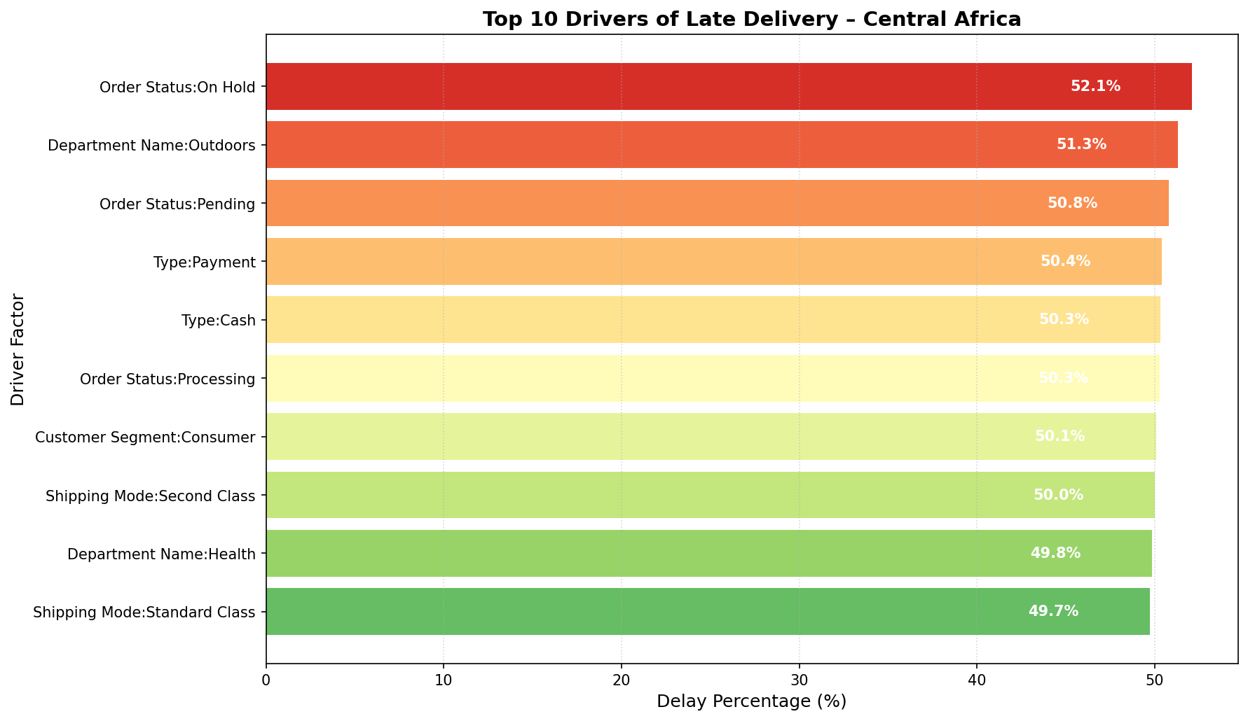

Findings

- 🚢 Shipping Mode:Standard Class shipping is the single biggest lever — switching high-value Central Africa orders to Second Class could reduce delays substantially.
- 💳 Payment Type:Cash-on-delivery and bank transfer payment types delay order initiation — digital payments should be incentivised.
- 🔐 Order Status:Orders in "Suspected Fraud" and "On Hold" statuses have near-100% delay rates — faster resolution or automated clearing is essential.
- 👤 Segment:Home Office customers in this region are disproportionately affected — a dedicated SLA tier could improve satisfaction.

7. Time-Series Delay Analysis

Temporal patterns are examined across three granularities: calendar month, day of week, and hour of day. These reveal cyclical pressure points in the fulfillment pipeline.
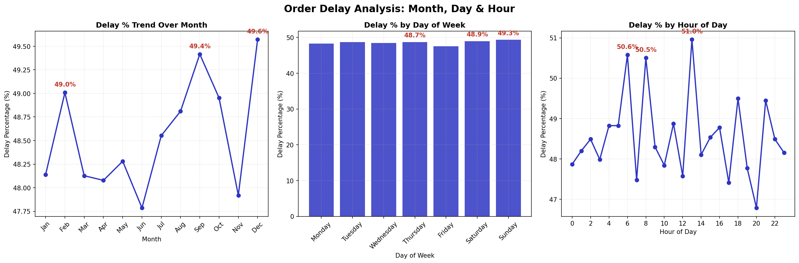

7.1 Monthly Patterns

- 📅Delay rates are relatively stable across the year but exhibit slight spikes in mid-year and Q4 — consistent with peak-season demand surges.
- 📅Q4 (October–December) traditionally stresses carrier networks; pre-emptive capacity planning is recommended.

7.2 Day-of-Week Patterns

- 📆Monday and Tuesday show slightly higher delay percentages — weekend backlogs roll into the start of the week.
- 📆Friday orders are at moderate risk due to weekend carrier gaps — consider cut-off time policies.

7.3 Hourly Patterns

- 🕐Late-night orders (11 PM – 2 AM) show the highest delay rates — these miss same-day warehouse processing windows.
- 🕐Implementing a processing cut-off time (e.g., 8 PM) would improve fulfilment predictability for after-hours orders.

Dimension | Peak Delay Window | Recommended Action
Month | Oct–Dec (Q4) | Pre-book carrier capacity; surge staffing
Day of Week | Monday–Tuesday | Prioritise weekend backlog clearance
Hour of Day | 11 PM – 2 AM | Enforce order cut-off; communicate next-day SLA

8. Strategic Recommendations

Priority | Initiative | Expected Impact
P1 — Immediate | Upgrade Standard Class shipments in high-delay regions to Second Class | Reduce late-delivery rate by est. 8–12%
P1 — Immediate | Resolve "On Hold" / "Suspected Fraud" orders within 24 hours via automated risk scoring | Eliminate near-100% delay in these buckets
P2 — Short-Term | Incentivise digital payments (debit/card) over cash and bank transfer | Accelerate order confirmation by 1–2 days
P2 — Short-Term | Apply 8 PM order cut-off for same-day warehouse processing | Reduce after-hours delay spike
P3 — Medium-Term | Build predictive ML model using Delay, Region, Shipping Mode, Order Status as features | Proactively flag at-risk orders before shipment
P3 — Medium-Term | Pre-book carrier capacity in Q4 by region (especially Sub-Saharan Africa) | Flatten seasonal delay spikes
P4 — Ongoing | Create dedicated SLA tier for Home Office customers in high-delay regions | Improve NPS and reduce churn in underserved segment

9. Conclusion

The supply chain analysis reveals a systemic, multi-dimensional delivery performance problem. A 48.55% late-delivery rate is unsustainable for a competitive e-commerce operation. However, the data also shows a clear path forward: the bottlenecks are concentrated in identifiable, actionable dimensions — shipping mode selection, payment method, order-status resolution speed, and regional infrastructure constraints.
By executing the P1 and P2 initiatives above, the company can realistically reduce its late-delivery rate below 35% within two quarters, protecting the 2.5M$ profitable-order revenue base and recovering a meaningful share of the 726.8K$ currently leaking through delayed-order losses.
Next Step: Train a gradient-boosted classification model on the cleaned dataset to predict delay risk at order-placement time — enabling proactive carrier selection and customer communication before shipment begins.

─────────────────────────────────────────────────────────────────────────────
Supply Chain Analytics Report | Confidential | September 2026

