Project High Level Design (HLD)
Restaurant Analytics Platform
Snowflake + Snowpipe + Informatica CDI + Star Schema + SCD2 + Streamlit + Cortex (Search, RAG, Analyst NL→SQL)
Document Date: 26 Jan 2026

1. Executive Summary
This document describes an end-to-end Restaurant Analytics platform built on Snowflake. Raw CSV files (customers, restaurant locations, menu items, and order line items) are ingested using Snowpipe into a RAW layer, then transformed using Informatica CDI into a Star Schema for analytics. A Snowflake Streamlit dashboard provides business KPIs and drilldowns. Cortex Search + RAG enable semantic Q&A over operational documents (KPI definitions, SOPs), and Cortex Analyst enables governed Natural Language Querying (NL→SQL).

2. Business Objectives & Success Metrics

2.1 Objectives
- Ingest restaurant operational data from CSV into Snowflake with low latency.
- Enable analytics on revenue, orders, average order value, item performance, and restaurant performance.
- Track Customer and Menu Item history using SCD Type 2 for accurate time-travel analysis.
- Provide Streamlit dashboard with filters (date, region/restaurant, cuisine, loyalty tier, channel).
- Provide knowledge assistant (RAG) for metric definitions, SOPs, and data dictionary.
- Enable governed NLQ (NL→SQL) for business users over curated semantic views.

2.2 Success Metrics
- Snowpipe ingestion latency < 5 minutes per file arrival.
- DW refresh SLA < 30 minutes after ingestion completion.
- Reject rate < 2% with quarantine and traceability (file + reason).
- NLQ restricted to semantic views with safe SQL enforcement (SELECT-only, LIMITs).

3. Scope (In-scope / Out-of-scope)

3.1 In-scope
- Landing folder structure and sample CSV source files.
- Snowflake ingestion using stages and Snowpipe pipes per entity.
- Star schema design with FACT_ORDERS and dimensions (Customer, Menu Item, Restaurant, Date).
- CDI mappings, mapping tasks, and taskflow orchestration.
- SCD Type 2 design for DIM_CUSTOMER and DIM_MENU_ITEM.
- Streamlit dashboard and Cortex features (Search+RAG, Analyst NL→SQL).

3.2 Out-of-scope
- Upstream POS/OMS system changes and MDM implementation.
- Predictive forecasting and dynamic pricing models (future enhancement).
- Third-party BI tools implementation.

4. Assumptions & Constraints

4.1 Assumptions
- CSV files are dropped hourly/daily to cloud storage.
- Snowflake account supports Snowpipe, Streamlit and Cortex features.
- Informatica CDI Secure Agent is configured with access to Snowflake.
- Business documents exist for indexing (KPI definitions, SOPs, glossary).

4.2 Constraints
- Potential CSV schema drift; ingestion must quarantine bad records.
- PII (email, phone) requires masking and role-based access.
- NLQ must be governed to avoid expensive queries and unauthorized access.

5. High Level Architecture (diagram description in text)
- Source Layer: POS/order exports and master data exports in CSV.
- Ingestion Layer: External stage + Snowpipe loads RAW tables.
- Transformation Layer: Informatica CDI loads DW star schema with SCD2 dimensions.
- Consumption Layer: Streamlit dashboard reads semantic views.
- GenAI Layer: Cortex Search indexes documents; RAG answers with citations; Cortex Analyst generates SQL from natural language.

6. End-to-End Data Flow
- Files land in landing folders by entity.
- Snowpipe auto-ingests into RAW tables and captures rejects/load history.
- CDI taskflow runs: DIM_DATE → DIM_RESTAURANT → DIM_CUSTOMER (SCD2) → DIM_MENU_ITEM (SCD2) → FACT_ORDERS.
- Streamlit dashboards query SEMANTIC views for KPIs and charts.
- RAG: user question → retrieve docs via Cortex Search → answer with citations.
- NLQ: user question → Cortex Analyst generates SQL over semantic views → execute safely → show result.

7. Source Data (CSV specs + samples)

7.1 Landing Folder Structure
/landing/restaurant_analytics/
customers/customers_YYYYMMDD.csv
restaurants/restaurants_YYYYMMDD.csv
menu/menu_items_YYYYMMDD.csv
orders/orders_YYYYMMDD.csv
/quarantine/restaurant_analytics/
/archive/restaurant_analytics/

7.2 Source Files Included
- restaurant_customers.csv (20 rows)
- restaurant_locations.csv (15 rows)
- menu_items.csv (20 rows)
- restaurant_orders.csv (25 rows)

8. Snowflake Ingestion Design (Snowpipe)
- Create CSV file format (skip header, trim spaces, null handling).
- Create external stage pointing to landing folders; optional internal stage for controlled operations.
- Create one pipe per entity to COPY INTO RAW tables (RAW_CUSTOMERS, RAW_RESTAURANTS, RAW_MENU_ITEMS, RAW_ORDERS).
- Include metadata columns (LOAD_TS, SOURCE_FILE_NAME).
- Error handling: ON_ERROR=CONTINUE + capture rejects; monitor using load history and alerts.

9. Data Model Design (Star Schema)

9.1 Star Schema Diagram
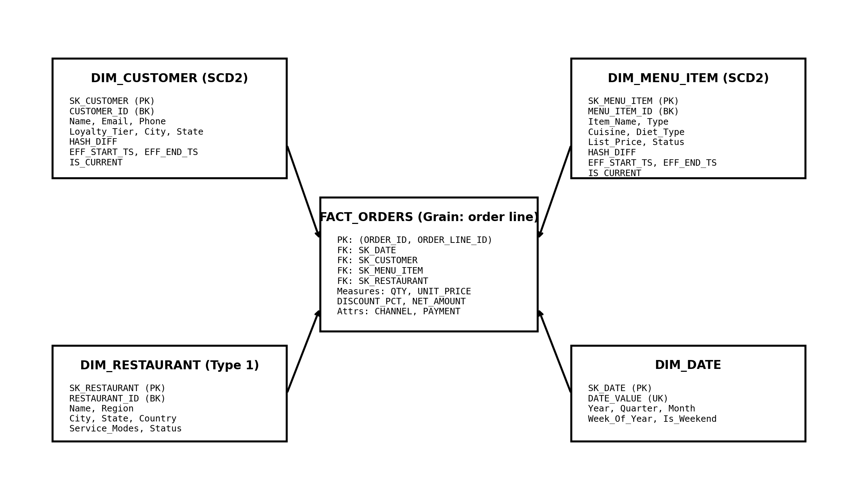
Figure: Restaurant Analytics Star Schema (Fact Orders at order-line grain with Customer/Menu Item SCD2).

9.2 Grain and Keys
- Fact grain: 1 row per ORDER_ID + ORDER_LINE_ID (order line item).
- Dimensions use surrogate keys (SK_*). Business keys retained for traceability.
- SCD2 applied to Customer and Menu Item to capture attribute changes over time.

9.3 Example DDL (DW layer)
Refer to Appendix A for example DDL definitions for dimensions and fact.

10. CDI Design (Mappings, Tasks, Parameters, Scheduling)

10.1 Mappings
- m_dim_date_load
- m_dim_restaurant_load (Type 1 upsert)
- m_dim_customer_scd2
- m_dim_menu_item_scd2
- m_fact_orders_load

10.2 Transformations
- Expression: standardize columns; compute hash diff; compute gross/discount/net amounts.
- Lookup: find current dimension row and fetch surrogate keys.
- Joiner: attach SKs to order lines.
- Router/Filter: new vs changed vs unchanged for SCD2; valid vs invalid records.
- Aggregator (optional): daily restaurant performance summary views.

10.3 Parameterization
- Parameters: $P_DB$, $P_RAW_SCHEMA$, $P_DW_SCHEMA$, $P_LOAD_TS$, $P_BATCH_ID$, $P_START_DATE$, $P_END_DATE$.
- DEV/TEST/PROD parameter files for environment portability.

10.4 Scheduling
- Taskflow tf_restaurant_dw_hourly (dims first, then fact).
- Idempotent loads: fact keyed by (ORDER_ID, ORDER_LINE_ID) to prevent duplicates.

11. SCD Type 2 Design (Customer and Menu Item)
- Compute HASH_DIFF using MD5(concat of tracked attributes).
- If record is new: insert current row with EFF_START_TS=load_ts and EFF_END_TS=9999-12-31, IS_CURRENT=TRUE.
- If unchanged: no action.
- If changed: expire current row and insert new current row.
Appendix B contains the high-level SQL pattern matching CDI SCD2 logic.

12. Data Quality & Reconciliation
- Ingestion: file row counts vs RAW load counts; reject reason capture.
- DW: counts by insert/update/no-change for SCD2; fact count equals order lines loaded.
- Referential integrity: every fact row must resolve SKs (use Unknown member strategy if needed).
- Measure validation: NET_AMOUNT = QTY*UNIT_PRICE - discount_amount.

13. Security & Access Control
- Roles: ROLE_INGEST, ROLE_ETL, ROLE_ANALYST, ROLE_APP_STREAMLIT, ROLE_ADMIN.
- Mask PII fields (EMAIL, PHONE) for analyst/app roles using masking policies.
- Optional row-level security by REGION or RESTAURANT_ID.

14. Monitoring & Operations
- Snowpipe: load history monitoring, failed file alerts.
- CDI: taskflow monitoring, run logs, alert on failures.
- OPS tables: LOAD_AUDIT (batch counts) and REJECTS (bad rows).
- Alerts: SLA breaches, high reject rate, frequent pipe failures, slow dashboard queries.

15. Streamlit Dashboard Design (screens + features)

15.1 Pages
- Executive Summary: Revenue, Orders, AOV; filters for date/region/restaurant/cuisine/loyalty/channel.
- Menu Performance: top items, cuisine mix, item contribution.
- Restaurant Performance: revenue by restaurant, region comparison, peak days.
- Explorer: drilldown table by restaurant, item, customer tier with export.

15.2 KPI Definitions
- Revenue: SUM(NET_AMOUNT)
- Orders: COUNT(DISTINCT ORDER_ID)
- AOV: Revenue / Orders

16. Cortex Search + RAG Design
- Index documents: KPI definitions, restaurant operations SOPs, data dictionary and glossary.
- Chunking: 500–1000 tokens with overlap; store metadata for doc type and subject.
- RAG: retrieve top-k chunks via Cortex Search, answer constrained to context, include citations.

16.1 RAG Prompt Template
System: Use only the provided context. If insufficient, state you do not have enough information. Provide citations.
User Template: Question={user_question}; Context={top_k_chunks_with_metadata}.

17. Cortex Analyst NL2SQL Design
- Create curated SEMANTIC views (e.g., V_REVENUE_DAILY, V_ITEM_PERFORMANCE, V_RESTAURANT_PERFORMANCE).
- NLQ allowed only on SEMANTIC schema; block RAW.
- Safe execution: SELECT-only validation, LIMIT 1000 default, enforce date filters and timeouts.

17.1 NLQ Prompt Template
Instruction: Generate one Snowflake SELECT query using only SEMANTIC views. Add filters and LIMIT 1000. Output SQL only.

18. Testing Strategy (unit/integration/UAT)
- Unit: validate each pipe and each CDI mapping with sample files.
- Integration: end-to-end file arrival → DW refresh → dashboard update.
- UAT: validate KPI results; validate NLQ and RAG answers with business users.

19. Deployment Plan (DEV → TEST → PROD)
- DEV: build and validate objects, initial loads.
- TEST: regression, performance, security checks.
- PROD: deploy DDL + CDI assets, enable Snowpipe integrations, schedule taskflows, enable alerts.

20. Risks & Mitigations
- CSV schema drift → validation and quarantine; versioned contracts.
- SCD2 table growth → optimization strategy and retention policies.
- NLQ expensive queries → semantic views only + LIMIT + timeouts.
- PII exposure → masking policies and role separation.

21. Appendix

Appendix A: Example DDL (summary)
DW tables: DIM_DATE, DIM_RESTAURANT, DIM_CUSTOMER (SCD2), DIM_MENU_ITEM (SCD2), FACT_ORDERS.

Appendix B: SCD2 High-level Pattern
Expire changed current rows; insert new current rows; keep unchanged rows. Implement using CDI Router + Update + Insert paths or SQL overrides as allowed.

