# Rancher Kubernetes Cluster setup on Multiple Nodes

In this example I have done with two nodes. Master and Worker

Master IP: 10.128.0.4

Worker IP: 10.128.0.5

## Prerequisites

* Initial Server Hardening for Docker & Kubernetes setup
* Creating user with root privileges in all nodes
* ssh setup within master and remaining nodes
* Docker installation steps
* Kubectl installation steps
* Rke tool installation
* Create config file and up the Rancher Kubernetes Cluster

## Initial Server Hardening for Docker & Kubernetes setup

yum upgrade -y

setenforce 0

sed -i --follow-symlinks 's/SELINUX=enforcing/SELINUX=disabled/g' /etc/sysconfig/selinux

modprobe br_netfilter

firewall-cmd --add-masquerade --permanent

firewall-cmd --reload

cat <<EOF > /etc/sysctl.d/k8s.conf

net.bridge.bridge-nf-call-ip6tables = 1

net.bridge.bridge-nf-call-iptables = 1

EOF

sysctl --system

swapoff -a

yum install wget -y

## Creating user with root privileges

## Create user and set password for communication b/w nodes

adduser radium

passwd radium

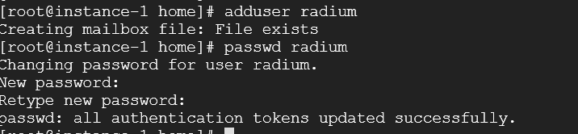

## Enable Root privileges for the radium user

echo "radium ALL=(ALL) NOPASSWD:ALL" >> /etc/sudoers

## SSH setup within master and worker nodes

su radium

ssh-keygen

cp ~/.ssh/id_rsa.pub ~/.ssh/authorized_keys

chmod 600 ~/.ssh/authorized_keys

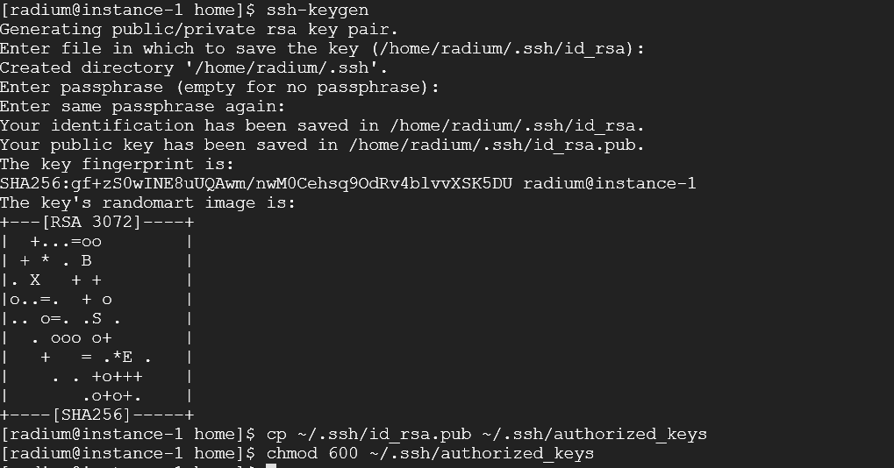

scp ~/.ssh/id_rsa.pub [target_user@host_address:tmp.pub](mailto:target_user@host_address:tmp.pub)

# (target_user: radium ; host_address: IP address of another node)

## Note: if ssh/scp connection not works, set below values on all nodes and restart

## ssh settings:

## vi /etc/ssh/sshd_config

## PubkeyAuthentication yes

## PasswordAuthentication yes

## sudo service sshd restart

cat tmp.pub >> ~/.ssh/authorized_keys

chmod 600 ~/.ssh/authorized_keys

## Docker Installation Steps

Reference: https://linuxconfig.org/how-to-install-docker-in-rhel-8

sudo dnf config-manager --add-repo=https://download.docker.com/linux/centos/docker-ce.repo

sudo dnf repolist -v

dnf list docker-ce --showduplicates | sort -r

sudo dnf install docker-ce-3:20.10.7-3.el8 -y

sudo systemctl start docker

sudo systemctl enable docker

systemctl status docker

sudo docker --version



## Add radium user to Docker group for cluster setup

sudo usermod -aG docker radium

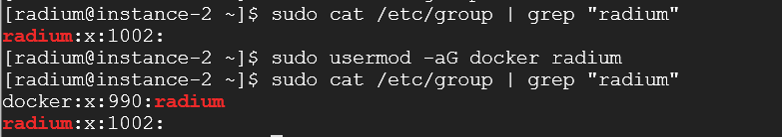

## Kubectl installation steps

Referrence link <https://kubernetes.io/docs/tasks/tools/install-kubectl-linux/>

curl -LO "https://dl.k8s.io/release/$(curl -L -s https://dl.k8s.io/release/stable.txt)/bin/linux/amd64/kubectl"

curl -LO "https://dl.k8s.io/$(curl -L -s https://dl.k8s.io/release/stable.txt)/bin/linux/amd64/kubectl.sha256"

echo "$(<kubectl.sha256) kubectl" | sha256sum --check

sudo install -o root -g root -m 0755 kubectl /usr/local/bin/kubectl

sudo install -o root -g root -m 0755 kubectl /usr/bin/kubectl

kubectl version --client

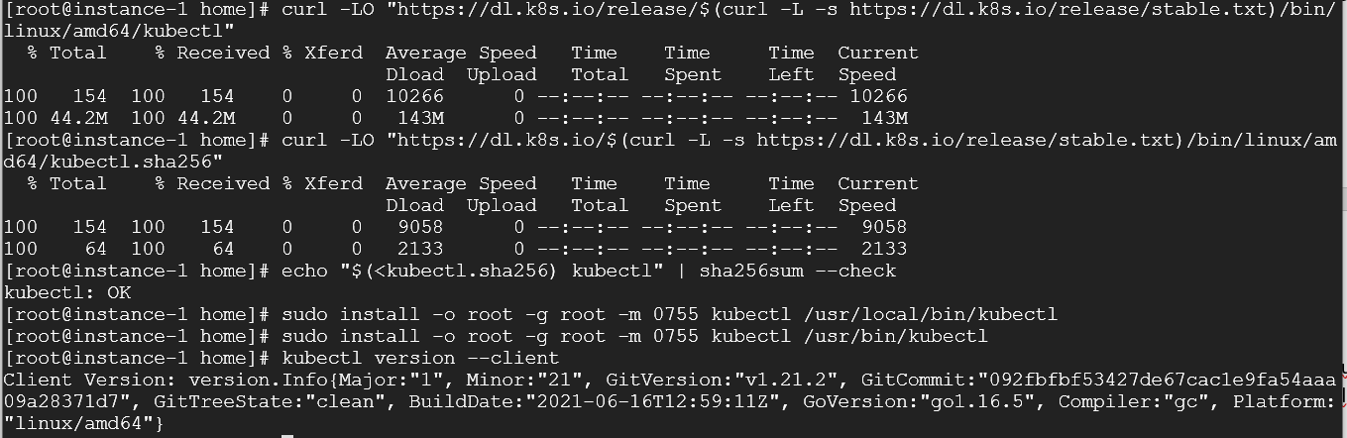

## RKE tool installation only on Master

RKE binaries path : https://github.com/rancher/rke/releases

wget https://github.com/rancher/rke/releases/download/v1.1.18/rke_linux-amd64

mv rke_linux-amd64 rke

chmod +x rke

sudo mv rke /usr/bin/

rke --version

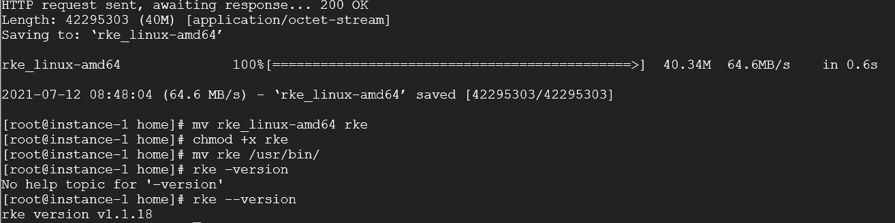

## Create config file using RKE tool

rke config -name cluster.yml

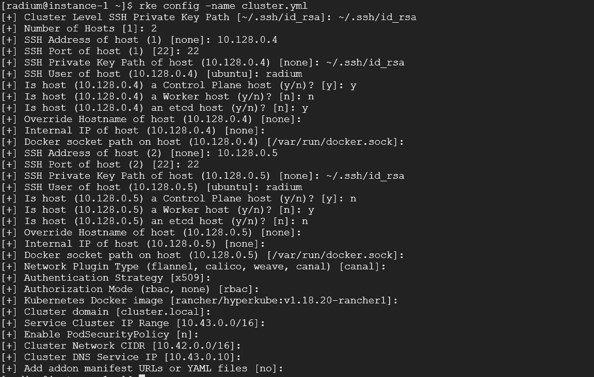

rke up -config cluster.yml

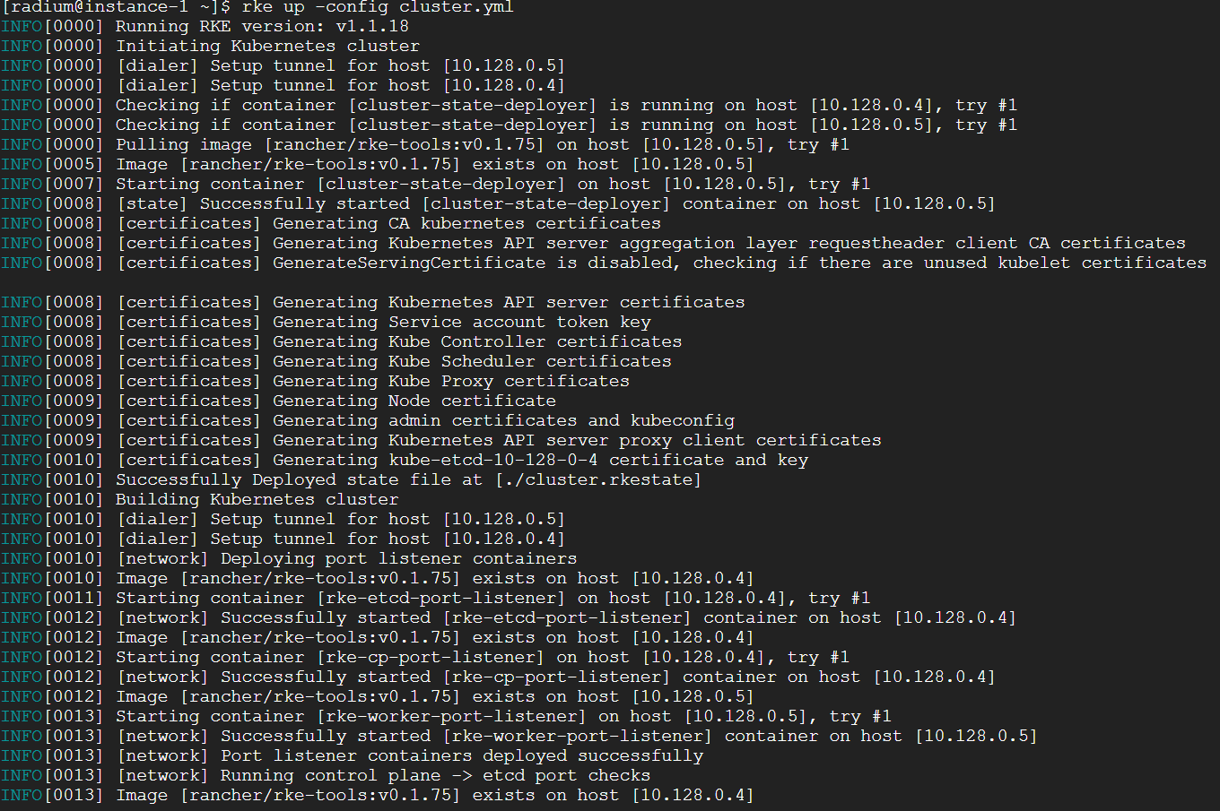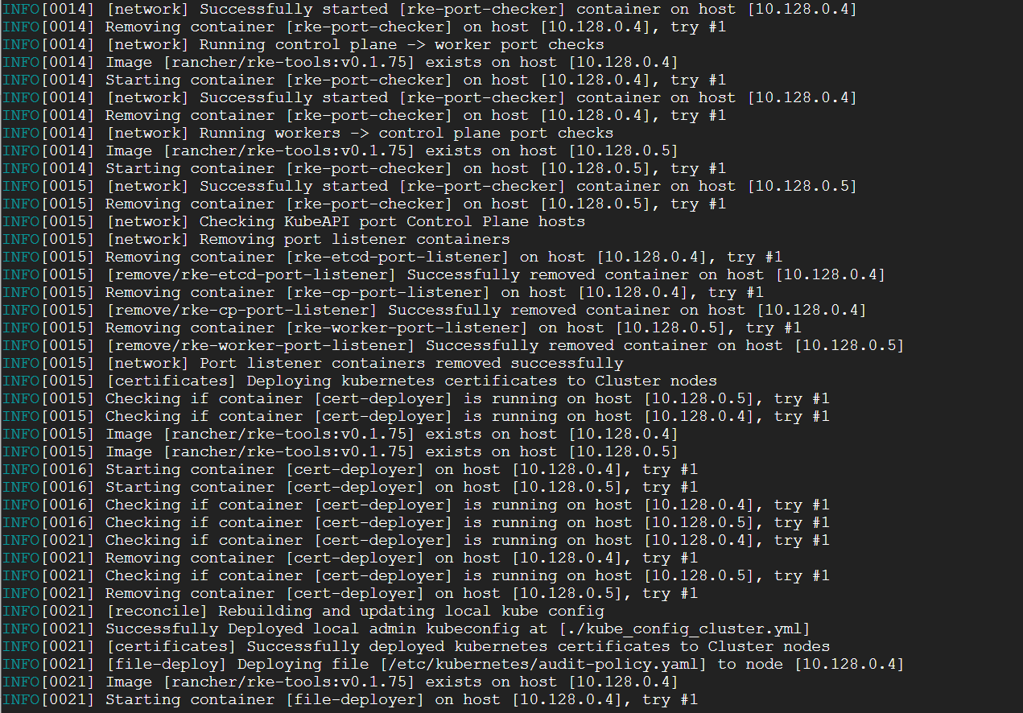

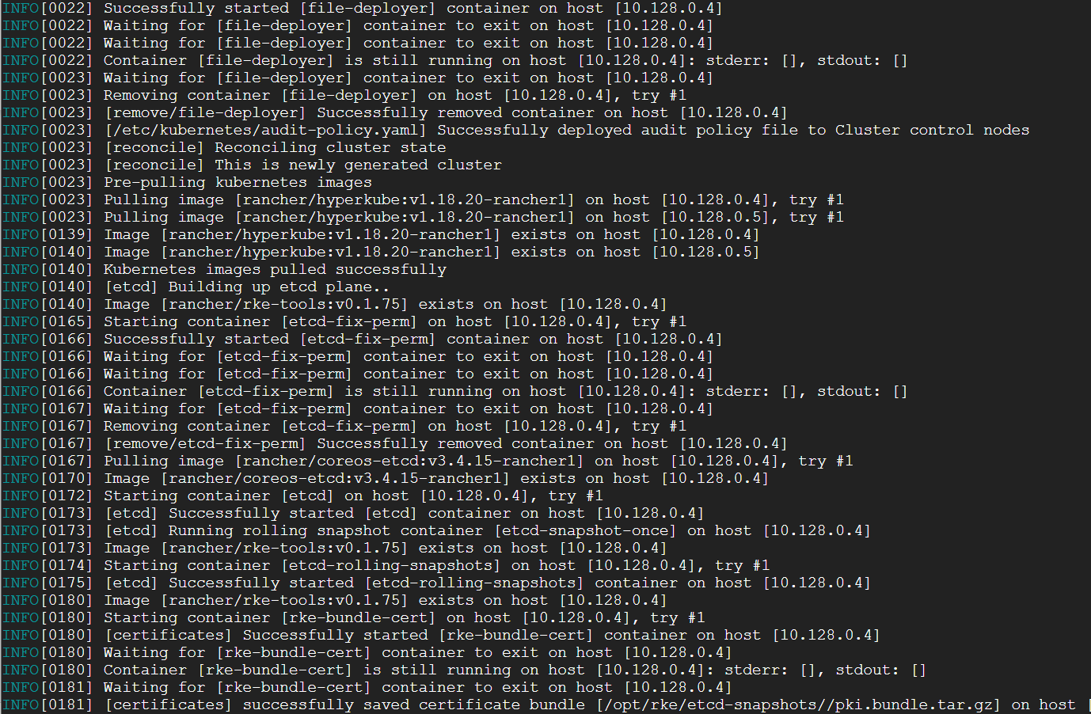

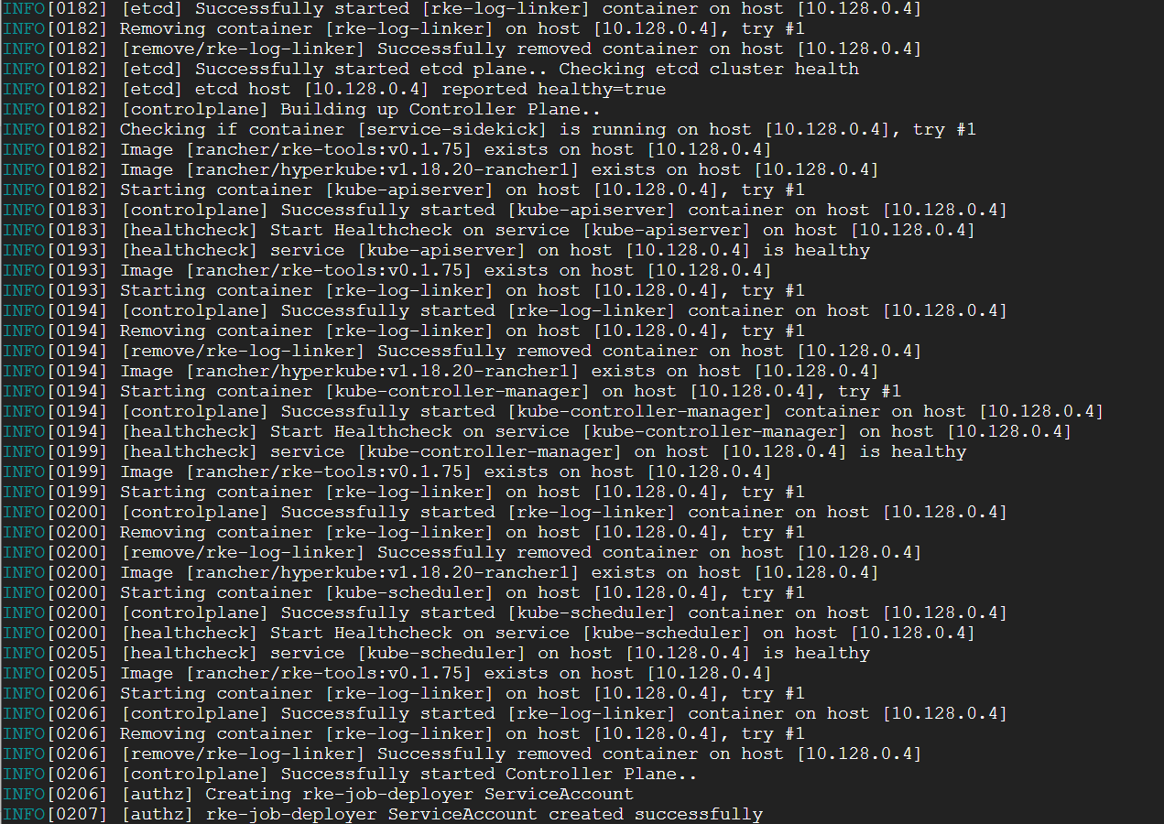

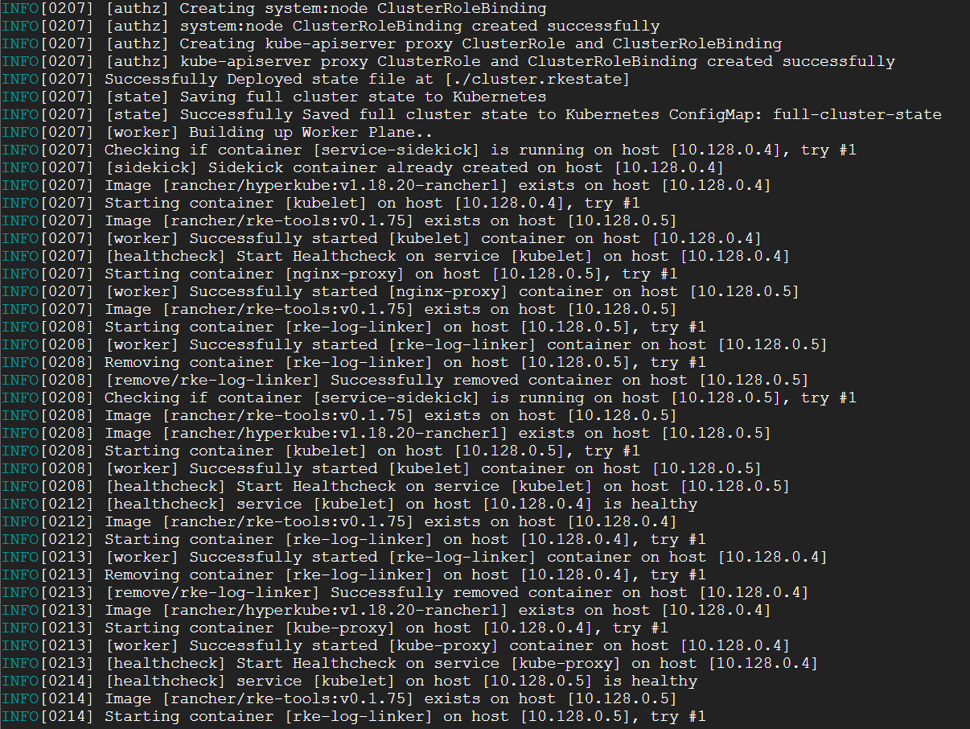

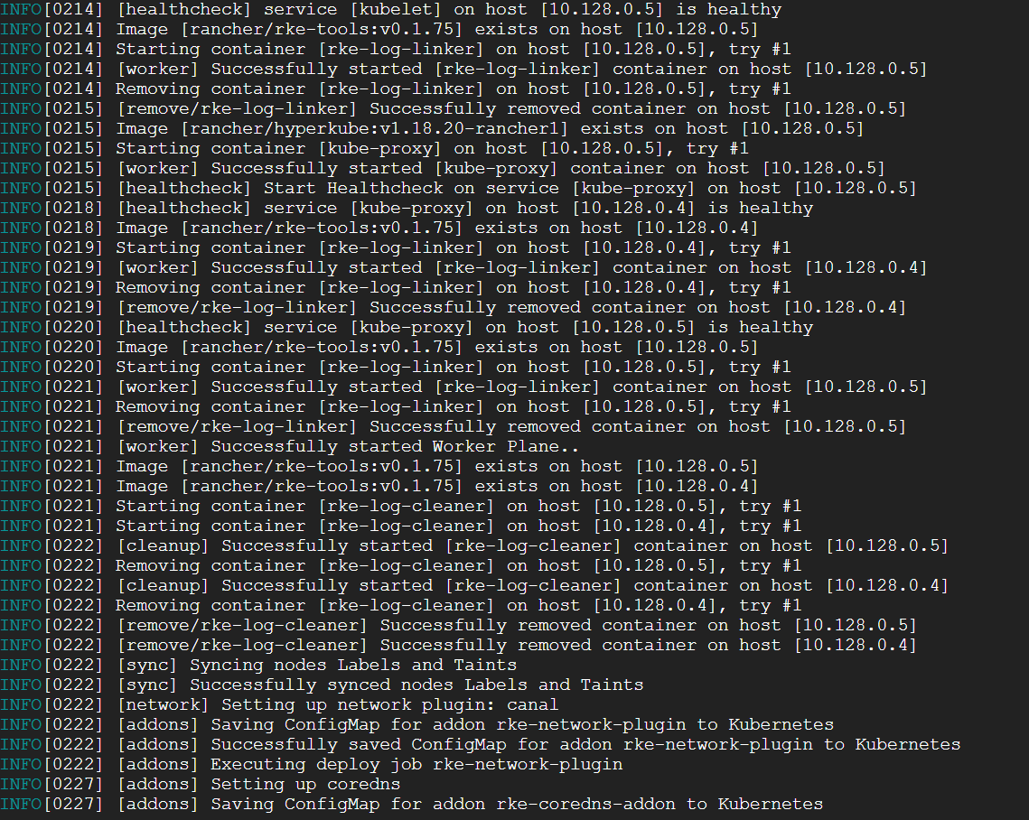

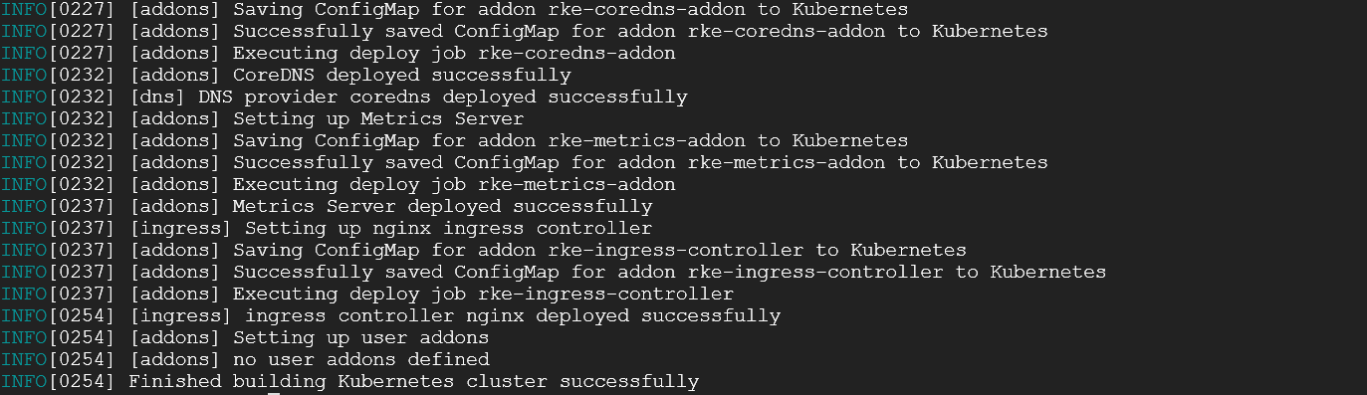

## Once the cluster setup is successful, you will get cluster.rkestate & kube_config_cluster.yml files

## copy kubectl file to the path /home/$USER/.kube/config, so that kubectl command, can be used easily by CLI tools

mkdir .kube

cp kube_config_cluster.yml .kube/config

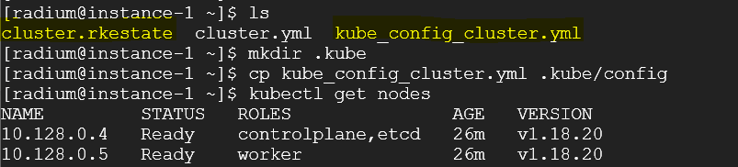

Now both the Master and Worker node are up and running.

***So, Rancher Kubernetes Cluster successfully deployed.***