Html and css assignment

Q 1.How are inline and block elements different from each other?

There are two types of elements in HTML page – INLINE and BLOCK.

In inline element, there is never a new line. Inline elements takes up the space of an entire line and there will be only one line within the space width. Inline elements do not respect the top and bottom margins but only the left and right and also consider the padding.An inline element does not start on a new line and only takes up as much width as necessary.

For eg. (<a href> , <p>) etc.
<!DOCTYPE html>
<html>
<head>
<title> Inline and block </title>
<style type=text/css>
div
</style>
</head>
<body>
<div>
<p>This is inline </p>
<p>
<span style="color:black;font-weight:bold">white</span>
This is how inline works<span style="color:darkolivegreen;font- weight:bold">dark green
</span>
</p>
</div>
</body>
</html>

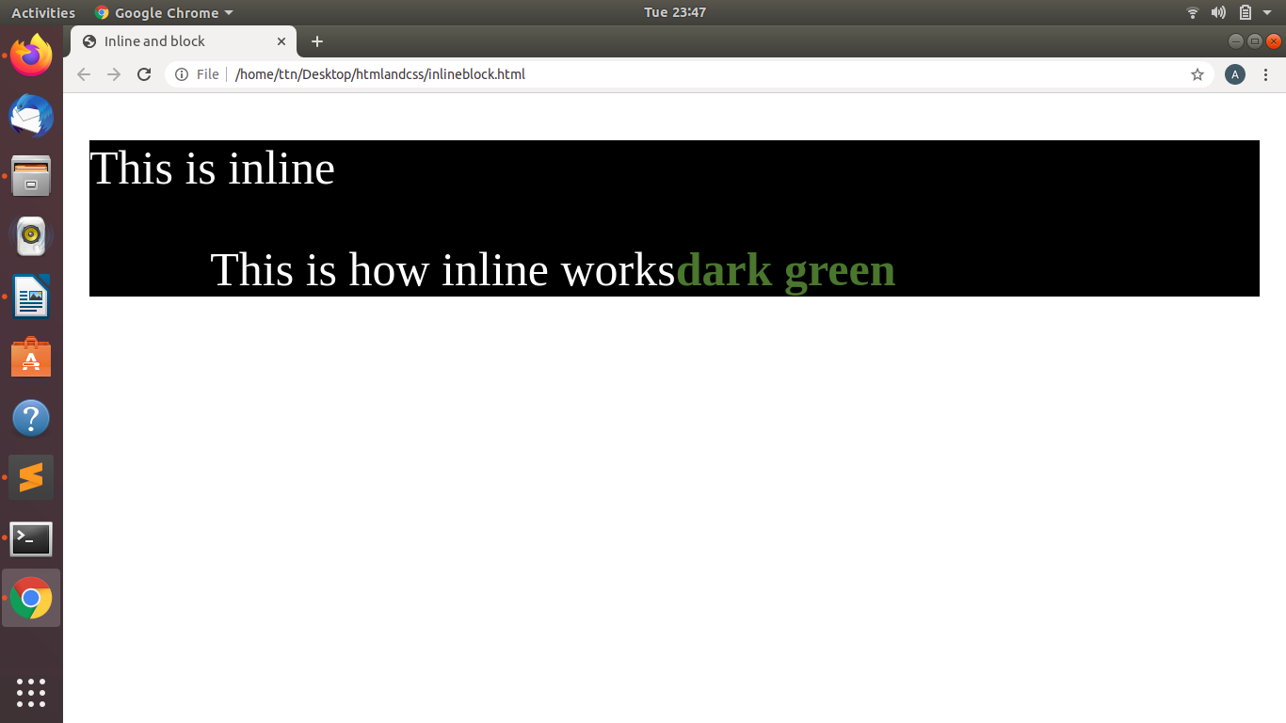

A block-level element always starts on a new line and takes up the full width available and it stretches out to the left and right as far as it can.A block-level HTML element will always create a new line after the closing tag.Block-level elements always create a new line Block elements are kind of blocks where there are many elements in a line itself.

For eg. The <div> element is a block-level element.

<!DOCTYPE html>
<html>
<head>
<title> Inline and block </title>
<style type=text/css>
div
{
color: white;
background-color: blue;
margin: 20px;
font-size: 50px;
}
</style>

</head>
<body>
<div>
Block Element
</div>
</body>
</html>

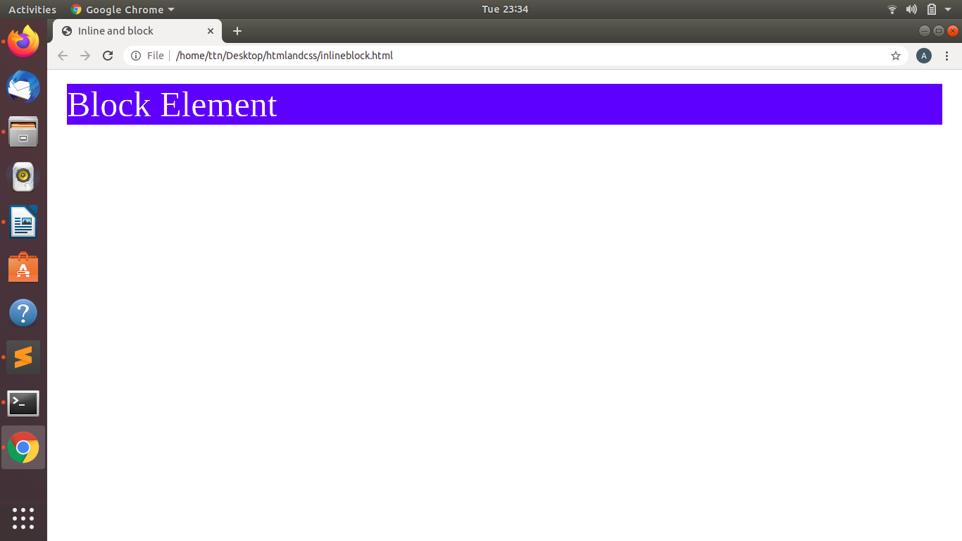

Q 2 .Explain the difference between visibility:hidden and display:none

Visibility:hidden :-The tag with this property is not visible, but space is allocated for it on the page.The tag is rendered,it just not seen on the page.

Display:none:-The display property specifies how an element is displayed.The tag with this property will not appear on the page at all.But one can still interact with it through the DOM(document object model).There will be no space allocated for it between the other tags.

<!DOCTYPE html>
<html>
<head>
<title> <h1>visible and hidden <h1> </title>
<style>
.visibility
{
visibility: hidden;
}

.display
{
display:none;
}
</style>
</head>
<body>

<h3>visibility and hidden Property</h3>
<p>Display and none
<span class="visibility">This heading is visible</span>
this is displayed
<span class="display">This heading is hidden</span>
this in none
</p>
</body>
</html>
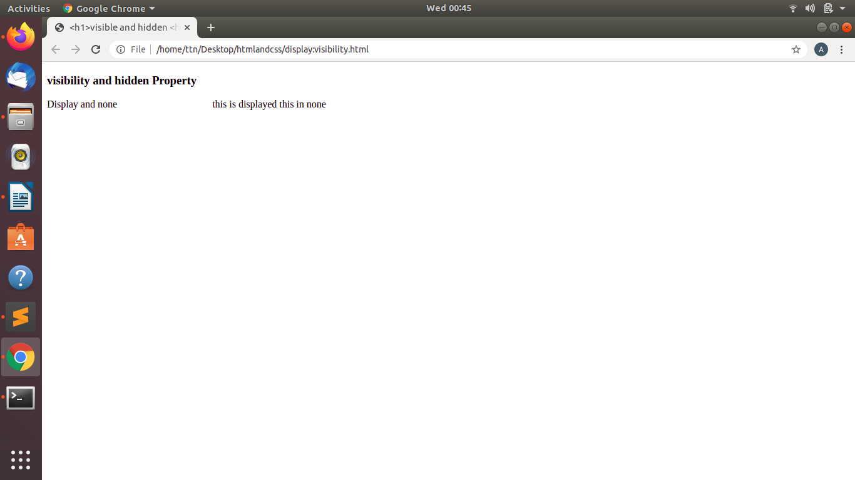

Q 3. Explain the clear and float properties.

Float property is used to specify how elemet should float.It is used for positioning and formatting content.
The clear property is directly related to the float property. It specifies if an element should be next to the floated elements or if it should move below them. This property applies to both floated and non-floated elements.
If an element can fit in the horizontal space next to the floated elements it will. Until and unless we apply the clear property to that element in the same direction as the float. Then the element will move below the floated elements.

The float property have the following values:-
1.Left-Element floats left to corner.
2.Right-Elements floats left to container.
3.None-Inherits float from parent.

The clear property can have following values:-
1.None- the element is not moved down to clear past floats.
2.Left- the element is moved down to clear past left floats.
3.Right- the element is moved down to clear past right floats.
4.Both- the element is moved down to clear past both left and right floats.

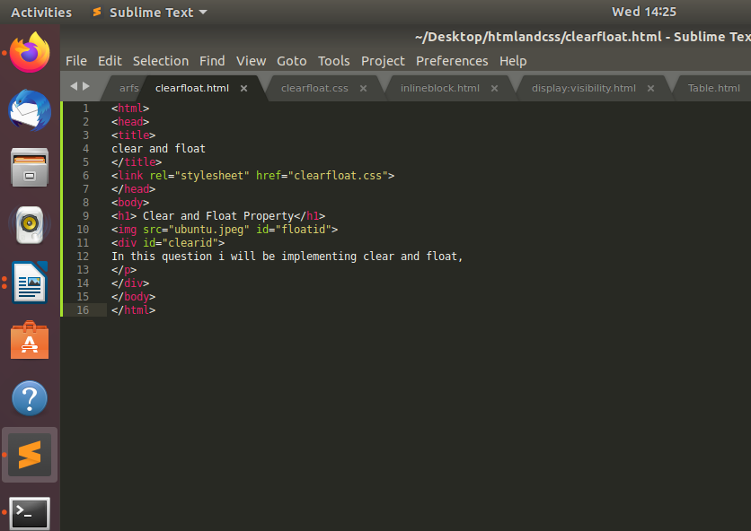

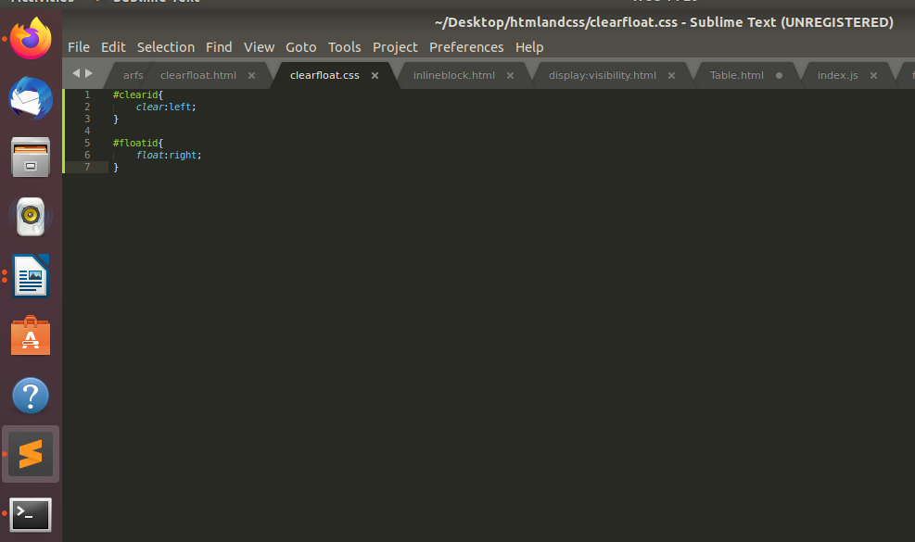
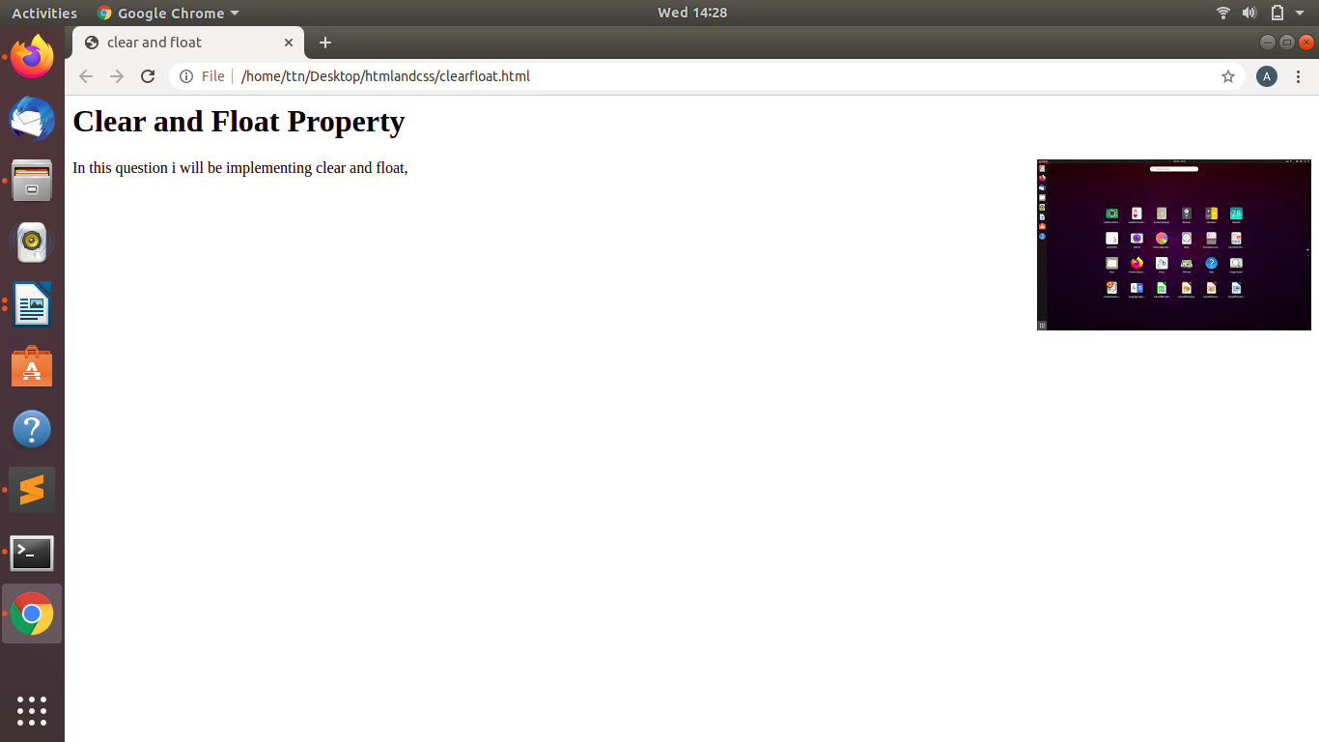

Q4. Explain difference between absolute, relative,fixed and static.
Static:- Static is a position property where static elements are not affected by the top,bottom.left and right properties.By default position is static.

Relative:-It is an position property where setting top,right,bottom and left properties of a relatively positioned element will cause it to be adjusted away from its normal position.

Fixed:-It is a positon property where the element remain on same place even if page is scrolled. Top,Bottom,Left and Right properties can be used to set its location.

Absolute:-An element with position: absolute; is positioned relative to the nearest positioned ancestor instead of positioned relative to the viewport, like fixed.However; if an absolute positioned element has no positioned ancestors, it uses the document body, and moves along with page scrolling.

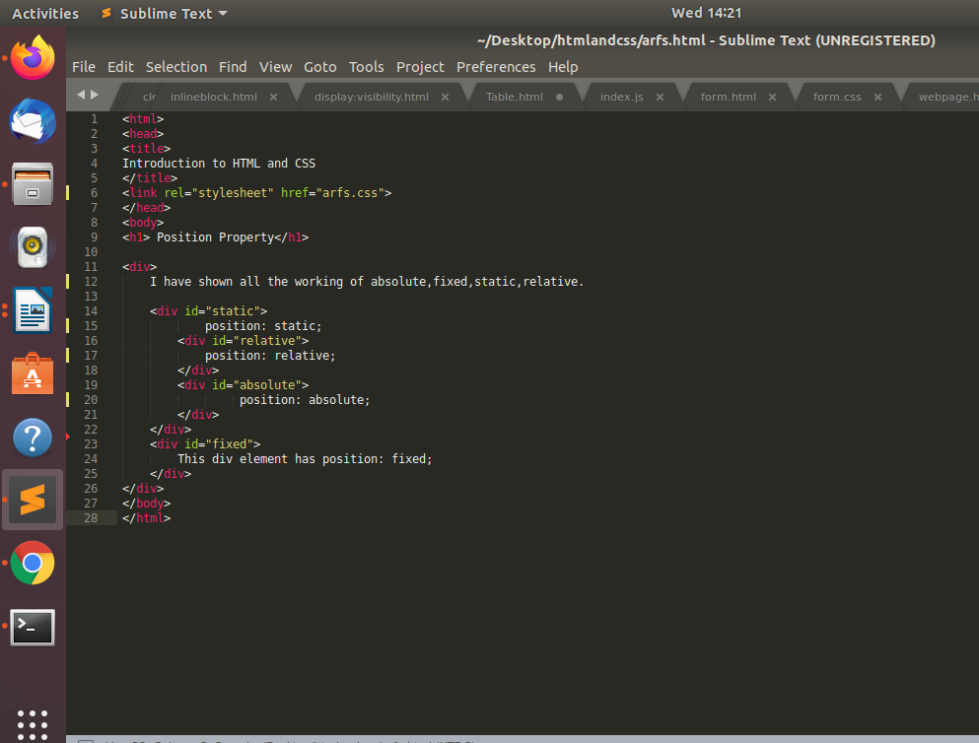

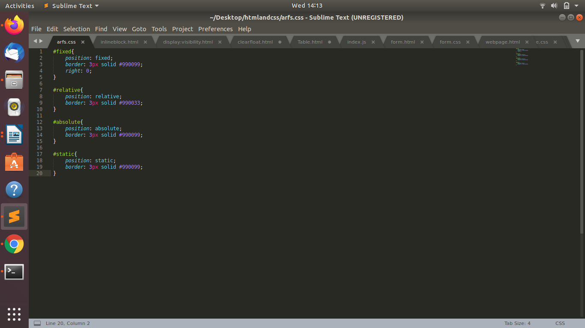
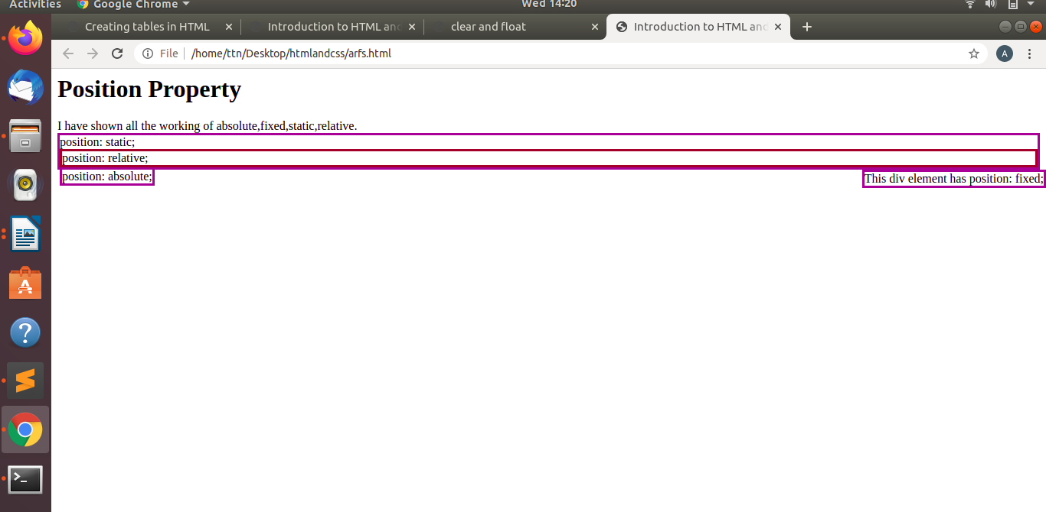

Q 5.Write the HTML code to create a table in which there are 4 columns( ID , Employee Name, Designation, Department) and at least 6 rows. Also do some styling to it.
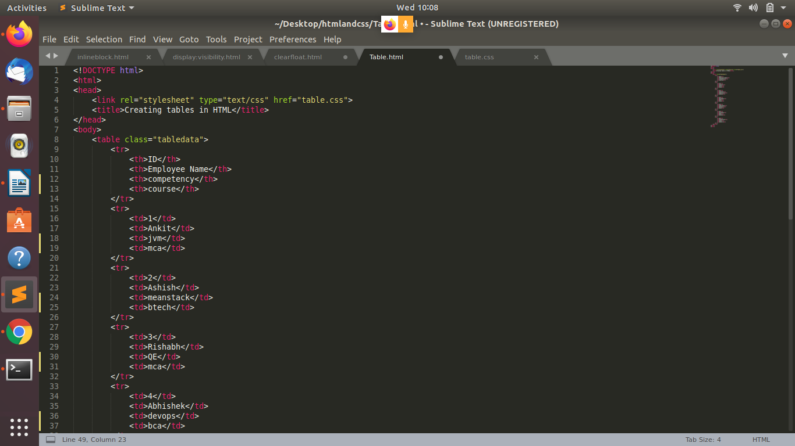

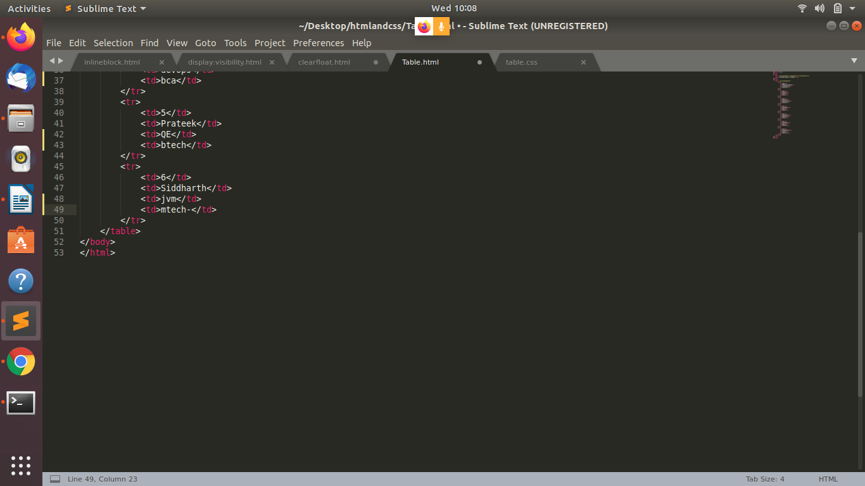

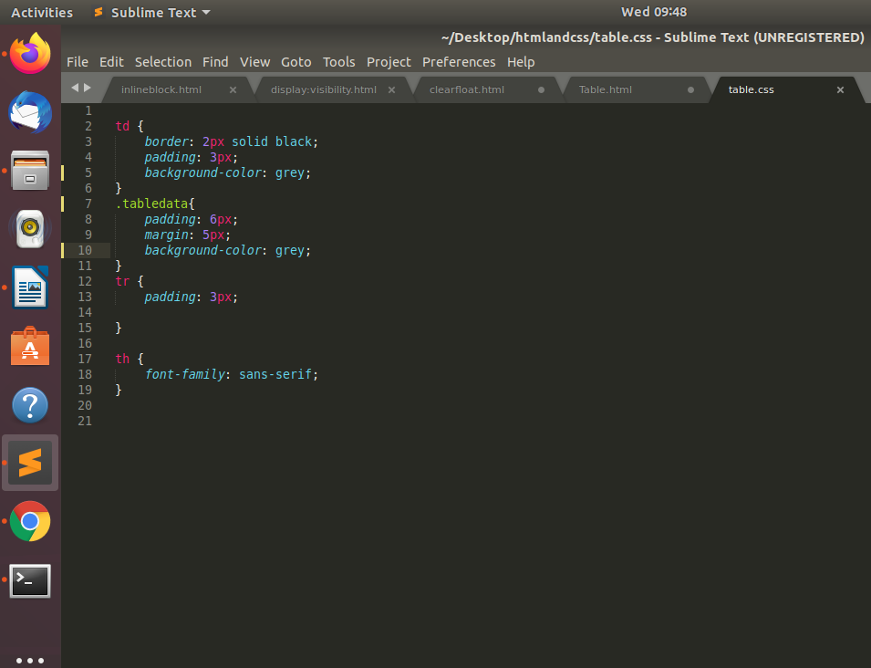

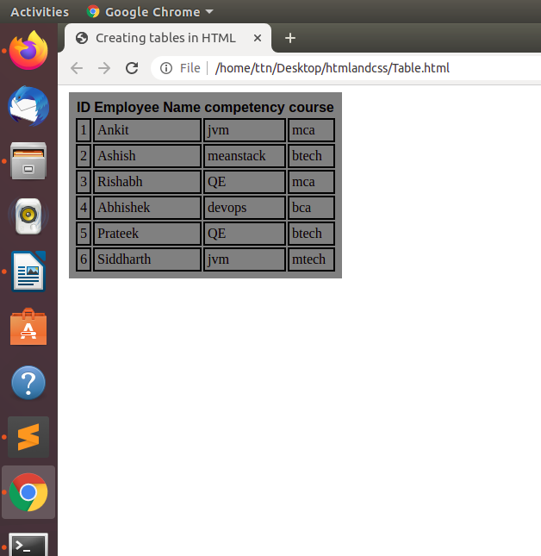

Q6. Why do we use meta tags?
The <meta> tag provides metadata about the HTML document. Metadata will not be displayed on the page, but will be machine parsable.
Meta elements are typically used to specify page description, keywords, author of the document, last modified, and other metadata. Also, it helps to improve the SEO( Search Engine Optimization) of a web page by using certain keywords related to the web page.
<meta> tags always go inside the <head> element.
7. Explain box model.
All HTML elements can be considered as boxes. In CSS, the term "box model" is used when talking about design and layout.
The CSS box model is essentially a box that wraps around every HTML element. It consists of: margins, borders, padding, and the actual content. The image below illustrates the box model:
Explanation of the different parts:
- Content - The content of the box, where text and images appear
- Padding - Clears an area around the content. The padding is transparent
- Border - A border that goes around the padding and content
- Margin - Clears an area outside the border. The margin is transparent
The box model allows us to add a border around elements, and to define space between elements.

8. What are the different types of CSS Selectors?
A CSS selector is the first part of a CSS Rule. It is a pattern of elements and other terms that tell the browser which HTML elements should be selected to have the CSS property values inside the rule applied to them. The element or elements which are selected by the selector are referred to as the subject of the selector.
We can divide CSS selectors into five categories:
- Simple selectors - select elements based on name, id, class
- Combinator selectors - select elements based on a specific relationship between them
- Pseudo-class selectors - select elements based on a certain state
- Pseudo-element selectors - select and style a part of an element
- Attribute selectors - select elements based on an attribute or attribute value

Q 9. Define Doctype.
All HTML documents must start with a <!DOCTYPE> declaration.
The declaration is not an HTML tag. It is an "information" to the browser about what document type to expect.
In HTML 5, the declaration is simple:
<!DOCTYPE html>
<html>
<head>
<title>Title of the document</title>
</head>
<body>
The content of the document......
</body>
</html>

Q10. Explain 5 HTML5 semantic tags.
Semantic HTML elements are those that clearly describe their meaning in a human- and machine-readable way.
Elements such as <header>, <footer> and <article> are all considered semantic because they accurately describe the purpose of the element and the type of content that is inside them.
Some of the commonly used new tags of HTML5 are :
<article> - Defines an article in the document
<aside> - Defines content aside from the page content like sidebar.
<footer> - Defines a footer for the document or a section
<header> - Defines a header for the document or a section
<nav> - Defines navigation links in the document
<section> - Defines a section in the document

11. Create HTML for web-page.jpg (check resources, highest weightage for answers).

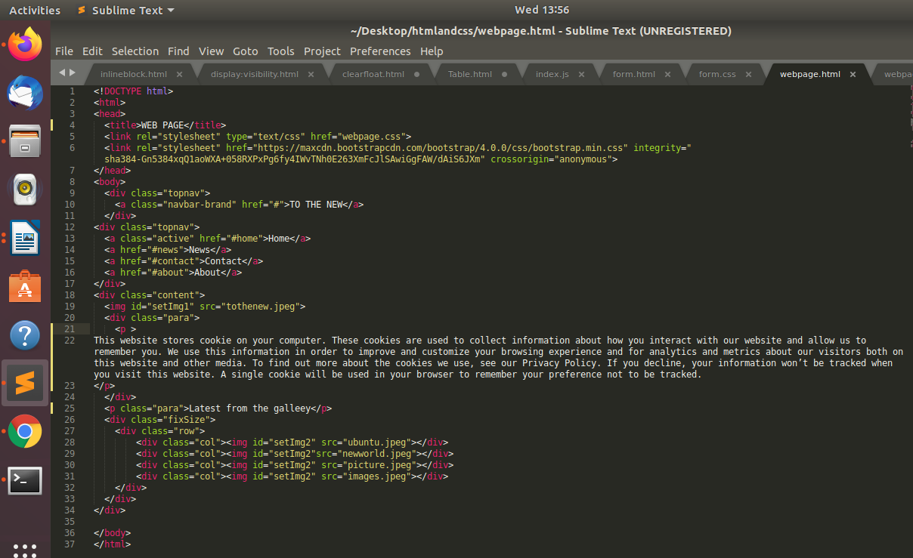

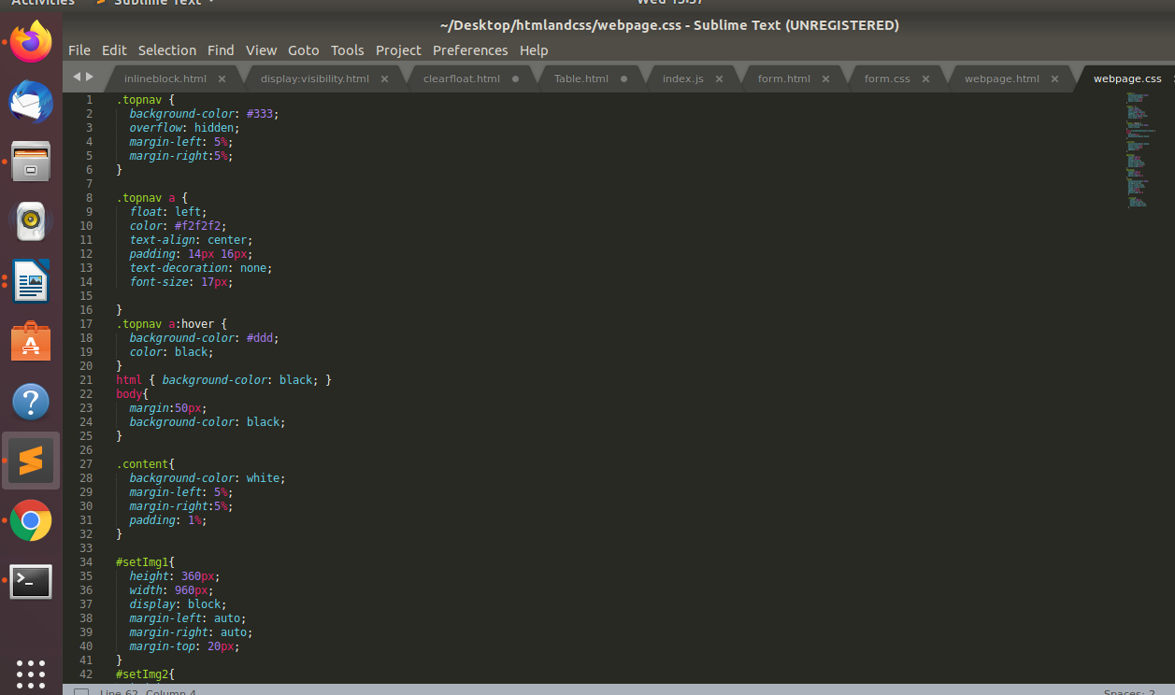

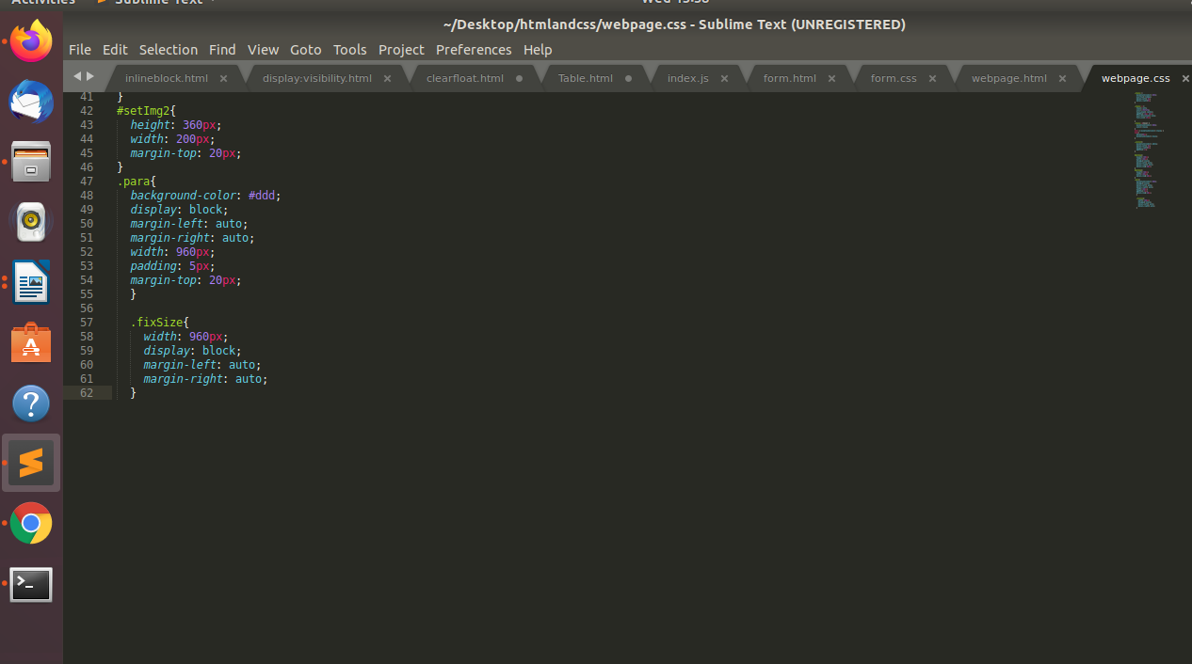

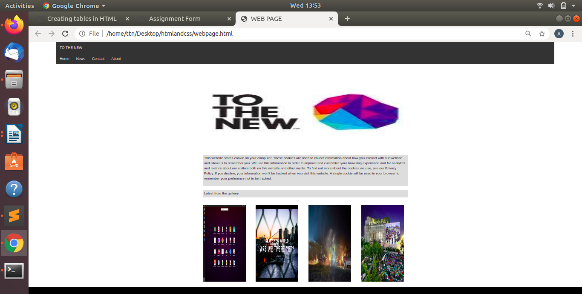

Q12. Create HTML for form.png (check resources, highest weightage for answers).
