Q1.Write Java code to define List . Insert 5 floating point numbers in List, and using an iterator, find the sum of the numbers in List.
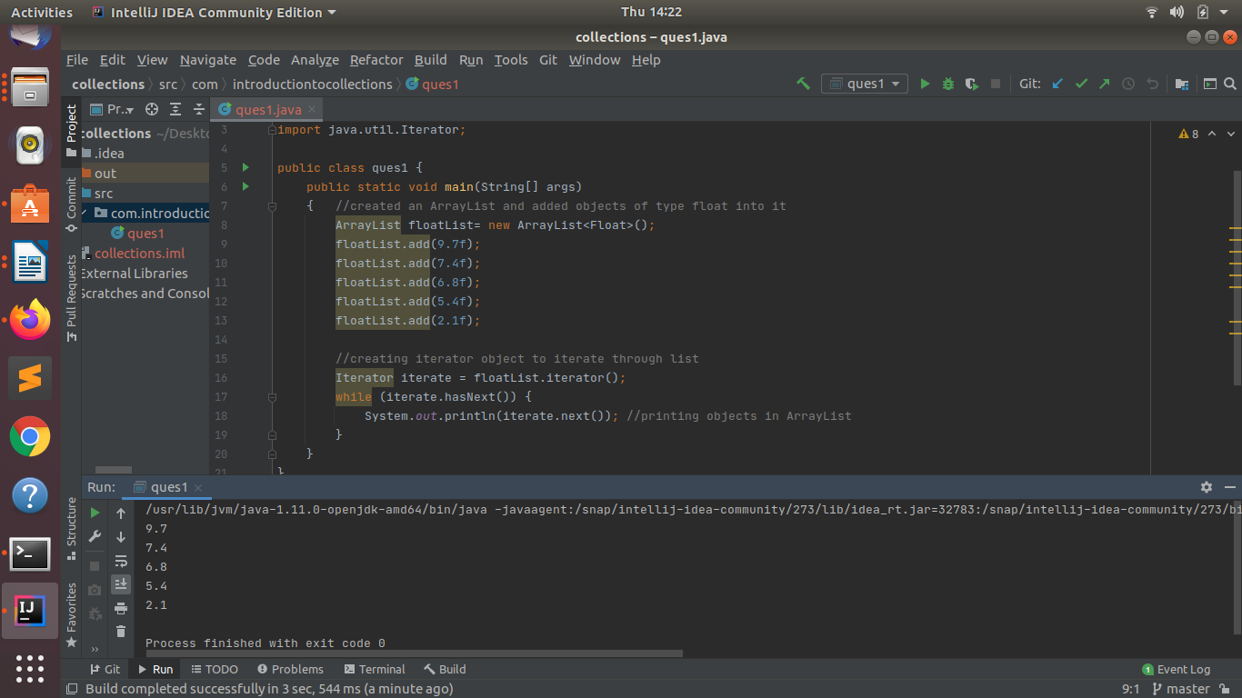

Q2.Write a method that takes a string and returns the number of unique characters in the string.
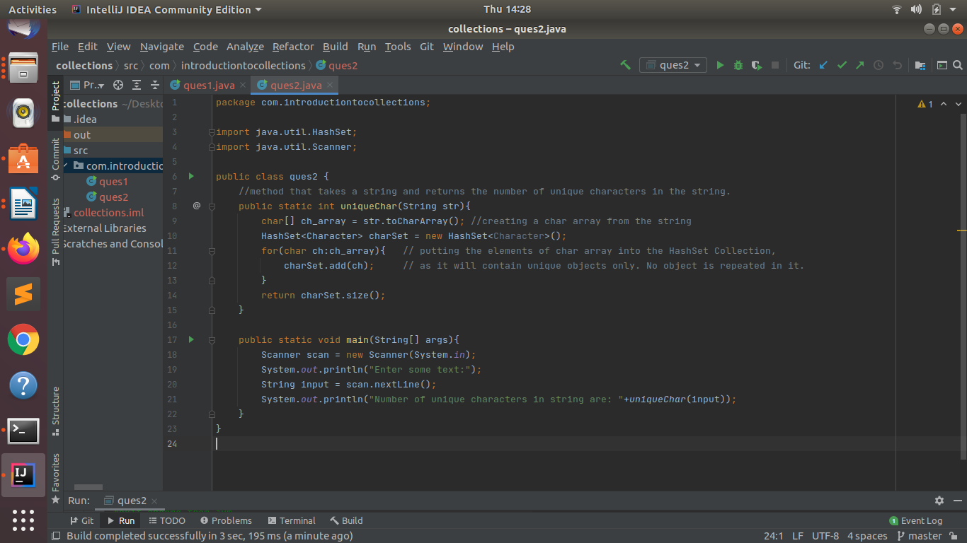
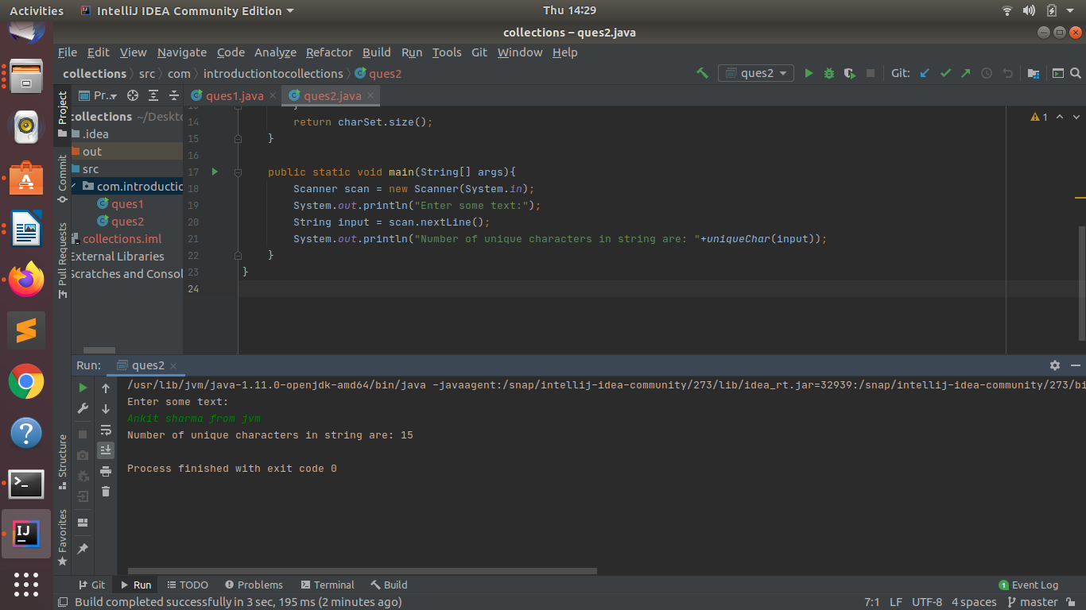

Q3.Write a method that takes a string and print the number of occurrence of each character characters in the string.
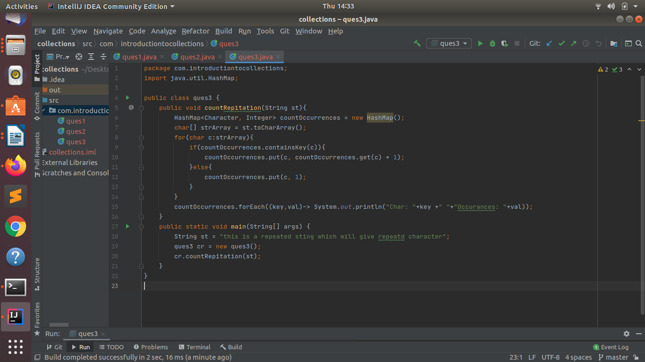
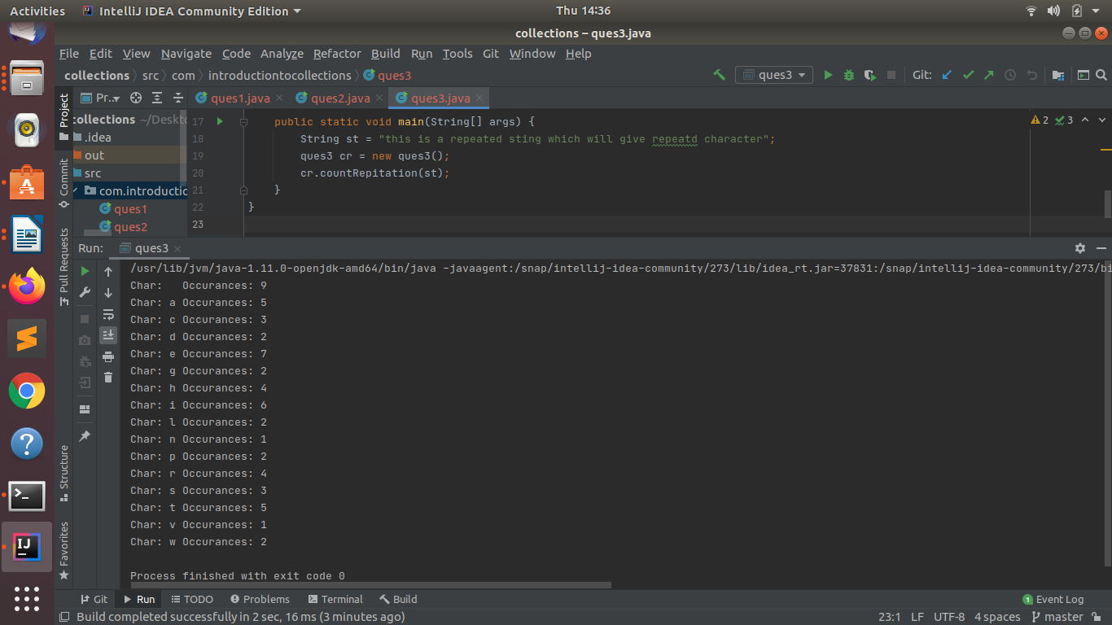

Q4.Write a program to sort Employee objects based on highest salary using Comparator. Employee class{ Double Age; Double Salary; String Name}.
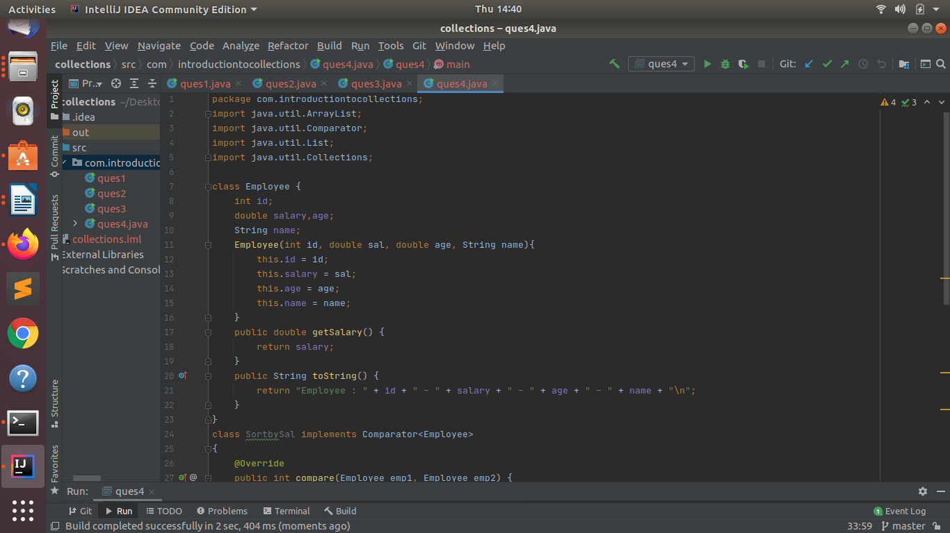
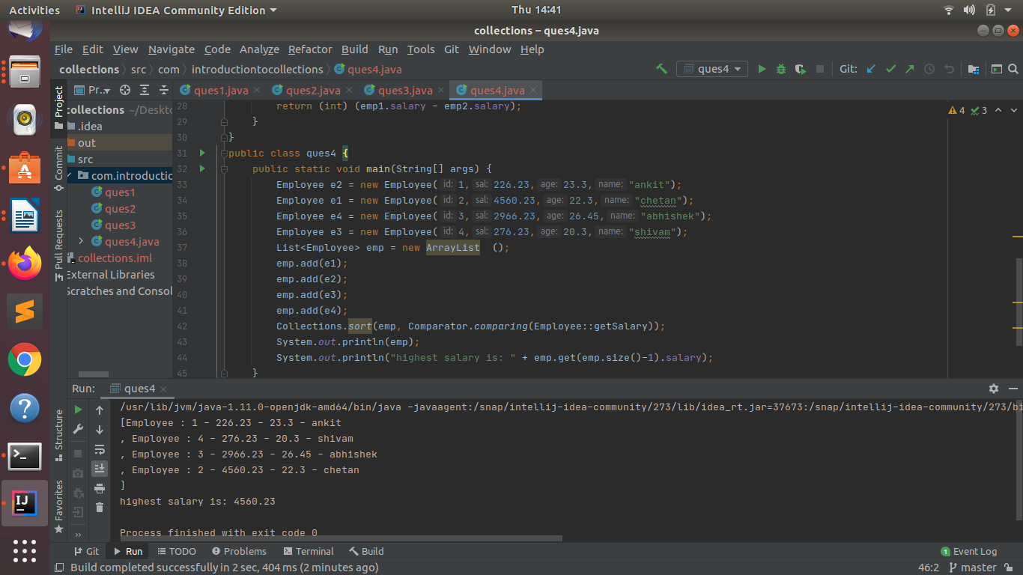

Q5.Write a program to sort the Student objects based on Score , if the score are same then sort on First Name . Class Student{ String Name; Double Score; Double Age}.
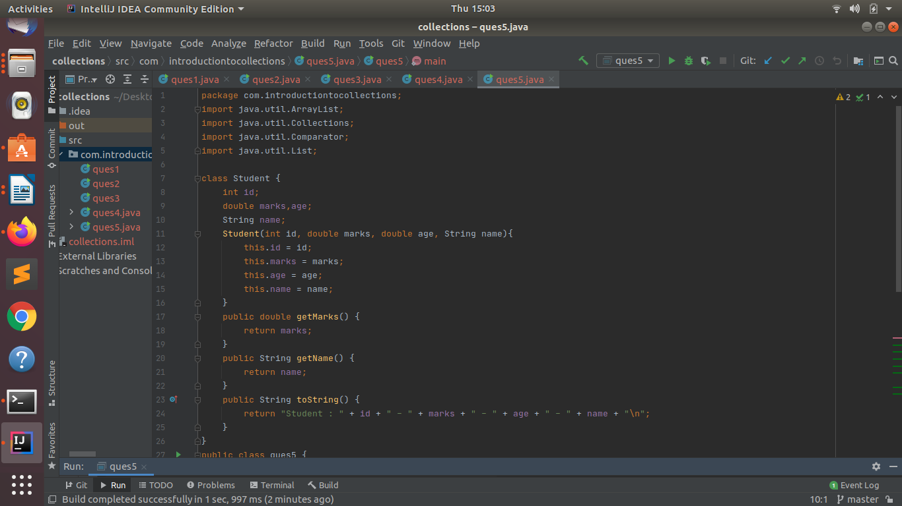
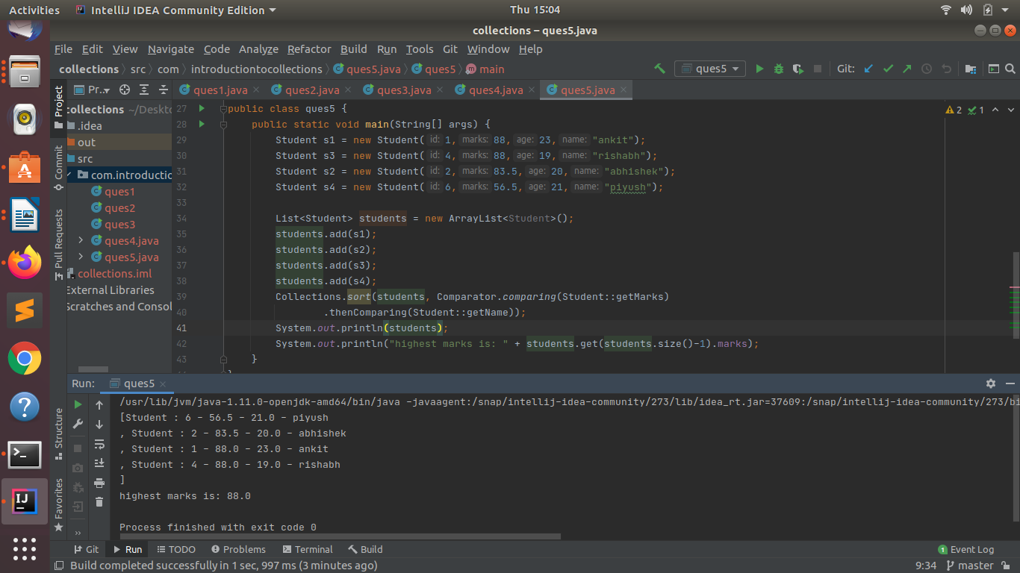

Q6.Print the elements of an array in the decreasing frequency if 2 numbers have same frequency then print the one which came first.
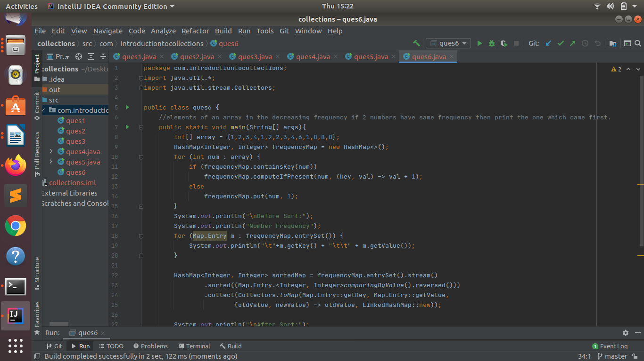
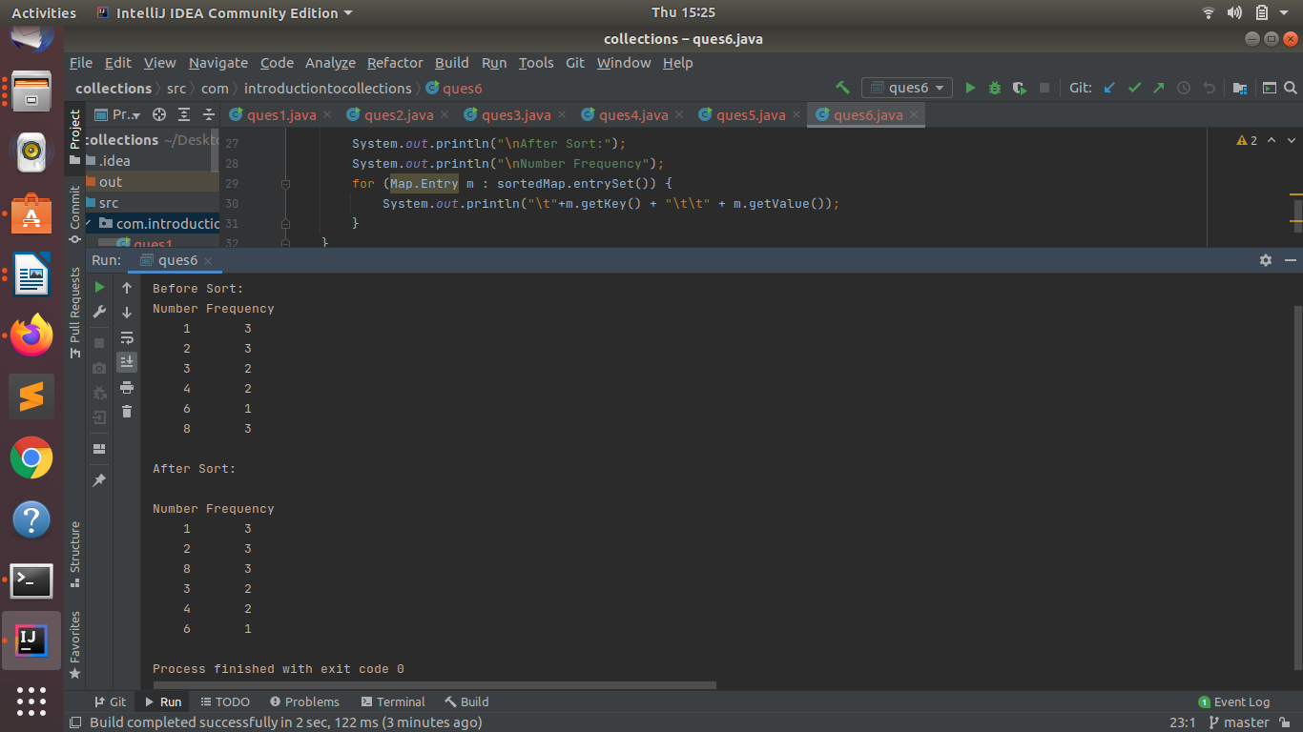

Q7.Design a Data Structure SpecialStack that supports all the stack operations like push(), pop(), isEmpty(), isFull() and an additional operation getMin() which should return minimum element from the SpecialStack. (Expected complexity O(1))
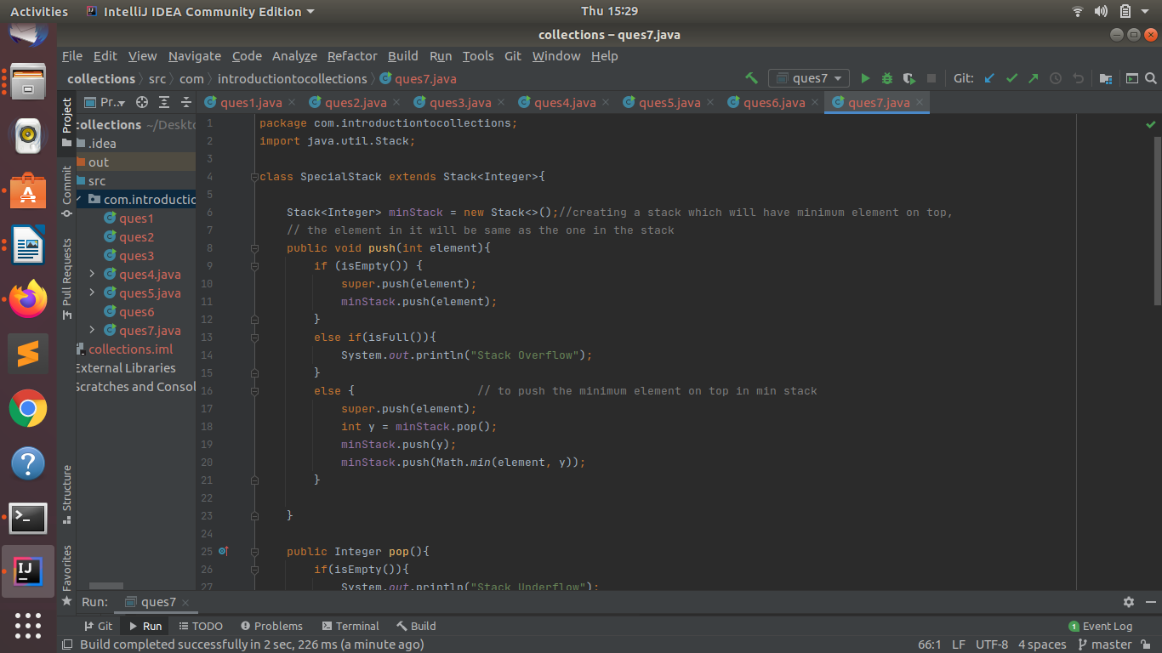

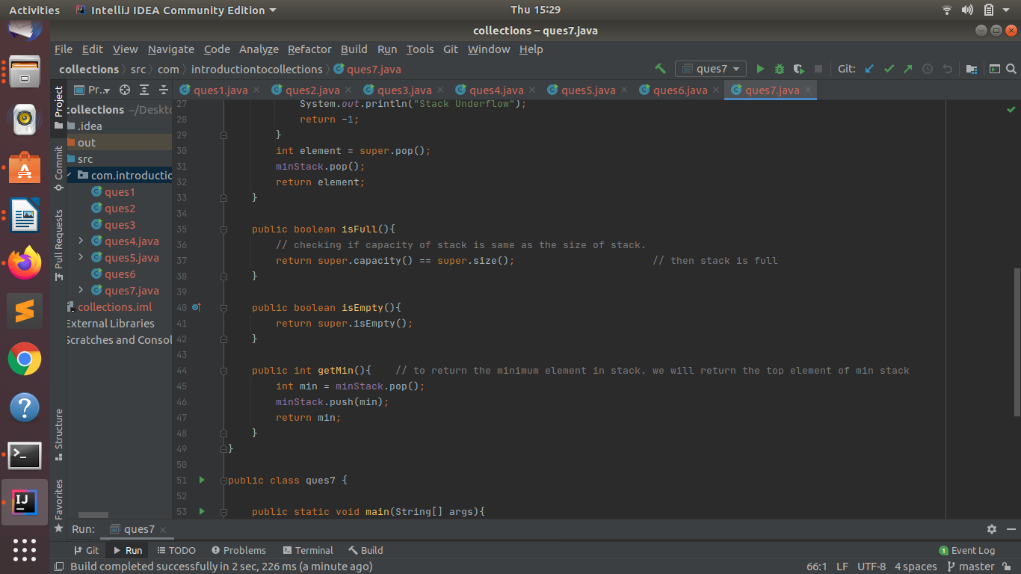

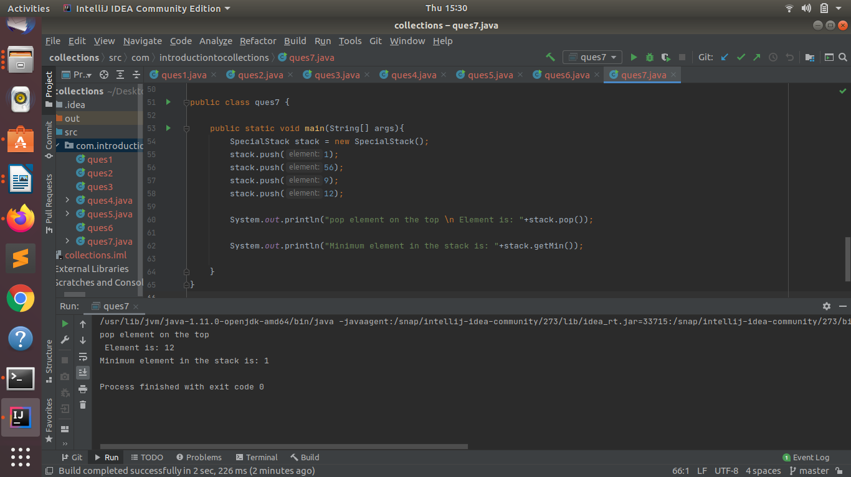

Q8.Write a program to format date as example "21-March-2016".
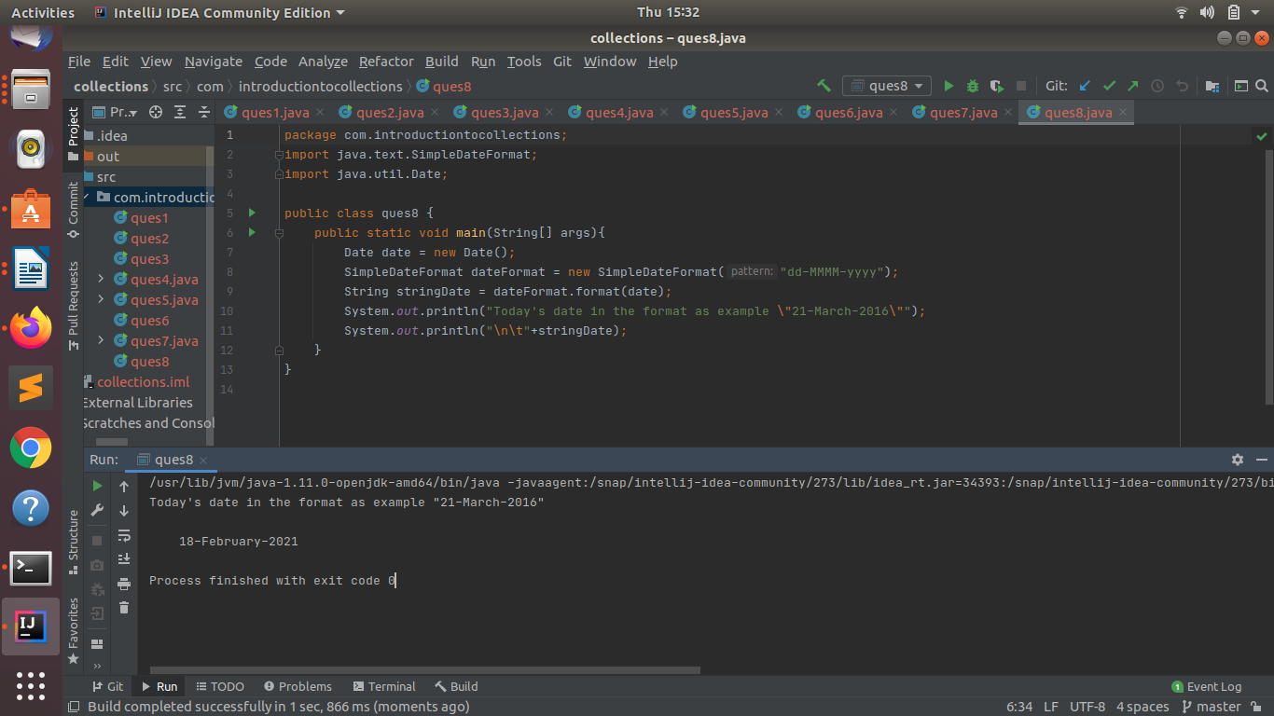

Q9.Write a program to display times in different country format.
