*Internationalization
Q1.Add support for Internationalization in your application allowing messages to be shown in English, German and Swedish, keeping English as default.
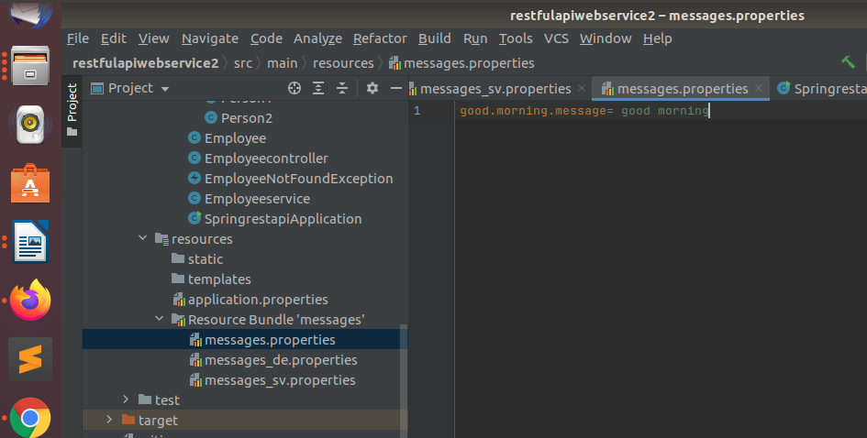

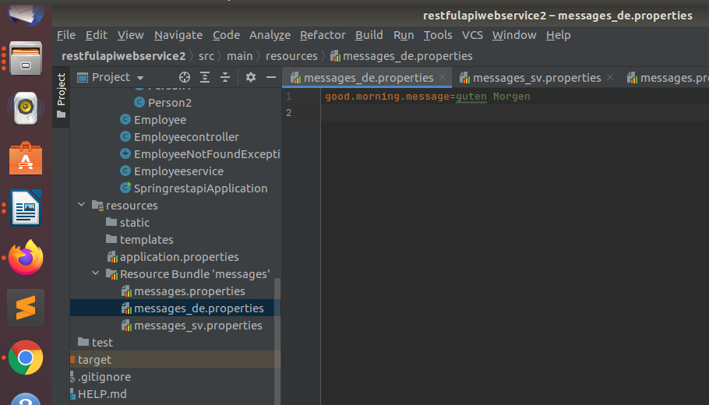

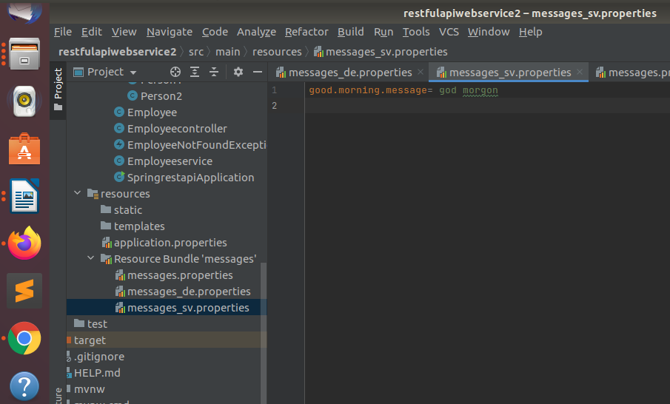

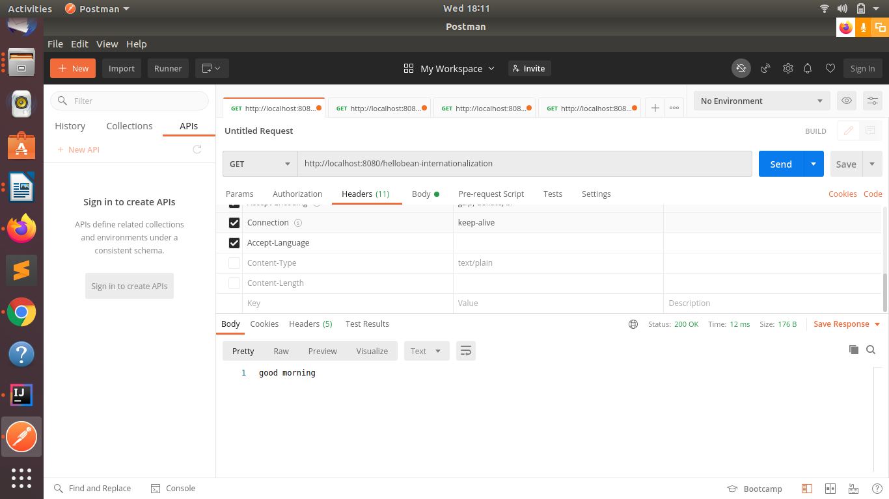
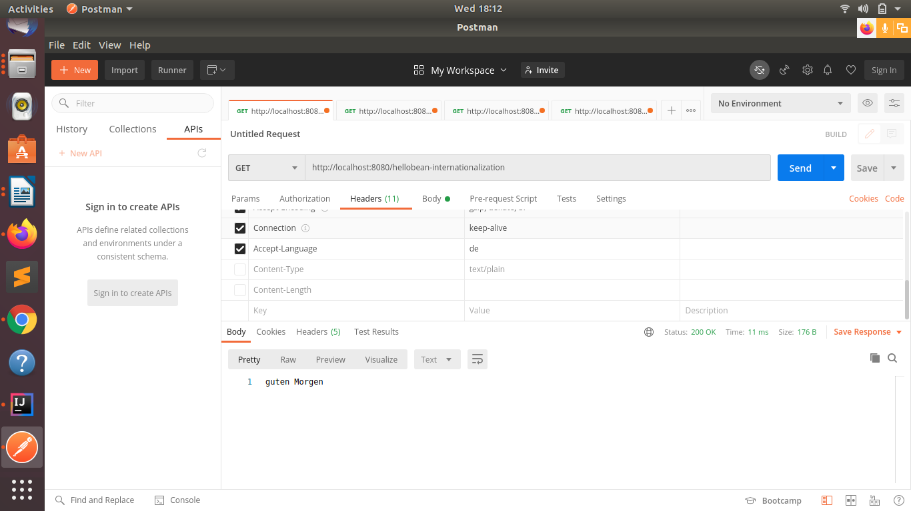

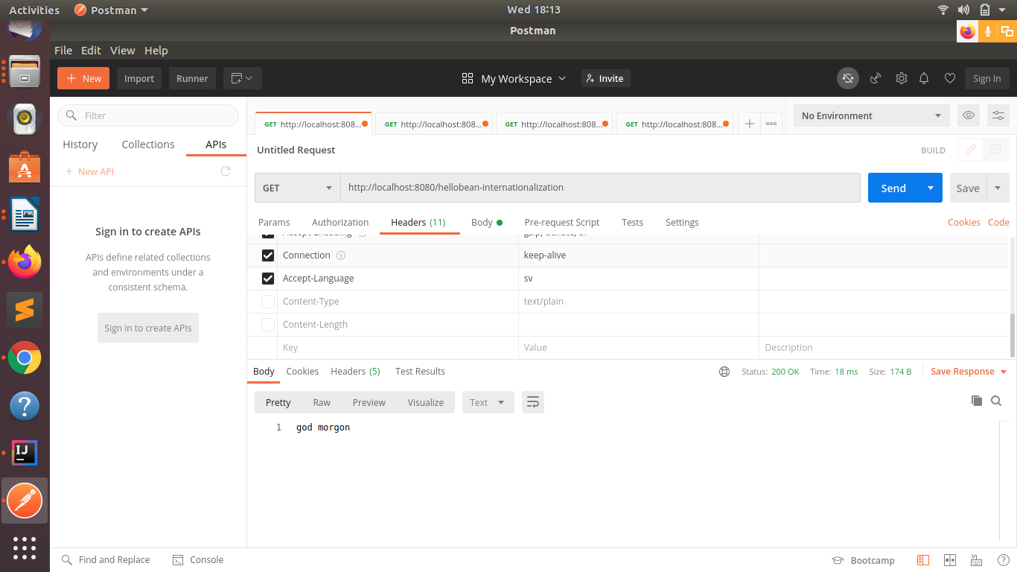

Q2.Create a GET request which takes "username" as param and shows a localized message "Hello Username". (Use parameters in message properties)
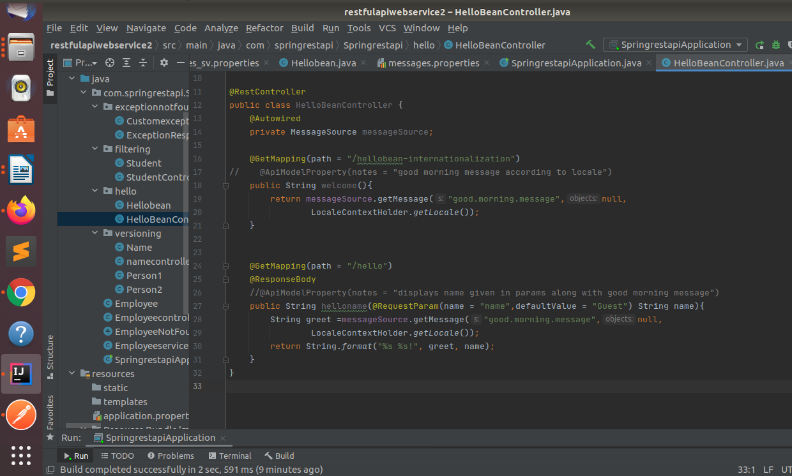
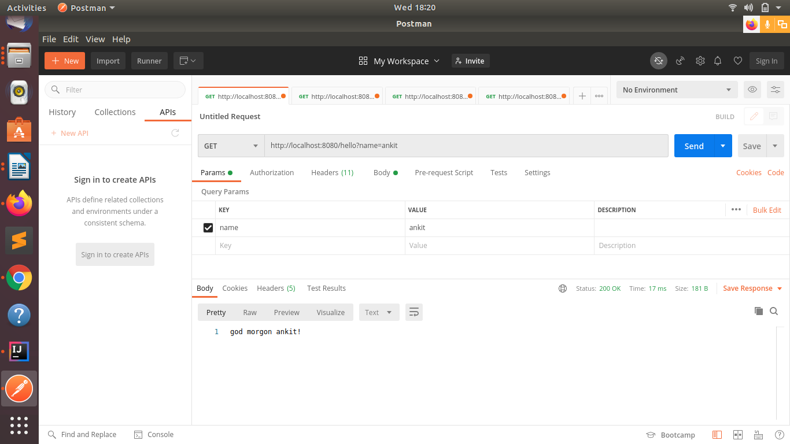

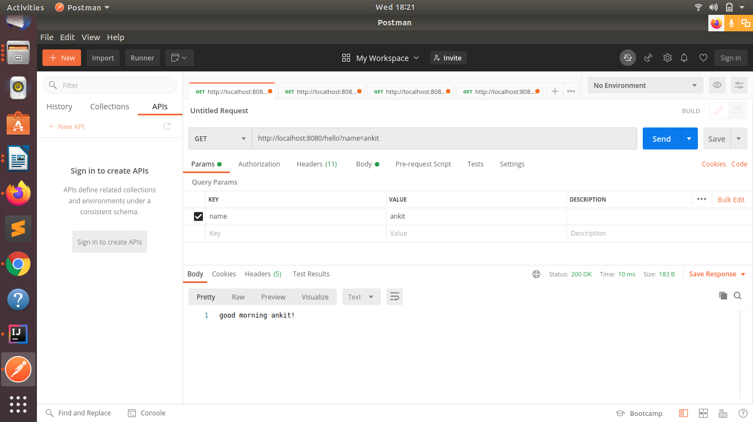

*Content Negotiation
Q3. Create POST Method to create user details which can accept XML for user creation.
//adding dependecy of jackson
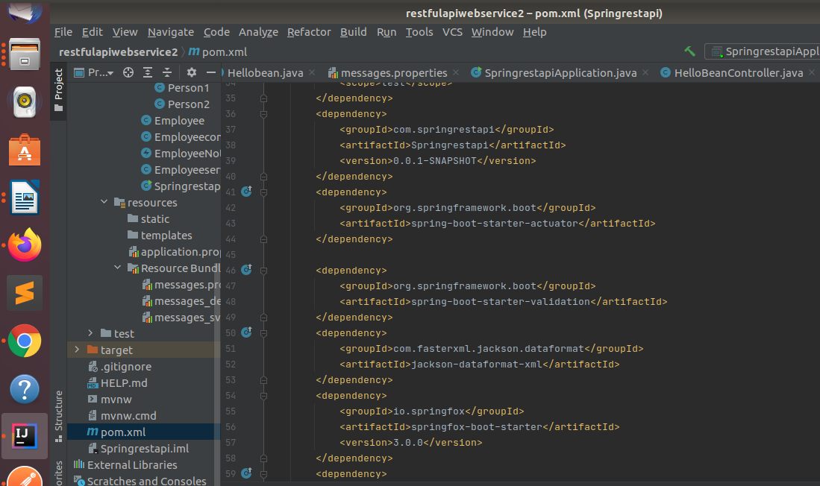
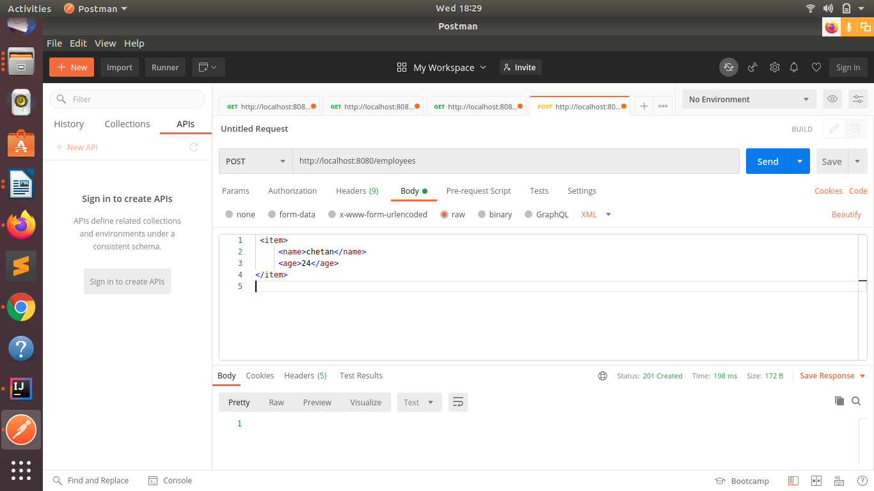
//POST method

Q4. Create GET Method to fetch the list of users in XML format.
//GET method
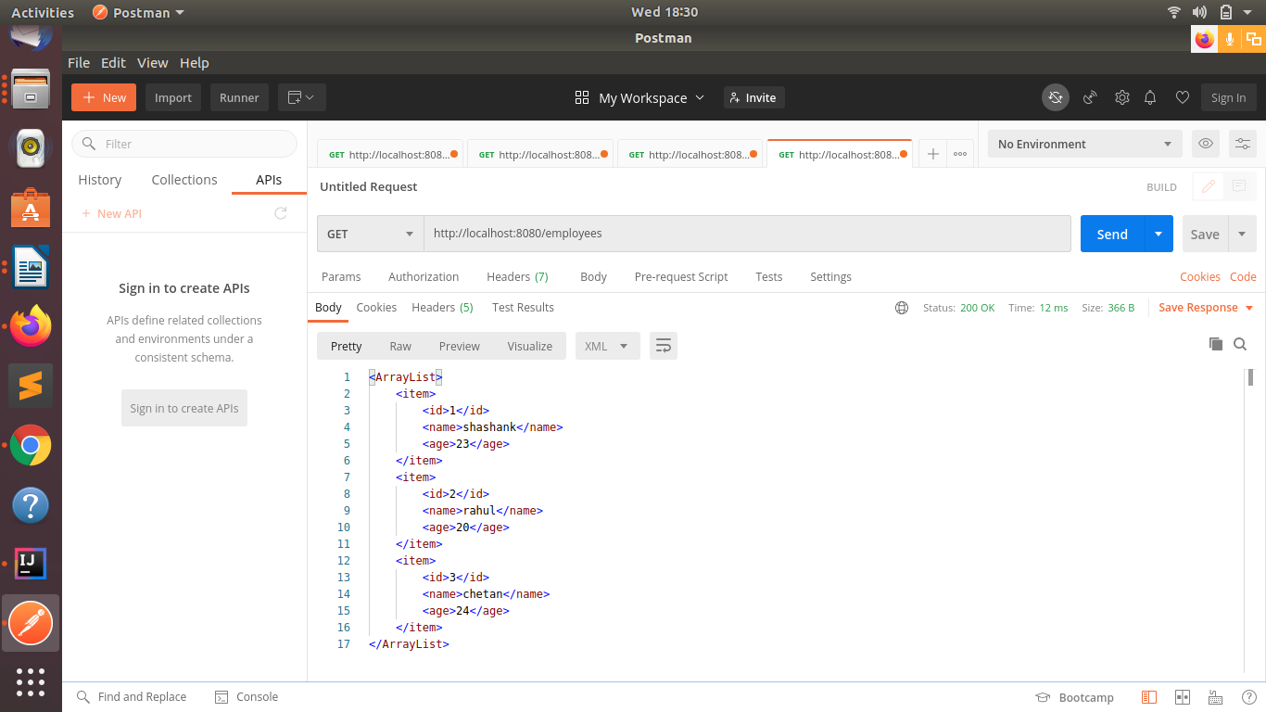

*Swagger

Q5.Configure swagger plugin and create document of following methods:
Get details of User using GET request.
Save details of the user using POST request.
Delete a user using DELETE request.
//Adding a swagger dependency
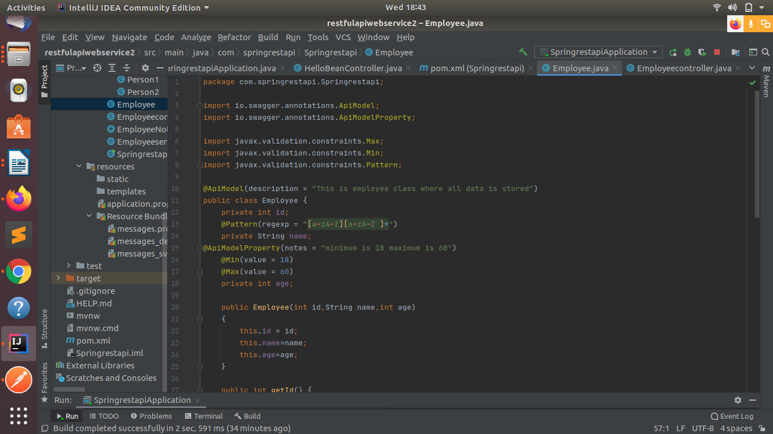
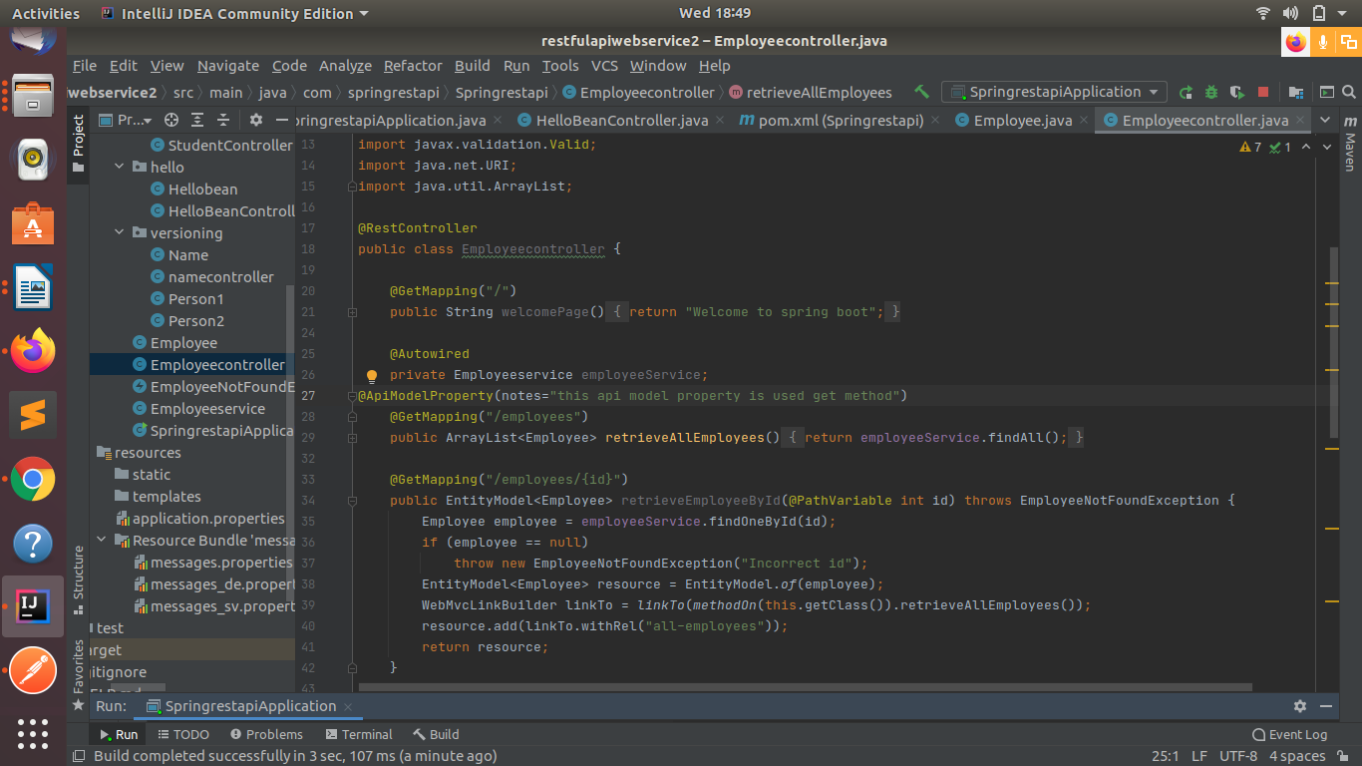
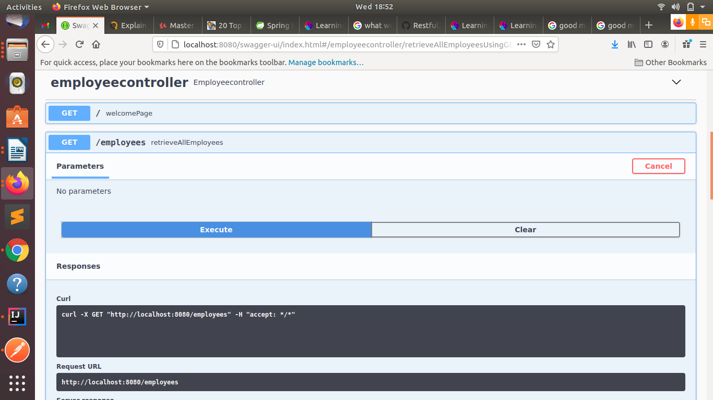
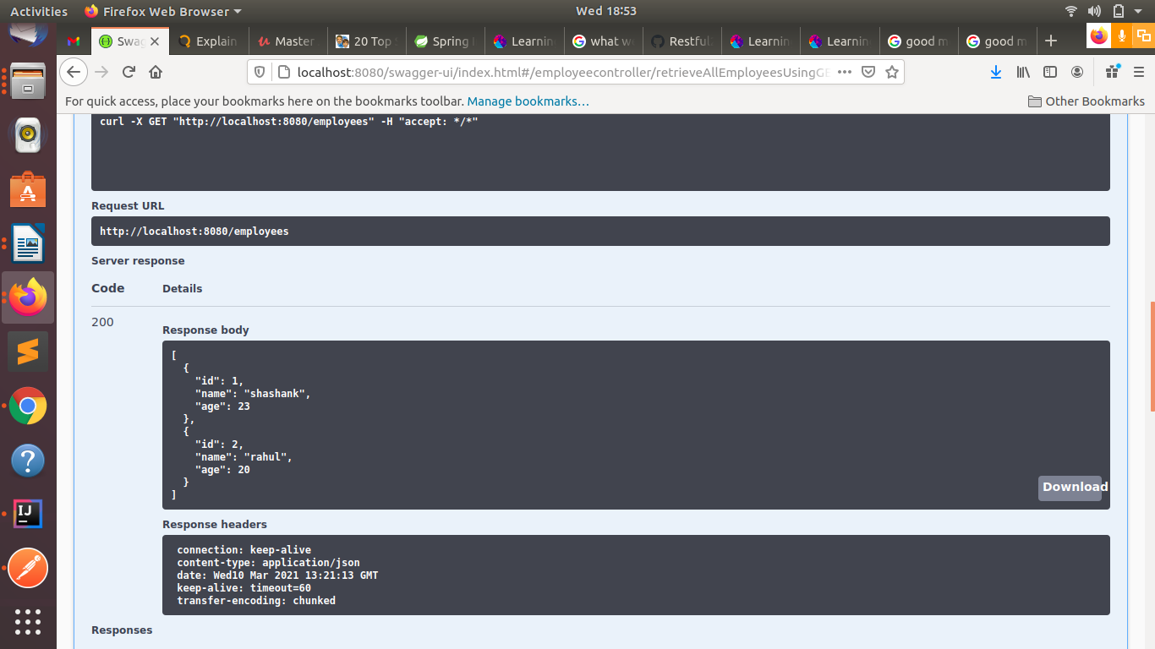

//Post request
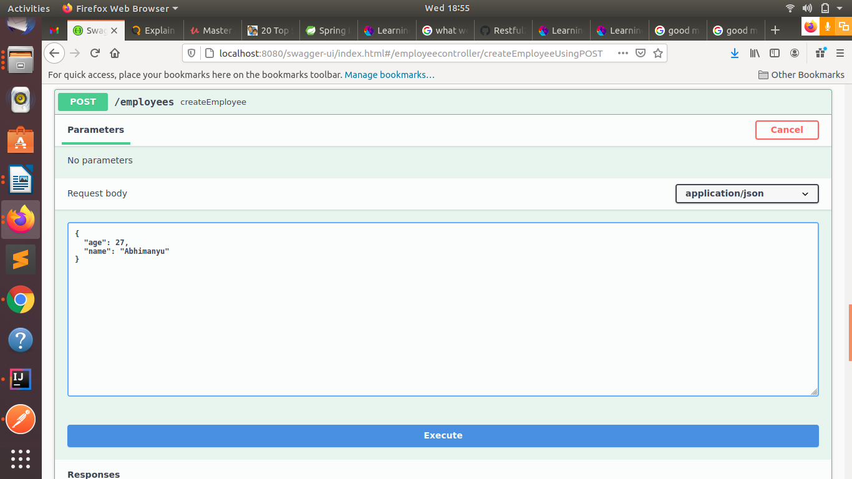
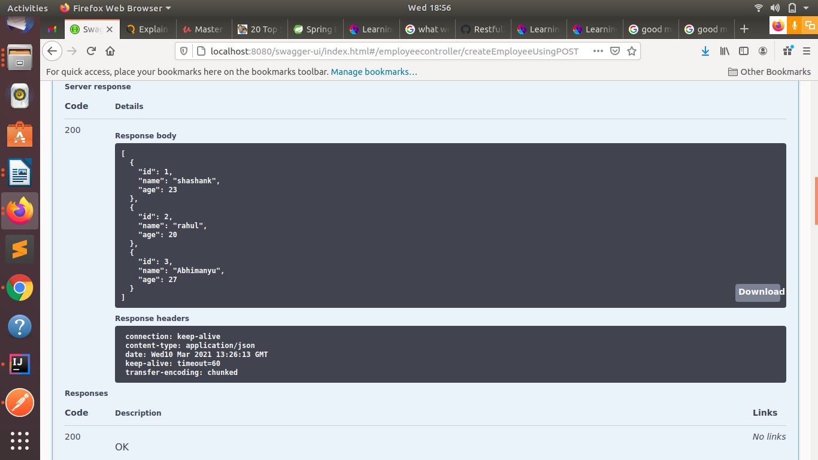

//delete
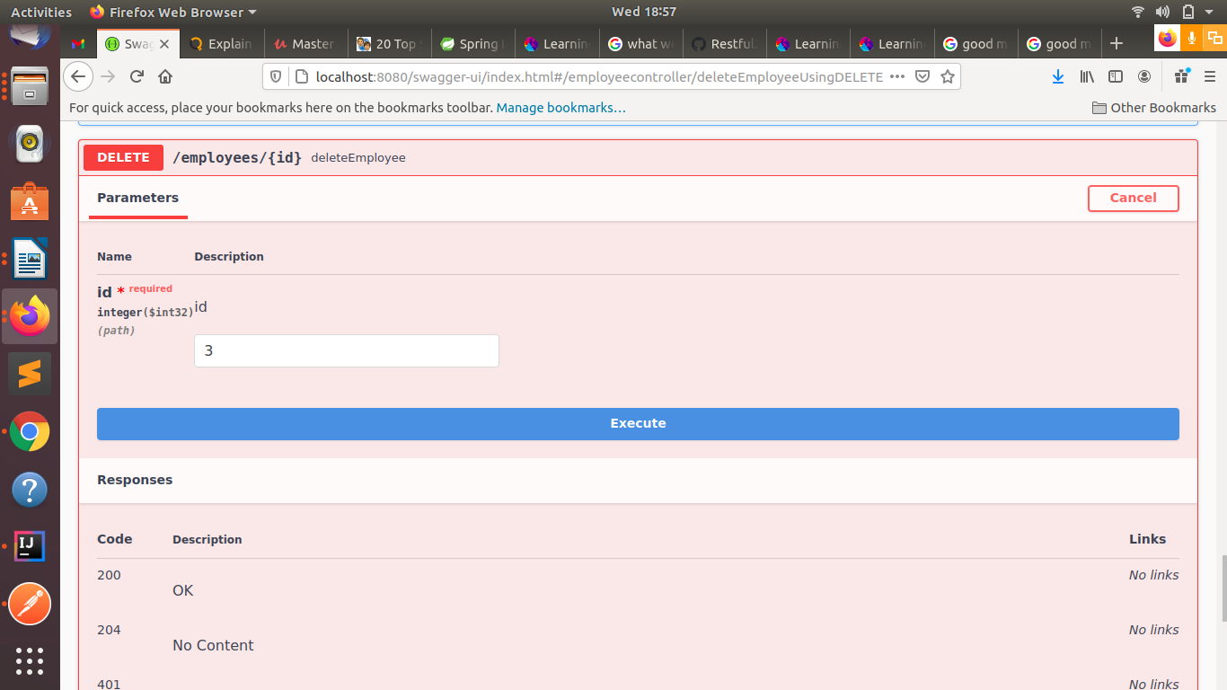
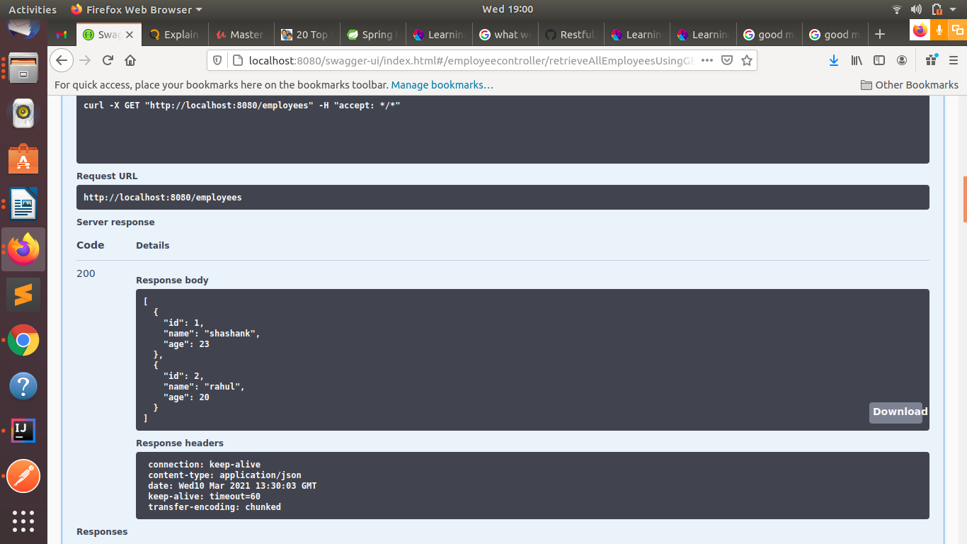

Q7.In swagger documentation, add the description of each class and URI so that in swagger UI the purpose of class and URI is clear.
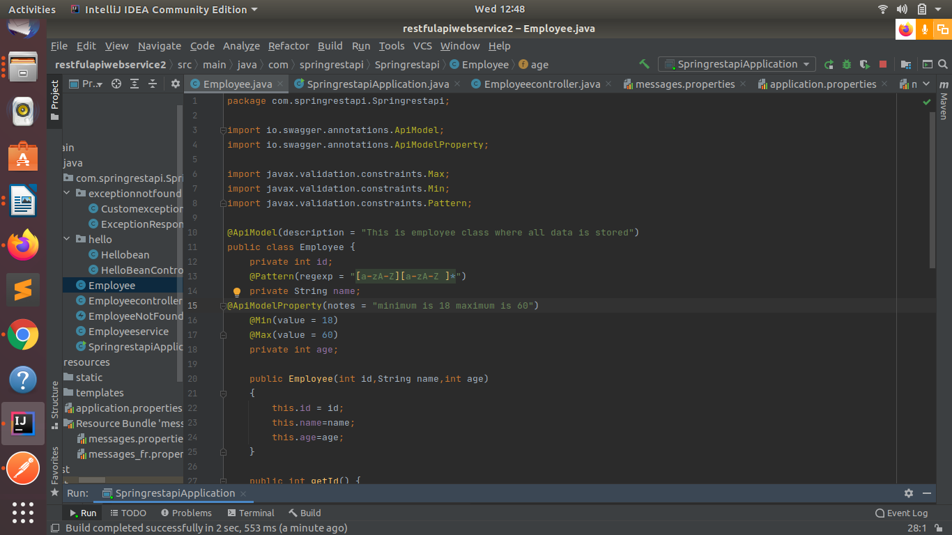
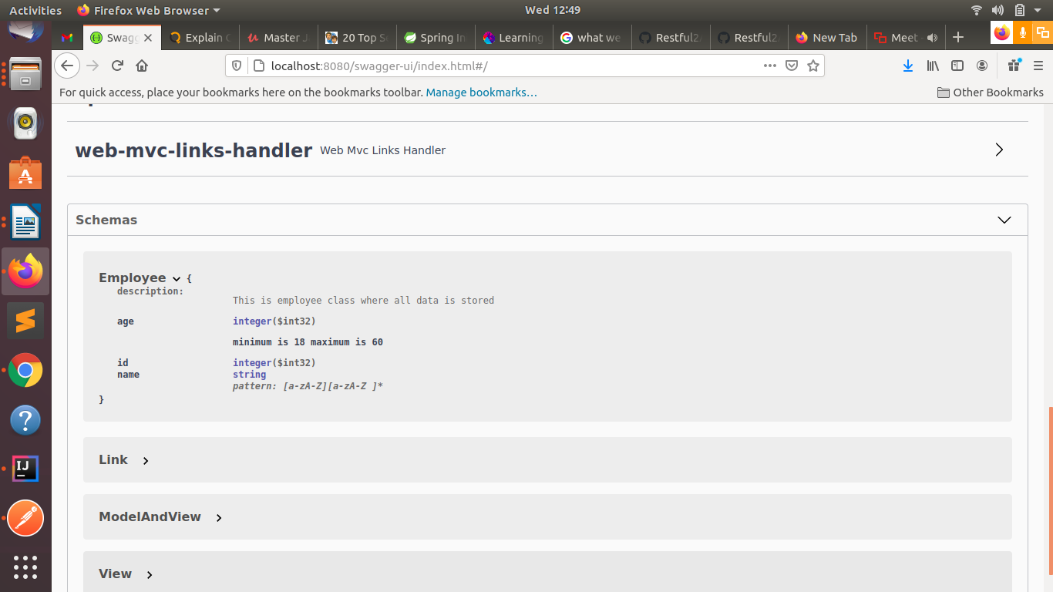

*Static and Dynamic filtering
Q6.Create API which saves details of User (along with the password) but on successfully saving returns only non-critical data. (Use static filtering)
//Ststic binding
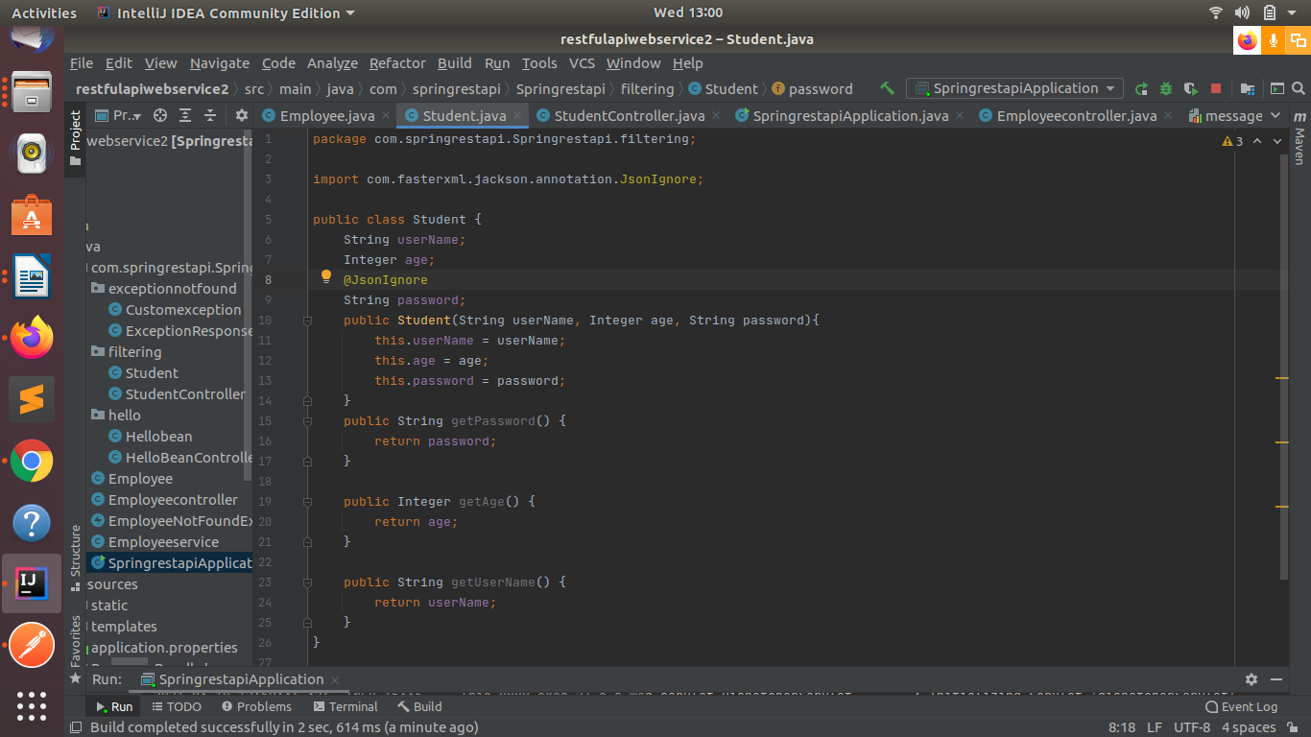
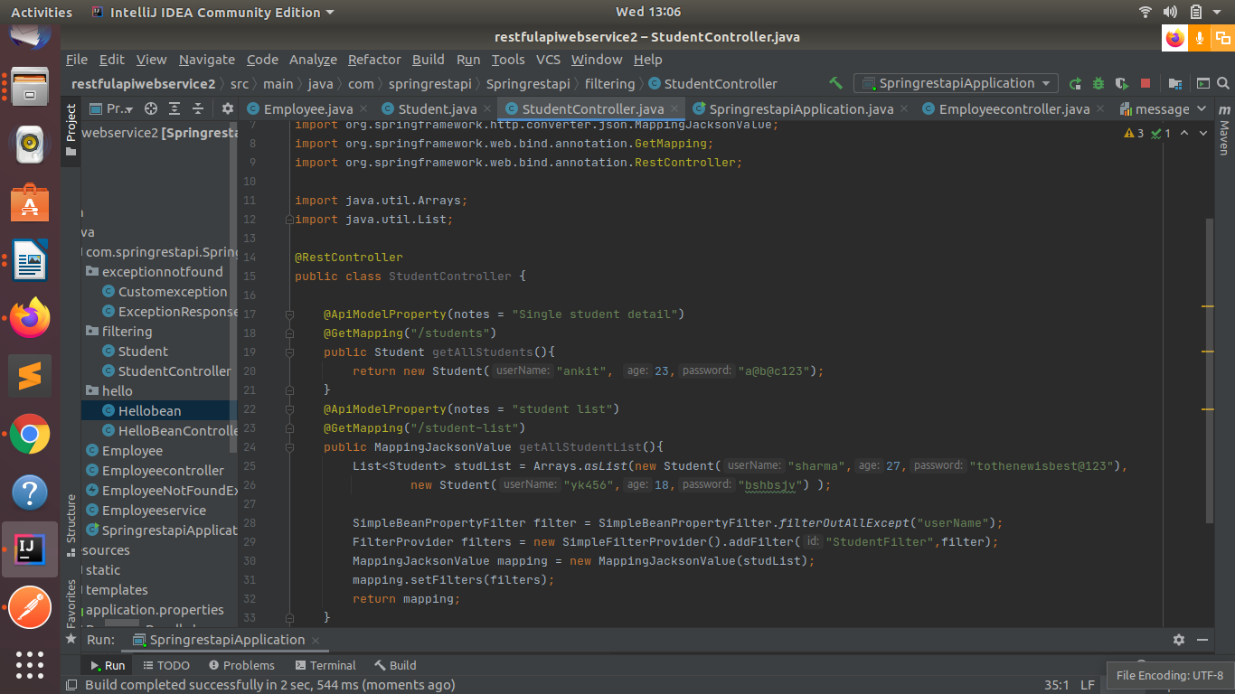

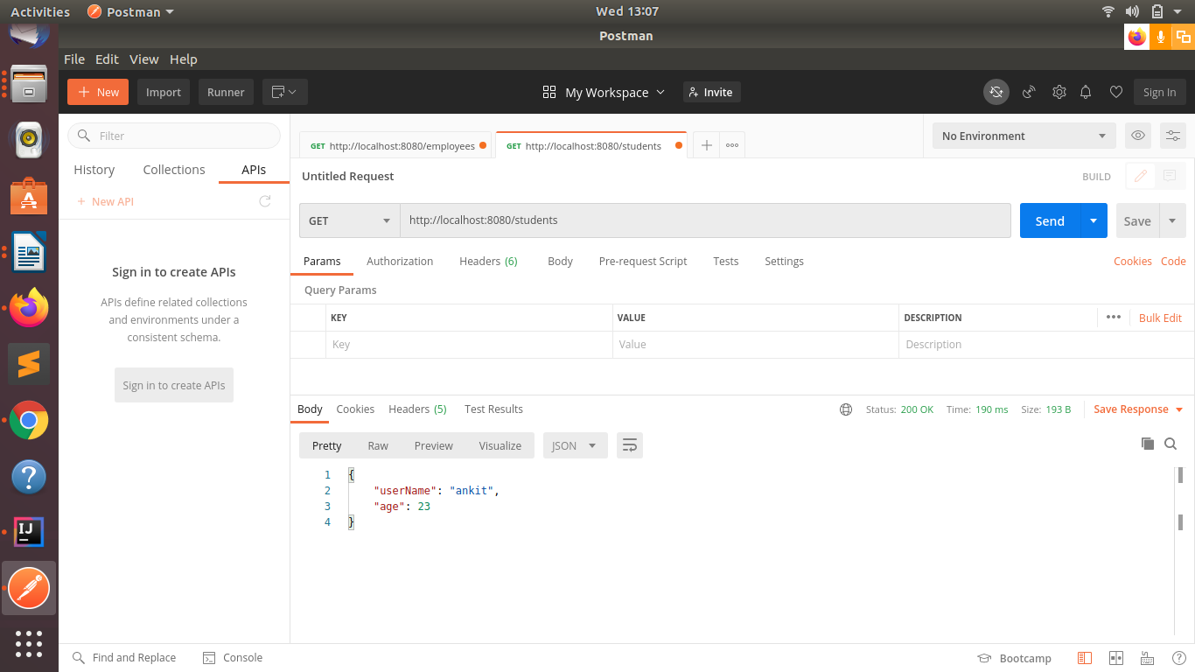

Q8.Create another API that does the same by using Dynamic Filtering.
//Dynamic bindind
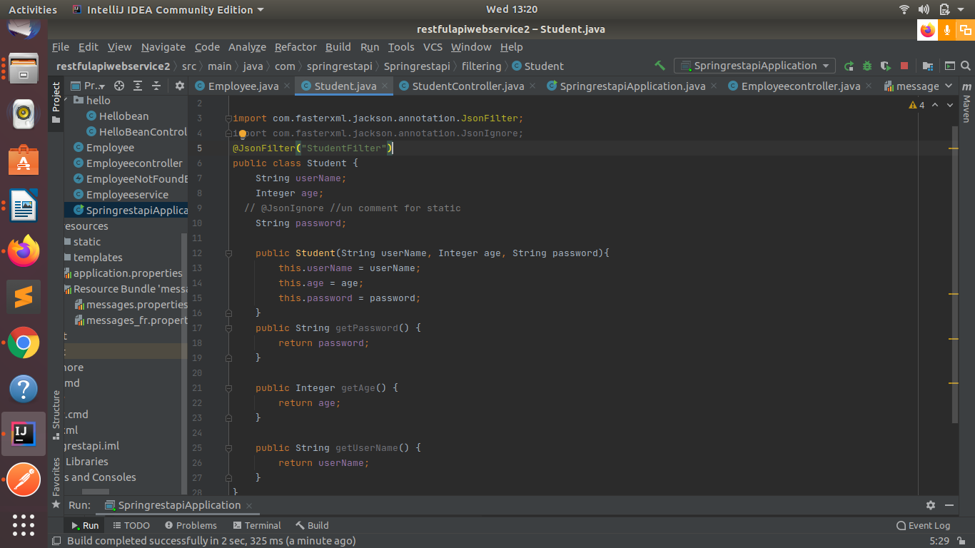
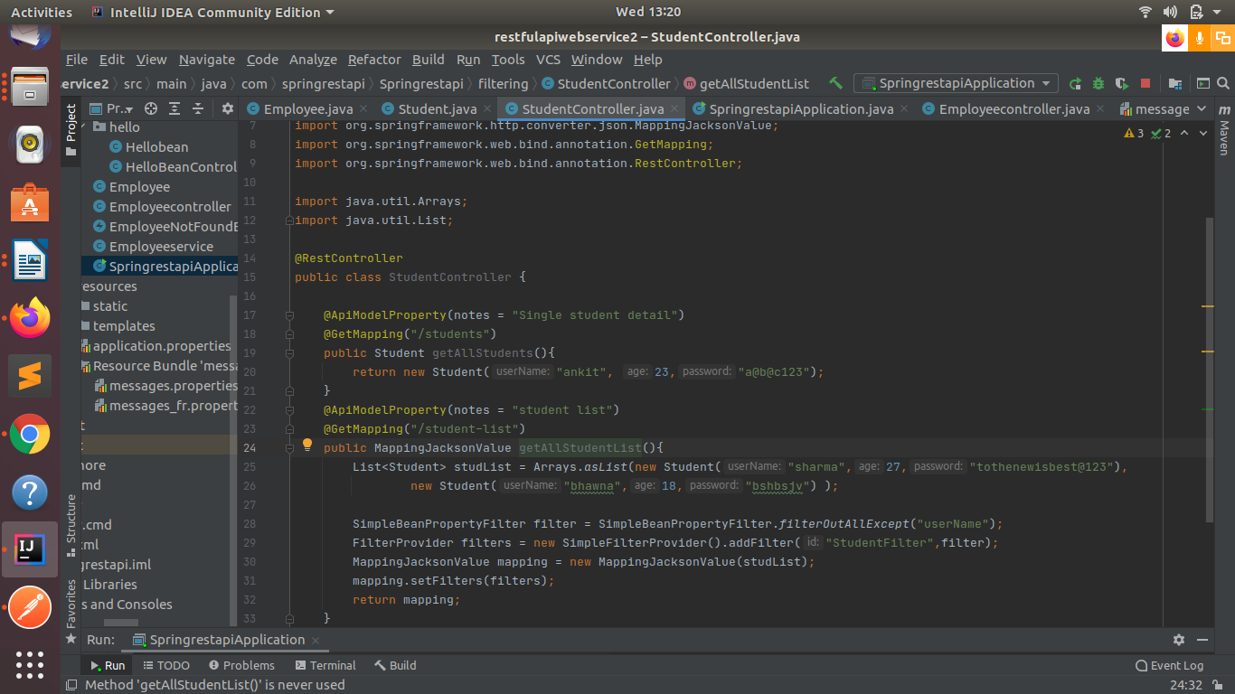

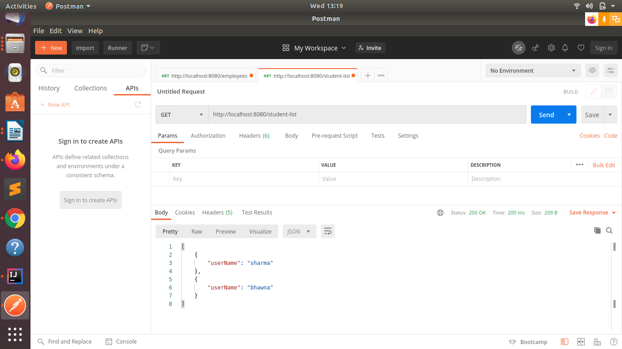

*Versioning Restful APIs
Q9.Create 2 API for showing user details. The first api should return only basic details of the user and the other API should return more/enhanced details of the user,
Now apply versioning using the following methods:
- MimeType Versioning.
- Request Parameter versioning.
- URI versioning.
- Custom Header Versioning.
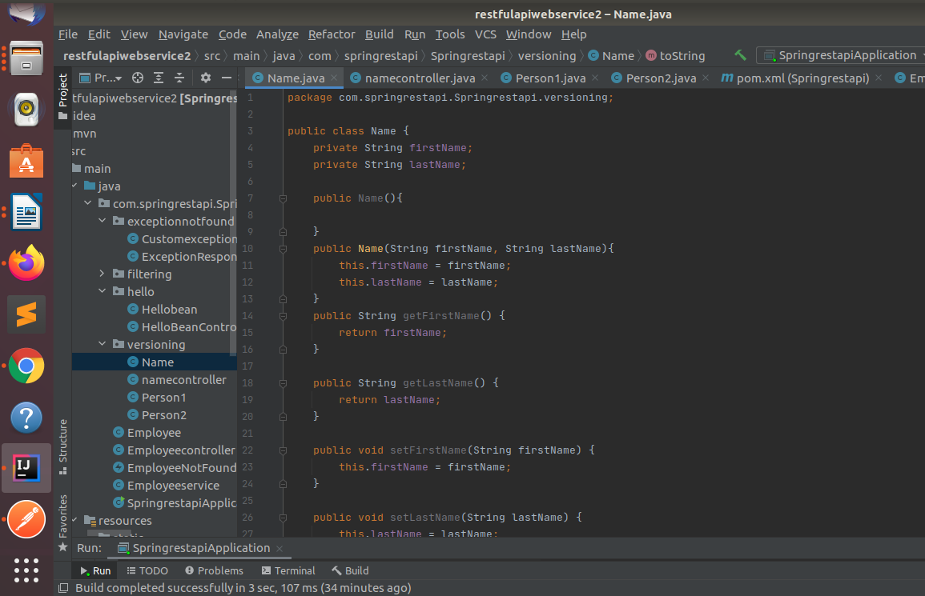

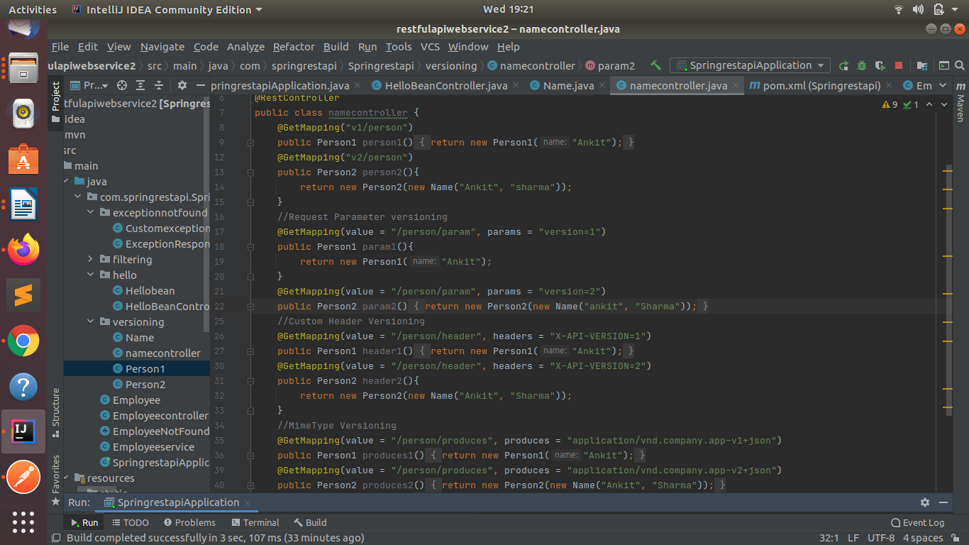
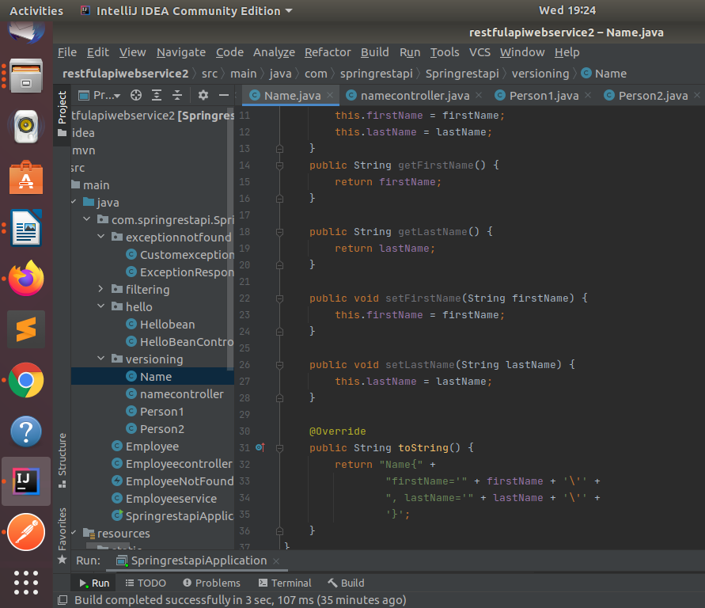
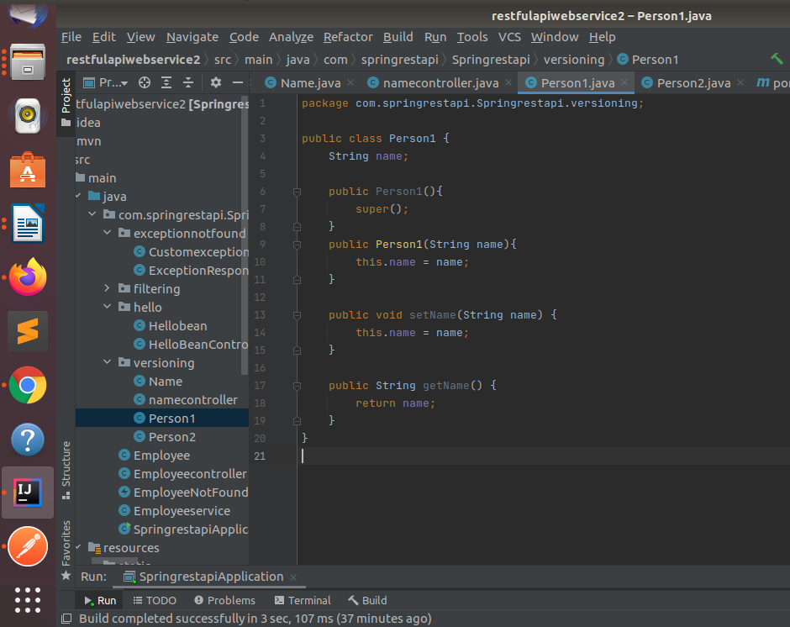

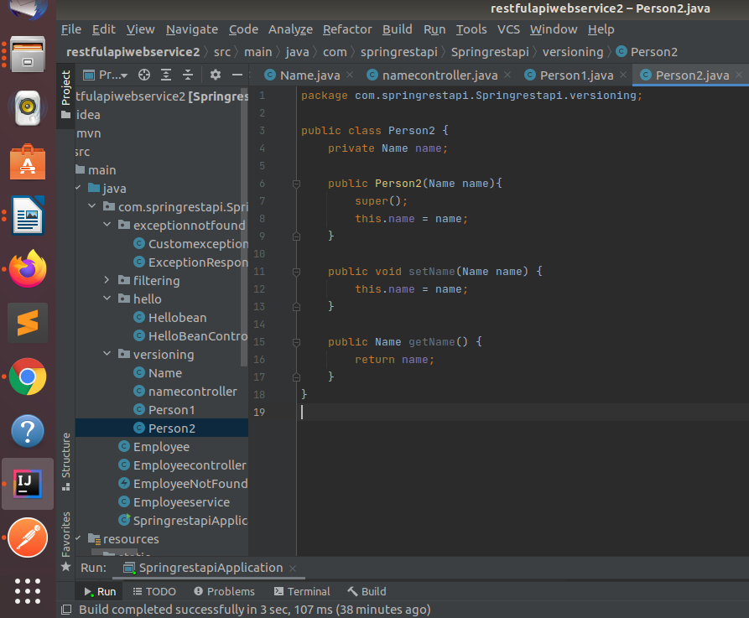

//Mime type versioning
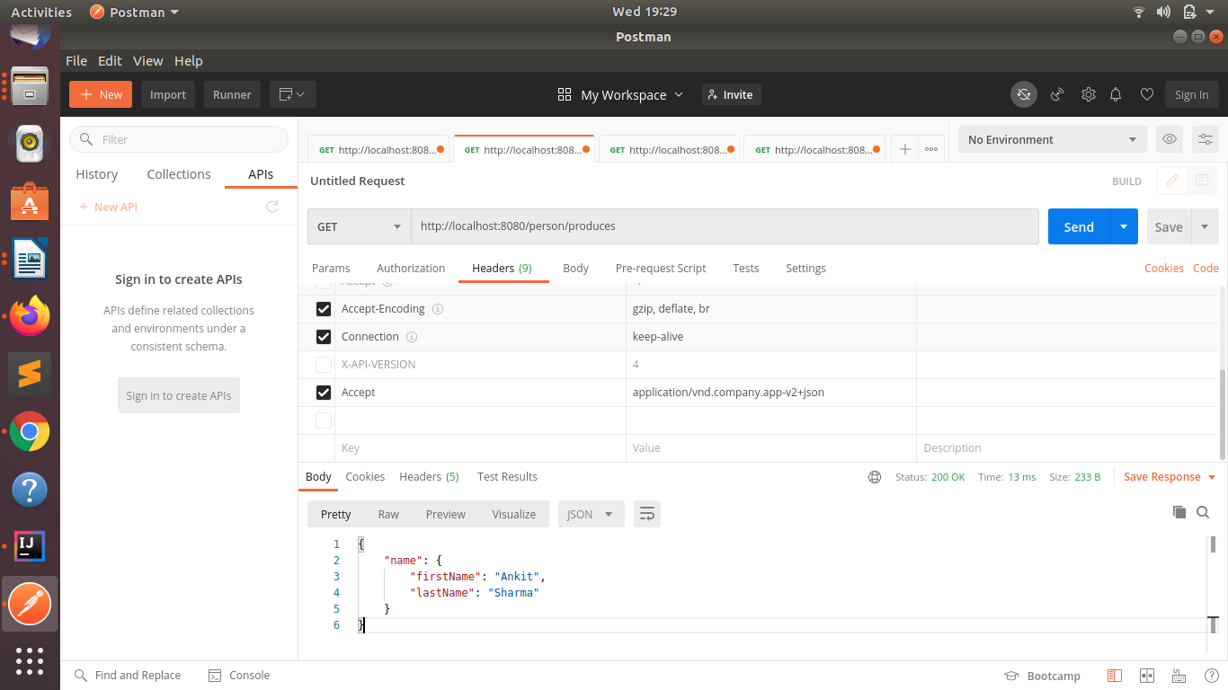
//Request Parameter versioning.
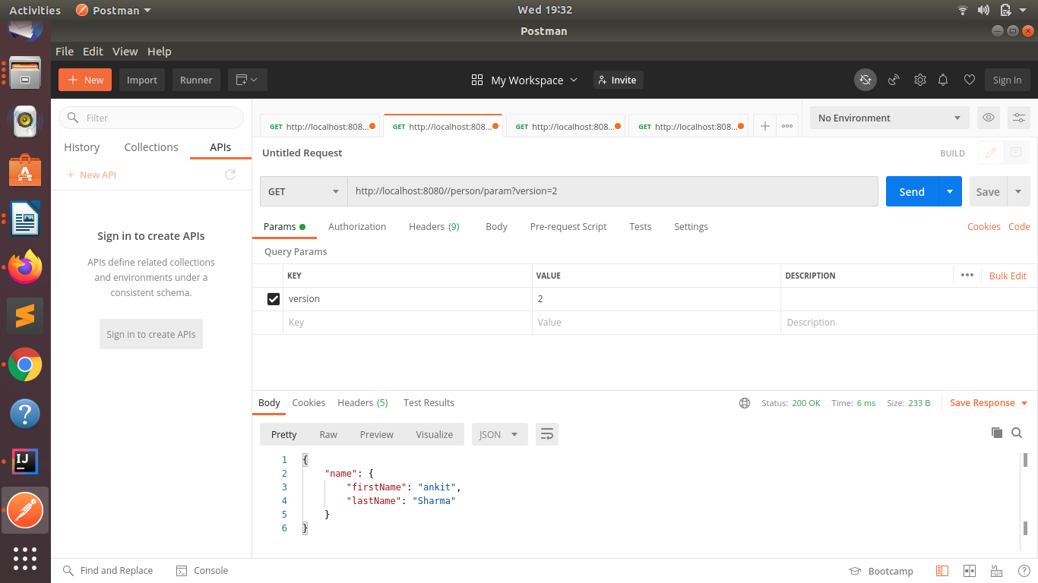

//custom header vesioning
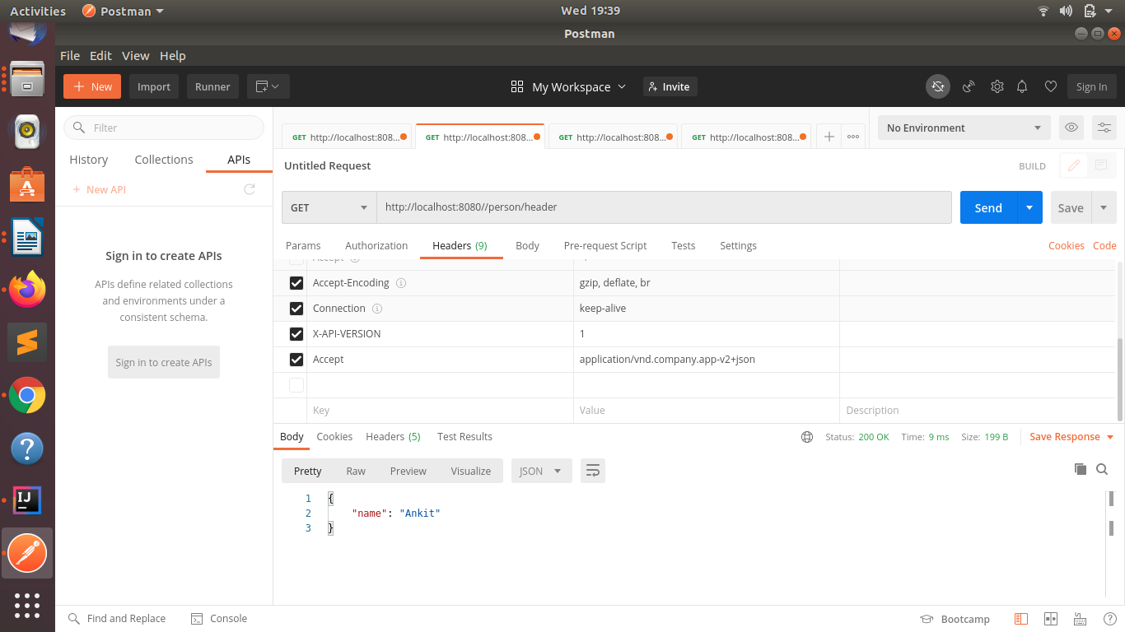
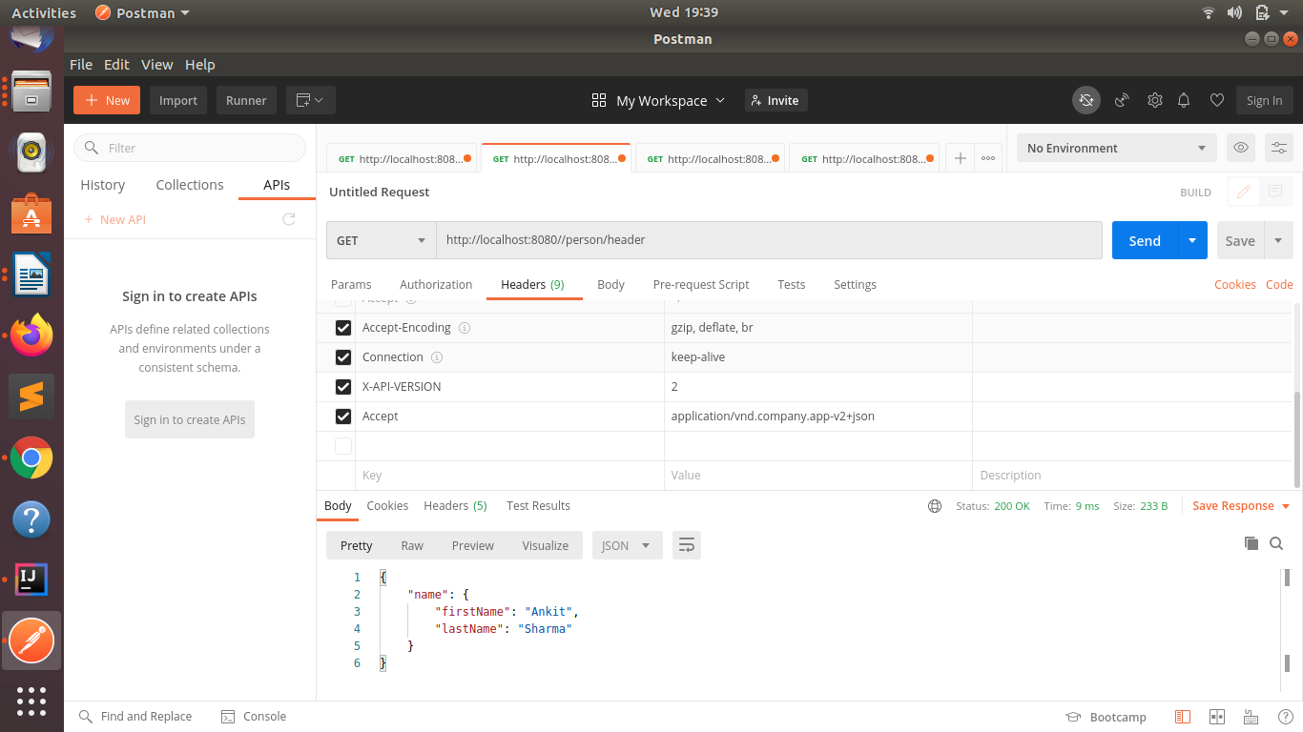

//URI versioning.
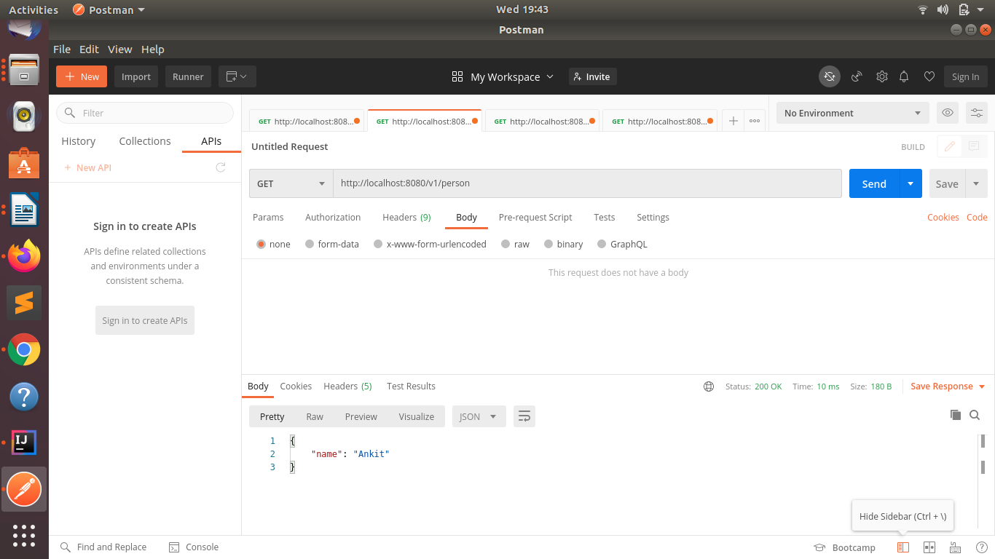
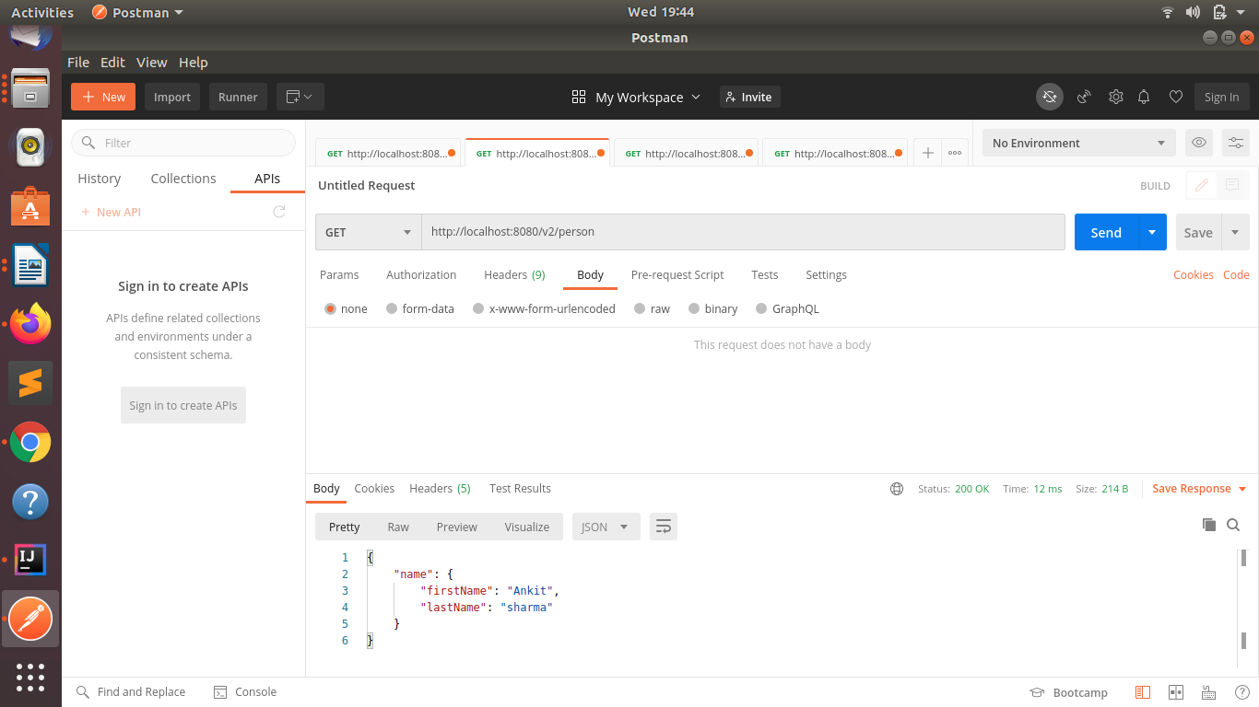

*HATEOAS
Q10.Configure hateoas with your springboot application. Create an api which returns User Details along with url to show all topics.
//Adding dependency of hateoas in pom.xml


