JPQL:
- Display the first name, last name of all employees having salary greater than average salary ordered in ascending by their age and in descending by their salary.
- Update salary of all employees by a salary passed as a parameter whose existing salary is less than the average salary.
- Delete all employees with minimum salary.

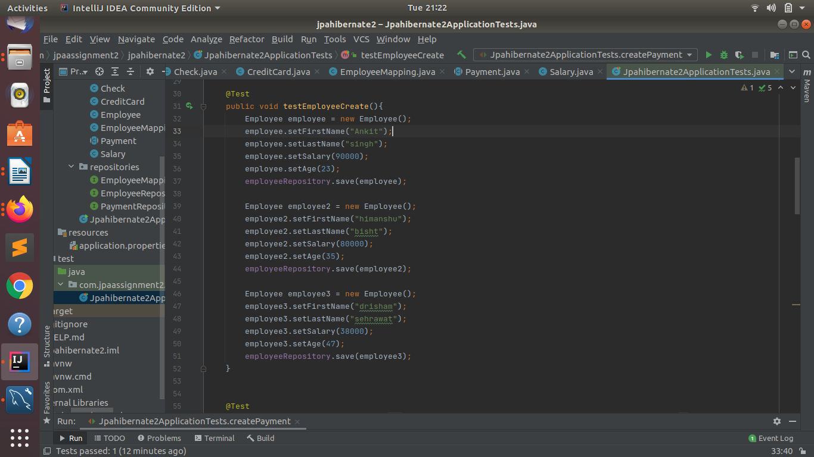
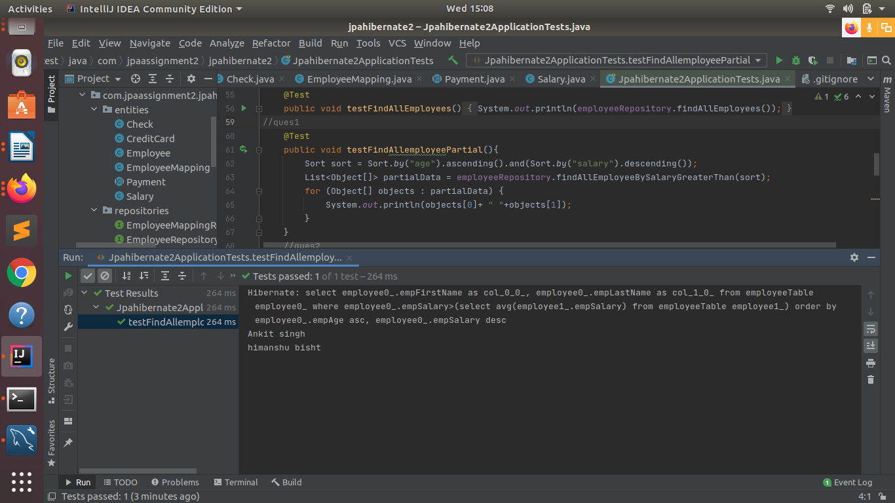
2.

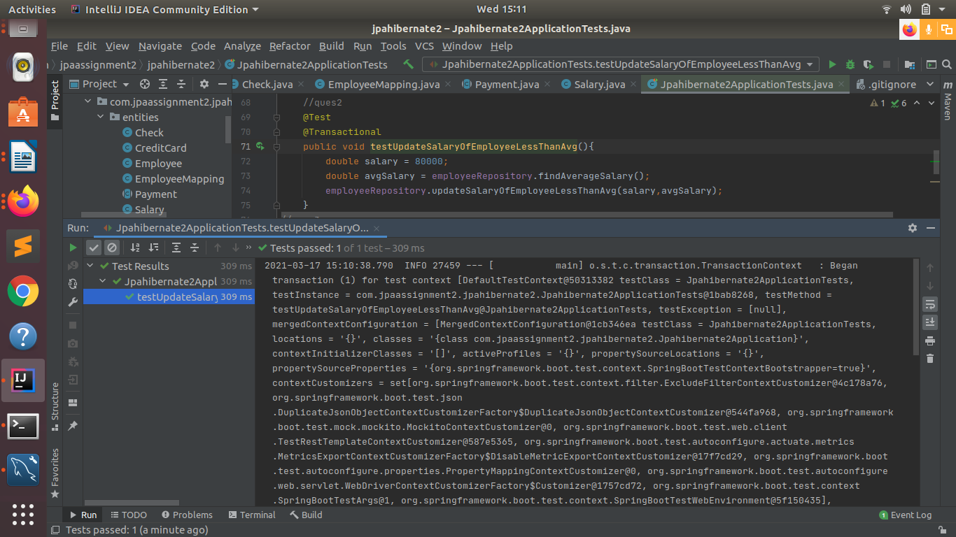
3.
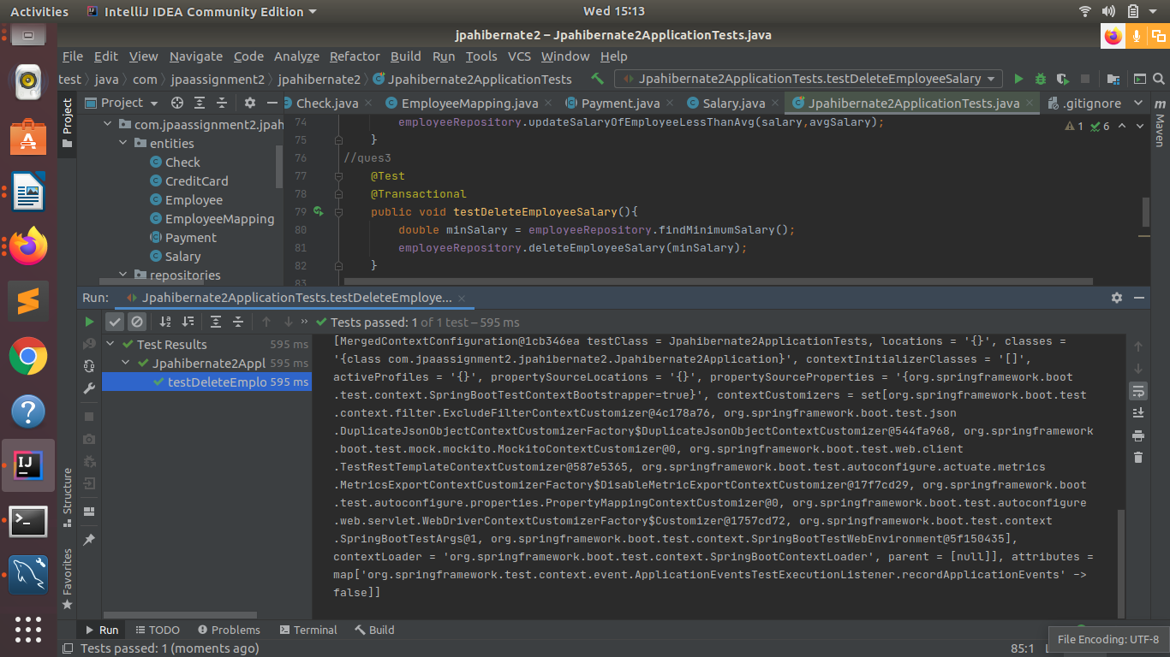

Native SQL Query:
- Display the id, first name, age of all employees where last name ends with "singh" .
- Delete all employees with age greater than 45(Should be passed as a parameter) .
1.
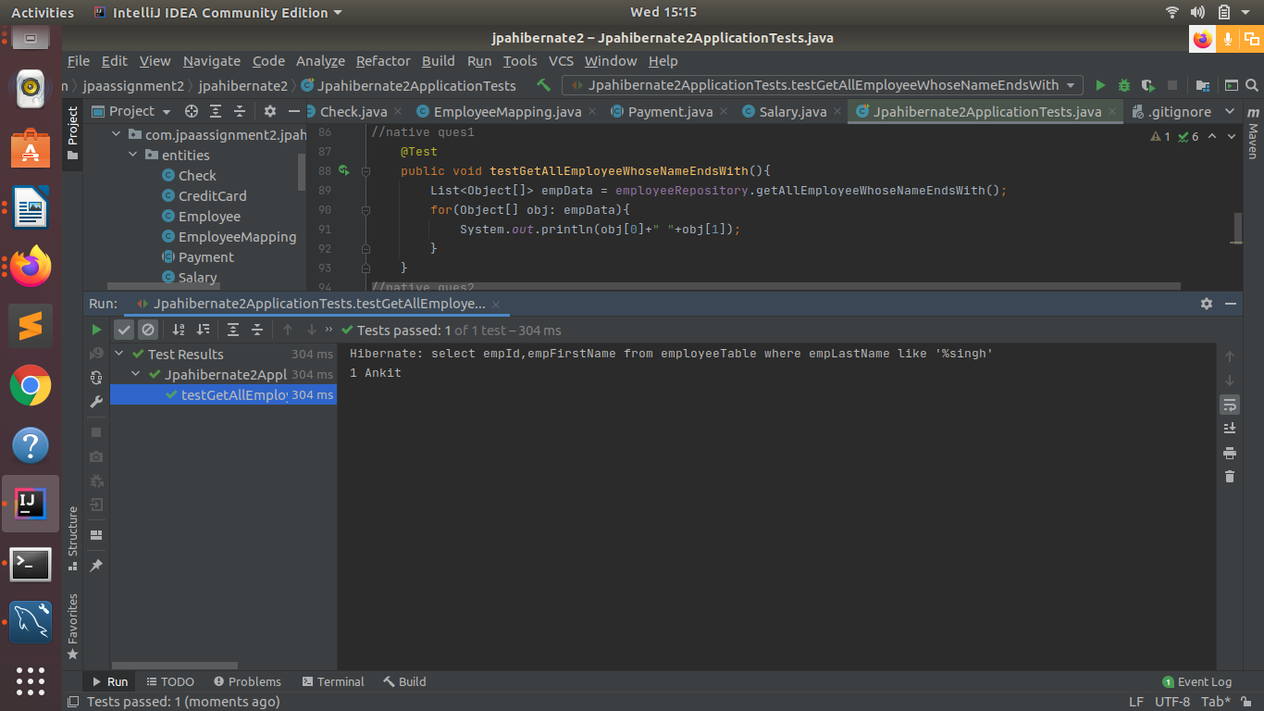
2.
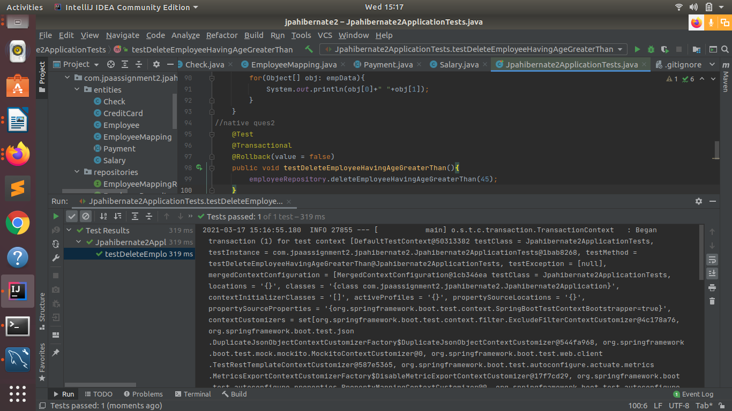

Inheritance Mapping:
- Implement and demonstrate Single Table strategy.

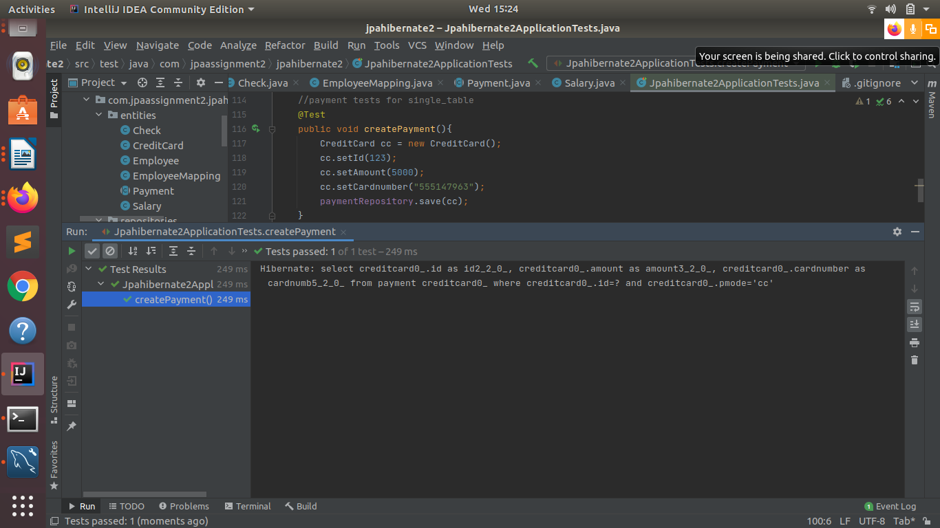
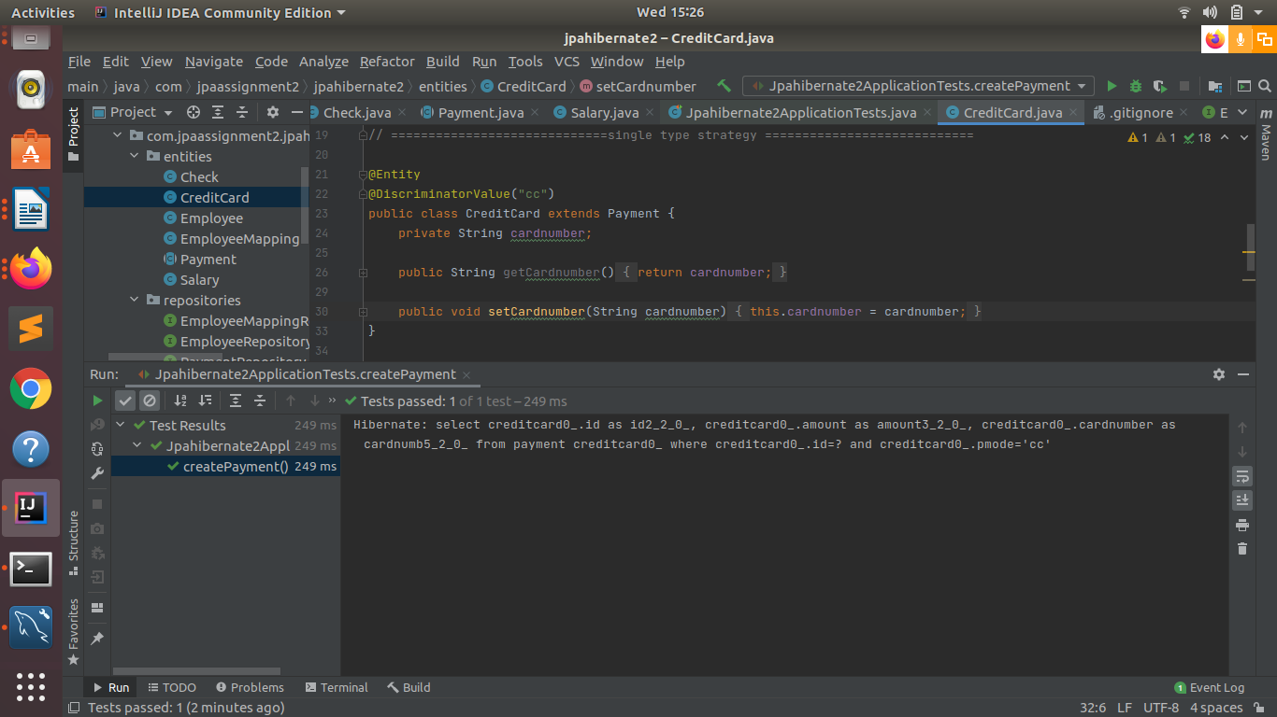

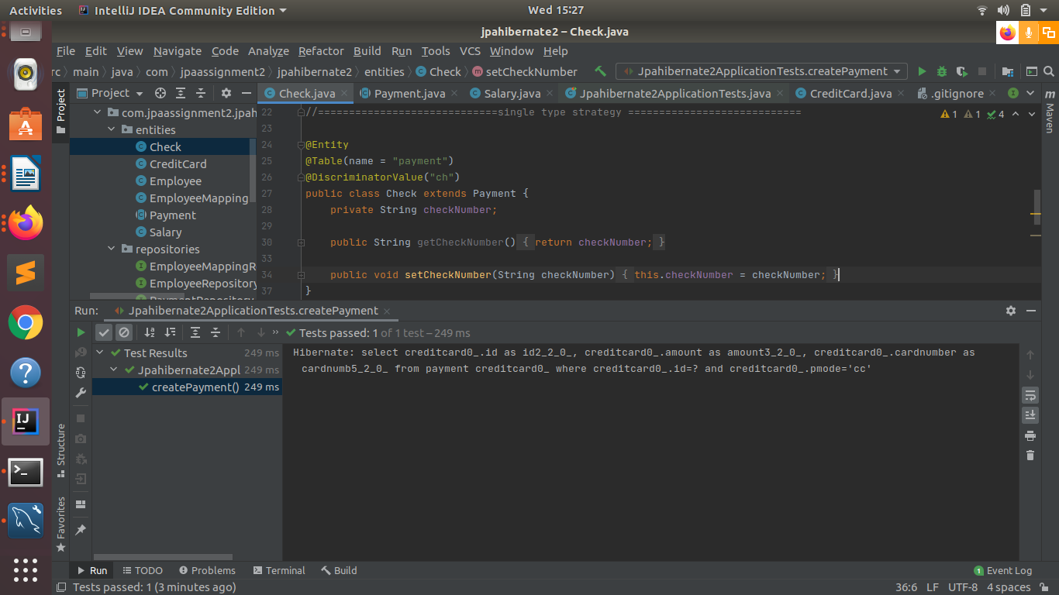
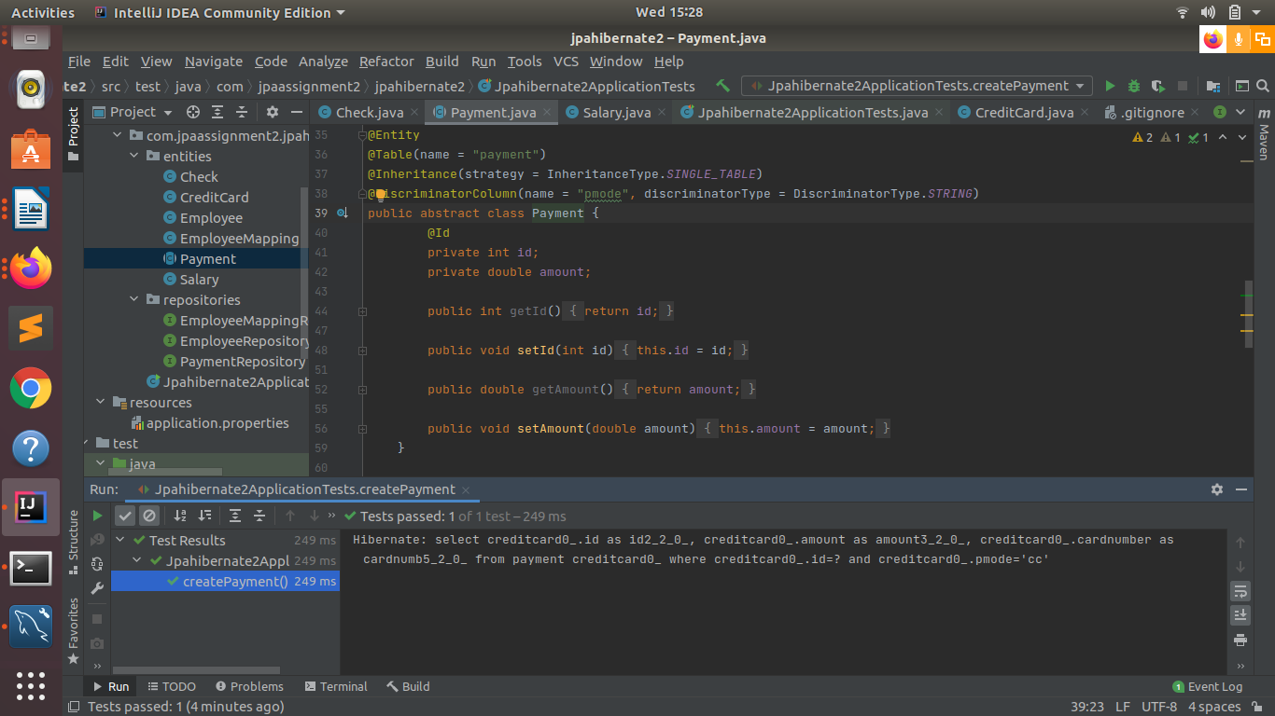

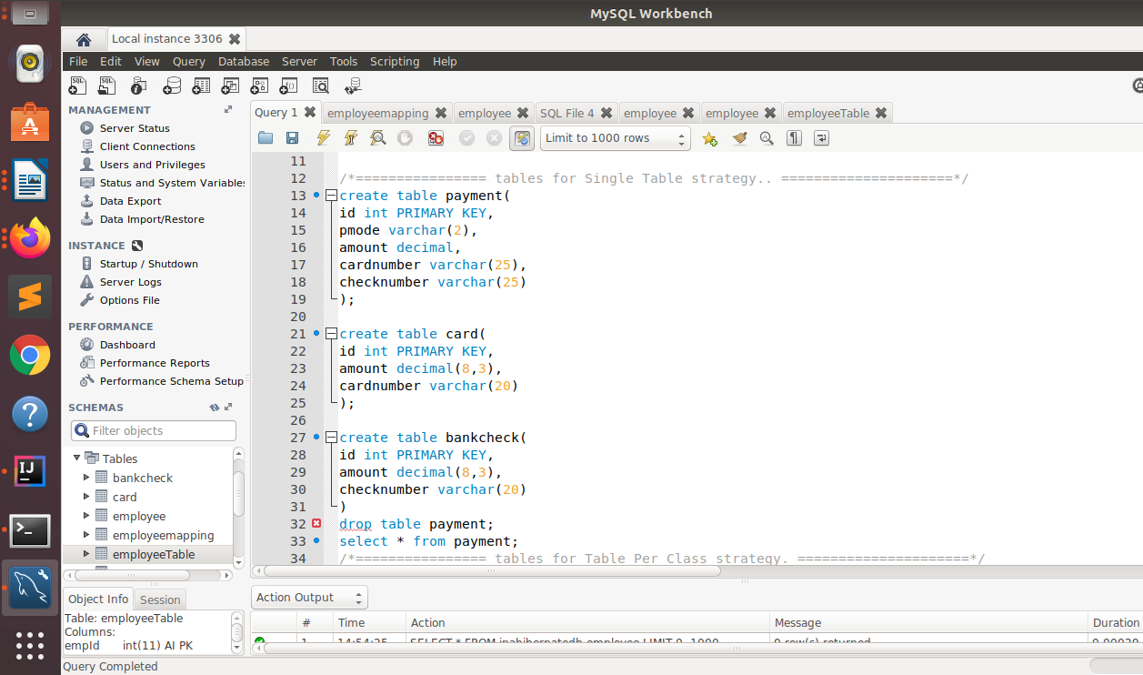

- Implement and demonstrate Joined strategy.
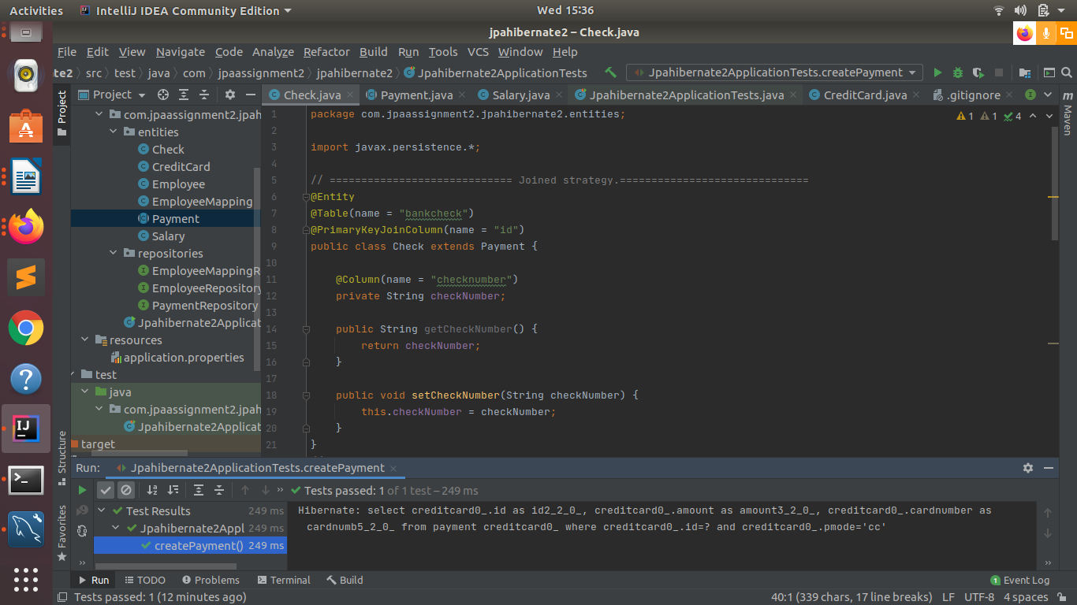
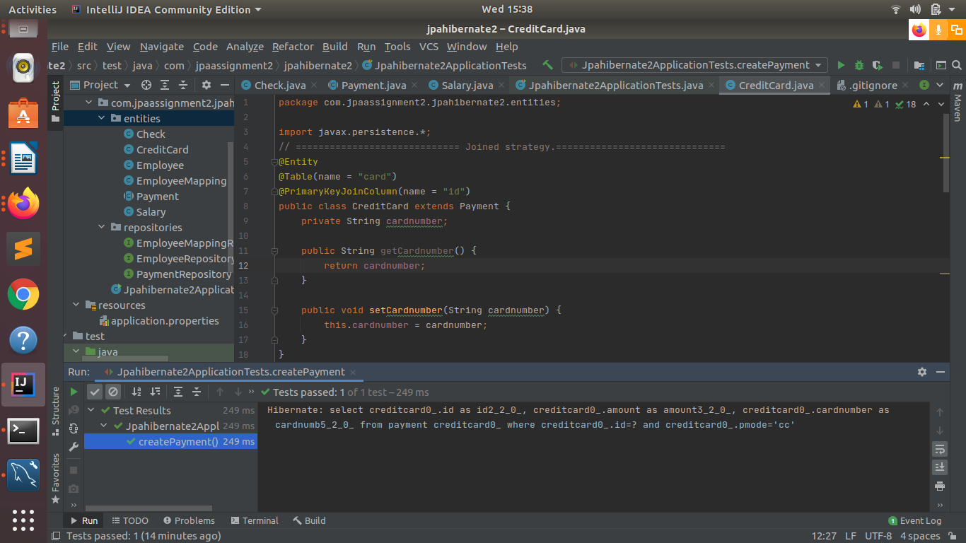

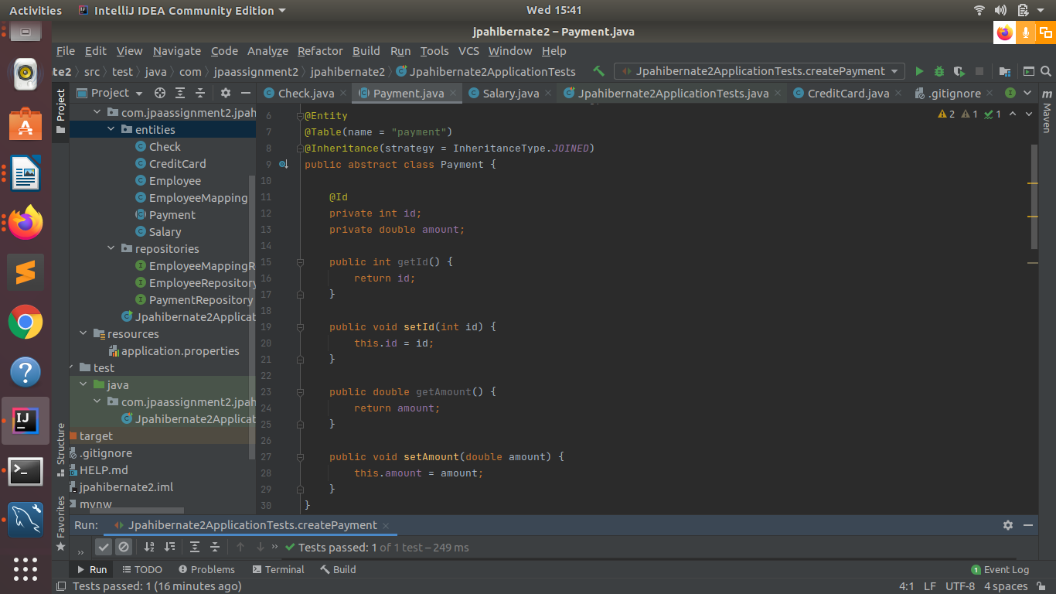
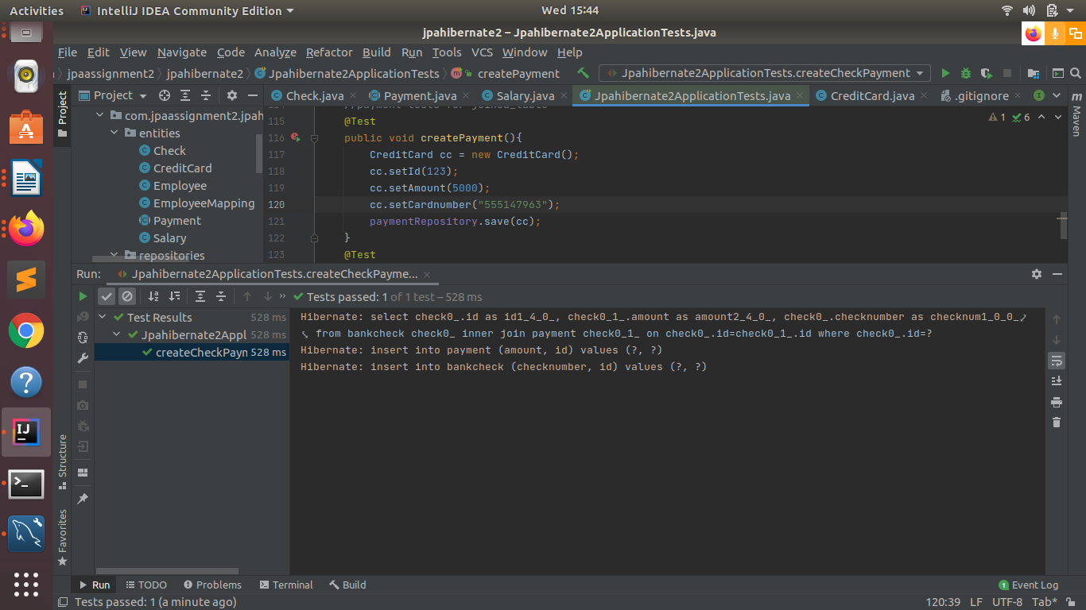

- Implement and demonstrate Table Per Class strategy.
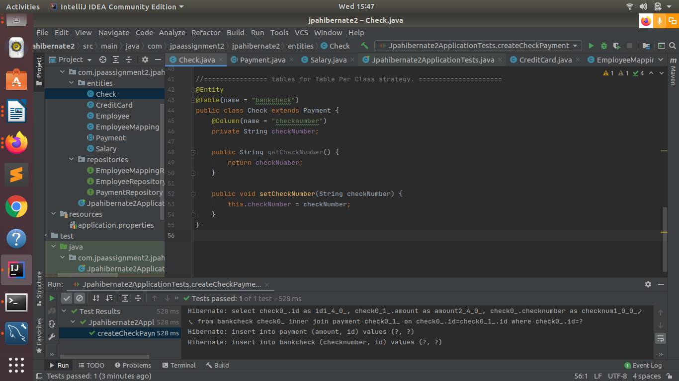
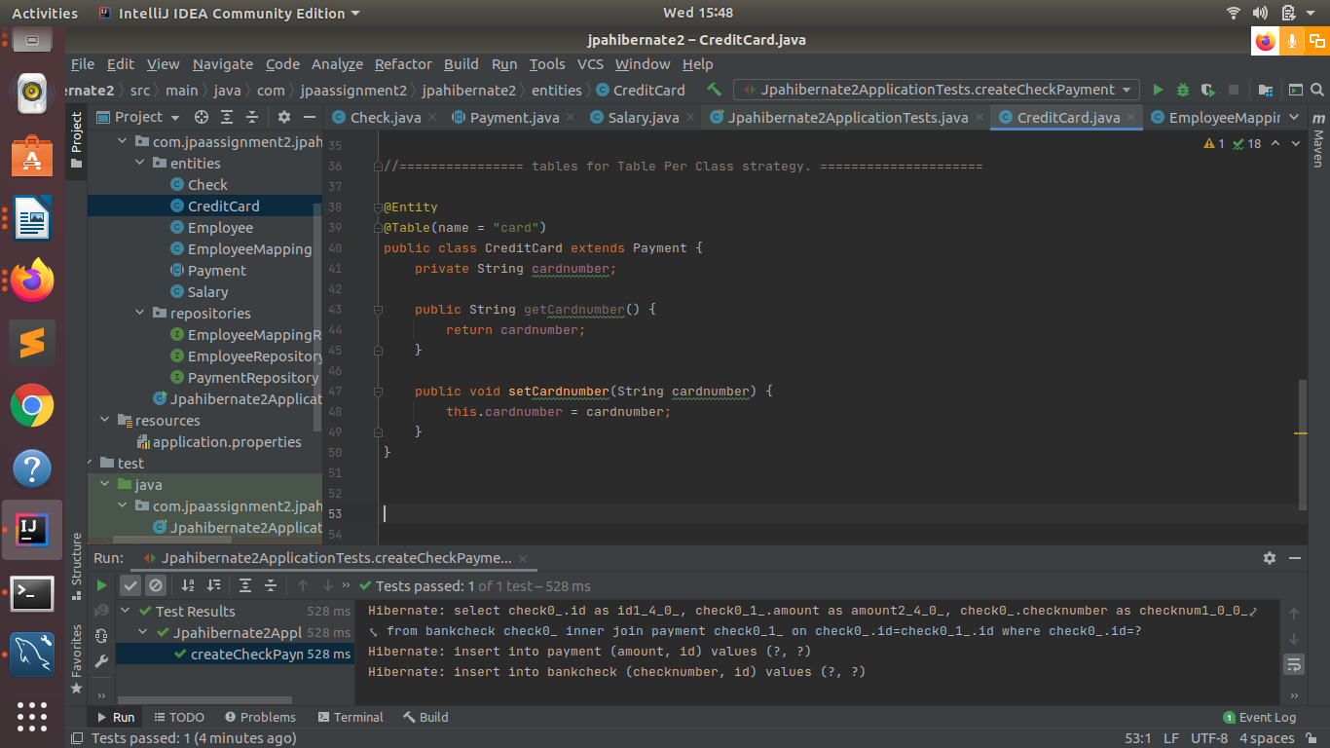

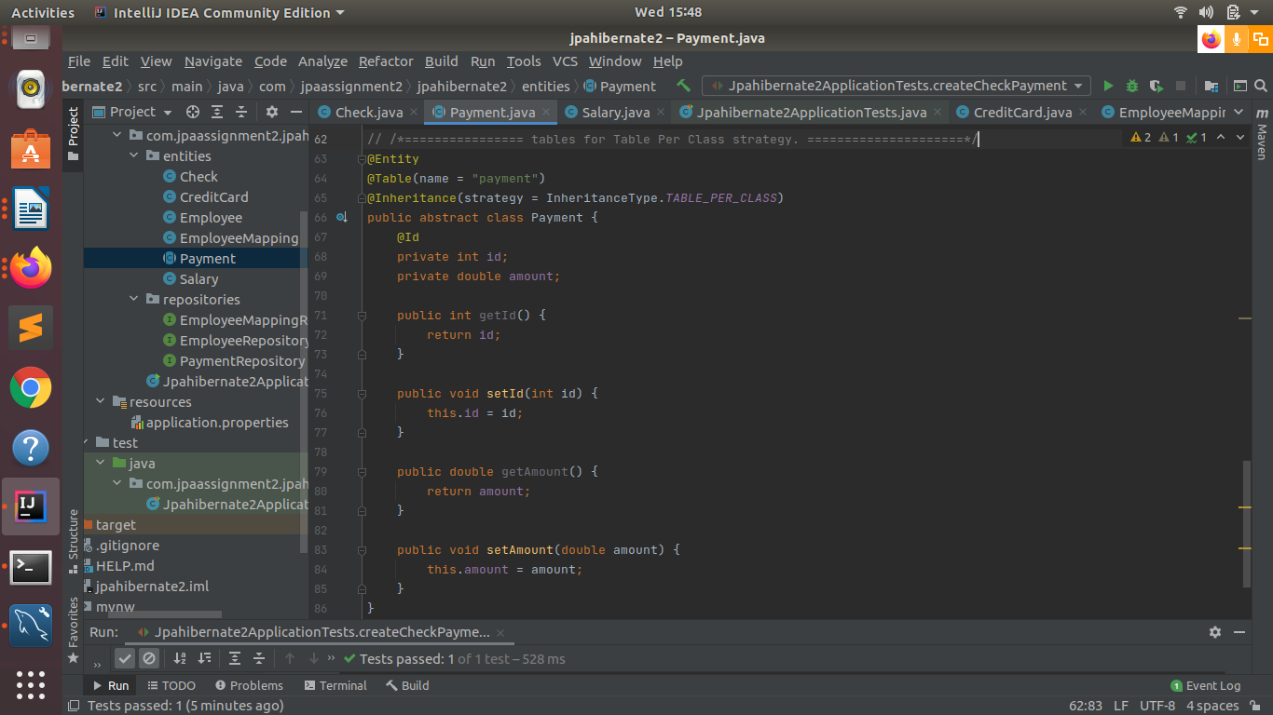

Q4.Component Mapping:
- Implement and demonstrate Embedded mapping using employee table having following fields: id, firstName, lastName, age, basicSalary, bonusSalary, taxAmount, specialAllowanceSalary.


