Maven Assignment
Q1. Add a maven dependency and its related repository URL.
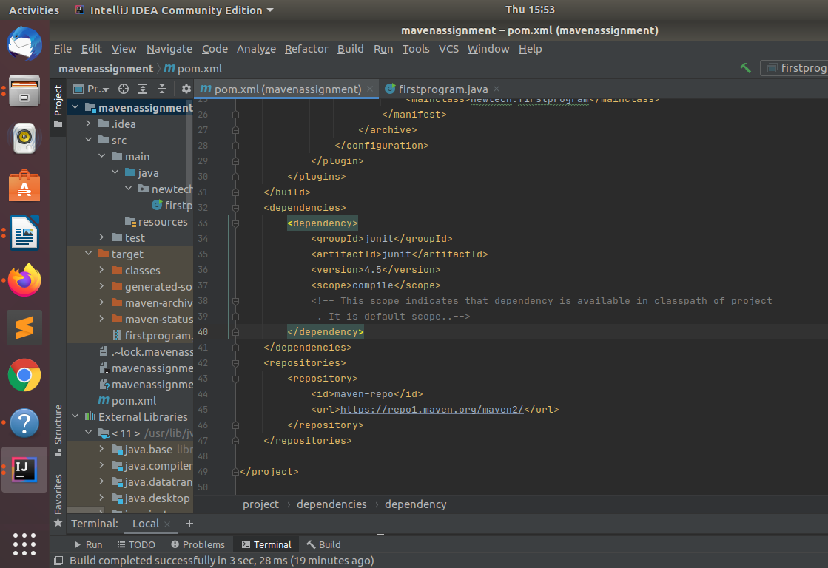
Q2.Add a new repository in the pom.xml and use its dependencies.
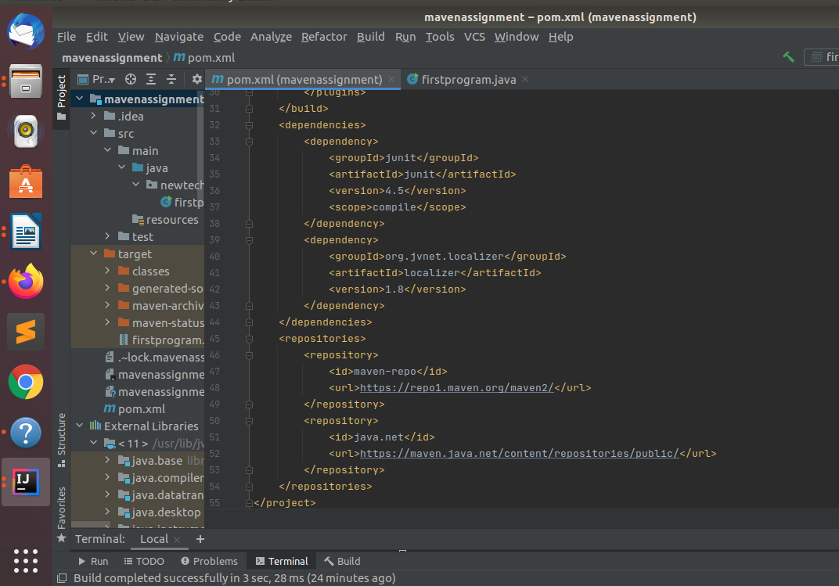

Q3.Using JAR plugin, make changes in the pom.xml to make the jar executable. Using java -jar JAR_NAME, the output should be printed as "Hello World"
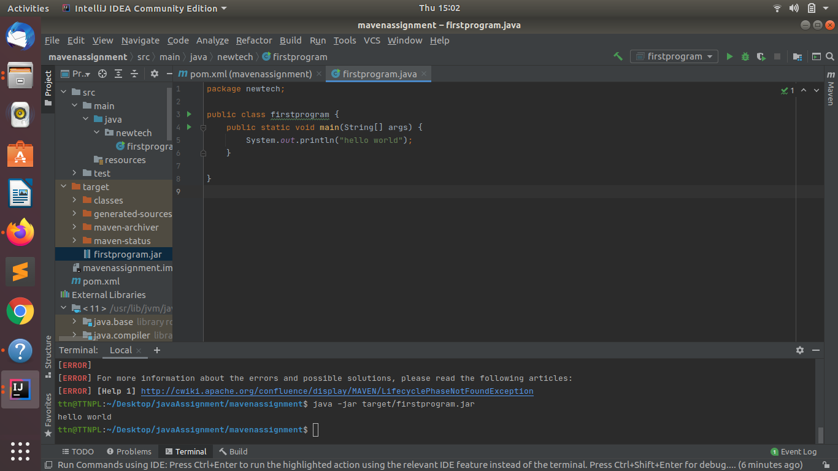

Q4.Differentiate between the different dependency scopes: compile, runtime, test, provided using different dependencies being defined in your pom.xml.
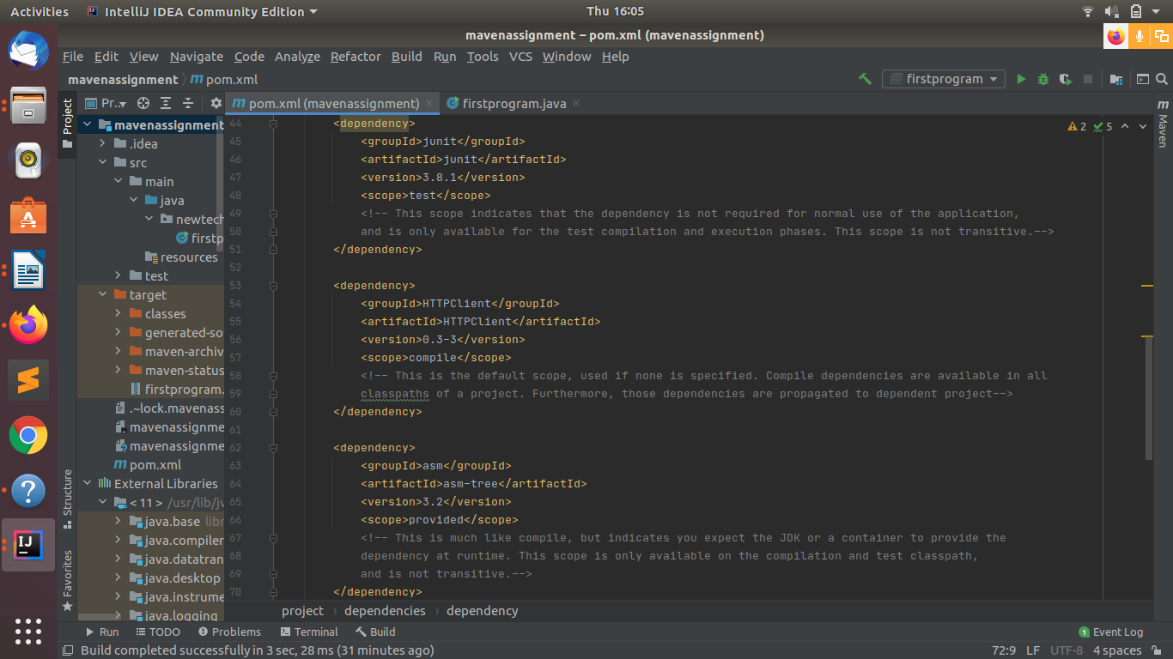

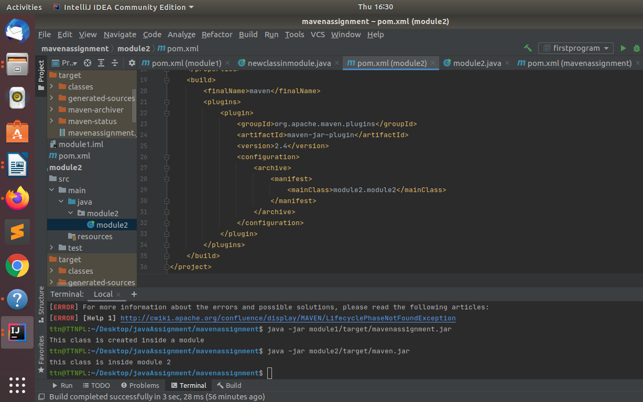
Q5.Create a multi-module project. Run package command at the top level to make jar of every module.

