A REPORT OF SIX MONTHS INDUSTRIAL TRAINING

at Infowiz

SUBMITTED IN PARTIAL FULFILLMENT OF THE REQUIREMENT FOR THE AWARD OF THE DEGREE OF

## BACHELOR OF TECHNOLOGY

(Computer Science and Engineering)



JULY-DEC 2022

##### SUBMITTED BY:

NAME: GURSIMRANPREET KAUR UNIVERSITY ROLL NO. : 1900657

DEPARTMENT OF COMPUTER SCIENCE AND ENGINEERING

COLLEGE name

FATEHGARH SAHIB

**BABA BANDA SINGH BAHADUR ENGINEERING COLLEGE FATEHGARH SAHIB**

**CANDIDATE'S DECLARATION**

I Gursimranpreet Kaur hereby declare that I have undertaken 6 months Software Training at Infowiz, Chandigarh during a period from July 2022 to January 2022 in partial fulfillment of requirements for the award of degree of B.Tech (Computer Science and Engineering) at BABA BANDA SINGH BAHADUR ENGINEERING COLLEGE,FATEHGARH SAHIB. The work

which is being presented in the training report submitted to Department of Computer Science and Engineering at BABA BANDA SINGH BAHADURENGINEERING COLLEGE, FATEHGARH

SAHIB is an authentic record of training work.

Signature of the Student

The Software training Viva–Voce Examination of has been held on and accepted.

Signature of Internal Examiner Signature of External Examiner

# ABSTRACT

During the training period MERN stack is used. The Front-end Technology React JS, HTML, CSS, Bootstrap. For Back End Technology Node JS, Express JS. For Database Mongo DB. It represents a summarized report of the complete project in a very concise and informative format covering main objective and aim of the project, the background information, processes and technologies used, followed with a brief conclusion of two to three lines talking about the results and scope of the project. “MIGRATE OVERSEAS” is a web application that is a one-stop solution for all the visa needs of all categories of people. It is a website that provides all kinds of visa i.e. Permanent Residence Visas, Visit Visas, Student Visas, and many more. Students can chat with the consultants available 24*7. They can check their eligibility and can apply visa accordingly.

## ACKNOWLEDGMENT

Date: Gursimranpreet Kaur

Contents

***Certificate by Company*** ***i***

***Candidate’s Declaration*** ***ii***

***Abstract…*** ***iii***

***Acknowledgement*** ***iv***

|  |  |  |  |
| --- | --- | --- | --- |
| **Chapter 1: INTRODUCTION TO ORGANIZATION** ............................................................................ | | | 1 |
| **1.1** | **Infowiz** ........................................................................................................ | | 1 |
| **1.2** | **LIVE PROJECT TRAININGS** ................................................................................................. | | 1 |
| **1.3** | **BEST INDUSTRIAL TRAINING**............................................................................................. | | 1 |
| **1.4** | **INTERNATIONAL HPE CERTIFICATIONS** ........................................................................ | | 1 |
| **1.5** | **100% PLACEMENT ASSISTANCE** ........................................................................................ | | 1 |
| **Chapter 2: SOFTWARE TRAINING WORK UNDERTAKEN** ............................................................ | | | 2 |
| **2.1** | **Full Stack Development**................................................................................................................ | | 2 |
| **2.2** | **MERN**........................................................................................................................................... | | 2 |
| **2.3** | **React.js Front End**........................................................................................................................ | | 3 |
| **2.4** | **Express.js and Node.js Server Tier** .............................................................................................. | | 3 |
| **2.5** | **MongoDB Database Tier** .............................................................................................................. | | 4 |
| **2.6** | **HTML5 (Hypertext Markup Language) .....................................................................................** | | **4** |
| **2.7** | **Cascading Style Sheet (CSS)** ........................................................................................................ | | 5 |
| **2.8** | **Javascript** ...................................................................................................................................... | | 5 |
| **2.9** | **Nodemon** ....................................................................................................................................... | | 6 |
| **2.10** | **Yarn** .............................................................................................................................................. | | 6 |
| **2.11** | **Tools Used** ................................................................................................................................... | | 6 |
| **2.11.1** | | **Sublime Text Editor ...........................................................................................................** | **6** |
| **2.11.2** | | **Visual Code Studio ...............................................................................................................** | **6** |
| **2.12.3** | | **MongoDB Compass ..............................................................................................................** | **6** |
| **Chapter 3: INDUSTRIAL TRAINING WORK UNDERTAKEN ..........................................................** | | | **7** |
| **3.1 Mini Projects Undertaken** ............................................................................................................... | | | 7 |
| **3.1.1 Resume ....................................................................................................................................** | | | **7** |
| **3.1.2 Hotel Website ...................................................................................................................**........ | | | 8 |
| **3.2** | **Project Idea**................................................................................................................................. | | 11 |
| **Chapter 4: PROJECT WORK** ............................................................................................................... | | | 12 |

* 1. Problem Statement 12
  2. Project Objective 12
  3. Project Scope 12
  4. System Development Methodology 13
     1. Model Phases 13
  5. Resource Planning 14
     1. Hardware Requirement 14
     2. Software Requirement 14
  6. Technology Used 14

4.6.1 Front end Technology 15

4.6.3 Database 15

* 1. Data Flow Diagrams 16
     1. Context Level Diagram 16

4..3 Use Case Diagram 16

Chapter 5: RESULT 18

Codes 22

Chapter 6: CONCLUSION AND FUTURE SCOPE 30

* 1. CONCLUSION 30
  2. FUTURE SCOPE 30

REFERENCES 31

**About the Company**

**COMPANY PROFILE:**

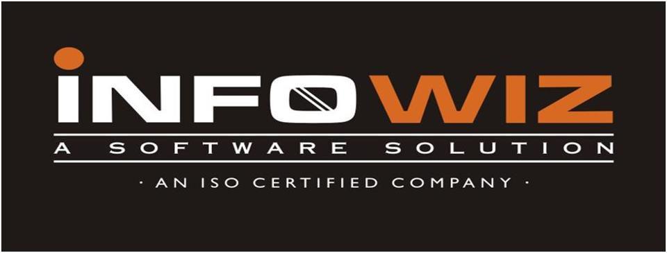

INFOWIZ Technologies is among the leading companies in India providing Mobile Application Development Services, Web Application Development Services, Web Enterprise Application Services, Web Design & Redesign Services, Ecommerce online shopping systems Services. Since then, we have an edge over other entrepreneurs with our best services and goal centred approach.

INFOWIZ is an ISO certified US based company. It has been working from more than 5 years in the field of IT and Web Development and has been providing its clients with its exceptional and quality Web Design, Development and SEO services. Our clients range from individuals to professionals and small, medium and large scaled Businesses. In 2008, INFOWIZ entered into IT outsourcing and partnered successfully with many offshore web and SEO companies of US, UK, France, Ireland, Canada, and Australia etc. to provide them quality and timely services.

INFOWIZ does not boost itself of being the best development company but automatically enjoys reputable position among top Web Development companies because we of our timely delivery and quality work. We don’t claim for something we can’t deliver. Before taking a project from a client, we ask for all his needs and requirements. After that our skilled team of professionals analyzes the needs and comes up with a plan as how we can work to completely satisfy those requirements of our clients. We then work step by step keeping our client informed about the progress and complete the project in time giving complete contentment to them.

From concept building to implementation of any project, our team manages the projects efficiently up to its completion. Our tactful strategy and dedication towards quality work has given us the recognition we enjoy and that is why our clients only come back to us whenever they require any kind of web related solutions. We do not only emphasize on formulating an attractive solution to our clients, but we believe in providing a workable solution. INFOWIZ is an organization which is established in the field of VLSI-VHDL, Embedded systems, PHP, .NET, Mern, Web Designing, Web Development, Network Support and Network training.

# Chapter 2: SOFTWARE TRAINING WORK UNDERTAKEN

#### Full Stack Development

Full stack development: It refers to the development of both front end (client side) and back end (server side) portions of web application.

Full stack web Developers: Full stack web developers have the ability to design complete web application and websites. They work on the frontend, backend, database and debugging of web application or websites.

## MERN

MERN stands for MongoDB, Express, React, Node, after the four key technologies that make up the stack.

* MongoDB - document database
* Express(.js) - Node.js web framework
* React(.js) - a client-side JavaScript framework
* Node(.js) - the premier JavaScript web server

Express and Node make up the middle (application) tier. Express.js is a server-side web framework, and Node.js the popular and powerful JavaScript server platform. Regardless of which variant you choose, MERN is the ideal approach to working with JavaScript and JSON, all the way through.

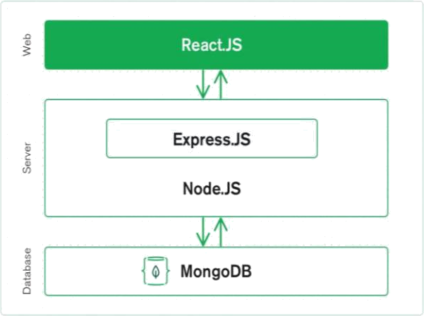

*Figure 1: MERN Structure*

### React.js Front End

The top tier of the MERN stack is React.js, the declarative JavaScript framework for creating dynamic client-side applications in HTML. React lets you build up complex interfaces through simple Components, connect them to data on our backend server, and render them as HTML.

React’s strong suit is handling stateful, data-driven interfaces with minimal code and minimal pain, and it has all the bells and whistles expect from a modern web framework: great support for forms, error handling, events, lists, and more.

#### Express.js and Node.js Server Tier

The next level down is the Express.js server-side framework, running inside a Node.js server. Express.js bills itself as a “fast, unopinionated, minimalist web framework for Node.js,” and that is indeed exactly what it is. Express.js has powerful models for URL routing (matching an incoming URL with a server function), and handling HTTP requests and responses.

By making XML HTTP Requests (XHRs) or GETs or POSTs from your React.js front-end, you can connect to Express.js functions that power your application. Those functions in turn use MongoDB’s

Node.js drivers, either via callbacks for using Promises, to access and update data in your MongoDB database.

#### MongoDB Database Tier

If our application stores any data (user profiles, content, comments, uploads, events, etc.), then we are going to want a database that’s just as easy to work with as React, Express, and Node.

That’s where MongoDB comes in: JSON documents created in our React.js front end can be sent to the Express.js server, where they can be processed and (assuming they’re valid) stored directly in MongoDB for later retrieval. Again, if we are building in the cloud, we will want to look at Atlas.

#### HTML5 (Hypertext Markup Language)

HTML5 is a markup language used for structuring and presenting content on the World Wide Web. It is the fifth and last major HTML version that is a World Wide Web Consortium (W3C) recommendation. The current specification is known as the HTML Living Standard

HTML5 includes detailed processing models to encourage more interoperable implementations; it extends, improves, and rationalizes the markup available for documents and introduces markup and application programming interfaces (APIs) for complex web applications. For the same reasons, HTML5 is also a candidate for cross-platform mobile applications because it includes features designed with low-powered devices in mind.

To enrich the semantic content of documents, new page structure elements such as <main>,

**<section>, <article>, <header>, <footer>, <aside>, <nav>**, and **<figure>** are added. New attributes were introduced, some elements and attributes were removed, and others such as <a>,

<cite>, and <menu> were changed, redefined, or standardized. The APIs and Document Object Model (DOM) are now fundamental parts of the HTML5 specification, and HTML5 also better defines the processing for any invalid documents.

### Cascading Style Sheet (CSS)

Cascading Style Sheets (CSS) is a style sheet language used for describing the presentation of a document written in a markup language such as HTML. CSS is a cornerstone technology of the World Wide Web, alongside HTML and JavaScript.

CSS is designed to enable the separation of presentation and content, including layout, colors, and fonts. This separation can improve content accessibility; provide more flexibility and control in the specification of presentation characteristics; enable multiple web pages to share formatting by specifying the relevant CSS in a separate .css file, which reduces complexity and repetition in the structural content; and enable the .css file to be cached to improve the page load speed between the pages that share the file and its formatting.

#### Javascript

JavaScript often abbreviated JS, is a programming language that is one of the core technologies of the World Wide Web, alongside HTML and CSS. Over 97% of websites use JavaScript on the client side for web page behavior, often incorporating third-party libraries. All major web browsers have a dedicated JavaScript engine to execute the code on the user's device.

JavaScript is a high-level, often just-in-time compiled language that conforms to the ECMAScript standard. It has dynamic typing, prototype-based object-orientation, and first-class functions. It is multi-paradigm, supporting event-driven, functional, and imperative programming styles. It has application programming interfaces (APIs) for working with text, dates, regular expressions, standard data structures, and the Document Object Model (DOM).

The ECMAScript standard does not include any input/output (I/O), such as networking, storage, or graphics facilities. In practice, the web browser or other runtime system provides JavaScript APIs for I/O.

JavaScript engines were originally used only in web browsers, but are now core components of some servers and a variety of applications. The most popular runtime system for this usage is Node.js.

### Nodemon

Nodemon is a tool that helps develop node. js based applications by automatically restarting the node application when file changes in the directory are detected. nodemon does not require any additional changes to your code or method of development.

### Yarn

Yarn is a new package manager that replaces the existing workflow for the npm client or other package managers while remaining compatible with the npm registry. It has the same feature set as existing workflows while operating faster, more securely, and more reliably.

### Tools Used

##### Sublime Text Editor

Sublime Text Editor is a full featured Text editor for editing local files or a code base. It includes various features for editing code base which helps developers to keep track of changes.

Sublime Text editor is used as an Integrated Development Editor (IDE) like Visual Studio code and NetBeans.

* + 1. **Visual Code Studio**

Visual Studio Code is a source-code editor made by Microsoft for Windows, Linux and macOS. Features include support for debugging, syntax highlighting, intelligent code completion, snippets, code refactoring, and embedded Git.

**2.12.3 MongoDB Compass**

MongoDB Compass is a powerful GUI for querying, aggregating, and analyzing your MongoDB data in a visual environment. Compass is free to use and source available, and can be run on macOS, Windows, and Linux.

* + 1. **Hotel Website**



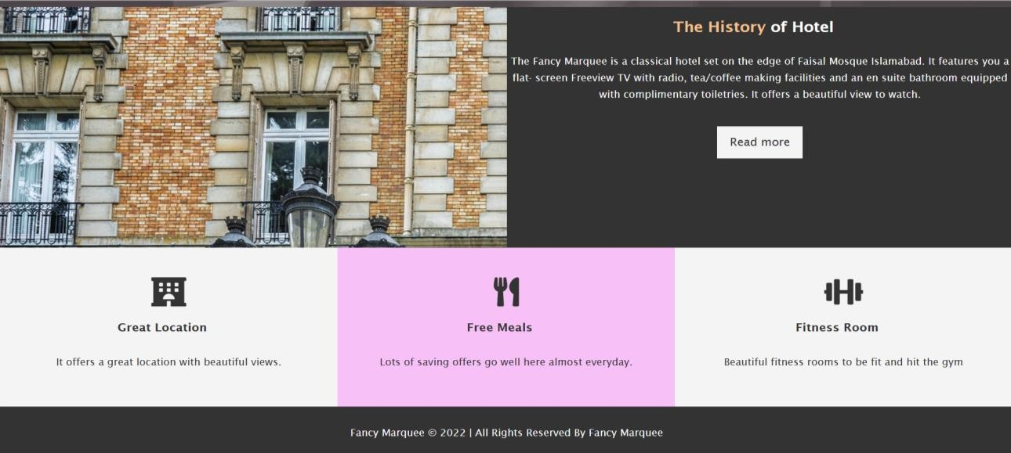

**About Page**

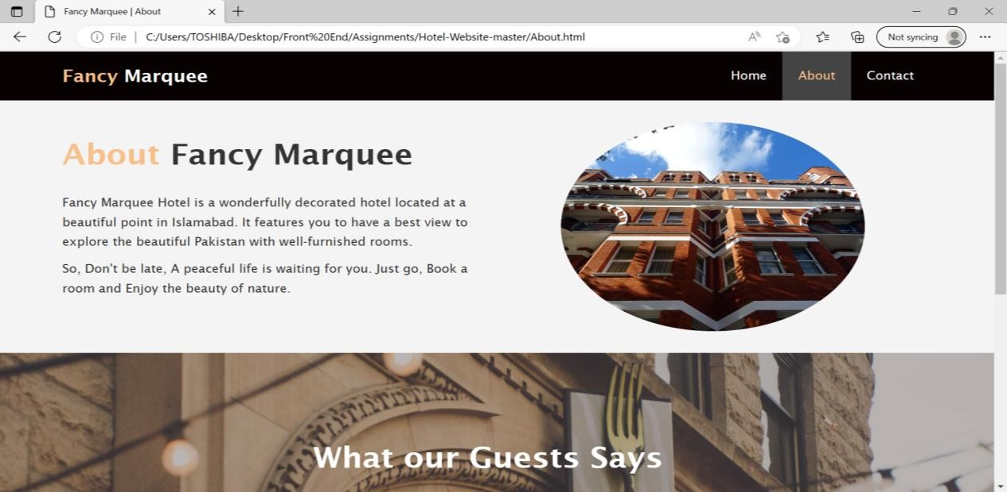

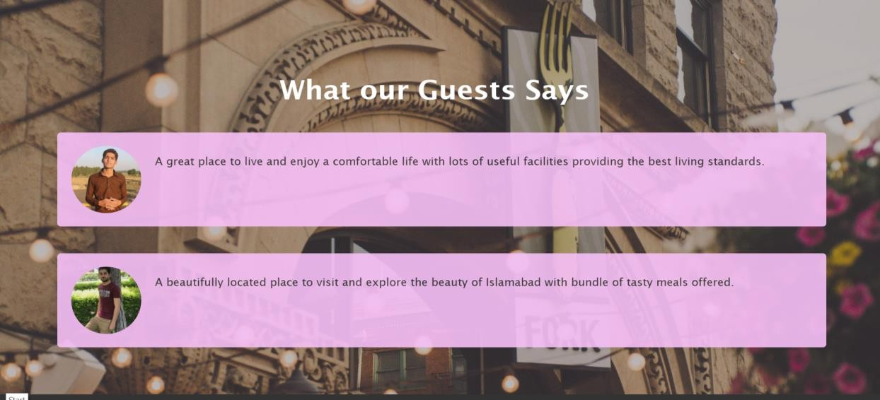

**Contact Us Page-**

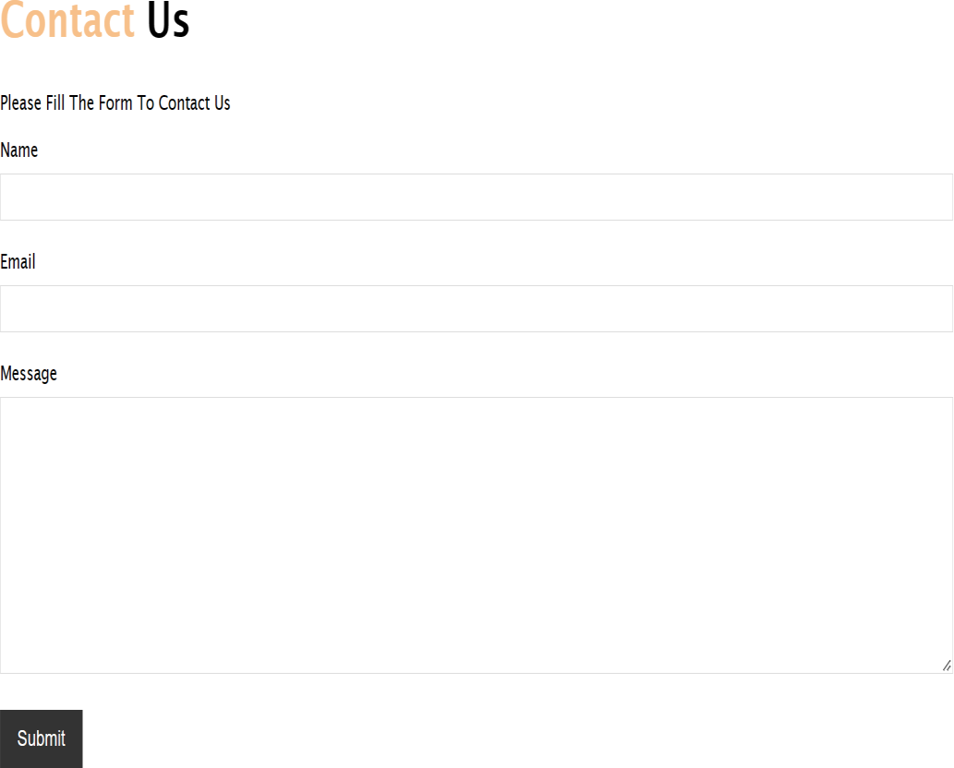

#### Project Idea

The main idea is to develop a website which is going to be one stop destination for the students trying to learn different technologies. Rather than filing several forms at multiple sites, the students can fill one single form which will be circulated in various training centers. In this way the centers will be contacting the students for the learning process. As the usage of internet is growing in our daily life providing online education through this medium can increase scope of education system as well as provide good business extension for educational institutes. This system will create new opportunities for training centers to improve their advertising standards.

User should register with the application and get unique user id and password for accessing this edulabs.

# Chapter 4: PROJECT WORK

### Problem Statement

Since the pandemic has disrupted the normal lifestyle of people across the globe, the virtual world has come to the rescue. Amongst many study centers have also shifted their base to virtual platforms to conduct their way of income online and to grow economically.

Although efforts are being made by both government and non-government organizations to make smooth transition to virtual world. There are still some issues faced by them.

To overcome the drawbacks of virtual world to some extend we have tried to develop a online system where students can access various company forms at one single online platform.

### Project Objective

“MIGRATE OVERSEAS” is a web application that is a one-stop solution for all the visa needs of all categories of people. It is a website that provides all kinds of visa i.e. Permanent Residence Visas, Visit Visas, Student Visas, and many more. Students can chat with the consultants available 24*7. They can check their eligibility and can apply visa accordingly.

### Project Scope

The benefit of this type of platform is that user can see each and every details regarding the visa applocations and the they can check their elegibilty whether they are eligible to apply or not.

### System Development Methodology

System Development methodology is the development of a system or method for a unique situation. Having a proper methodology helps us in bridging the gap between the problem statement and turning it into a feasible solution. It is usually marked by converting the System Requirements Specifications (SRS) into a real world solution. System design takes the following inputs: Statement of work, Requirement determination plan, Current situation analysis. Proposed system requirements including a conceptual data model and metadata (data about data). The development method followed in this project is the waterfall model.

##### Model Phases

The waterfall model is a sequential software development process, in which progress is seen as flowing steadily downwards (like a waterfall) through the phases of Requirement initiation, Analysis, Design, Implementation, Testing and maintenance.

* **Requirement Analysis:** This phase is concerned about collection of requirements of the system. This process involves generating document and requirement review.
* **System Design:** Keeping the requirements in mind the system specifications are translated into a software representation. In this phase the designer emphasizes on:- algorithm, data structure, software architecture etc.
* **Coding:** In this phase the programmer starts his coding in order to give a full sketch of the product. In other words system specifications are only converted into machine readable compute code.
* **Implementation:** The implementation phase involves the actual coding or programming of the software. The output of this phase is typically the library, executables, user manuals and additional software documentation.

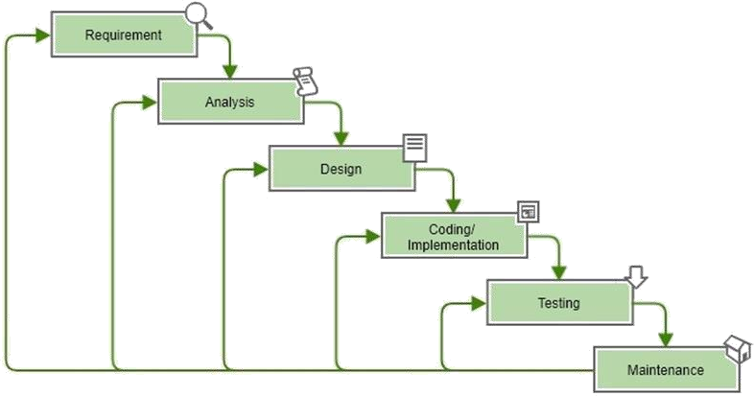

Figure 4.1 Waterfall Model

* **Testing:** In this phase all programs (models) are integrated and tested to ensure that the complete system meets the software requirements. The testing is concerned with verification and validation.
* **Maintenance:** The maintenance phase is the longest phase in which the software is updated to fulfill the changing customer needs, adapt to accommodate changes in the external environment, correct errors and oversights previously undetected in the testing phase, and enhance the efficiency of the software.

##### Advantages of Waterfall model

* + - * + Clear project objective
        + Stable project requirements
        + Progress of the system is measurable.
        + Logic of software development is clearly understood.

|  |  |  |  |
| --- | --- | --- | --- |
| **4.5** | **Resource Planning** | |  |
| **4.5.1 Hardware Requirement** | | | |
| • | Processor | - | 2.0 GHZ or above |
| • | RAM | - | 2GB RAM or above |
| • | Hard Disk | - | 1 TB HDD or above |

##### 4.5.2 Software Requirement

* Operating System -
* Database -

Windows MongoDB

#### Technology Used

##### Front end Technology

* + - * React JS
      * HTML
      * CSS
      * Bootstrap

##### Back End Technology

* + - * Node JS
      * Express JS

##### Database

* + - * Mongo DB

#### Data Flow Diagrams

It is a two-dimensional diagram that explains how data is processed and transferred in a system. The graphical depiction identifies each source of data and how it interacts with other data sources to reach a common output.

#### Context Level Diagram

This is a brief structure which depicts the environment in which a software system exists and helps in communicating about what lies outside the system boundary.

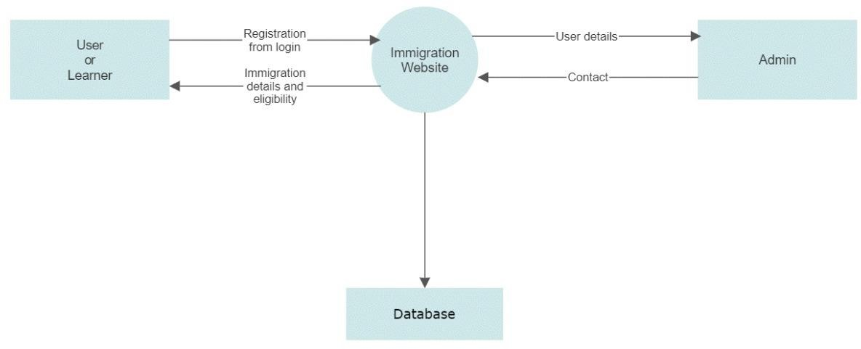

### 4..3 Use Case Diagram

A use case diagram is used to represent the dynamic behavior of a system. It encapsulates the system's functionality by incorporating use cases, actors, and their relationships. It models the tasks, services, and functions required by a system/subsystem of an application. It depicts the high- level functionality of a system and also tells how the user handles a system.

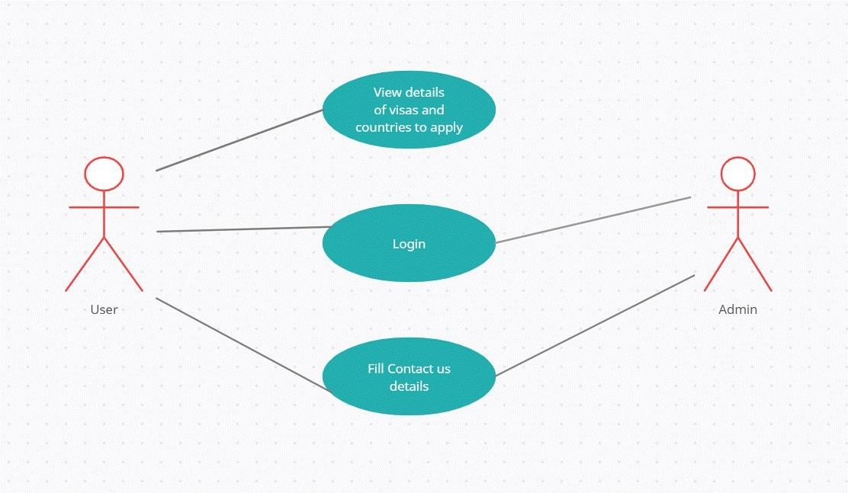

# Chapter 5: RESULT

**Home Page**



**About Page**





**Services Page**



**Footer Page**



**Services-**



**Login Page**

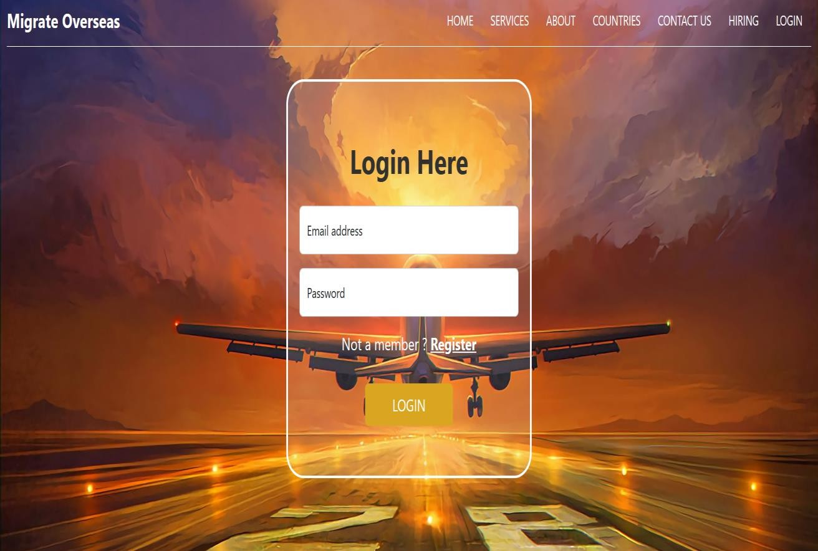

**Register Page**

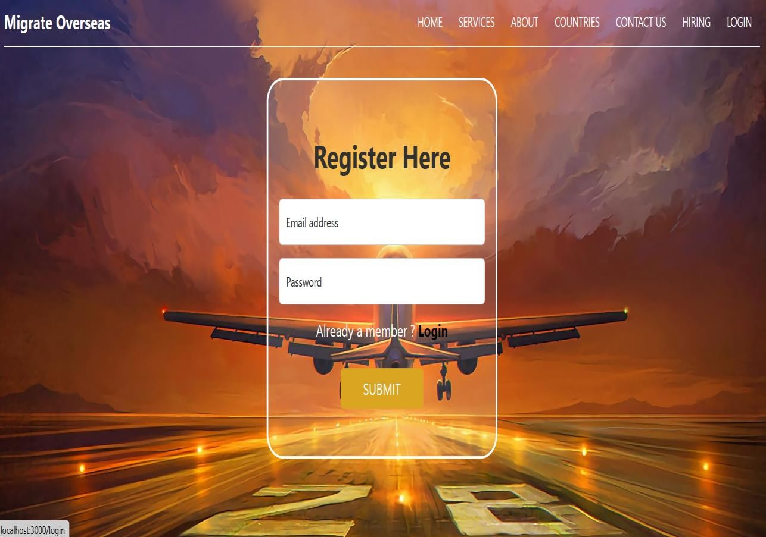

### Codes

**Navbar**

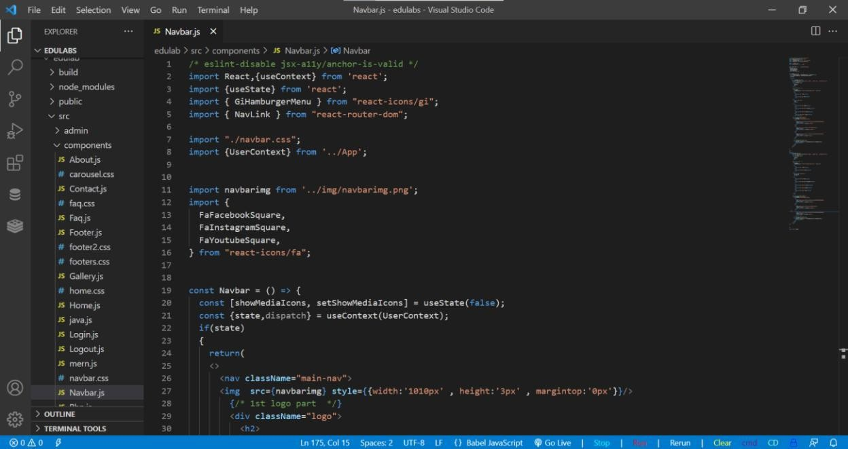

**Home Page**

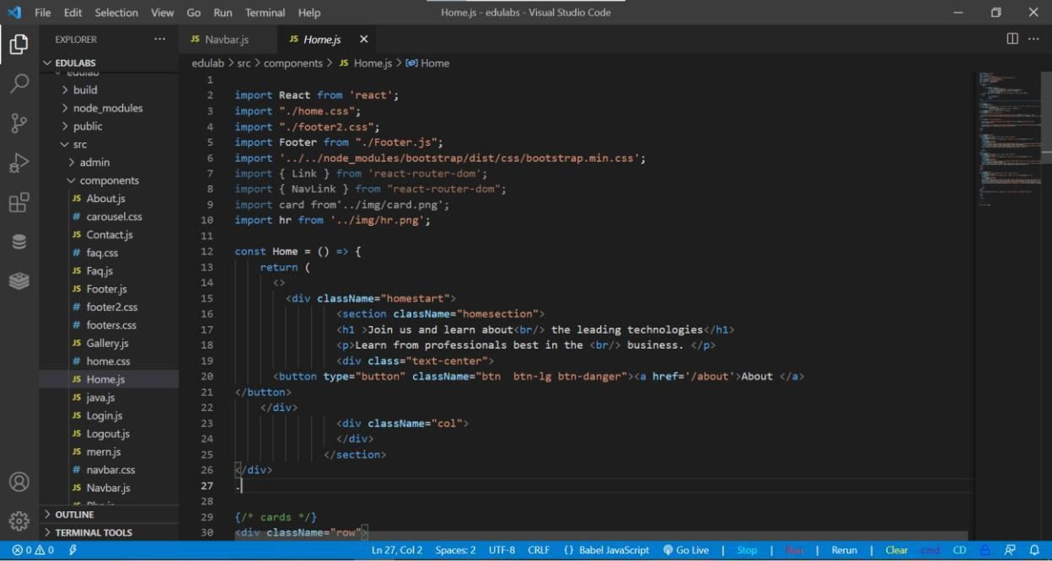

**About Page**

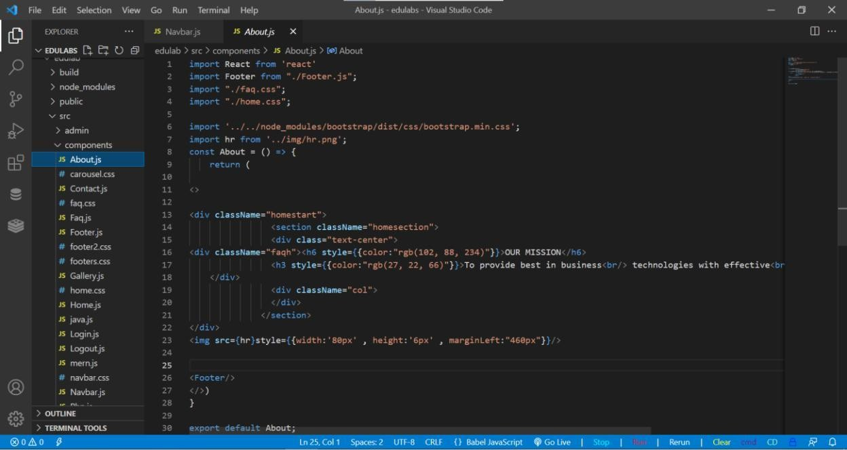

**Contact Us Page**

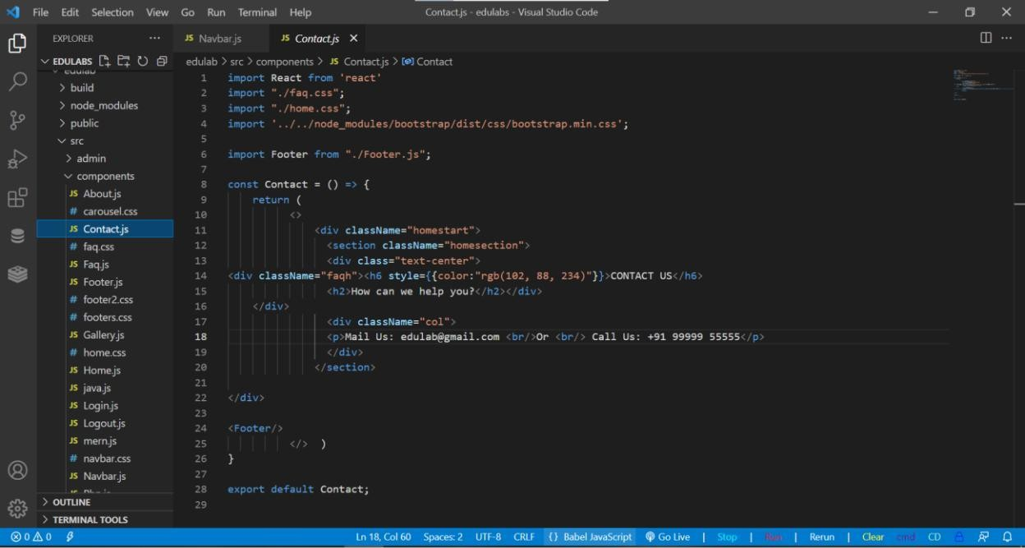

**Services Page**

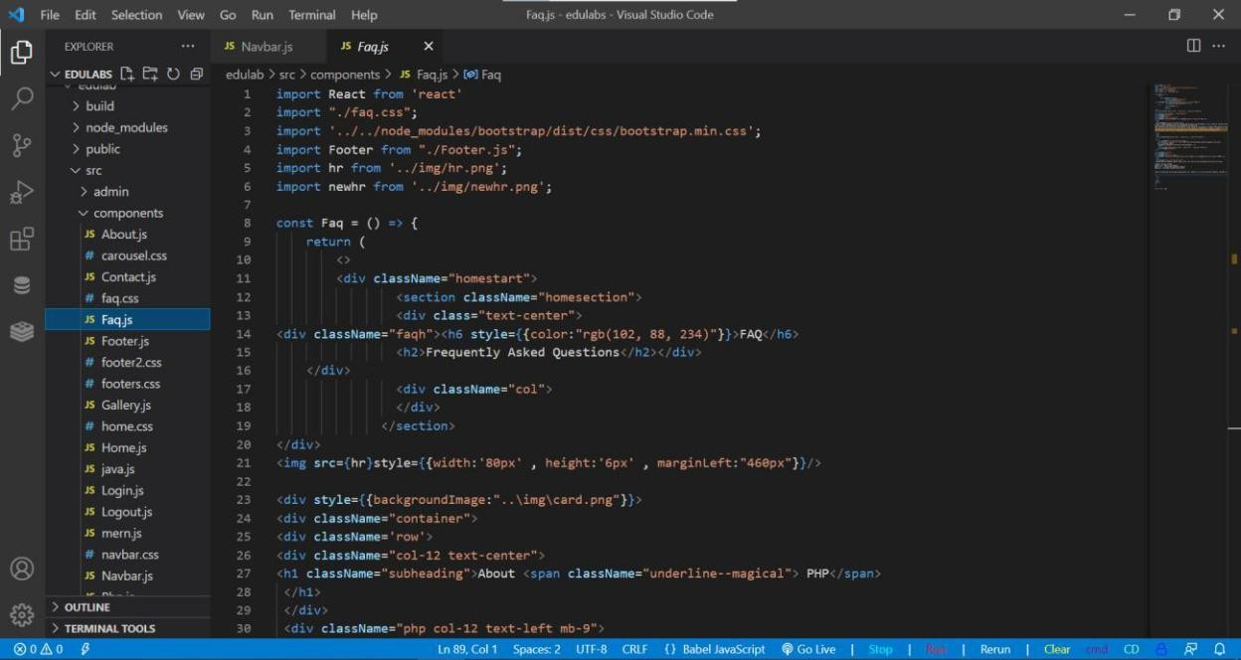

**Signup Page**

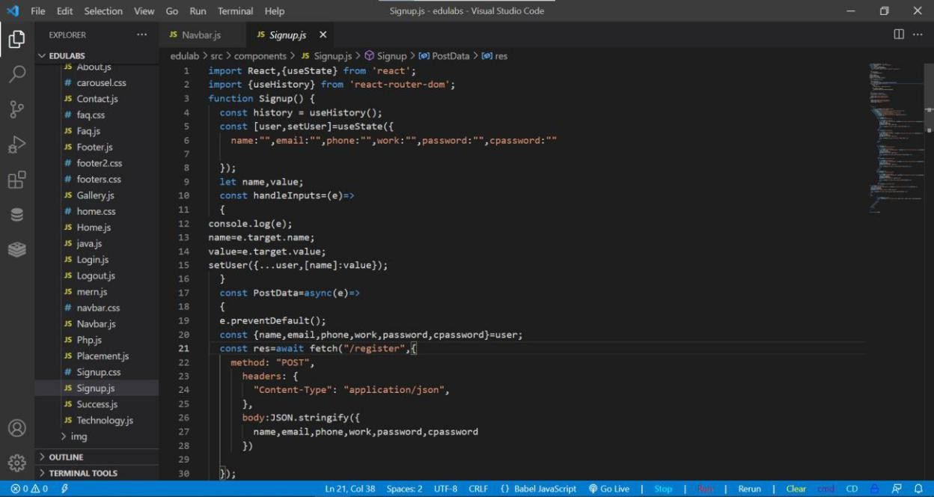

**Login Page**

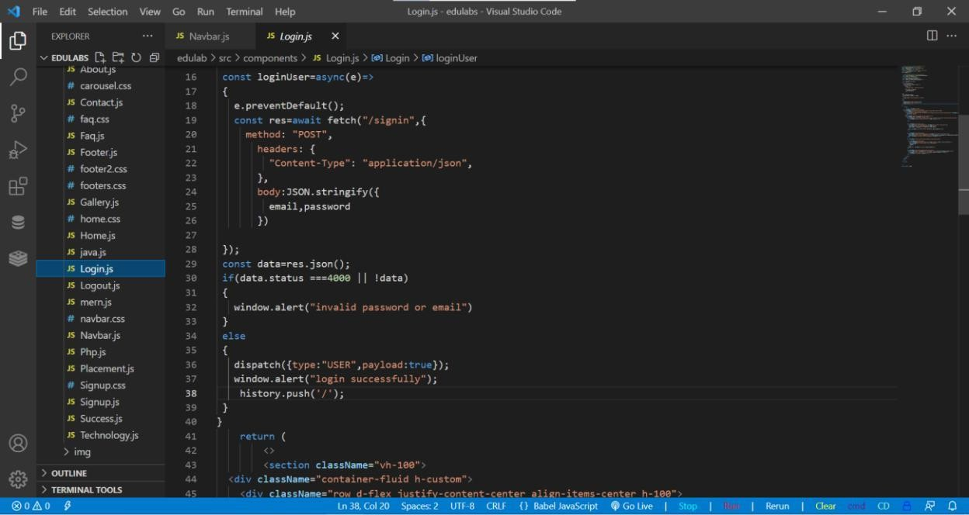

**Logout**

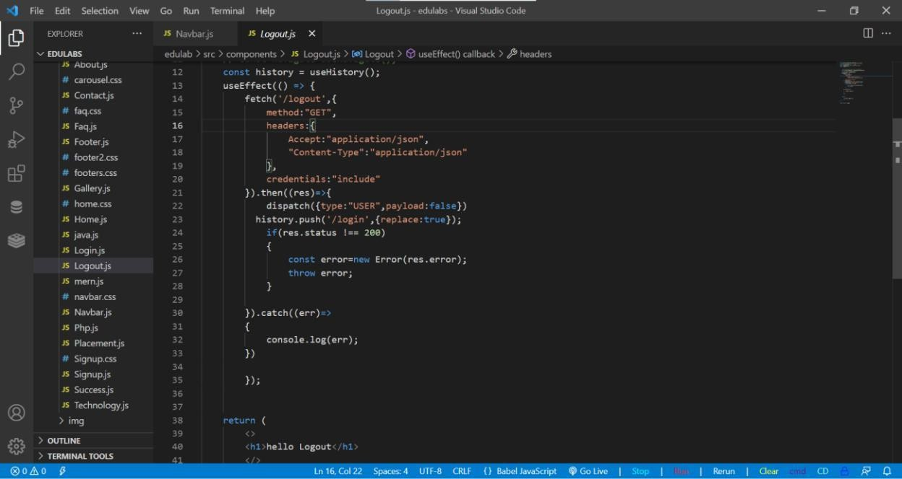

**Success**

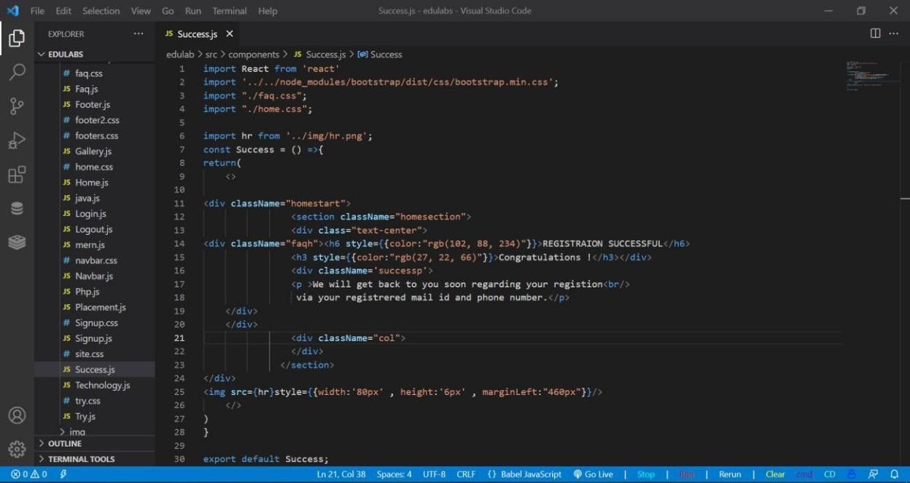

**Database**

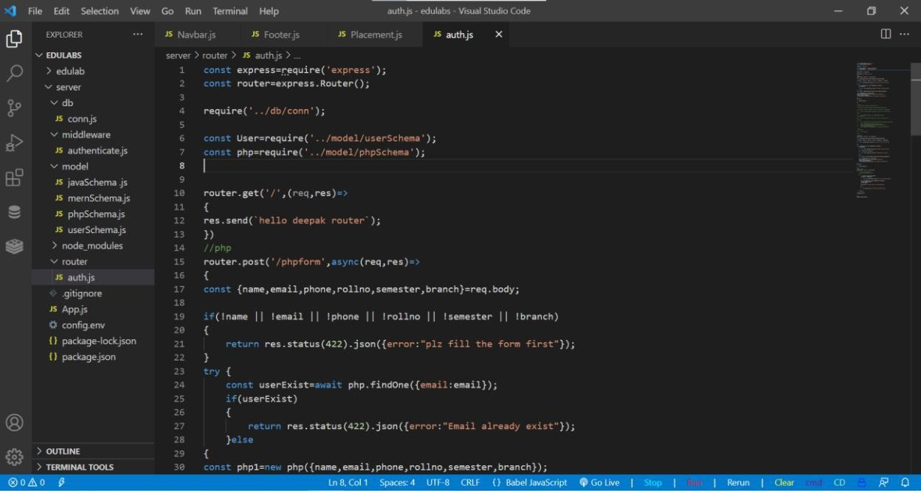

**Database Connectivity**

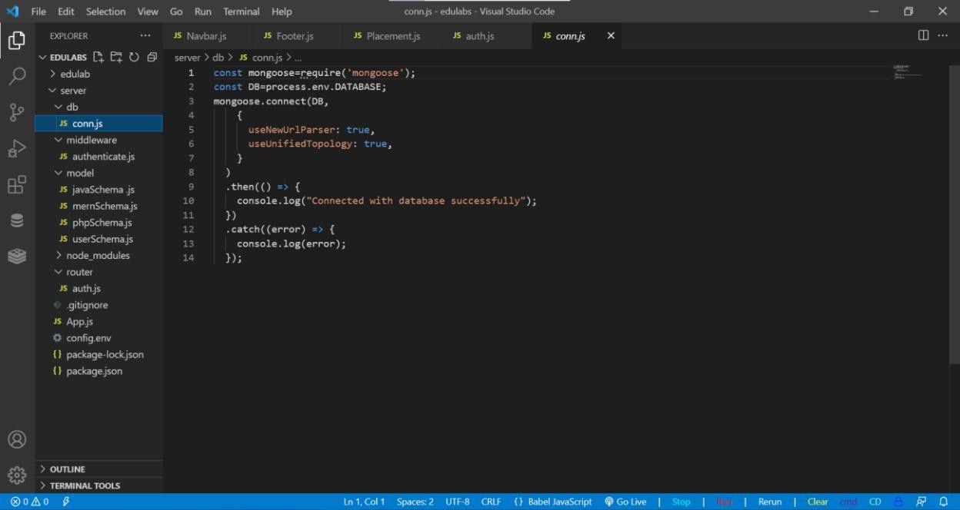

**User Schema**

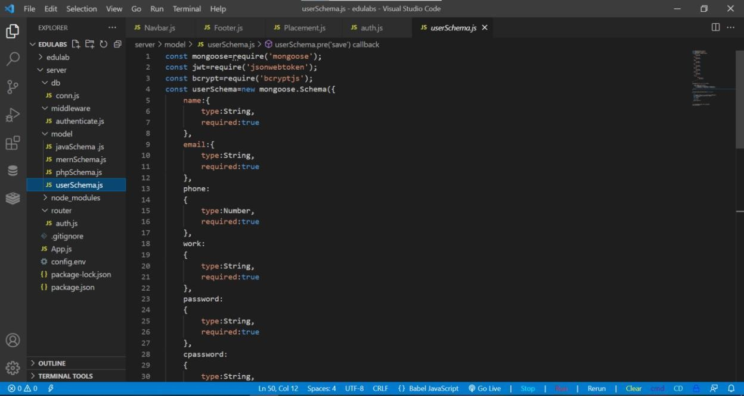

**Authentication**

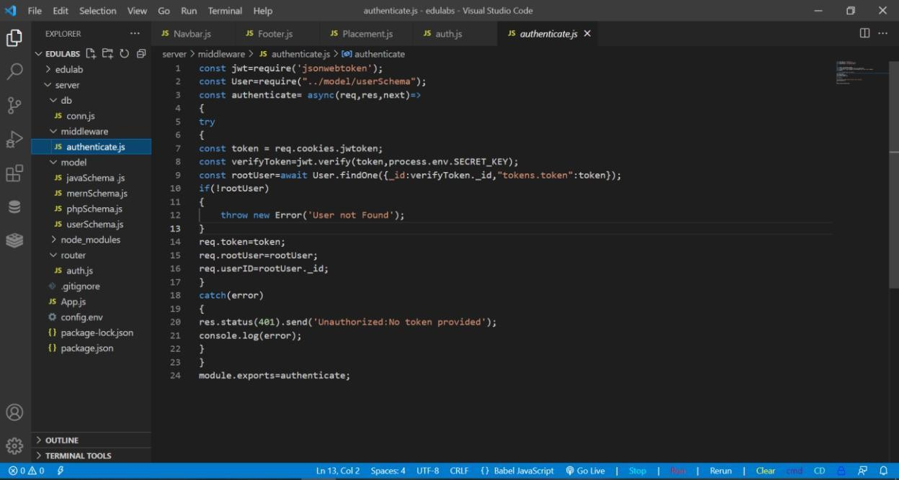

**Database:**

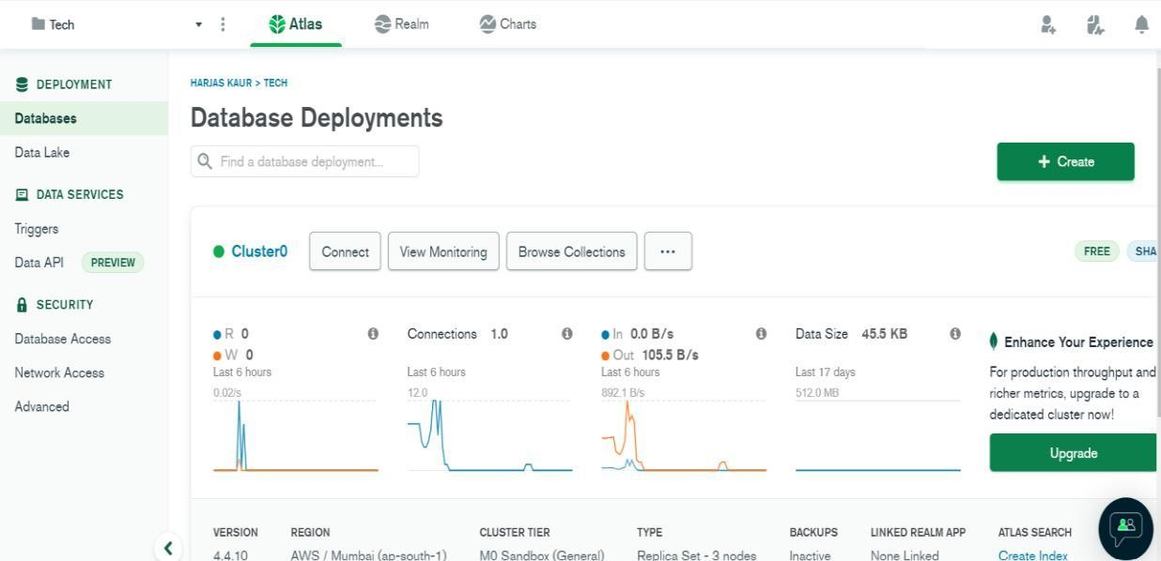

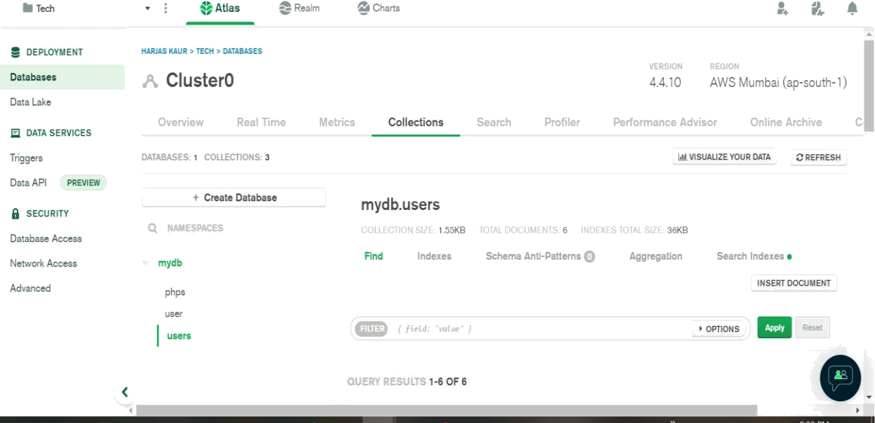

**Data Inserted**

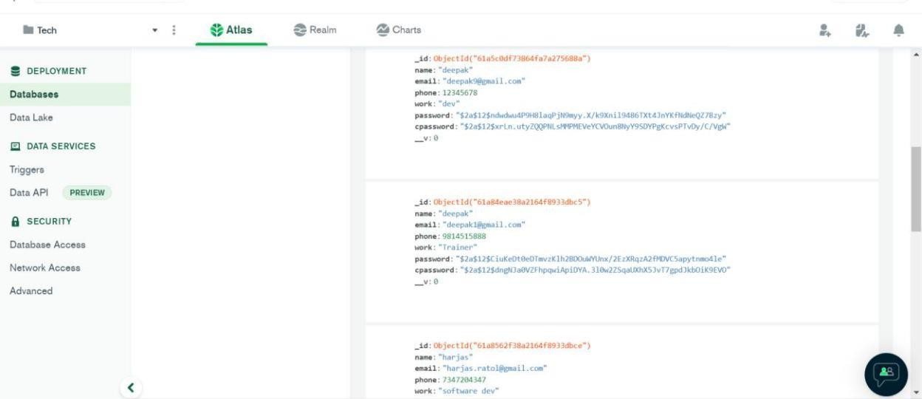

**Contacts details:**

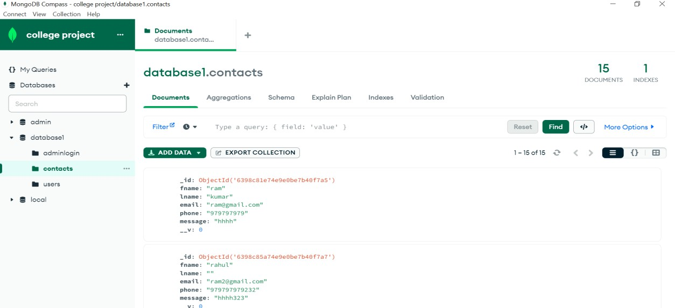

**User details:**

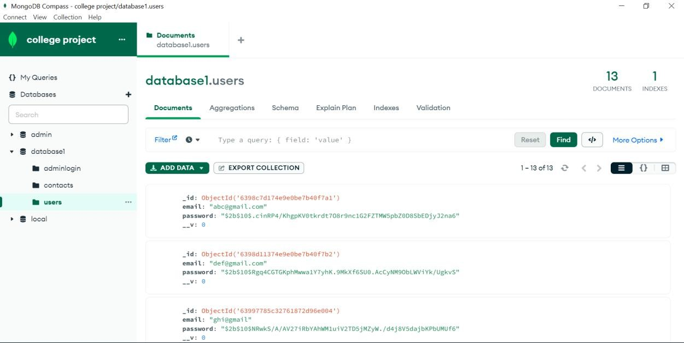

# Chapter 6: CONCLUSION AND FUTURE SCOPE

## CONCLUSION

So, we can say that MERN Stack has bright future ahead. In order to get started with MERN Stack development, all you really need is a good understanding of JavaScript and ES6 Fundamentals, but also at least some familiarity with the basic concepts of React and Node.js. With the MERN stack you can ideally build any web application you want by learning just one language, Javascript. With increased popularity of NoSQL databases, MongoDB is a go to database because of its scalability

and flexible document schemas.

Though, the MERN stack is ideally suited for more JSON heavy, cloud native and dynamic web applications. One can build simple applications like the todo list, task manager to more complex ones like e-commerce sites and social media sites. MERN stack has growing popularity and many advantages with backing from a community of developers. If one aspires to be a full stack developer, he/she should definitely try out the MERN stack!

## FUTURE SCOPE

This project can be enhanced or upgraded by adding some more functionalities wherein user or student can directly choose the desirable visa according to their need. This can make the platform more reliable and easily accessible for the students who wants to apply.

# REFERENCES

* + 1. Web Development (w3schools.com)
    2. Web Development - GeeksforGeeks
    3. Website Development (tutorialspoint.com)
    4. Goodkit Theme (themes.getbootstrap.com/preview/?theme_id=46793)
    5. React – A JavaScript library for building user interfaces (reactjs.org)
    6. Web Application | What is Web Application - Javatpoint
    7. MongoDB Atlas: Cloud Document Database | MongoDB