# High-Level Design Document for Mushroom Classification Project

| Date Issued | Version | Description | Author |
| --- | --- | --- | --- |
| 22-01-2025 | 1 | Initial HLD – V1 | Ankit |
|  |  |  |  |
|  |  |  |  |

## content

**1. Abstract  
2. General Description  
 - 2.1 Problem Statement  
 - 2.2 Proposed Solution  
 - 2.3 Scope  
3. Technical Requirements  
 - 3.1 Dataset Details  
 - 3.2 Tools and Libraries  
 - 3.3 Infrastructure  
4. Design Details  
 - 4.1 Process Flow  
 - 4.2 Experiment Tracking  
 - 4.3 Logging and Error Handling  
5. Performance Metrics  
6. Dashboards and Monitoring  
7. Constraints and Assumptions  
 - 7.1 Constraints  
 - 7.2 Assumptions  
8. Further Improvements  
9. Conclusion**

## Abstract

This project aims to build a machine learning solution to classify mushrooms as either edible or poisonous based on their physical and chemical characteristics. By leveraging a well-structured dataset, machine learning models, and a robust deployment framework, this solution provides a reliable and scalable approach to mushroom classification. The system ensures high accessibility through its deployment as a web service, making it convenient for end users, researchers, and field experts.

The project addresses both practical safety concerns and academic exploration, creating a comprehensive framework for understanding and analyzing mushroom data. By offering a user-friendly interface, the solution also promotes widespread use and engagement.

## 1. General Description

### 1.1 Problem Statement

The primary challenge addressed by this project is accurately predicting whether a mushroom is poisonous or edible based on its attributes. This classification is essential for ensuring safety and preventing accidental consumption of toxic mushrooms. It also provides a scalable, automated method to replace manual classification, which is often time-consuming and prone to errors.

### 1.2 Proposed Solution

The solution involves:  
- Data preprocessing and feature engineering to prepare the dataset.  
- Training and hyperparameter tuning of multiple machine learning models to identify the optimal algorithm.  
- Selection of the best-performing model based on detailed evaluation metrics.  
- Deployment of the model via a Flask API on a scalable web platform (e.g., Render), ensuring easy accessibility.  
- Integration of MLflow for effective experiment tracking and version control, providing a streamlined development process.

This comprehensive approach combines technical rigor with practical deployment considerations, ensuring robustness and scalability.

### 1.3 Scope

This project provides a full-stack classification pipeline, including data preprocessing, model training, and web deployment. It is tailored for a diverse audience, ranging from mycologists and researchers to hobbyists and enthusiasts looking for an automated tool for mushroom classification. The solution ensures a balance between technical accuracy and practical usability.

## 2. Technical Requirements

### 2.1 Dataset Details

* The dataset contains multiple categorical features, such as:

**Cap Shape:**  bell, conical, convex, etc.  
**Odor:** almond, anise, foul, pungent, etc.  
**Habitat:** grasses, leaves, meadows, urban areas, etc.

* The target variable: `edible (e)` or `poisonous (p)`.
* Dataset preprocessing involves encoding categorical variables, handling missing values, and ensuring balance across classes.

### 2.2 Tools and Libraries

* **Programming Language:** Python  
* **Libraries:**  
 Scikit-learn for modeling and evaluation  
 NumPy, Pandas for data manipulation and analysis  
 Matplotlib, Seaborn for data visualization  
* **IDE:** Jupyter Notebook for interactive development **\* Experiment Tracking:** ML flow for logging and monitoring experiments  
* **Web Deployment:** Flask API, hosted on Render for scalability



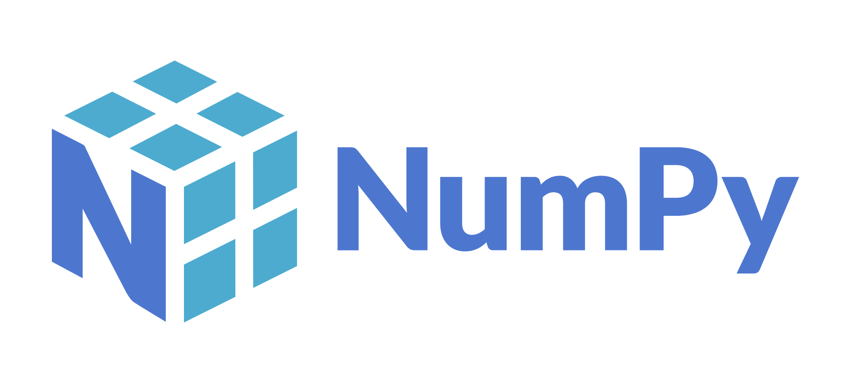







### 2.3 Infrastructure

1. Deployed on Render with capabilities to handle varying traffic loads, ensuring seamless performance.  
2. Local development and testing conducted on systems with Python 3.8 or higher, ensuring compatibility and ease of integration.

## 3. Design Details

### 3.1 Process Flow

#### 1. Data Preprocessing:

- Encode categorical features using label encoding or one-hot encoding techniques.  
- Split the dataset into training and testing subsets to evaluate model performance effectively.  
- Handle missing values and normalize data to ensure compatibility across models.

#### 2. Model Training and Evaluation:

- Train various machine learning models, including Logistic Regression, Random Forest, SVM, and Gradient Boosting.  
- Perform hyperparameter tuning using grid search or random search methods to optimize model performance.  
- Evaluate models based on metrics such as accuracy, precision, recall, and F1-score. Visualize results for comparative analysis.

#### 3. Model Deployment:

- Wrap the selected model in a Flask API, ensuring flexibility and ease of integration.  
- Host the API on Render, enabling real-time predictions and scalability for multiple users.  
- Provide detailed API documentation for seamless integration with other systems or applications.

### 3.2 Experiment Tracking

- MLflow is employed to:  
 - Log details of every experiment, including model parameters, metrics, and results.  
 - Track performance across multiple iterations, ensuring reproducibility and transparency.  
 - Facilitate easy rollback to previous versions if necessary.

### 3.3 Logging and Error Handling

- Implement robust logging mechanisms to track system activities and identify potential issues during runtime.  
- Use custom exception handling to ensure the application remains resilient and provides meaningful error messages for debugging.

-Machine Learning Model Development Pipeline | Download Scientific Diagram

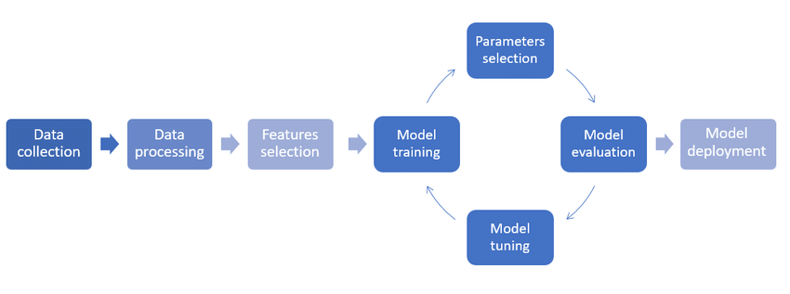

## 4. Performance Metrics

Accuracy: Proportion of correctly classified instances across the dataset.  
Precision: Measure of positive predictive value, ensuring the model minimizes false positives.  
Recall: Measure of sensitivity, ensuring high true positive rates.  
F1-Score: Harmonic mean of precision and recall, providing a balanced evaluation metric.  
Confusion Matrix: Detailed breakdown of true positives, true negatives, false positives, and false negatives to understand model performance.

## 5. Dashboards and Monitoring

- Visualizations include key metrics such as accuracy trends, feature importance, confusion matrix heatmaps, and ROC curves.  
- MLflow dashboards provide experiment histories, comparing model versions and their respective performances.  
- Logs and monitoring tools track real-time application performance and user interactions.

## 6. Constraints and Assumptions

### 6.1 Constraints

- The solution’s performance heavily depends on the quality, completeness, and diversity of the dataset.  
- Deployment and real-time predictions require reliable hosting services such as Render.

### 6.2 Assumptions

- All categorical features are correctly encoded and free of inconsistencies.  
- The dataset is representative of real-world mushroom characteristics, ensuring generalizability.   
- Users interacting with the API have a basic understanding of the input format and requirements.

## 7. Further Improvements

- Extend the solution to include interpretability tools such as SHAP or LIME, allowing users to understand predictions at a granular level.  
- Incorporate a larger and more diverse dataset to enhance model robustness and generalizability across different mushroom types.  
- Explore deep learning approaches for image-based mushroom classification, expanding the scope of the project.  
- Integrate additional deployment platforms such as mobile apps or IoT devices for broader accessibility.  
- Optimize the web service further for real-time prediction efficiency, minimizing latency.

## 8. Conclusion

This mushroom classification project exemplifies a robust and scalable machine learning pipeline, encompassing data preparation, model training, evaluation, and deployment. The solution’s accuracy and efficiency ensure that users can confidently classify mushrooms as edible or poisonous, thereby enhancing safety and awareness. Future enhancements, including interpretability tools and broader integrations, will further enrich the project’s scope and usability, making it a valuable asset for diverse applications.