**SCANIA TRUCK FAILURES PREDICTION**

Wireframe Document

Home Page

1.

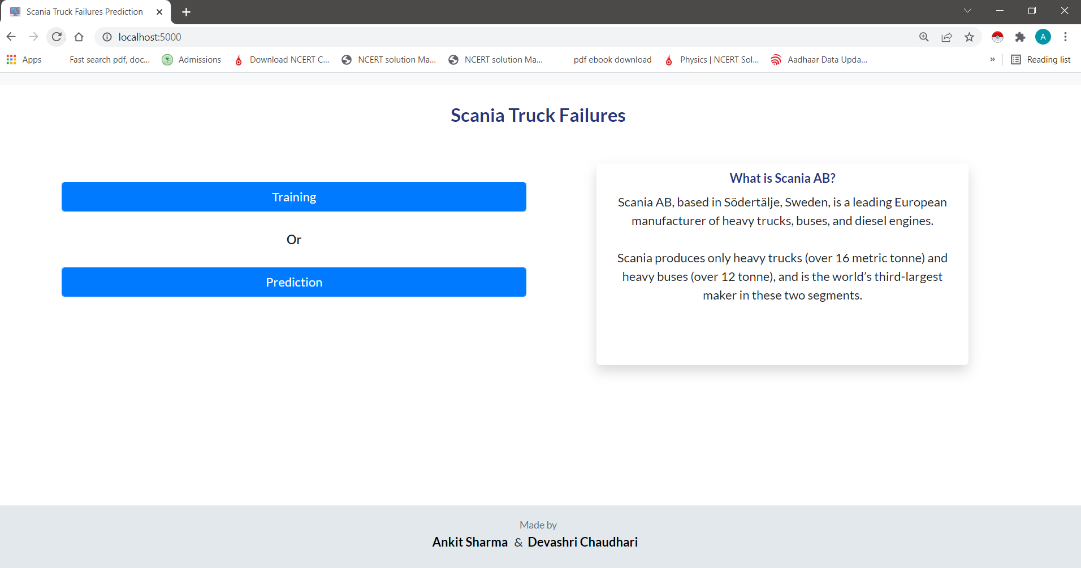

In Homepage we choose either training or prediction for next step

Training Page

2.

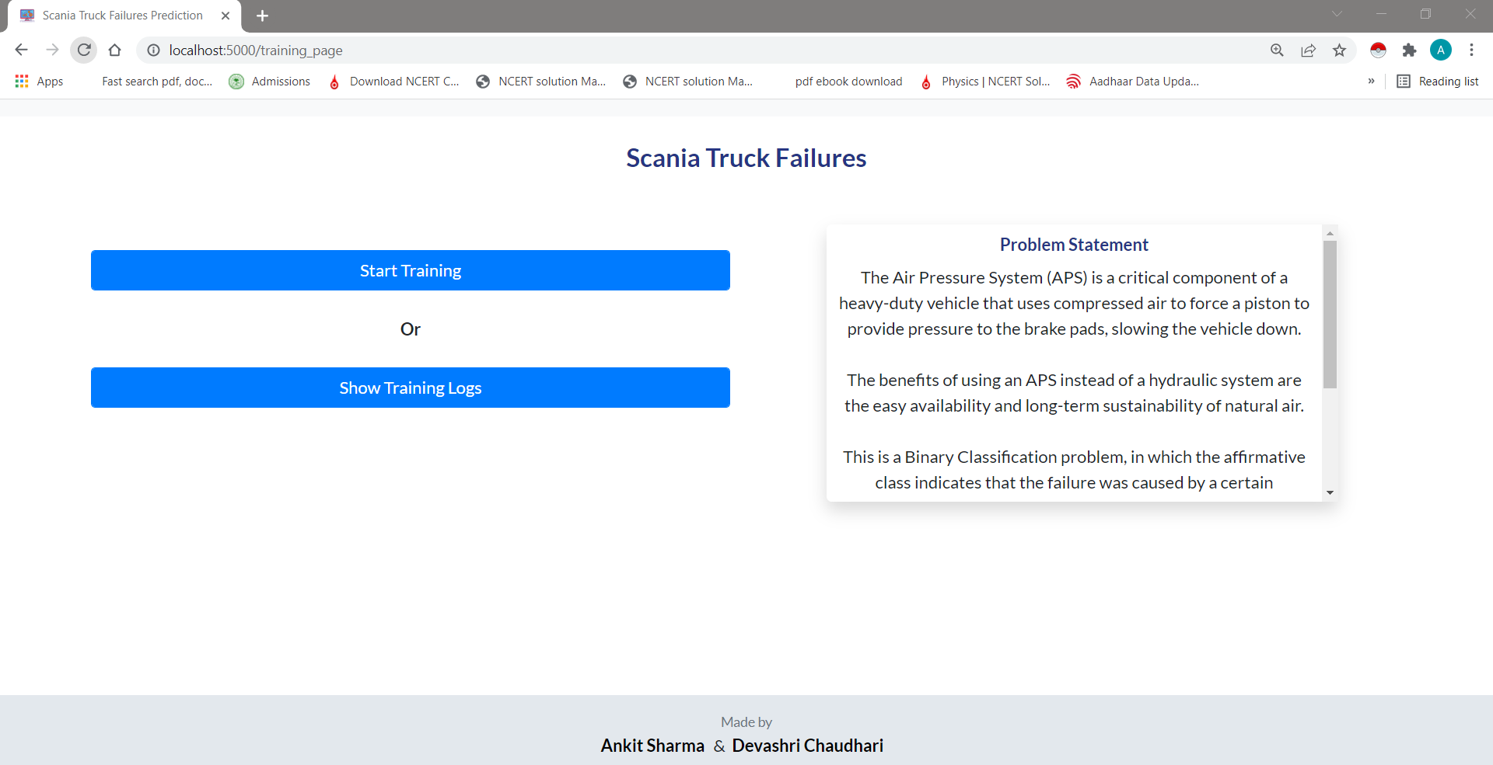

It gives you the option to choose Start Training or Show Training Logs.

If we click on Start Training , It will give you the facility to Enter your email address so we can notify you once the model training finishes –

3.

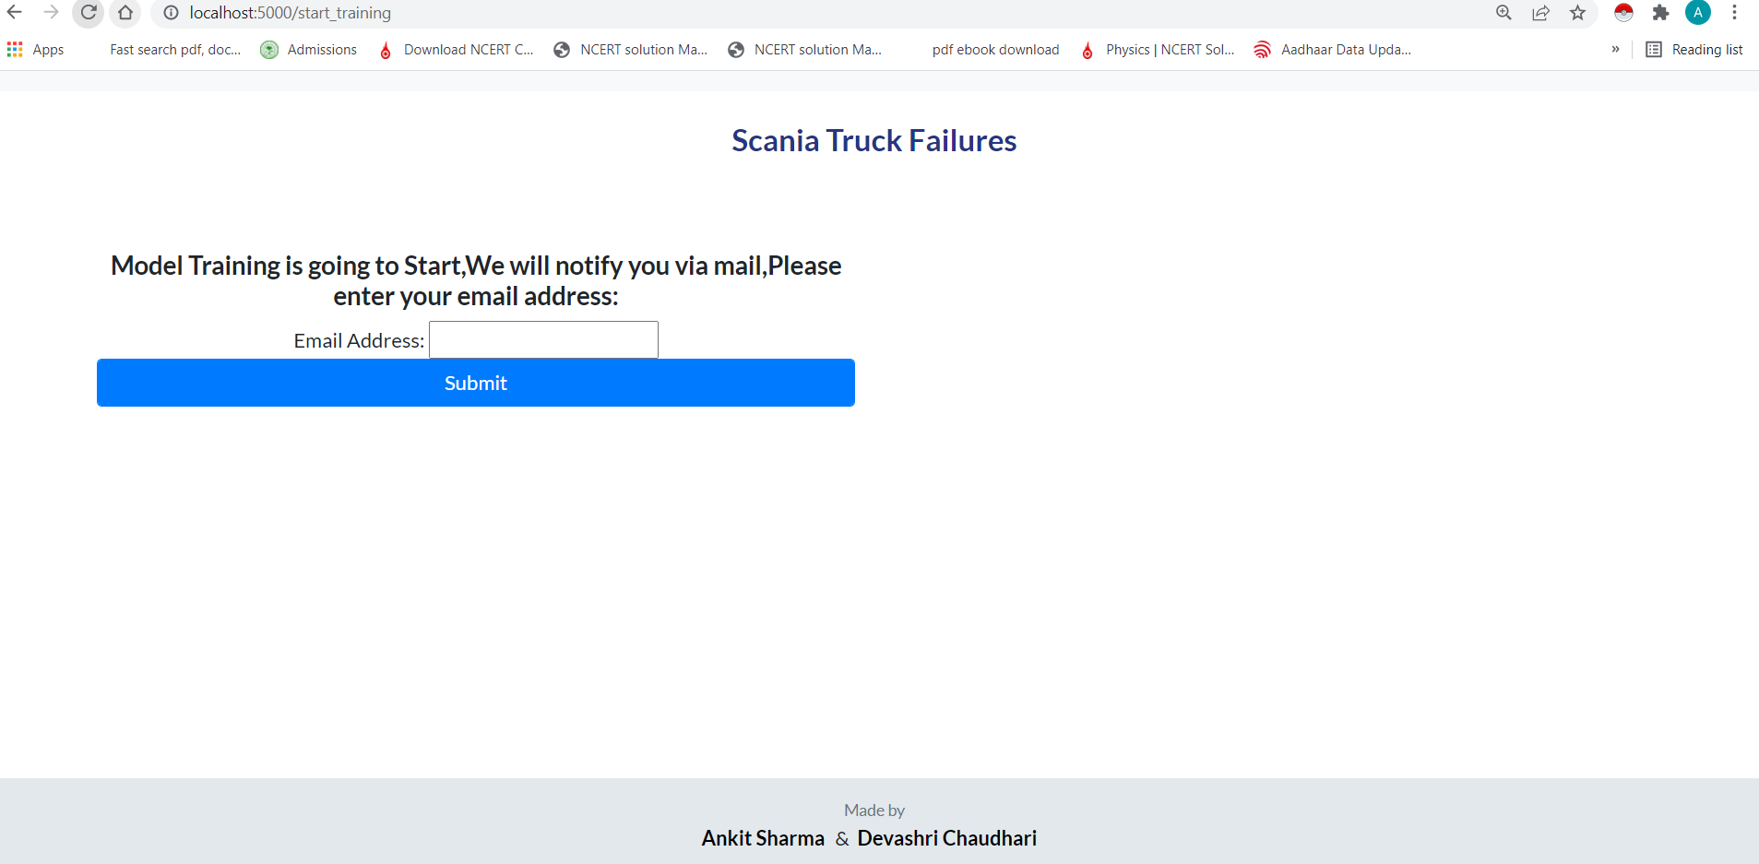

If we do not enter email address, Then it will not `proceed further and will show this page only again.

4.

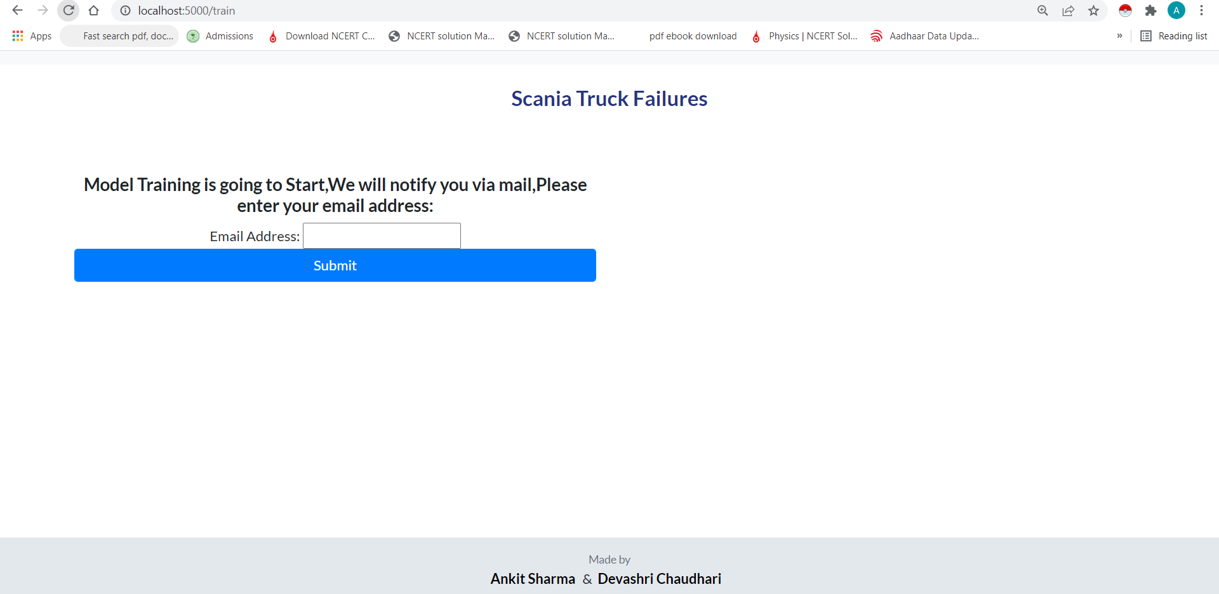

Suppose If you have entered wrong email address , So it will not proceed further as part of email validation and show the below mentioned page.

5.

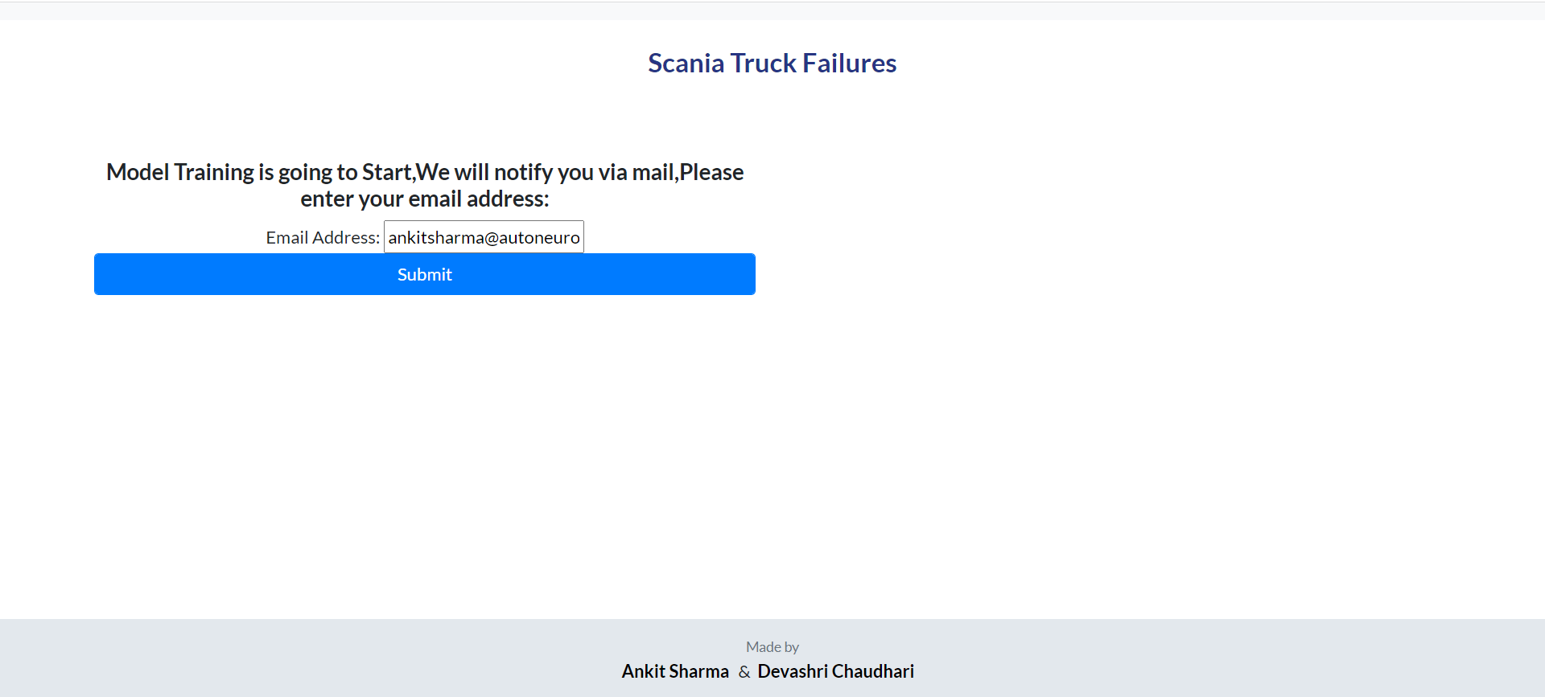

6.

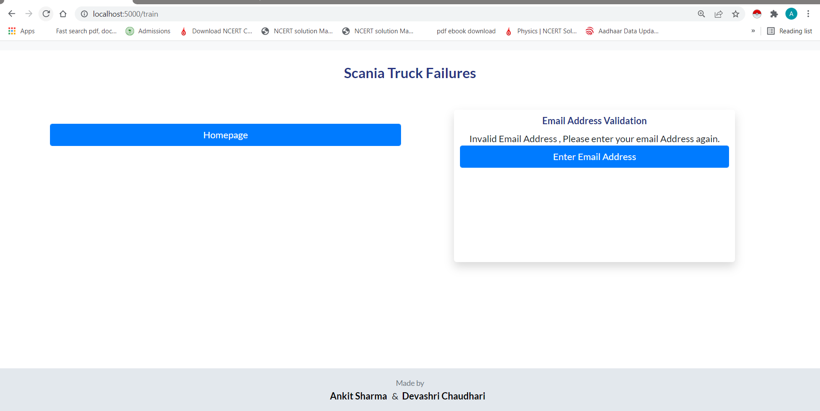

Here Either You can go to homepage or You can enter valid email address.

Suppose If you have entered the valid email address.Then it will show the UI like this –

7.

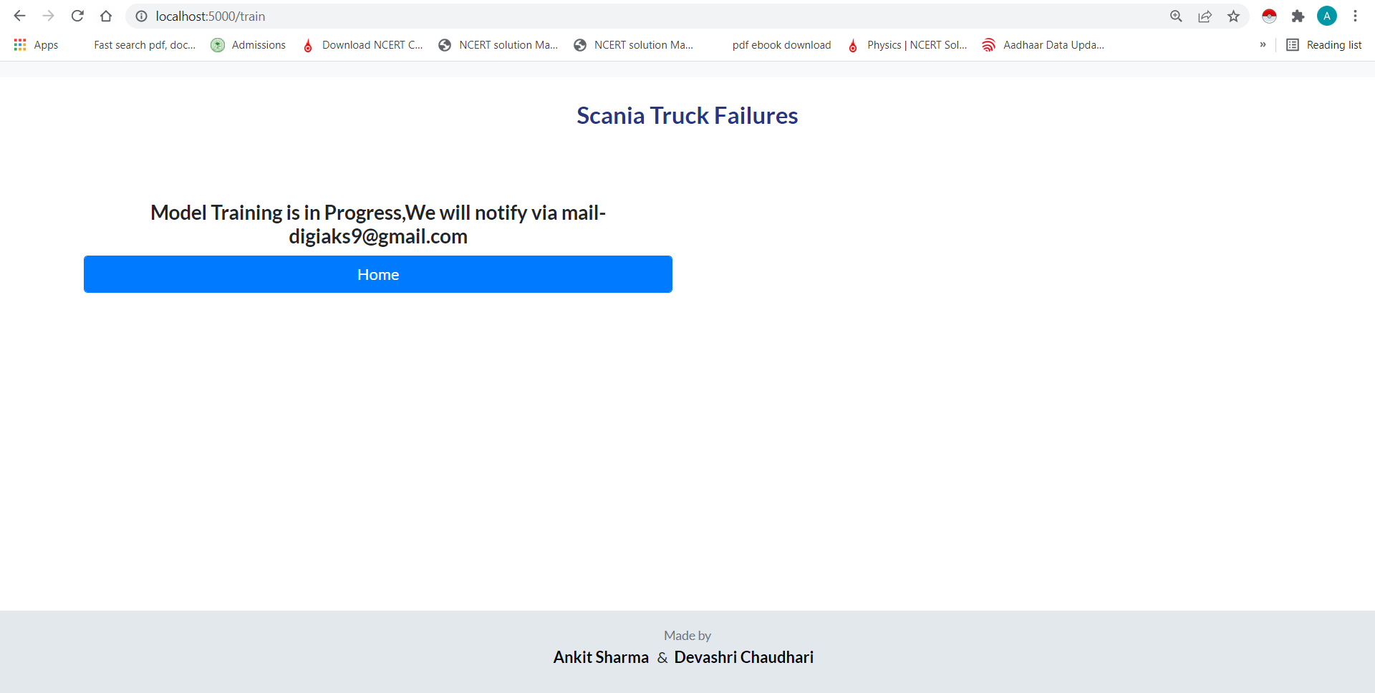

From Here You can return to Homepage.

Let’s go back to training page and Lets see what happens if we click on Start Training again as we already know that the Model Training is already in progress.

8.



When we click on Start training again, It will show the below mentioned UI.

9.

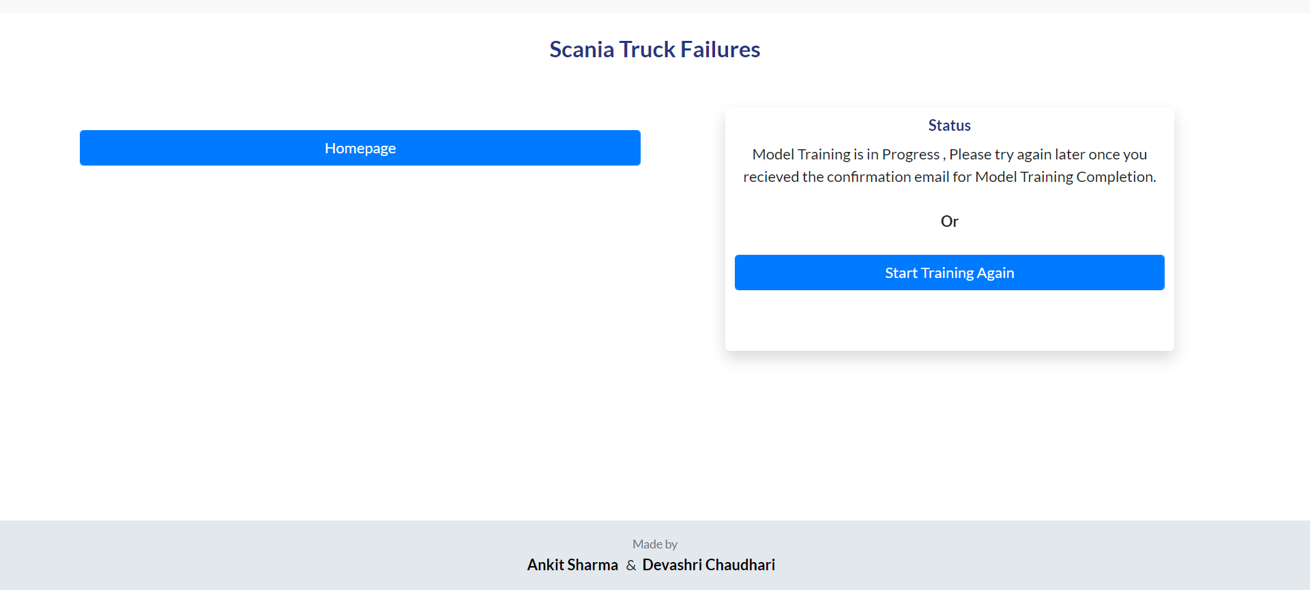

From here either we can go to homepage or If we want to start training again .

If we click on Start training again , It will start the training from scratch.

It will stop the previous running model training and will ask you to enter your email address and will follow same process as shown in image 3 to image 7.

Let’s go back to training page and Lets see what happens if we click on Show Training Logs page

10.



It will show the Training Logs.

11.

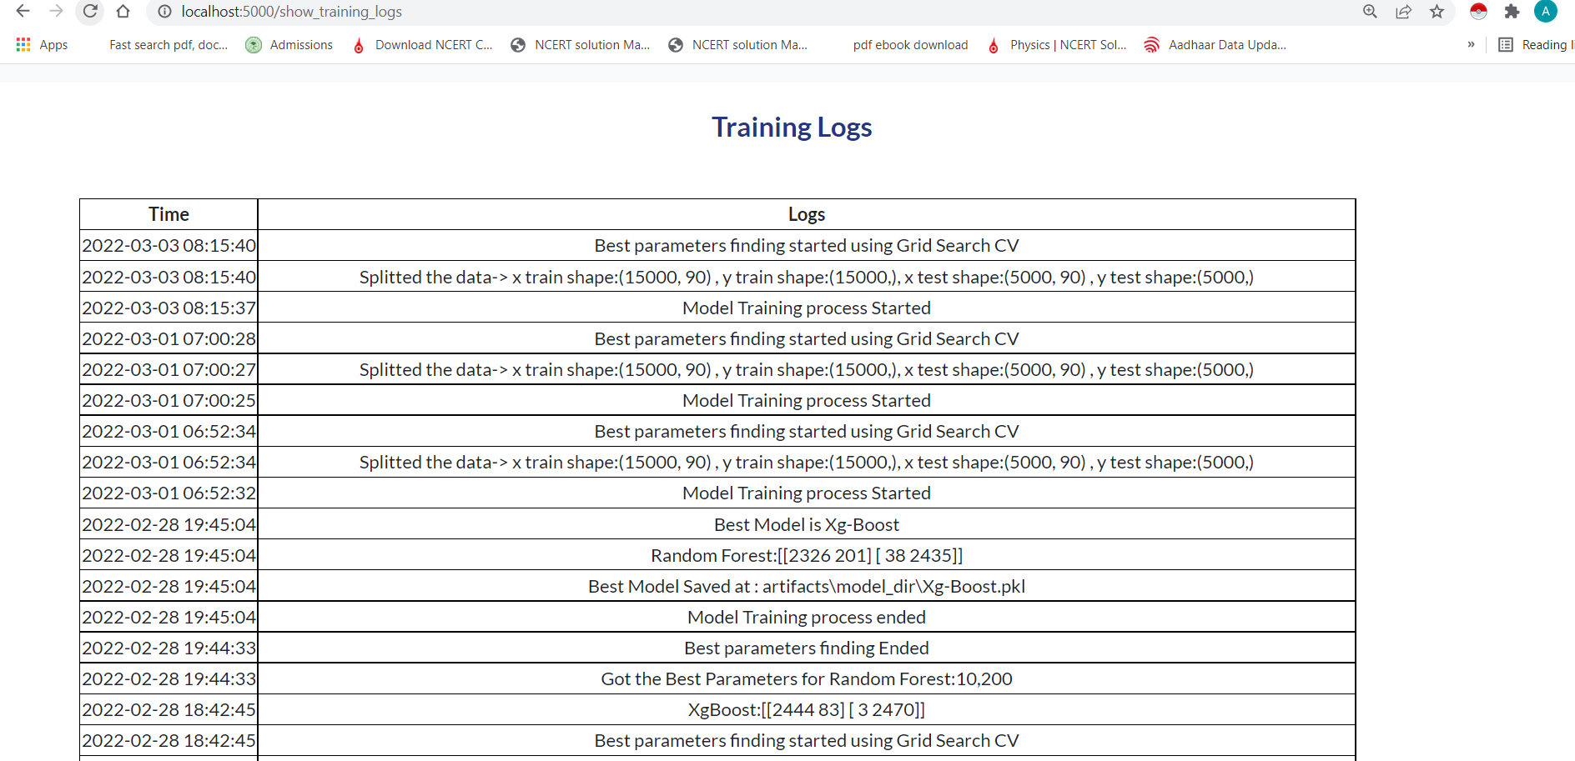

Prediction

When we click on Prediction button from Homepage.

It will show the UI as shown below.

12.

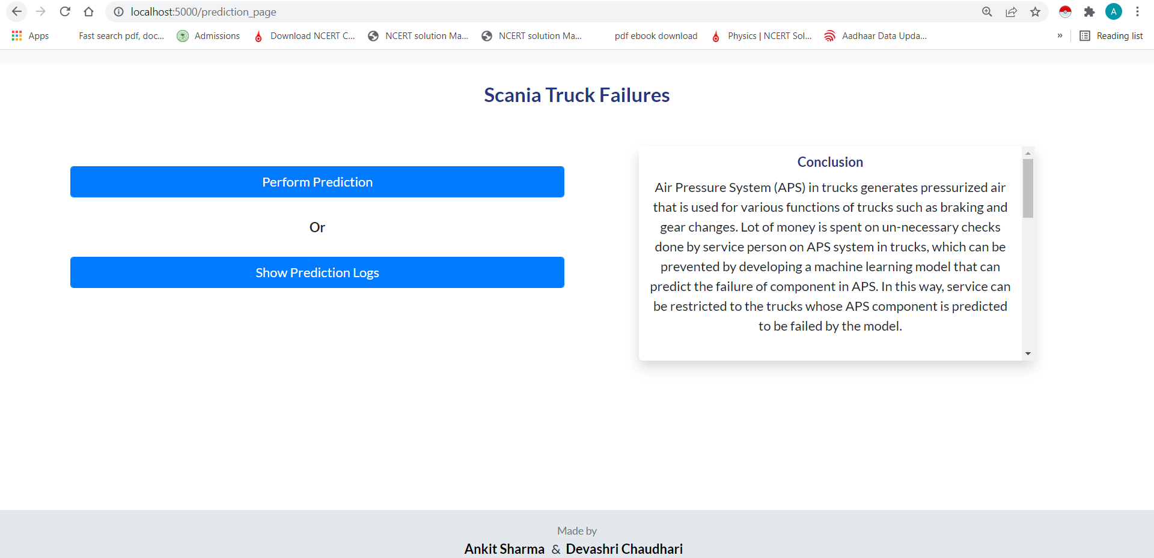

From Here Either we can click on Perform Prediction or we can show prediction logs.

Lets click on Perform prediction page.

13.

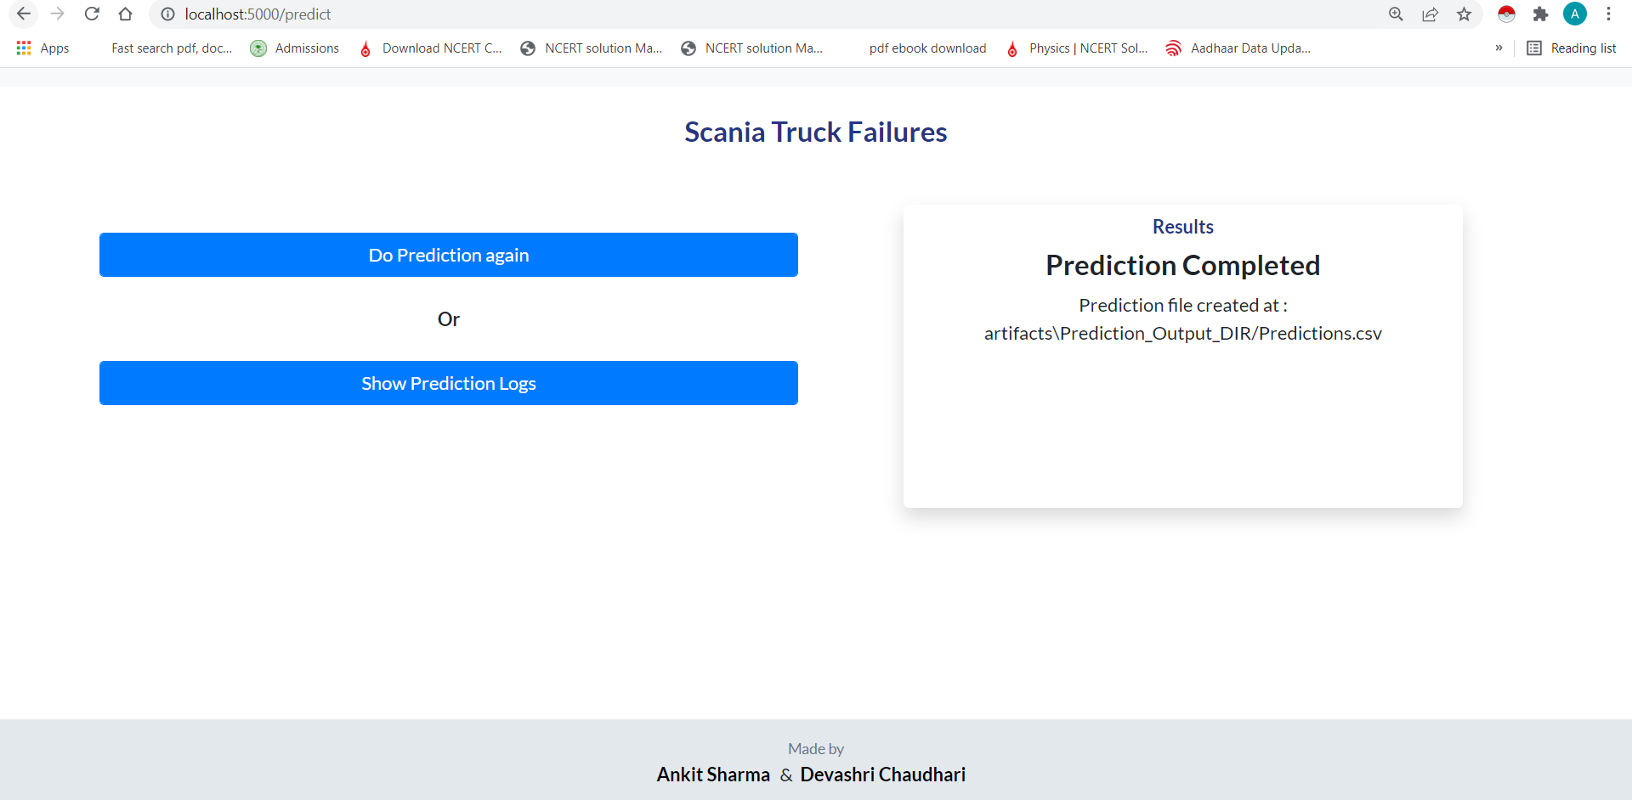

From here we get the location where the prediction file is saved.

Also If we want to do prediction again we can click on “Do Prediction again” button.

Now Let’s Check what happens we if we click on “Show Prediction Logs” Button-

14.

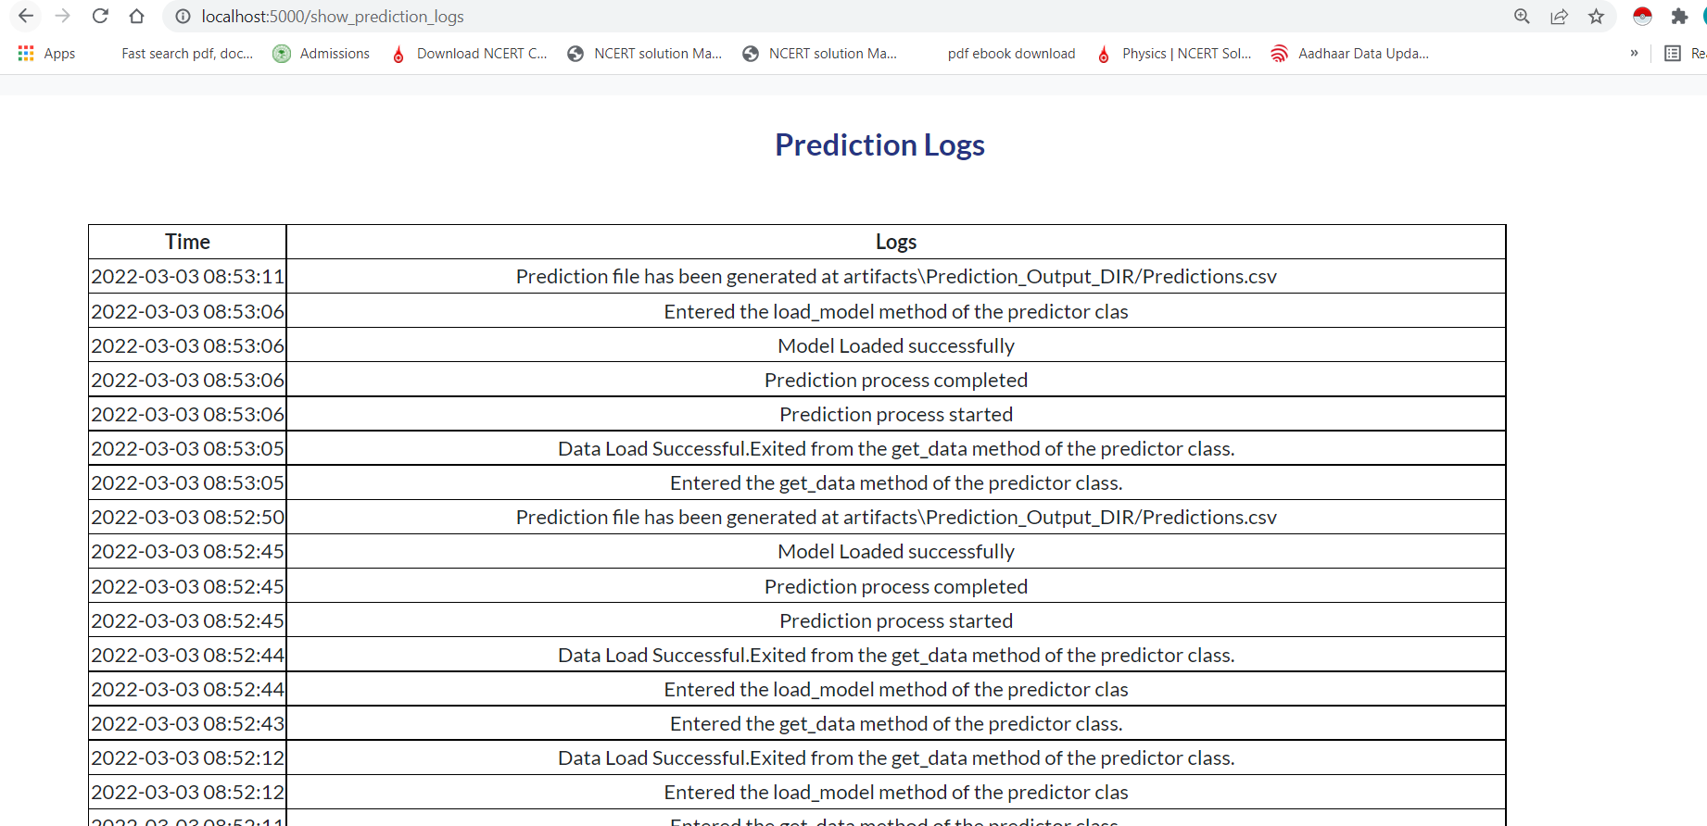

It will show the prediction Logs