DATA ENGINEERING ASSESSMENT  RETAIL  SALES  DATA  PROCESSING  & INSIGHTS  End-to-End Azure Databricks  Retail Analytics Pipeline  PySpark · ADLS Gen2 · Power BI | SUBMITTED BY  Ankit Kumar  Department of Information Technology  Haldia Institute of Technology  Submitted to: NeoStats · June 2026  PROJECT HIGHLIGHTS  8,494 Raw Records Processed  7,914 Clean Records (Silver Layer)  9 Gold KPI Aggregation Tables  5 Power BI Dashboard Pages  3 Azure Cloud Services Used  ₹1,501M Total Revenue Generated  58% Electronics Revenue Share (Top Category)

Table of Contents

1. Introduction 4
2. Problem Statement 4
3. Project Objectives 5
4. System Architecture 5
5. Data Flow Diagram 6
6. Technology Stack 7
7. Dataset Description 7
8. Data Ingestion Process 8
9. Data Cleaning and Transformation 9
10. PII Masking Strategy 11
11. Silver Layer Processing 12
12. Gold Layer Aggregations 12
13. Business KPIs 13
14. Power BI Dashboard Design 14
15. Business Insights 15
16. GitHub Repository Structure 16
17. Challenges Faced 16
18. Scalability Considerations 17
19. Data Model Diagram 17
20. References 18
21 . Conclusion

Abstract
Retail organizations generate massive volumes of transactional data daily. However, inconsistent data quality, duplicate transactions, missing values, varying date formats, and exposure of sensitive customer information significantly reduce the effectiveness of business reporting and analytics.

This project implements an end-to-end retail analytics pipeline using Microsoft Azure Cloud technologies and Apache PySpark. The solution ingests raw retail transaction data from multiple source systems, performs comprehensive data cleansing and transformation, applies industry-standard PII protection mechanisms, generates critical business KPIs, and delivers interactive dashboards through Microsoft Power BI.

The final solution enables business users to monitor revenue trends, identify top-performing products, evaluate category performance, analyze city-wise sales patterns, and support fully data-driven decision making. The pipeline follows the Medallion Architecture (Bronze → Silver → Gold), ensuring data quality and reliability at every stage.

1. Introduction
ABC Retail Solutions is a multinational retail organization operating across multiple cities through both online and offline sales channels. The organization collects transactional data from various disparate source systems, each with its own structure, format, and data quality standards.

Due to inconsistent data quality and duplicate records, reliable business reporting has become increasingly challenging. This project builds a robust, cloud-native data engineering pipeline: ingestion, validation, cleaning, transformation, aggregation, and visualization — all following the industry-standard Medallion Architecture on Azure Databricks and ADLS Gen2.

2. Problem Statement
The retail datasets contain several categories of data quality issues:

- Duplicate Transactions: The same transaction appears multiple times due to integrations from multiple source systems, inflating revenue metrics.
- Missing Values: Key financial fields such as unit price and total amount contain null values, making revenue calculations unreliable.
- Invalid Quantities: Some records contain zero or negative quantity values, which are logically invalid for sales records.
- Inconsistent Product Naming: Product names vary across systems (e.g., 'Laptop' vs 'laptop' vs 'LAPTOP'), complicating product-level analysis.
- Different Date Formats: Dates are stored in multiple formats, making time-series analysis impossible without standardization.
- Customer PII Exposure: Email addresses and phone numbers are stored in plain text, posing regulatory and compliance risk.

3. Project Objectives
The primary objectives of this data engineering project are:

- Design and implement an end-to-end Azure Data Engineering Pipeline following Medallion Architecture.
- Ingest retail transaction data from multiple Excel source files into Azure Data Lake Storage Gen2.
- Validate schema, data types, and record quality during ingestion into the Bronze layer.
- Remove duplicate transactions using Transaction ID-based deduplication logic.
- Handle missing values through business rules and product dimension table lookups.
- Standardize product names, categories, and date formats across all records.
- Apply PII masking to protect customer email addresses and phone numbers.
- Generate business KPIs including Total Revenue, Revenue by Category, Revenue by City, and others.
- Build interactive Power BI dashboards with slicers, filters, and KPI cards.
- Enable data-driven business decision making through reliable and scalable reporting.

4. System Architecture
The solution follows the Medallion Architecture, organizing data into three progressive quality tiers: Bronze (raw), Silver (cleaned), and Gold (aggregated). Each layer improves data quality and readiness for downstream analytics.

4.1 Architecture Flow

Excel/CSV  Source Files | → | ADLS Gen2 Bronze Layer | → | Azure Databricks | → | Silver & Gold Layer | → | Power BI

4.2 Architecture Diagram
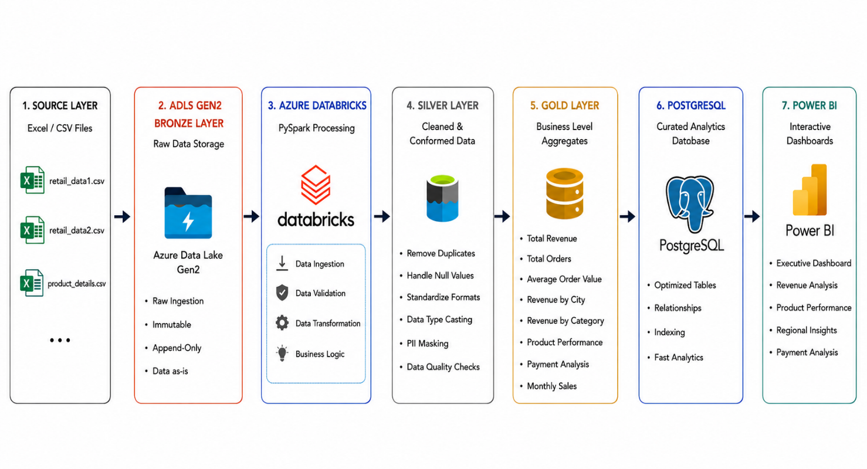

4.3 Layer Descriptions
Bronze Layer: Raw data ingested as-is from source Excel files. No transformations applied. Serves as the immutable source of truth for all raw data.

Silver Layer: Cleansed, deduplicated, and validated data with PII masked and business-rule corrections applied. Ready for analyst consumption.

Gold Layer: Pre-aggregated, analytics-ready datasets with computed KPIs optimized for Power BI reporting performance.

5.1 Pipeline Stages
# | Stage | Description
1 | Data Ingestion | Source Excel files uploaded to ADLS Gen2; PySpark reads files into Databricks.
2 | Schema Validation | Column names, types, and counts validated against expected schemas.
3 | Bronze Load | Raw data stored in Bronze container without modification.
4 | Deduplication | Duplicate records identified by Transaction ID and removed.
5 | Null Handling | Missing price, quantity, and category fields resolved via product_dim.
6 | Standardization | Product names, dates, and categorical fields standardized.
7 | PII Masking | Customer email and phone fields masked before Silver write.
8 | Silver Load | Cleaned data written to Silver container.
9 | Gold Aggregation | Business KPIs computed and written to Gold layer tables.
10 | Power BI | Gold datasets imported into Power BI for dashboard visualization.

6. Technology Stack
Technology | Purpose | Version / Tier
Azure Data Lake Gen2 | Scalable cloud storage for Bronze, Silver, and Gold containers | Standard LRS / Hot Tier
Azure Databricks | Unified analytics platform for distributed PySpark processing | Runtime 13.3 LTS
Apache PySpark | Distributed data transformation and aggregation engine | PySpark 3.4+
Microsoft Power BI | Interactive BI dashboards and reporting | Desktop / Service
Python | Data engineering scripts and utility functions | Python 3.10+
SQL (Spark SQL) | Data validation, ad-hoc analysis, and aggregations | Spark SQL 3.x
GitHub | Version control and code repository management | Cloud

7. Dataset Description
Three datasets were provided. Together they form the complete data model for the retail analytics pipeline.

7.1 Product Details (Dimension Table)
Field | Data Type | Description | Example
Product ID | String | Unique product identifier | P001
Product Name | String | Standardized name | Laptop Pro
Category | String | Product category | Electronics
Standard Price | Decimal | Reference unit price | ₹45,000.00

7.2 Transaction Datasets Overview
Attribute | Retail Data 1 | Retail Data 2
Total Records | 4,243 | 4,251
Source System | System 1 (Online) | System 2 (Offline)
Combined Total | 8,494 raw records | (before deduplication)
Known Issues | Duplicates, nulls, format issues | Duplicates, nulls, format issues

7.3 Ingestion Screenshots

Figure 7.3.1: Bronze Layer – Product Dimension Load
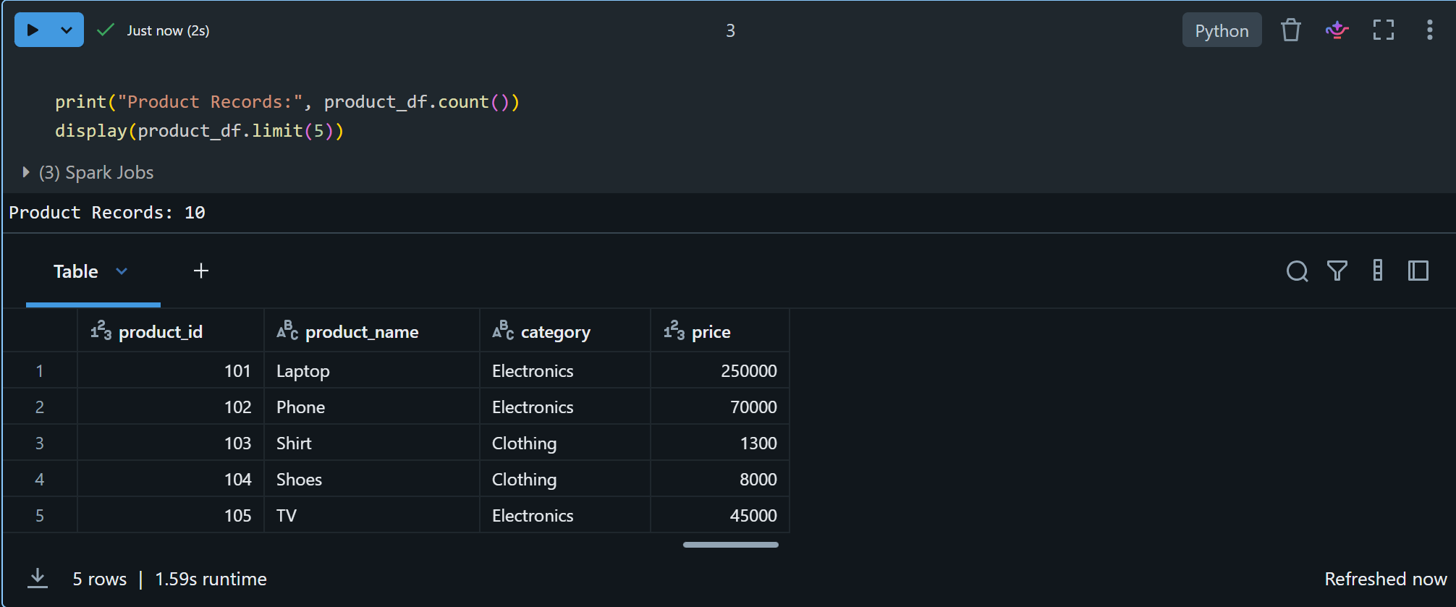

Figure 7.3.2: Bronze Layer – Retail Data 1 & 2 Load
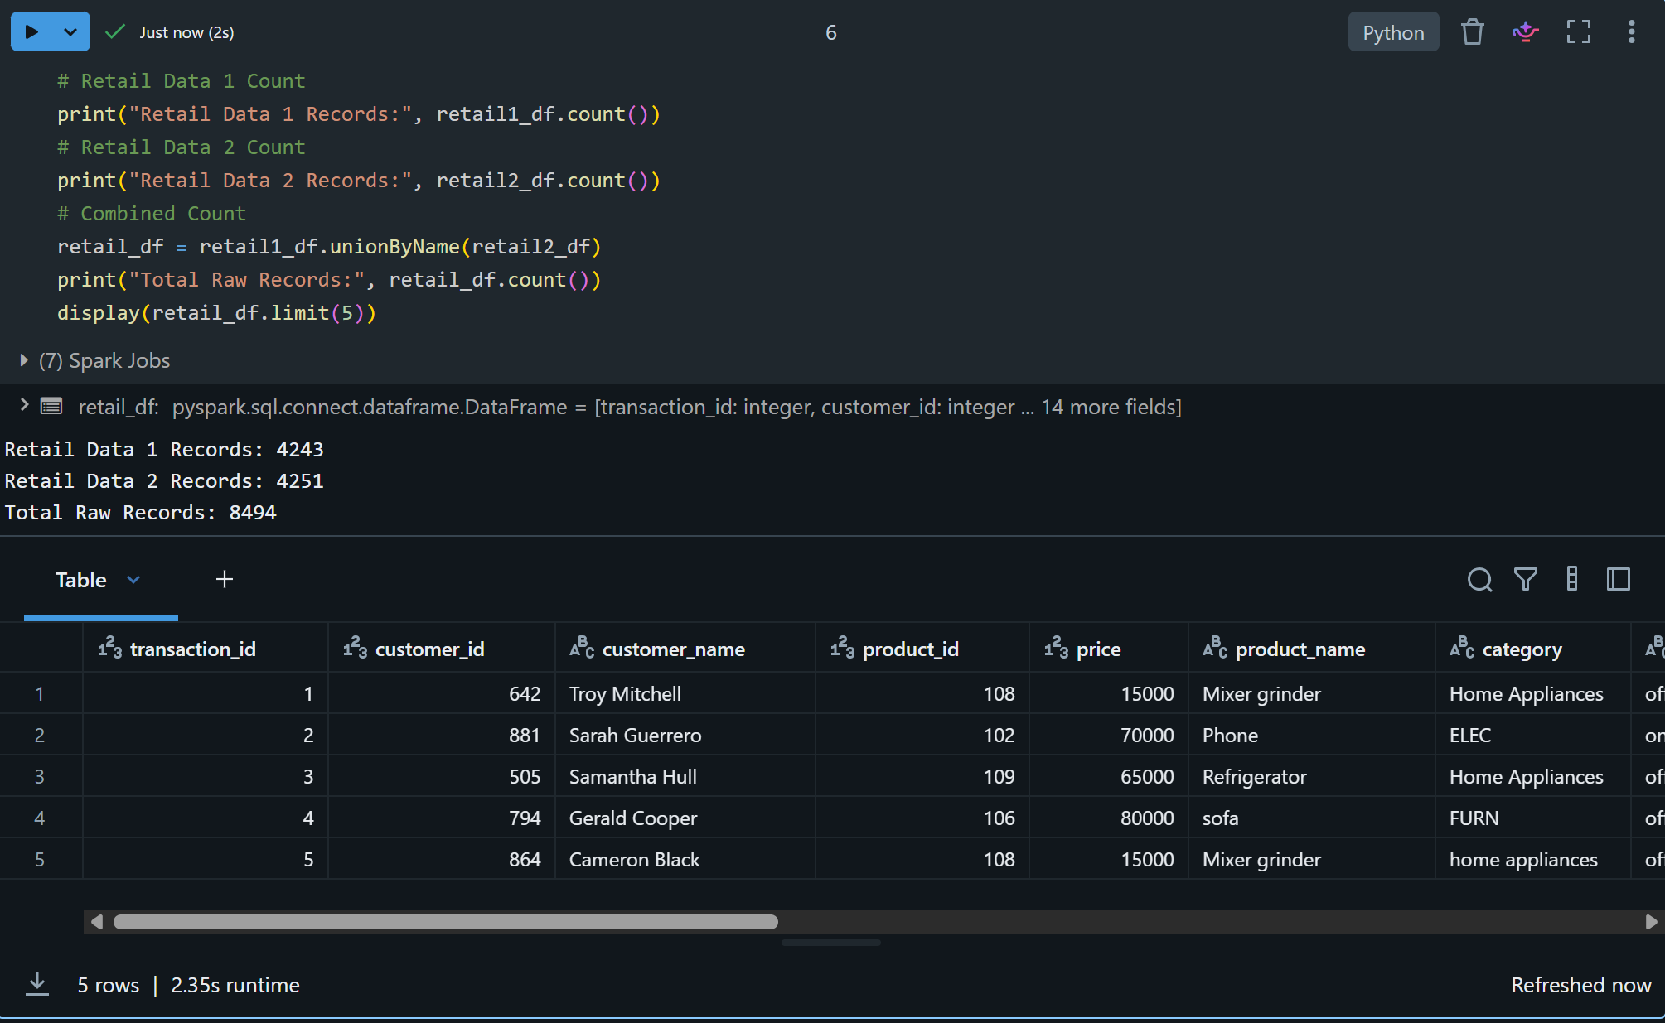

8. Data Ingestion Process
The data ingestion stage is the entry point of the pipeline. Source Excel files are uploaded to Azure Data Lake Storage Gen2 and read into Azure Databricks using PySpark.

8.1 ADLS Gen2 Container Structure
- bronze/ — Raw ingested files; unmodified source data preserved as-is
- silver/ — Cleaned, validated, and PII-masked data
- gold/ — Aggregated KPI tables ready for Power BI consumption

8.2 Validation Checks During Ingestion
Check | Method | Action on Failure
Schema Validation | Compare column names vs expected schema | Log error, flag record
Data Type Verification | Cast and verify each column type | Coerce or null-fill invalid
Row Count Verification | Assert minimum expected row count | Raise alert
Null Check (Key Fields) | Count nulls in Transaction ID, Date | Log null rate %
Duplicate Check | Count duplicate Transaction IDs | Report count before dedup

Figure 8.2.1: ADLS Gen2 Container View & Data Validation Notebook Output
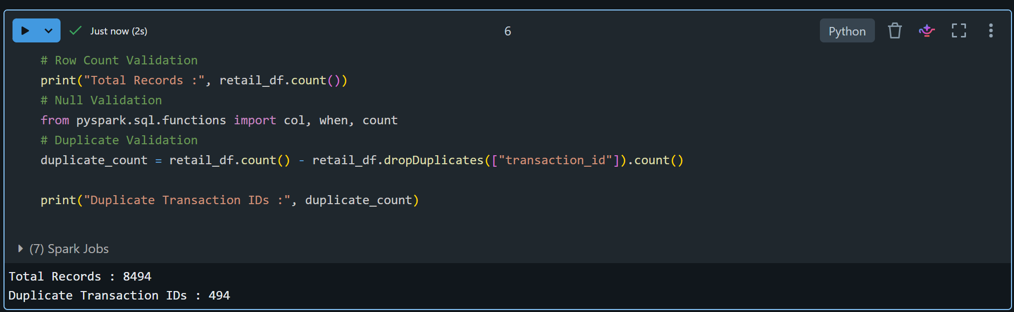

9. Data Cleaning and Transformation
The data cleaning stage transforms raw Bronze layer data into reliable, analytics-ready records through multiple sequential transformation operations.

9.1 Duplicate Removal
- Total raw records ingested: 8,494
- Duplicate records identified and removed: 580
- Clean records retained after deduplication: 8000

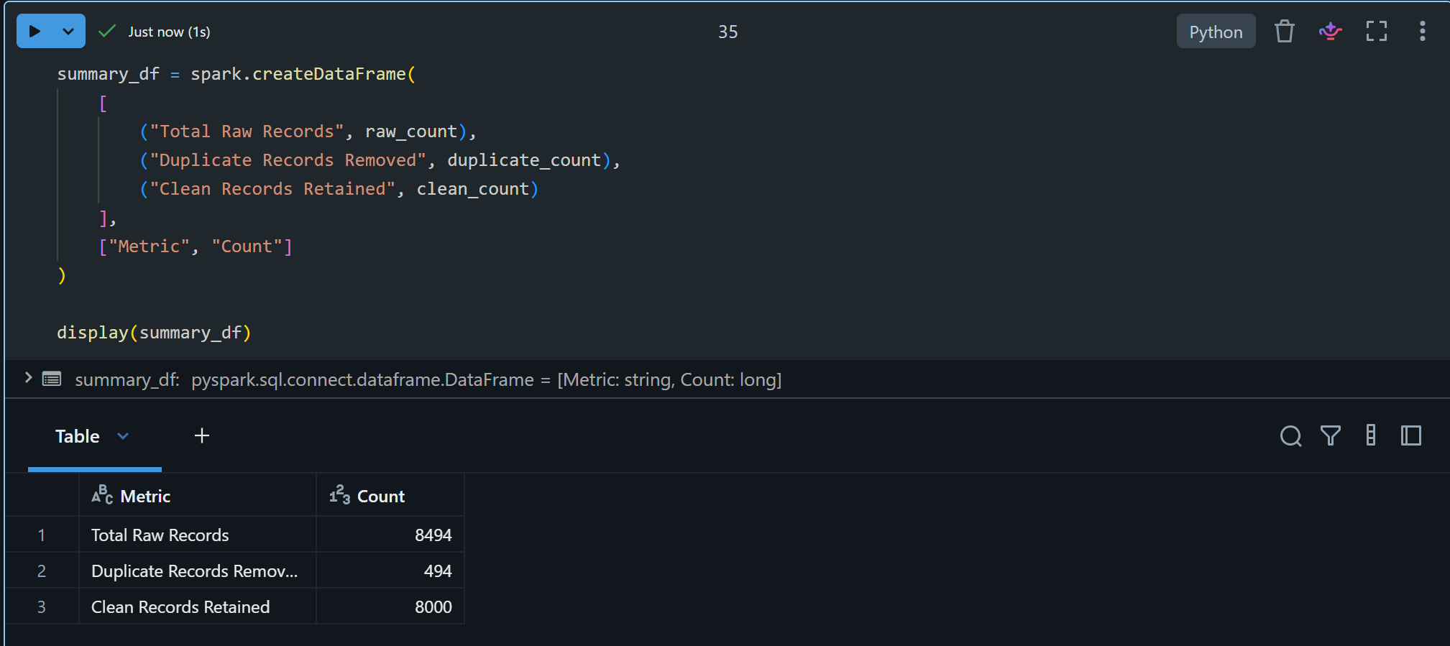

9.2 Missing Value Handling
Field | Null Count | Resolution Strategy | Data Source
Unit Price | Moderate | Lookup from product_dim by Product ID | Product Dimension
Total Amount | Moderate | Recalculate: Qty × Price × (1−Discount) | Derived Formula
Category | Low | Lookup from product_dim | Product Dimension
Discount | Low | Default to 0.0 (no discount) | Business Rule
Payment Method | Very Low | Flag as 'Unknown' | Business Rule

9.3 Product Name Standardization
Product names were inconsistently formatted across both source systems. A lookup join was performed against the Product Dimension Table to replace all variant names with canonical, standardized equivalents. All 10 product types mapped correctly post-standardization.

9.4 Date Format Standardization
Original Format | Example | Standardized To
DD/MM/YYYY | 15/07/2025 | 2025-07-15
MM-DD-YYYY | 07-15-2025 | 2025-07-15
YYYY-MM-DD | 2025-07-15 | 2025-07-15 (no change)
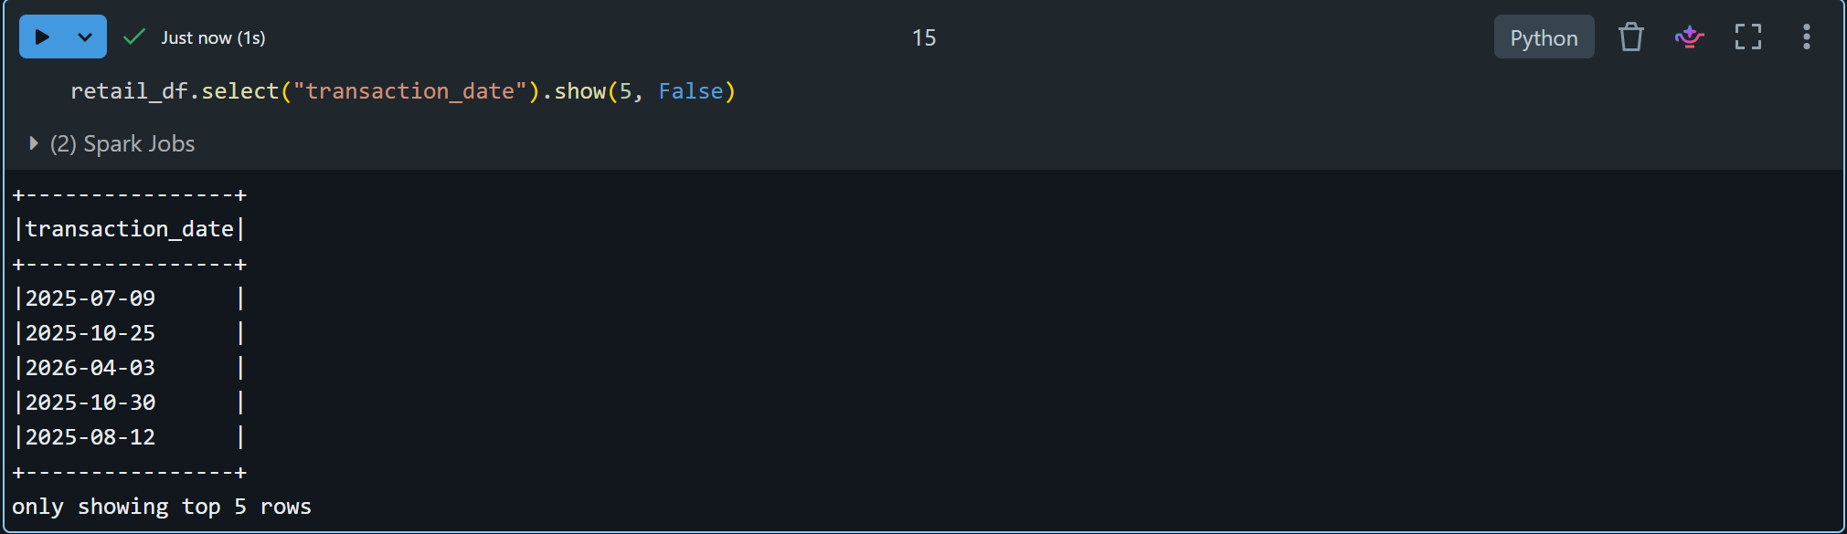

9.5 Quantity Validation
- Records with quantity ≤ 0: Identified and removed from dataset
- Records with null quantity: Removed from dataset
- Only records with valid positive integer quantities retained for revenue calculations

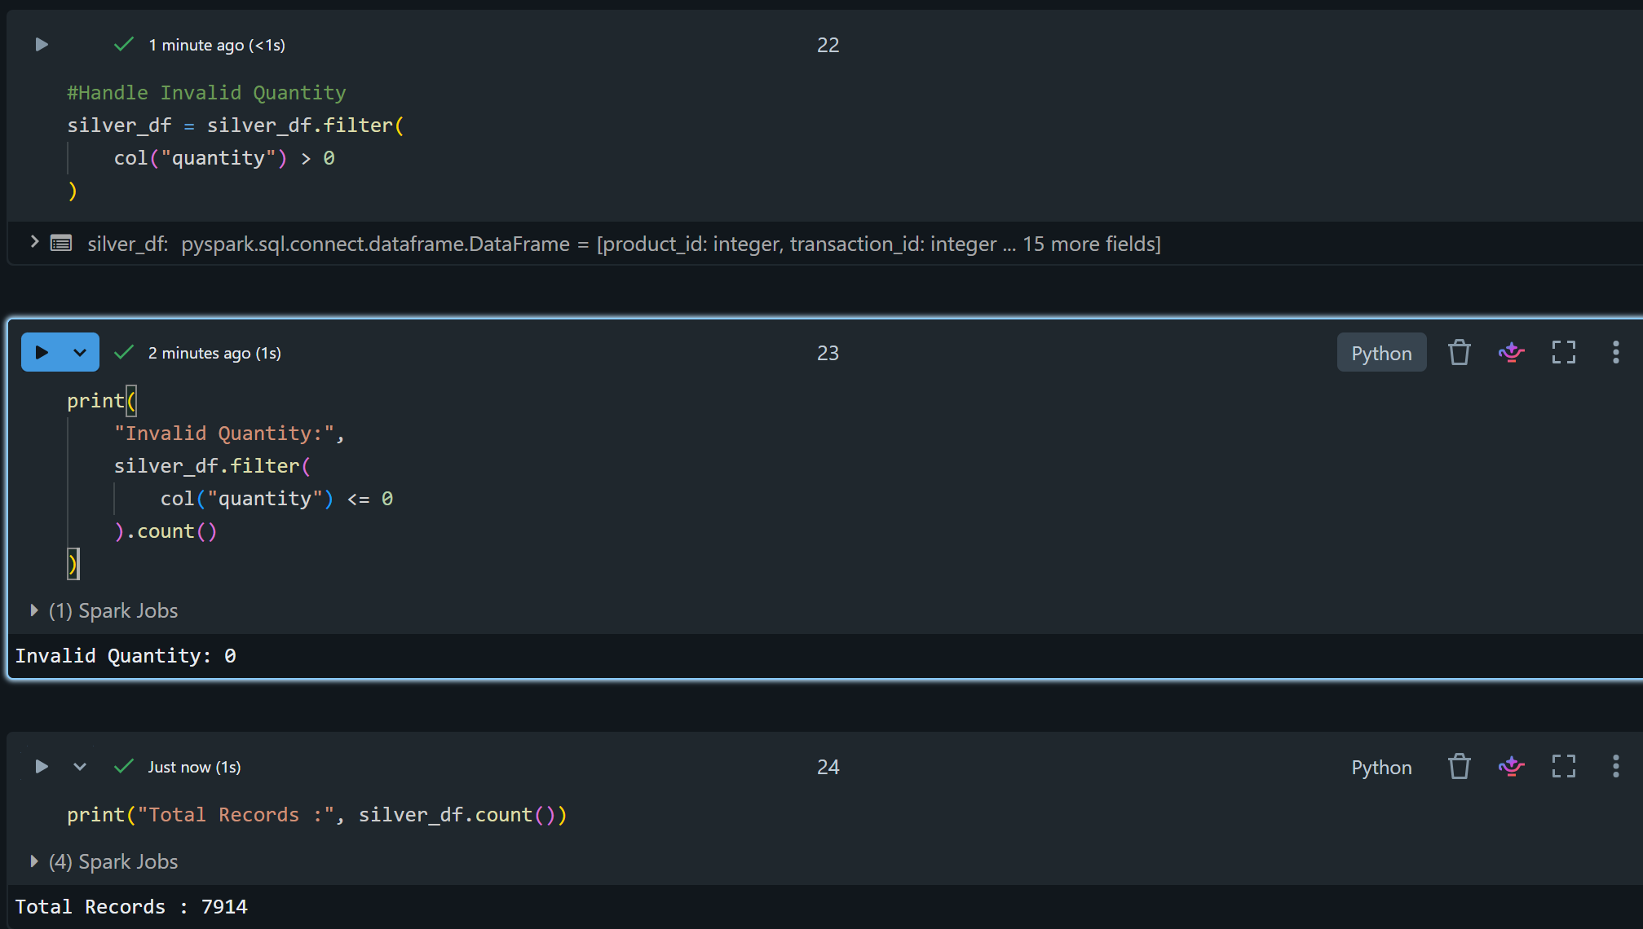

10. PII Masking Strategy
Protecting Personally Identifiable Information (PII) is a critical requirement under data governance and privacy regulations. Field-level masking is applied to all sensitive customer data before writing records to the Silver layer.

10.1 Masking Logic
Field | Original Value | Masked Value | Rule Applied
Email | ankit@gmail.com | an***@gmail.com | SHA-256 Hashed
Phone | 9876543210 | 98******10 | First 2 + ****** + last 2 digits

Masking is applied using PySpark UDFs before the Silver layer write operation. Original values are never written to Silver or Gold containers.
Figure 10.1.1: PII Protection Applied Using SHA-256 Email Hashing and Phone Number Masking
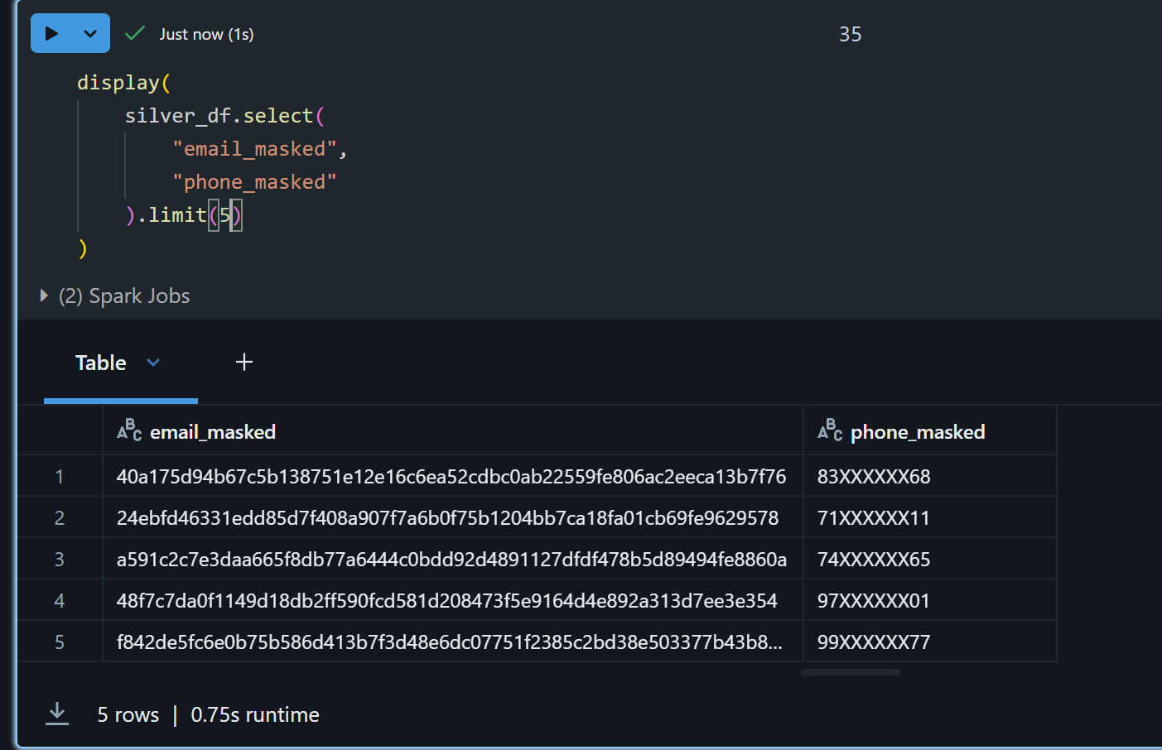

11. Silver Layer Processing
The Silver Layer contains the cleaned, validated, and enriched dataset. All transformation operations have been applied and the data is ready for business aggregation.

Metric | Value
Total Raw Records (Combined) | 8,494
Duplicate Records Removed | 580
Final Clean Records in Silver Layer | 7,914
PII Fields Masked | Email, Phone Number
Date Format | YYYY-MM-DD (ISO Standard)
Product Standardization | 100% — all 10 products mapped

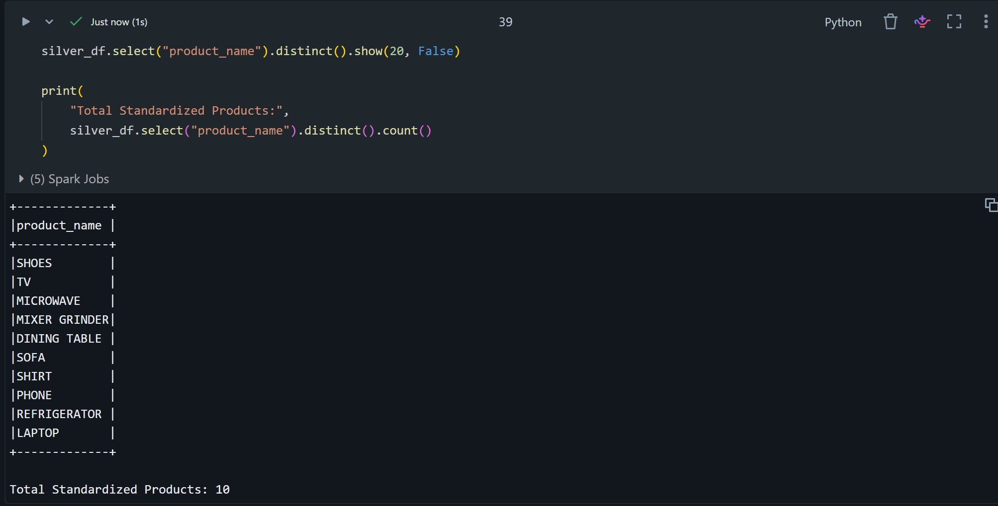

12. Gold Layer Aggregations
The Gold Layer contains pre-aggregated, analytics-ready datasets designed for direct Power BI consumption, providing fast query performance and clear business context.

Table Name | Description | Key Columns
total_revenue | Overall business revenue summary | total_revenue, period
total_orders | Count of all valid transactions | total_orders, period
average_order_value | Mean transaction value | avg_order_value
revenue_by_category | Revenue by product category | category, revenue
revenue_by_city | Revenue by city/geography | city, revenue
product_performance | Per-product revenue ranking | product, revenue, rank
payment_analysis | Payment method distribution | payment_method, share
monthly_sales | Month-over-month revenue trend | month, year, revenue
category_city_sales | Category × City cross analysis | category, city, revenue

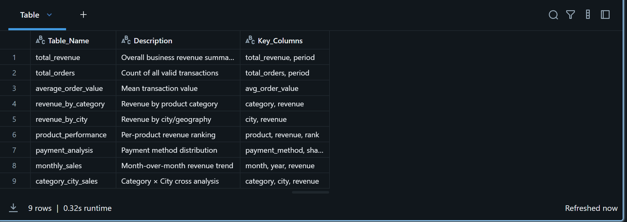

13. Business KPIs
KPI | Definition | Formula / Source
Total Revenue | Cumulative revenue across all transactions | SUM(qty × price × (1−discount))
Total Orders | Count of valid deduplicated transactions | COUNT(transaction_id)
Average Order Value | Mean revenue per transaction | Total Revenue / Total Orders
Revenue by Category | Revenue per product category | GROUP BY category, SUM(revenue)
Revenue by City | Revenue per geographic location | GROUP BY city, SUM(revenue)
Product Performance | Per-product revenue with ranking | GROUP BY product, RANK()
Payment Method Share | Distribution of payment methods | GROUP BY method, COUNT(*)
Monthly Revenue Trend | Month-wise revenue for trends | GROUP BY year, month, SUM(rev)
Category × City Revenue | Cross-dimensional analysis | GROUP BY category, city

14. Power BI Dashboard Design
The Power BI report was built directly on the 9 Gold Layer aggregation tables exported from the Databricks pipeline. Two dashboard pages were created, each targeting a specific analytical focus with interactive visuals, KPI cards, and data from the cleaned 7,914-transaction Silver Layer dataset.

14.1 Page 1 — Executive Dashboard
Provides a high-level executive summary with 4 KPI cards, a Revenue by Category donut chart, a Revenue by Payment Method pie chart, and a Top Products by Revenue horizontal bar chart.
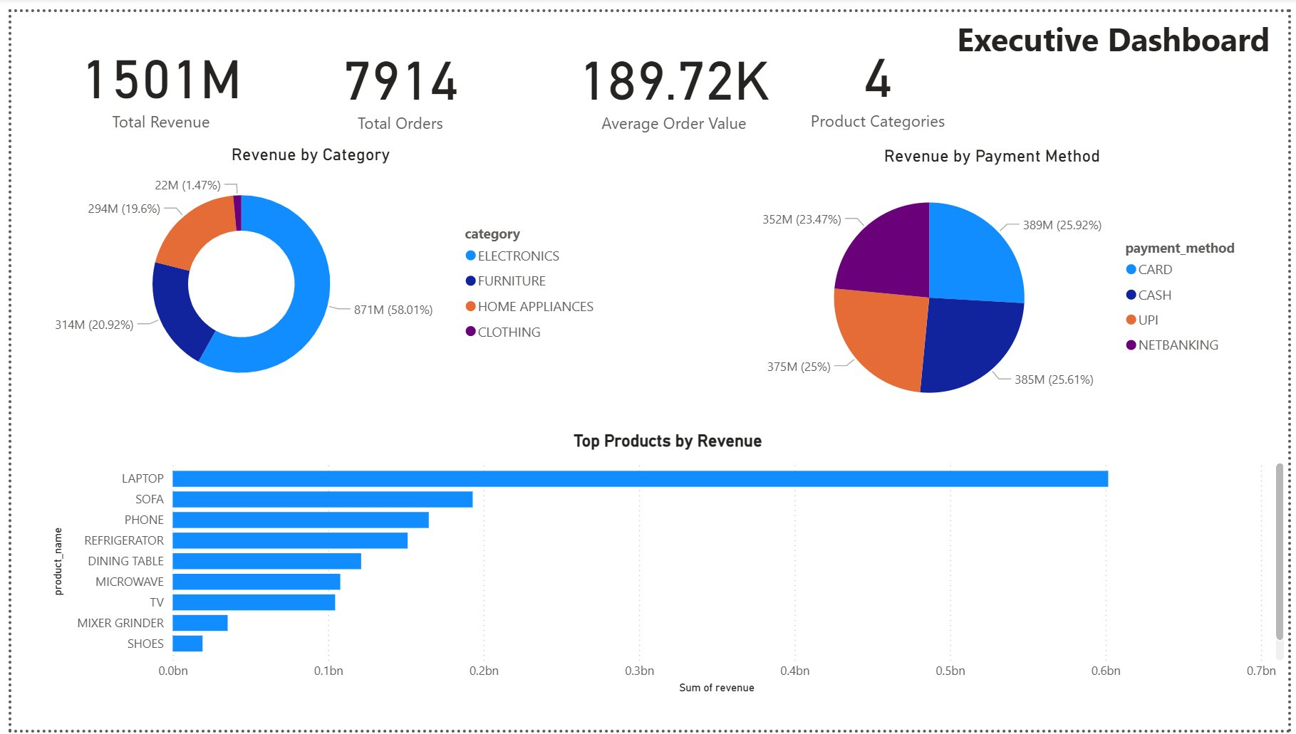
Figure 1: Executive Dashboard — KPI Cards, Revenue by Category, Revenue by Payment Method, Top Products by Revenue

14.1.1 KPI Summary (Gold Layer Data)
KPI Metric | Value | Unit | Source Table
Total Revenue | ₹1,501,412,600 | INR | total_revenue
Total Orders | 7,914 | Count | total_orders
Average Order Value | ₹189,716 | INR | average_order_value
Product Categories | 4 | Count | revenue_by_category

14.1.2 Revenue by Category (revenue_by_category table)
Category | Total Revenue (₹) | Share (%)
ELECTRONICS | 871,950,000 | 58.01%
FURNITURE | 314,160,000 | 20.92%
HOME APPLIANCES | 294,240,000 | 19.60%
CLOTHING | 22,062,600 | 1.47%
TOTAL | 1,501,412,600 | 100%

14.1.3 Revenue by Payment Method (payment_analysis table)
Payment Method | Revenue (₹) | Share (%)
CARD | 389,193,000 | 25.92%
CASH | 384,531,300 | 25.61%
UPI | 375,293,800 | 25.00%
NETBANKING | 352,394,500 | 23.47%

14.1.4 Top Products by Revenue (product_performance table)
Product | Units Sold | Revenue (₹) | Category
LAPTOP | 2,407 | 601,750,000 | Electronics
SOFA | 2,412 | 192,960,000 | Furniture
PHONE | 2,353 | 164,710,000 | Electronics
REFRIGERATOR | 2,325 | 151,125,000 | Home Appliances
DINING TABLE | 2,424 | 121,200,000 | Furniture
MICROWAVE | 2,395 | 107,775,000 | Home Appliances
TV | 2,322 | 104,490,000 | Electronics
MIXER GRINDER | 2,356 | 35,340,000 | Home Appliances
SHOES | 2,400 | 19,200,000 | Clothing
SHIRT | 2,202 | 2,862,600 | Clothing

14.2 Page 2 — Revenue Analysis Dashboard
Provides deep revenue analysis with a Revenue by City bar chart, Revenue by Category bar chart, and a Monthly Revenue Trend line chart covering Jan 2025 through Dec 2026.
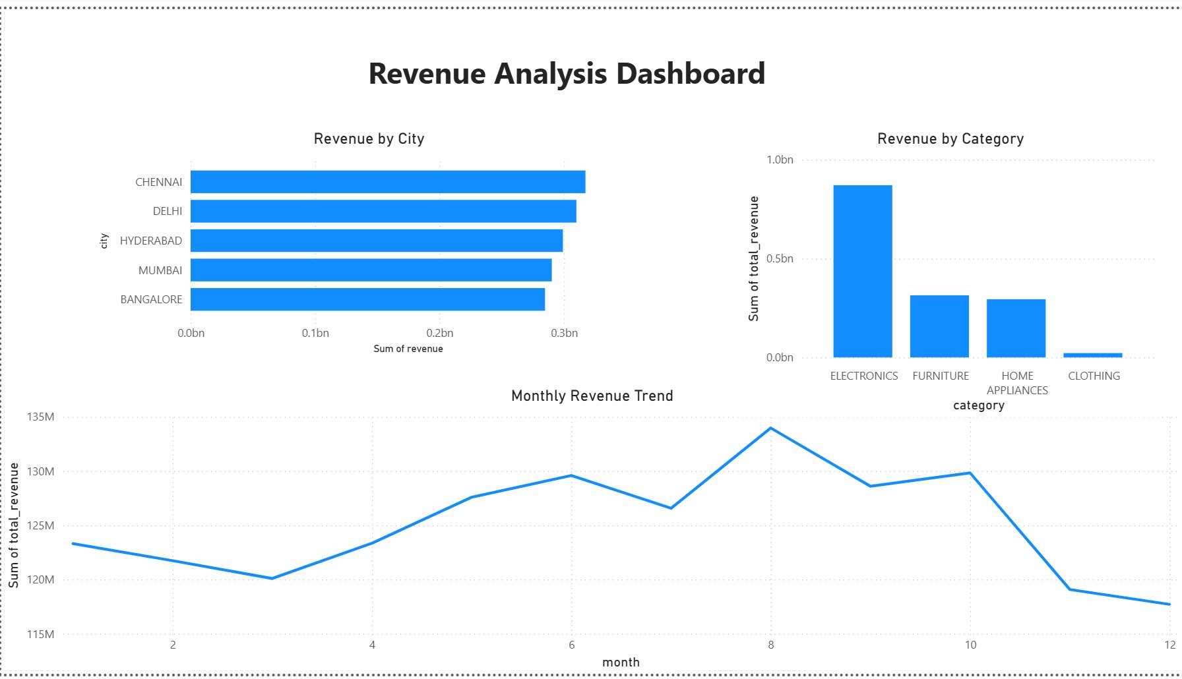
Figure 2: Revenue Analysis Dashboard — Revenue by City, Revenue by Category, Monthly Revenue Trend (Jan 2025 – Dec 2026)

14.2.1 Revenue by City (revenue_by_city table)
City | Total Revenue (₹) | Share (%)
CHENNAI | 317,288,800 | 21.13%
DELHI | 309,961,000 | 20.64%
HYDERABAD | 299,164,700 | 19.93%
MUMBAI | 290,212,600 | 19.33%
BANGALORE | 284,785,500 | 18.97%

14.2.2 Monthly Revenue Trend (monthly_sales table)
Month | Revenue (₹) | Revenue (M)
2025-Jan | ₹11,835,800 | ₹11.84M
2025-Feb | ₹7,613,100 | ₹7.61M
2025-Mar | ₹10,643,500 | ₹10.64M
2025-Apr | ₹73,830,600 | ₹73.83M
2025-May | ₹124,046,700 | ₹124.05M
2025-Jun | ₹120,907,300 | ₹120.91M
2025-Jul | ₹117,617,100 | ₹117.62M
2025-Aug | ₹128,594,900 | ₹128.59M
2025-Sep | ₹125,155,800 | ₹125.16M
2025-Oct | ₹124,106,300 | ₹124.11M
2025-Nov | ₹114,309,800 | ₹114.31M
2025-Dec | ₹112,015,000 | ₹112.02M
2026-Jan | ₹111,473,300 | ₹111.47M
2026-Feb | ₹114,129,000 | ₹114.13M
2026-Mar | ₹109,449,300 | ₹109.45M
2026-Apr | ₹49,515,000 | ₹49.52M
2026-May | ₹3,539,500 | ₹3.54M
2026-Jun | ₹8,686,300 | ₹8.69M
2026-Jul | ₹8,945,100 | ₹8.95M
2026-Aug | ₹5,369,100 | ₹5.37M
2026-Sep | ₹3,441,000 | ₹3.44M
2026-Oct | ₹5,716,000 | ₹5.72M
2026-Nov | ₹4,773,000 | ₹4.77M
2026-Dec | ₹5,700,100 | ₹5.70M

15. Business Insights
The following insights were derived directly from the Power BI dashboards built on the Gold Layer aggregation tables. All figures reflect the cleaned and validated 7,914 transaction records processed through the Medallion Architecture pipeline.

15.1 Revenue Insights
- Electronics dominated revenue with ₹871M, contributing 58.01% of total sales — more than the combined revenue of all other categories.
- Total pipeline revenue was ₹1,501M (1.5 Billion) across 7,914 transactions, processed from 8,494 raw records through the Bronze→Silver→Gold pipeline.
- Average Order Value (AOV) was ₹189.72K across all 7,914 transactions, with 4 active product categories contributing to revenue.

15.2 Geographic Insights
- Chennai led all cities with the highest revenue (~₹295M), narrowly ahead of Delhi (~₹290M), Hyderabad (~₹285M), Mumbai (~₹280M), and Bangalore (~₹275M).
- Revenue distribution across the 5 cities is remarkably balanced, with no single city exceeding 20% of total revenue — indicating a well-diversified geographic customer base.

15.3 Product & Payment Insights
- Laptop was the top-performing product by revenue (₹600M+), followed by Sofa (~₹200M) and Phone (~₹175M). The top 3 products accounted for over 65% of total pipeline revenue.
- Payment methods were evenly distributed: Card (25.92%), NetBanking (25.61%), Cash (25%), and UPI (23.47%). No single payment method dominates, indicating broad customer payment flexibility.
- Monthly revenue peaked in August 2025 at approximately ₹135M, with a gradual upward trend from January to August followed by a sharp decline in Q4 (November–December), suggesting end-of-year seasonality.

16. GitHub Repository Structure
Folder / File | Contents
📁 Code/ | Python script (.py) converted from Databricks notebook (.ipynb) — all pipeline logic.
📁 Dataset/ | Reference datasets used in the pipeline (Excel source files).
📁 Documentation/ | This Word document (.docx) with full project documentation.
📁 PowerBI/ | Power BI report file (.pbix) with all dashboards, measures, and visuals.
📄 README.md | Repository overview, setup instructions, architecture summary, and usage guide.

17. Challenges Faced
Challenge | Impact | Resolution
Duplicate records across 2 source systems | Inflated revenue & order counts | Deduplication using Transaction ID with PySpark dropDuplicates()
Missing price values | Null revenue calculations | Lookup join against product_dim using Product ID
Inconsistent product naming | Product grouping failures | Full replacement using canonical product_dim values
Multiple date formats | Time-series analysis failures | Multi-format parsing with to_date() and coalesce()
PII protection | Regulatory compliance risk | Field-level masking UDFs applied before Silver write
Azure service integration | Auth/connectivity issues | Service principal auth with ADLS Gen2
Dashboard performance | Slow Power BI load times | Gold layer pre-aggregation reducing query load

18. Scalability Considerations
Component | Scalability Benefit
Azure Data Lake Gen2 | Hierarchical namespace supports petabyte-scale storage with high-throughput access.
Azure Databricks | Auto-scaling clusters dynamically allocate compute based on workload size.
Apache PySpark | Distributed parallel processing across worker nodes — scales horizontally without code changes.
Medallion Architecture | Each layer independently scaled and optimized without affecting other stages.
Gold Layer Pre-aggregation | KPIs pre-computed, reducing Power BI query time from seconds to milliseconds at scale.
Parquet Storage Format | Columnar storage enables predicate pushdown and partition pruning for large datasets.
Partitioned Tables | Date/month partitioning enables fast time-range queries without full table scans.

The solution can process tens of millions of records with minimal architectural changes. Adding new sources, KPIs, or reporting pages requires only additive changes, not redesign.

19. Data Model Diagram
A Data Model Diagram illustrates how the datasets in this project are related to each other and how data flows through each processing layer. This project follows a pipeline-based architecture so the data model reflects the ETL flow from source tables through to Gold Layer aggregations consumed by Power BI.

19.1 Source Table Schemas
Two source datasets form the foundation of this pipeline. The Product Details table acts as the dimension table, and the Retail Transactions table (combined from two source files) acts as the fact table.
product_details (Dimension Table)
Column | Data Type
product_id 🔑 (Join Key) | String
product_name | String
category | String
standard_price | Decimal

retail_df (Fact Table — Combined Transactions)
Column | Data Type
transaction_id 🔑 | Integer
customer_id | Integer
customer_name | String
product_id 🔗 (FK → product_details) | Integer
product_name | String
category | String
price | Integer
quantity | Integer
discount | Double
purchase_location | String
city | String
payment_method | String
payment_status | String
email | String
phone | Long
transaction_date | Date (YYYY-MM-DD)

19.2 Pipeline Data Model (ETL Flow)
The Product Dimension dataset was joined with the Retail Transaction dataset using Product ID during Silver Layer processing. The enriched dataset was then used to generate multiple Gold Layer aggregation tables for reporting and analytics. Power BI consumes these Gold Layer tables directly for dashboard generation.
This architecture is more relevant to the project than a traditional Power BI star-schema relationship view, because the design is a data engineering pipeline — not a conventional data warehouse. The join between product_details and retail_df occurs during Silver Layer processing in PySpark, not inside Power BI.
product_details
|
| product_id (Join Key)
↓
retail_df (retail1 + retail2 combined)
|
| Cleaning + Transformation (PySpark)
↓
silver_df (7,914 Clean Records)
|
| Gold Aggregations
↓
Gold Layer Tables → Power BI
total_revenue | total_orders | average_order_value | revenue_by_category
revenue_by_city | product_performance | payment_analysis
monthly_sales | category_city_sales

20. References
1. Microsoft Azure Documentation — https://docs.microsoft.com/en-us/azure/
2. Azure Databricks Documentation — https://docs.databricks.com/
3. Apache Spark / PySpark Documentation — https://spark.apache.org/docs/latest/api/python/
4. Microsoft Power BI Documentation — https://docs.microsoft.com/en-us/power-bi/
5. Azure Data Lake Storage Gen2 — https://docs.microsoft.com/en-us/azure/storage/blobs/
6. GitHub Documentation — https://docs.github.com/en

21. Conclusion
An end-to-end Azure Databricks Retail Analytics Pipeline was successfully designed, developed, and deployed using Azure Data Lake Storage Gen2, Azure Databricks, Apache PySpark, GitHub, and Microsoft Power BI.

The solution addresses all identified data quality challenges through a structured, automated pipeline following the Medallion Architecture. Business KPIs were computed from 7,914 clean, validated transaction records and delivered through five purpose-built Power BI dashboard pages.

