A

PRACTICAL TRAINING REPORT

ON

SPAM DETECTION

SUBMITTED IN PARTIAL FULFILLMENT OF THE REQUIREMENT FOR

COMPLETION OF DEGREE

BACHELOR OF ENGINEERING
IN
COMPUTER SCIENCE ENGINEERING

BY:

NAME | ENROLL | SEM
Afshan Mairaj | 6563 | 6th
Mansha Muzaffer | 6546 | 6th
Jazil Javeed | 6606 | 6th
Huzaif Zargar |  | 4th

SUBMITTED TO:

SSM COLLEGE OF ENGINEERING
PARIHASPORA,PATTAN,KASHMIR,193121

CONTENTS

S.N. Title

- Introduction
About The Project
- Organization Overview
- System Analysis
3.1. Feasibility Study
3.2. Technical Feasibility
3.3. Economic Feasibility
3.4. Behavioral Feasibility
- Introduction
4.1. Module Design
5. Software Environment
5.1. Software and Hardware Requirement
5.2. Hardware Specifications
5.3. Software Specifications
5.4. Project Architecture and Platform
5.5. Coding Standards
5.6. Naming Convention
5.7. Labels and comments
5.8. Sample codes
6. Testing Introduction
7.Implementation
7.1. Implementation Procedures
7.2. User Training
8. Screen Shots
9. Conclusion
10. Bibliography

INTRODUCTION ABOUT THE PROJECT

Text mining (deriving information from text) is a wide field which has gained popularity with the huge text data being generated. Automation of a number of applications like sentiment analysis, document classification, topic classification, text summarization, machine translation, etc has been done using machine learning models.
Spam filtering is a beginner’s example of document classification task which involves classifying a message as spam or non-spam
( ham) mail. Spam box in your Gmail account is the best example of this.

Before starting we must preprocess the messages. First of all, we shall make all the character lowercase. This is because ‘free’ and ‘FREE’ mean the same and we do not want to treat them as two different words.

Then we tokenize each message in the dataset. Tokenization is the task of splitting up a message into pieces and throwing away the punctuation characters. The words like ‘go’, ‘goes’, ‘going’ indicate the same activity. We can replace all these words by a single word ‘go’.
We then move on to remove the stop words. Stop words are those words which occur extremely frequently in any text. For example words like ‘the’, ‘a’, ‘an’, ‘is’, ‘to’ etc. These words do not give us any information about the content of the text. Thus it should not matter if we remove these words for the text.
You can also use n-grams to improve the accuracy. As of now, we only dealt with 1 word. But when two words are together the meaning totally changes.

2.Modules:

- HOME:
Through this HR can takes the user to the starting point of the site.

- LOGIN:

In this module HR enter the User id and password is checked andonly valid user id and password will get entry into search zone. This is a security feature to avoid entry of unauthorized users.

- RESET:
Through this HR can reset all the fields.

- PREDICT:

In this module HR can predict whether the email given is spam or ham.

2. ORGANIZATION OVERVIEW:

Getting a job is as difficult as beating the crowd because being in the corporate world demands a lot from the applicant because of which the applicants are putting their best, which results in the increment of difficulty level. You can see each and every thing is connected but the solution of this problem is either spending years to reach to a desired position or come to Ducat. At Ducat we provide the entire necessary computer training which helps the newbie’s and also the experienced workers so that they can achieve better recognition in this competitive world.
Like other educational and training industry at Ducat you will be offered varieties programs but the instructors makes the difference and make Ducat stand out from others. We have a variety of skilled and trained trainers whose approach is different which you can see anywhere. Ducat contributes a lot to the knowledge of its trainees and we try our level hard to contribute the best to increase our trainee’s ability so that they stand out from others and whatever they contribute to the corporate world automatically becomes productive. Not only the fresher but also the corporates who are not able to deal with the rising technology and software are also helped here. We try our level best to deliver our services to every corner of the world by the help of customized education. Our motto is to deliver the best services to you and that is why we have taken the customized approach because we do not want you to compromise with your education.
It is not necessary that you have to leave your job in order to make-up with us. You can contact our experts and can get the best result. To serve you we are always at your service, you can contact us as and when you get time and clear your queries.

Ducat provides the best available programs which helps in enhancing the technical skills which seems to be beneficial for all the applicants.
- Software Development: We provide the best and latest IT software training which helps all the fresher and the cooperates to understand well and give them the knowledge to go hand in hand with the latest technologies. This does not only helps the companies but also increases the self-level to deal with all the necessary software.
- Instructor led campus: Ducat helps all the new instructors to get the best exposure to show their talent in right way.
- Workshops and Placement Service: At Ducat, workshops are held to increase the understanding level because theoretical values are always not enough and workshops helps in getting the practical knowledge which results in better understanding. As everything leads to the placement because if the institute does not provide placement services then it is ultimately bad for the applicants but we provide the best placements services and for that we give our best to give you the best.

.

3. FEASIBILITY STUDY:

Feasibility study is made to see if the project on completion will serve the purpose of the organization for the amount of work, effort and the time that spend on it. Feasibility study lets the developer foresee the future of the project and the usefulness. A feasibility study of a system proposal is according to its workability, which is the impact on the organization, ability to meet their user needs and effective use of resources. Thus when a new application is proposed it normally goes through a feasibility study before it is approved for development.

The document provide the feasibility of the project that is being designed and lists various areas that were considered very carefully during the feasibility study of this project such as Technical, Economic and Operational feasibilities. The following are its features:

3.1 TECHNICAL FEASIBILITY
The system must be evaluated from the technical point of view first. The assessment of this feasibility must be based on an outline design of the system requirement in the terms of input, output, programs and procedures. Having identified an outline system, the investigation must go on to suggest the type of equipment, required method developing the system, of running the system once it has been designed.

Technical issues raised during the investigation are:

- Does the existing technology sufficient for the suggested one?
- Can the system expand if developed?
The project should be developed such that the necessary functions and performance are achieved within the constraints. The project is developed within latest technology. Through the technology may become obsolete after some period of time, due to the fact that never version of same software supports older versions, the system may still be used. So there are minimal constraints involved with this project. The system has been developed using Java the project is technically feasible for development.

3.2 ECONOMIC FEASIBILITY
The developing system must be justified by cost and benefit. Criteria to ensure that effort is concentrated on project, which will give best, return at the earliest. One of the factors, which affect the development of a new system, is the cost it would require.

The following are some of the important financial questions asked during preliminary investigation:

- The costs conduct a full system investigation.
- The cost of the hardware and software.
- The benefits in the form of reduced costs or fewer costly errors.

Since the system is developed as part of project work, there is no manual cost to spend for the proposed system. Also all the resources are already available, it give an indication of the system is economically possible for development.

3.3 BEHAVIORAL FEASIBILITY
This includes the following questions:

- Is there sufficient support for the users?
- Will the proposed system cause harm?

The project would be beneficial because it satisfies the objectives when developed and installed. All behavioral aspects are considered carefully and conclude that the project is behaviorally feasible.

4. Data Flow Diagram:

The Data flow Diagram shows the flow of data. It is generally made of symbols given below:

(1) A square shows the Entity: -

(2) A Circle shows the Process: -

(3) An open Ended Rectangle shows the data store: --

(4) An arrow shows the data flow:-

The DFD can be up to several levels.

The 0 level DFD states the flow of data in the system as seen from the outward in each module.

The first level DFD show more detail, about the single process of the 0 level DFD

The second level DFD can show even more details and so on.

Context Level DFD

ARRIVING MESSAGE

FILTER

SPAM

SPAM

INBOX
USER

- SOFTWARE ENVIRONMENT:

Python:

Python is an interpreted, high-level, general-purpose programming language. Created by Guido van Rossum and first released in 1991, Python's design philosophy emphasizes code readability with its notable use of significant whitespace. Its language constructs and object-oriented approach aim to help programmers write clear, logical code for small and large-scale projects.^{[27]}
Python is dynamically typed and garbage-collected. It supports multiple programming paradigms, including procedural, object-oriented, and functional programming. Python is often described as a "batteries included" language due to its comprehensive standard library.^{[28]}
Python was conceived in the late 1980s as a successor to the ABC language. Python 2.0, released in 2000, introduced features like list comprehensions and a garbage collection system capable of collecting reference cycles. Python 3.0, released in 2008, was a major revision of the language that is not completely backward-compatible, and much Python 2 code does not run unmodified on Python 3.
The Python 2 language, i.e. Python 2.7.x, is "sunsetting" in less than a month on January 1, 2020 (after extension; first planned for 2015), and the Python team of volunteers will not fix security issues, or improve it in other ways after that date.^{[29][30]} With the end-of-life, only Python 3.5.x and later will be supported.
Python interpreters are available for many operating systems. A global community of programmers develops and maintains CPython, an open source^{[31]} reference implementation. A non-profit organization, the Python Software Foundation, manages and directs resources for Python and CPython development.

6. SOFTWARE AND HARDWARE SPECIFICATION:

>Hardware Specification:

>Microprocessor :
Microprocessor is a controlling unit of a micro-computer, fabricated on a small chip capable of performing ALU (Arithmetic Logical Unit) operations and communicating with the other devices connected to it.
Microprocessor consists of an ALU, register array, and a control unit. ALU performs arithmetical and logical operations on the data received from the memory or an input device. Register array consists of registers identified by letters like B, C, D, E, H, L and accumulator. The control unit controls the flow of data and instructions within the computer.

>RAM :
RAM (Random Access Memory) is the internal memory of the CPU for storing data, program, and program result. It is a read/write memory which stores data until the machine is working. As soon as the machine is switched off, data is erased.
Access time in RAM is independent of the address, that is, each storage location inside the memory is as easy to reach as other locations and takes the same amount of time. Data in the RAM can be accessed randomly but it is very expensive.
>Hard Disk :
Hard disk drive is made up of a series of circular disks called platters arranged one over the other almost ½ inches apart around a spindle. Disks are made of non-magnetic material like aluminum alloy and coated with 10-20 nm of magnetic material.
Standard diameter of these disks is 14 inches and they rotate with speeds varying from 4200 rpm (rotations per minute) for personal computers to 15000 rpm for servers. Data is stored by magnetizing or demagnetizing the magnetic coating. A magnetic reader arm is used to read data from and write data to the disks. A typical modern HDD has capacity in terabytes (TB).

>Software Specification:

Language : Python
Concept : Python and Data Science
Libraries :
- Tkinter : Tkinter is the standard GUI library for Python. Python when combined with Tkinter provides a fast and easy way to create GUI applications. Tkinter provides a powerful object-oriented interface to the Tk GUI toolkit.

- Docxpy : It is a pure python-based utility to extract text from docx files. The code is taken and adapted from python-docx. It can however also extract text from header, footer and hyperlinks.

- Pypdf : The PyPDF2 package is a pure-Python PDF library that you can use for splitting, merging, cropping and transforming pages in your PDFs. According to the PyPDF2 website, you can also use PyPDF2 to add data, viewing options and passwords to the PDFs too.

- Pyinstaller : PyInstaller bundles a Python application and all its dependencies into a single package. ... PyInstaller reads a Python script written by you. It analyzes your code to discover every other module and library your script needs in order to execute.

- Filedialog : File dialogs help you open, save files or directories. This is the type of dialog you get when you click file,open. This dialog comes out of the module, there's no need to write all the code manually. Tkinter does not have a native looking file dialog, instead it has the customer tk style.

- Os : The OS module in Python provides a way of using operating system dependent functionality. The functions that the OS module provides allows you to interface with the underlying operating system that Python is running on – be that Windows, Mac or Linux.

- Sklearn : Scikit-learn is a library in Python that provides many unsupervised and supervised learning algorithms. It's built upon some of the technology you might already be familiar with, like NumPy, pandas, and Matplotlib.

- PIL : Python Imaging Library is a free library for the Python programming language that adds support for opening, manipulating, and saving many different image file formats. It is available for Windows, Mac OS X and Linux.

- Imagetk : The ImageTk Module. The ImageTk module contains support to create and modify Tkinter BitmapImage and PhotoImage objects from PIL images. For examples, see the demo programs in the Scripts directory. ... For example, on Ubuntu, you need both python-imaging and python-imaging-tk.

- Pandas : In computer programming, pandas is a software library written for the Python programming language for data manipulation and analysis. In particular, it offers data structures and operations for manipulating numerical tables and time series.

- MultinomailNB : The multinomial Naive Bayes classifier is suitable for classification with discrete features (e.g., word counts for text classification). The multinomial distribution normally requires integer feature counts. However, in practice, fractional counts such as tf-idf may also work.

Other Tools :

- Python 3.x
- Idle : IDLE (short for Integrated DeveLopment Environment^{[1][2]} or Integrated Development and Learning Environment^{[3]}) is an integrated development environment for Python, which has been bundled with the default implementation of the language since 1.5.2b1.^{[4][5]} It is packaged as an optional part of the Python packaging with many Linux distributions. It is completely written in Python and the Tkinter GUI toolkit (wrapper functions for Tcl/Tk).
IDLE is intended to be a simple IDE and suitable for beginners, especially in an educational environment. To that end, it is cross-platform, and avoids feature clutter.

- Anaconda (Jupyter Lab) : Anaconda is a free and open-source^{[5]} distribution of the Python and R programming languages for scientific computing (data science, machine learning applications, large-scale data processing, predictive analytics, etc.), that aims to simplify package management and deployment. Package versions are managed by the package management system conda.^{[6]} The Anaconda distribution includes data-science packages suitable for Windows, Linux, and MacOS.

6.1 Project Architecture and Platform:

> Front End :

Python tkinter
Tkinter is Python's de-facto standard GUI (Graphical User Interface) package. It is a thin object-oriented layer on top of TcI/Tk.
Tkinter is not the only GuiProgramming toolkit for Python. It is however the most commonly used one.

>Back End :

Python and Data Science

Python:
Python is an interpreted, high-level, general-purpose programming language. Created by Guido van Rossum and first released in 1991, Python's design philosophy emphasizes code readability with its notable use of significant whitespace. Its language constructs and object-oriented approach aim to help programmers write clear, logical code for small and large-scale projects.^{[27]}

Data Science:
Data science is a multi-disciplinary field that uses scientific methods, processes, algorithms and systems to extract knowledge and insights from structured and unstructured data.^{[1][2]} Data science is related to data mining and big data.
Data science is a "concept to unify statistics, data analysis, machine learning and their related methods" in order to "understand and analyze actual phenomena" with data.^{[3]} It employs techniques and theories drawn from many fields within the context of mathematics, statistics, computer science, and information science. Turing award winner Jim Gray imagined data science as a "fourth paradigm" of science (empirical, theoretical, computational and now data-driven) and asserted that "everything about science is changing because of the impact of information technology" and the data deluge.^{[4][5]} In 2015, the American Statistical Association identified database management, statistics and machine learning, and distributed and parallel systems as the three emerging foundational professional communities.^{[6]}

7. TESTING INTRODUCTION:

Software Testing is the process of executing software in a controlled manner, in order to answer the question - Does the software behave as specified?. Software testing is often used in association with the terms verification and validation. Validation is the checking or testing of items, includes software, for conformance and consistency with an associated specification. Software testing is just one kind of verification, which also uses techniques such as reviews, analysis, inspections, and walkthroughs. Validation is the process of checking that what has been specified is what the user actually wanted.

Validation : Are we doing the right job?
Verification : Are we doing the job right?

Software testing should not be confused with debugging. Debugging is the process of analyzing and localizing bugs when software does not behave as expected. Although the identification of some bugs will be obvious from playing with the software, a methodical approach to software testing is a much more thorough means for identifying bugs. Debugging is therefore an activity which supports testing, but cannot replace testing.
Other activities which are often associated with software testing are static analysis and dynamic analysis. Static analysis investigates the source code of software, looking for problems and gathering metrics without actually executing the code. Dynamic analysis
looks at the behavior of software while it is executing, to provide information such as execution traces, timing profiles, and test coverage information.
Testing is a set of activity that can be planned in advanced and conducted systematically. Testing begins at the module level and work towards the integration of entire computers based system. Nothing is complete without testing, as it vital success of the system testing objectives, there are several rules that can serve as testing objectives.
They are

- Testing is a process of executing a program with the intend of findingan error.
- A good test case is one that has high possibility of finding an undiscovered error.
- A successful test is one that uncovers an undiscovered error.

If a testing is conducted successfully according to the objectives as stated above, it would uncovered errors in the software also testing demonstrate that the software function appear to be working according to the specification, that performance requirement appear to have been met.

There are three ways to test program.
- For correctness
- For implementation efficiency
- For computational complexity

Test for correctness are supposed to verify that a program does exactly what it was designed to do. This is much more difficult than it may at first appear, especially for large programs.

7.1 TEST PLAN
A test plan implies a series of desired course of action to be followed in accomplishing various testing methods. The Test Plan acts as a blue print for the action that is to be followed. The software engineers create a computer program, its documentation and related data structures. The software developers is always responsible for testing the individual units of the programs, ensuring that each performs the function for which it was designed. There is an independent test group (ITG) which is to remove the inherent problems associated with letting the builder to test the thing that has been built. The specific objectives of testing should be stated in measurable terms. So that the mean time to failure, the cost to find and fix the defects, remaining defect density or frequency of occurrence and test work-hours per regression test all should be stated within the test plan.
The levels of testing include:
- Unit testing
- Integration Testing
- Data validation Testing
- Output Testing

7.1.1 UNIT TESTING

Unit testing focuses verification effort on the smallest unit of software design – the software component or module. Using the component level design description as a guide, important control paths are tested to uncover errors within the boundary of the module. The relative complexity of tests and uncovered scope established for unit testing. The unit testing is white-box oriented, and step can be conducted in parallel for multiple components. The modular interface is tested to ensure that information properly flows into and out of the program unit under test. The local data structure is examined to ensure that data stored temporarily maintains its integrity during all steps in an algorithm’s execution. Boundary conditions are tested to ensure that all statements in a module have been executed at least once. Finally, all error handling paths are tested.

Tests of data flow across a module interface are required before any other test is initiated. If data do not enter and exit properly, all other tests are moot. Selective testing of execution paths is an essential task during the unit test. Good design dictates that error conditions be anticipated and error handling paths set up to reroute or cleanly terminate processing when an error does occur. Boundary testing is the last task of unit testing step. Software often fails at its boundaries.

Unit testing was done in Sell-Soft System by treating each module as separate entity and testing each one of them with a wide spectrum of test inputs. Some flaws in the internal logic of the modules were found and were rectified.

7.1.2 INTEGRATION TESTING

Integration testing is systematic technique for constructing the program structure while at the same time conducting tests to uncover errors associated with interfacing. The objective is to take unit tested components and build a program structure that has been dictated by design. The entire program is tested as whole. Correction is difficult because isolation of causes is complicated by vast expanse of entire program. Once these errors are corrected, new ones appear and the process continues in a seemingly endless loop.

After unit testing in Sell-Soft System all the modules were integrated to test for any inconsistencies in the interfaces. Moreover differences in program structures were removed and a unique program structure was evolved.

7.1.3 VALIDATION TESTING OR SYSTEM TESTING

This is the final step in testing. In this the entire system was tested as a whole with all forms, code, modules and class modules. This form of testing is popularly known as Black Box testing or System tests.
Black Box testing method focuses on the functional requirements of the software. That is, Black Box testing enables the software engineer to derive sets of input conditions that will fully exercise all functional requirements for a program.
Black Box testing attempts to find errors in the following categories; incorrect or missing functions, interface errors, errors in data structures or external data access, performance errors and initialization errors and termination errors.

7.1.4 OUTPUT TESTING OR USER ACCEPTANCE TESTING

The system considered is tested for user acceptance; here it should satisfy the firm’s need. The software should keep in touch with perspective system; user at the time of developing and making changes whenever required. This done with respect to the following points

- Input Screen Designs,
- Output Screen Designs,
- Online message to guide the user and the like.

The above testing is done taking various kinds of test data. Preparation of test data plays a vital role in the system testing. After preparing the test data, the system under study is tested using that test data. While testing the system by which test data errors are again uncovered and corrected by using above testing steps and corrections are also noted for future use.

Validation Checking:
At the culmination of integration testing, software is completely assembled as a package; interfacing errors have been uncovered and corrected, and a final series of software test-validation checks may begin. Validation can be defined in many ways, but a simple definition (Albeit Harsh) is that validation succeeds when software functions in a manner that can be reasonably expected by a customer. Software validation is achieved through a series of black-box tests to be conducted and a test procedure defines specific test cases that will be used in attempt to uncover errors in conformity with requirements. Both the plan and procedure are designed to ensure that all functional requirements are satisfied; all performance requirements are achieved; documentation is correct and human –Engineered and other requirements are met. Once the application was made free of all logical and interface errors , inputting dummy data to ensure that the software developed satisfied all the requirements of the user did validation checks .However , the data are created with the intent of determining whether the system will process them correctly .
In the proposed system, if the clients click the send button after selecting a file from his file list, then the system will show the confirmation message for sending files. Similarly if a client makes an attempt to download a file from the server file list, then also the system will show the confirmation message for downloading. This is how the data validations were made in the proposed system.

8. IMPLEMENTATION:
Implementation is the stage of the project where the theoretical design is turned into a working system. It can be considered to be the most crucial stage in achieving a successful new system gaining the users confidence that the new system will work and will be effective and accurate. It is primarily concerned with user training and documentation. Conversion usually takes place about the same time the user is being trained or later. Implementation simply means convening a new system design into operation, which is the process of converting a new revised system design into an operational one.
Implementation is the stage of the project where the theoretical design is tuned into a working system. At this stage the main work load, the greatest upheaval and the major impact on the existing system shifts to the user department. If the implementation is not carefully planned and controlled it can create chaos and confusion.
Implementation includes all those activities that take place to convert from the existing system to the new system. The new system may be a totally new, replacing an existing manual or automated system or it may be a modification to an existing system. Proper implementation is essential to provide a reliable system to meet organization requirements. The process of putting the developed system in actual use is called system implementation. This includes all those activities that take place to convert from the old system to the new system. The system can be implemented only after through testing is done and if it is found to be working according to the specifications. The system personnel check the feasibility of the system. The more complex the system being implemented, the more involved will be the system analysis and design effort required to implement the three main aspects: education and training, system testing and changeover. The implementation state involves the following tasks:
- Careful planning.
- Investigation of system and constraints.
- Design of methods to achieve the changeover.
- Training of the staff in the changeover phase.

8.1 Implementation Procedures
Implementation of software refers to the final installation of the package in its real environment, to the satisfaction of the intended uses and the operation of the system. In many organizations someone who will not be operating it, will commission the software development project. In the initial stage people doubt about the software but we have to ensure that the resistance does not build up, as one has to make sure that
- The active user must be aware of the benefits of using the new system.
- Their confidence in the software is built up.
- Proper guidance is imparted to the user so that he is comfortable in using the application.
Before going ahead and viewing the system, the user must know that for viewing the result, the server program should be running in the server. If the server object is not up running on the server, the actual process won’t take place.
8.2. User Training
User training is designed to prepare the user for testing and converting the system. To achieve the objective and benefits expected from computer based system, it is essential for the people who will be involved to be confident of their role in the new system. As system becomes more complex, the need for training is more important. By user training the user comes to know how to enter data, respond to error messages, interrogate the database and call up routine that will produce reports and perform other necessary functions.

9. SCREEN SHOTS
Home Page

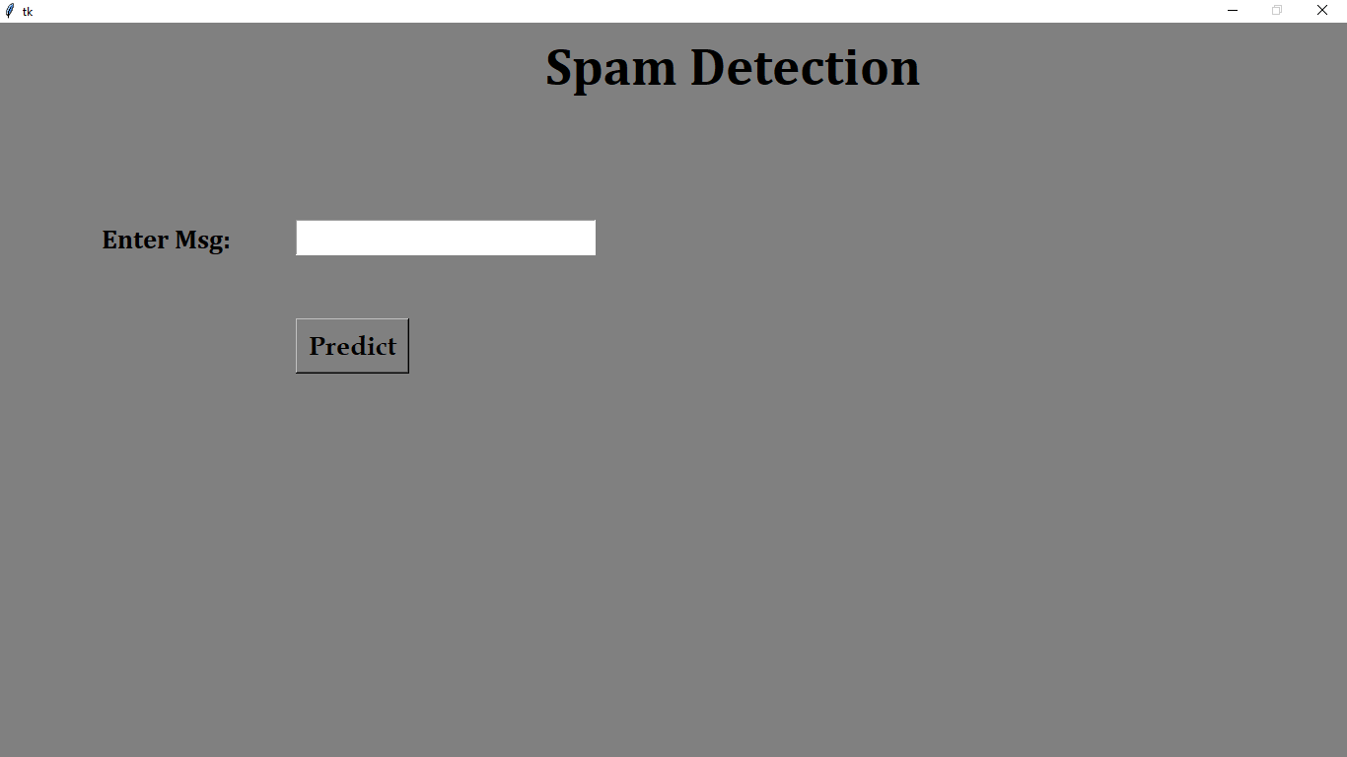

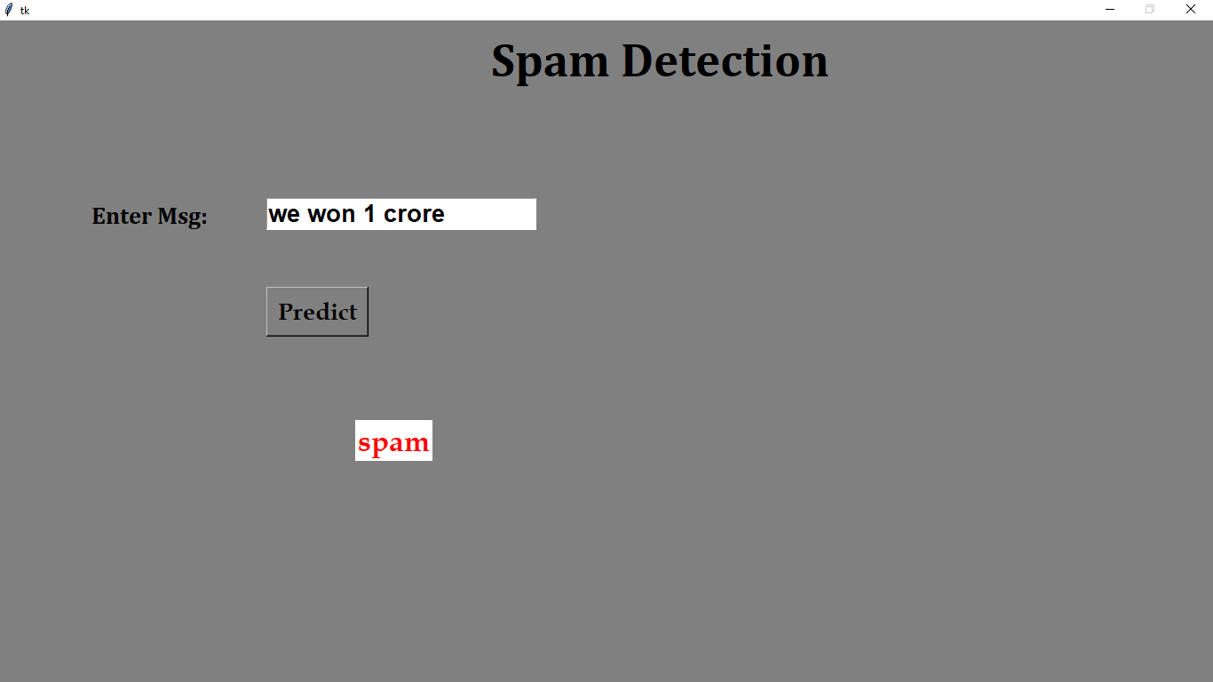

10. CONCLUSION :
- With the help of PDF word count, we can find the number of words in a PDF file.
- It gives us the frequency of words in a pdf file.

11. BIBILOGRAPHY :

- Head First Python: A Brain-Friendly Guide, by Paul Barry
- DUCAT – Under the guidance of Mr. Aditya.

