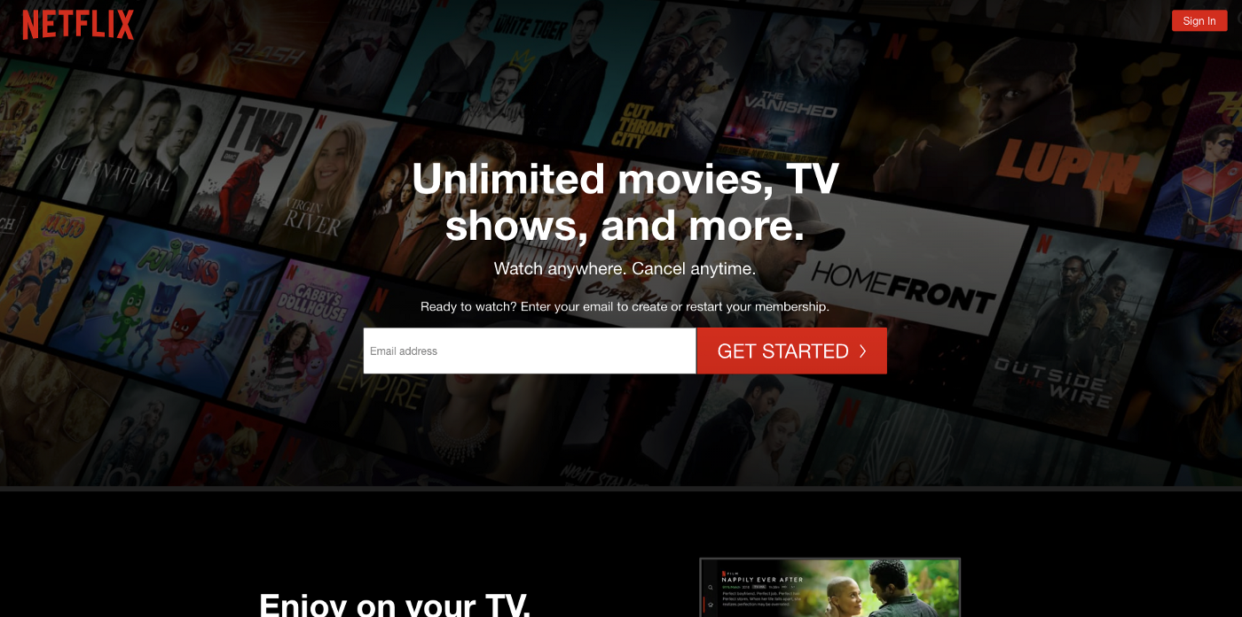

**PROJECT NAME**: **NETFLIX**

### Ankit Singh

*Edureka Presents*

**Overview:**

Netflix is an OTT Platform in which many Entertainment content is available from all over the world and it is the best OTT platform in the world.

**Goals:**

1. Login page

2. Subscription page

3. Payment page

4. Streaming page

5. Login and logout page

**History:**

**Netflix was founded in 1997 by Reed Hastings and Marc Randolph** in Scotts Valley, California. Netflix initially both sold and rented DVDs by mail, but the sales were eliminated within a year to focus on the DVD rental business. In 2007, Netflix introduced streaming media and video on demand.

**Technology Used in Netflix:**

**Front-End:**

1.HTML

2.CSS

3.JAVA

4.BOOTSTRAP

**Dynamic:**

1. Javascript

2. Ci/cd with AWS

**Database:**

1. Mongodb

2. Json Data

**Code compilers:**

1. Visual studio code

2. Git bash

3. Git hub

4. Node js.