Business Problem

Effective inventory and sales management are critical for optimizing profitability in the retail and wholesale industry. Companies need to ensure that they are not incurring losses due to inefficient pricing, poor inventory turnover, or vendor dependency.

Exploratory Data Analysis Insights

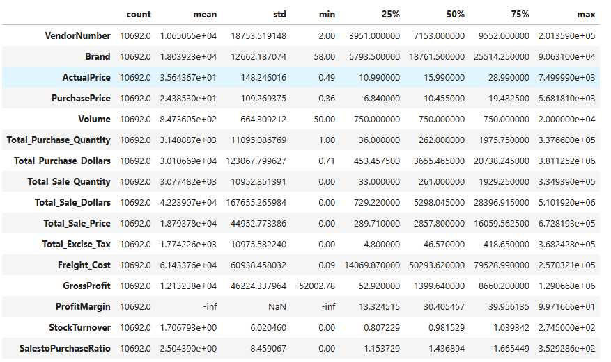

summary statistics insights

1.GrossProfit has Min value -52002.78 it may be due to some Product are selling low price then actual price

2.ProfitMargin has Min value -inf it may be due revenue is zero

3.Total_Sale_Dollars is showing zero it may be due to some Product are not sold

Data Filtering

To enhance the reliability of the insights, we removed inconsistent data points where:

● Gross Profit ≤ 0 (to exclude transactions leading to losses).

● Profit Margin ≤ 0 (to ensure analysis focuses on profitable transactions).

● Total Sales Quantity = 0 (to eliminate inventory that was never sold).

Correlation Insights

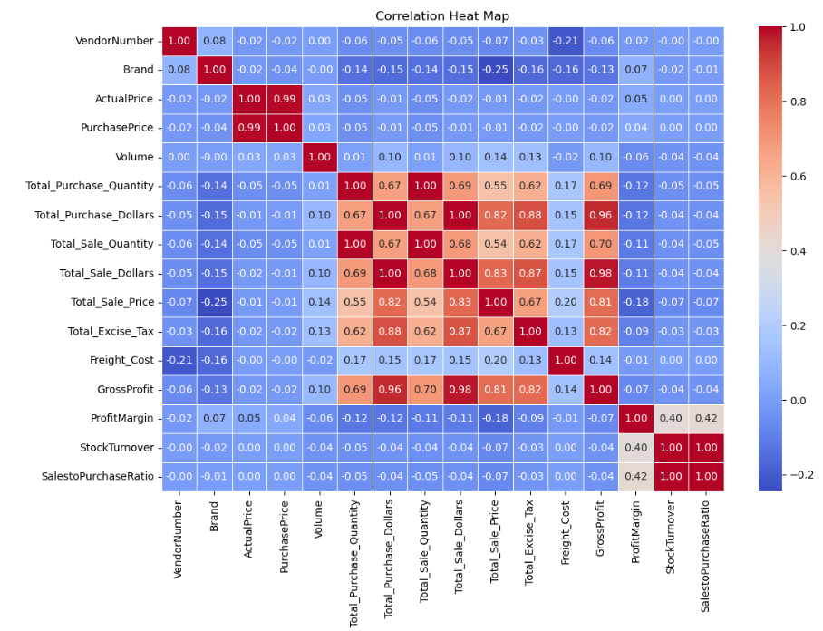

1. purchase price has week relation with gross Profit (-0.02) and profit margin it means price variation will not impact sale revenue

2. There is height correlation between Total_Purchase_Quantity and Total_Sale_Quantity is 1

confirming efficient inventory turnover.

3. There is hight correlation between Total_Sale_Dollars and GrossProfit is 0.98

4. Stock_Turn_over has Negative correlation with GrossProfit(-0.04) and ProfitMargin (0.04) indicating that faster stock turnover does not necessarily equate to higher profitability

Research Questions & Key Findings

**Identifying Vendors with Low Inventory Turnover**

Slow-moving inventory increases storage costs, reduces cash flow efficiency, and affects overall profitability.

Identifying vendors with low inventory turnover enables better stock management, minimizing financial strain.

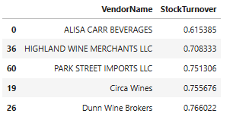

Impact of Bulk Purchasing on Cost Savings

Bulk pricing strategies encourage larger orders, increasing total sales while maintaining profitability.

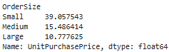

How much capital is locked in unsold inventory per vendor, and which vendors contribute the most to it?

* Poor inventory turnover means capital is tied up in unsold goods, increasing holding costs and risk of obsolescence.
* Just-in-time (JIT) inventory systems, demand forecasting, and regular stock audits help improve turnover rates.

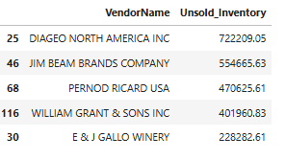

**Final Recommendations**

● Re-evaluate pricing for low-sales, high-margin brands to boost sales volume without sacrificing profitability.

● Diversify vendor partnerships to reduce dependency on a few suppliers and mitigate supply chain risks.

● Leverage bulk purchasing advantages to maintain competitive pricing while optimizing inventory management. .

● Enhance marketing and distribution strategies for low-performing vendors to drive higher sales volumes without compromising profit margins.

● By implementing these recommendations, the company can achieve sustainable profitability, mitigate risks, and enhance overall operational efficiency.