MAKE DOCUMENTATION

WHY USE MAKE?
1)Makefiles are a simple way to organize code compilation.

2)Compiling all the source codes become very lengthy everytime, hence we can use Makefiles which are the special format files that help build and manage projects easily.

3)And The main purpose of make utility is to determine automatically which pieces of a large program need to be recompiled, and issue the commands to recompile them.

4)And also As programming projects grow in size, compiling the programs
often becomes very complicated. An example...

$ gcc -I./poker-eval/include -O3 -mcpu=pentiumpro -march=pentiumpro
-fomit-frame-pointer -ffast-math -static ByteArray.c queue.c
access.c message.c bot.c util.c read solution.c hand strength.c
util game def.c hash.c translate solution.c make bucket game.c
new poker.c sequence form.c tableau.c avl tree.c
sequence form solution.c -L../game theory/poker-eval/lib -lpoker
-lm -o psoptiNolan

Makefiles save your time in typing complicated commands and allow other people to compile your code with no knowledge of how your code works.

5)And if we switch the computers then we will have to retype thee entire code which leads to extreme ineffeciency, hence we use makefile.

To prepare to use make, you must write a file called the makefile that
describes the relationships among files in your program, and the states
the commands for updating each file. In a program, typically the executable file is updated from object files, which are in turn made by compiling source files.

Normally makefiles can have these names - makefile or Makefile or GNUmakfile. (Normally Makefile because it appears near the beginning of a directory listing, right near other important files such as README.) The GNUmakefile, is not recommended for most makefiles. You should use this name if you have a makefile that is specific to GNU make, and will not be understood by other versions of make.

Makefiles are text files used by a program called
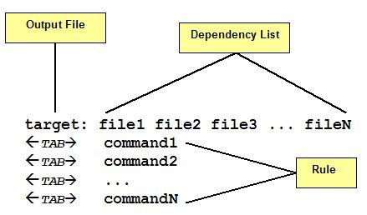
’make’ that help automate tasks

The main 3 parts of the makefile are : Targets, Dependencies and Rules.

1)Target:A target most of time is a file to be created/updated. Target depends upon a set of source files or even others targets described in Dependency List

2)Rules are the necessary commands to create the target file by using Dependency List.

3) As you see in figure 1 each command in the Rules part must be on lines that start with a TAB character. Space issue errors. Also, a space at end of the rule line may cause make issues an error message.

How does make work?
1)On the terminal we type the command make.

2)make suffices to perform all necessary recompilations. The make program uses the makefile data base and the last-modification times of the files to decide which of the files need to be updated. For each of those files, it issues the commands recorded in the data base.

That also means
1) The makefile is read by make command which determines target files to be built by comparing the dates and times (timestamp) of source files in Dependency List.

2) If any dependency has a changed timestamp since the last build make command will execute the rule associated with the target.

SAMPLE CODE:
all : output
output : fact.o fact2.o
gcc fact.o fact2.o -o output

fact.o : fact.c
gcc -c fact.c
fact2.o : fact2.c
gcc -c fact2.c

RUN: make

The flags::

1) -f --> If we want to give any other name to the file (except Makefile,makefile and GNUmakefile) for make
then we use the -f flag
make -f filename
2)-d --> Print debugging information which says::
a.) which files are being considered for remaking,
b.)which file-times are being compared and with what results,
c.)which files actually need to be remade,which implicit rules are considered and which are applied.
3)-p --> Print the data base (rules and variable values) that results from reading the makefiles.

