Data Acquisition, Cleaning, and Preprocessing
A Case Study on the Titanic Passenger Dataset
Data Science Internship — Week 1 Task
Prepared by: Ankit
September 2026

Table of Contents

1. Introduction and Objective
This report documents the complete process of acquiring, exploring, cleaning, and preprocessing a real-world public dataset using Python. The objective of the task is not simply to produce a clean CSV file, but to demonstrate a defensible, well-reasoned workflow: understanding what is wrong with a dataset before fixing it, choosing treatments that suit the nature of each problem, and being explicit about the trade-offs that every cleaning decision carries.
The dataset used throughout is the raw Titanic passenger manifest — 891 passengers and 11 original fields, sourced from Kaggle's “Titanic: Machine Learning from Disaster” competition. It was deliberately chosen over a pre-cleaned version of the same data because it still contains its original missing values, its original inconsistent free-text fields, and several genuine anomalies (for example, a group of passengers with a recorded fare of zero). That makes it a realistic, rather than an artificial, exercise in data cleaning.
Sections 2–4 cover acquisition and exploration. Sections 5–8 cover the cleaning and preprocessing pipeline itself, each with the Python code used, the reasoning behind the chosen approach, and the measurable effect of the step. Sections 9–10 step back and reflect on the challenges encountered and the downstream implications of the choices made.

2. Dataset Selection and Data Acquisition

2.1 Source and Reliability
The dataset is the raw training file from Kaggle's Titanic competition (kaggle.com/c/titanic), which is itself compiled from public historical passenger records for the RMS Titanic (cross-referenced against sources such as Encyclopedia Titanica). It is one of the most widely used and independently verified public datasets in introductory data science, which makes it easy to sanity-check any cleaning decision against external references. For this task a mirrored copy of the untouched raw file was retrieved from the seaborn-data GitHub repository (path: raw/titanic.csv), which republishes the original Kaggle training file unmodified for teaching purposes.

2.2 Acquisition Method
The file was downloaded programmatically and loaded directly with pandas — no manual editing was performed at any point, so every transformation applied to the data is captured in code and is fully reproducible.
import pandas as pd

df = pd.read_csv('data/titanic_raw.csv')
print(df.shape) # (891, 11)
print(df.head(3))
The raw file has 891 rows and 11 columns: survived, pclass, name, sex, age, sibsp, parch, ticket, fare, cabin, and embarked. Each row is one passenger; there is no separate metadata file, so column meaning was confirmed against the official Kaggle data dictionary.

3. Initial Data Exploration

3.1 Structure and Data Types
Before touching the data, the shape, data types, and cardinality of every column were checked to understand what kind of cleaning each one would need.
print(df.dtypes)
for c in ['sex', 'embarked', 'pclass']:
print(c, '->', df[c].unique())
sex -> ['male' 'female']
embarked -> ['S' 'C' 'Q' nan]
pclass -> [3 1 2]

Numeric columns (age, fare, sibsp, parch) are correctly typed; sex, embarked, name, ticket, and cabin are text. pclass is numeric but is really an ordinal category (1st/2nd/3rd class).

3.2 Missing Value Audit
A column-by-column missing-value count was the first real diagnostic run on the data:
missing = df.isnull().sum()
missing_pct = (df.isnull().mean() * 100).round(2)
Column | Missing count | Missing %
cabin | 687 | 77.10%
age | 177 | 19.87%
embarked | 2 | 0.22%
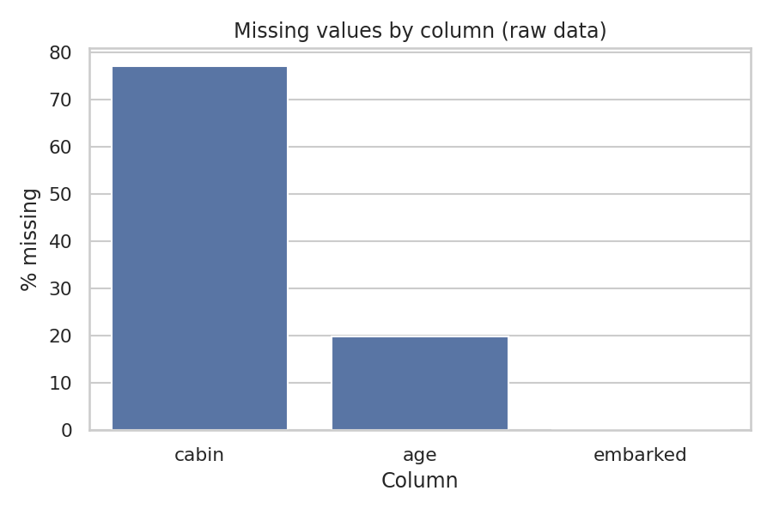
Figure 1. Missing values by column in the raw dataset.
Three columns need attention, and each needs a different treatment: cabin is missing for more than three-quarters of passengers, age for roughly a fifth, and embarked for only two rows. Treating all three the same way (e.g. “drop every row with any missing value”) would discard 77% of the dataset's information just because of the cabin column — clearly the wrong default, and the first sign that missingness has to be handled column-by-column rather than with one blanket rule.

3.3 Descriptive Statistics and Duplicates
df[['age','fare','sibsp','parch']].describe()
df.duplicated().sum() # 0
Stat | age | fare | sibsp | parch
count | 714 | 891 | 891 | 891
mean | 29.70 | 32.20 | 0.52 | 0.38
std | 14.53 | 49.69 | 1.10 | 0.81
min | 0.42 | 0.00 | 0 | 0
25% | 20.13 | 7.91 | 0 | 0
50% | 28.00 | 14.45 | 0 | 0
75% | 38.00 | 31.00 | 1 | 0
max | 80.00 | 512.33 | 8 | 6
There are zero exact duplicate rows. fare is heavily right-skewed (mean 32.20 far above the median of 14.45, with a maximum of 512.33 — more than 15 times the mean), which flags it as a column that will need outlier and skew treatment later. age has a plausible range (0.42 to 80 years) with no impossible values such as negative ages or ages above 120.

4. Identifying Data Quality Issues

4.1 Missing Values (summary)
Covered in detail in Section 3.2 above: cabin (77.10%), age (19.87%), and embarked (0.22%) are the three columns with missing data. No other column has a single missing value.

4.2 Erroneous and Anomalous Entries
Beyond missing values, the exploration surfaced a group of records that look like errors at first glance but turn out to be a real, meaningful category rather than corrupted data:
zero_fare = df[df['fare'] == 0]
print(len(zero_fare)) # 15
print(zero_fare[['pclass','sex','ticket','fare']])
pclass sex ticket fare
179 3 male LINE 0.0
263 1 male 112059 0.0
271 3 male LINE 0.0
277 2 male 239853 0.0
... ... ... ... ...

Fifteen passengers (1.7% of the dataset) paid a fare of exactly zero. Several of them share the ticket value “LINE” instead of a normal ticket number — this is a documented quirk of the Titanic manifest corresponding to employees of the American Line who were being repositioned and travelled without a paid fare. This is not a data-entry error to be corrected; it is a genuine, informative subcategory of passenger. It is flagged explicitly in Section 7.4 rather than being silently imputed away.

4.3 Duplicate Records vs. Shared Ticket Numbers
A naive duplicate check on ticket numbers would be misleading: 134 distinct ticket numbers are shared by more than one passenger, covering 344 passengers in total (over a third of the dataset). These are not duplicated records — a full-row duplicate check confirms zero exact duplicates — they are families or groups who purchased a single ticket together. Recognising this distinction matters, because dropping “duplicate tickets” would have deleted a third of the real passengers.
- Full-row duplicates: 0 — no rows to remove on this basis.
- Shared ticket numbers: 134 tickets / 344 passengers — kept, and used in Section 5 to engineer a family_size feature instead.

5. Feature Engineering to Support Cleaning
Two of the raw text fields — name and cabin — are almost useless to a model as-is (891 and 147 distinct values respectively), but they contain structured information that is very useful once extracted. This extraction was done before the missing-value treatment in Section 6, because the new features (title_group, deck, has_cabin) are what make an evidence-based imputation strategy possible in the first place.

5.1 Title Extracted from Name
df['title'] = df['name'].str.extract(r',\s*([^\.]*)\.')
title_map = {'Mr':'Mr','Miss':'Miss','Mrs':'Mrs','Master':'Master',
'Mlle':'Miss','Ms':'Miss','Mme':'Mrs'}
df['title_group'] = df['title'].map(title_map).fillna('Rare')
The name field follows a consistent “Lastname, Title. Firstname” pattern, so a regular expression reliably recovers the honorific for every passenger. Seventeen distinct raw titles were found (Mr, Miss, Mrs, Master, Dr, Rev, Major, Col, Capt, Don, Sir, Lady, Mme, Mlle, Ms, the Countess, Jonkheer). Equivalent titles were consolidated (Mlle/Ms → Miss, Mme → Mrs) and the remaining rare honorifics were grouped into a single Rare category so that one-hot encoding later does not create 17 mostly-empty columns. The result is five clean groups: Mr (517), Miss (185), Mrs (126), Master (40), Rare (23).
This feature turned out to be far more useful than a name-derived feature usually is, for one specific reason: title strongly predicts age. Master (a boy) has a median age of 3.5, versus 30 for Mr and 48.5 for the Rare group of senior officers and titled adults. That relationship is used directly in Section 6.2 to impute missing ages far more accurately than a single dataset-wide median could.

5.2 Cabin Presence and Deck
df['has_cabin'] = df['cabin'].notnull().astype(int)
df['deck'] = df['cabin'].str[0]
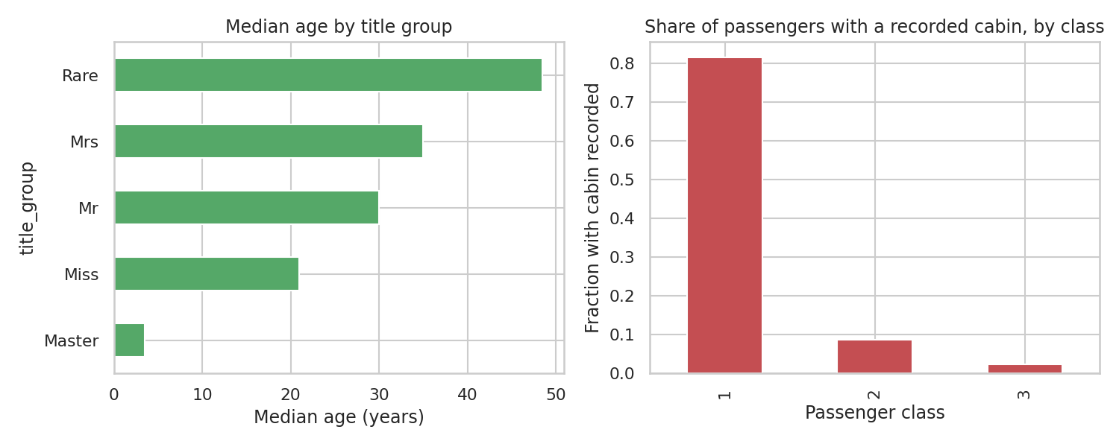
Figure 2. Left: median age by title group, used for grouped imputation. Right: share of passengers with a recorded cabin, by class.
The right-hand panel of Figure 2 is the key finding here: 81.5% of first-class passengers have a recorded cabin number, versus 8.7% of second class and only 2.4% of third class. Missing cabin data is not random (it is not “MCAR”) — it is driven almost entirely by passenger class, most likely because third-class cabin assignments were simply less carefully recorded on the surviving manifest. This is important: it means the fact that a cabin is missing is itself informative and worth keeping as a feature (has_cabin), rather than something to impute over.

5.3 Family Size
df['family_size'] = df['sibsp'] + df['parch'] + 1
df['is_alone'] = (df['family_size'] == 1).astype(int)
sibsp (siblings/spouses aboard) and parch (parents/children aboard) are combined into a single family_size count (including the passenger) and a simple is_alone flag, both of which are more directly interpretable than the two raw counts and are used in the correlation analysis in Section 8.

6. Missing Value Treatment
Each of the three columns identified in Section 3.2 was treated differently, in proportion to how much was missing and what the missingness meant.

6.1 Embarked — 2 missing values (0.22%)
df[df['embarked'].isnull()][['name','pclass','ticket','cabin','fare']]
name ticket cabin fare
61 Icard, Miss. Amelie 113572 B28 80.0
829 Stone, Mrs. George Nelson (Martha Evelyn) 113572 B28 80.0

The two passengers with a missing port of embarkation share the same ticket number and the same cabin, meaning they were almost certainly travelling together (a first-class passenger and, per public historical records, her travelling maid). Historical passenger records commonly cited for this dataset (Encyclopedia Titanica) list both as having boarded at Southampton, which is also by far the most common port in the dataset overall (about 72% of passengers) — so the statistical default (the column mode) and the historical record agree here.
It is worth noting this is a genuinely debated case in the wider data-cleaning community: because both women paid an $80 fare, and the median first-class fare out of Cherbourg is closer to that figure than the median first-class fare out of Southampton, some published analyses instead infer Cherbourg from the fare alone. Both are defensible; this report follows the historical-record / mode-based route for Southampton (“S”), and documents the alternative view rather than presenting the choice as beyond dispute.
df['embarked'] = df['embarked'].fillna('S')

6.2 Age — 177 missing values (19.87%)
A single global median or mean would ignore the fact that age varies hugely by who the passenger is — a global median of 28 would be a poor estimate for missing “Master” (child) records and a poor estimate for missing “Mrs” records alike, just in opposite directions. Instead, each missing age was filled with the median age of that passenger's title_group (computed in Section 5.1):
df['age'] = df.groupby('title_group')['age']\
.transform(lambda s: s.fillna(s.median()))
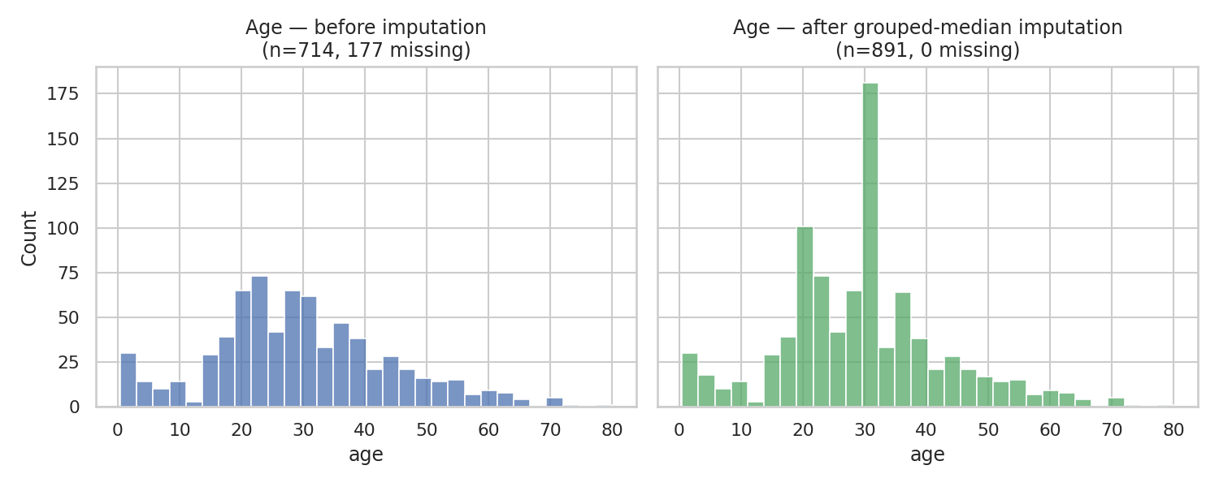
Figure 3. Age distribution before (177 missing, excluded from the histogram) and after grouped-median imputation (0 missing).
This closes all 177 gaps while respecting the age structure of each title group (children imputed near 3.5, adult men near 30, adult women near 35, and so on). The trade-off is visible in Figure 3: the “after” histogram has a noticeably taller spike exactly at each group's median value, since every passenger with a missing age in that group now takes on the identical median value. This is a known limitation of median imputation — it manufactures artificial mass at a single point and slightly understates the true variance of the age column — and it is discussed further in Section 10.

6.3 Cabin — 687 missing values (77.10%)
At 77% missing, cabin is far too sparse to impute at the individual-cabin level (there is no reliable way to guess a specific cabin number for a given passenger). Rather than dropping the column outright and losing the information it does carry, two lighter-weight features were kept instead:
- has_cabin (0/1) — already shown in Section 5.2 to be strongly related to passenger class and, as seen later, to survival.
- deck — the first letter of the cabin code (A–G, plus one T), with missing values filled as an explicit 'Unknown' category rather than imputed to a guessed deck.
df['deck'] = df['deck'].fillna('Unknown')
The original free-text cabin column itself (147 distinct values, e.g. “C85”, “B28 B30”) is dropped in Section 8.1 once its useful signal has been captured in these two simpler features.

7. Outlier Detection and Treatment

7.1 Method
Outliers were flagged using the standard interquartile range (IQR) rule: any value below Q1 − 1.5×IQR or above Q3 + 1.5×IQR is flagged. This was run deliberately after the age imputation in Section 6.2, not before, since running it on a column that still has missing values would compute quartiles from an incomplete, potentially biased sample. This ordering has a real, visible effect: imputing 177 ages at group medians pulls the interquartile range in, which is exactly why the age bounds shift and why more values fall outside them afterward (35, versus 11 when the same test is run on the incomplete raw column) — a useful reminder that the order of cleaning steps changes their outcome, not just their convenience.
def iqr_bounds(s):
q1, q3 = s.quantile(.25), s.quantile(.75)
iqr = q3 - q1
return q1 - 1.5*iqr, q3 + 1.5*iqr

7.2 Age Outliers
Column | IQR bounds | Flagged points | % of rows
age (post-imputation) | 0.00 – 56.00 | 35 | 3.93%
All 35 flagged points are older passengers above 56, up to the recorded maximum of 80. There is nothing biologically implausible about an 80-year-old passenger, and age is one of the strongest predictors of who survived (women and children were prioritised, but elderly passengers of either sex fared worse) — so these points are retained without modification. Removing them would remove real signal, not noise.

7.3 Fare Outliers and Skew
Column | IQR bounds | Flagged points | % of rows
fare | −$26.72 – $65.63 | 116 | 13.02%
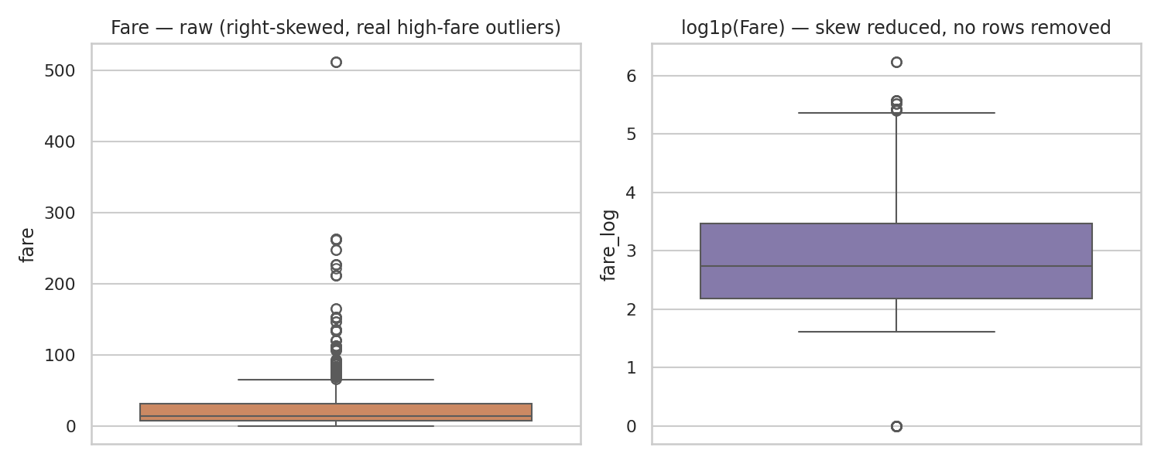
Figure 4. Fare before (left) and after a log1p transform (right). No rows are removed either way.
13% of fares exceed the upper IQR bound, up to a maximum of $512.33 (a small number of first-class suite bookings). As with age, these are legitimate, informative values rather than data-entry errors — the whole point of the fare column is that first-class tickets cost far more than third-class ones. Deleting the top 13% of fares would specifically strip out the first-class passengers with the highest survival rate, badly distorting any later analysis. Instead of removing anything, a log1p-transformed column (fare_log) was added alongside the original, which compresses the long right tail (visible in Figure 4) for the benefit of models and visualisations that are sensitive to scale, while the untransformed fare is kept for reference.
df['fare_log'] = np.log1p(df['fare'])

7.4 The Zero-Fare Case Revisited
The 15 zero-fare passengers identified in Section 4.2 are a useful illustration of why outlier detection must not be applied mechanically: the IQR lower bound for fare is negative (−$26.72), so a fare of exactly $0 is mathematically inside the “normal” range and is never flagged by the statistical test at all, even though it is arguably the most unusual value in the column. Statistical outlier tests catch extreme magnitude, not categorical anomalies. These rows were handled separately with an explicit indicator rather than being caught, or missed, by the outlier rule:
df['fare_is_zero'] = (df['fare'] == 0).astype(int)

8. Final Preprocessing for Modeling

8.1 Dropping Redundant Raw Columns
With their useful signal already extracted into engineered features, four raw columns were dropped from the modeling table: name and ticket (near-unique free text, no generalisable signal on their own), cabin (superseded by has_cabin and deck), and the intermediate title column (superseded by the consolidated title_group).
model_df = df.drop(columns=['name','ticket','cabin','title'])

8.2 Encoding Categorical Variables
sex was mapped to a binary 0/1 indicator. embarked, title_group, and deck — all unordered categories — were one-hot encoded, since these are nominal variables with no natural numeric order; representing them as single integer codes would falsely imply that, say, deck “B” is numerically “between” decks A and C in some meaningful way. pclass was deliberately left as a single numeric column (1/2/3) rather than one-hot encoded, since it is a genuinely ordinal feature — first class is a strictly higher travel tier than second, which is higher than third.
model_df['sex'] = model_df['sex'].map({'male': 0, 'female': 1})
model_df = pd.get_dummies(
model_df, columns=['embarked','title_group','deck'])

8.3 Train/Test Split and Feature Scaling
The data was split into training (80%) and test (20%) sets, stratified on the target so that both sets keep the same 38% survival rate. Numeric columns (age, fare, fare_log, family_size) were then standardised — but the StandardScaler was fit only on the training set and merely applied to the test set, to avoid leaking any information about the test set's distribution into the scaling parameters.
X_train, X_test, y_train, y_test = train_test_split(
X, y, test_size=0.2, random_state=42, stratify=y)

scaler = StandardScaler()
X_train[num_cols] = scaler.fit_transform(X_train[num_cols])
X_test[num_cols] = scaler.transform(X_test[num_cols])
Split | Rows | Survival rate
Train | 712 | 38.3%
Test | 179 | 38.5%

8.4 Before vs. After: Summary
Metric | Before cleaning | After cleaning
Rows | 891 | 891 (none dropped)
Columns | 11 | 29 (after one-hot encoding)
Missing cells | 866 | 0
Exact duplicate rows | 0 | 0
No rows were removed anywhere in this pipeline — every cleaning decision above was chosen specifically because it did not require discarding passengers, which matters more than usual on a dataset of only 891 records.
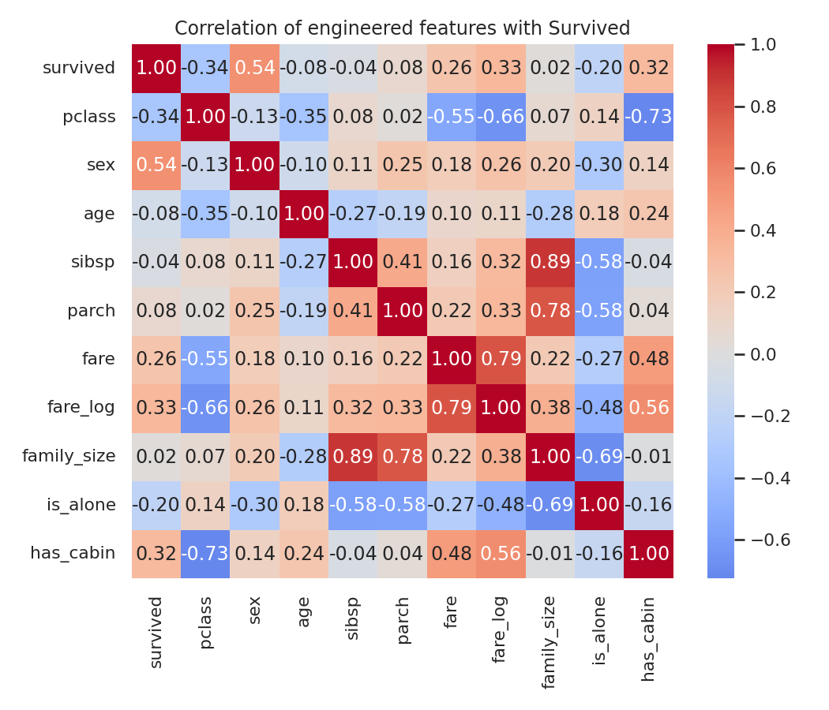
Figure 5. Correlation of the cleaned/engineered features with survived.
The correlation heatmap gives a first sanity check that the engineered features carry real signal rather than noise: sex (0.54) and pclass (−0.34) show the strongest raw correlation with survival, exactly as widely documented for this dataset, and the newly engineered has_cabin (0.32) and fare_log (0.33) are competitive with the original fare column (0.26), suggesting the feature engineering in Sections 5–7 added genuine predictive value rather than just cosmetic cleanup.
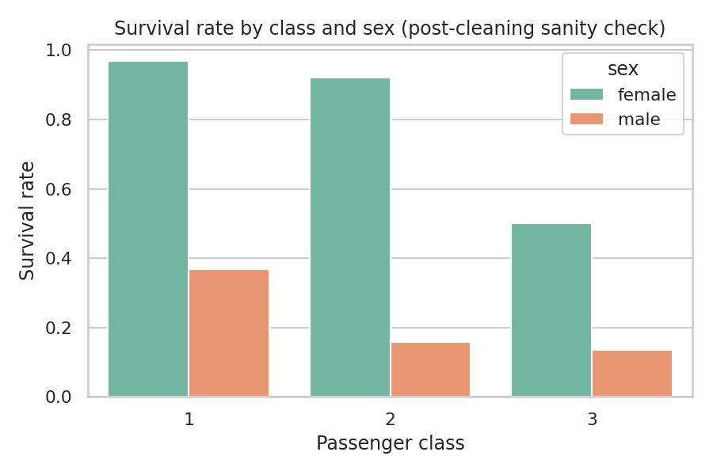
Figure 6. Survival rate by class and sex, computed after cleaning, as a final plausibility check.
Figure 6 reproduces the well-documented “women and first-class passengers first” pattern (96.8% survival for first-class women down to 13.5% for third-class men). Recovering this expected historical pattern from the cleaned data is a useful final check that no cleaning step accidentally introduced bias or corrupted the target relationship.

9. Challenges Faced and How They Were Overcome
- No single missing-value strategy fit every column. cabin, age, and embarked were missing for very different reasons and in very different amounts. Applying one rule (e.g. “drop rows with any missing value”) would have deleted the majority of the dataset. This was resolved by profiling each column's missingness separately (Section 3.2) before deciding on a treatment, rather than choosing a treatment first.
- Distinguishing real anomalies from statistical outliers. The zero-fare passengers (Section 7.4) are exactly the kind of case a purely statistical pipeline would miss: they are not extreme enough in magnitude to trip an IQR test, but they are clearly a distinct category once the ticket field is inspected. The fix was to combine automated outlier detection with manual inspection of the categorical/text fields, rather than relying on IQR or z-score thresholds alone.
- Deciding what to do with a highly informative but 77%-missing column. cabin could not be reasonably imputed at the individual level, but dropping it entirely would have discarded a column that turned out to correlate with survival almost as strongly as fare. The resolution was to re-express it as two lower-dimensional, non-imputed features (has_cabin, deck) instead of either extreme.
- A genuinely ambiguous imputation case (Embarked). The two missing-embarked passengers admit two reasonable answers depending on whether fare similarity or historical record is weighted more heavily (Section 6.1). Rather than silently picking one, both lines of reasoning are documented so the choice is auditable.
- Avoiding data leakage during scaling. It would have been easy to fit the StandardScaler on the full dataset before splitting into train and test, which subtly leaks test-set statistics into training. The split was performed first, and the scaler was fit on the training partition only (Section 8.3).

10. Impact of Preprocessing on Downstream Analysis
Every cleaning and preprocessing decision above changes what a downstream model or analysis can and cannot conclude from the data. The main effects worth flagging explicitly are:
- Median imputation compresses variance. The visible spike in the “after” panel of Figure 3 means models trained on the imputed age column will see slightly less spread than the true (unknown) age distribution actually has, particularly within the Master and Rare groups where fewer real observations anchor the median. A model relying heavily on fine-grained age effects should treat this imputation as an approximation, not ground truth.
- Retaining outliers preserves a real subpopulation. Because age and fare outliers were kept rather than removed (Section 7), any model trained on this data will still be exposed to, and can still learn from, the highest-fare and oldest passengers — both groups with distinctly different survival rates. A pipeline that had removed them would look cleaner on paper but would systematically under-represent first-class and elderly passengers.
- The has_cabin / deck split converts unusable missingness into a usable signal. Because cabin's missingness is driven by class rather than being random (Section 5.2), simply dropping the column would have discarded information that is almost as predictive as fare itself, while imputing specific cabin numbers would have invented data that does not exist. This is a case where the 'right' amount of information to keep sits between the two obvious extremes.
- One-hot encoding increases dimensionality (11 raw columns → 29 modeling columns), which is a reasonable trade for correctness with nominal categories, but means models that are sensitive to the number of features (e.g. k-nearest neighbours) or that need every category to appear in both train and test splits should be checked for rare-category imbalance — the Rare title group (23 passengers) and the T deck (1 passenger) are the two thinnest categories in this dataset.
- Fitting the scaler on the training split only means test-set metrics reported from this pipeline are a fair, leakage-free estimate of how the pipeline would perform on genuinely new passengers — at the cost of a small amount of extra pipeline complexity compared to scaling the whole dataset up front.

11. Conclusion
Starting from an 891-row, 11-column raw manifest with 866 missing cells across three columns and several non-obvious anomalies, this report worked through a full, documented cleaning and preprocessing pipeline: column-specific missing-value treatment informed by newly engineered features (title, deck, family size), outlier detection that distinguished genuine variability from data errors, and a leakage-aware encoding/scaling step suitable for downstream modeling. No rows were dropped at any stage, missing cells were reduced from 866 to 0, and the resulting 29-column feature table reproduces the well-documented survival patterns in this dataset (Figure 6), which is a reasonable, independent check that the cleaning process preserved rather than distorted the underlying signal.
The recurring theme across almost every decision in this report is that data cleaning is not a mechanical checklist — the same statistical technique (IQR outlier detection, median imputation, dropping sparse columns) can be the right or the wrong choice depending on why a value is missing or unusual, and that reasoning has to be made explicit and revisited whenever it is applied to a new column.

12. References
- Kaggle. “Titanic – Machine Learning from Disaster” (dataset and data dictionary). kaggle.com/c/titanic
- mwaskom/seaborn-data GitHub repository (raw/titanic.csv mirror of the Kaggle training file). github.com/mwaskom/seaborn-data
- Encyclopedia Titanica (public historical passenger records, referenced for the Embarked imputation discussion in Section 6.1). encyclopedia-titanica.org
- pandas, NumPy, scikit-learn, matplotlib, and seaborn — Python libraries used throughout for data manipulation, statistics, and visualization.

