Unsupervised Learning and Clustering Analysis
Segmenting the Titanic Passenger Dataset with K-Means and Hierarchical Clustering
Data Science Internship — Week 3 Task
Prepared by: Ankit
September 2026

Table of Contents

1. Introduction and Objective
This is the third stage of an internship exercise built around the Titanic passenger dataset. Weeks 1 and 2 cleaned the data and explored it with supervised-flavored EDA (i.e. analysis organized around the known survived label). This week deliberately turns that around: the objective is to apply unsupervised clustering — K-Means and hierarchical clustering — to segment passengers using only their own characteristics, with no access to the survival outcome at all, and then ask afterwards whether the resulting segments turn out to mean anything.
This is a genuinely different exercise from Weeks 1-2, not a relabeled continuation of it: clustering has to discover structure on its own, and the interesting question is whether that unsupervised structure lines up with, or adds to, what was already learned from supervised EDA. It does, in an interesting way, and Section 8 discusses exactly how.

1.1 Structure of this Report
Section 2 recaps the dataset and explains why it is still a reasonable choice for a clustering task. Section 3 covers feature selection, the deliberate exclusion of the survival label, and scaling. Section 4 works through choosing the number of clusters. Sections 5-6 apply K-Means (the primary method) and hierarchical clustering (a secondary method used for comparison and a dendrogram view). Section 7 interprets each cluster in depth, Section 8 checks the clusters against survival as a post-hoc validation, Section 9 discusses research/business implications, and Section 10 is a candid discussion of this analysis's limitations.

2. Dataset and Preparation Recap

2.1 Dataset
The dataset is, again, the Titanic passenger manifest used in Weeks 1-2 (891 passengers, Kaggle's “Titanic: Machine Learning from Disaster” competition, mirrored via the seaborn-data GitHub repository). The cleaning steps are unchanged from Week 1 and are reproduced here only as a compact function so this week's script runs standalone.

2.2 Why Reuse This Dataset for Clustering
Continuing with the same dataset (rather than acquiring a fresh one) is a deliberate choice, for two reasons. First, it lets this week ask a sharper question than “what clusters exist in some arbitrary data”: because the true survival outcome is already known from Weeks 1-2, clustering here can be validated against a real external signal that the algorithm never sees, which is normally hard to do with unsupervised learning. Second, it tests whether purely demographic and travel features — with no reference to sex-based social norms, ticket price tiers, or survival — recover the same structure that supervised EDA already flagged as important, which is a meaningful check on the earlier analysis as much as a new one in its own right.

3. Feature Selection and Preprocessing for Clustering

3.1 Selected Features and Rationale
Clustering used six features: age, fare_log, family_size, pclass, sex_num (binary), and has_cabin (binary). embarked, deck, and title_group were deliberately left out. This is a smaller feature set than Week 2's full EDA used, for a reason specific to distance-based clustering: one-hot encoding embarked (3 categories), deck (8 categories), and title_group (5 categories) would add 16 more mostly-0/1 columns, and because Euclidean distance treats every column equally, a large block of sparse binary columns can dominate the distance calculation and wash out the signal from the six meaningful continuous/binary features actually chosen. Keeping the feature set small and each feature individually interpretable was judged more valuable here than completeness — a trade-off that would be made differently for, say, a predictive model rather than a distance-based clustering algorithm.

3.2 Deliberately Excluding Survived
survived was excluded from the clustering feature set on principle, not merely by oversight: including it would let the algorithm partly cluster on the very outcome this analysis wants to check the clusters against afterwards, which would make Section 8's validation circular and meaningless. It is used exactly once in this entire pipeline — after clustering is complete, to describe the resulting groups — and nowhere in the distance calculation that produces them.
FEATURES = ['age', 'fare_log', 'family_size', 'pclass', 'sex_num', 'has_cabin']
X = df[FEATURES] # note: 'survived' is not in this list

3.3 Scaling
K-Means and Ward-linkage hierarchical clustering are both distance-based, so features on very different scales would distort the result before the algorithm even starts.
Feature | Min | Max | Mean | Std
age | 0.42 | 80.00 | 29.39 | 13.27
fare_log | 0.00 | 6.24 | 2.96 | 0.97
family_size | 1 | 11 | 1.90 | 1.61
pclass | 1 | 3 | 2.31 | 0.84
sex_num | 0 | 1 | 0.35 | 0.48
has_cabin | 0 | 1 | 0.23 | 0.42
Without scaling, family_size (range up to 11) and age (range up to 80) would dominate the Euclidean distance almost entirely, while the two binary features (sex_num, has_cabin, both confined to {0,1}) would barely register at all — not because they are less informative, but purely because of the units they happen to be measured in. All six features were standardized (zero mean, unit variance) with scikit-learn's StandardScaler before clustering.
scaler = StandardScaler()
X_scaled = scaler.fit_transform(X) # mean 0, std 1 for every feature

4. Choosing the Number of Clusters
Two standard diagnostics were run across k = 2 to 8 before committing to a final number of clusters: the elbow method (within-cluster sum of squares, or inertia) and the mean silhouette score.
for k in range(2, 9):
km = KMeans(n_clusters=k, random_state=42, n_init=10).fit(X_scaled)
inertias.append(km.inertia_)
sil_scores.append(silhouette_score(X_scaled, km.labels_))
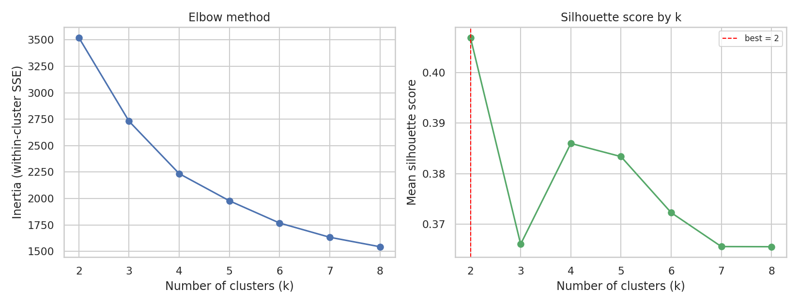
Figure 1. Elbow method (left) and mean silhouette score (right) for k = 2-8.

4.1 What the Two Diagnostics Say
The elbow curve bends gradually rather than sharply, without one unambiguous “elbow” — common for real demographic data that doesn't form perfectly separated blobs. The silhouette score is actually highest at k=2 (0.407), dips at k=3, and forms a smaller local peak at k=4 (0.386) before declining further.

4.2 Why k=4, Not the Silhouette-Maximizing k=2
Maximizing silhouette score alone would pick k=2. Fitting that solution for comparison shows why it was not used here: the two clusters split almost entirely along wealth/class (has_cabin 0.02 vs. 0.86, mean pclass 2.71 vs. 1.08) and say nothing about family structure or sex — essentially a coarser restatement of a single variable already fully visible in Week 2's EDA (Figure 5 of that report). k=4 scores only slightly lower on silhouette (0.386 vs. 0.407) but resolves two additional, genuinely distinct groups — large families and a sex-based split among passengers who are neither wealthy nor traveling in a large family — that k=2 collapses together. This is a deliberate trade of a small amount of measured cluster cohesion for a much more informative and actionable segmentation, and is documented here explicitly rather than silently defaulting to whichever k scores highest on one metric.
k | Inertia | Silhouette
2 | 3521.0 | 0.407
3 | 2730.1 | 0.366
4 | 2234.5 | 0.386
5 | 1978.0 | 0.383
6 | 1767.7 | 0.372

5. K-Means Clustering (Primary Method)

5.1 Method and Parameters
kmeans = KMeans(n_clusters=4, random_state=42, n_init=10)
df['cluster_kmeans'] = kmeans.fit_predict(X_scaled)
K-Means was chosen as the primary method because it is efficient on a dataset of this size, produces clusters defined by an interpretable centroid (the average passenger profile in each group, used directly in Section 7), and is the algorithm the task explicitly names as an option. n_init=10 reruns the algorithm from 10 random centroid initializations and keeps the best result, which protects against K-Means converging to a poor local optimum from an unlucky starting position.

5.2 Cluster Sizes and Profiles
Cluster | n | Age | Fare ($) | Family size | Class (mean) | % female | % w/ cabin
0 | 55 | 15.7 | 36.37 | 6.84 | 2.98 | 49% | 0%
1 | 437 | 29.4 | 12.81 | 1.31 | 2.69 | 0% | 2%
2 | 190 | 24.9 | 16.14 | 1.91 | 2.62 | 100% | 6%
3 | 209 | 37.2 | 86.26 | 1.84 | 1.05 | 46% | 88%
The four groups that emerge are not a simple split on any single feature. Two of them (0 and 3) mix both sexes and are instead defined by family size and wealth respectively; the other two (1 and 2) are exactly single-sex, splitting the remaining passengers — those who are neither in a large family nor wealthy — along sex instead. This interaction is explored fully in Section 7.

5.3 Visualizing the Clusters (PCA Projection)
pca = PCA(n_components=2, random_state=42)
X_pca = pca.fit_transform(X_scaled) # for visualization only —
# clustering itself used all 6 dimensions
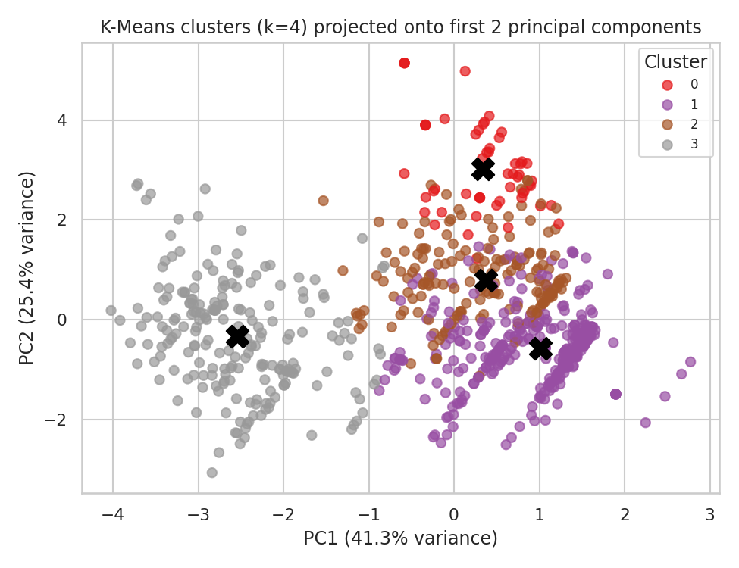
Figure 2. K-Means clusters projected onto the first two principal components (66.7% of total variance).
Cluster 3 (grey, the affluent group) separates cleanly even in this 2-D projection. Clusters 0, 1, and 2 overlap more visibly here, which looks like weaker separation than it really is: PCA is used only to compress six dimensions down to two for plotting, and it captures 66.7% of total variance (41.3% + 25.4%), so roughly a third of the information the clustering algorithm actually used is simply not visible in this picture. The moderate silhouette score reported below (0.386, computed in the full 6-dimensional space) is the more trustworthy measure of separation than this 2-D picture alone.

5.4 Cluster Validity: Silhouette Diagram
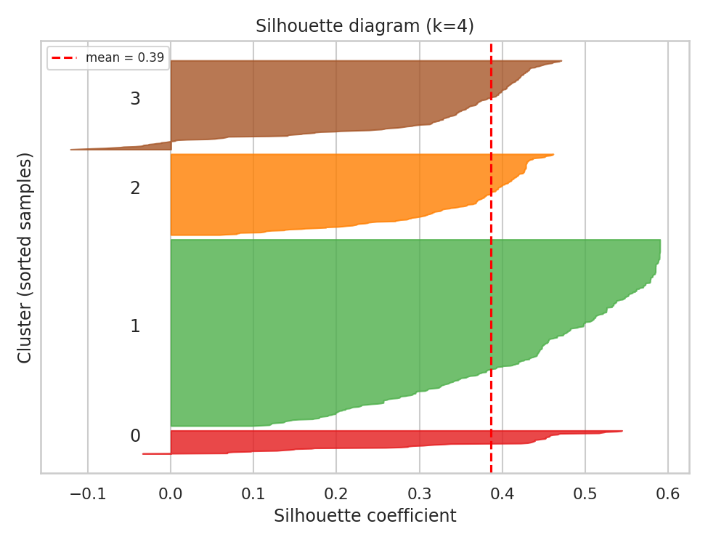
Figure 3. Per-sample silhouette diagram for the k=4 solution (mean = 0.386).
Every cluster sits mostly to the right of, or straddling, the red mean line, and only a small tail of points in clusters 0 and 1 have a slightly negative silhouette (borderline cases sitting close to another cluster's boundary rather than being clearly misclustered). Cluster 1 (the largest, at 437 points) has the widest range of silhouette values, which fits its role as a large, somewhat heterogeneous “everyone else” group of lower/middle-class solo men rather than a tightly bounded segment.
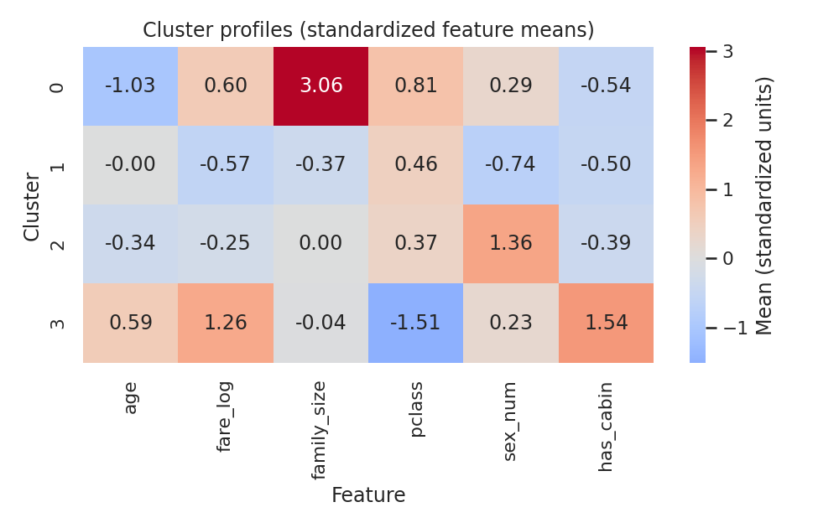
Figure 4. Cluster profiles as standardized feature means — a compact fingerprint for each group.
This heatmap is the fastest way to read what distinguishes each cluster: cluster 0 is overwhelmingly defined by family_size (+3.06 standard deviations above the mean), cluster 3 by has_cabin (+1.54) and pclass (−1.51, i.e. strongly first-class), and clusters 1 and 2 are mirror images of each other on sex_num (−0.74 vs. +1.36) while looking similar on every other feature.

6. Hierarchical Clustering (Secondary Method, for Comparison)

6.1 Method
Agglomerative (bottom-up) hierarchical clustering with Ward linkage was run as a second, independent method on the same six standardized features. Ward linkage was chosen because, like K-Means, it minimizes within-cluster variance at each merge step, making the two methods reasonably comparable.
Z = linkage(X_scaled, method='ward')
agg = AgglomerativeClustering(n_clusters=4, linkage='ward')
df['cluster_hier'] = agg.fit_predict(X_scaled)

6.2 Dendrogram
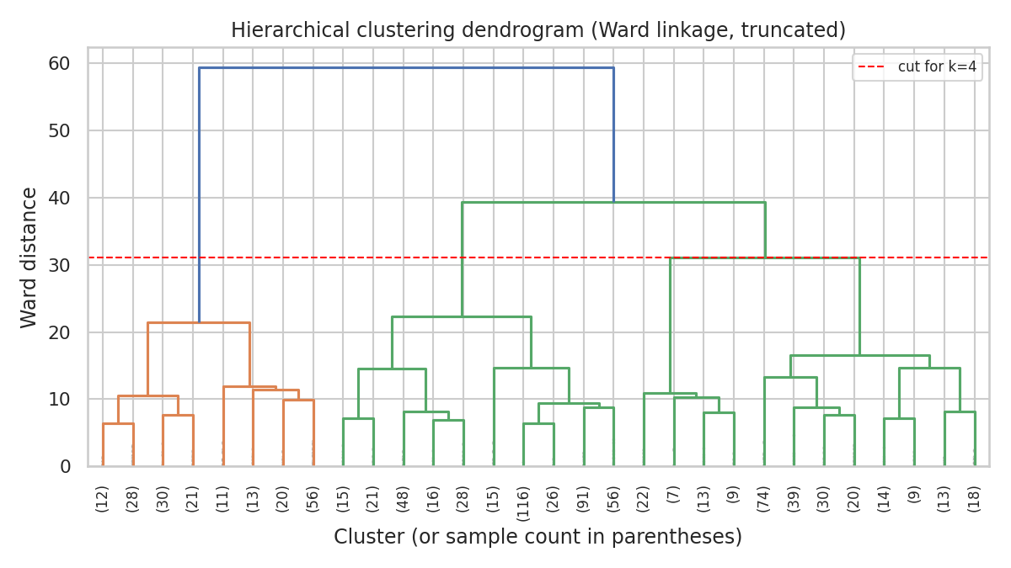
Figure 5. Ward-linkage dendrogram, truncated to the last 30 merges for readability. The dashed line marks the height at which cutting the (full, untruncated) tree yields 4 clusters.
The dendrogram's shape supports the k=4 decision independently of the silhouette analysis in Section 4: the tree's very first (highest) split — at roughly double the height of anything else in the diagram — separates one small, clearly distinct branch (the orange branch on the left, corresponding closely to the large-family cluster) from everything else, and the remaining branch does not obviously want to merge back into fewer, larger groups until much lower down the tree, i.e. into more than 2 clusters.

6.3 Agreement with K-Means
adjusted_rand_score(df['cluster_kmeans'], df['cluster_hier'])
Metric | Value
Hierarchical clustering silhouette score (k=4) | 0.372
Adjusted Rand Index (K-Means vs. Hierarchical) | 0.862
An Adjusted Rand Index of 0.862 (1.0 would mean identical partitions, 0.0 would mean agreement no better than chance) indicates the two methods, run completely independently with different underlying mechanics, largely agree on how the 891 passengers should be grouped. The crosstab below shows exactly where they agree and differ:
cluster_hier 0 1 2 3
cluster_kmeans
0 0 0 5 50
1 418 0 19 0
2 0 2 187 1
3 14 189 6 0

The bulk of each K-Means cluster maps cleanly onto one hierarchical cluster (418/437, 187/190, 189/209, and 50/55), with only a modest number of boundary cases reassigned. This cross-method agreement is a meaningful piece of evidence that the four-group structure is a genuine property of the data rather than an artifact of K-Means' specific algorithmic assumptions (e.g. its bias toward roughly spherical, similarly sized clusters).

7. Cluster Interpretation and Personas
Combining the standardized profile (Figure 4) with the categorical breakdowns (title, class, embarkation port) not shown in the profile table gives each cluster a clear real-world identity:

7.0 (Cluster 0) Large Steerage Families — n=55
Average age 15.7 (skewed young by many children), family size 6.84 (by far the highest of any group), 98% third class, no recorded cabins, roughly balanced by sex. The title breakdown confirms the story: 19 Master (boys), 19 Miss (girls), plus a smaller number of Mr/Mrs — whole families traveling together in third class. This is the group Week 2 already flagged as the worst-off family-size bracket (Section 6.3 of that report, “Large (5+)” at 16.1% survival); clustering rediscovers it from scratch using none of that prior analysis.

7.1 (Cluster 1) Lower/Middle-Class Solo Men — n=437 (largest cluster)
100% male, average family size 1.31 (traveling alone or with one companion), the lowest average fare of any cluster ($12.81), 73% third class. The title breakdown is almost entirely Mr (412 of 437). This is the single largest and most “ordinary” passenger segment on the ship — adult men traveling cheaply and alone — and also, as Section 8 shows, the segment with the worst survival odds.

7.2 (Cluster 2) Women in Second/Third Class — n=190
100% female, younger on average (24.9), modest fares ($16.14), spread across second (71) and third (118) class with almost no first-class representation. Title breakdown: 118 Miss, 72 Mrs. This cluster captures women who benefited from the “women and children first” protocol without also having the added advantage of first-class status — useful for separating the effect of sex from the effect of wealth, which overlap in cluster 3 below.

7.3 (Cluster 3) Affluent First-Class Passengers, Both Sexes — n=209
95% first class, by far the highest fare ($86.26 average) and cabin-recording rate (88%), older on average (37.2), and — unlike clusters 1 and 2 — genuinely mixed by sex (112 male, 97 female). This is the one cluster where wealth/class, not sex or family structure, is clearly the defining trait, and it is the only cluster where a large share of men (112 of them) still ended up in a relatively high-survival group.

8. Post-Hoc Validation: Clusters vs. Survival
survived was not used anywhere in Sections 3-7. It is used here for the first and only time, purely to check whether the unsupervised structure found above happens to mean anything against a real, independently known outcome.
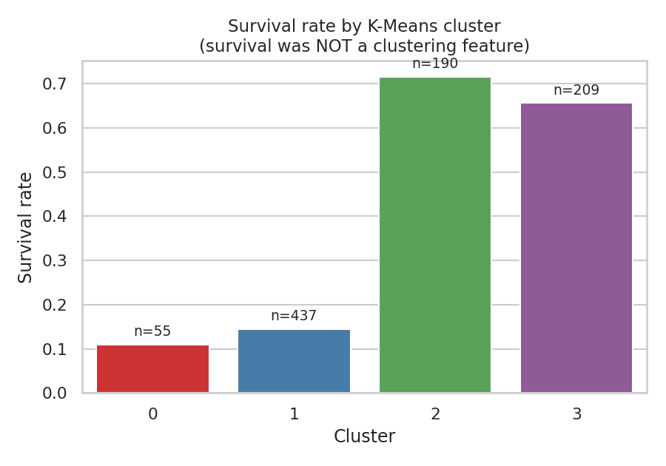
Figure 6. Survival rate by K-Means cluster, computed after clustering, never used to produce it.
Cluster | Persona | n | Survival rate
0 | Large steerage families | 55 | 10.9%
1 | Lower/middle-class solo men | 437 | 14.4%
2 | Women, 2nd/3rd class | 190 | 71.6%
3 | Affluent 1st class, both sexes | 209 | 65.6%
The result lines up with, and sharpens, the two dominant factors already identified through supervised EDA in Week 2 (sex and class/wealth) — but expressed here as four purely data-driven groups rather than two separate single-variable effects. The two worst-off clusters (0 and 1) are defined respectively by family overload and by being an ordinary lower-class man; the two best-off clusters (2 and 3) are defined respectively by being a woman outside the wealthy class, and by being wealthy regardless of sex. In other words: sex and wealth each independently improve survival odds, and this cluster solution effectively separates out the passengers who had access to one advantage, the other, both (implicitly, wealthy women, who are split across clusters 2 and 3 depending on exact class), or neither.

9. Research and Business Implications
Although this dataset is historical, the analytical pattern generalizes directly to a common commercial use of clustering: segmenting a population by naturally-collected attributes (here: age, spending/fare, group size, class, sex, amenity access) into groups that can then be checked against, or used to predict, an outcome of interest (here: survival; in a business setting, typically churn, response to a campaign, or lifetime value).
- Historical/social-science research. The four clusters give researchers a compact, data-driven vocabulary (“large steerage families,” “solo lower-class men,” etc.) for discussing differential survival on the Titanic without having to manually cross-tabulate every combination of sex, class, and family size by hand — useful for framing further historical analysis or comparison with other maritime disasters.
- Risk segmentation, more generally. The same workflow (select a handful of interpretable attributes, scale them, cluster, then check the clusters against a real outcome the algorithm never saw) is directly transferable to insurance risk pooling, hospital patient triage grouping, or any setting where a population needs to be split into a small number of meaningfully different risk tiers before an outcome is known.
- Marketing/customer segmentation (the classic business use case). Swap fare for spending, family_size for household size, and has_cabin for a loyalty-tier indicator, and Sections 3-7 of this report describe essentially the standard customer-segmentation workflow: pick interpretable behavioral/demographic features, scale them, choose k via elbow + silhouette, profile each segment, and only then check the segments against a business KPI (here, survival; commercially, retention or spend) that was withheld from the clustering step itself.

10. Limitations and Reflections
- The silhouette scores are moderate, not excellent. 0.386 for k=4 indicates real but imperfect separation — expected for correlated human/demographic data that doesn't naturally form well-isolated blobs, and a reminder not to over-claim precision the data doesn't support.
- K-Means assumes roughly spherical, similarly sized clusters. Cluster 1 (437 passengers) is nearly eight times the size of cluster 0 (55); K-Means can still find genuinely unequal clusters, but its algorithmic bias toward compact, evenly sized groups means a different method (e.g. DBSCAN, which was not used here) might carve the boundaries differently, particularly around cluster 1's edges.
- Feature selection was a judgment call. Section 3.1's decision to exclude embarked, deck, and title_group kept the feature space compact and interpretable, but a different, larger feature set (or a distance metric better suited to mixed categorical/continuous data, such as Gower distance) could plausibly surface a different, equally valid segmentation.
- The k=4 vs. k=2 decision in Section 4.2 is a judgment call, not a purely statistical one. It was made and documented deliberately, but a stakeholder who cared only about maximum statistical cluster cohesion, rather than actionable segment richness, could reasonably prefer k=2.

11. Conclusion
Six interpretable, standardized passenger features — with the survival label deliberately withheld — were enough for K-Means and hierarchical clustering to independently agree (Adjusted Rand Index 0.862) on a four-group structure: large steerage families, solo lower/middle-class men, women outside the wealthy class, and affluent first-class passengers of both sexes. Checked afterwards against the real survival outcome, those four unsupervised groups reproduce and sharpen the two dominant explanatory factors (sex and wealth/class) already identified through supervised EDA in Week 2, without having had access to that analysis or to the outcome itself during clustering. That agreement between an unsupervised, feature-only method and a fully independent, previously-known outcome is the strongest evidence in this report that the clusters found here reflect genuine structure in the data rather than an artifact of the chosen algorithm or parameters.

12. References
- Kaggle. “Titanic – Machine Learning from Disaster” (dataset and data dictionary). kaggle.com/c/titanic
- mwaskom/seaborn-data GitHub repository (raw/titanic.csv mirror of the Kaggle training file). github.com/mwaskom/seaborn-data
- Week 1 and Week 2 Task reports (this internship), for the cleaning rationale and prior EDA findings referenced in Sections 2, 4, and 8.
- scikit-learn documentation (KMeans, AgglomerativeClustering, silhouette_score, PCA) and SciPy's hierarchy.linkage/dendrogram — the libraries used throughout for clustering, evaluation, and visualization.

