Exploratory Data Analysis and Visualization
A Case Study on the Titanic Passenger Dataset
Data Science Internship — Week 2 Task
Prepared by: Ankit
September 2026

Table of Contents

1. Introduction and Objective
This report is the second stage of a two-part internship exercise built on the Titanic passenger dataset. Week 1 acquired, cleaned, and preprocessed the raw data; this week's task picks up the cleaned dataset and performs exploratory data analysis (EDA) — using summary statistics, univariate, bivariate, and multivariate visualizations to surface patterns, quantify relationships, and interpret why those patterns plausibly exist.
The guiding question throughout is not just “what correlates with survival?” but “why might it, and how confident should we be?” Every visualization below is paired with a plain-language interpretation, and the strongest claims are checked against a simple statistical test rather than left as a visual impression alone.

1.1 Structure of this Report
Section 2 briefly recaps how the analysis-ready dataset was produced (full justification is in the Week 1 report). Sections 3-4 cover initial and univariate analysis. Sections 5-6 cover bivariate and multivariate relationships with the survival outcome, the core of the EDA. Section 7 backs the key visual claims with statistical tests. Section 8 documents the transformations and aggregations used. Section 9 pulls the findings together into a short set of ranked insights, and Section 10 concludes.

2. Dataset and Preparation Recap

2.1 Dataset
The dataset is the same one used in Week 1: the raw Titanic passenger manifest from Kaggle's “Titanic: Machine Learning from Disaster” competition (891 passengers, originally 11 fields), retrieved via the seaborn-data GitHub mirror. Continuing with the same dataset keeps the two weeks of work connected — Week 1 established that the data was fit to analyze; Week 2 is where that groundwork gets used.

2.2 Preparation Recap
The cleaning and feature-engineering decisions themselves were made and justified in the Week 1 report; they are reproduced here only as a compact function so this week's script can run on its own, and are not re-argued in this report. In summary: age was imputed using the median of each passenger's title group, embarked was imputed with its mode, cabin was re-expressed as has_cabin and deck rather than dropped or guessed, and family_size / is_alone were engineered from sibsp and parch.
def prepare_data(path):
df = pd.read_csv(path)
df['title'] = df['name'].str.extract(r',\s*([^\.]*)\.')
df['title_group'] = df['title'].map(title_map).fillna('Rare')
df['has_cabin'] = df['cabin'].notnull().astype(int)
df['deck'] = df['cabin'].str[0].fillna('Unknown')
df['family_size'] = df['sibsp'] + df['parch'] + 1
df['embarked'] = df['embarked'].fillna('S')
df['age'] = df.groupby('title_group')['age']\
.transform(lambda s: s.fillna(s.median()))
df['fare_log'] = np.log1p(df['fare'])
return df
Two additional transformations were added specifically for this week's visual analysis (they were not needed for Week 1's modeling-oriented preprocessing): age was binned into age_group (Child/Teen/Adult/Senior) and family_size into family_group (Alone/Small/Large), both purely to make categorical plots and group comparisons easier to read. These are explained further in Section 8.
The result is an 891-row, 0-missing-value, analysis-ready dataframe — the starting point for everything that follows.

3. Initial Analysis: Basic Statistics and Notable Features

3.1 Summary Statistics
df[['age','fare','family_size']].describe().round(2)
Stat | age | fare | family_size
mean | 29.39 | 32.20 | 1.90
std | 13.27 | 49.69 | 1.61
min | 0.42 | 0.00 | 1.00
50% (median) | 30.00 | 14.45 | 1.00
max | 80.00 | 512.33 | 11.00

3.2 First Observations
print(df['survived'].mean()) # 0.384
df.groupby('sex')['survived'].mean()
df.groupby('pclass')['survived'].mean()
df.groupby('title_group')['survived'].mean()
Group | Survival rate
Overall | 38.4%
Female | 74.2%
Male | 18.9%
1st class | 63.0%
2nd class | 47.3%
3rd class | 24.2%
Two features stand out immediately, before any visualization is even drawn: sex (a 55-point gap in survival rate between women and men) and class (a 39-point gap between 1st and 3rd class). Both are explored in depth in Sections 5-6, and both are confirmed statistically significant in Section 7. A third, more subtle observation is revisited from Week 1: the 15 passengers who paid a fare of exactly $0 survived at only 6.7%, versus 38.9% for everyone else — a striking gap for what looked, in Week 1, like a small data curiosity rather than a meaningful feature.

4. Univariate Analysis

4.1 Numeric Distributions
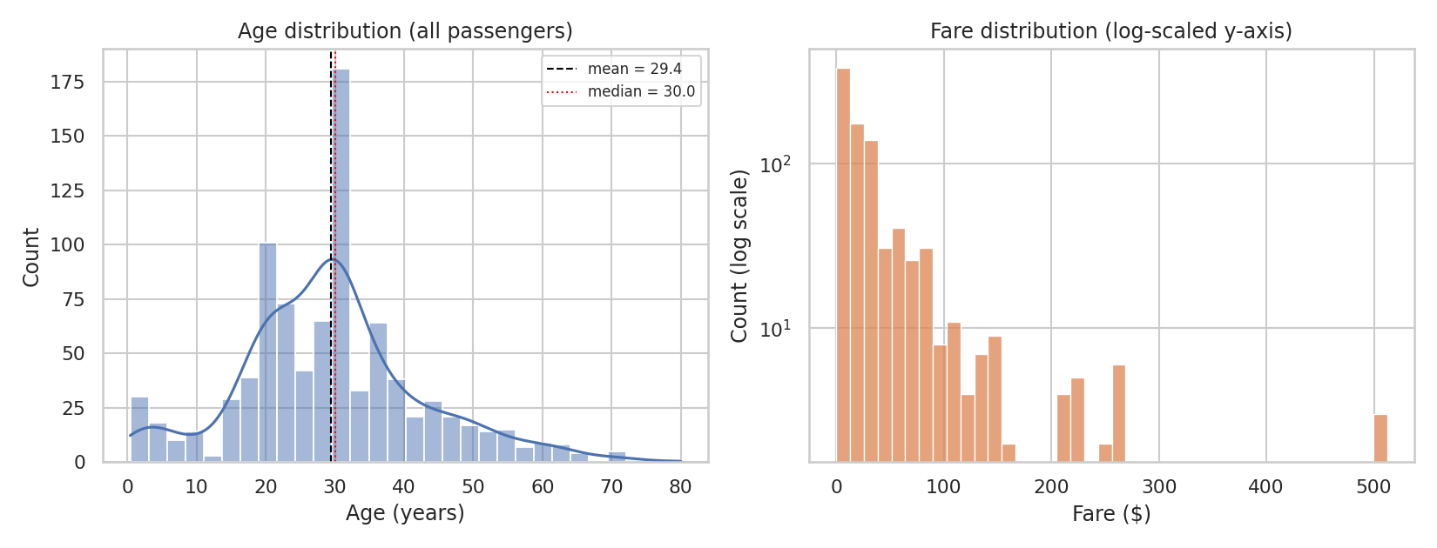
Figure 1. Age (left) and fare (right, log-scaled count axis) distributions across all 891 passengers.
Age is unimodal and roughly bell-shaped, centered in the late twenties (mean 29.4, median 30.0), with a distinct secondary bump under age 5 — infants and young children traveling with family. Fare is heavily right-skewed: most tickets cluster under $50, but the log-scaled count axis is needed just to make the rare $200-500+ tickets visible on the same chart as the far more common low fares. This confirms the skew already identified in Week 1 and is the reason fare_log is used for most of the visual comparisons later in this report.

4.2 Categorical Distributions
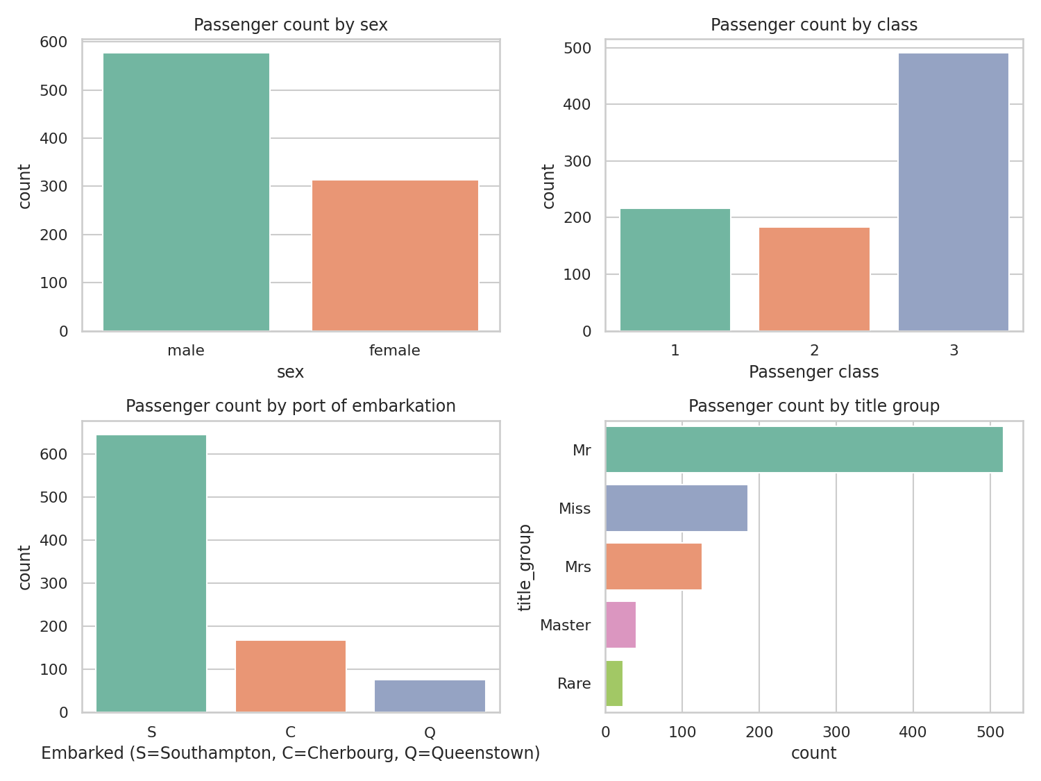
Figure 2. Passenger counts by sex, class, port of embarkation, and title group.
The passenger population is imbalanced along several dimensions that matter for interpreting later charts: almost twice as many men as women (577 vs. 314), nearly twice as many third-class as first- or second-class passengers (491 vs. 216 and 184), and the large majority boarded at Southampton (644, vs. 168 at Cherbourg and 77 at Queenstown). The Rare title group (23 passengers: officers, nobility, and clergy) and Master group (40 young boys) are both small; any survival-rate claim about them later in this report should be read with that small sample size in mind.

5. Bivariate Analysis: Relationship with Survival

5.1 Categorical Predictors vs. Survival
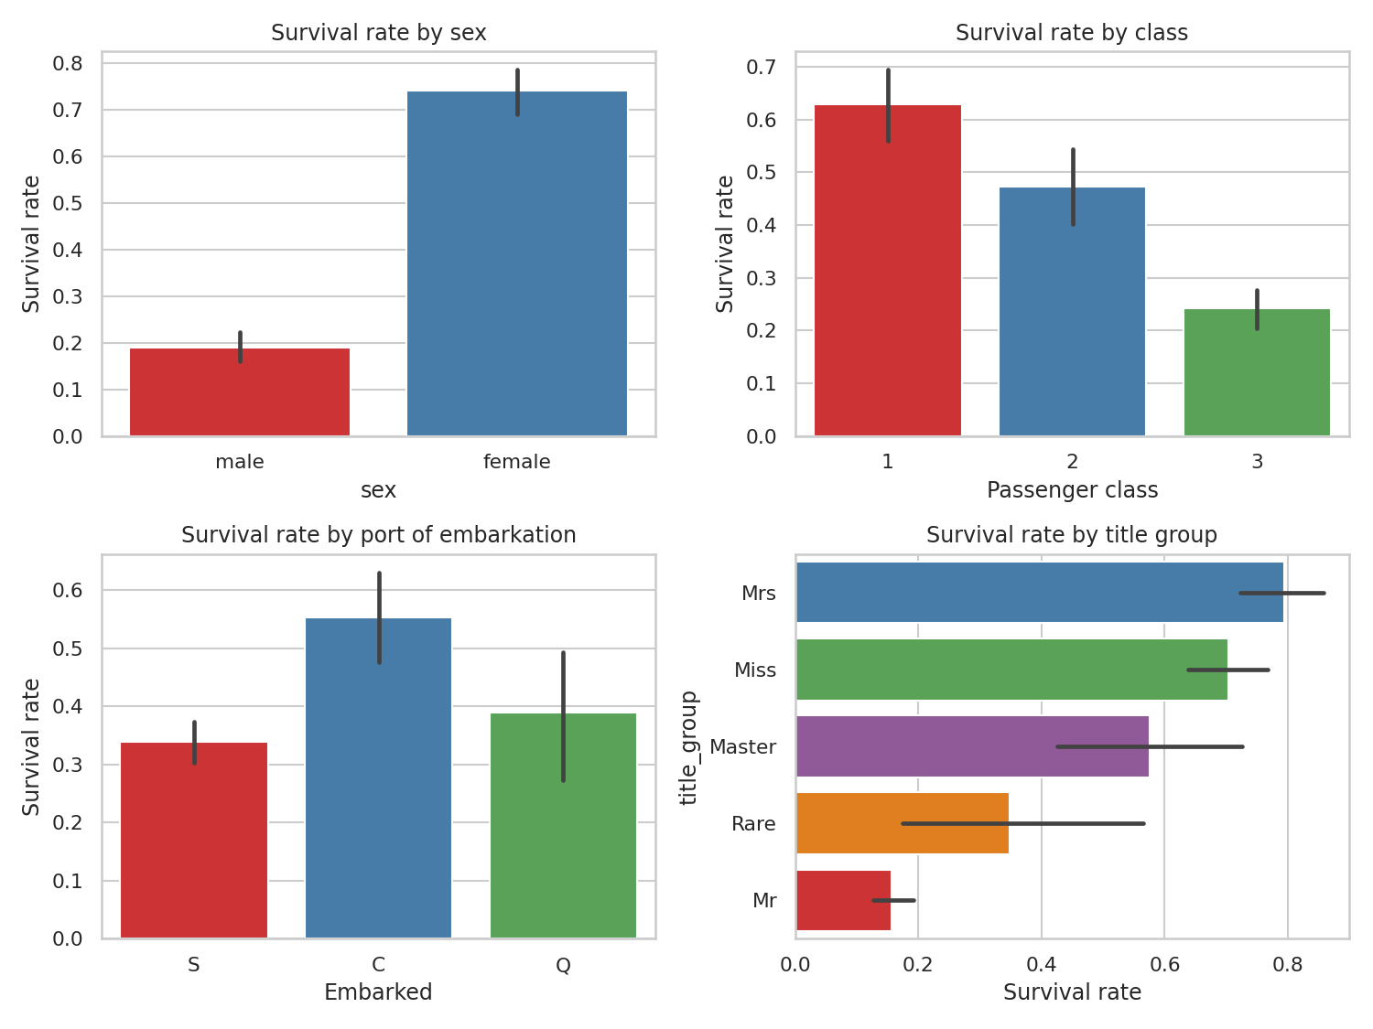
Figure 3. Survival rate by sex, class, port of embarkation, and title group (error bars: 95% CI).
Sex and class reproduce the gap already seen in the summary statistics, now with confidence intervals: the sex gap (about 19% vs. 74%) is large enough that its error bars do not come close to overlapping, while embarked's apparent “Cherbourg advantage” (55%) has much wider, overlapping intervals — a hint that at least part of it is confounded with something else (Cherbourg happened to embark a higher proportion of first-class passengers) rather than being a direct effect of the port itself. The title-group panel effectively re-derives the sex and age effects from a single feature: Mrs and Miss (adult and young women) sit at the top, Master (young boys) sits above the general male rate, and Mr (adult men) sits at the very bottom.

5.2 Numeric Predictors vs. Survival
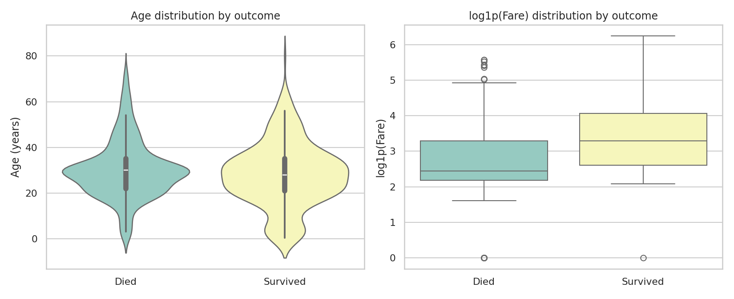
Figure 4. Age distribution (violin) and log1p(fare) distribution (box) split by outcome.
The age violin plot shows two distributions that mostly overlap — survivors are not dramatically younger overall, though the survivor violin is slightly fuller below age 10, consistent with children being prioritized. The fare box plot tells a clearer story: the median log-fare for survivors is visibly higher than for those who died, and the entire survivor box sits higher on the axis. Fare is doing a lot of the same work that class does (unsurprisingly, since fare and class are strongly related), but as a continuous variable it shows the relationship as a gradient rather than three discrete steps.

6. Multivariate Analysis

6.1 Class x Sex Interaction
df.pivot_table(index='pclass', columns='sex', values='survived', aggfunc='mean')
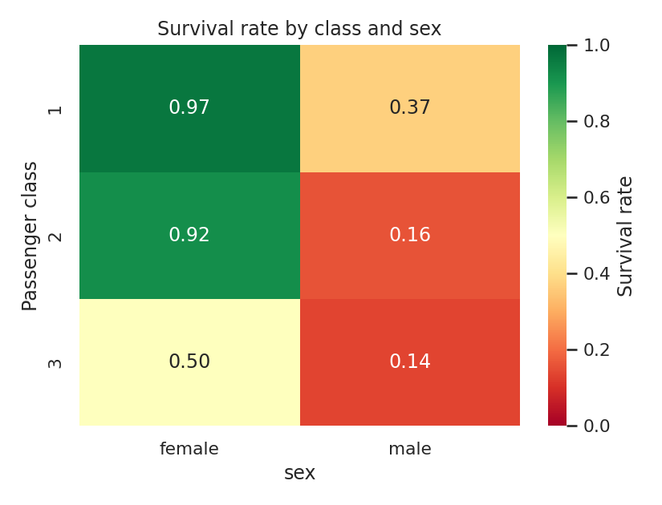
Figure 5. Survival rate by class and sex simultaneously.
This is the single most informative chart in the report, because it shows that sex and class do not act independently — they compound. First- and second-class women survived at 96.8% and 92.1% respectively, essentially regardless of class. Third-class women still survived at 50.0%, a full 47 points lower than their first-class counterparts — so being a woman helped enormously, but did not fully cancel out the disadvantage of being in third class. Men show the opposite pattern at a lower level throughout: even first-class men survived at only 36.9%, barely better than third-class men at 13.5%. The two single-variable charts in Section 5.1 each told half of this story on their own; only looking at them jointly shows that the size of the “women and children first” effect itself depended on class.

6.2 Age vs. Fare, Jointly with Outcome and Class
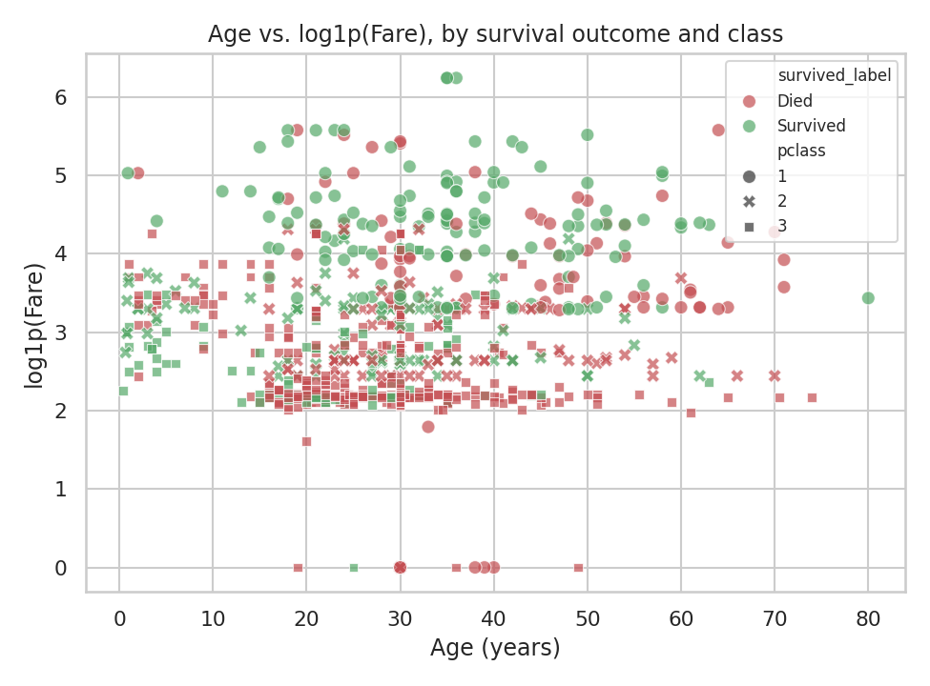
Figure 6. Age vs. log1p(fare), colored by outcome and styled by class.
This view adds two things the earlier charts could not show on their own: first, the third-class (square marker) points are heavily concentrated in the low-fare band regardless of age, and are visibly more red (died) throughout that band; first-class (circle) points are spread through the high-fare band and are visibly more green (survived) at almost every age. Second, the handful of $0-fare points (visible as a horizontal line at log1p(fare)=0) are almost all red, which is the clearest visual confirmation yet of the pattern first flagged in Week 1 and quantified in Section 3.2.

6.3 Family Size and Survival
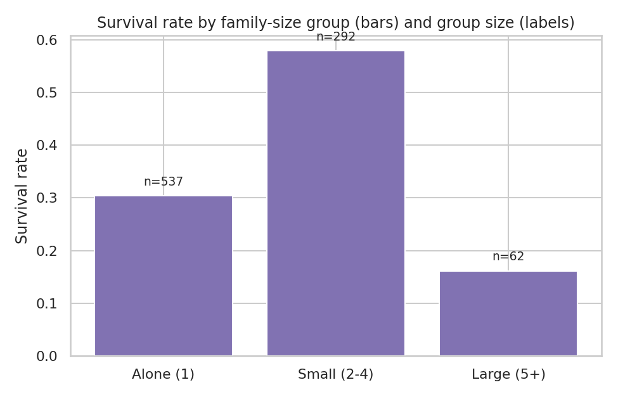
Figure 7. Survival rate by family-size group, with group sizes labeled.
Survival rate by family size is not a straight line but an inverted U: passengers traveling alone survived at 30.4% (n=537), those in small families of 2-4 survived at 57.9% (n=292) — the best outcome of the three groups — and those in large families of 5 or more dropped sharply to 16.1% (n=62). A plausible explanation is that solo travelers (disproportionately young single men in third class) had no one to help them react quickly, while very large families struggled to stay together and board lifeboats as a unit, whereas small family groups were large enough to help each other but not so large that mobility became a liability.

6.4 Deck and Survival
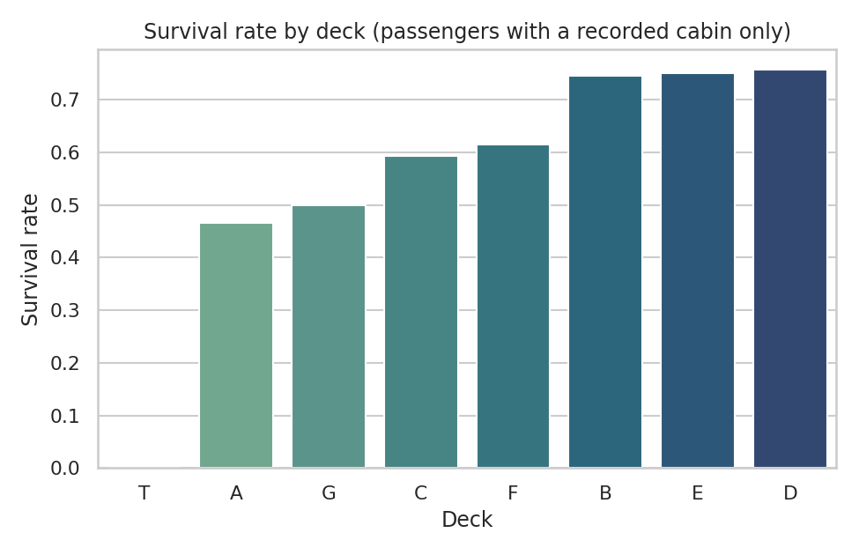
Figure 8. Survival rate by deck, for the 23% of passengers with a recorded cabin.
Among passengers whose cabin was recorded, decks B, D, and E show the highest survival (74-76%), while deck A — technically the uppermost deck — sits lower (46.7%). This is counterintuitive until cross-referenced with what is publicly documented about the ship's layout: decks B/D/E held a larger share of the boat-deck-adjacent first-class cabins actually used, while deck A had fewer, more exposed staterooms. Deck T (0%) is a single passenger and is a sample-size artifact, not a real effect, and is flagged as such rather than over-interpreted.

6.5 Correlation Matrix
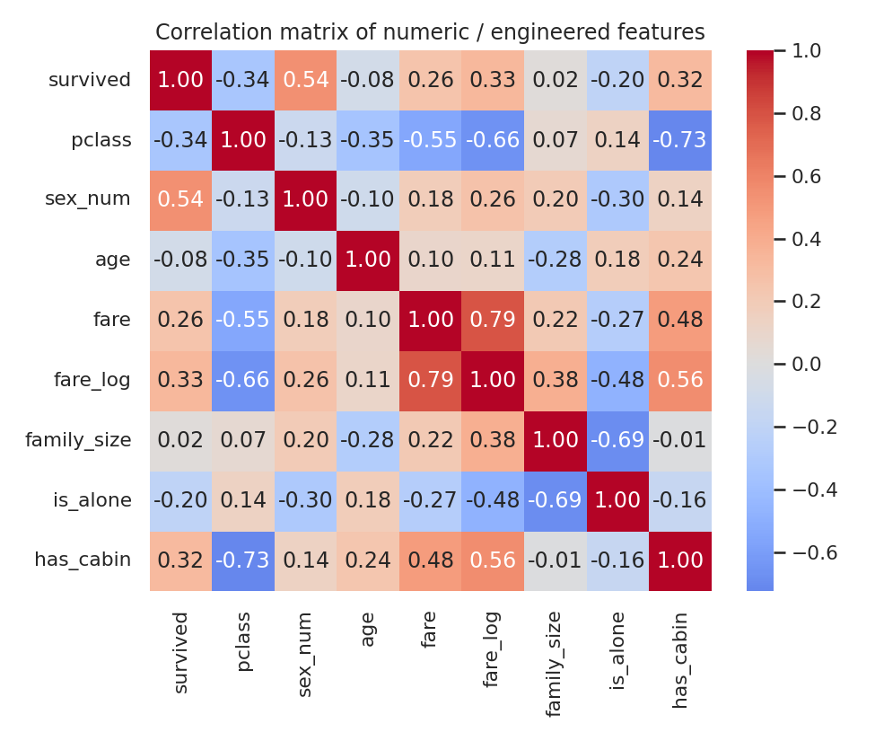
Figure 9. Pairwise correlation of numeric and engineered features.
The correlation matrix summarizes several of the visual findings numerically: sex_num (0.54) and pclass (-0.34) remain the two strongest linear correlates of survival, fare_log (0.33) and has_cabin (0.32) are close behind, and family_size correlates only weakly and near-linearly (0.02) with survival — consistent with Section 6.3's finding that the real relationship is non-linear (an inverted U) and therefore understated by a single linear correlation coefficient. This is a useful reminder that a correlation matrix can miss a real, strong relationship if that relationship isn't monotonic.

7. Statistical Significance Checks
Visual gaps can arise from genuine effects or from sampling noise, especially in the smaller subgroups. Two simple, well-known tests were used to check the four relationships emphasized above: a chi-square test of independence for the two categorical predictors, and a Welch's t-test (which does not assume equal variances) for the two numeric predictors.
chi2, p, _, _ = stats.chi2_contingency(pd.crosstab(df['sex'], df['survived']))
chi2c, pc, _, _ = stats.chi2_contingency(pd.crosstab(df['pclass'], df['survived']))
t_age, p_age = stats.ttest_ind(age_survived, age_died, equal_var=False)
t_fare, p_fare = stats.ttest_ind(fare_log_survived, fare_log_died, equal_var=False)
Test | Statistic | p-value | Conclusion
Chi-square: sex vs. survived | χ² = 260.72 | 1.2 × 10⁻⁵⁸ | Extremely significant
Chi-square: pclass vs. survived | χ² = 102.89 | 4.6 × 10⁻²³ | Extremely significant
Welch t-test: age (survived vs. died) | t = −2.30 | 0.022 | Significant, but a much smaller effect
Welch t-test: log-fare (survived vs. died) | t = 10.12 | 1.8 × 10⁻²² | Extremely significant
All four relationships are statistically significant at any conventional threshold, but the age result is a useful contrast: its p-value (0.022) is real but far less extreme than the other three, which matches the visual impression from Figure 4 that the two age distributions mostly overlap. In other words, statistical significance here confirms that age has some relationship with survival, but the sex, class, and fare effects are of an entirely different, much larger magnitude — a distinction that a p-value alone doesn't communicate as clearly as comparing all four side by side.

8. Data Transformations and Aggregations Used
Beyond the cleaning steps carried over from Week 1, this week's analysis relied on a small number of additional transformations, each included because it made a specific visualization or comparison clearer rather than as a default habit:
- log1p(fare) → fare_log. Used in Figures 4, 6, and 9. Fare's raw right skew (Section 4.1) compresses almost the entire dataset into a narrow band at the bottom of any chart that also has to show the $500+ tickets; the log transform spreads the bulk of the data out for comparison while keeping every original data point (no values were removed).
- age_group and family_group binning. Used to make Section 6.3-style group comparisons legible; five or six age buckets and three family-size buckets are far easier to read on a bar chart than a continuous axis, at the cost of losing some within-group resolution.
- Group-wise aggregation (groupby / pivot_table). Every survival-rate figure in Sections 5-6 is a groupby or pivot_table mean of the binary survived column, which is the standard way to turn a 0/1 outcome into an interpretable rate per group.
- Cross-tabulation (pd.crosstab). Used to build the contingency tables that feed directly into the chi-square tests in Section 7.

9. Key Insights and Interpretation
Pulling the sections above together, ranked roughly by strength of evidence:
- Sex was the single strongest factor, by a wide margin. 74.2% of women survived versus 18.9% of men (χ²=260.72, p≈1.2×10⁻⁵⁸) — almost certainly reflecting the “women and children first” lifeboat protocol that is well documented for this disaster.
- Class and sex compound rather than acting separately. The heatmap in Figure 5 shows the survival gap between classes is far smaller for women (96.8% → 50.0%) than the raw class averages suggest, and the benefit of being female is smaller in third class than in first — a genuinely joint effect that neither variable shows on its own.
- Fare (and by extension wealth/class) mattered on a continuous gradient, not just as three tiers. log-fare was significantly higher among survivors (t=10.12, p≈1.8×10⁻²²), and the scatter plot in Figure 6 shows this gradient holding within each class, not just between them.
- Family size has a non-linear, inverted-U relationship with survival. Small groups (2-4) outperformed both solo travelers and large families (5+), a pattern a simple correlation coefficient (0.02, Figure 9) almost completely misses — a concrete example of why visual EDA is necessary even after computing a correlation matrix.
- The zero-fare passengers are a small but striking anomaly worth flagging explicitly. Only 15 passengers, but their 6.7% survival rate versus 38.9% overall lines up with the Week 1 finding that these were non-revenue (crew-adjacent) passengers rather than a data error — a case where a data-quality footnote from one week became a real analytical finding in the next.
- Age matters, but far less than sex, class, or fare. The age effect is statistically real (p=0.022) but small next to the other three, and is best understood as a modifier of the other patterns (e.g. the Master title-group bump in Figure 3) rather than a major driver on its own.

10. Conclusion
This EDA moved from summary statistics through univariate, bivariate, and multivariate visualization to a small set of statistically checked conclusions. The two strongest, most confident findings — the effect of sex and the effect of class, and critically, how they interact rather than simply add together — are exactly the pattern most commonly cited about this disaster, and it is reassuring that an independent visual and statistical analysis of the cleaned data reproduces it clearly. The more novel findings for this exercise are the non-linear family-size effect (Section 6.3) and the re-emergence of the Week 1 zero-fare anomaly as a genuine survival-rate finding (Section 6.2) — both cases where moving from a single summary number to a full visualization changed the conclusion, which is the core argument for doing EDA at all rather than jumping straight from cleaned data to a model.

11. References
- Kaggle. “Titanic – Machine Learning from Disaster” (dataset and data dictionary). kaggle.com/c/titanic
- mwaskom/seaborn-data GitHub repository (raw/titanic.csv mirror of the Kaggle training file). github.com/mwaskom/seaborn-data
- Week 1 Task report (this internship): “Data Acquisition, Cleaning, and Preprocessing — A Case Study on the Titanic Passenger Dataset,” for the full cleaning rationale summarized in Section 2.2.
- pandas, NumPy, SciPy, scikit-learn, matplotlib, and seaborn — Python libraries used throughout for data manipulation, statistics, and visualization.

