

Project on

**Tableau IMDB Movies Ratings Data Analysis**

Tableau

Name: Ankit Verma

Prep Id: prep0122092@prepleaf.com

**1.KPIs- avg duration, Gross, avg IMDB score, no. of records**

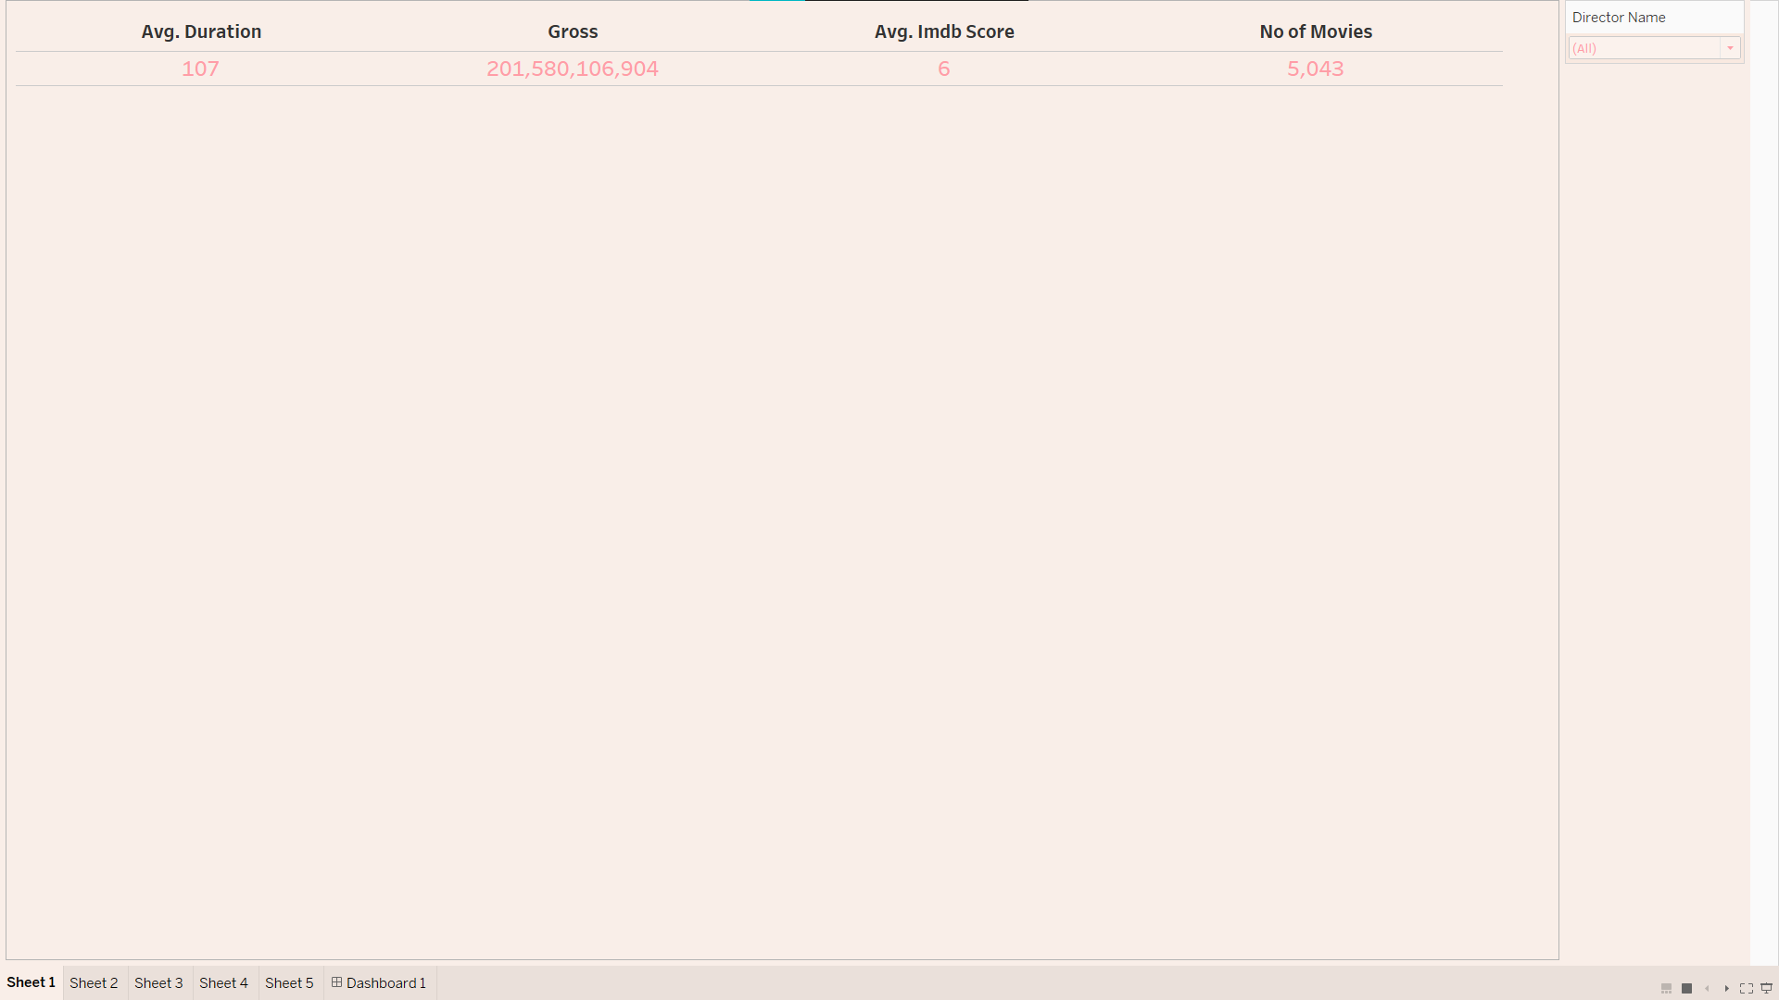

Link: https://public.tableau.com/views/Project_P5/Sheet1?:language=en-US&publish=yes&:display_count=n&:origin=viz_share_link

**2. Tree map - Genre by revenue**

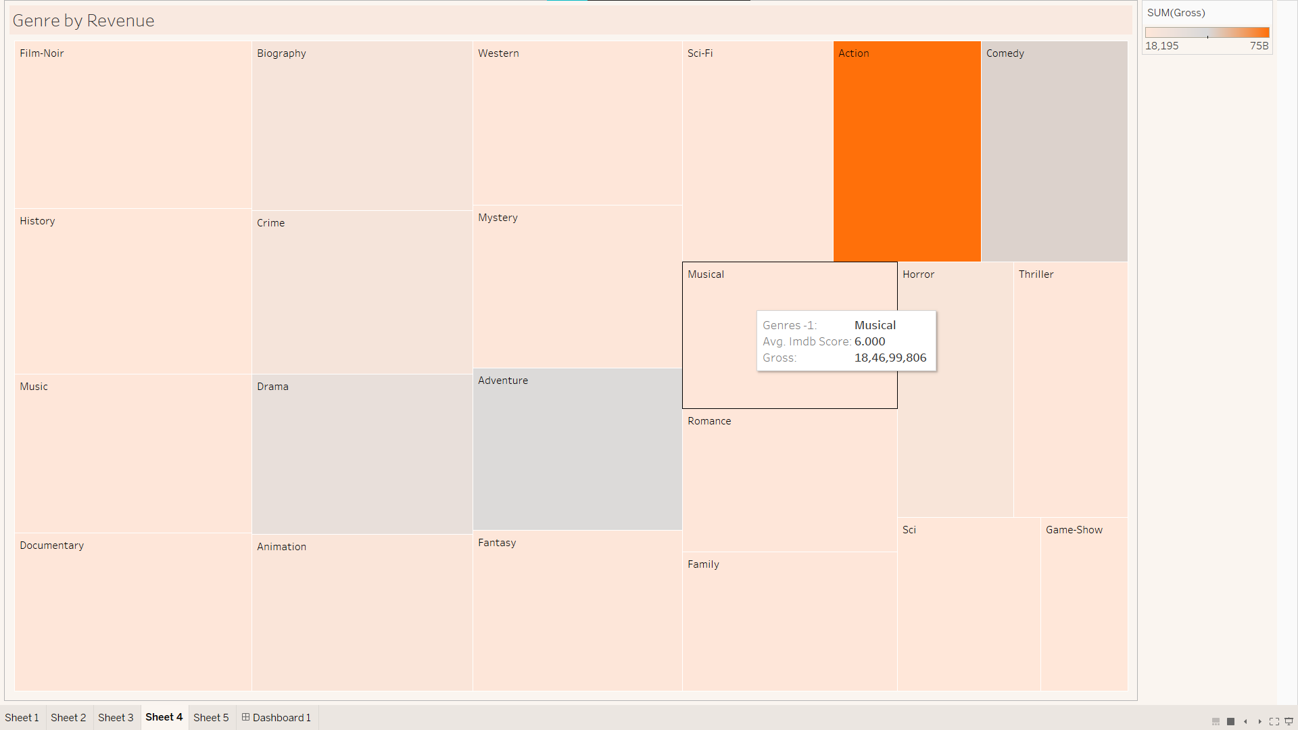

**Link:** https://public.tableau.com/views/Project_P2/Sheet4?:language=en-US&publish=yes&:display_count=n&:origin=viz_share_link

**3. Bar chart - favourite actor**

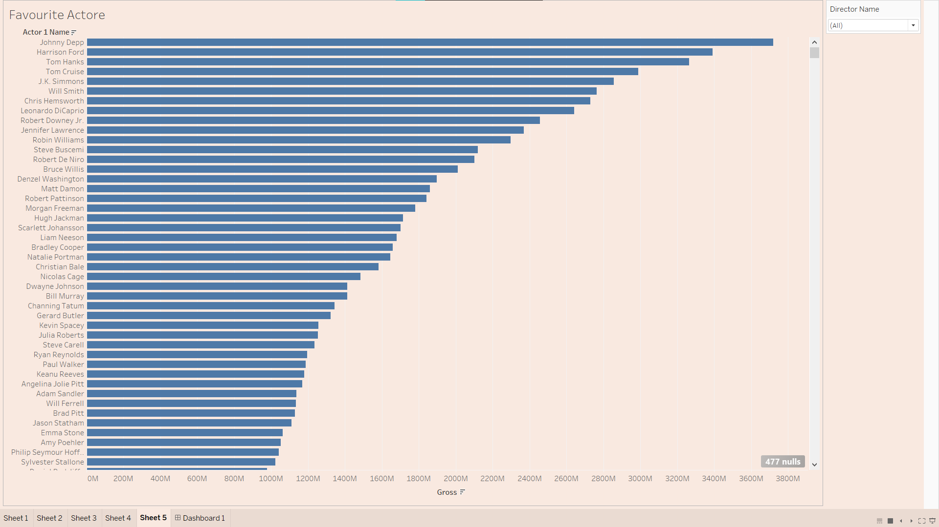

**Link:** https://public.tableau.com/views/Project_P1/Sheet5?:language=en-US&publish=yes&:display_count=n&:origin=viz_share_link

**4. Visualize the movie by duration and gross revenue**

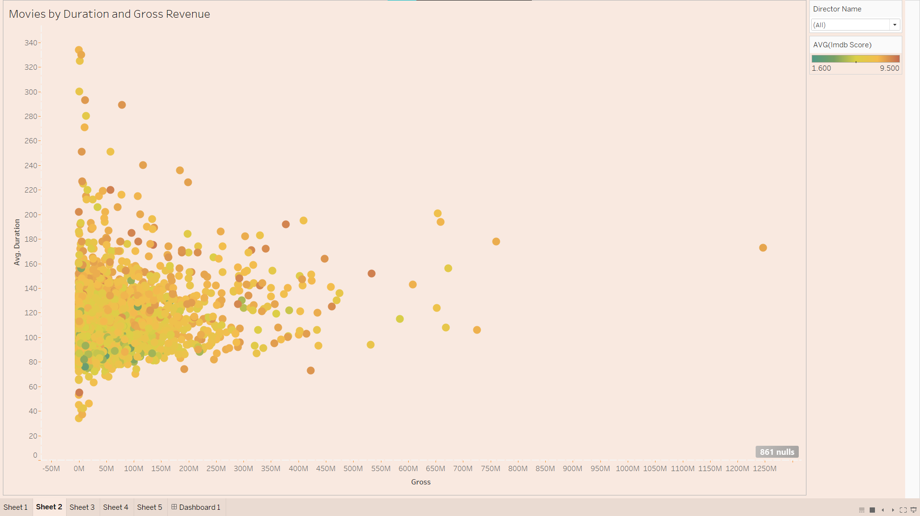 **Link:** <https://public.tableau.com/views/Project_P4/Sheet2?:language=en-US&publish=yes&:display_count=n&:origin=viz_share_link>

**5. Visualize no. of movies**

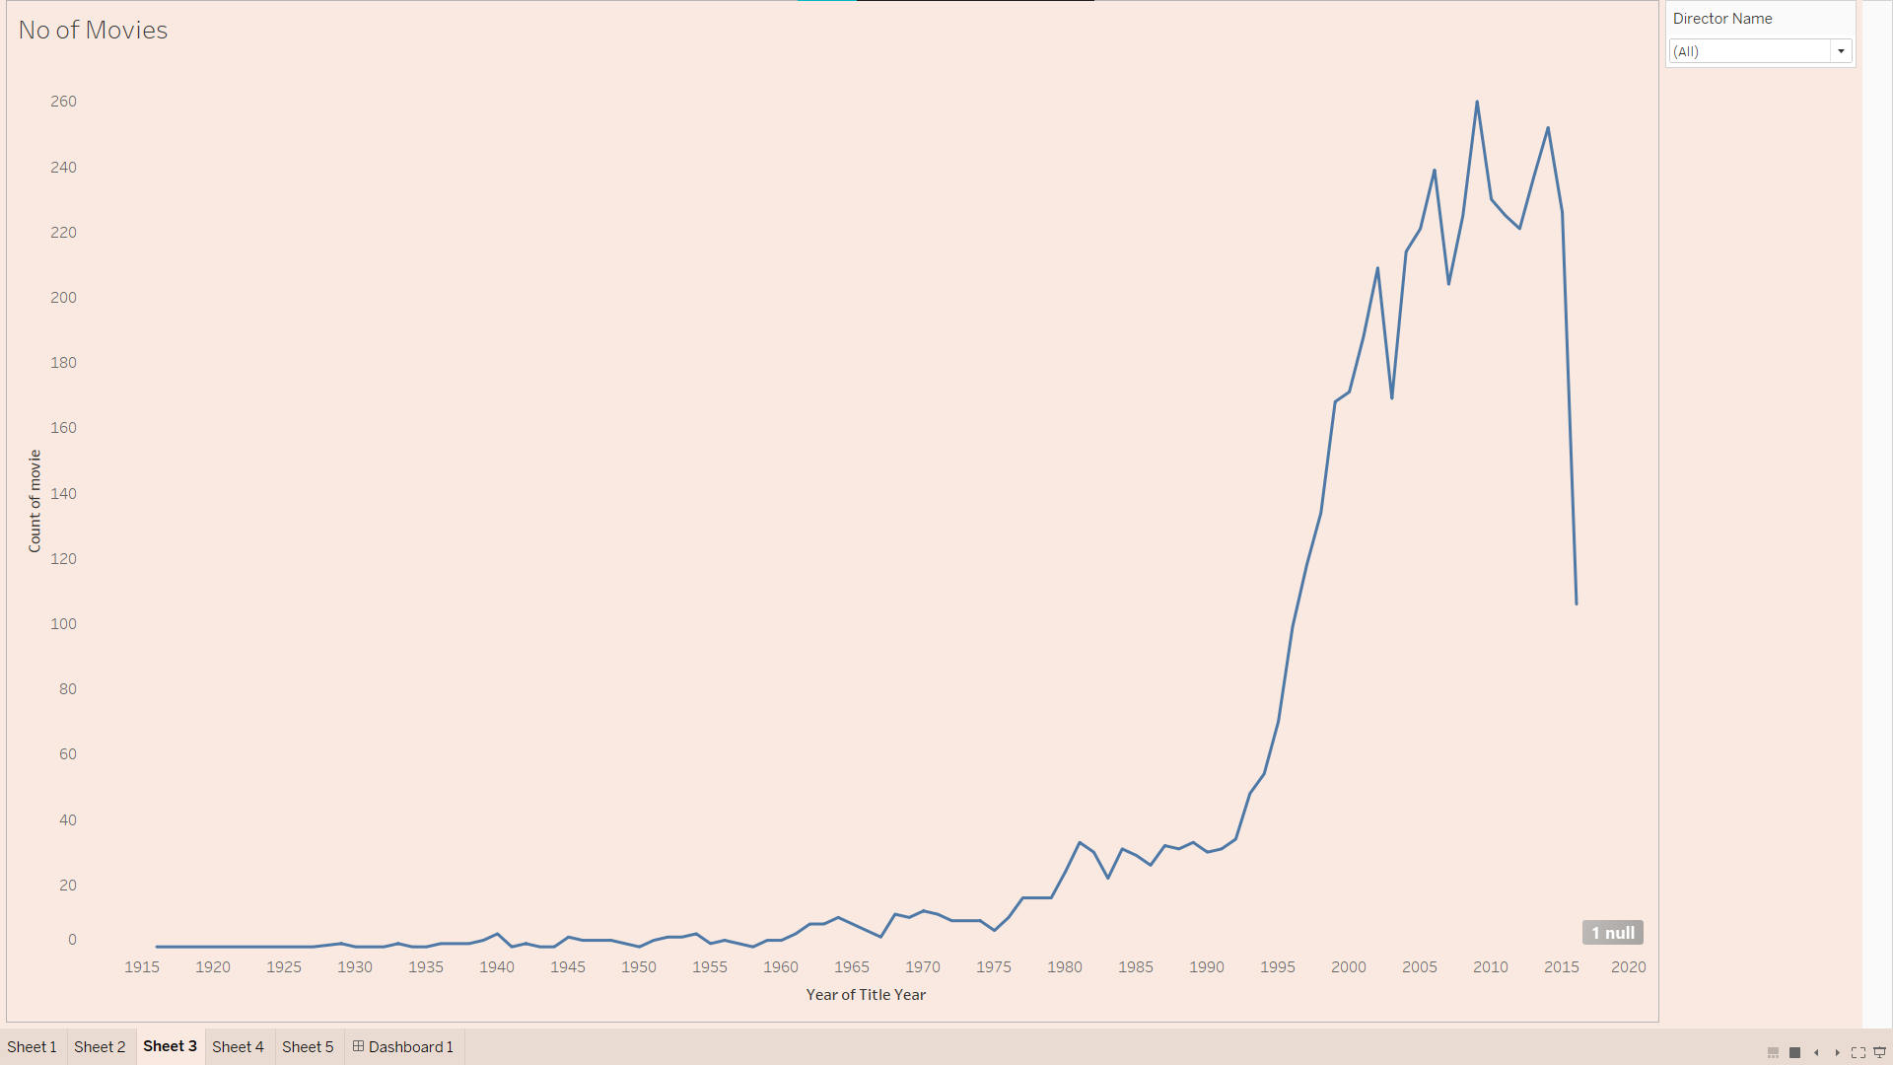

**Link:** https://public.tableau.com/views/Project_P3/Sheet3?:language=en-US&publish=yes&:display_count=n&:origin=viz_share_link

**Dashboard**

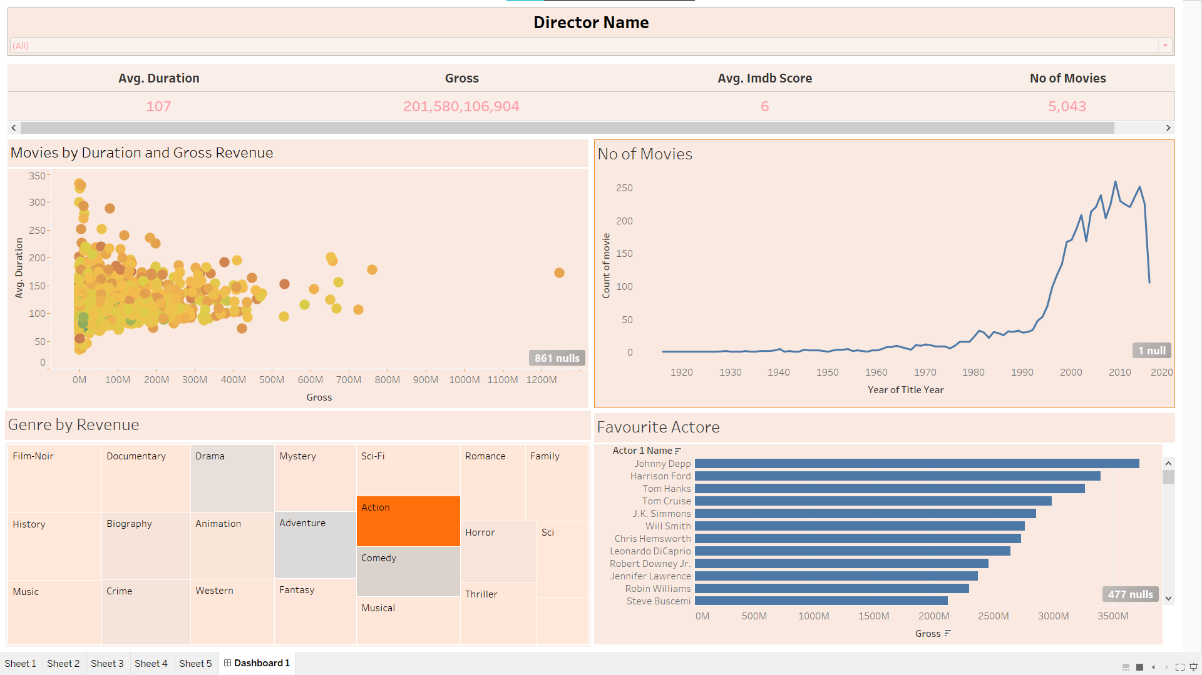

**Link:** https://public.tableau.com/views/Project_Dashboard_16567384092800/Dashboard1?:language=en-US&:display_count=n&:origin=viz_share_link

