* 

**SQL Assignment**

Name: Ankit Verma

Mobile no: +91-7004518207

Email: ankitv2524@gmail.com

**Actual Query is in the last Slide ↓**

|  |  |  |
| --- | --- | --- |
| **Write a script block in any RDBMS (MySQL Work benck /Oracle /SQL Server etc ) for performing the below** | |  |
|  |  |  |
| **1. Create Plan database and load the above data into a table from an excel or csv file into it** | |  |
| **2. Calculate the BillValue based on the Usage and UsageRateSlabs. The calculation should be done in the script not preloaded from the excel** | |  |
| **3. The rate slabs should not be hardcoded in the script written and should be read from the database. If the value changes, then the result should without needing to change the code.** | |  |
|  | |  |
|  |  |  |
|  |  |  |
| **One example is given** | |  |
| **Example: for Plan A, based on the customer usage and rate slabs the bill value will be calculated as below** | |  |
| **Based on the usage of 33000, the BillValue = 6300** | |  |
| **Calculation: =10000*0.25+10000*0.2+10000*0.15+3000*0.1** | |  |

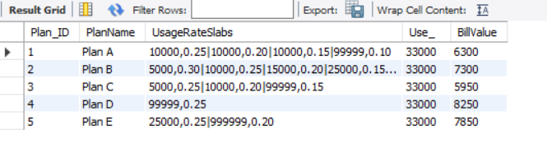

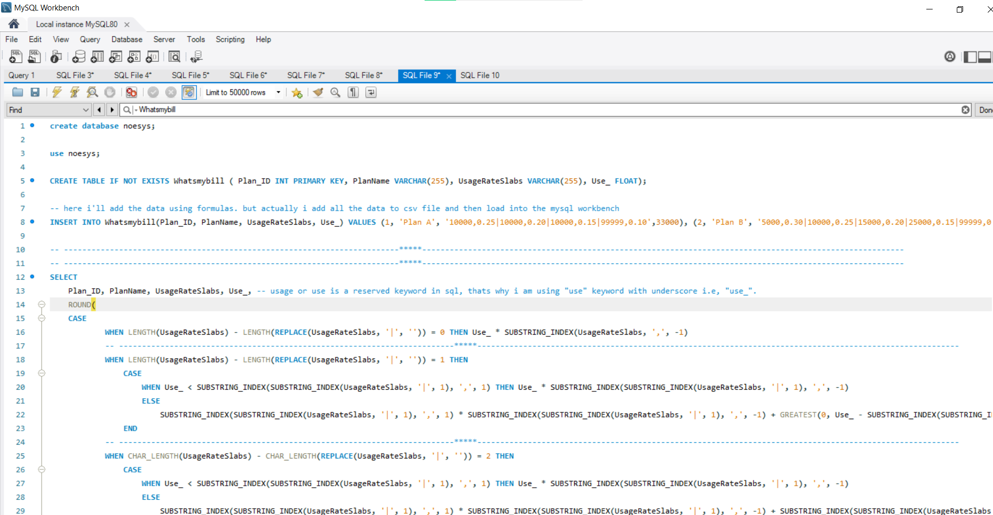

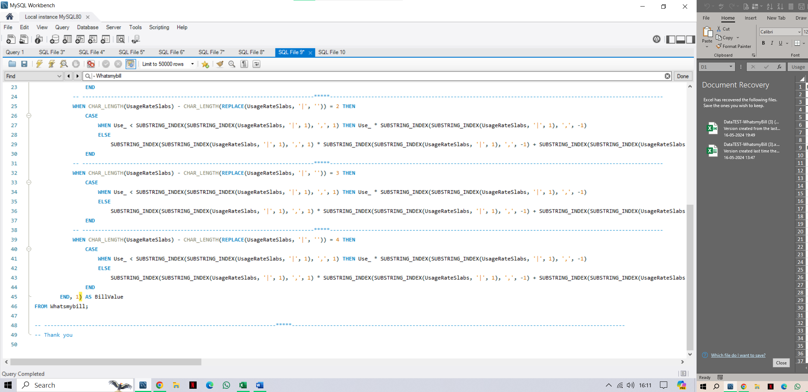

**SQL QUERY:** This is a simple copy data from MySQL work bench

create database noesys;

use noesys;

CREATE TABLE IF NOT EXISTS Whatsmybill ( Plan_ID INT PRIMARY KEY, PlanName VARCHAR(255), UsageRateSlabs VARCHAR(255), Use_ FLOAT);

**-- here i'll add the data using queries. but actually i add all the data to csv file and then load into the mysql workbench**

INSERT INTO Whatsmybill(Plan_ID, PlanName, UsageRateSlabs, Use_) VALUES (1, 'Plan A', '10000,0.25|10000,0.20|10000,0.15|99999,0.10',33000), (2, 'Plan B', '5000,0.30|10000,0.25|15000,0.20|25000,0.15|99999,0.10',33000), (3, 'Plan C', '5000,0.25|10000,0.20|99999,0.15', 33000), (4, 'Plan D', '99999,0.25', 33000), (5, 'Plan E','25000,0.25|999999,0.20', 33000);

-- -------------------------------------------------------------------------*****---------------------------------------------------------------------------------------------------------

-- -------------------------------------------------------------------------*****---------------------------------------------------------------------------------------------------------

SELECT

Plan_ID, PlanName, UsageRateSlabs, Use_, -- usage or use is a reserved keyword in sql, thats why i am using "use" keyword with underscore i.e, "use_".

ROUND(

CASE

WHEN LENGTH(UsageRateSlabs) - LENGTH(REPLACE(UsageRateSlabs, '|', '')) = 0 THEN Use_ * SUBSTRING_INDEX(UsageRateSlabs, ',', -1)

-- -------------------------------------------------------------------------*****---------------------------------------------------------------------------------------------------------

WHEN LENGTH(UsageRateSlabs) - LENGTH(REPLACE(UsageRateSlabs, '|', '')) = 1 THEN

CASE

WHEN Use_ < SUBSTRING_INDEX(SUBSTRING_INDEX(UsageRateSlabs, '|', 1), ',', 1) THEN Use_ * SUBSTRING_INDEX(SUBSTRING_INDEX(UsageRateSlabs, '|', 1), ',', -1)

ELSE

SUBSTRING_INDEX(SUBSTRING_INDEX(UsageRateSlabs, '|', 1), ',', 1) * SUBSTRING_INDEX(SUBSTRING_INDEX(UsageRateSlabs, '|', 1), ',', -1) + GREATEST(0, Use_ - SUBSTRING_INDEX(SUBSTRING_INDEX(UsageRateSlabs, '|', 1), ',', 1)) * SUBSTRING_INDEX(SUBSTRING_INDEX(UsageRateSlabs, '|', 2), ',', -1)

END

-- -------------------------------------------------------------------------*****---------------------------------------------------------------------------------------------------------

WHEN CHAR_LENGTH(UsageRateSlabs) - CHAR_LENGTH(REPLACE(UsageRateSlabs, '|', '')) = 2 THEN

CASE

WHEN Use_ < SUBSTRING_INDEX(SUBSTRING_INDEX(UsageRateSlabs, '|', 1), ',', 1) THEN Use_ * SUBSTRING_INDEX(SUBSTRING_INDEX(UsageRateSlabs, '|', 1), ',', -1)

ELSE

SUBSTRING_INDEX(SUBSTRING_INDEX(UsageRateSlabs, '|', 1), ',', 1) * SUBSTRING_INDEX(SUBSTRING_INDEX(UsageRateSlabs, '|', 1), ',', -1) + SUBSTRING_INDEX(SUBSTRING_INDEX(UsageRateSlabs, '|', 2), '|', -1) * SUBSTRING_INDEX(SUBSTRING_INDEX(UsageRateSlabs, '|', 2), ',', -1) + GREATEST(0, Use_ - SUBSTRING_INDEX(SUBSTRING_INDEX(UsageRateSlabs, '|', 1), ',', 1) - SUBSTRING_INDEX(SUBSTRING_INDEX(UsageRateSlabs, '|', 2), '|', -1)) * SUBSTRING_INDEX(SUBSTRING_INDEX(SUBSTRING_INDEX(UsageRateSlabs, '|', 3), '|', -1), ',', -1)

END

-- -------------------------------------------------------------------------*****---------------------------------------------------------------------------------------------------------

WHEN CHAR_LENGTH(UsageRateSlabs) - CHAR_LENGTH(REPLACE(UsageRateSlabs, '|', '')) = 3 THEN

CASE

WHEN Use_ < SUBSTRING_INDEX(SUBSTRING_INDEX(UsageRateSlabs, '|', 1), ',', 1) THEN Use_ * SUBSTRING_INDEX(SUBSTRING_INDEX(UsageRateSlabs, '|', 1), ',', -1)

ELSE

SUBSTRING_INDEX(SUBSTRING_INDEX(UsageRateSlabs, '|', 1), ',', 1) * SUBSTRING_INDEX(SUBSTRING_INDEX(UsageRateSlabs, '|', 1), ',', -1) + SUBSTRING_INDEX(SUBSTRING_INDEX(UsageRateSlabs, '|', 2), ',', 1) * SUBSTRING_INDEX(SUBSTRING_INDEX(UsageRateSlabs, '|', 2), ',', -1) + SUBSTRING_INDEX(SUBSTRING_INDEX(UsageRateSlabs, '|', 3), ',', 1) * SUBSTRING_INDEX(SUBSTRING_INDEX(UsageRateSlabs, '|', 3), ',', -1) + GREATEST(0, Use_ - SUBSTRING_INDEX(SUBSTRING_INDEX(UsageRateSlabs, '|', 1), ',', 1) - SUBSTRING_INDEX(SUBSTRING_INDEX(UsageRateSlabs, '|', 2), ',', 1) - SUBSTRING_INDEX(SUBSTRING_INDEX(UsageRateSlabs, '|', 3), ',', 1)) * SUBSTRING_INDEX(SUBSTRING_INDEX(UsageRateSlabs, '|', 4), ',', -1)

END

-- -------------------------------------------------------------------------*****---------------------------------------------------------------------------------------------------------

WHEN CHAR_LENGTH(UsageRateSlabs) - CHAR_LENGTH(REPLACE(UsageRateSlabs, '|', '')) = 4 THEN

CASE

WHEN Use_ < SUBSTRING_INDEX(SUBSTRING_INDEX(UsageRateSlabs, '|', 1), ',', 1) THEN Use_ * SUBSTRING_INDEX(SUBSTRING_INDEX(UsageRateSlabs, '|', 1), ',', -1)

ELSE

SUBSTRING_INDEX(SUBSTRING_INDEX(UsageRateSlabs, '|', 1), ',', 1) * SUBSTRING_INDEX(SUBSTRING_INDEX(UsageRateSlabs, '|', 1), ',', -1) + SUBSTRING_INDEX(SUBSTRING_INDEX(UsageRateSlabs, '|', 2), ',', 1) * SUBSTRING_INDEX(SUBSTRING_INDEX(UsageRateSlabs, '|', 2), ',', -1) + SUBSTRING_INDEX(SUBSTRING_INDEX(UsageRateSlabs, '|', 3), ',', 1) * SUBSTRING_INDEX(SUBSTRING_INDEX(UsageRateSlabs, '|', 3), ',', -1) + SUBSTRING_INDEX(SUBSTRING_INDEX(UsageRateSlabs, '|', 4), ',', 1) * SUBSTRING_INDEX(SUBSTRING_INDEX(UsageRateSlabs, '|', 4), ',', -1) + GREATEST(0, Use_ - SUBSTRING_INDEX(SUBSTRING_INDEX(UsageRateSlabs, '|', 4), ',', 1)) * SUBSTRING_INDEX(SUBSTRING_INDEX(UsageRateSlabs, '|', 5), ',', -1)

END

END, 1) AS BillValue

FROM Whatsmybill;

-- -------------------------------------------------------------------------*****---------------------------------------------------------------------------------------------------------

-- Thank you