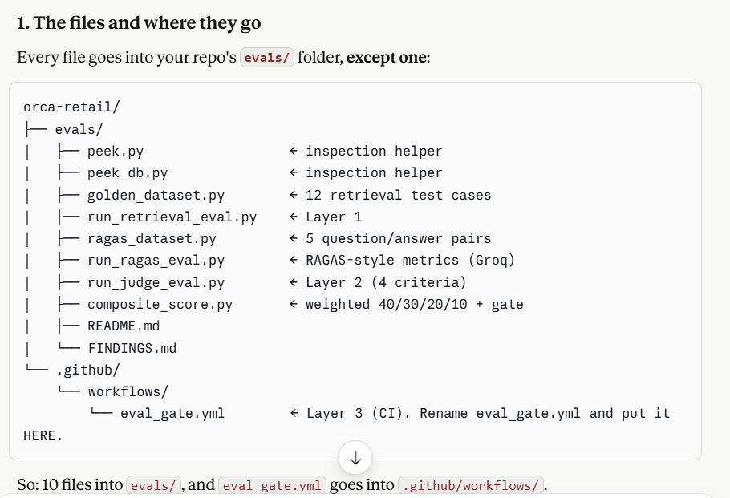

I have pasted all codes. but few things make pe understadn in plain english like andrew ng. Layer 1 i inderstood the test case thing as i run that earlier this morning. what is this ragas dataset and what values it is adding to eval step. we ran layer 2 in morning right, but what extra things you added

Great questions — let me explain both like you're sitting across from me, no jargon. You understood Layer 1 by doing it this morning, so I'll build on that.
First, a quick recap of what you already get
Layer 1 (retrieval eval) answers one question: "Did the right policy text show up in what the agent reads?" You check for keywords. It's fast, free, and shallow — it only knows if words are present, not if the agent used them well.
That "shallow" part is the gap. Layer 1 can't tell you if the agent actually gave a good answer. That's where the next two pieces come in.

What is ragas_dataset.py and what does it add?
Think of Layer 1 like checking if a student's textbook is open to the right page. Useful — but it doesn't tell you if the student wrote a good answer.
run_ragas_eval.py checks the answer quality, and ragas_dataset.py is the question bank with answer keys it uses.
Here's the difference in plain terms:
 | Layer 1 (retrieval) | RAGAS-style eval
Checks | Is the right text present? | Is the answer actually good?
How | keyword match | a smart LLM grades it
Example | "does 'CP003' appear?" | "did the answer correctly say the limit is 20,000?"
What's in ragas_dataset.py? Just 5 question + correct-answer pairs, like a teacher's answer key:
python
{
"question": "What is the auto-approve limit for CP003?",
"ground_truth": "AED 20,000. Orders above it require approval.",
}
What the eval does with each pair:
- Retrieves the real policy context for that question.
- Asks the agent model (the small llama-3.1-8b) to answer the question using that context.
- Asks the judge model (the big llama-3.3-70b) to grade that answer on 4 quality measures:
- faithfulness — did the answer stick to the context, or make stuff up? (catches hallucination)
- context_recall — did the retrieved context actually contain all the facts needed? (the "silent failure" check)
- context_precision — was the context relevant, or full of noise?
- answer_relevance — did the answer actually address the question?
The value it adds: Layer 1 says "the words were there." RAGAS-style says "and here's a 0–1 score for whether the answer built from those words is actually good and grounded." It's the deeper quality layer keyword-matching can't reach. Those are the industry-standard RAG metrics (the 0.80 / 0.75 / 0.70 thresholds you wanted).
Note: we're computing these ourselves with the Groq judge instead of the ragas library (which wouldn't install). Same metrics, same definitions — just no broken dependency.

What's extra in Layer 2 vs this morning?
This morning your judge graded one thing: consistency (does the briefing match the decision). That's what found the briefing bug.
The new run_judge_eval.py grades four things per saved decision instead of one:
1. consistency ← you had this morning (briefing vs decision agree?)
2. hitl_accuracy ← NEW: was approval triggered exactly when cost > limit?
3. scoring_accuracy ← NEW: did Agent 3 do the scoring math correctly?
4. classa_safety ← NEW: was Option B correctly never used for Class A?
So this morning's version was 1 question per run. The new version is 4 questions per run — it checks the agent's decision quality from four angles, not just one. Each gets its own 1–5 score and the summary shows an average per criterion.
In plain terms: this morning the judge was a reviewer checking only "do these two things match?" Now it's a reviewer checking "do they match, did you escalate correctly, is your math right, and did you follow the Class-A safety rule?" — a much more thorough review.

The one-line mental model
Layer 1 : are the right facts PRESENT? (keyword, free, fast)
RAGAS : is the ANSWER built from them GOOD? (4 quality scores, Groq)
Layer 2 : is the DECISION good across 4 rules? (4 judge criteria, Groq)
Composite: roll it all into one number + gate. (the 40/30/20/10 weighting)
Each layer goes one level deeper: facts present → answer quality → decision quality → single score.

so judge model is being used at two places right?? also we have not done the ragas way right due to limitation. Help me to visualize how a FAANG company would do this step as I have my google interview and I need to show then that I reaslly worked he he he

Yes — you've got it exactly right on both counts. Let me confirm, then build you the visualization for your Google interview.
Your two observations — both correct
1. The judge model is used in two places. Yes:
- In run_ragas_eval.py → grades answer quality (faithfulness, recall, precision, relevance)
- In run_judge_eval.py → grades decision quality (the 4 criteria)
Same judge model (llama-3.3-70b), two different jobs. That's normal and good — one strong judge, reused.
2. We did NOT use the real RAGAS library. Correct. We computed the same metrics with the Groq judge because the ragas package conflicted with your LangChain. Be honest about this in the interview — it's actually a strength (more on that below).
Let me build the visual.
Now let me build the visual — a diagram showing how a FAANG company runs this eval pipeline, mapping each piece to what you actually built.
That's the FAANG pattern. Now here's the part that matters for your Google interview — how what you built maps onto it, and what they'd add at scale.
Your ORCA files → the FAANG pipeline
Pipeline stage | What you built | What Google adds at scale
Golden dataset | golden_dataset.py + ragas_dataset.py | 100s–1000s of cases, version-controlled, reviewed like code
Retrieval eval | run_retrieval_eval.py | same idea, plus nDCG/recall@k ranking metrics
LLM-as-judge | run_judge_eval.py + run_ragas_eval.py | a cross-vendor judge (e.g. Gemini grading a non-Gemini agent), human-calibrated
Composite + gate | composite_score.py | dashboards, historical trend tracking
CI gate | eval_gate.yml | blocks merges on every PR, runs on a fleet
Online sampling | (not built — the honest gap) | grade 1–5% of real traffic, alert on drift
The shape is identical. The difference is scale and polish, not concept. You built the real thing in miniature.
How to talk about it in the interview (this is the gold)
Three things will land hard with a Google interviewer:
1. The two-layer insight. Say this:
"I evaluate retrieval and generation separately. A system can score high on faithfulness — the answer matches the context — while context recall is low, because the retriever quietly missed documents. Faithfulness stays high because the model answers coherently from partial context. You only catch it by measuring both layers."
That single point separates people who've done eval from people who've read about it.
2. The bug you found. This is your strongest card — you didn't just build tests, you found a real production bug with them:
"My LLM-judge flagged 7 of 10 runs for inconsistency. I verified two by hand — the human approval briefing named a different option and cost than the system actually chose. In a real system a human would approve based on wrong information. That's the kind of silent failure eval exists to catch."
3. The RAGAS honesty. Do NOT hide that you didn't use the library. Flip it into a strength:
"I wanted RAGAS, but the package hard-imports a Vertex class that conflicted with our LangChain version and a forced install destabilized the agent stack. So I implemented the same four metrics — faithfulness, context recall, context precision, answer relevance — directly with the judge model. The metric definitions are what matter; the library is replaceable. And implementing them myself means I can explain exactly how each is computed."
A senior engineer makes exactly that call — knowing when a dependency isn't worth the risk. That story shows judgment, not just coding.
The one honest caveat to mention (shows maturity)
If they probe, volunteer the limitation:
"The gap in my version is online eval — I built the offline gate and the harness for live sampling, but I haven't wired up production traffic grading and drift alerting yet. That'd be the next step."
Naming your own gap makes everything else you claim more credible.

just tell me how ragas works for those 4 things
3:52 PM
Sure — here's how RAGAS computes those 4 metrics under the hood, in plain terms. The core trick for all of them: break text into individual claims, then check each claim with an LLM. Don't compare whole paragraphs — compare piece by piece.
Let me walk through each.
1. Faithfulness — "did the answer make things up?"
Step 1: Take the ANSWER. Break it into separate factual claims.
Step 2: For each claim, ask the LLM: "Is this supported by the CONTEXT? yes/no"
Step 3: Score = (claims supported) / (total claims)
Example: Answer = "CP003's limit is AED 20,000 and it refreshes weekly."
- Claim 1: "limit is AED 20,000" → context says so → ✅
- Claim 2: "refreshes weekly" → context says quarterly → ❌
- Faithfulness = 1/2 = 0.5
It catches hallucination by checking each claim against the retrieved text, not vibes.
2. Answer Relevance — "did it actually answer the question?"
Step 1: Take the ANSWER. Ask the LLM to generate questions this answer would answer.
Step 2: Compare those generated questions to the ORIGINAL question (via embeddings).
Step 3: Score = how similar they are (high = the answer was on-point).
Intuition: if your answer is good, you should be able to reconstruct the original question from it. If the answer rambles off-topic, the reconstructed questions won't match the real one. This is the one metric that needs embeddings (to measure similarity), which is why RAGAS needs an embedding model.
3. Context Recall — "did retrieval find everything needed?"
Step 1: Take the GROUND-TRUTH answer. Break it into claims.
Step 2: For each claim, ask the LLM: "Is this claim present in the retrieved CONTEXT? yes/no"
Step 3: Score = (claims found in context) / (total ground-truth claims)
Key: this uses the ground truth, not the answer. It asks: of the facts a correct answer needs, how many did the retriever actually pull? If a needed fact isn't in the context, recall drops — even if the answer happened to sound fine. This is the silent-failure metric.
4. Context Precision — "was the retrieved context relevant, or noisy?"
Step 1: Look at each chunk in the retrieved CONTEXT.
Step 2: Ask the LLM: "Is this chunk relevant to answering the question? yes/no"
Step 3: Score rewards relevant chunks ranked HIGH (near the top), penalizes noise.
Intuition: if the retriever pulled 5 chunks and only 2 were useful — and the 2 useful ones were buried at the bottom — precision is low. It measures signal-to-noise and ranking.

The pattern across all four
faithfulness : answer claims → checked against context
context_recall : ground-truth claims → checked against context (the silent-failure one)
context_precision : context chunks → checked for relevance to question
answer_relevance : answer → reverse-engineer question, compare (needs embeddings)
Three of them are "break into claims, ask the LLM yes/no on each, take the ratio." One (relevance) uses embeddings to compare reconstructed questions.
That's exactly what your run_ragas_eval.py does — it asks the Groq judge for the ratio directly instead of importing the library. Same definitions, same logic.
One interview-ready line: "RAGAS is mostly claim decomposition plus an LLM yes/no on each claim — faithfulness checks the answer's claims against context, recall checks the ground-truth's claims against context. The library is convenience; the method is simple enough to implement directly, which is what I did."

so if we would have gone the raags way , then have we created ragas_dataset too ?
3:56 PM
Yes — you'd still need ragas_dataset.py (or its equivalent). RAGAS doesn't invent test data; you have to supply it. Let me show you exactly what RAGAS needs as input, because this clears up what the library does vs. what you provide.
What RAGAS needs from you (the dataset)
RAGAS evaluates a dataset where each row has up to 4 columns:
question ← you write this
ground_truth ← you write this (the correct answer)
contexts ← what your retriever returned for that question
answer ← what your agent generated for that question
The first two (question, ground_truth) are exactly what's in your ragas_dataset.py — the question + correct-answer pairs. So yes, you'd have created that file either way. RAGAS can't grade without knowing the question and what "correct" looks like.
The last two (contexts, answer) aren't hand-written — your pipeline produces them at eval time (retrieve context, generate answer). That's the part the eval script fills in automatically.
So who makes what
YOU provide (the dataset):
question → "What is CP003's auto-approve limit?"
ground_truth → "AED 20,000"

YOUR PIPELINE generates (at run time):
contexts → the chunks the retriever pulled
answer → what the agent said

RAGAS computes (the metrics):
faithfulness, context_recall, context_precision, answer_relevance
The only difference between RAGAS-way and your way
It's tiny — just the format you hand the data over in:
RAGAS way — you'd shape the dataset into RAGAS's required object:
python
from datasets import Dataset
data = Dataset.from_dict({
"question": [...],
"ground_truth": [...],
"contexts": [[...], [...]], # list of chunks per question
"answer": [...],
})
result = evaluate(data, metrics=[faithfulness, ...], llm=..., embeddings=...)
Your way — same question/ground_truth pairs in ragas_dataset.py, but you loop and call the Groq judge yourself instead of handing it to evaluate().
Same dataset. Same inputs. Same metrics. The only thing RAGAS would have added is the evaluate() function that does the claim-decomposition loop for you — the loop you now do explicitly in run_ragas_eval.py.
So: ragas_dataset.py isn't a workaround you built because RAGAS failed — it's the test data any RAGAS setup requires. You'd have written it regardless. Good question to ask — it shows you understand that the library never replaces the dataset; you always own the dataset.

